The Status of Widow Rockfish (*Sebastes entomelas*) Along the U.S. West Coast in 2015

Allan C. Hicks

Chantel R. Wetzel

Northwest Fisheries Science Center

U.S. Department of Commerce

National Oceanic and Atmospheric Administration

National Marine Fisheries Service

2725 Montlake Boulevard East

Seattle, Washington 98112-2097

[Allan.Hicks@noaa.gov](mailto:Allan.Hicks@noaa.gov)

[Chantel.Wetzel@noaa.gov](mailto:Chantel.Wetzel@noaa.gov)

Final SAFE document

November 24, 2015

**Table of Contents**

[Executive Summary i](#_Toc427647358)

[Stock i](#_Toc427647359)

[Landings i](#_Toc427647360)

[Data and assessment iii](#_Toc427647361)

[Stock biomass iv](#_Toc427647362)

[Recruitment v](#_Toc427647363)

[Exploitation status vii](#_Toc427647364)

[Ecosystem considerations ix](#_Toc427647365)

[Reference points ix](#_Toc427647366)

[Management performance x](#_Toc427647367)

[Unresolved problems and major uncertainties xi](#_Toc427647368)

[Decision table xi](#_Toc427647369)

[Research and data needs xiv](#_Toc427647370)

[1 Introduction 1](#_Toc427647371)

[1.1 Distribution and stock structure 1](#_Toc427647372)

[1.2 Life History and ecosystem interactions 1](#_Toc427647373)

[1.3 Historical and current fishery 2](#_Toc427647374)

[1.4 Management history and performance 2](#_Toc427647375)

[1.5 Fisheries and assessments in Canada and Alaska 3](#_Toc427647376)

[2 Data 3](#_Toc427647377)

[2.1 Fishery-independent data 3](#_Toc427647378)

[2.1.1 Juvenile survey 4](#_Toc427647379)

[2.1.2 AFSC/NWFSC triennial bottom trawl survey 4](#_Toc427647380)

[2.1.3 NWFSC shelf/slope survey 5](#_Toc427647381)

[2.1.4 Fishery-independent surveys not used in this analysis 6](#_Toc427647382)

[2.2 Fishery-dependent data 7](#_Toc427647383)

[2.2.1 Commercial catch reconstruction 7](#_Toc427647384)

[2.2.2 Fishery catch-per-unit-effort 12](#_Toc427647385)

[2.2.3 Fishery length and age data 13](#_Toc427647386)

[2.2.4 Discards 14](#_Toc427647387)

[2.3 Biological data 15](#_Toc427647388)

[2.3.1 Weight-length relationship 15](#_Toc427647389)

[2.3.2 Maturity schedule 16](#_Toc427647390)

[2.3.3 Fecundity 16](#_Toc427647391)

[2.3.4 Natural mortality 16](#_Toc427647392)

[2.3.5 Length-at-age 17](#_Toc427647393)

[2.3.6 Sex ratios 17](#_Toc427647394)

[2.3.7 Ageing bias and imprecision 17](#_Toc427647395)

[2.4 History of modeling approaches used for this stock 18](#_Toc427647396)

[3 Assessment 19](#_Toc427647397)

[3.1 General model specifications and assumptions 19](#_Toc427647398)

[3.1.1 Summary of fleets and areas 19](#_Toc427647399)

[3.1.2 Other specifications 20](#_Toc427647400)

[3.1.3 Priors 21](#_Toc427647401)

[3.1.4 Sample weights 21](#_Toc427647402)

[3.1.5 Estimated and fixed parameters 21](#_Toc427647403)

[3.2 Model selection and evaluation 22](#_Toc427647404)

[3.2.1 Key assumptions and structural choices 22](#_Toc427647405)

[3.2.2 Alternate models explored 22](#_Toc427647406)

[3.2.3 Convergence status 23](#_Toc427647407)

[3.3 Response to STAR panel review and recommendations 23](#_Toc427647408)

[3.3.1 STAR panel in 2011 23](#_Toc427647409)

[3.3.2 SSC recommendations in 2011 25](#_Toc427647410)

[3.3.3 STAR panel in 2015 25](#_Toc427647411)

[3.4 Base-model results 27](#_Toc427647412)

[3.4.1 Parameter estimates 27](#_Toc427647413)

[3.4.2 Fits to the data 29](#_Toc427647414)

[3.4.3 Population trajectory 31](#_Toc427647415)

[3.5 Uncertainty and sensitivity analyses 32](#_Toc427647416)

[3.5.1 Parameter uncertainty 32](#_Toc427647417)

[3.5.2 Sensitivity analysis 32](#_Toc427647418)

[3.5.3 Retrospective analysis 33](#_Toc427647419)

[3.5.4 Likelihood profiles over key parameters 33](#_Toc427647420)

[3.5.5 Overall assessment uncertainty 34](#_Toc427647421)

[4 Reference points 35](#_Toc427647422)

[5 Harvest projections and decision tables 35](#_Toc427647423)

[6 Regional management considerations 36](#_Toc427647424)

[7 Research and data needs 36](#_Toc427647425)

[8 Acknowledgments 37](#_Toc427647426)

[9 Literature cited 38](#_Toc427647427)

[10 Tables 40](#_Toc427647428)

[11 Figures 75](#_Toc427647429)

[Appendix A. Year-specific fits to the length compositions 150](#_Toc427647430)

[Appendix B. Predicted numbers-at-age 177](#_Toc427647431)

[Appendix C. SS data file 181](#_Toc427647432)

[Appendix D. SS control file 239](#_Toc427647433)

[Appendix E. SS starter file 247](#_Toc427647434)

[Appendix F. SS forecast file 248](#_Toc427647435)

Executive Summary

Stock

This is an assessment of Widow Rockfish (*Sebastes entomelas*) that reside in the waters off California, Oregon, and Washington from the U.S.-Canadian border in the north to the U.S.-Mexico border in the south. Widow Rockfish inhabit water depths of 25–370 m from northern Baja California, Mexico to Southeastern Alaska. Although catches north of the U.S.-Canada border and south of the U.S.-Mexico border were not included in this assessment, it is not certain if those populations contribute to the biomass of Widow Rockfish off of the U.S. West Coast, possibly through adult migration and/or larval dispersion.

There is little evidence of genetically separate stocks along the U.S. coast and past assessments have used a single area, coastwide model with multiple fisheries ([He et al. 2011](#_ENREF_11)). In 2011, a two-area assessment model was brought forward for review, and was found to be similar to a coastwide model ([He et al. 2011](#_ENREF_11)). There is some evidence of biological differences between areas. For example, Widow Rockfish collected off California tend to mature at a smaller length than Widow Rockfish collected off of Oregon ([Barss and Echeverria 1987](#_ENREF_1)). This may be due to environmental or anthropogenic effects rather than genetic differences. It was decided to continue with a single area model for this assessment instead of potentially lose prediction power by splitting the data into two separate areas.

Landings

The historical reconstruction of landings for Widow Rockfish suggests that hook-and-line and bottom trawl fisheries have caught Widow Rockfish since the turn of the 20th century. Landings in the trawl fishery are estimated to have increased into the 1940s and remained relatively constant throughout the 1950s and into the 1960s before the foreign trawl fleet increased catches into the 1970s, peaking at almost 5,000 mt in 1967. In the late 1970s a midwater trawl fishery developed for Widow Rockfish and catches increased rapidly with the discovery of large aggregations that form at night.

Total landings of Widow Rockfish peaked in the early 1980s, increasing from approximately 1,000 metric tons (mt) in 1978 to a peak in landings exceeding 25,000 mt in 1981. After this sudden increase in catch, Widow Rockfish were given their own market category and often specifically identified in the landings. However, species composition sampling of market categories occurred before the mid-1980s when Widow Rockfish was not specifically identified. The uncertainty in species composition is greater in past years, thus landings of Widow Rockfish are not well known further back in history.

The large landings in the early 1980s were curtailed with trip limits beginning in 1982, which resulted in a decline in landings throughout the 1980s and 1990s following sequential reductions in the trip limits. From 2000 to 2003, landings of Widow Rockfish dropped from over 4,000 mt to about 40 mt and have been slowly increasing since, with a more rapid relative increase in 2013 and 2014 to above 700t. Bottom trawl and midwater trawl gears in groundfish and Pacific Whiting fisheries make up the majority of the catch.

Widow Rockfish are a desirable market species and it is believed that discarding was low historically. However, management restrictions (e.g., trip limits) resulted in a substantial amount of discarding beginning in 1982. Trawl rationalization was introduced in 2011, and since then very little discarding of Widow Rockfish has occurred. Discards were estimated in the model with the assistance of data from the West Coast Observer Program (WCGOP), and total catches (discards plus landings) are reported in addition to landings.

Table a: Recent landings for the bottom trawl, midwater trawl, at-sea hake, net, and hook-and-line fisheries and the total landings across fisheries and the total estimated catch (discards + landings) (mt).

|  |  |  |  |  |  |  |  |
| --- | --- | --- | --- | --- | --- | --- | --- |
| Year | Trawl | Midwater Trawl | At-Sea Hake | Net | Hook-and-line | Total Commercial Landings | Estimated Total Catch |
|
|
| 2005 | 3.13 | 32.82 | 157.99 | 0.13 | 1.22 | 195.29 | 203.57 |
| 2006 | 6.01 | 12.86 | 193.19 | 0.00 | 0.88 | 212.94 | 220.68 |
| 2007 | 4.81 | 1.55 | 228.39 | 2.91 | 1.93 | 239.59 | 244.72 |
| 2008 | 2.15 | 42.15 | 217.96 | 0.00 | 1.25 | 263.51 | 272.37 |
| 2009 | 4.19 | 36.45 | 135.35 | 0.21 | 0.41 | 176.61 | 186.28 |
| 2010 | 4.73 | 54.67 | 106.35 | 0.00 | 0.15 | 165.90 | 178.87 |
| 2011 | 18.34 | 43.88 | 149.65 | 0.00 | 0.12 | 211.99 | 212.65 |
| 2012 | 41.23 | 47.36 | 181.43 | 0.00 | 0.33 | 270.35 | 271.34 |
| 2013 | 51.27 | 241.09 | 176.41 | 0.00 | 0.98 | 469.75 | 472.96 |
| 2014 | 71.28 | 306.62 | 342.16 | 0.03 | 1.84 | 721.93 | 726.17 |

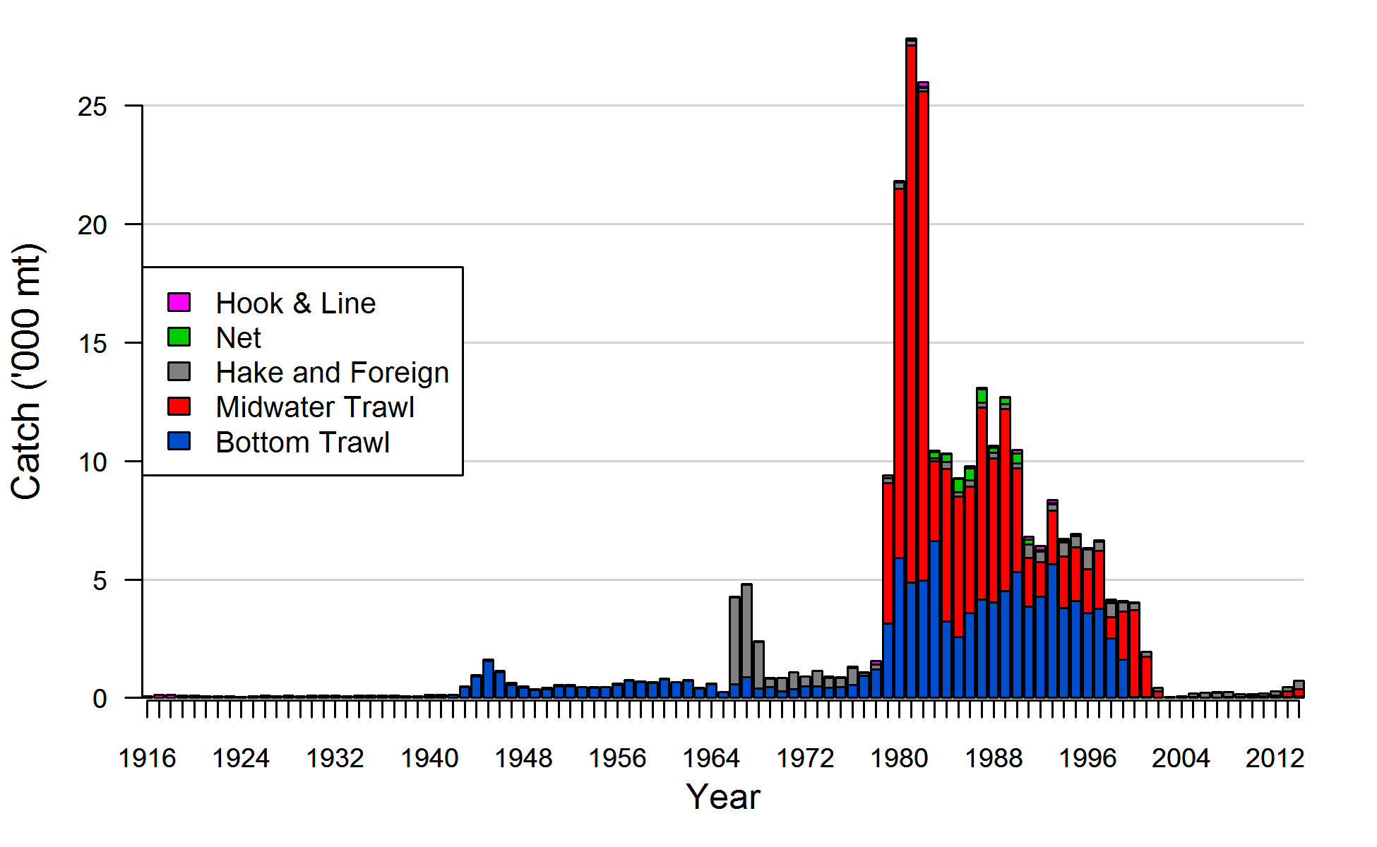

Figure a: Landings of Widow Rockfish from 1916 to 2014 for bottom trawl, midwater trawl, net, and hook-and-line fisheries, and catches of Widow Rockfish for the foreign (1966–1976), and Pacific Whiting (hake) fisheries.

Data and assessment

This is a new full assessment for Widow Rockfish which was last assessed in 2011. In this assessment, all aspects of the model including catches, data, and modelling assumptions were re-evaluated as much as possible. The assessment was conducted using the length- and age-structured modeling software Stock Synthesis (version 3.24U, pers. comm. Richard Methot, NMFS). The coastwide population was modeled assuming separate growth and mortality parameters for each sex (a two-sex model) from 1916 to 2015, and forecasted beyond 2015.

The definitions of fishing fleets have been changed from those in the 2011 assessment separating fisheries by strategy rather than space. Five fishing fleets were specified within the model: 1) a shorebased bottom trawl fleet with coastwide catches from 1916–2014, 2) a shorebased midwater trawl fleet with coastwide catches from 1979–2014, 3) a mostly midwater trawl fleet that targets Pacific Hake/Whiting (*Merluccius productus*) and includes a foreign and at-sea fleet with catches from 1975–2014, a domestic shorebased fleet that targeted Pacific Hake with catches from 1991–2014, and foreign vessels that targeted Pacific Hake and rockfish between 1966–1976, 4) a net fishery consisting of catches mostly from California from 1981–2014, and 5) a hook-and-line fishery (predominantly longline) with coastwide catches from 1916–2014.

Data from three fishery-independent surveys were also included in the model: 1) the National Marine Fisheries Service (NMFS) Southwest Fisheries Science Center (SWFSC) and Northwest Fisheries Science Center (NWFSC)/Pacific Whiting Conservation Cooperative (PWCC) Midwater Trawl Survey that provides pre-recruit indices of abundance, 2) the triennial survey which was conducted from 1977–2004 in depths less than 500 meters, and 3) the NWFSC shelf/slope survey which has been surveying the entire U.S. West Coast in depths between 55 and 1,280 meters since 2003.

The data used in the assessment model consisted of survey abundance indices, length compositions, discard data, and age compositions. Model-based biomass indices and length compositions were determined for the triennial and NWFSC surveys. Length and age compositions were also available from the five fisheries. Age data for all years of the NWFSC shelf/slope survey were input as age-at-length. Discard data for the bottom trawl, midwater trawl, and hook-and-line fisheries were available in various years in the form of discarded biomass and length compositions. A small amount of data was available to inform discarding practices of Widow Rockfish prior to 2002. The variances and sample sizes on all of the data were tuned to the expected variability in the model predictions.

The base model estimated parameters for length-based selectivity for all fleets and surveys, retention curves based on length for the bottom trawl, midwater trawl, and hook-and-line fishing fleets, a length-at-age relationship, natural mortality, and recruitment deviations starting in 1900. A Beverton-Holt stock-recruitment function was used to model productivity and the steepness parameter was fixed at 0.798 based on a steepness meta-analysis for west coast rockfishes (pers. comm. Jim Thorson, NWFSC).

Uncertainty for the parameter estimates and derived quantities was determined in three ways. First, estimation uncertainty in the base model was determined using approximate asymptotic 95% confidence intervals based on maximum likelihood theory. Second, model uncertainty was investigated with various sensitivity runs where alternative model structures were implemented. Finally, the major axis of uncertainty was determined to define a range of states of nature and results are presented in a decision table.

Although there are many types of data available for Widow Rockfish since the late 1970s, which were used in this assessment, there is little information about steepness and natural mortality, and recent recruitment. Estimates of steepness are uncertain partly because of variable recruitment. Uncertainty in natural mortality is common in many fish stock assessments even when length and age data are available. Finally, there is little information about the strength of recent recruitment because the young fish are seen with a lower probability in the fisheries and surveys. These uncertainties were characterized as best as possible in the predictions and projections from this assessment.

Stock biomass

The predicted spawning biomass from the base model generally showed a slight decline over the time series until 1966 when the foreign fleet began. A short, but sharp decline occurred, followed by a steep increase due to strong recruitment. The spawning biomass declined rapidly with the developing domestic midwater fishery in the late 1970s and early 1980s. The stock continued to decline until 2000 when a combination of strong recruitment and low catches resulted in a quick increase. The 2015 spawning biomass relative to unfished equilibrium spawning biomass is above the target of 40% of unfished spawning biomass (75.1%), with a low of 37.3% in 1998.

Approximate confidence intervals based on the asymptotic variance estimates show that the uncertainty in the estimated spawning biomass is high, especially in the early years. The standard deviation of the log of the spawning biomass in 2015 is 0.18.

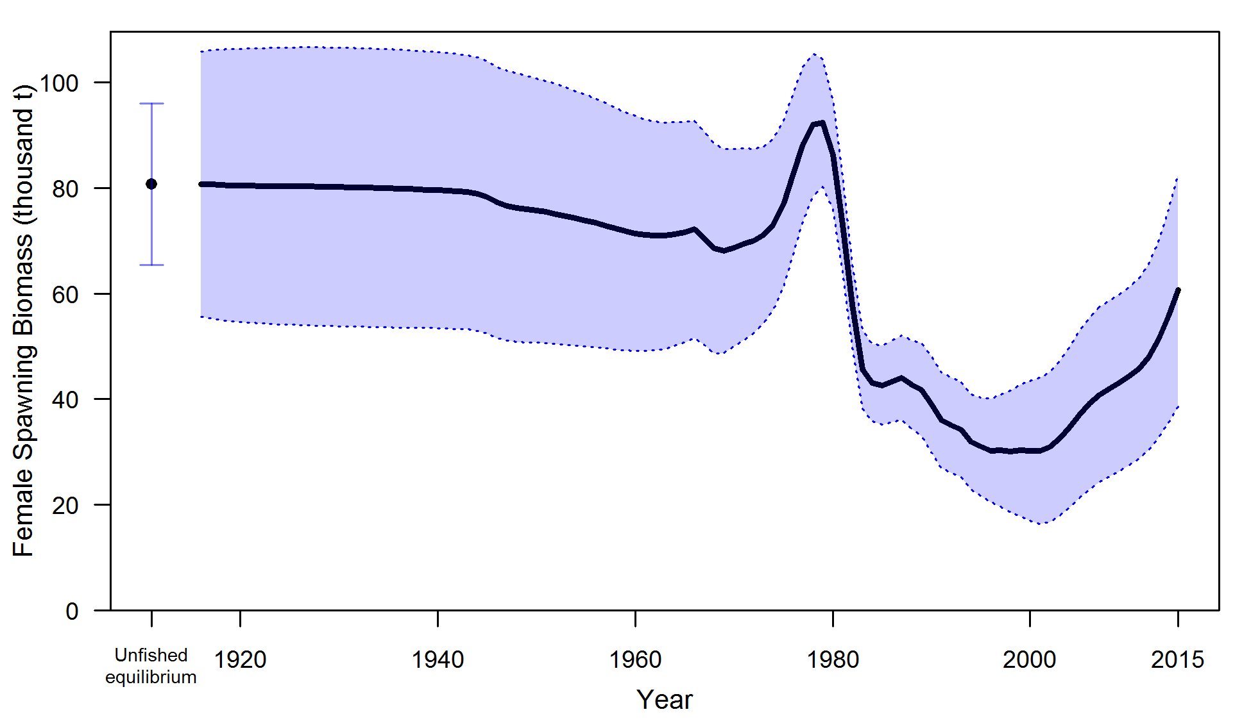

Figure b: Estimated female spawning biomass time-series from the base model (solid line) with an approximate asymptotic 95% confidence interval (shaded area).

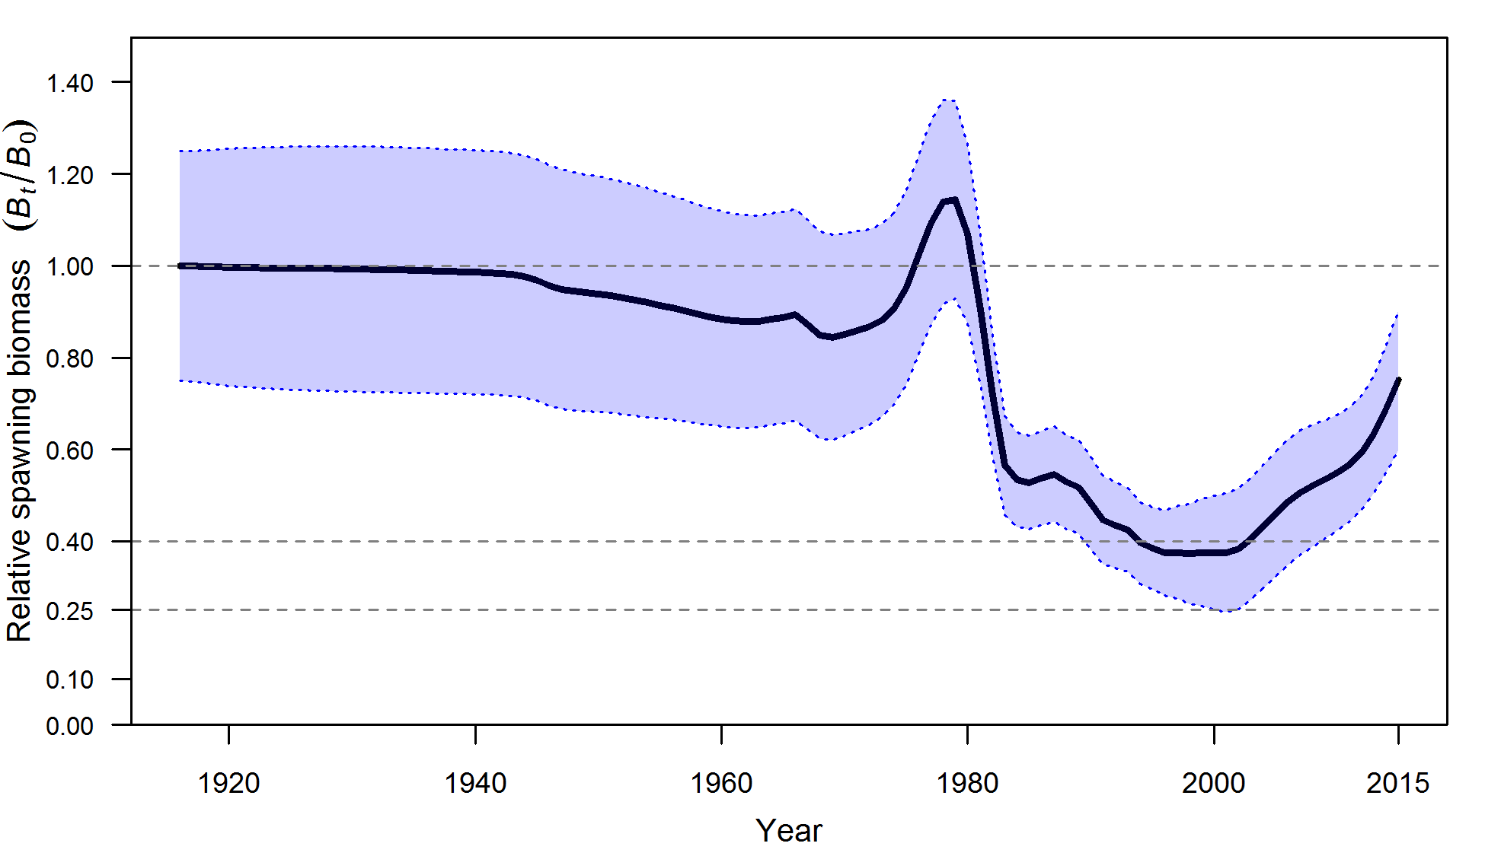

Figure c. Estimated relative spawning biomass (depletion) with approximate 95% asymptotic confidence intervals (filled area) for the base case assessment model.

Table b: Recent trend in estimated female spawning biomass (mt) and relative spawning biomass (depletion).

|  |  |  |  |  |
| --- | --- | --- | --- | --- |
| Year | Spawning Biomass | ~95% Confidence Interval | Estimated Depletion (%) | ~95% Confidence Interval |
|
|
| 2006 | 39,164 | 22,905–55,422 | 48.5 | 34.8–62.2 |
| 2007 | 40,825 | 24,272–57,377 | 50.6 | 37.0–64.2 |
| 2008 | 42,031 | 25,372–58,689 | 52.1 | 38.8–65.4 |
| 2009 | 43,110 | 26,388–59,832 | 53.4 | 40.5–66.4 |
| 2010 | 44,280 | 27,467–61,093 | 54.9 | 42.2–67.5 |
| 2011 | 45,813 | 28,751–62,874 | 56.8 | 44.3–69.2 |
| 2012 | 47,912 | 30,355–65,470 | 59.4 | 47.0–71.8 |
| 2013 | 51,215 | 32,650–69,779 | 63.5 | 50.6–76.3 |
| 2014 | 55,669 | 35,553–75,785 | 69.0 | 55.1–82.8 |
| 2015 | 60,608 | 38,622–82,594 | 75.1 | 59.8–90.4 |

Recruitment

Recruitment deviations were estimated for the entire time series modeled. There is little information regarding recruitment prior to 1965, and the uncertainty in these estimates is expressed in the model. There are very large, but uncertain, estimates of recruitment in 2008, 1970, and 1971. Other large recruitment events (in descending order of magnitude) occurred in 1978, 2010, 1981, 1991, and 1977. The five lowest recruitments (in ascending order) occurred in 1976, 2005, 1973, 1996, and 1972.

Estimates of recruitment appear to be episodic and characterized by periods of low recruitment. Two of the five largest estimated recruitments happened in the last decade.

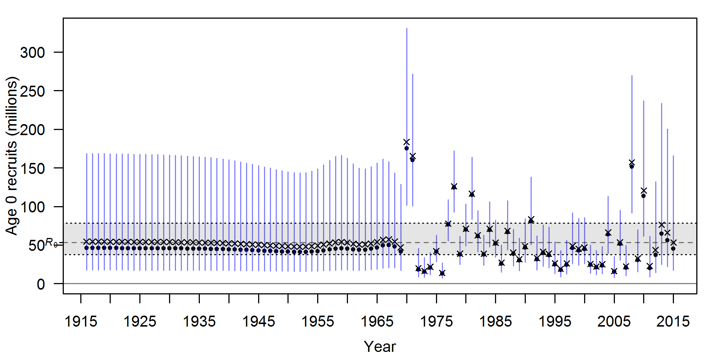

Figure d: Time-series of estimated recruitments (medians as solid circles and mean as an ‘x’) for the base case model with approximate asymptotic 95% confidence interval (vertical bars). Estimated mean unfished equilibrium recruitment (*R*0) is shown as the horizontal dashed line with a 95% confidence interval shaded between the dotted lines.

Table c: Recent estimated trend in Widow Rockfish recruitment with approximate 95% confidence intervals determined from the base model.

|  |  |  |  |  |
| --- | --- | --- | --- | --- |
| Year | Estimated Recruitment  (number in thousands) | ~95% Confidence Interval | Estimated Recruitment Deviation | ~95% Confidence Interval |
| 2006 | 53,702 | 30,309–95,149 | 0.212 | -0.181–0.606 |
| 2007 | 22,470 | 10,225–49,378 | -0.664 | -1.352–0.025 |
| 2008 | 157,219 | 91,670–269,639 | 1.278 | 0.921–1.635 |
| 2009 | 32,713 | 15,331–69,803 | -0.295 | -0.950–0.361 |
| 2010 | 120,622 | 61,356–237,136 | 1.007 | 0.453–1.561 |
| 2011 | 22,961 | 8,562–61,575 | -0.709 | -1.683–0.265 |
| 2012 | 43,443 | 14,268–132,274 | -0.130 | -1.276–1.015 |
| 2013 | 76,349 | 24,956–233,579 | 0.373 | -0.780–1.526 |
| 2014 | 66,109 | 21,826–200,234 | 0.221 | -0.918–1.361 |
| 2015 | 53,370 | 17,161–165,975 | 0.0 | NA |

Exploitation status

The spawning biomass of Widow Rockfish reached a low in 2001 before increasing due to low catches. The estimated depletion was possibly below the overfished level in the early 2000s, but has likely remained above that level otherwise, and currently is significantly greater than the 40% unfished spawning biomass target. Throughout the 1980s and 1990s the exploitation rate and (1-*SPR*) were mostly above target levels. Recent exploitation rates on Widow Rockfish were predicted to be significantly below target levels.

Table d. Recent trend in spawning potential ratio (entered as 1-SPR) and summary exploitation rate.

|  |  |  |  |  |
| --- | --- | --- | --- | --- |
| Year | Estimated 1-SPR (%) | ~95% confidence interval | Harvest rate (proportion) | ~95% confidence interval |
|
| 2005 | 5.03 | 2.49–7.57 | 0.0026 | 0.0015–0.0037 |
| 2006 | 5.13 | 2.61–7.65 | 0.0027 | 0.0016–0.0039 |
| 2007 | 5.39 | 2.81–7.98 | 0.0030 | 0.0018–0.0042 |
| 2008 | 5.78 | 3.09–8.48 | 0.0032 | 0.0019–0.0044 |
| 2009 | 3.92 | 2.12–5.71 | 0.0021 | 0.0013–0.0030 |
| 2010 | 3.67 | 2.03–5.31 | 0.0020 | 0.0012–0.0027 |
| 2011 | 4.19 | 2.37–6.01 | 0.0023 | 0.0015–0.0032 |
| 2012 | 5.19 | 3.00–7.39 | 0.0026 | 0.0016–0.0035 |
| 2013 | 8.22 | 4.88–11.57 | 0.0042 | 0.0026–0.0058 |
| 2014 | 11.44 | 6.90–15.98 | 0.0057 | 0.0036–0.0079 |

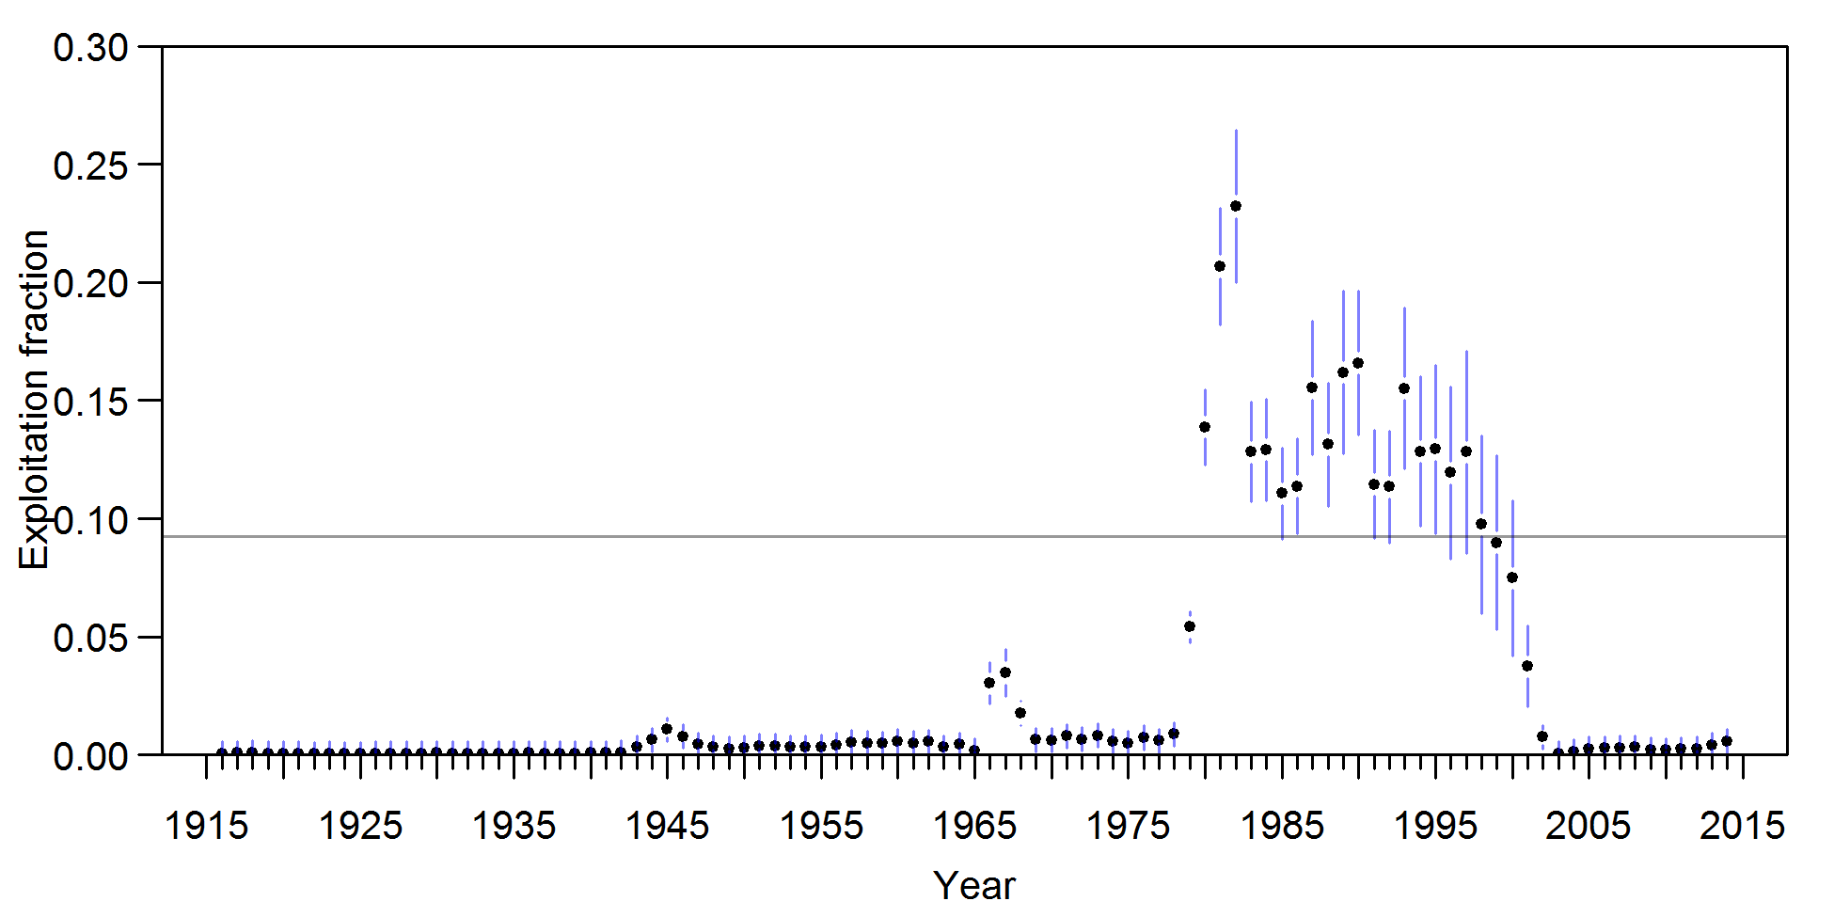

Figure e. Time-series of estimated summary harvest rate (catch divided by age 4+ biomass) for the base case model (round points) with approximate 95% asymptotic confidence intervals (gray lines). The horizontal line is the harvest rate at the overfishing FMSY harvest rate proxy of SPR50%.

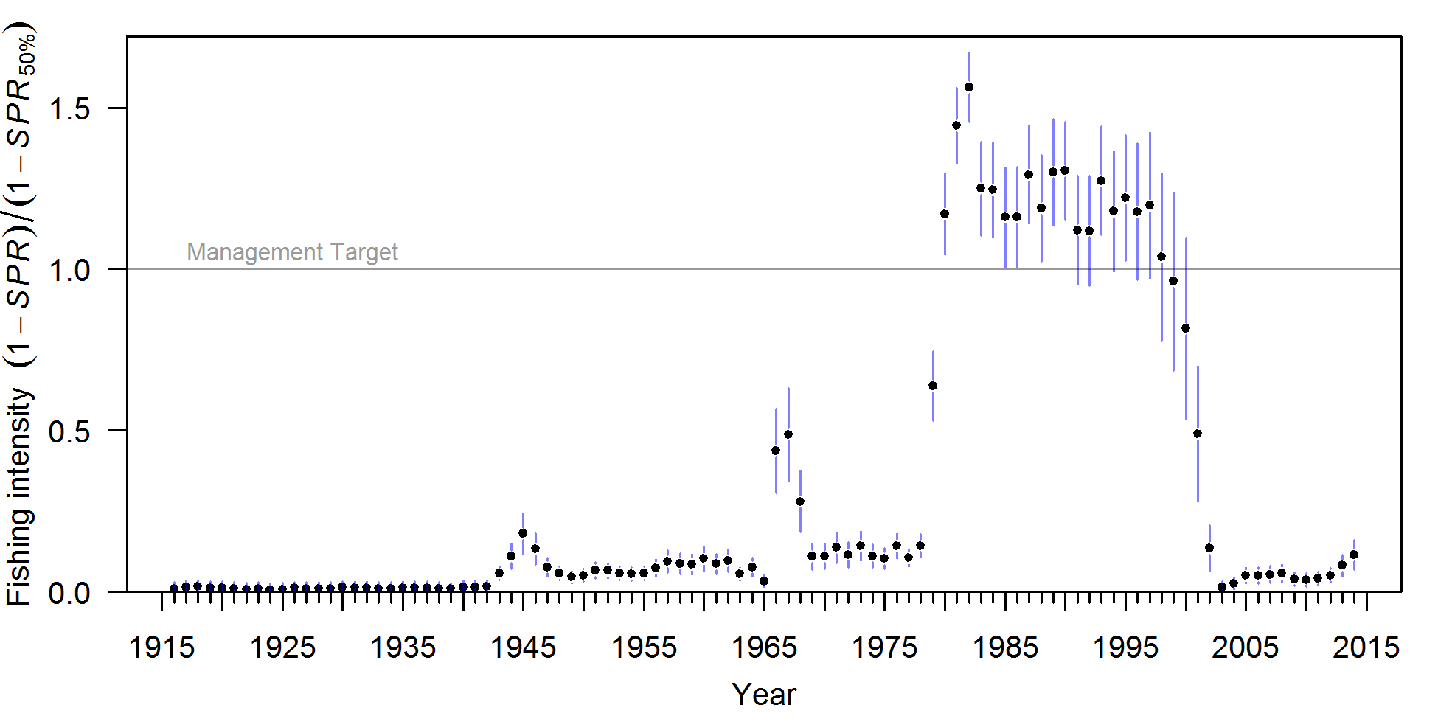

Figure f. Trend in estimated fishing intensity (relative to the SPR management target) through 2014 with 95% asymptotic confidence intervals. One minus SPR is used so that higher exploitation rates occur on the upper portion of the y-axis. The relative management target is plotted as a horizontal line and values above this reflect harvests in excess of the overfishing proxy based on SPR50%.

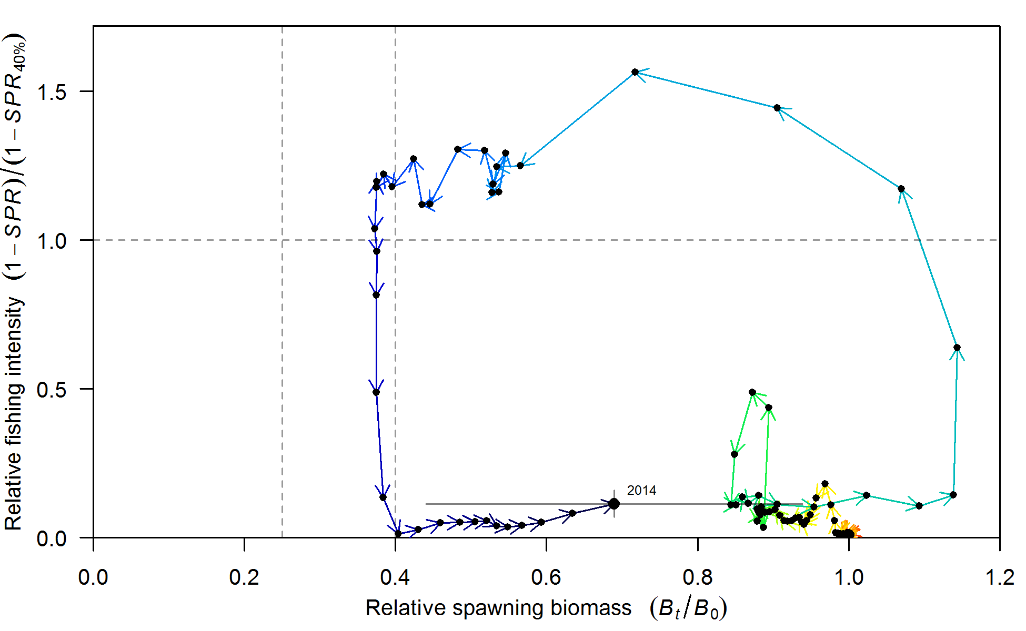

Figure g. Phase plot of estimated relative (1-SPR) vs. relative spawning biomass for the base case model. The relative (1-SPR) is (1-SPR) divided by 0.5 (one minus the SPR target). 2014 is noted with 95% asymptotic confidence intervals.

Ecosystem considerations

Rockfish are an important component of the California Current ecosystem along the U.S. West Coast, with its more than sixty five species filling various niches in both soft and hard bottom habitats from the nearshore to the continental slope, as well as near bottom and pelagic zones. Widow Rockfish frequently aggregate in the pelagic zone.

Recruitment is one mechanism by which the ecosystem may directly impact the population dynamics of Widow Rockfish. The 1999 cohort for many species of rockfish was large – sometimes significantly so – from these species’ long-term averages suggesting that environmental conditions may influence the spawning success and survival of larvae and juvenile rockfish. Widow Rockfish showed an above average recruitment deviation in 1999, but absolute recruitment was not as large as other years. The specific pathways through which environmental conditions exert influence on Widow Rockfish dynamics are unclear; however, changes in water temperature and currents, distribution of prey and predators, and the amount and timing of upwelling are all possible linkages. Changes in the environment may also result in changes in age-at-maturity, fecundity, growth, and survival which can affect how the status of the stock and its susceptibility to fishing are determined. Unfortunately, there are few data available for Widow Rockfish that provide insights into these effects.

Fishing has effects on both the age structure of a population as well as the habitat with which the target species is associated. Fishing often targets larger, older fish, and years of fishing mortality results in a truncated age-structure when compared to unfished conditions. Rockfish are often associated with habitats containing living structure such as sponges and corals, and fishing may alter that habitat to a less desirable state. This assessment provides a look at the effects of fishing on age structure, and recent studies on essential fish habitat are beginning to characterize important locations for rockfish throughout their life history; however there is little current information available to evaluate the specific effects of fishing on the ecosystem issues specific to Widow Rockfish.

Reference points

Reference points were calculated using the estimated selectivities and catch distribution among fleets in the most recent year of the model (2014). Sustainable total yields (landings plus discards) were 7,776 mt when using an *SPR50%* reference harvest rate and with a 95% confidence interval of 5,881 to 9,670 mt based on estimates of uncertainty. The spawning biomass equivalent to 40% of the unfished spawning output (*SB*40%) was 32,283 mt. The recent catches (landings plus discards) have been below the point estimate of potential long-term yields calculated using an *SPR50%* reference point and the population has been increasing over the last decade.

Table e. Summary of reference points and management quantities for the base case model.

|  |  |  |
| --- | --- | --- |
| Quantity | Estimate | ~95% Confidence Interval |
|
| Unfished Spawning Biomass (mt) | 80,708 | 65,427–95,989 |
| Unfished age 4+ biomass (mt) | 156,990 | 127,085–186,895 |
| Unfished recruitment (R0) | 60,608 | 38,622–82,594 |
| Spawning Biomass (2015) | 54,490 | 34,342–74,638 |
| Depletion (2015) | 75.1 | 59.82–90.37 |
| ***Reference points based on SB40%*** |  |  |
| Spawning biomass (S*B40%,* mt) | 32,283 | 26,171–38,396 |
| SPR resulting in *B40%* (*SPRB40%*) | 0.438 | 0.438–0.438 |
| Exploitation rate resulting in *B40%* | 0.113 | 0.102–0.124 |
| Yield with *SPRB40%* at *B40%* (mt) | 8,468 | 6,397–10,540 |
| ***Reference points based on SPR proxy for MSY*** |  |  |
| Spawning Biomass (S*BSPR50%,* mt) | 37,628 | 30,503–44,752 |
| *SPR50%* | 0.5 | NA |
| Exploitation rate corresponding to *SPR50%* | 0.092 | 0.083–0.101 |
| Yield with *SPR50%* at *SBSPR50%* (mt) | 7,776 | 5,881–9,670 |
| ***Reference points based on estimated MSY values*** |  |  |
| Spawning biomass at *MSY* (*SBMSY,* mt) | 18,247 | 14,812–21,681 |
| *SPRMSY* | 0.275 | 0.269–0.281 |
| Exploitation rate corresponding to *SPRMSY* | 0.197 | 0.175–0.218 |
| *MSY* (mt) | 9,464 | 7,111–11,817 |

Management performance

Exploitation rates on Widow Rockfish exceeded *MSY* proxy target harvest rates during the 1980s and 1990s and spawning biomass is predicted to have fallen below the proxy management target of 40%. Exploitation rates decreased in the late 1990s due to management restrictions, and have slightly increased in recent years. Predicted catches in the last decade have not exceeded the annual catch limit (ACL) set by management.

Table f. Recent trend in total catch and commercial landings (mt) relative to the management guidelines. Estimated total catch reflects the commercial landings plus the model estimated discarded biomass.

|  |  |  |  |  |  |
| --- | --- | --- | --- | --- | --- |
| Year | OFL (mt) (termed ABC prior to 2011) | ABC (mt) | ACL (mt) (termed OY prior to 2011) | Commercial Landings (mt) | Estimated Total Catch (mt) |
| 2004 | 3,460 | NA | 284 | 87 | 99 |
| 2005 | 3,218 | NA | 285 | 195 | 204 |
| 2006 | 3,059 | NA | 289 | 213 | 221 |
| 2007 | 5,334 | NA | 368 | 240 | 245 |
| 2008 | 5,144 | NA | 368 | 264 | 272 |
| 2009 | 7,728 | NA | 522 | 177 | 186 |
| 2010 | 6,937 | NA | 509 | 166 | 179 |
| 2011 | 5,097 | 4,872 | 600 | 212 | 213 |
| 2012 | 4,923 | 4,705 | 600 | 270 | 271 |
| 2013 | 4,841 | 4,598 | 1,500 | 470 | 473 |
| 2014 | 4,435 | 4,212 | 1,500 | 722 | 726 |
| 2015 | 4,137 | 3,929 | 2,000 | NA | NA |

Unresolved problems and major uncertainties

This is a reconfiguration of a long line of stock assessments for Widow Rockfish on the U.S. West Coast and although scientifically credible advice is provided by synthesizing many sources of data, there remain data and structural assumptions that contribute to uncertainty in the estimates. Major sources of uncertainty include landings, discards, natural mortality, and recruitment, which are discussed below.

Discards of Widow Rockfish are even more uncertain than landings, but because Widow Rockfish is a marketable species, historical discard rates were likely lower than less desirable or smaller species. In this assessment, we assumed that discarding was nearly negligible before management restrictions began in 1982. Once trip limits were introduced, discarding tended to be an all or none event, and detecting large, but rare, discard events with far less than 100% observer coverage has a low probability. For the years 2002–2010, the WCGOP has provided data on discards from vessels that were randomly selected for observer coverage, thus some uncertainty is present in the total amount discarded. The implementation of trawl rationalization in 2011 resulted in almost 100% observer coverage for the trawl fleet and very little incentive to discard Widow Rockfish. However, the open access fixed-gear fleet is not monitored by the full observer coverage required under trawl rationalization and data show that discarding of Widow Rockfish has occurred on fixed gear vessels in recent years (limited entry vessel fishing with fixed gear are subject to 100% observer coverage). Uncertainty in recent discards is greatly reduced because of observer coverage, but it is unknown what historical discarding may have been. The model assumes a discard rate of 1% pre-1982, which is arbitrary, but reasonable.

Widow Rockfish is a relatively long-lived fish, and natural mortality is likely to be lower than many species of fish, such as gadoids. Ages above 50 years have been observed and it is expected that natural mortality would be less than 0.10 yr-1. However, even with length and age data available back to the late 1970s, natural mortality was estimated above 0.15 yr-1 with a small amount of uncertainty (7% coefficient of variation). This assessment attempts to capture that uncertainty by estimating natural mortality (*M*) and integrating that uncertainty into the derived biomass estimates, as well as additional uncertainty by including levels outside of the predicted interval in a decision table.

Model sensitivities and profiles over *M* showed that current stock status was highly sensitive to the assumption about natural mortality. The estimates of *M* varied slightly depending on the weight given to age and length data, or removing recent years of data, but *M* was always estimated above 0.15 yr-1. Profiles over natural mortality provide support for values above 0.13 yr-1.

Steepness was fixed at 0.798 in the base model, but a likelihood profile showed that it would be estimated at a value less than that. Estimates of *M* increased slightly with lower steepness, while unfished equilibrium spawning biomass increased and current spawning biomass decreased. Equilibrium yield ranged from approximately 4,000 to 8,000 mt depending on the value of steepness.

Decision table

Model uncertainty has been described by the estimated uncertainty within the base model and by the sensitivities to different model structure. The estimated parameter that resulted in the most variability of predicted status and yield advice was natural mortality (*M*), which was estimated with much more certainty than the prior distribution implied. In fact, the 95% confidence interval for estimated *M* was entirely greater than and did not include the point estimate from the prior distribution. There is the possibility that the base model and the approximate uncertainty intervals based on maximum likelihood theory may not entirely convey the actual uncertainty of this assessment. However, preliminary (and non-converged) MCMC tests suggest that the uncertainty is similar to the results presented here for natural mortality, spawning biomass, and depletion.

Three categories of parameters that greatly contribute to uncertainty in the results were natural mortality (an important estimated parameter), steepness (not estimated in the model), and the strength of recent year classes (influential on projections). A combination of these three factors was used as the axis of uncertainty to define low and high states of nature. The 12.5% and 87.5% quantiles for female and male natural mortality (independently) were chosen as low and high values (0.145 yr-1 and 0.170 yr-1 for females; 0.158 yr-1 and 0.183 yr-1 for males). The 12.5% and 87.5% quantile of t 2010 recruitment deviation were also used (0.7340 and 1.3826). Steepness is probably the most important factor since it was fixed in the base model and is not incorporated in the estimation uncertainty. The 12.5% and 87.5% quantiles from the steepness prior (without Widow Rockfish data) were used to define the low and high values of steepness (0.632 and 0.943). The low combination of these three factors defined the low state of nature and the high combination of these three factors defined the high state of nature. The predictions of spawning biomass in 2015 from the low and high states of nature are close to the 12.5% and 87.5% lognormal quantiles from the base model.

This assessment synthesizes many sources of data and estimates recruitment variability, thus it is classified as a Category 1 stock assessment. Therefore, the sigma for P\* to determine the catch reduction to account for scientific uncertainty is 0.36, since the estimated sigma in the assessment is less than this for current spawning biomass.

Table g. Projection of potential OFL, landings, and catch, summary biomass (age-4 and older), spawning biomass, and depletion for the base case model projected with total catch equal to the default ACL of 2,000 mt annually. The predicted OFL is the calculated total catch determined by *FSPR=50%*.

|  |  |  |  |  |  |
| --- | --- | --- | --- | --- | --- |
| **Year** | **Predicted OFL (mt)** | **Projected Total Catch (mt)** | **Age 4+ biomass (mt)** | **Spawning Biomass (mt)** | **Depletion (%)** |
|  |
| 2015 | 4,137\* | 2,000 | 132,031 | 60,608 | 75.1 |  |
| 2016 | 3,990\* | 2,000 | 135,187 | 64,599 | 80.0 |  |
| 2017 | 14,130 | 2,000 | 140,098 | 67,674 | 83.9 |  |
| 2018 | 14,511 | 2,000 | 144,029 | 69,856 | 86.6 |  |
| 2019 | 14,746 | 2,000 | 146,237 | 71,533 | 88.6 |  |
| 2020 | 14,966 | 2,000 | 147,574 | 72,892 | 90.3 |  |
| 2021 | 15,132 | 2,000 | 148,209 | 73,866 | 91.5 |  |
| 2022 | 15,200 | 2,000 | 148,328 | 74,413 | 92.2 |  |
| 2023 | 15,179 | 2,000 | 148,098 | 74,604 | 92.4 |  |
| 2024 | 15,108 | 2,000 | 147,654 | 74,556 | 92.4 |  |
| 2025 | 15,016 | 2,000 | 147,099 | 74,369 | 92.2 |  |
| 2026 | 14,924 | 2,000 | 146,502 | 74,110 | 91.8 |  |
| \*Value determined prior to the 2015 assessment as part of the harvest specifications | | | | | |  |

Table h. Summary table of 12-year projections beginning in 2017 for alternate states of nature based on the axis of uncertainty (a combination of *M*, *h*, and 2010 recruitment strength). Columns range over low, mid, and high state of nature, and rows range over different assumptions of total catch levels (discards + retained). Catches in 2015 and 2016 are allocated using the percentage of landings for each fleet in 2014.

|  |  |  |  |  |  |  |  |  |  |
| --- | --- | --- | --- | --- | --- | --- | --- | --- | --- |
|  |  |  |  | **State of nature** | | | | | |
|  |  |  |  | Low | | Base case | | High | |
| **Relative probability of ln(SB\_2013)** | | | | 0.25 | | 0.5 | | 0.25 | |
| **Management decision** | Year | OFL | Catch (mt) | Spawning biomass (mt) | Depletion (%) | Spawning biomass (mt) | Depletion (%) | Spawning biomass (mt) | Depletion (%) |
| 2,000K | 2017 | 14,130 | 2,000 | 53,178 | 64% | 67,674 | 84% | 79,081 | 98% |
| 2018 | 14,511 | 2,000 | 54,831 | 67% | 69,856 | 87% | 82,026 | 101% |
| 2019 | 14,746 | 2,000 | 56,417 | 68% | 71,533 | 89% | 83,858 | 103% |
| 2020 | 14,966 | 2,000 | 58,025 | 70% | 72,892 | 90% | 84,911 | 105% |
| 2021 | 15,132 | 2,000 | 59,510 | 72% | 73,866 | 92% | 85,270 | 105% |
| 2022 | 15,200 | 2,000 | 60,750 | 74% | 74,413 | 92% | 85,015 | 105% |
| 2023 | 15,179 | 2,000 | 61,745 | 75% | 74,604 | 92% | 84,317 | 104% |
| 2024 | 15,108 | 2,000 | 62,549 | 76% | 74,556 | 92% | 83,365 | 103% |
| 2025 | 15,017 | 2,000 | 63,222 | 77% | 74,369 | 92% | 82,306 | 101% |
| 2026 | 14,924 | 2,000 | 63,805 | 77% | 74,110 | 92% | 81,233 | 100% |
| ACL  P\* =0.45 sigma=0.36 | 2017 | 14,130 | 13,508 | 53,178 | 64% | 67,675 | 84% | 79,081 | 98% |
| 2018 | 13,237 | 12,655 | 48,794 | 59% | 63,900 | 79% | 76,172 | 94% |
| 2019 | 12,375 | 11,830 | 45,047 | 55% | 60,314 | 75% | 72,826 | 90% |
| 2020 | 11,714 | 11,198 | 42,188 | 51% | 57,284 | 71% | 69,581 | 86% |
| 2021 | 11,181 | 10,689 | 39,951 | 48% | 54,659 | 68% | 66,465 | 82% |
| 2022 | 10,691 | 10,221 | 38,060 | 46% | 52,260 | 65% | 63,435 | 78% |
| 2023 | 10,235 | 9,784 | 36,431 | 44% | 50,080 | 62% | 60,578 | 75% |
| 2024 | 9,835 | 9,402 | 35,056 | 43% | 48,173 | 60% | 58,014 | 72% |
| 2025 | 9,502 | 9,083 | 33,908 | 41% | 46,561 | 58% | 55,803 | 69% |
| 2026 | 9,232 | 8,826 | 32,943 | 40% | 45,225 | 56% | 53,944 | 67% |
| ACL  P\* =0.25  sigma=0.36 | 2017 | 14,130 | 11,078 | 53,178 | 64% | 67,675 | 84% | 79,081 | 98% |
| 2018 | 13,506 | 10,589 | 50,069 | 61% | 65,158 | 81% | 77,409 | 95% |
| 2019 | 12,855 | 10,078 | 47,348 | 57% | 62,584 | 78% | 75,058 | 93% |
| 2020 | 12,345 | 9,678 | 45,261 | 55% | 60,313 | 75% | 72,555 | 89% |
| 2021 | 11,918 | 9,344 | 43,598 | 53% | 58,241 | 72% | 69,970 | 86% |
| 2022 | 11,502 | 9,018 | 42,141 | 51% | 56,241 | 70% | 67,308 | 83% |
| 2023 | 11,096 | 8,699 | 40,839 | 50% | 54,339 | 67% | 64,692 | 80% |
| 2024 | 10,726 | 8,409 | 39,709 | 48% | 52,615 | 65% | 62,267 | 77% |
| 2025 | 10,409 | 8,160 | 38,752 | 47% | 51,113 | 63% | 60,117 | 74% |
| 2026 | 10,147 | 7,955 | 37,945 | 46% | 49,838 | 62% | 58,267 | 72% |

Research and data needs

There are many areas of research that could be improved to benefit the understanding and assessment of Widow Rockfish. Below, we specifically identify five topics that we believe are most important.

* **Historical landings and discards:** The historical landings and discards are uncertain for Widow Rockfish and improvements would increase the certainty that fishing removals are applied appropriately. Because landings are assumed to be known exactly in the assessment model, uncertainty in the predictions does not include uncertainty in the landings. A thorough look at historical landings, species compositions, and discarding practices would potentially account for and possibly reduce the uncertainty. More importantly, though, a measure of uncertainty on the estimated historical landings would allow for reasonable sensitivities to be investigated.
* **Natural mortality:** Uncertainty in natural mortality translates into uncertain estimates of status and sustainable fishing levels for Widow Rockfish. The collection of additional age data, re-reading of older age samples, reading old age samples that are unread, and improved understanding of the life-history of Widow Rockfish may reduce that uncertainty.
* **Maturity and fecundity:**  There are few studies on the maturity of Widow Rockfish and even less recent information. There have been no studies that reported results of a histological analysis. Further research on the maturity and fecundity of Widow Rockfish, the potential differences between areas, the possibility of changes over time would greatly improve the assessment of these species.
* **Age data and error:** There is a considerable amount of error in the age data and potential for bias. Investigating the ageing error and bias would help to understand the influences that the age data have on this assessment.
* **Basin-wide understanding of stock structure, biology, connectivity, and distribution:** This is a stock assessment for Widow Rockfish off of the west coast of the U.S. and does not consider data from British Columbia or Alaska. Further investigating and comparing the data and predictions from British Columbia and Alaska to determine if there are similarities with the U.S. West Coast observations would help to define the connectivity between Widow Rockfish north and south of the U.S.-Canada border.

Table i. Summary table of results for the assessment of Widow Rockfish.

|  |  |  |  |  |  |  |  |  |  |  |
| --- | --- | --- | --- | --- | --- | --- | --- | --- | --- | --- |
|  | 2006 | 2007 | 2008 | 2009 | 2010 | 2011 | 2012 | 2013 | 2014 | 2015 |
| Commercial landings (mt) | 213 | 240 | 264 | 177 | 166 | 212 | 270 | 470 | 722 | NA |
| Total catch (mt) | 221 | 245 | 272 | 186 | 179 | 213 | 271 | 473 | 726 | NA |
| OFL (mt) | 3059 | 5334 | 5144 | 7728 | 6937 | 5097 | 4923 | 4841 | 4435 | 4137 |
| ACL (mt) | 289 | 368 | 368 | 522 | 509 | 600 | 600 | 1500 | 1500 | 2000 |
| 1-SPR (%) | 0.05 | 0.05 | 0.06 | 0.04 | 0.04 | 0.04 | 0.05 | 0.08 | 0.11 | NA |
| Exploitation rate (catch/ age 4+ biomass) | 0.0027 | 0.003 | 0.0032 | 0.0021 | 0.002 | 0.0023 | 0.0026 | 0.0042 | 0.0057 | NA |
| Age 4+ biomass (mt) | 80,300 | 81,347 | 86,157 | 86,889 | 90,515 | 91,387 | 106,032 | 112,532 | 126,652 | 132,031 |
| Spawning Biomass | 39,164 | 40,825 | 42,031 | 43,110 | 44,280 | 45,813 | 47,912 | 51,215 | 55,669 | 60,608 |
| ~95% Confidence Interval | 22,905-55,422 | 24,272-57,377 | 25,372-58,689 | 26,388-59,832 | 27,467-61,093 | 28,751-62,874 | 30,355-65,470 | 32,650-69,779 | 35,553-75,785 | 38,622-82,594 |
| Recruitment | 53,702 | 22,470 | 157,219 | 32,713 | 120,622 | 22,961 | 43,443 | 76,349 | 66,109 | 53,370 |
| ~95% Confidence Interval | 30,309-95,149 | 10,225-49,378 | 91,670-269,639 | 15,331-69,803 | 61,356-237,136 | 8,562-61,575 | 14,268-132,274 | 24,956-233,579 | 21,826-200,234 | 17,161-165,975 |
| Depletion (%) | 48.5 | 50.6 | 52.1 | 53.4 | 54.9 | 56.8 | 59.4 | 63.5 | 69 | 75.1 |
| ~95% Confidence Interval | 34.8-62.2 | 37.0-64.2 | 38.8-65.4 | 40.5-66.4 | 42.2-67.5 | 44.3-69.2 | 47.0-71.8 | 50.6-76.3 | 55.1-82.8 | 59.8-90.4 |

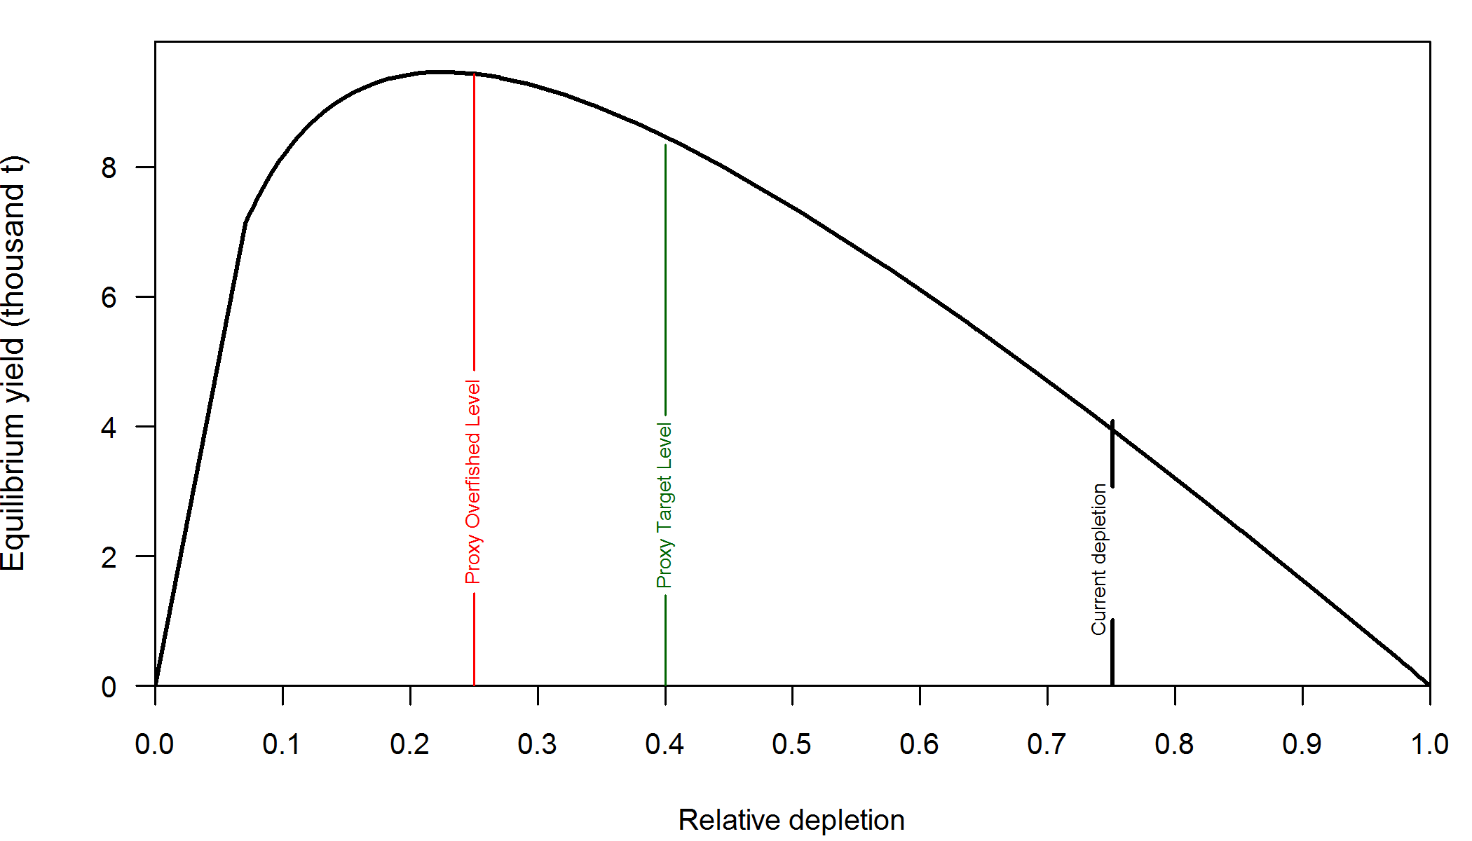

Figure h. Equilibrium yield curve (derived from reference point values reported in Table e) for the base case model. Values are based on 2015 fishery selectivity and distribution with steepness fixed at 0.798. The depletion is relative to unfished spawning biomass.

# Introduction

*Sebastes entomelas* (Widow Rockfish) is named after its black-lined gut cavity (*ento* meaning within and *melas* meaning black). It has been referred to as buda, beccafico (Italian bird), and viuva (widow) prior to the 1930s. More recently, the Widow Rockfish is also called brownie, belinda bass, brown bomber, and soft brown.

This is an assessment of Widow Rockfish that inhabit the waters off California, Oregon, and Washington from the U.S.-Canadian border in the north to the U.S.-Mexico border in the south, and does not include Puget Sound waters (Figure 1). This assessment represents a thorough reconsideration of the data, data preparation, and model structure for assessing Widow Rockfish, including reinvestigations of recent and historical catches (including discards), length and age data, and fleet structure.

## Distribution and stock structure

Widow Rockfish inhabit water depths of 25–370 m from northern Baja California, Mexico to Southeastern Alaska, and are most abundant from British Columbia to Northern California. Although catches north of the U.S.-Canada border or south of the U.S.-Mexico border were not included in this assessment, it is possible that these populations contribute to the biomass of Widow Rockfish off of the U.S. West Coast through adult migration and/or larval dispersion.

There is little evidence of genetically separate stocks along the U.S. coast and past assessments have used a single area, coastwide model with multiple fisheries ([He et al. 2011](#_ENREF_11)). In 2011, a two-area assessment model was brought forward for review, and was found to be similar to a coastwide model ([He et al. 2011](#_ENREF_11)). There is some evidence of biological differences between areas. For example, Widow Rockfish collected off California tend to mature at a smaller length than Widow Rockfish collected off of Oregon (Barss & Echevarria 1984). This may be due to environmental or anthropogenic effects rather than genetic differences. The connectivity of Widow Rockfish populations throughout its range is unknown and it was decided to continue with a single area model for this assessment instead of potentially lose prediction power by splitting the data into two separate areas.

## Life History and ecosystem interactions

Widow Rockfish are atypical for West Coast rockfish species because they form dense midwater aggregations at night, which were largely undetected until the late 1970s. They are typically found over high relief strata and near cobblestone. The diet of Widow Rockfish is dominated by species that comprise the deep scattering layers, including salps, myctophids, *Sergestes similis* (a caridean shrimp), and euphausiids (Adams 1987).

Widow Rockfish are ovoviviparous with gestation lasting from 1 to 3 months. Parturition occurs earlier in southern latitudes (December-March off California) than in northern latitudes (April in British Columbia) and occur once a year (Barss & Echeverria, 1987). Estimates of fecundity of Widow Rockfish range from 95,375 oocytes at 33 cm to 1,113,000 oocytes at 52 cm (Boehlert et al, 1982).

There is little information regarding the movement of Widow Rockfish. Past assessments have assumed a two-area model because of differences in growth and maturity ([see He et al. 2011](#_ENREF_11)). However, using recent observations from the NWFSC shelf/slope survey to follow two separate cohorts through time and space suggests that Widow Rockfish may recruit in the south and disperse northward as they age (Figure 2). Spatial recruitment and movement patterns of Widow Rockfish are uncertain and much more investigation and sampling is needed to fully understand them.

## Historical and current fishery

Widow Rockfish were lightly exploited by bottom trawl and hook-and-line gears prior to the 1980s. After many attempts to start trawl fisheries off the west coast of the United States in the late 1800s, the availability of otter trawl nets and the diesel engine in the mid-1920s helped trawl fisheries expand ([Douglas 1998](#_ENREF_4)). The trawl fisheries really became established during World War II when demand increased for shark livers and bottomfish. A mink food fishery also developed during World War II ([Jones and Harry 1960](#_ENREF_15)). Foreign fleets began fishing for rockfish in the mid-1960s until the EEZ was implemented in 1977 ([Rogers 2003](#_ENREF_21)). Longline catches of Widow Rockfish are present from the turn of the century and continue in recent years, mainly from fisheries targeting sablefish and halibut.

In the late 1960s and early 1970s, it is reported that foreign fishing vessels caught large numbers of Widow Rockfish (Rogers 2003). In the late 1970s a domestic midwater trawl fishery began developing off of Oregon when it was realized that Widow Rockfish form dense aggregations at night (Gunderson 1984). The fishery expanded very quickly, with landings from trawl, net, and hook-and-line gears increasing more than 20 times by the early 1980s (Table 1). As early as 1982, trip limits were imposed to keep catches below recommended annual levels (Table 3). Trip limits became more restrictive over the years until Widow Rockfish was declared overfished in 2001. In 2002, harvest guidelines were greatly reduced and over the last decade have been small, although increasing since 2004 (Table 4).

Historical discarding practices are not well known, but it is believed that little discarding occurred prior to management restrictions. With the introduction of trip limits, limited data from the mid-1980s show occasional very high discard rates of Widow Rockfish from tows that occurred near the end of a trip.

More detailed information of the fisheries in each state is given in Section 2.2.1 where the reconstructed landings are discussed.

## Management history and performance

Widow Rockfish has been a small large component of groundfish fisheries since the late 1970s. The landings of Widow Rockfish have been historically governed by harvest guidelines and trip limits, while recently management is imposed with total catch harvest limits in the form of overfishing limits (OFLs), acceptable biological catches (ABCs), and annual catch limits (ACLs). A trawl rationalization program, consisting of an individual fishing quota (IFQ) or catch shares system was implemented in 2011 for the limited entry trawl fleet targeting non-whiting groundfish, including Widow Rockfish, and the trawl fleet targeting and delivering whiting to shore-based processors. The limited entry at-sea trawl sectors (motherships and catch-processors) that target whiting and process at sea are managed in a system of harvest cooperatives.

Limits on Widow Rockfish were first established in 1982 (Table 3). These were implemented as trip limits and cumulative landing limits that were first imposed by trip, then week, then every 2 weeks, month, 2 months, and eventually into periods. In many years, the trip limits on Widow Rockfish were significantly reduced at the end of the year to avoid exceeding the harvest recommendations. Some important years were 1985 when trip limits were reduced to 30,000 pounds once per week or 60,000 pounds once every 2 weeks, 1990 when trip limits were reduced to 15,000 or 25,000 pounds every one or two weeks, respectively, 1998 when a 25,000 pound cumulative limit per two-month period was implemented, and 2011 when catch shares was implemented.

A sorting requirement was implemented for Widow Rockfish in the early 1980s with California beginning in 1982, Oregon in 1984, and Washington in 1988. Some important events that could affect fishery selectivity are the gear restrictions implemented in 2000, implementation of Rockfish Conservation Areas (RCA’s) in 2002, seasonal changes to the RCA’s in 2007, and the beginning of catch shares in 2011.

Table 4 shows that recent landings have been below recommended catch levels. Landings are a considerable amount below the ACL, and it is unlikely that total mortality has exceeded the ACL in the last 10 years.

## Fisheries and assessments in Canada and Alaska

Widow Rockfish are distributed throughout Canada and Southeast Alaska and are commonly caught in trawl and hook-and-line fisheries. However, the landings from the fisheries in these areas are estimated to harvest Widow Rockfish at much smaller rate than has been observed off California, Oregon, and Washington mostly due to lower abundance of Widow Rockfish, but also partly due to precautionary behavior of Canadian managers after the large catches followed by management restrictions and concerns of the U.S. fishery in the early 1980s.

Alaska formed the “Other Rockfish” complex in 2012 from the combination of Other Slope Rockfish and the Widow and Yellowtail Rockfishes from the Pelagic Shelf Rockfish category. This new complex includes 18 species and Widow Rockfish are a small proportion of the catch (less than 5%). Total biomass estimates are provided by the Gulf of Alaska (GOA) triennial/biennial trawl survey. ABC’s and OFL’s were set for the Other Rockfish Complex and component species in 2013 with a recommended OFL in 2014 of 5,347 mt for the complex. Widow Rockfish comprise a small part of this complex in Alaska.

The fishery for Widow Rockfish in British Columbia, Canada started in 1986 although some very small landings occurred in the mid-1970s. Landings peaked at about 4,500 mt in 1990 and were around 2,000 mt throughout the 1990s ([DFO 1999](#_ENREF_2)). Most landings occurred in a midwater trawl fishery, but there have also been reports of “nuisance catches in the salmon troll fishery”. An assessment of Widow Rockfish in Canada was completed in 1998 (Stanley 1999) as part of a shelf rockfish complex. Additional research has since been done on the estimation of biomass of particular aggregations of Widow Rockfish ([Stanley et al. 2000](#_ENREF_22)), but no formal assessment has been done since.

# Data

Many sources of data were available for this assessment, including indices of abundance (Table 5), length observations, and age observations from fishery-dependent and fishery-independent sources.

## Fishery-independent data

Data from three fishery-independent surveys were used in this assessment: 1) the SWFSC and NWFSC/PWCC Midwater Trawl Survey (hereafter, “juvenile survey”); 2) the Alaska Fisheries Science Center (AFSC)/NWFSC triennial Pacific Coast Bottom Trawl Survey (hereafter, “triennial survey”); and 3) the NWFSC Pacific Coast Groundfish Bottom Trawl Survey (hereafter, “NWFSC shelf/slope survey”). These surveys employed different designs and sampling methodologies, were conducted during different years and time periods within years, and included coverage over different areas of the coast. In some instances, the survey frequency, depths, and geographic areas covered were not internally consistent within surveys. A brief description of each survey is provided below.

Strata were defined by latitude and depth to analyze the catch-rates, length compositions, and age compositions using stratified random sampling theory. The latitude and depth breaks were chosen based on the design of the survey as well as by looking at biological patterns in relation to latitude and depth.

Indices of abundance for all of the surveys were derived using a Delta-generalized linear mixed model (GLMM) following the methods of [Thorson and Ward (2013](#_ENREF_29)). The surveys were stratified by latitude and depth, and vessel-specific differences in catchability (via inclusion of random effects for the NWFSC and the Triennial surveys) were estimated for each survey time series. The Delta-GLMM approach explicitly models both the zero and non-zero catches and allows for skewness in the distribution of catch rates. Lognormal and gamma errors structures were considered for the positive tows, including the option to model extreme catch events (ECEs), defined as hauls with extraordinarily large catches, as a mixture distribution ([Thorson et al. 2011](#_ENREF_28)). There were therefore four total positive tow error structures considered: gamma or lognormal with or without ECEs mixture distributions. Model convergence was evaluated using the effective sample size of all estimated parameters (typically >500 of more than 1000 kept samples would indicate convergence), while model goodness-of-fit was evaluated using Bayesian Q-Q plots and deviance. The resultant coefficient of variations (CVs) of each model were also considered when determining viable indices (i.e., CVs consistently >2 in each year were deemed uninformative and not used).

### Juvenile survey

An update of the coastwide pre-recruit indices of abundance was obtained from John Field (SWFSC, pers. comm.). These indices of abundance were estimated using data from three separate midwater trawl surveys for young-of-the-year (YOY) pelagic juvenile rockfish. Identical gear was used by each survey, and combining the data provides the best opportunity to create coastwide indices. Only years that covered waters from 36°N latitude to the U.S./Canada border were used. Estimates, in numbers of age-0 fish, were bias corrected for the lognormal distribution to get a median value before fitting in the model.

The index shows a very large number of age-0 fish in 2013, followed by a large number in 2014, and a moderate value in 2004 (Table 8 and Figure 4). Coefficients of variation were all above 60%, and approaching 100% for the largest estimates.

### AFSC/NWFSC triennial bottom trawl survey

The triennial survey was first conducted by the AFSC in 1977 and spanned the timeframe from 1977–2004. The survey’s design and sampling methods are most recently described in [Weinberg et al. (2002](#_ENREF_30)). Its basic design was a series of equally-spaced transects from which searches for tows in a specific depth range were initiated (Figure 5). The survey design changed slightly over time (Table 6 and Figure 6). In general, all of the surveys were conducted in the mid-summer through early fall: the 1977 survey was conducted from early July through late September; the surveys from 1980 through 1989 ran from mid-July to late September; the 1992 survey spanned from mid-July through early October; the 1995 survey was conducted from early June to late August; the 1998 survey ran from early June through early August; and the 2001 and 2004 surveys were conducted in May-July (Figure 6).

Haul depths ranged from 91–457 m during the 1977 survey with no hauls shallower than 91 m. The surveys in 1980, 1983, and 1986 covered the West Coast south to 36.8°N latitude and a depth range of 55–366 meters. The surveys in 1989 and 1992 covered the same depth range but extended the southern range to 34.5°N (near Point Conception). From 1995 through 2004, the surveys covered the depth range 55–500 meters and surveyed south to 34.5°N latitude. In the final year of the triennial series (2004), the NWFSC’s Fishery Resource and Monitoring division (FRAM) conducted the survey and followed very similar protocols as the AFSC.

Given the different depths surveyed during 1977, the data from that year were not included in this assessment. Water hauls ([Zimmermann et al. 2003](#_ENREF_31)) and tows located in Canadian waters were also excluded from the analysis of this survey. The survey was analyzed as an early series (1980–1992) and a late series (1995–2004), as has been done in other West Coast rockfish assessments.

The triennial index was estimated as a single time-series using a GLMM with the stratifications shown in Table 7. Boxplots of the deviance for triennial survey series are shown in Figure 7 and show that the gamma and the lognormal distributions with random strata-year effects including an extreme catch event mixture distribution (ECE) have the lowest median deviance values. Random or fixed strata-year effects without extreme catch events produced a similar deviance to each other, and the deviance was greatly reduced when ECEs were accounted for. Deviance Information Criterion (DIC) values were also compared among models. DIC values favored the gamma distribution with ECEs over the lognormal distribution with ECEs. The Q-Q plot for the gamma distribution with random strata-year effects and ECEs did not show a departure from the normality assumption (Figure 8). Therefore, based on the deviance and the DIC criteria the gamma distribution with random strata-year effects accounting for ECEs was used to estimate the indices given in Table 8. The time series suggests a possible slightly increasing trend in biomass from 1980 - 1983, although is relatively flat until the end of the period in 2001 and 2004 when the index declines significantly. The design-based estimates (average density expanded to the stratum area then summed over strata) are compared to the model-based estimates in Figure 9. The trends generally vary between the design-based and the Delta-GLMM based model, with the highest estimates based on the design-based occurring in 1989 and 1992. However, the design-based abundance estimates result in the lowest abundances in 2001 and 2004, similar to the Delta-GLMM model.

Length frequencies for each year were expanded using the same stratification as the GLMM, and weighted by strata estimated numbers from the GLMM when combining them into a coastwide length composition (Figure 10). Unsexed fish were apportioned to males and females according to the estimated sex ratio for lengths greater than 28 cm. The sex ratio of lengths less than 28 cm was assumed to be 0.5. There was considerable variability in length frequencies in the triennial survey data. Smaller fish (less than 15 cm) were observed in small proportions from 1992 onwards. There is no clear difference in length composition pre- and post-1995 that would support the split into early and late periods.

### NWFSC shelf/slope survey

The NWFSC shelf/slope survey is based on a random-grid design, covering the coastal waters from a depth of 55 m to 1,280 m (Keller et al. 2007). This design uses four chartered industry vessels in most years, assigned to a roughly equal number of randomly selected grid cells. The survey, which has been conducted from late-May to early-October each year, is divided into two 2-vessel passes of the coast, which are executed from north to south. This design therefore incorporates both vessel-to-vessel differences in catchability as well as variance associated with selecting a relatively small number (~700) of cells from a very large population of possible cells (greater than 11,000) distributed from the Mexican to the Canadian border. Much effort has been expended on appropriate analysis methods for this type of data, culminating in the West Coast trawl survey workshop held in Seattle in November 2006.

Widow Rockfish are not commonly caught in the NWFSC shelf/slope survey. Higher catch rates occur north of 40° N latitude and catches are rare south of 36° N latitude (Figure 11). Few large fish are found shallower than 100 m and few small fish are found in the deeper water of the slope (Figure 12). There is no clear trend in length with latitude other than smaller fish tend to occur south of approximately 36° N latitude, and there appears to be some very small fish found near 39° N latitude.

The indices for this survey were developed using a GLMM with the stratification shown in Table 7. Boxplots of the deviance for this survey (Figure 7) show that the gamma distribution with random strata-year effects and ECE had the lowest median deviance and was chosen as the final model. The Q-Q plot does not show any departures from the assumed distribution (Figure 8).The Delta-GLMM can account for impact of survey timing by incorporating pass as a covariate. Explorations were done with and without the inclusion of the pass covariate that showed little to no improvement in model deviance or improved DIC values when pass was included as a covariate. Therefore, the gamma distribution with the ECE mixture distribution and random effects on the year-strata interaction without pass as a covariate was used to estimate the indices given in Table 8.

The indices for the NWFSC shelf/slope survey show a slight increasing trend over the time series (Figure 9). The design-based estimates also show a generally increasing trend but are more variable than the model-based estimates (Figure 9). Accounting for ECEs dampened the high peaks observed in the design-based time series in years with only a few large hauls.

Length, age, and conditional age-at-length compositions were created by expanding to the tow and summing to give a strata specific composition. The strata compositions were combined to a coastwide composition using the numbers in each strata estimated from the GLMM. Numbers in each strata were calculated by converting the numbers-at-length to weight-at-length to calculate a mean weight. The GLMM biomass estimate within each stratum was divided by the strata specific mean weight.

Expanded length frequencies from this survey show intermittent years of small fish (Figure 13). In 2003 and 2004, a high proportion of fish were seen around 35–40 cm, but in later years, it was uncommon to see fish in that range. Age compositions (Figure 14) show a high proportion of a single age in 2003 and 2004. Strong cohorts are not immediately apparent and it seems that ageing error may result in some variability between years. In 2012, there was a high proportion of 4 year old fish, which appears in successive years as a strong 2008 year class. Conditional age-at-length proportions (Figure 15) show relatively consistent length-at-age with few outliers.

### Fishery-independent surveys not used in this analysis

#### AFSC slope survey

The AFSC slope survey operated during autumn (October-November) aboard the R/V *Miller Freeman*. Partial survey coverage of the U.S. west coast occurred during 1988–96 and complete coverage (north of 34° 30’ S latitude) during 1997, 1999, 2000, and 2001, which observed Widow Rockfish in 10, 17, 5 and 8 tows, respectively. Length data are available in each year, with 89 samples in 1999, but less than 20 combined between 2000 and 2001.

#### NWFSC slope survey

The NWFSC slope survey covered waters throughout the summer from 183 m to 1280 m north of 34° 30’ S latitude, which is near Point Conception. The survey took place from 1998–2002. In 1999, Widow Rockfish were caught in 18 hauls, the most seen for this survey. In 1998, rockfish were not recorded. This survey was not used because it occurred over a short time period, surveyed slope waters (>183 m) that exclude some of the Widow Rockfish habitat, observed few Widow Rockfish, and did not record any lengths of Widow Rockfish.

#### IPHC longline survey

The International Pacific Halibut Commission (IPHC) has conducted an annual longline survey for Pacific halibut off the coast of Oregon and Washington (IPHC area “2A”) since 1999 with a fixed station design. Approximately 1,800 hooks are deployed at 84 locations each year (Figure 16). Rockfish bycatch is routinely recorded during this survey, and originally estimates of rockfish bycatch in area 2A were based on subsampling the first 20 hooks of each 100-hook skate. Recently, all rockfish are tagged and recorded for later sampling by WDFW and ODFW biologists (see <http://www.iphc.int/publications/rara/2012/rara2012503_ssa_survey.pdf>). Some variability in exact sampling location is practically unavoidable, and leeway is given in the IPHC methods to center the set on the target coordinates but to allow wind and currents to dictate the actual direction in which the gear is deployed. This can result in different habitats accessed at each fixed location among years.

The IPHC longline survey fishes in suitable habitat for Widow Rockfish, but the majority of the rockfish catch is yelloweye rockfish (*S.* *ruberrimus*). From 2002 to 2012, only one observation of Widow Rockfish was recorded, which was at station 1064 off of Westport.

## Fishery-dependent data

Widow Rockfish have been caught in trawl and hook-and-line fisheries since the early part of the 20th century. Widow Rockfish are a desirable rockfish and are not likely to be discarded for market reasons. However, smaller Widow Rockfish are found at shallower depths and discarding practices in the early 1900s are uncertain. Few Widow Rockfish have been observed (relative to other gear types) in recreational, commercial pot, and commercial shrimp fisheries, thus only trawl, net, and hook-and-line landings were used in this assessment.

In data from the early 1980s, Widow Rockfish have had their own landing category. California began in 1982, Oregon in 1984, and Washington in 1988. Estimates of historical landings of Widow Rockfish rely upon species-composition sampling data from each period. The uncertainty in species composition is greater in past years, with less systematic and extensive sampling occurring prior to 1980. Consequently, the precision with which landings of Widow Rockfish can be estimated likely decreases for earlier years. A description of the methods used to determine the historical and current landings is provided below.

### Commercial catch reconstruction

PacFIN serves as a clearinghouse for commercial landings data since the early 1980s, and before that, landings for each state were reconstructed using the assumptions described below. The at-sea trawl fleet catches are calculated from observer data stored in the NORPAC database, maintained by the AFSC.

#### Washington

Historical commercial landings of three gear types, bottom trawl, midwater trawl, and longline, were reconstructed for Widow Rockfish landed in Washington. It was assumed that landings from other gears constitute a negligible amount of the total mortality.

**Washington’s trawl fishery**

Washington’s coastal trawl fishery began in the early 1930s off of Cape Flattery and landings increased substantially by the 1940s ([Tagart and Kimura 1982](#_ENREF_25)). In 1946, rockfish landings experienced a sharp decline, presumably in response to weakened market demand following World War II. After a period of steady landings of around 5,000 metric tons (mt) annually, landings rapidly increased in the 1960s, followed by a decline in the mid-1970s and a further increase in the late 1970s. After World War II and before the mid-1970s a substantial proportion of the rockfish and Pacific Ocean Perch (POP, *S. alutus*) catch came from Canadian waters. The implementation of the EEZ brought higher landings in Washington from U.S. waters, which rose to over 10,000 mt up until 1983. After that time, rockfish landings declined to around 500 mt in the late 1990s.

Most of the rockfish landed in the Washington trawl fishery were historically assigned into two market categories: “Pacific Ocean Perch” (POP) or “other rockfish” (URCK). Widow Rockfish were specifically identified and sorted in 1988 in Washington. Figure 17 shows the amount landed in each category between 1930 and 1966 before proportioning out the species.

Theresa Tsou (pers comm., WDFW, *Pre80CommSpeciesCom.xlsx*) provided species composition data from landings for 1968–1980. From these data, the years 1968–1975 were used to calculate the average proportion of Widow Rockfish in the URCK market categories, and the years 1972 and 1974 were used to calculate the average proportion of Widow Rockfish in the UPOP market category. These proportions were then applied to historical landings of each category to determine historical Widow Rockfish landings. These years were chosen because landings in these two market categories were consistently sampled for species compositions and after 1975 was when the Widow Rockfish fishery appeared to be developing because the proportion of Widow Rockfish in the landings began increasing. UPOP had Widow Rockfish observations only in 1972 and 1974. The average proportion of Widow Rockfish in UPOP landings in 1972 and 1974 was 0.00049 and the average proportion of Widow Rockfish in URCK landings from 1968–1975 was 0.0095. The average proportion of Widow Rockfish in the sum of UPOP and URCK landings for 1972 and 1974 was 0.0054.

A database of historical Washington landings (Greg Lippert, WDFW, pers comm.) contained landings from Puget Sound and was used to calculate a proportion of the U.S. and Canadian rockfish landings (without POP) that were not from Puget Sound. POP was excluded because it was assumed all POP were caught outside of Puget Sound. From 1949 to 1969, the proportion of landings outside of Puget Sound were greater than 0.95. These estimates agreed closely with estimates calculated using data from research reports on the Washington trawl fishery ([Holmberg et al. 1962](#_ENREF_14), [Holmberg et al. 1967](#_ENREF_13)). Prior to 1949, when POP and rockfish landings were not separated, it was assumed that 99% of the landings came from outside of Puget Sound.

Catches from U.S. waters were derived from [Forrester (1967](#_ENREF_6)) and [Tagart and Kimura (1982](#_ENREF_25)). [Forrester (1967](#_ENREF_6)) reports the separate U.S. vessel and Canadian vessel catches of POP and rockfish for PSMFC areas near British Columbia in the years 1954–1965. Catches south of PSMFC area 3B were not reported, but it is likely that a large proportion of the catch south of 3B came from Oregon vessels. The proportion of Washington landings caught in US waters was calculated as the ratio between the US vessel catch in area 3B and the total catch by US vessels. It is unclear if area 3C as used by [Forrester (1967](#_ENREF_6)) includes a portion of U.S. waters. [Tagart and Kimura (1982](#_ENREF_25)) report catches by PSMFC area for the years 1966–1979 and there was little catch in the areas south of 3B. Additionally, an extraction of Washington fish tickets (supplied by Teresa Tsou, pers comm., WDFW, *FT\_WithComps05222015.xlsx*) for 1939–1969 listed general areas of the catch, some of which were obviously US only while others were spanned US and Canadian waters. These data were mostly classified as US/Canadian waters, with more than 90% of the years showing more than 57% of the catch in this two-country category, and more than 55% of the years showing more than 90% of the catch in this two-country category. The years which had the smallest proportion of catch in this two-country category were the years with very small total catches. After 1954, more than 90% of the catch was reported in this two-country category, except for 1959, which had 86% reported.

In the data available, the first observation coded as midwater trawl was in 2000. From 1994, Pacific Fishery Information Network (PacFIN) database provides a category called Dahl\_Sector which can identify shoreside hake, which is most likely midwater trawls. Using data from PacFIN (1994-2014), at most 8.7% of the GFT landings were reported as Dahl\_Sector 3, although typically more than 20% of those landings had an unknown Dahl\_Sector. Alternatively, I used the annual proportion of trawl catch reported in logbooks (downloaded from PacFIN on June 1, 2015) as midwater trawl gear and filled in missing years with the proportion of midwater trawl catches in Oregon (Figure 18)

Historical landings from trawl fisheries of Widow Rockfish were determined as follows for the periods shown.

**< 1930:** Assumed no catch of Widow Rockfish.

**1930–1934:** The Pacific Fisherman Yearbook rockfish landings were used and it was assumed that all landings were caught in U.S. waters. It was assumed that 1% of the total catch was from Puget Sound, thus was removed (1% was used because POP could have been aggregated with rockfish). The proportion of Widow Rockfish used was 0.00327.

**1935–1942:** Washington Department of Fisheries reported landings (1955 Commercial Fishing Statistics, Washington Dept Fisheries) were used instead of the Pacific Fisherman Yearbook. The sources are quite different, and the Pacific Fisherman Yearbook states it is reporting foodfish only (there was a substantial mink food fishery). We used 0.00543 as the proportion of Widow Rockfish in the landings since POP landings were not separated. For U.S. catches, we assumed a linear decrease from 100% of the catches in U.S. waters in 1934 to 17.65% catches from U.S. waters in 1946 (calculated from the average percentage of catch of rockfish+POP in U.S. waters between 1954-1974, see [Forrester (1967](#_ENREF_6)) and [Tagart and Kimura (1982](#_ENREF_25)). However, it is likely that fishing vessels stayed closer to home during the war years. Puget Sound catches were assumed to comprise 1% of the total landings and were removed.

**1943–1966:** A spreadsheet of Washington landings provided by Theresa Tsou (pers. comm., WDFW) and called *FT\_WithComps05222015.xlsx/Pre1970\_Data* was used for separated rockfish and POP landings. It was assumed that the proportion of Widow Rockfish caught with POP was 0.00049 because few Widow Rockfish were seen in POP species comps from 1972–1977 even though [Tagart and Kimura (1982](#_ENREF_25)) report that prior to 1968, POP landings were invariably 100% Pacific Ocean Perch and species composition does not need to be applied (see the Hicks et al 2013 rougheye assessment for why this may not be entirely true). A value of 0.0095 was used as the proportion of Widow Rockfish in the other rockfish (URCK) category. The proportion of landings from U.S. waters were determined for the years 1954–1965 using data reported by [Forrester (1967](#_ENREF_6)) and ranged from 9.9–46.4% for rockfish landings and from 3.1–40.1% for POP landings. The assumed proportions of rockfish and POP from US waters for the years prior to 1954 were 0.215 and 0.143, respectively. These were determined by calculating the average of the proportions from U.S. waters in the years 1954–1974 (before the proportion of landings caught in U.S. waters began steadily increasing). Tagart & Kimura (1982) reported proportions of rockfish and POP from US waters for 1966 as 0.21 and 0.19, respectively.

**1967–1969** The spreadsheet of Washington landings provided by Theresa Tsou (pers. comm., WDFW) and called *FT\_WithComps05222015.xlsx/Pre1970\_Data* provided actual Widow Rockfish landings determined using species composition sampling.

**1970–1980:** The estimate of Widow Rockfish landings for this set of years was obtained from a spreadsheet supplied by Teresa Tsou (pers. comm., WDFW). This spreadsheet is called *FT\_WithComps05222015.xlsx/1970-1980\_Data*” and has the landings of Widow Rockfish specifically listed, based on species comps. Therefore, no proportions needed to be applied. Landings were greater than landings estimated using [Tagart and Kimura (1982](#_ENREF_25)) UPOP and URCK landings and species proportions as described above. All of these observations were coded as groundfish trawl (GFT), and the annual ratios of midwater trawl landings to total groundfish trawl landings in Oregon were used to partition midwater and bottom trawl landings in 1979 and 1980 (87.7% and 95.4% from midwater trawls, respectively).

**1981–2014:** Widow Rockfish landings were obtained from PacFIN (retrieval dated June, 11 2015, Pacific States Marine Fisheries Commission, Portland, Oregon; [www.psmfc.org](http://www.psmfc.org)). Puget Sound catches were removed and only non-shrimp trawl gear was used. When possible, the ratio of midwater trawl catch to total groundfish trawl catch reported in Washington logbooks was used to partition midwater and bottom trawl landings (1988–1991 & 1995–1998). The ratio of midwater trawl landings from Oregon groundfish trawl landings were used in the years 1981–1987, 1992–1994, and 1999 (Figure 18). The midwater trawl landings were specifically reported in PacFIN from 2000–2014.

The landings of Widow Rockfish in the Washington trawl fishery were low until the late 1970s when the EEZ was implemented and US vessels fished more often in US waters, and midwater trawling became more common (Figure 19). Midwater trawl landings peak at the start of the fishery in the early 1980s near 7,000 mt and has declined to landings less than 100 mt since 2002 (Figure 20).

**Washington’s hook-and-line fisheries**

A longline fishery has operated since at least the middle of the 20th century in Washington. However, the few data sources available with species compositions of historical longline catches did not have any records of Widow Rockfish. In addition, estimates of hook-and-line catches of Widow Rockfish in Oregon were less than 1% of total landings since 1940. Therefore, without any additional information, we assumed that hook-and-line landings of Widow Rockfish in Washington were zero prior to 2000. From 2000 to 2014, PacFIN reports some very small hook-and-line catches.

**Washington’s net fisheries**

Occasional observations of Widow Rockfish landings that were caught with net gears were present in the fish ticket database supplied by Theresa Tsou (pers. comm., WDFW, file *FT\_WithComps05222015.xlsx*). Landings with net gear were very small prior to 1980, then peaked in 1985 at 40 mt before declining to just tens of kilograms in 1986 and onward. These landings are included in the Net fleet.

**Comparison with previous assessment**

Washington landings prior to 1981 in the previous assessment ([He et al. 2011](#_ENREF_11)) were simply calculated under the assumption that they were 72% of Oregon landings. Using that assumption produced Washington landings greater than those reconstructed for this assessment, especially in the mid-1940s and after the late 1950s (Figure 21). Reasons for this difference is that the 2011 assessment catches included discards (a fixed rate applied to them), and included foreign at-sea catches from 1966–1976, which are accounted for in the At-Sea fleet of this assessment. Accounting for those explanations, the overall landings for the entire time series are very similar.

#### Oregon

Historical reconstructed trawl and hook-and-line landings of Widow Rockfish from Oregon for the years 1892–1986 were obtained from Vladlena Gertseva (NWFSC, NOAA). A description of the methods can be found in [Karnowski et al. (2012](#_ENREF_16)). Hook-and-line catches of Widow Rockfish were present in a small amount since 1892, bottom trawl catches started in 1932 with landings similar to hook-and-line landings, but quickly surpassed them, and midwater trawl landings began in 1979 with very large catches (Figure 22).

Recent landings (1987–2014) of these three gear types were obtained from PacFIN (retrieval dated June 11, 2015, Pacific States Marine Fisheries Commission, Portland, Oregon; [www.psmfc.org](http://www.psmfc.org)). Landings associated with the shoreside hake fleet were separated from other trawl landings following the methods described below.

Catches prior to 1981 in the 2011 assessment were very similar to the landings reconstructed for this assessment (Figure 22). Catches in the 2011 assessment after 1980 tended to be larger than the landings reconstructed here, which is likely due to the 2011 assessment catches including discards using a fixed rate. Accounting for those explanations, the overall landings for the entire time series are very similar.

#### California

Historical commercial fishery landings of Widow Rockfish were obtained from the California Cooperative Groundfish Survey, also known as CALCOM (http://calcomfish.ucsc.edu/) for the years 1916–1968. The majority of these landings was classified as “other” gear, and were a significant amount. Trawl landings were specifically reported and were consistent with the bottom trawl landings in the period following 1968; therefore, we chose to classify them as bottom trawl landings. Lenarz (1986) reports that prior to 1943, most rockfish in California were caught with hook-and-line gear. We decided to classify the “other” gear in this historical reconstruction as hook-and-line because of Lenarz (1986) and because they are consistent with hook-and-line catches reported immediately following 1968. Trawl landings increased over this time period while hook-and-line landings declined.

Landings in California for 1969–1980 were also obtained from CALCOM (<http://calcomfish.ucsc.edu/>) for bottom trawl, midwater trawl, hook-and-line, and net gears. Trawl landings made up the majority of the landings (Figure 23).

Recent landings (1981–2014) were obtained from PacFIN (retrieval dated June 11, 2015) for bottom trawl, hook-and-line, and net gear types. CALCOM landings were used for midwater trawl because there appeared to be significant landings in CALCOM that were not in PacFIN (up to 29.2 mt in 2008). No midwater trawl landings were reported by either source from 2011–2014. The early 1980s is the period with the largest landings of Widow Rockfish in California (Figure 23).

Catches in the 2011 assessment were similar to the landings reconstructed for this assessment except from the mid-1960s onward (Figure 23). Catches in the 2011 assessment after 1980 tended to be larger than the landings reconstructed here, which is likely due to the 2011 assessment catches including discards (a fixed rate applied to them).

#### Shoreside hake

The domestic shoreside Pacific Hake fishery has been operating since the early 1990s and encounters rockfish as bycatch, which includes Widow Rockfish. These bycatch events are often landed and accounted for because the fishery does not normally discard catch at sea. Instead, hauls are quickly dumped into the hold (with ice or refrigerated seawater) to cool the hake quickly. The non-hake species are then accounted for when off-loading. Therefore, discards were not investigated and the landings were assumed to include the entire catch of Widow Rockfish.

Catches of Widow Rockfish in the shoreside hake fishery were separated from general trawl catches reported in PacFIN using the following method. Fish ticket landings of Widow Rockfish and Pacific Hake were downloaded from the vdrfd in the PacFIN database. Fish tickets with Pacific hake catches were matched to fish tickets with Widow Rockfish to determine the amount of hake landed with the Widow Rockfish. The following criteria were used to classify a Widow Rockfish landing as shoreside hake.

* The catch was made with bottom trawl or midwater trawl gear.
* The landing occurred in the months May through November.
* The landing occurred in years 1991 and later.
* The catch of Pacific Hake was greater than 50 kg.
* All landings with a DAHL\_SECTOR indicating shoreside hake (3 or 17).

DAHL\_SECTOR is a field in the vdrfd table that indicates many different sectors for landings from 1994 onward. Two codes, 3 and 17, were used to indicate shoreside hake. The rules for classifying a landing in these codes are

**Code 3 (Shoreside Whiting Sector):** Removal type is not research, Pacific Hake catch was greater than 50% of the total vessel-day-gear catch, PacFIN gear group was TWL, and the vessel had a valid trawl endorsement.

**Code 17 (Treaty Shoreside Whiting Sector):** Pacific Hake catch was greater than 50% of the total vessel-day-gear catch, and PacFIN gear group was TWL.

The reason that additional rules were created to classify shoreside hake catches of Widow Rockfish was that the DAHL\_SECTOR’s were not available for 1991–1993. The criteria were chosen because the shoreside hake fishery is conducted with trawl gear, the majority of the landings occur in the months of May through November, the domestic hake fishery started landing significant amounts of hake in 1991, and we wanted to make sure that the years 1994 and later matched the classification in DAHL\_SECTOR.

To determine the cutoff for hake catch the classification errors at different cutoffs were investigated using all landings from 1994–2014 and comparing the classification routine to what was indicated by DAHL\_SECTOR. There are two types of classification errors: 1) classify a non-shoreside hake catch as a shoreside hake catch, and 2) classify a shoreside hake catch as a non-shoreside hake catch. Using various cutoff weights of hake landed, and classifying all tows in months other than May–November, the best overall classification (lowest misclassification) occurred once a small (>20 kg) weight was used (Figure 24). Misclassification rates are low even with 0 kg of hake in the landing because there are many non-shoreside hake landings, which is the initial assumption. Numbers of landings with Widow Rockfish was more sensitive, but the weight of landed Widow Rockfish showed that larger cutoffs did not change the weight due to the trade-off of each type of misclassification. A cutoff of 50 kg was chosen to classify shoreside hake tows.

Landings of Widow Rockfish from the shoreside hake fishery were greatest in the mid-1990s, but have been increasing over the last few years (Figure 25). Oregon has typically landed the most Widow Rockfish in a year. California has occasionally landed Widow Rockfish in the shoreside hake fishery, but since catch shares, there have been very few hake landings in California because the incentive of an early fishery is gone.

#### At-sea

Catches of Widow Rockfish are determined aboard at-sea processsing vessels by observers in the At-Sea hake Observer program (ASHOP). Observers use a spatial sample design, based on weight, to randomly choose a portion of the haul to sample for species composition. For the last decade, this has typically been 30-50% of the total weight, with a target of 50%. The total weight of the sample is determined by all catch passing over a flow scale. All species other than hake are removed and weighed, by species, on a motion compensated flatbed scale. Observers record the weights of all non-hake species. Non-hake species total weights are expanded (in the database) by using the proportion of the haul sampled to the total weight of the haul. The catch of non-hake species in unsampled hauls is determined using annual bycatch rates observed in sampled hauls. Table 10 provides a summary of the total number of hauls, the total number of unsampled hauls, the total sampled weight of all of the hauls, and the median tow expansion factor used to expand from the sample to the haul. Since 2001, more than 97% of the hauls have been observed and sampled.

The at-sea fleet consists of catcher-processor vessels (CP) and mother-ship vessels (MS). These two fleets have caught similar amounts of Widow Rockfish in past years, with some variation (Figure 26). Since 2002, the catch of Widow Rockfish has general been less than before 2002.

### Fishery catch-per-unit-effort

Changes in management during the years with the largest catches of Widow Rockfish and restrictive limits, including the cessation of the target fishery beginning in 2002 after the Widow Rockfish stock was declared overfished make it difficult to create a catch-per-unit-effort (index of abundance from fishery-dependent information that adequately reflect the population trend. In the 2011 assessment for Widow Rockfish, four fishery-dependent CPUE indices were used. These were derived from the following fisheries: 1) Oregon bottom trawl, 2) Pacific Whiting at-sea foreign fleet, 3) Pacific Whiting at-sea joint-venture fleet, and 4) Pacific Whiting at-sea domestic fleet.

Investigating the raw catch-per-effort data can be time consuming, and the decisions on what should be kept as data to input into the modelling of the CPUE index can often be subjective. In the limited time to complete this new assessment for Widow Rockfish, we decided to focus on catch reconstruction, length and age data, fishery-independent surveys, assessment model restructuring, and assessment model investigation. Therefore, we do not present new fishery CPUE indices, but use the same four series that were included in the 2011 assessment. These four indices are shown in Figure 4.

### Fishery length and age data

Biological data from commercial fisheries that caught Widow Rockfish were extracted from PacFIN (PSMFC) on June 25, 2015, from CALCOM on June 17, 2015 and from the NORPAC database on June 29, 2015. Lengths taken during port sampling in California, Oregon, and Washington were used to calculate length and age compositions. The data were classified into bottom trawl, midwater trawl, hake trawl, net, and hook-and-line fleets

Table 11 shows the number of landings sampled and Table 12 shows the number of lengths taken for each year, gear, and fleet from the three states. Table 13 shows these numbers for the at-sea fleet.

Length and age samples from PacFIN and CALCOM were expanded up to the total landing then combined into state-specific frequencies. Expansion factors were calculated in a way such that large expansions would not occur and based on ideas first presented by Owen Hamel (pers. comm., NWFSC). First the expansion factor (*Ek*) was the total catch weight (*Wk*) divided by the sample weight (*wk*), and raised to 0.9 to account for non-homogeneity within a trip. Then, expansion factors greater than 300 were capped (100 for net fisheries) to reduce the influence of small samples (i.e., a few fish representing a large catch). The predicted total numbers at length or age weighted by landings for each state were added to create a coast-wide length frequency. The effective sample sizes of the state combined length frequencies were determined from the following formula, which has been used in previous Widow Rockfish assessments as well as other west coast groundfish assessments.

|  |  |
| --- | --- |
| Fishery Samples | Survey Samples |
|  |  |

This is slightly different than the sample size of 2.43 per haul for rockfish that Stewart & Hamel (2014) report.

Observed lengths were expanded to the tow from At-Sea Hake Observer Program samples (NORPAC). Tows are typically well sampled, thus expansion factors were not modified from what was calculated. Hake fishery length compositions were created by combining shoreside and at-sea length compositions, weighting by the catch from each sector. The effective sample sizes for hake fishery length and age comps were calculated using the above equations for the shoreside fleet and added to the number of tows sampled from the at-sea fleet.

Expanded length compositions for bottom trawl, midwater trawl, hake fisheries, net, and hook-and-line are shown in Figure 27 to Figure 31. It is quickly apparent that all of these fisheries rarely land fish less than 26 cm. All of the non-hake fleets show a strong cohort coming though in the late 1970s and early 1980s, and then another cohort coming through in the late 1980s. Sample sizes typically dropped off after 2000, except in the hake fishery where nearly every tow is sampled.

Age compositions for the five fleets are shown in Figure 32 to Figure 36. Occasional cohorts appear to move through the population, indicating that Widow Rockfish population dynamics may be characterized by episodic recruitment events.

### Discards

Data on discards on Widow Rockfish are available from three different sources. The earliest source is called the Pikitch data and comes from a study organized by Ellen Pikitch that collected data on trawl discards from 1985–1987 (John Wallace, pers. comm and a manuscript in prep). The second source is called EDCP data, which stands for Enhanced groundfish Data Collection Project. These data were collected from late 1995 to early 1999 by at-sea observers on vessels that voluntarily participated in the project. These data were obtained from John Wallace (NWFSC, pers. comm.) and a report to the Oregon Trawl Commission written by David Sampson describes the data. The third data source is from the WCGOP. This program is part of the NWFSC and has been recording discard observations since 2003.

Results of the Pikitch data were obtained from John Wallace (NWFSC, pers. comm.) in the form of ratios of discard weight to retained weight of Widow Rockfish and sex-specific length frequencies. Although results were extended to additional years using data from a mesh study, it was decided to use only the results from the specific years of the study since there were many observations from those years (1985–1987). Discard estimates are shown in Table 17 and range from 523 to 1,134 mt. Length compositions for discards show a wide range of sizes being discarded, with a peak around 40 cm (Figure 37).

Observations of discards from the EDCP dataset were provided as total discards and total landings per trip (i.e., fish ticket). For each year, the discards were summed and divided by the total observed landings to provide a ratio of discarded to retained catch. This was then applied to the total landings of that fleet to estimate to total discards in that year (Table 17). Variability was estimated from individual trip discard ratios. Length data were not available.

The WCGOP has been collecting on-vessel data since 2002 to mainly record discard information, and are current through 2013. A proportion of the fleet for various gear types has been observed in each year and the data collected are used to estimate the total mortality for various species. Since 2011, under trawl rationalization, 100% observer coverage is required for the limited entry trawl sectors, which resulted in a large increase in data and ability to determine discard behavior. However, given the change in management, it is likely that there has been a change in discarding behavior.

Table 18 shows the number of vessels, trips, hauls with Widow Rockfish and the number of Widow Rockfish observed by the WCGOP in the years 2002–2013 for each fleet. One year of data from midwater trawl had to be removed due to confidentiality (at least three vessels need to be observed within a year, regardless of species caught, for the strata defined). Sample sizes are largest for bottom trawl and least for hook-and-line. Midwater trawl and shoreside hake were sampled in few years, mostly since 2011. Since 2011, when the trawl rationalization program was implemented, observer coverage rates increased to nearly 100% for all the limited entry trawl vessels in the program. Open access and non-sablefish fixed gear fisheries have continued with observer rates less than 13% of all groundfish landings (WCGOP report, http://www.nwfsc.noaa.gov/research/divisions/fram/observation/data\_products/sector\_products.cfm).

Table 17 shows discard totals in metric tons for each year since the WCGOP has been collecting data. Total discards by fleet were calculated by summarizing the observed discards (*d*) and observed retention (*r*) by fleet on a coastwide basis. Using the observed landings (*R*), the total discards were calculated as

where *y* and *f* indicate year and fleet, respectively. The groundfish mortality reports written by WCGOP personnel were not used because they did not contain the exact fleet structure needed and did not have uncertainty associated with the estimates. Coefficients of variation (CV) were calculated by bootstrapping vessels within ports because the observer program randomly chooses vessels within ports to be observed in the non-catch shares sectors.

Total discards were estimated in many years for some fleets and few for others (Table 17). Discards in the bottom trawl fleet were estimated for all available years (2002–2013), and discard rates (d/[d+r])were typically greater than 50% prior to implementation of the trawl rationalization program in 2011, but less than 5% thereafter. The hook-and-line fleet had a paucity of data in 2002, 2003, and 2009 (see Table 18), but other years (2004–2008 and 2010–2013) produced estimates with discard rates ranging from 10.71% to 71.7%. Observations of the midwater trawl fleet were available in only one year prior to catch-shares (2002), and in two years post-catch shares (2012 & 2013). The discard ratio was 42.5% in 2002, and virtually zero after catch shares was implemented. The shoreside hake fleet was only observed post-trawl rationalization, and even though they do not typically sort the catch at-sea, 2011 showed a discard rate of 9.6%. This was mainly the result of a single very large discard event recorded in the observer database, and because it was not indicative of more recent years and the shoreside hake fishery is managed under a maximum retention regulation, discard estimates were simply added into landings and not modeled separately for this fleet. No observations of the net fleet were available even though a very small amount of Widow Rockfish was landed by this gear between 2002 and 2013. Overall, this period of time (2002–2013) is a period with highly regulated fisheries, and discarding could have been a result of trip limits being reached. Therefore, these numbers may not be indicative of previous years when the fishery was not as tightly regulated. Variability from bootstrapping the discard data often had a long tail or was characterized by small discards or large discards, indicating that tow-specific discard rates were sometimes zero and sometimes near 100% (Figure 38).

Length compositions of the discards for the bottom trawl and hook-and-line fleets were quite different from each other (Figure 39). The hook-and-line fleet was characterized by small fish, while the bottom trawl fleet consisted mainly of large fish until 2011.

These discards were fitted to in the model. Estimated total catches, the sum of estimated discards and fixed landings, are reported where necessary.

## Biological data

### Weight-length relationship

Weight-at-length data collected from fisheries sampling and by the Triennial and NWFSC shelf/slope trawl surveys were used to estimate a weight-length relationship for Widow Rockfish (Figure 40). Weight-at-length was similar between sources with the fishery samples showing a slightly smaller weight at large sizes when compared to the survey data (Figure 41). WCGOP data were not used because only small fish were sampled, the weight of these small fish were typically less than from other sources (Figure 40), and the curves fitted to only WCGOP data were unable to estimate the slope. There were only 81 observations from the WCGOP data, which is a small amount of data compared to everything available. However, these observations may be useful to understand discards.

The weight-length relationship used in the 2011 assessment was similar for males but predicted slightly heavier females at larger sizes (Figure 41). The following relationships between weight and length for females and males were estimated from all of the data combined:

Females

Males

where weight is measured in kilograms and length in cm. These relationships were used in the assessment as fixed relationships.

### Maturity schedule

Estimates of maturity at length have been presented by Barss & Echeverria (1987), Echeverria (1987), and Love et al (1990). Barss & Echeverria (1987) supplied data collected from Oregon and California commercial and recreational samples, which allowed us to estimate the proportion mature-at-length and proportion mature-at-age for samples from each state (Figure 42). As noted by Barss & Echeverria (1987), the samples from Oregon matured at older age and larger length. Estimates of maturity-at-length from California reported by Barss & Echeverria (1987) are similar to estimates of length-at-50%-mature from samples collected in California reported by Echeverria (1987) and Love et al (1990), although Barss & Echeverria show the smallest length-at-50%-mature.

To maintain some consistency with the 2011 assessment and to avoid any potential growth issues by area, we decided to use maturity-at-age in this assessment, but used the data provided by Barss & Echeverria (1987) to estimate a new maturity curve following a logistic function with the data from California and Oregon equally weighted to avoid California dominating the estimated relationship. This maturity-at-age curve falls between the estimated California and Oregon maturity-at-age curves (Figure 42, right), with the age-at-50%-mature estimated at 5.47 and with a slope of -0.7747 (as specified in SS3). This logistic maturity-at-age curve was used in the assessment except that maturity-at-age for ages 2 and lower were set equal to zero (Table 19).

### Fecundity

Fecundity in rockfish is often not a linear function of weight, but increases faster at larger weights ([Dick 2009](#_ENREF_3)). Therefore, this relationship is often accounted for in rockfish assessments by using spawning output (numbers of eggs) to determine current status. Dick (2009) did not find a significant relationship between the number of eggs per gram of body weight and body weight for Widow Rockfish. Therefore, spawning output was assumed to be proportional to weight, which is the same as spawning biomass, and is reported here.

### Natural mortality

Natural mortality (*M*) is a parameter that is often highly uncertain in fish stocks. Past assessments of Widow Rockfish assumed constant natural mortality of 0.125 yr-1or 0.15 yr-1. The 2011 assessment estimated *M* with a prior developed by Owen Hamel (NWFSC, pers. comm.) using methods described in Hamel (2014). This prior was based on a maximum age of 44 and 40 for females and males, respectively, a mean temperature of 8 degrees Celsius (about 150m deep off of Oregon), and a gonadosomatic index of 9.99% and 1.86% for females and males, respectively (Love et al 1990). The sex-specific lognormal priors for *M* have medians of 0.124 yr-1 and 0.129 yr-1 for females and males, respectively, and a coefficient of variation (CV) of 30.7% for each sex. Discussions with Owen Hamel (NWFSC) led to the development of a new prior based solely on maximum age to use when estimating *M*. Using all of the available age data, a maximum age of 54 was determined for both females and males, although it has been rare to observe Widow Rockfish older than about 45 years old (Figure 43). This resulted in a prior with a much smaller median (0.0810 or -2.513284 in log space) and a larger standard deviation in log space (0.523694). Figure 44 shows that these prior distributions are wide and not highly informative.

### Length-at-age

Two different labs have aged the majority of processed otoliths for Widow Rockfish. The SWFSC has been aging Widow Rockfish otoliths for many years, including all of the fishery data prior to 2011 and otoliths collected from the NWFSC shelf/slope survey in 2009 and 2010. The Cooperative Ageing Project (CAP) in Newport, Oregon aged 1,100 otoliths from the NWFSC shelf/slope survey, 2,026 otoliths provided by ASHOP, and 3,467 otoliths collected by port samplers. All of the commercial fishery samples were collected in the years 2011–2014. In total, there are 105,814 paired age and length observations ranging from 1978 to 2014.

Figure 45 shows the lengths and ages for all years and all data as well as predicted von Bertalanffy fits to the data. Females grow larger than males and sex specific growth parameters were estimated at the following values:

Females

Males

The data from each source (ASHOP, port sampling/BDS, Triennial survey, and NWFSC survey) are shown in Figure 46 with fitted von Bertalanffy lines. All of these sources are quite similar, especially observations from ASHOP and the NWFSC survey.

The standard deviation (SD) and coefficient of variation (CV) of length-at-age are shown in Figure 47. Modelling the CV as a function of predicted length-at-age appears to be somewhat linear from a value just under 0.1 at small lengths and slightly less value at larger lengths.

### Sex ratios

Females tend to grow larger than males and it is expected that the proportion of females approaches one at large lengths and is less than 0.5 at intermediate lengths. Figure 48 shows that the proportion of females at length from survey data is approximately 50% until approximately 34 cm, when the proportion of females drops below 50%. At lengths larger than 46 cm, the proportion of females increases rapidly to one, suggesting that few males grow larger than 50 cm. Using all available length data with sex recorded from fishery and survey samples produces a smoother curve with the proportion of females dripping below 50% around 30 cm and increasing above 50% at lengths greater than 43 cm (Figure 49).

### Ageing bias and imprecision

Uncertainty surrounding the ageing-error process for widow rockfish was incorporated by estimating ageing error by age. Age-composition data used in the model were from break-and-burn and surface reads and were aged by the Cooperative Ageing Project (CAP) in Newport, Oregon and the SWFSC in Santa Cruz, California.

Break-and-burn double reads of 1788 otoliths were performed by both the CAP and the SWFSC lab combined. Additionally, 100 otoliths were read both by surface and break-and-burn methods. An ageing error estimate was made based on these double reads using a computational tool specifically developed for estimating ageing error ([Punt et al. 2008](#_ENREF_19)), and using release 1.0.0 of the R package *nwfscAgeingError* (Thorson et al. 2012) for input and output diagnostics, publicly available at: <https://github.com/nwfsc-assess/nwfscAgeingError>. The maximum aged fished read by the surface reading method was 10 years and the cross otolith reads between the surface and break-and-burn ageing methods showed limited variation. Therefore, a unique ageing error was not created for surface read otoliths. A non-linear standard error was estimated by age where there is more variability in the estimated age of older fish was estimated for each reading lab (Table 20, Figure 50). The SWFSC labs were estimated to be biased relative to the CAP read otoliths with a constant CV across age.

## History of modeling approaches used for this stock

Interest in assessing Widow Rockfish began with a workshop on Widow Rockfish that was held at the NMFS SWFSC lab on December 11–12, 1980 (Lenarz & Gunderson 1987). This workshop was in response to the increase in catches that began in 1979. Descriptions of the fisheries in different states were given along with the biological research that was being done.

A 1984 assessment of Widow Rockfish (Lenarz 1984) summarizes a 1983 report provided to the groundfish management team, and then reports the results of a full assessment. Changes included reducing *M* from 0.25 yr-1 to 0.15 yr-1, modeling sexes combined, and making improvements to the cohort analysis. The assessment reported that the population had declined considerably since 1980 (more than 50%) and that 1977 and 1978 were potentially strong cohorts. Assessments though 1988 suggested an equilibrium yield around 10,000 mt and strong cohorts in the late 1970s or early 1980s.

In 1989 (Hightower & Lenarz1989), stock synthesis was introduced as an assessment tool and *F*0.1 was used to determine sustainable yield for *M* values of 0.15 yr-1 and 0.2 yr-1. Equilibrium yield estimates were slightly less than 10,000 mt. In 1990 (Hightower & Lenarz1990) *F*SPR=35%was used to determine and ABC, which was 11% less than the ABC from the previous assessment. This assessment also reported results of an area-stratified model where northern and southern areas were treated as separate fisheries, with different selectivities.

An assessment in 1993 (Rogers & Lenarz 1993) produced similar results as the 1990 assessment, but made some notable observations. They found that the 1980 and 1981 year classes were stronger than the 1978, 1979, and 1984 year classes. They also reported different selectivities between bottom trawl and midwater trawl gears and suggested separating the landings by gear type.

The 1997 assessment (Ralston & Pearson 1997) defined the fleet structure that would pretty much remain until 2011. They define a mixed gear fishery in Eureka and Conception INPFC areas, an Oregon bottom trawl fishery, an Oregon midwater trawl fishery, and a Vancouver-Columbia trawl fishery. They reported that the fishery had been supported by a small number of strong cohorts: 1977, 1978, 1980, 1981, and especially 1970. They cautioned against using a constant harvest rate policy of *F35%* or *F*40% because of the low stock size.

An age-based model similar to Stock Synthesis was coded in ADMB ([Fournier et al. 2012](#_ENREF_7)) for the 2000 assessment (Williams et al. 2000). The differences between SS and the new ADMB model were minor. This assessment predicted that the Widow Rockfish stock was overfished, but that the population is likely to increase with reasonable catches. Natural mortality was fixed at 0.15 yr-1 in this model and a starting year of 1968 was chosen based on the assumption that the 1965 year class was the earliest recruitment that could be estimated given the available data. The assessment model remained the same through 2007 with the exception of starting in year 1958 and reducing the fixed value of *M* to 0.125 yr-1. In 2009, a full assessment was completed with a two-area model for a coastwide stock that estimated the proportion of recruitment in each area and started with reconstructed landings back to 1916 ([He et al. 2009](#_ENREF_10)).

The stock was not declared rebuilt until the 2011 assessment ([He et al. 2011](#_ENREF_11)). This assessment was a one-area model with fisheries stratified by areas as in previous assessments. This was the result of an investigation that found little difference between a one-area model and a two-area model. The model used Stock Synthesis, started in 1916, estimated recruitment, estimated *M* with a prior distribution, used length-based selectivity, and assumed a time-varying, but constant discard rate for all fisheries before 2007. This 2011 single-area model was the starting point for this assessment, and a bridging was done to investigate the differences in assumptions and updated data.

# Assessment

An age-structured stock assessment model was used to predict the biomass trajectory of Widow Rockfish with an approach of balancing parsimony with complexity. This allowed for the determination of general trends in the biomass over time without introducing extraneous data partitions that explain little additional variation.

This assessment was a fresh look at Widow Rockfish and started by reconfiguring the fleet structure based on fishing strategy rather than space. For example, states were combined, but gears were kept separate. We also separated fleets based on discarding practices. This was also an opportunity to compile all possible sources of data, and additional length and age data were used. Unfortunately, the limited time available for this assessment did not allow for the re-analysis of all data sources, in particular, the fishery-dependent indices of abundance.

## General model specifications and assumptions

Stock Synthesis v3.24U was used to estimate the parameters in the model. R4SS, revision 1.23.4, along with R version 3.2.0 were used to investigate and plot model fits. A summary of the data sources used in the model (details discussed above) is shown in Figure 51.

Stock Synthesis has many options when setting up a model and the assessment model for Widow Rockfish was set up in the following manner.

### Summary of fleets and areas

Widow Rockfish are observed along the entire U.S. West Coast in survey and fishery observations. Past assessments have attempted modelling Widow Rockfish in two separate areas split by latitude 43° N. However, in 2011, investigations found that a single area model produced similar results. A multi-area model was not attempted here for that reason plus others listed here. First, splitting the data into two areas reduces the amount of data in each area, and should be done only when there are obvious differences that may bias the results (as in stratified sampling). Second, there is little information to inform the life-history assumptions of each area, such as maturity and movement. For example, Barss & Echeverria (1987) reported differences in maturity for samples collected from California and Oregon, but they also explained that these differences could have been due to samples collected from shallow versus deep fisheries. Finally, following two cohorts that were seen by the NWFSC bottom trawl survey indicated that they may recruit to Central and Southern California and move north as they age (Figure 2).

For the management of Widow Rockfish, a single area will suffice, but if understanding the life-history and movement of Widow Rockfish is desired, then a multi-area model may be necessary.

Multiple fisheries encounter Widow Rockfish. Bottom and midwater trawl fisheries account for the majority of the Widow Rockfish landings both historically and currently. Five fishing fleets were specified within the model: 1) a shorebased bottom trawl fleet with coastwide catches from 1916–2014, 2) a shorebased midwater trawl fleet with coastwide catches from 1979–2014, 3) a fleet that targets Pacific Hake/Whiting (*Merluccius productus*) and includes a foreign and at-sea fleet with catches from 1975–2014, a domestic shorebased fleet with catches from 1991–2014, and foreign vessels that targeted Pacific Hake and rockfish between 1966–1976, 4) a net fishery consisting of catches mostly from California from 1981–2014, and 5) a hook-and-line fishery (mostly longline) with coastwide catches from 1916–2014.

### Other specifications

The specifications of the assessment are listed in Table 21. The model is a two-sex, age-structured model starting in 1916 with an accumulated age group at 40 years. Growth and natural mortality were estimated. The lengths in the population were tracked by 1 cm intervals and the length data were binned into 2 cm intervals. A curvilinear ageing imprecision relationship was estimated and used to model ageing error. Fecundity was assumed to be proportional to body weight, thus spawning biomass was used as the measure of spawning output.

The Triennial survey was kept as a single series. Assessment of other groundfish have split this survey into an early and a late series, based mostly on the shift to deeper depths and the timing of the survey (see section 2.1.2), by estimating different catchability parameters and selectivity parameters for each period. Age data were not available for the Triennial survey, but were available for the NWFSC shelf/slope survey and were entered into the model as conditional age-at-length. Length-frequencies were calculated for the Triennial and the NWFSC shelf/slope surveys within each stratum, and then combined across strata using the biomass in each stratum as the weighting factor. This reduced the influence of a few fish observed in a large area.

The specification of when to estimate recruitment deviations is an assumption that likely affects model uncertainty. It was decided to estimate recruitment deviations from 1900–2014 to appropriately quantify uncertainty. The earliest length-composition data occur in 1976 and the earliest age data were in 1978. The most informed years for estimating recruitment deviations were from about the mid-1970s to about 2011. The period from 1900-1974 was fit using an early series with little or no bias adjustment, the main period of recruitment deviates occurred from 1975–2010 with an upward and downward ramping of bias adjustment, and 2011 onward was fit using forecast recruitment deviates with little bias adjustment. [Methot and Taylor (2011](#_ENREF_18)) summarize the reasoning behind varying levels of bias adjustment based on the information available to estimate the deviates. Recruitment deviation was assumed to be 0.60, based on iteratively tuning to a value slightly less than the observed variability of recruitment deviations in the period 1975–2010.

The recommended selectivity type in Stock Synthesis is the double normal and was used in this assessment for the fleets. The symmetric quality of the double normal appeared to affect the fits to survey data, so the survey selectivities were modeled with a 3-node cubic spline curve. Changes in selectivity and retention curves were estimated for the trawl and fixed gear fisheries.

Time blocks for the bottom trawl, midwater trawl, and hook-and-line fishery are provided in Table 21. Bottom trawl selectivity was shifted in 2002 based on the implementation of RCAs. The time block on the retention curves for the trawl fishery were set from 1982–1989 and 1990–2010 based on changes in trip limits that likely resulted in changes to discarding patterns of Widow Rockfish. The early period (1916-1981) of the model and the final years (2011–) were mirrored and assumed to a constant 1% discard rate. Time blocks for the midwater trawl fishery were set from 1916–1982, 1983–2001, 2002–2010, and 2011–2015. These blocks were based on trip limits and major changes in the observed landings. No length data were available for discards from the midwater trawl fishery, thus the asymptote was constant across all lengths and modified up or down to change the discard rate. Hook-and-line selectivity changed in 2003 based on the implementation of RCA’s, and retention changed in 1983 with the introduction of trip limits.

The following distributions were assumed for data fitting. Survey indices were lognormal, total discards were lognormal.

### Priors

A prior distribution was developed for the natural mortality parameter from an analysis of a maximum age of 54 years. The analysis was performed by Owen Hamel (pers comm, NWFSC, NOAA) and used data from [Then et al. (2015](#_ENREF_27)) to provide a lognormal distribution for natural mortality. The median of the lognormal prior is 0.081 and has a standard deviation in log space of 0.52. The distribution is shown in Figure 44.

The prior for steepness (*h*) assumes a beta distribution with parameters based on an update of the Dorn rockfish prior (commonly used in past West Coast rockfish assessments) conducted by J. Thorson (pers. comm, NWFSC, NOAA) which was reviewed and endorsed by the SSC in 2015. During the stock assessment review, if was decided that the steepness prior should be developed without the past Widow Rockfish data, because that would be essentially using data twice if the 2011 assessment results were included in the prior. Without Widow Rockfish, the prior is a beta distribution with µ=0.798 and =0.132). The distribution is shown in Figure 44. It was also decided to fix steepness at the mean of the prior without Widow Rockfish included because using the prior with the 2011 Widow Rockfish results may be inconsistent with this new assessment of Widow Rockfish.

### Sample weights

Initially, the base case assessment model was iteratively reweighted such that the various data sources were mostly consistent with each other in terms of the relationship between input and effective sample sizes. Length and age-at-length compositions from the NWFSC shelf/slope survey were fit along with length and marginal age compositions from the fishery fleets. Length data started with a sample size determined from the equation listed in Section 2.2.3. Age-at-length data assumed that each age was a random sample within the length bin and started with a sample size equal to the number of fish in that length bin . One extra variability parameter that was added to the input variance was estimated for each survey index series. Vessels present in the WCGOP data were bootstrapped to provide uncertainty of the total discards (Table 17).

An alternative method to determine weightings for the different data sources is called the Francis method, which was based on equation TA1.8 in [Francis (2011](#_ENREF_8)). This formulation looks at the mean length or age and the variance of the mean to determine if across years, the variability is explained by the model. If the variability around the mean does not encompass the model predictions, then that data source should be down-weighted. This method does account for correlation in the data (i.e., the multinomial distribution) as opposed to the [McAllister and Ianelli (1997](#_ENREF_17)) method of looking at the difference between individual observations and predictions. This weighting method is presented as a sensitivity.

The method to weight the compositions datasets in SS was to use the lambdas as the weighting factor. The fleet and data-type (length or age) factor was entered as lambdas until the harmonic mean of the effective sample sizes matched the mean of the adjusted input sample sizes. Once the weighting was determined, lambda factors for all fleets with both marginal length and marginal age compositions were down-weighted by 0.5 to account for the potential double use of data since length and age are observed from the same fish.

### Estimated and fixed parameters

There were 202 estimated parameters in the base case model. These included one parameter for *R0*, 10 parameters for growth, two sex-specific natural mortality parameters, 4 parameters for extra variability on the survey indices (survey indices were fixed at zero), 3 parameters for the catchability of the hake series and the Triennial survey (the catchabilities for other surveys were calculated analytically), 47 parameters for selectivity, retention, and time blocking of the fleets, 8 parameters for survey selectivity, 115 recruitment deviations, and 12 forecast recruitment deviations.

Fixed parameters in the model were as follows. Steepness was fixed at 0.798, which is the mean of the current rockfish prior. A sensitivity analysis and a likelihood profile were done for steepness. The standard deviation of recruitment deviates was fixed at 0.60. Maturity at age was fixed as described in Section 2.3.2. Length-weight parameters were fixed at estimates using all length-weight observations (Figure 41 and Table 22).

Dome-shaped selectivity was explored for both the fishery and the surveys. Older Widow Rockfish are often found in deeper waters and may move into areas that limit their availability to fishing gear, especially trawl gear. Little evidence was found for domed shape selectivity in all but the midwater trawl fleet. The final base model assumed asymptotic selectivity for each fishery except for the midwater trawl fishery, and for both surveys.

## Model selection and evaluation

The base case assessment model for Widow Rockfish was developed to balance parsimony and realism, and the goal was to estimate a biomass trajectory for the population of Widow Rockfish on the west coast of the United States. The model contains many assumptions to achieve parsimony and uses many different sources of data to estimate reality. A series of investigative model runs were done to achieve the final base case model.

### Key assumptions and structural choices

The key assumptions in the model were that the assessed population is a single stock with biological parameters characterizing the entire coast, maturity at age has remained constant over the period modeled, weight-at-length has remained constant over the period modeled, the standard deviation in recruitment deviation is 0.60, and steepness is 0.798. These are simplifying assumptions that unfortunately cannot be verified or disproven. Sensitivity analyses were conducted for most of these assumptions to determine their effect on the results.

Structurally, the model assumed that the catches from each fleet were representative of the coastwide population, instead of specific areas, and fishing mortality prior to 1916 was negligible. It also assumed that discards were low prior to 1982 and after 2010.

### Alternate models explored

The exploration of models began by bridging from the 2011 assessment to SS version 3.24U, which produced no discernable difference. The updated catch series with discards added per the 2011 assessment produced insignificant differences because the total catches with assumed discards added were similar. Updating the survey indices produced small differences, except with the NWFSC shelf/slope survey. When updating this survey to 2010, the biomass decreased. However, when adding the years 2011–2014, the spawning biomass was again similar to the 2011 assessment (Figure 52). Adding age and length data from the survey produced minor differences (triennial not shown, NWFSC shelf/slope survey shown in Figure 53).

This assessment attempted to estimate discards in the model, so time was spent investigating time blocks for changes in selectivity and retention to match the limited discard data as best as possible. Using major changes in management (mainly in trip limits, Table 3) and observed changes in landings, a set of blocks was found for the bottom trawl, midwater trawl, and hook-and-line fleets. In the spirit of parsimony, we used as few blocks as possible, allowed blocks only for time periods with data, and added new blocks when we felt they were justified by changes in management and they improved the fit to the data.

Natural mortality was also investigated and a new prior was developed assuming a maximum age of 54 years for females and males. The new prior showed a median natural mortality that was quite a bit less than the prior for natural mortality used in the 2011 assessment. Therefore, even though *M* was estimated using the new prior, sensitivities were done fixing M at the medians of the sex-specific priors from the 2011 assessment ([He et al. 2011](#_ENREF_11)).

Age compositions show strong occasional cohorts (Figure 32 to Figure 36), thus it was assumed that the estimation of recruitment deviations would be necessary. A simple production type model was fit to the data during the initial explorations where recruitment was not estimated. This simple model captured the gross trends, but did not capture the intricacies of strong year classes and periods of low recruitment, and uncertainty was very small. We felt that these assumptions could be relaxed with a more complex model, and poor residual patterns were explained much better.

Finally, many data configurations and model assumptions were explored during the STAR panel review. Slight changes were made to the survey length and age-at-length compositions, the steepness prior without Widow Rockfish was used, and the data weighting method was slightly modified. The changes made during the STAR panel made very little difference to the model results.

### Convergence status

Proper convergence was determined by starting the minimization process from dispersed values of the maximum likelihood estimates to determine if the model found a better minimum. This was repeated 100 times and a better minimum was not found. The model did not experience convergence issues when provided reasonable starting values. Through the jittering done as explained above and likelihood profiles, we are confident that the base case as presented represents the best fit to the data given the assumptions made. There were no difficulties in inverting the Hessian to obtain estimates of variability, although much of the early model investigation was done without attempting to estimate a Hessian.

## Response to STAR panel review and recommendations

### STAR panel in 2011

1. *A thorough review of model structure and available data should be conducted, including but not limited to evaluation of one-area vs two areas models, the use of age- or length-based selectivities, evaluation of fixed model parameters (i.e. natural mortality), the use of dome-shaped or asymptotic selectivity curves, and the spatial definition of fisheries. Some of these items are discussed in detail below.*

**Response:** All data used in the assessment model presented here, except for the fisheries indices of abundance, were obtained from appropriate sources and completely re-analyzed. This includes discards, lengths, ages, maturity, and catches. A single area assessment model was thorough investigated. A two-area model is not presented because time was better spent investigating spatial differences in the data.

1. *Provide data and/or maps on spatial patterns of fishing harvest and/or effort, particularly as it relates to the split between the northern and southern areas, in order to assess whether the division at 43° N corresponds to a natural break in the fishery or whether it divides a continuous pattern.*

**Response:** Specific spatial patterns have not been fully investigated, but it was assumed that specific fishery practices have more influence on the dynamics of the population that dividing fisheries by space. Catches in California have historically been large, and may have had an effect on local abundance. However, following two recent cohorts with the NWFSC shelf/slope bottom trawl survey data show that as the cohort ages, it appears farther north, suggesting potential coastwide movement of Widow Rockfish. Spatial differences in the fisheries, the distribution of Widow Rockfish recruitment, and movement of Widow Rockfish are concepts that should be investigated further.

1. *Consider the theoretical basis of selectivity with regard to whether the mechanistic process is age-based or size-based, and the types of data which would provide information on this topic.*

**Response:** A thorough investigation of age and length data was done and all available data were compiled. A specific theoretical investigation of selectivity was not done, but all possible sources of data were included in this model to inform selectivity. Selectivity was modeled as length-based because it was obvious in the fishery data that larger fish were selected (Figure 27 to Figure 31). An upper dome-shape on age-based selectivity was not investigated.

1. *Obtain all length composition from the fisheries and surveys, and evaluate whether the inclusion of these data in the model improves model performance.*

**Response:** A thorough investigation of available age and length data was done, and much more data were included in this model. It is difficult to say if model performance has improved since the authors of this assessment do not have a lot of experience with the 2011 assessment, but the model was stable and uncertainty was much smaller than for many groundfish assessments.

1. *Consider multiple model-independent estimates of natural mortality in order to assess potential variation, with the possibility of developing a prior distribution for M.*

**Response:** A discussion with Owen Hamel (NWFSC) led to the development of a new prior distribution based on a maximum age of 54. This prior showed a lower median than previous prior distributions, and we feel that this is the lower range of natural mortality, although the assessment of Widow Rockfish in Alaska assumes a natural mortality of 0.05 (which would indicate that fish grow to 100 years old). Owen Hamel believes that accounting for other life-history components would increase *M* for Widow Rockfish. The prior for *M* is broad and covers a wide range of possibilities.

1. *Future estimates of steepness should be accompanied by comparisons to other west coast rockfish stocks, with proposed biological explanations for any large discrepancies from other rockfish stocks.*

**Response:** A new prior distribution for steepness was developed for West Coast rockfish, but was not much different than previous prior distributions. This model does not seem to be as sensitive to steepness as previous models, but that may be because *M* was estimated. Sensitivities exploring different values of steepness in combination with *M* were done.

1. *Apply other assessment methodologies, potentially including catch curves, surplus production models, stock reduction analysis, etc., to evaluate whether the information obtained on stock status, vital rates, and productivity are consistent with the assessment model.*

**Response:** A proxy to a surplus production model was done in SS by fixing recruitment deviations at zero. The general trend in spawning biomass was similar, except that spawning biomass started at a higher value. Estimates of natural mortality were nearly identical to the base model. The end of the time series increased faster than the base model to nearly unfished equilibrium levels.

### SSC recommendations in 2011

The SSC recommends that the next assessment of this stock should be

1. *a full assessment to incorporate reconstructed historical landings data for Washington,*

**Response:**  This is a full assessment and although a formal reconstruction of Washington landings is not complete, the assessment authors worked closely with WDFW to reconstruct the landings of Widow Rockfish in Washington.

1. *resolve potential inconsistencies in the age-reading data,*

**Response:** The ages have been historically read at the SWFSC, but with many different readers. A small number of ages were surface reads, and a comparison of surface to break-and-burn (100 double reds ranging in age from 4–10) showed little bias and similar standard error. In addition, 618 otoliths were re-read by CAP that were originally read by the SWFSC. The ageing error used in this assessment accounts for the bias and error of these two sources, although it has to assume that the CAP readings are unbiased. Further investigation, and possibly re-ageing, of older otoliths should be done.

1. *evaluate the strength of incoming year-classes,*

**Response:** One of the main goals of this assessment was to enumerate past and recent recruitment in the best way possible. This included eliminating spurious trends in early recruitment, but also using up-to-date data to estimate recent recruitments. The main sources of information were the NWFSC shelf/slope survey and the juvenile survey. Strong 2008 and 2010 cohorts were predicted.

1. *explore the utility of several legacy data sets, such as the Oregon bottom trawl catch per unit of effort (CPUE) index, for which complete documentation is lacking.*

**Response:** Initial investigations of logbook data were done before it was realized that a proper investigation would require more time than is available to complete this assessment. This would be a useful non-assessment year research topic.

### STAR panel in 2015

The stock assessment review (STAR) panel for this assessment was held at the NWFSC satellite lab in Newport, OR from July 27–31, 2015. David Sampson was the chair, while Paul Medley, Neil Klaer, and Ian Stewart were invited reviewers. It was a productive and busy review that thoroughly reviewed many facets of the assessments. As mentioned above, slight changes were made to the survey length and age-at-length compositions, the steepness prior without Widow Rockfish was used, and the data weighting method was slightly modified. The changes made during the STAR panel made very little difference to the model results.

The STAR panel had many recommendations, of which a great proportion applied to stock assessments in general. Only the recommendations specific to Widow Rockfish are listed here with a specific response.

#### Specific recommendations for this assessment

1. Produce diagnostics (residual plots, sample size estimates) based on a model run with sample size multipliers used for length and age compositions, rather than the lambda adjustment. This will make diagnostics and residual plots more straightforward to interpret.
2. The description of the W-L relationship on page 16 of the draft document describes the relationship in grams to cm; this should be kilograms.
3. Include a sensitivity run using logistic selectivity for the NWFSC survey.
4. Include a retrospective over historical assessments.
5. Include the summary table of indices used in the assessment with relative rankings.

#### Specific recommendations for the next widow rockfish assessment

1. The next iteration of this assessment should be an update assessment.

**Response:** We agree.

1. Minor anomalies in the weight-length data from the BDS system should be excluded or reconciled.

**Response:** We agree, although these anomalies had minimal effect on the assessment results.

1. A reanalysis of the foreign at-sea index that best overlaps the period of largest stock decline could be conducted before the next assessment. Other fishery indices are unlikely to have an appreciable impact on the results and may not be worth reanalyzing. In particular, an analysis should consider effort measures that include search as well as towing time, given the schooling nature of this species.

**Response:** This could potentially provide better information to the period of time when the population was declining fastest. The analysis done for previous assessments, and used here, is defensible and sound. A reanalysis of these data may provide minimal return for the time invested.

1. Widow rockfish should be considered in any future discussions about trans-national stocks. Although a joint assessment with Canada may be difficult to arrange, it should be explored. It is possible that lack of information from Canada affects estimates of productivity and, in particular, steepness. Until such time as a joint assessment can be conducted, evaluation of relative catches and trend information on abundance in Canadian waters would also be helpful. Potential exchange also clouds the clear interpretation of what represents steepness for this stock.

**Response:** Data on the Widow Rockfish fishery in Canada are sparse. Recent catches are well determined, but there is little additional information. To fully understand the Widow Rockfish population in Canada and its connectivity to the west coast of the United States would likely require additional sampling. However, this would result in a more complete assessment.

1. Updated maturity data representing the current stock distribution should be collected and analyzed, preferably using histological methods.

**Response:** We agree completely.

1. Since there was so little information in the data on steepness, the informative prior might be strong enough to allow for estimation in future assessments. This should be explored.

**Response:** Sensitivities are provided that estimate steepness with the prior. However, we are concerned that using two independent priors for natural mortality and steepness is not completely correct, and a joint prior would be the correct method. In addition, the likelihood profiles for steepness show little information about steepness, thus it was fixed and included as an axis of uncertainty.

1. Based on the variability estimated for the juvenile index, it should be removed from future analyses unless it can be improved and validated. Specifically, the estimated variance is greater than the RMSE of the recruitments, so it will add more noise than signal at the end of the time-series when there are no other data to inform recruitment. This decreases the predictive ability of the model.

**Response:** We feel that this should be investigated further.

1. The recreational catch is higher than might be expected for this species. Although recreational removals are still likely to be low in relation to other removals for this stock, these should at least be reported in a table for comparison in future documents.

**Response:** We agree, and have not included those catches in this document because they are difficult to compile and subject to great uncertainty.

1. It may be improve the model if the H&L and NET fisheries are combined with other fleets, as these represent very little removals and noisy data. Removals of these data did not appreciably change the results for this assessment and their selectivity showed similar patterns to other fleets. Removing these as separate fleets would likely to make the modelling simpler with no loss of signal.

**Response:** This assessment included a major overhaul of the fleet structure compared to previous assessments. It is likely that future assessments can improve the assessment by learning from this and past assessments about what the important fleet structure may be.

1. Select one or more fleets (as run-time allows) and create conditional age at length data in order to inform growth and selectivity from more than just the most recent years where survey data is available.

**Response:** We agree that this will be a useful investigation. Based on the advice from reviewers for this assessment, the conditional age-at-length compositions should be expanded by sample (trip or tow). Doing this for this assessment was too time consuming during the review week, so the original structure of marginal age compositions for the fishing fleets was retained.

## Base-model results

The base model parameter estimates along with approximate asymptotic standard errors are shown in Table 23 and the likelihood components are shown in Table 24. Estimates of key derived parameters and approximate 95% asymptotic confidence intervals are shown in Table 25.

### Parameter estimates

The estimates of natural mortality (0.1572 yr-1 and 0.1705 yr-1 for females and males, respectively) were higher than suggested by the medians of the prior distributions used in this assessment and the 2011 assessment. Fixing *M* at lower values than those estimates resulted in a recruitment pattern immediately before the fishery started of reduced recruitment. This suggests that the model is doing what it can to reduce the number of observations of older fish in the data. The estimates of *M* fall within the 95% confidence interval of the prior distribution (0.029–0.225), and are shown in Figure 54. The prior medians from the 2011 assessment are lower than the lower value of the 95% estimated confidence interval of *M* from this assessment (0.1362–0.1782 yr-1 for females and 0.1485–0.1925 yr-1 for males).

Estimating *M* is difficult in stock assessments, and the parameters may represent model misspecification instead of the actual life-history trait. However, when investigating models leading up to the base case model, the estimates of M were rarely less than 0.12 yr-1. Uncertainty in the estimated *M* was also much less than the range of the prior (Figure 54). The assumption that appeared to have the largest effect on *M* was introducing dome-shaped selectivity in the midwater trawl fleet made *M* smaller.

Selectivity curves were estimated for commercial and survey fleets. The estimated selectivity, retention, and keep (the product of selectivity and retention) curves for the trawl and hook-and-line fleets are shown in Figure 55. The selectivity curves showed a shift to larger fish in 2002 for the bottom trawl fishery and a shift to smaller fish in 2003 for the hook-and-line fishery. The bottom trawl shift is consistent with the introduction of the RCA and gear restrictions (shoreward of the RCA) that virtually eliminated fishing in shelf habitats where smaller Widow Rockfish would more likely be encountered. Around this same time, the fixed-gear RCA specifications began preventing fishing between 30 and 100 fm.

The retention curves showed a shift to retaining a lower percentage of fish since trip limits were introduced. The asymptote of the retention curve for the bottom trawl fishery sequentially decreased as more management restrictions were introduced to about 50% retention of larger fish in the 1998-2010 period. Midwater trawl and hook-and-line fisheries estimated an asymptote to retention just above 80% for the period 1983-2010.

Estimated selectivity for the hake fleet was nearly identical to the selectivity of the net fleet (Figure 56) and neither of these fleets supported dome-shaped selectivity. The estimated selectivity curves for the Triennial and NWFSC shelf/slope surveys were similar except that the triennial survey selected smaller fish and the NWFSC slope/shelf survey was minimally dome-shaped at large sizes (Figure 56). Adding a parameter to estimate a change in selectivity for the later years of the triennial survey (a sensitivity case not shown) produced a curve that was shifted to smaller fish and slightly dome-shaped. This is unexpected since the late triennial survey coincided with a move to include deeper water (Table 6).

Additional survey variability (process error added directly to each year’s input variability) for the triennial and NWFSC shelf/slope surveys was not estimated in the model because when it was estimated the estimate was zero. To avoid bound issues in estimation of the Hessian, these parameters were fixed at zero. In other words, the GLMM model-based results provided reasonable estimates of variance. The additional standard deviation added to the fishery-dependent indices was quite large, ranging from 0.16 for the bottom trawl index and 0.59 for the foreign at-sea hake fleet. The additional variability on the juvenile survey was the highest, at 0.93, giving the index very little weight in the model.

The estimates of maximum size for both females and males (Table 23) were not unexpected given the data in Figure 45. Estimates of *k* were slightly different in the model, but that is expected when accounting for selectivity. Estimated growth curves are shown in (Figure 57).

Estimates of recruitment suggest that the Widow Rockfish population is characterized by variable recruitment with occasional strong recruitments and periods of low recruitment (Figure 58). There is little information regarding recruitment prior to 1965, and the uncertainty in these estimates is expressed in the model. There are very large, but uncertain, estimates of recruitment in 2008, 1970, and 1971. Other large recruitment events (in descending order of magnitude) occurred in 1978, 2010, 1981, 1991, and 1977. The five lowest recruitments (in ascending order) occurred in 1976, 2005, 1973, 1996, and 1972.

Estimates of recruitment appear to be episodic and characterized by periods of low recruitment. Two of the five largest estimated recruitments happened in the last decade.

Patterns in estimated recruitment change considerably with different values of natural mortality. The base model showed the least pattern, but there is the appearance of a period of higher recruitment in the 1970s and 1980s, followed by lower recruitment in the 1990s and early 2000s. With lower values of natural mortality, the declining pattern from the 1970s to the early 2000s was more prominent. More concerning, the recruitment for a few decades before 1970 showed a prominent decline that indicated a misspecification was present in the model (Figure 59). For a base model, it was decided to estimate *M* and reduce the model-induced trends in recruitment that were not supported by data.

### Fits to the data

There are numerous types of data for which the fits are discussed: survey abundance indices, discard data (biomass and length compositions), length composition data for the fisheries and surveys, marginal age compositions for the fisheries, and conditional age-at-length observations for the NWFSC shelf/slope survey.

The fits to the five survey series are shown in Figure 60. Extra standard error was estimated for all of the series except for the two survey series (Table 23). None of the series showed patterns in residuals, and with the large amount of error, none of the series showed serious lack of fit. The recent NWFSC shelf/slope survey showed a general increase over the time period, which was also estimated in the base model (Figure 60, lower left), although the low estimate of abundance in 2014 was not fit very well.

Fitting the total observed discard amounts required time blocks (Figure 61). Fits to the trawl discards from the Pikitch data in 1985–1987 in the time block 1982–1989 were quite good. The EDCP data (1995–1999) were not fit as well. In the time block 1990–1997, the EDCP discard observations showed a high error, and the fits were within the confidence limits, but below the point estimate in two of the three years. A time block was introduce in 1998 because a serious reduction in trip limits occurred in that year (Table 3) and continued to 2010. The EDCP data showed a very small amount of discarding, which was consistent with the WCGOP data from that time period, but in 1998 and 1999, landings from the bottom trawl fleet were very large compared to 2000–2010. Therefore, a large amount of discards were predicted for 1998 and 1999, which do not match the observations. It is believed that the EDCP observations in 1998 and 1999 are not indicative of the actual discards because the sample sizes from the EDCP data were small in those years, and 1999 had a few samples from early in the year and at the beginning of the two-month trip limit period. The predicted discards for the years 2002–2010 were small (ranging from 1.98 to 15.82 mt), and the WCGOP points estimates showed more interannual variation than the predictions (ranging from 0.03 to 26.57 mt). There were not specific patterns in residuals other than when the observation was high, the prediction was less, and vice versa. Since catch shares was introduced in 2011, the predicted discards were 0.5 mt or less (with a fixed discard rate of 1%). Observed discards in 2013, with nearly 100% observer coverage, were 2.43 mt.

The midwater trawl fishery had four time blocks, two with estimated constant discard rates across length, and two with a fixed constant discard rate of 1% across length (see Figure 55). The first time block with discard data was 1983 to 2001. Predicted discards for all three years of the Pikitch data (1985–1987) were underfit, but within the confidence limits (Figure 61). The fits to the EDCP data in 1997 and 1998 were overfit. The second time block was 2002 to 2010, which contained only one observation in 2002 (and was fit exactly, as expected). The last time block (2011 onward) assumed a 1% discard rate (as did 1916–1982). The two observations were nearly zero, and the model predicted 2.4 mt of discards in 2013.

The hook-and-line fleet had one period when retention was estimated (1983 onward). Fits to the discard data were variable, but reasonable (Figure 61).

Fits to the length-composition data are displayed in two different ways: the Pearson residuals-at-length are shown for each year for all types of length compositions, and also compared across fleets. More detailed plots of fitted lines drawn over the plotted proportions at length are shown in Appendix A. Pearson residuals for the fisheries (Figure 62 to Figure 63) do not show consistent patterns, but they do show that some fleets are not fitting some cohorts. Each fleet also shows that there are periods where older fish are underfit, and periods when older fish are overfit. With a peaked length frequency distribution, it is common for these patterns to appear given shifts in the expected distribution due to sampling error, and time-varying parameters that are assumed time-invariant. The net fishery observed some very large fish in the first two years of data, but did not observe those fish in later years. This pattern was not seen in any other fishery. There were also years where females showed positive residuals (filled circle, observed > expected) and males showed negative residuals (e.g., Figure 62, early years of bottom trawl and midwater trawl). It is uncertain if this pattern is related to growth, sexing error, or to sex-specific selectivity (e.g., when Widow Rockfish aggregate, sexes possibly may be aggregating separately). Overall, the fits to commercial fishery length compositions showed some patterns that would require complicated modelling assumptions to alleviate. However, the residuals were mostly less than 2 in absolute value, especially for fleets with a lot of sampling and catch.

Looking at the fits to length compositions aggregated for all years shows that the general shape of the length distributions are captured (Figure 64). The net and hook-and-line fisheries commonly overpredicted the catch of larger males.

The discard length frequencies for the bottom trawl and hook-and-line fleets showed a few patterns and some large residuals in a few years (Figure 65). The fits to bottom trawl discard length frequencies were generally good except in the years since catch shares began. These recent years observed small fish, which the estimated selectivity of the trawl fleet did not allow for. There were no other years that showed small fish being caught by the trawl fleet. Attempting to explain these small fish with additional time blocks on selectivity and retention did not help because explaining the small fish in the discards worsened the fits to the landed and larger fish. Discards are extremely small in this time period, so it is unlikely that a misfit here will have a lot of effect on the model. Combining the discard length frequencies over years may not be appropriate for the bottom trawl fishery due to the likely changes in discarding practices, but Figure 66 shows the prediction of discarding smaller females than observed and a more peaked observed distribution of discarded males than predicted.

Hook-and-line discard length frequencies showed a pattern of observed small fish unable to be explained by the model. These residuals were small and likely have a small effect on the model results. Combining the discard length frequencies over years showed that to capture the pattern of many small fish and a few large fish in the hook-and-line fleet would require observations of fish of sizes in the 30-40 cm range (Figure 66). Modeling discards with a simple retention function may not capture the actual discarding pattern of all or none observed in the Widow Rockfish fishery.

The triennial and NWFSC shelf/slope surveys length frequencies showed underfitting of older fish in some years and underfitting of younger fish in others (Figure 67). The combined length frequencies across years were bimodal with a valley around 37 cm, and the model showed an indication of a bimodal distribution but was unable to adequately capture both peaks (Figure 68). The nonparametric selectivity pattern helped to reduce this pattern, but selectivity may be even more complicated for the surveys. It is interesting that the fishery fleets, especially the midwater trawl fleet, typically caught fish in the 35–45 cm range, which is where some of the valley in the survey selectivities is.

Age data were fitted to as marginal age compositions for the fishing fleets and as conditional age-at-length for the NWFSC shelf/slope survey, which was expanded by tow and then by strata. Raw observations of age-at-length, which assumes that within each length bin the observed ages are a random sample of fish, were not used because they are inconsistent with the length compositions which are expanded. Using expanded age-at-length ensures that as the length bin size is increased, it approaches the expanded marginal age composition. Pearson residuals for the commercial fleets are shown in Figure 62 and Figure 63. For the trawl fisheries in Figure 62, there are diagonal patterns that mostly correspond to cohorts ageing through the years. However, there are instances where the diagonal seems to shift, such as the filled circles of the midwater trawl fishery on the lower left of the plot (years 1981–1991). The patterns match the length compositions residuals in some cases. The hake fishery shows the largest residuals in the most recent years, which could indicate a change in selectivity due to changes in how the industry responds to bycatch of Widow Rockfish. The net and hook-and-line fits to age compositions (Figure 63) showed larger residuals than the trawl fisheries. As with the fits to the length compositions, the net fishery showed the inability to match the large number of older fish observed in the early years. There appear to be a strong shift in residuals in 1988 when a lack of fit to potentially a cohort appears. The residuals were typically less than 2 for fits to the age data. However, the female age compositions occasionally produced some large residuals that were not consistently seen in the male age compositions. Aggregating across years shows that the fit to age comps was good to the trawl fleets and less so for the net and hook-and-line fleets, which had smaller sample sizes (Figure 69). The aggregated data also showed that the predictions were often unable to fit the peak in the data.

The observed and expected age-at-length are shown in Figure 70 for the twelve years of the NWFSC shelf/slope survey observations. The fits generally match the observations with some misfit at larger lengths. The standard deviation of age-at-length was variable and often the expectation was higher than the observations at larger lengths. Plots with the residuals for individual observations showed reasonably good fits to the conditional age-at-length data from the NWFSC shelf/combo survey (Figure 71). Some outliers are apparent, with large residuals mostly at smaller lengths for a given age.

### Population trajectory

The predicted spawning biomass (in metric tons) is given in Table 26 and plotted in Figure 72. The predicted spawning biomass from the base model generally showed a slight decline over the time series until 1966 when the foreign fleet began. A short, but sharp decline occurred, followed by a steep increase due to strong recruitment. The spawning biomass declined rapidly with the developing domestic midwater fishery in the late 1970s and early 1980s. The stock continued to decline until 2000 when a combination of strong recruitment and low catches resulted in a quick increase at the end of the time series. The recent increase is even faster for summary biomass (Figure 73) because not all age 4 fish are mature (Figure 42). The 2015 spawning biomass relative to unfished equilibrium spawning biomass is above the target of 40% of unfished spawning biomass (75.1%), with a low of 37.3% in 2001 (Figure 74). Approximate confidence intervals based on the asymptotic variance estimates show that the uncertainty in the estimated spawning biomass is high, especially in the early years. The standard deviation of the log of the spawning biomass in 2015 is 0.18.

Recruitment deviations were estimated for the entire time series that was modeled (Figure 58 and discussed in Section 3.4.1) and provide a more realistic portrayal of uncertainty. Recruitment predictions from 1992 to 2007 were mostly below average (11 out of 16), with the 1998, 2004, and 2006 cohorts being the strongest in this time period, although these are weaker than the 1991 and 2008 cohorts. Many other stock assessments of rockfish along the west coast of the U.S. have estimated a large recruitment event in 1999 (e.g., greenstriped rockfish ([Hicks et al. 2009](#_ENREF_12)), chilipepper rockfish ([Field 2007](#_ENREF_5)), darkblotched rockfish ([Gertseva and Thorson 2013](#_ENREF_9))), and the 1999 cohort is predicted to be slightly above average for Widow Rockfish. The 2008 and 2010 year classes were estimated as 2 of the 4 strongest year classes. These are also very strong year classes for Pacific Hake ([Taylor et al. 2015](#_ENREF_26)). It may be worthwhile to investigate the periods of strong and weak year classes further to see if it is an artifact of the data, a consistent autocorrelation, or a result of the environment.

The stock-recruit curve resulting from a fixed value of steepness is shown in Figure 75 with estimated recruitments also shown. The stock is predicted to have never fallen to low enough levels that the steepness is obvious. However, the lowest levels of predicted spawning biomass showed some of the smallest recruitments and very few above average recruitments. Steepness was not estimated in this model, but sensitivities to alternative values of steepness are discussed below.

The population numbers-at-age for each year are shown in Appendix B.

## Uncertainty and sensitivity analyses

Three types of uncertainty are presented for the assessment of Widow Rockfish. First, uncertainty in the parameter estimates was determined using approximate asymptotic estimates of the standard error. These estimates were based on the maximum likelihood theory that the inverse of the Hessian matrix (the second derivative of the log-likelihood function with respect to the parameter vector) approaches the true uncertainty of the parameter estimates as the sample size approaches infinity. This approach takes into account the uncertainty in the data and supplies correlation estimates between parameters, but does not capture possible skewness in the error distribution of the parameters and may not accurately estimate the standard error in some cases ([see Stewart et al. 2013](#_ENREF_24)).

The second type of uncertainty that is presented is related to modeling and structural error. This uncertainty cannot be captured in the base model as it is related to errors in the assumptions used in specifying the base model. Therefore, sensitivity analyses were conducted where assumptions were modified to reveal the effect they have on the model results.

Lastly, a major axis of uncertainty was determined from a parameter or structural assumption that results in the greatest change in stock status and advice, and projections were made for different states of nature based upon that parameter or structural assumption.

### Parameter uncertainty

Parameter estimates are shown in Table 23 along with approximate asymptotic standard errors. The only parameters with an absolute value of correlation greater than 0.95 were the female and male natural mortality parameters, which is expected. Estimates of key derived parameters are given in Table 25 along with approximate 95% asymptotic confidence intervals. There is a reasonable amount of uncertainty in the estimates of biomass and the coefficient of variation (CV) of the spawning biomass in 2015 is 0.18, much below the default value (0.36) used to calculate P\* for a Category 1 stock ([Ralston et al. 2011](#_ENREF_20)). The CV of the 2015 estimate of depletion is 10.4%, and 99.9% of the approximate normal distribution describing uncertainty around depletion is above the management target of 40% of the unfished spawning biomass.

### Sensitivity analysis

Sensitivity analysis was performed to determine the model behavior under different assumptions than those of the base case model. Seven sensitivity analyses were conducted to explore the potential differences in model structure and assumptions, including

1. Steepness fixed at 0.40.
2. Steepness fixed at 0.60.
3. Fixed natural mortality at 0.081 for both sexes.
4. Fixed natural mortality at 0.124 yr-1 for females and 0.129 yr-1 for males.
5. Removing the 2012–2014 survey length and age compositions.
6. Forcing asymptotic selectivity on the midwater trawl fleet.
7. Weighting the composition data using the Francis method.
8. Fitting logistic curves for survey selectivities.

Likelihood values and estimates of key parameters are shown in Table 27. Predicted spawning biomass trajectories and estimated recruitments are shown in in Figure 76. The estimates of current stock status ranged from 23.2–76.5% across the sensitivity runs, with fixing *M* at 0.081 resulting in the lowest estimate and Francis Weighting resulting in the highest estimate.

The value of steepness had a small effect on the end of the time series with smaller values of steepness resulting in a more depleted stock in 2015. The estimates of *M* increased slightly with smaller steepness. Equilibrium yield also decreased significantly, as expected, to a low of 3,878 mt with a steepness of 0.40.

Fixing *M* at values lower than the estimate resulted in the largest changes to spawning biomass (Figure 76) and changes to equilibrium yield that were comparable to the steepness sensitivity. Due to the changes in spawning biomass, the relative spawning biomass in 2015 changed from 75.1% in the base model to 57.3% with an *M* of 0.124 yr-1 and 0.129 yr-1 for females and males, respectively, and then to 23.2% with an *M* of 0.081 yr-1. The total likelihood for both of these sensitivities were beyond the significance level for a two-parameter likelihood profile (the significance level is 3.0).

Sensitivities to the recent survey compositions, dome-shaped selectivity, the Francis weighting method, and logistic selectivities for the surveys did not show the large differences that changes in *M* showed. Estimates of *M* showed little change for all of these sensitivities. Estimating dome-shaped selectivity for the midwater fleet did not result in a significant improvement to the likelihood, but remained in the base model due to a lack of time to fully investigate these sensitivities during the STAR panel. Equilibrium unfished spawning biomass changed little for these four sensitivities.

The results were the most sensitive to natural mortality and higher mortality resulted in a higher relative spawning biomass in 2015 (i.e., less depleted), higher equilibrium yield, and less pattern in estimated recruitment deviations before the data were influential (Figure 58 and Figure 59). Fixing *M* at the prior median of 0.081 would suggest that the stock is currently overfished, which is not supported by the data.

### Retrospective analysis

A 5-year retrospective analysis was conducted by running the model using data only through 2009, 2010, 2011, 2012, and 2013, progressively (Table 28 and Figure 77). The initial scale of the spawning population was basically unchanged for all of these retrospectives. The size of the population for the last 15 years generally increased as data were removed, although slightly. The estimate of natural mortality decreased slightly when 2 to 4 years of data were removed. No alarming trends were present in the retrospective analysis.

A look at past assessments shows that the prediction of spawning biomass has generally increased with each assessment (Figure 78). This assessment (2015) predicts the largest spawning biomass. All assessments show similar trends.

### Likelihood profiles over key parameters

Likelihood profiles were conducted for *R0*,steepness (even though it was not estimated in the base case) and over male and female natural mortality values simultaneously. These likelihood profiles were conducted by fixing the parameter at specific values and removing the prior on the parameter being profiled. Without the original prior distribution the MLE estimates from the base case will likely be different than the MLE in the likelihood profile, but this displays what information the data have.

As *R0* increased, natural mortality also increased and the relative spawning biomass in 2015 was less depleted (Table 29). The total likelihood strongly supported the estimated value (Figure 79). All length compositions except for those from the net and hook-and-line fisheries and the NWFSC shelf/slope survey supported low values of *R0*. The age composition data from the midwater trawl fleet and the NWFSC shelf/slope survey also supported low values while the age compositions from the bottom trawl fleet supported a value near the estimated value. The abundance index data also supported a value near the estimated *R0* with the bottom trawl fleet, hake fleet, and NWFSC shelf/slope survey keeping *R0* from going to low values, and the two surveys along with the hake fleet and bottom trawl fleet keeping it from higher values. The index data had the most influence to keeping *R0* high, while the age and length data had the most influence of keeping *R0*  low.

For steepness, the negative log-likelihood was minimized at a steepness of 0.4605, but the 95% confidence interval extends over the entire range of possible steepness values (Table 30 and Figure 80). Likelihood components by data source show that the net, hook& line, and hake (slightly) length compositions support values of steepness above 0.5. For the age data, the hake and bottom trawl data supported high values of steepness. The abundance index data supported high values of steepness overall, mostly because of the bottom trawl index. The hake indices also supported high steepness while the triennial and juvenile surveys supported low values. No single data source were the most influential on the estimate of steepness, but compositions supported low values while the indices of abundance supported high values, generally.

Bivariate likelihood profiles for female and male natural mortality are shown in Figure 81 and Figure 82. The bivariate profile (Figure 81) shows a strong diagonal pattern indicating that the difference between female and male natural mortality is well defined, but the value is not as well defined. *M* values less than 0.14 yr-1 are not strongly supported. As *M* increases, the stock status in 2015 also increases. The length and age data contained all of the information about the difference between female and male *M* (Figure 82). Small values of *M* were not supported mostly because of the recruitment penalty. As mentioned early, smaller *M* values resulted in patterns in recruitment deviations that depart from zero and add to the overall penalty. The only data to strongly support values less than 0.12 yr-1 were the length compositions. Fleet-specific components of the bivariate likelihood profile show that the bottom trawl data have the most influence on keeping *M* high (Figure 83). The NWFSC survey length data contradict the NWFSC survey age data.

### Overall assessment uncertainty

Model uncertainty has been described by the estimated uncertainty within the base model and by the sensitivities to different model structure. The parameters that resulted in the most variability of predicted status and yield advice were natural mortality (*M*) and steepness (*h*). The 95% confidence interval for *M* was greater than and did not include the median of the prior distribution with a maximum age of 54, nor did it include the medians of the prior distributions used in the 2011 assessment (which were higher than the estimates from that assessment). There is the possibility that the base model and its approximate uncertainty intervals based on maximum likelihood theory may not entirely convey the actual uncertainty of this assessment. However, preliminary (and non-converged) MCMC tests suggest that the uncertainty is similar to the results presented here for natural mortality, spawning biomass, and depletion.

The estimates of natural mortality in this assessment are higher than the values estimated in the 2011 assessment. This assessment included much more length and age data, but the same index data with updates to the juvenile survey and the NWFSC shelf/slope survey. It is likely that the additional length and age data suggest that fewer fish are reaching old ages and large lengths than suggested by assumed smaller values of natural mortality. In addition, this assessment does not show as strong of a pattern in the estimated recruitment deviations immediately before fishing began (Figure 58 and Figure 59). The pattern of below average recruitment deviations before data were available is a way for the model to explain fewer old and fewer large fish in the years when data were available.

Recent recruitment is estimated with low precision because there are few observations to inform those year classes. However, the cohorts are very important to projections because they will be an important component of the fishery in future years. The 2008 and 2010 cohorts are estimated to be above average, but looking at retrospective estimates of year class strength (Figure 84), the year class strength is not often well known until age 5 or 6, and for some year classes until age 10.

Three major sources of uncertainty were natural mortality, steepness, and the strength of recent year classes. Therefore, the axis of uncertainty to define low and high states of nature was a combination of these three factors. The 12.5% and 87.5% quantiles for female and male natural mortality (independently) were chosen as low and high values (0.145 yr-1 and 0.170 yr-1 for females; 0.158 yr-1 and 0.183 yr-1 for males). The 12.5% and 87.5% quantile of t 2010 recruitment were also used (0.7340 and 1.3826). Steepness is probably the most important factor since it was fixed in the base model and is not incorporated in the estimation uncertainty. The 12.5% and 87.5% quantiles from the steepness prior (without Widow Rockfish data) were used to define the low and high values of steepness (0.682 and 1.333). The low combination of these three factors defined the low state of nature and the high combination of these three factors defined the high state of nature. The predictions of spawning biomass in 2015 from the low and high states of nature are close to the 12.5% and 87.5% lognormal quantiles from the base model.

# Reference points

Reference points were calculated using the estimated selectivities and catch distribution among fleets in the most recent year of the model (2014). Sustainable total yields (landings plus discards) were 7,776 mt when using an *SPR50%* reference harvest rate and with a 95% confidence interval of 5,881 to 9,670 mt based on estimates of uncertainty. The spawning biomass equivalent to 40% of the unfished spawning output (*SB*40%) was 32,283 mt. The recent catches (landings plus discards) have been below the point estimate of potential long-term yields calculated using an *SPR50%* reference point and the population has been increasing over the last decade.

The predicted spawning biomass from the base model generally showed a slight decline until the late 1970s, steep increase above unfished equilibrium levels, then a steep decline until the mid-1980s followed by less of a decline until 2001 (Figure 72). Since 2001, the spawning biomass has been increasing due to small catches, and recently, above average recruitment. The 2015 spawning biomass relative to unfished equilibrium spawning biomass is above the target of 40% of unfished spawning biomass (Figure 74). The fishing intensity (relative 1-*SPR*) exceeded the current estimates of the harvest rate limit (*SPR50%*) throughout the 1980s and early 1990s, as seen in Figure 86. Recent exploitation rates on Widow Rockfish were predicted to be much less than target levels. In recent years, the stock has experienced exploitation rates that have been below the target level while the biomass level has remained above the target level (Figure 87).

The equilibrium yield plot is shown in Figure 88, based on a steepness value fixed at 0.798. The predicted maximum sustainable yield under the assumptions of this assessment occurs near 25% of equilibrium unfished spawning biomass.

# Harvest projections and decision tables

A twelve year projection of the base model with catches equal to the current ACL (2,000 mt) for all years and a catch allocation equal to the percentages for each fleet in 2014 predicts an increase in the spawning biomass to levels just below unfished equilibrium spawning biomass, with a slight downturn beginning in 2023 (Table 31). This increase is due to the recent large estimated recruitments (2008 and 2010) and because 2,000 mt is less than the equilibrium yield. Projections with the current ACL using the low and high states of nature an increase in stock size and the stock remaining above 40% of unfished equilibrium spawning biomass (Table 32).

Projections were also down with an annual catch of 1,000 mt, which may be more reasonable since the largest catch in the last decade was in 2014 with total landings of 722 mt. Projections are slightly more optimistic than the 2000 mt series.

Projections with catches based on the predicted annual catch limit (ACL) using the SPR rate of 50%, the 40:10 control rule, and a 0.45 P\* adjustment using a sigma of 0.36 from 2017 onward suggest that the spawning biomass will decrease over the projection period for all states of nature (Table 32). Predicted ACL catches range from 13,514 mt in 2017 to 8,832 mt in 2026.

# Regional management considerations

Widow Rockfish have shown latitudinal differences in life-history parameters, which has led past assessment authors to pursue a two-area model. Modelling a stock with two areas is difficult because it requires many assumptions about recruitment distribution, movement, and connectivity, while also splitting data into two areas that reduces sample sizes when compared to a coastwide model. The upside is that it can result in a better model that more accurately predicts regional status. This assessment is a coastwide model because not enough is known about the assumptions that would have to be made for a two-area model.

It is still important to consider regional differences when making management decisions. Following recent cohorts through time with survey data showed that older fish showed up in the north after younger fish were observed in the south (Figure 2). This may indicate connectivity between the north and the south and that this is truly one stock. However, more investigation is needed.

Widow Rockfish are managed on a coastwide basis and observed more often in the NWFSC shelf/slope bottom trawl survey north of latitude 40° 10′ N. Bottom trawl catches in California have historically been as large as in Oregon and larger than in Washington, but recently catches in California have been small. Rockfish Conservation Areas (RCAs) cover a significant proportion of Widow Rockfish habitat, but a midwater trawl fishery is beginning to re-develop that can fish in these areas. Future assessments and management of Widow Rockfish may want to monitor where catches are being taken to make sure that specific areas are not being overexploited. In addition, research on the connectivity along the coast as well as regional differences would help to inform the potential for overfishing specific areas.

# Research and data needs

There are many areas of research that could be improved to benefit the understanding and assessment of Widow Rockfish. Below, we specifically identify five topics that we believe are most important.

* **Historical landings and discards:** The historical landings and discards are uncertain for Widow Rockfish and improvements would increase the certainty that fishing removals are applied appropriately. Because landings are assumed to be known exactly in the assessment model, uncertainty in the predictions does not include uncertainty in the landings. A thorough look at historical landings, species compositions, and discarding practices would reduce the potential uncertainty that is not entirely accounted for.
* **Natural mortality:** Uncertainty in natural mortality translates into uncertain estimates of status and sustainable fishing levels for Widow Rockfish. The collection of additional age data, re-reading of older age samples, reading old age samples that are unread, and improved understanding of the life-history of Widow Rockfish may reduce that uncertainty.
* **Maturity and fecundity:**  There are few studies on the maturity of Widow Rockfish and even less recent information. There have been no studies that reported results of a histological analysis. Further research on the maturity and fecundity of Widow Rockfish, the potential differences between areas, the possibility of changes over time would greatly improve the assessment of these species.
* **Age data and error:** There is a considerable amount of error in the age data and potential for bias. Investigating the ageing error and bias would help to understand the influences that the age data have on this assessment.
* **Basin-wide understanding of stock structure, biology, connectivity, and distribution:** This is a stock assessment for Widow Rockfish off of the west coast of the U.S. and does not consider data from British Columbia or Alaska. Further investigating and comparing the data and predictions from British Columbia and Alaska to determine if there are similarities with the U.S. West Coast observations would help to define the connectivity between Widow Rockfish north and south of the U.S.-Canada border.

# Acknowledgments

Many people were instrumental in the successful completion of this assessment and their contribution is greatly appreciated. Ian Taylor contributed greatly with discussions about data, modeling, and SS, as well as updating the R4SS code when needed. Jon Short quickly loaded ages into the NORPAC database when we needed them. Theresa Tsou (WDFW) was very helpful with compiling data and references from Washington fisheries. Don Pearson (NOAA) provided advice on data from California, provided access to the CALCOM database, and has read countless numbers of Widow Rockfish otoliths in the past.

We are very grateful to Patrick McDonald and the team of agers at CAP for their hard work reading numerous otoliths and availability to answer questions when needed. Beth Horness was always eager to help, quick to supply survey extractions, and answered numerous questions we had. Jason Jannot assisted with data from the WCGOP and entertained our many questions. Vanessa Tuttle was especially patient and accommodating with our last minute requests. We would like to acknowledge our survey team and their dedication to improving the assessments we do. The assessment was greatly improved through the many discussions within the Population Ecology team in the FRAM division at the NWFSC. And, Jim Hastie, Owen Hamel, and John DeVore supplied advice on the assessment and greatly improved an early draft.

Many industry representatives, including Brad Pettinger, Heather Mann, Pete Leipzig, and Dan Waldeck were a great help in understanding the Widow Rockfish fisheries.

The reviewers of the STAR panel (Neil Klaer, Paul Medley, and Ian Stewart), the STAR panel chair (David Sampson), the GMT representative (Lynn Mattes), and the GAP representative (Heather Mann) are greatly appreciated for their patience, advice, focus, understanding, and comments before, during, and after the STAR panel meeting. John Devore was an indispensable resource of past, current, and future management as well as a great organizer and representative of the Pacific Fishery Management Council.

Finally, there are numerous people not mentioned here that were a huge help. A fisheries stock assessment is a product of many people and I greatly appreciate everyone that contributed.

# Literature cited

Adams P. B. 1987. Diet of widow rockfish Sebastes entomelas in northern California. in W. H. Lenarz and D. R. Gunderson, editors. Widow Rockfish Proceedings of a workshop, Tiburon, California, December 11-12, 1980. U.S. Department of Commerce, NOAA, NMF

Barss, W. H. and T. W. Echeverria. 1987. Maturity of widow rockfish *Sebastes entomelas* from the northeastern Pacific, 1977-1982.*in* W. H. Lenarz and D. R. Gunderson, editors. Widow Rockfish Proceedings of a workshop, Tiburon, California, December 11-12, 1980. U.S. Department of Commerce, NOAA, NMFS.

DFO. 1999. Widow Rockfish. DFO Science Stock Status Report A6-01.

Dick, E. J. 2009. Modeling the Reproductive Potential of Rockfishes (Sebastes spp.). Doctoral dissertation. University of California, Santa Cruz.

Douglas, D. A. 1998. Species composition of rockfish in catches by Oregon trawlers, 1963-93.

Field, J. C. 2007. Status fo Chilipepper rockfish, *Sebastes goodei*, in 2007. Pacific Fishery Management Council, Portland, OR. 227 p.

Forrester, C. R. 1967. Trawl production by Canadian and United States vessels from grounds adjacent to British Columbia during the years 1954 to 1965, inclusive.

Fournier, D. A., H. J. Skaug, J. Ancheta, J. N. Ianelli, A. Magnusson, M. N. Maunder, A. Nielsen, and J. Sibert. 2012. AD Model Builder: using automatic differentiation for statistical inference of highly parameterized complex nonlinear models. Optim. Methods Sftw. **27**:233-249.

Francis, R. I. C. C. 2011. Data weighting in statistical fisheries stock assessment models. Canadian Journal of Fisheries and Aquatic Sciences **68**:1124-1138.

Gertseva, V. V. and J. T. Thorson. 2013. Status of the darkblotched rockfish resource off the continental U.S. Pacific Coast in 2013 (Draft). Pacific Fishery Management Council, Portland, OR. 350 p.

He, X., D. E. Pearson, E. J. Dick, J. C. Field, S. Ralston, and A. D. MacCall. 2009. Status of the widow rockfish resource in 2009. Pacific Fishery Management Council, Portland, OR 187 p.

He, X., D. E. Pearson, E. J. Dick, J. C. Field, S. Ralston, and A. D. MacCall. 2011. Status of widow rockfish resource in 2011. Pacific Fishery Management Council, Portland, OR 317 p.

Hicks, A. C., M. H. Haltuch, and C. Wetzel. 2009. Status of greenstriped rockfish (*Sebastes elongatus*) along the outer coast of California, Oregon, and Washington. Pacific Fishery Management Council, Portland, OR. 237 p.

Holmberg, E., D. Day, N. Pasquale, and B. Pattie. 1967. Research report on the Washington trawl fishery 1962–1964.

Holmberg, E., G. DiDonato, N. Pasquale, and R. Laramie. 1962. Research report on the Washington trawl fishery 1960 and 1961.

Jones, W. G. and G. Y. Harry, Jr. 1960. The Oregon trawl fishery for mink food 1948-1957. Fish Commission of Oregon Research Briefs **8**:14-30.

Karnowski, M., V. V. Gertseva, and A. Stephens. 2012. Historical Reconstruction of Oregon’s Commercial Fisheries Landings. September 2012.

McAllister, M. K. and J. N. Ianelli. 1997. Bayesian stock assessment using catch-age data and the sampling - importance resampling algorithm. Canadian Journal of Fisheries and Aquatic Sciences **54**:284-300.

Methot, R. D. and I. G. Taylor. 2011. Adjusting for bias due to variability in estimated recruitments in fishery assessment models. Canadian Journal of Fisheries and Aquatic Sciences **68**:1744-1760.

Punt, A. E., D. C. Smith, K. KrusicGolub, and S. Robertson. 2008. Quantifying age-reading error for use in fisheries stock assessments, with application to species in Australia’s southern and eastern scalefish and shark fishery. Canadian Journal of Fisheries and Aquatic Sciences **65**:1991-2005.

Ralston, S., A. E. Punt, O. S. Hamel, J. D. Devore, and R. J. Conser. 2011. A meta-analytic approach to quantifying scientific uncertainty in stock assessments. Fishery Bulletin **109**:217-231.

Rogers, J. B. 2003. Species allocation of *Sebastes* and *Sebastolobus* sp. caught by foreign countries from 1965 through 1976 off Washington, Oregon, and California, USA. U.S. Dept. Commer., NOAA Tech. Memo. NMFS-NWFSC-57, 117 p.

Stanley, R. D., R. Kieser, K. Cooke, A. M. Surry, and B. Mose. 2000. Estimation of a widow rockfish (*Sebastes entomelas*) shoal off British Columbia, Canada as a joint exercise between stock assessment staff and the fishing industry. ICES Journal of Marine Science **57**:1035-1049.

Stewart, I. J. 2007. Status of the U.S. canary rockfish resource in 2007. Pacific Fishery Management Council, Portland, OR. 362 p.

Stewart, I. J., A. C. Hicks, I. G. Taylor, J. T. Thorson, C. Wetzel, and S. Kupschus. 2013. A comparison of stock assessment uncertainty estimates using maximum likelihood and Bayesian methods implemented with the same model framework. Fisheries Research **142**:37-46.

Tagart, J. V. and D. K. Kimura. 1982. Review of Washington's coastal trawl rockfish fishery.

Taylor, I. G., C. Grandin, A. C. Hicks, N. Taylor, and S. Cox. 2015. Status of the Pacific Hake (whiting) stock in U.S. and Canadian waters in 2015. Prepared by the Joint Technical Committee of the U.S. and Canada Pacific Hake/Whiting Agreement; National Marine Fishery Service; Canada Department of Fisheries and Oceans. 159 p.

Then, A. Y., J. M. Hoenig, N. G. Hall, and D. A. Hewitt. 2015. Evaluating the predicitive performance of empirical estimators of natural mortality rate using information on over 200 fish species. ICES Journal of Marine Science **72**:82-92.

Thorson, J. T., I. J. Stewart, A. E. Punt, and J. M. Jech. 2011. Accounting for fish shoals in single- and multi-species survey data using mixture distribution models. Canadian Journal of Fisheries and Aquatic Sciences **68**:1681-1693.

Thorson, J. T. and E. J. Ward. 2013. Accounting for space–time interactions in index standardization models. Fisheries Research.

Weinberg, J. R., P. J. Rago, W. W. Wakefield, and C. Keith. 2002. Estimation of tow distance and spatial heterogeneity using data from inclinometer sensors: an example using a clam survey dredge. Fisheries Research **55**:49-61.

Zimmermann, M., M. E. Wilkins, K. L. Weinberg, R. R. Lauth, and F. R. Shaw. 2003. Influence of improved performance monitoring on the consistency of a bottom trawl survey. ICES Journal of Marine Science **60**:818-826.

# Tables

Table : Landings for bottom trawl, midwater trawl, net, and hook-and-line (mt) fisheries from Washington, Oregon, and California.

|  |  |  |  |  |  |  |  |  |  |  |  |
| --- | --- | --- | --- | --- | --- | --- | --- | --- | --- | --- | --- |
|  | **Bottom Trawl** | | | **Midwater Trawl** | | | **Net** | | **Hook-and-line** | | |
| **Year** | **CA** | **OR** | **WA** | **CA** | **OR** | **WA** | **CA** | **WA** | **CA** | **OR** | **WA** |
| 1916 | 6.2 | 0.0 | 0.0 | 0.0 | 0.0 | 0.0 | 0.0 | 0.0 | 71.8 | 0.3 | 0.0 |
| 1917 | 9.6 | 0.0 | 0.0 | 0.0 | 0.0 | 0.0 | 0.0 | 0.0 | 111.9 | 0.3 | 0.0 |
| 1918 | 11.2 | 0.0 | 0.0 | 0.0 | 0.0 | 0.0 | 0.0 | 0.0 | 128.5 | 0.3 | 0.0 |
| 1919 | 7.8 | 0.0 | 0.0 | 0.0 | 0.0 | 0.0 | 0.0 | 0.0 | 88.6 | 0.3 | 0.0 |
| 1920 | 8.0 | 0.0 | 0.0 | 0.0 | 0.0 | 0.0 | 0.0 | 0.0 | 90.7 | 0.4 | 0.0 |
| 1921 | 6.6 | 0.0 | 0.0 | 0.0 | 0.0 | 0.0 | 0.0 | 0.0 | 75.1 | 0.4 | 0.0 |
| 1922 | 5.7 | 0.0 | 0.0 | 0.0 | 0.0 | 0.0 | 0.0 | 0.0 | 65.2 | 0.4 | 0.0 |
| 1923 | 6.1 | 0.0 | 0.0 | 0.0 | 0.0 | 0.0 | 0.0 | 0.0 | 71.7 | 0.4 | 0.0 |
| 1924 | 3.6 | 0.0 | 0.0 | 0.0 | 0.0 | 0.0 | 0.0 | 0.0 | 46.2 | 0.4 | 0.0 |
| 1925 | 3.1 | 0.0 | 0.0 | 0.0 | 0.0 | 0.0 | 0.0 | 0.0 | 58.7 | 0.4 | 0.0 |
| 1926 | 8.7 | 0.0 | 0.0 | 0.0 | 0.0 | 0.0 | 0.0 | 0.0 | 85.5 | 0.4 | 0.0 |
| 1927 | 11.7 | 0.0 | 0.0 | 0.0 | 0.0 | 0.0 | 0.0 | 0.0 | 66.4 | 0.5 | 0.0 |
| 1928 | 16.6 | 0.0 | 0.0 | 0.0 | 0.0 | 0.0 | 0.0 | 0.0 | 72.0 | 0.8 | 0.0 |
| 1929 | 23.4 | 0.0 | 0.0 | 0.0 | 0.0 | 0.0 | 0.0 | 0.0 | 62.1 | 1.3 | 0.0 |
| 1930 | 20.8 | 0.0 | 0.0 | 0.0 | 0.0 | 0.0 | 0.0 | 0.0 | 90.4 | 1.2 | 0.0 |
| 1931 | 20.4 | 0.0 | 0.0 | 0.0 | 0.0 | 0.0 | 0.0 | 0.0 | 78.6 | 0.9 | 0.0 |
| 1932 | 21.7 | 0.4 | 0.0 | 0.0 | 0.0 | 0.0 | 0.0 | 0.0 | 77.7 | 0.3 | 0.0 |
| 1933 | 34.3 | 0.2 | 0.0 | 0.0 | 0.0 | 0.0 | 0.0 | 0.0 | 50.9 | 0.5 | 0.0 |
| 1934 | 30.7 | 0.0 | 0.0 | 0.0 | 0.0 | 0.0 | 0.0 | 0.0 | 59.7 | 0.5 | 0.0 |
| 1935 | 28.9 | 0.2 | 0.7 | 0.0 | 0.0 | 0.0 | 0.0 | 0.0 | 67.9 | 0.5 | 0.0 |
| 1936 | 23.4 | 0.7 | 1.1 | 0.0 | 0.0 | 0.0 | 0.0 | 0.0 | 84.3 | 1.2 | 0.0 |
| 1937 | 33.6 | 1.3 | 0.9 | 0.0 | 0.0 | 0.0 | 0.0 | 0.0 | 66.3 | 1.3 | 0.0 |
| 1938 | 32.2 | 0.0 | 1.1 | 0.0 | 0.0 | 0.0 | 0.0 | 0.0 | 49.6 | 1.0 | 0.0 |
| 1939 | 38.8 | 1.9 | 1.0 | 0.0 | 0.0 | 0.0 | 0.0 | 0.0 | 34.2 | 0.7 | 0.0 |
| 1940 | 30.6 | 43.7 | 1.0 | 0.0 | 0.0 | 0.0 | 0.0 | 0.0 | 43.9 | 1.5 | 0.0 |
| 1941 | 24.8 | 67.3 | 1.4 | 0.0 | 0.0 | 0.0 | 0.0 | 0.0 | 34.1 | 1.9 | 0.0 |
| 1942 | 5.4 | 126.1 | 1.8 | 0.0 | 0.0 | 0.0 | 0.0 | 0.0 | 10.2 | 3.1 | 0.0 |
| 1943 | 28.3 | 439.2 | 1.2 | 0.0 | 0.0 | 0.0 | 0.0 | 0.0 | 18.0 | 3.9 | 0.0 |
| 1944 | 148.6 | 770.7 | 2.0 | 0.0 | 0.0 | 0.0 | 0.0 | 0.0 | 38.0 | 1.4 | 0.0 |
| 1945 | 353.4 | 1,196.6 | 3.4 | 0.0 | 0.0 | 0.0 | 0.0 | 0.0 | 66.8 | 1.1 | 0.0 |
| 1946 | 353.2 | 735.0 | 0.8 | 0.0 | 0.0 | 0.0 | 0.0 | 0.0 | 69.7 | 1.3 | 0.0 |
| 1947 | 98.1 | 452.8 | 0.2 | 0.0 | 0.0 | 0.0 | 0.0 | 0.0 | 91.3 | 0.7 | 0.0 |
| 1948 | 139.4 | 297.3 | 0.1 | 0.0 | 0.0 | 0.0 | 0.0 | 0.0 | 39.6 | 1.2 | 0.0 |
| 1949 | 75.1 | 254.7 | 0.0 | 0.0 | 0.0 | 0.0 | 0.0 | 0.0 | 43.9 | 0.6 | 0.0 |
| 1950 | 70.9 | 286.8 | 1.8 | 0.0 | 0.0 | 0.0 | 0.0 | 0.0 | 63.4 | 0.8 | 0.0 |
| 1951 | 249.4 | 252.9 | 2.0 | 0.0 | 0.0 | 0.0 | 0.0 | 0.0 | 49.1 | 0.6 | 0.0 |

**Table 1 continued**

|  |  |  |  |  |  |  |  |  |  |  |  |
| --- | --- | --- | --- | --- | --- | --- | --- | --- | --- | --- | --- |
|  | **Bottom Trawl** | | | **Midwater Trawl** | | | **Net** | | **Hook-and-line** | | |
| **Year** | **CA** | **OR** | **WA** | **CA** | **OR** | **WA** | **CA** | **WA** | **CA** | **OR** | **WA** |
| 1952 | 236.6 | 264.2 | 0.2 | 0.0 | 0.0 | 0.0 | 0.0 | 0.0 | 39.9 | 0.6 | 0.0 |
| 1953 | 242.6 | 211.5 | 1.2 | 0.0 | 0.0 | 0.0 | 0.0 | 0.0 | 13.7 | 0.3 | 0.0 |
| 1954 | 155.8 | 267.3 | 3.1 | 0.0 | 0.0 | 0.0 | 0.0 | 0.0 | 21.3 | 0.4 | 0.0 |
| 1955 | 166.3 | 277.5 | 2.5 | 0.0 | 0.0 | 0.0 | 0.0 | 0.0 | 18.2 | 0.4 | 0.0 |
| 1956 | 196.8 | 361.3 | 0.7 | 0.0 | 0.0 | 0.0 | 0.0 | 0.0 | 41.8 | 0.3 | 0.0 |
| 1957 | 233.1 | 489.5 | 0.1 | 0.0 | 0.0 | 0.0 | 0.0 | 0.0 | 37.4 | 0.6 | 0.0 |
| 1958 | 284.3 | 380.4 | 0.2 | 0.0 | 0.0 | 0.0 | 0.0 | 0.0 | 36.6 | 0.1 | 0.0 |
| 1959 | 229.9 | 412.8 | 0.1 | 0.0 | 0.0 | 0.0 | 0.0 | 0.0 | 28.6 | 0.2 | 0.0 |
| 1960 | 180.0 | 608.6 | 0.2 | 0.0 | 0.0 | 0.0 | 0.0 | 0.0 | 21.9 | 0.2 | 0.0 |
| 1961 | 118.4 | 543.1 | 0.2 | 0.0 | 0.0 | 0.0 | 0.0 | 0.0 | 15.0 | 0.5 | 0.0 |
| 1962 | 115.9 | 623.8 | 2.0 | 0.0 | 0.0 | 0.0 | 0.0 | 0.0 | 15.4 | 0.4 | 0.0 |
| 1963 | 221.2 | 190.2 | 2.1 | 0.0 | 0.0 | 0.0 | 0.0 | 0.0 | 19.6 | 0.4 | 0.0 |
| 1964 | 104.1 | 480.9 | 3.2 | 0.0 | 0.0 | 0.0 | 0.0 | 0.0 | 13.0 | 0.1 | 0.0 |
| 1965 | 155.9 | 80.6 | 2.2 | 0.0 | 0.0 | 0.0 | 0.0 | 0.0 | 20.2 | 0.6 | 0.0 |
| 1966 | 123.0 | 455.8 | 0.6 | 0.0 | 0.0 | 0.0 | 0.0 | 0.0 | 37.4 | 0.4 | 0.0 |
| 1967 | 141.9 | 743.9 | 0.6 | 0.0 | 0.0 | 0.0 | 0.0 | 0.0 | 31.9 | 1.1 | 0.0 |
| 1968 | 155.0 | 240.6 | 16.7 | 0.0 | 0.0 | 0.0 | 0.0 | 0.0 | 19.0 | 1.0 | 0.0 |
| 1969 | 223.5 | 229.3 | 16.7 | 0.0 | 0.0 | 0.0 | 0.0 | 0.0 | 17.6 | 2.3 | 0.0 |
| 1970 | 257.3 | 27.7 | 3.0 | 0.0 | 0.0 | 0.0 | 0.0 | 0.0 | 9.0 | 0.9 | 0.0 |
| 1971 | 316.2 | 50.6 | 11.7 | 0.0 | 0.0 | 0.0 | 0.0 | 0.0 | 10.2 | 1.8 | 0.0 |
| 1972 | 411.9 | 51.8 | 14.1 | 0.0 | 0.0 | 0.0 | 0.0 | 0.0 | 17.8 | 2.3 | 0.0 |
| 1973 | 428.1 | 20.9 | 32.4 | 0.0 | 0.0 | 0.0 | 0.0 | 0.0 | 15.8 | 2.5 | 0.0 |
| 1974 | 426.4 | 7.3 | 6.5 | 0.0 | 0.0 | 0.0 | 0.0 | 0.0 | 41.3 | 3.1 | 0.0 |
| 1975 | 429.9 | 9.0 | 12.0 | 0.0 | 0.0 | 0.0 | 0.0 | 0.0 | 28.4 | 1.6 | 0.0 |
| 1976 | 467.3 | 56.0 | 36.2 | 0.0 | 0.0 | 0.0 | 0.0 | 0.0 | 39.5 | 2.2 | 0.0 |
| 1977 | 459.0 | 340.0 | 125.8 | 0.0 | 0.0 | 0.0 | 0.0 | 0.0 | 38.1 | 2.6 | 0.0 |
| 1978 | 538.9 | 340.1 | 336.7 | 0.0 | 0.0 | 0.0 | 0.0 | 0.0 | 157.4 | 3.8 | 0.0 |
| 1979 | 2,315.4 | 519.4 | 305.0 | 0.0 | 3,746.0 | 2,199.8 | 0.0 | 0.0 | 97.1 | 6.4 | 0.0 |
| 1980 | 5,175.6 | 410.8 | 338.4 | 150.8 | 8,460.7 | 6,969.4 | 0.0 | 3.4 | 55.9 | 3.7 | 0.0 |
| 1981 | 2,660.2 | 1,527.1 | 681.2 | 2,627.4 | 13,861.9 | 6,183.5 | 15.5 | 3.2 | 67.5 | 4.0 | 0.0 |
| 1982 | 3,656.7 | 782.8 | 522.0 | 7,008.1 | 8,184.4 | 5,458.0 | 38.1 | 37.1 | 180.6 | 5.9 | 0.0 |
| 1983 | 3,667.1 | 1,403.6 | 1,554.6 | 205.1 | 1,495.6 | 1,656.5 | 280.0 | 14.5 | 23.5 | 10.2 | 0.0 |
| 1984 | 1,434.6 | 1,428.5 | 381.8 | 1,378.6 | 3,982.8 | 1,064.6 | 324.8 | 26.6 | 22.8 | 3.8 | 0.0 |
| 1985 | 1,363.0 | 895.1 | 317.6 | 1,281.6 | 3,423.4 | 1,214.6 | 585.8 | 40.2 | 26.1 | 1.1 | 0.0 |
| 1986 | 1,640.4 | 1,230.1 | 716.1 | 362.2 | 3,150.5 | 1,834.1 | 500.8 | 0.0 | 81.5 | 1.9 | 0.0 |
| 1987 | 2,261.1 | 1,185.5 | 698.4 | 0.0 | 5,114.5 | 3,013.1 | 584.6 | 0.0 | 52.4 | 2.7 | 0.0 |
| 1988 | 1,585.3 | 1,152.8 | 1,290.3 | 0.0 | 4,305.6 | 1,785.0 | 220.7 | 0.0 | 72.3 | 1.0 | 0.2 |
| 1989 | 1,838.3 | 2,027.5 | 647.7 | 0.0 | 4,957.7 | 2,726.9 | 253.6 | 0.1 | 44.7 | 0.4 | 0.0 |
| 1990 | 1,812.7 | 2,289.3 | 1,210.4 | 0.0 | 3,352.8 | 1,021.1 | 411.2 | 0.0 | 126.9 | 7.3 | 0.2 |

**Table 1 continued**

|  |  |  |  |  |  |  |  |  |  |  |  |
| --- | --- | --- | --- | --- | --- | --- | --- | --- | --- | --- | --- |
|  | **Bottom Trawl** | | | **Midwater Trawl** | | | **Net** | | **Hook-and-line** | | |
| **Year** | **CA** | **OR** | **WA** | **CA** | **OR** | **WA** | **CA** | **WA** | **CA** | **OR** | **WA** |
| 1991 | 996.4 | 1,989.2 | 878.9 | 0.0 | 1,779.9 | 260.2 | 234.8 | 0.0 | 89.7 | 5.2 | 0.3 |
| 1992 | 917.4 | 2,709.5 | 646.5 | 0.0 | 1,183.8 | 282.5 | 45.4 | 0.0 | 165.8 | 9.2 | 0.5 |
| 1993 | 1,088.3 | 3,457.0 | 1,109.8 | 1.2 | 1,706.8 | 547.9 | 51.6 | 0.0 | 63.7 | 44.7 | 0.5 |
| 1994 | 557.9 | 2,600.7 | 644.1 | 210.0 | 1,564.4 | 387.5 | 58.4 | 0.0 | 71.7 | 9.6 | 0.4 |
| 1995 | 1,361.1 | 2,386.7 | 339.0 | 292.7 | 1,283.4 | 700.7 | 57.6 | 0.0 | 19.0 | 7.2 | 0.1 |
| 1996 | 1,056.8 | 2,292.1 | 237.9 | 238.8 | 998.2 | 609.4 | 16.1 | 0.0 | 21.6 | 11.0 | 0.1 |
| 1997 | 1,032.5 | 2,502.8 | 241.7 | 253.6 | 1,453.1 | 735.8 | 16.4 | 0.0 | 22.4 | 15.6 | 0.0 |
| 1998 | 686.2 | 1,641.1 | 188.4 | 81.6 | 493.4 | 307.8 | 48.7 | 0.0 | 62.4 | 24.1 | 0.0 |
| 1999 | 485.0 | 945.0 | 182.7 | 100.1 | 1,634.2 | 315.9 | 10.0 | 0.0 | 29.0 | 14.7 | 0.1 |
| 2000 | 34.2 | 19.6 | 2.9 | 680.8 | 2,604.8 | 379.4 | 6.8 | 0.0 | 11.9 | 2.5 | 0.0 |
| 2001 | 9.3 | 28.8 | 1.0 | 310.3 | 1,092.4 | 287.1 | 7.0 | 0.0 | 6.4 | 0.7 | 0.0 |
| 2002 | 8.7 | 6.0 | 2.4 | 40.0 | 151.7 | 59.8 | 0.0 | 0.0 | 0.4 | 0.1 | 0.0 |
| 2003 | 3.1 | 0.3 | 0.2 | 0.4 | 0.0 | 9.3 | 0.4 | 0.0 | 0.3 | 0.6 | 0.0 |
| 2004 | 5.9 | 2.4 | 0.1 | 7.5 | 0.0 | 21.3 | 0.0 | 0.0 | 0.2 | 0.1 | 0.0 |
| 2005 | 2.7 | 0.2 | 0.2 | 5.2 | 0.0 | 27.6 | 0.1 | 0.0 | 0.4 | 0.8 | 0.1 |
| 2006 | 3.8 | 2.0 | 0.3 | 3.6 | 0.0 | 9.3 | 0.0 | 0.0 | 0.8 | 0.0 | 0.0 |
| 2007 | 2.7 | 1.8 | 0.3 | 1.0 | 0.0 | 0.5 | 2.9 | 0.0 | 1.6 | 0.3 | 0.0 |
| 2008 | 0.2 | 1.7 | 0.2 | 29.2 | 0.0 | 12.9 | 0.0 | 0.0 | 1.2 | 0.0 | 0.0 |
| 2009 | 1.9 | 2.1 | 0.2 | 2.3 | 0.0 | 34.1 | 0.2 | 0.0 | 0.4 | 0.0 | 0.0 |
| 2010 | 1.2 | 2.9 | 0.7 | 9.0 | 0.0 | 45.7 | 0.0 | 0.0 | 0.0 | 0.1 | 0.0 |
| 2011 | 1.1 | 10.0 | 7.2 | 0.0 | 12.4 | 31.5 | 0.0 | 0.0 | 0.0 | 0.0 | 0.0 |
| 2012 | 2.3 | 27.0 | 12.0 | 0.0 | 5.9 | 41.5 | 0.0 | 0.0 | 0.2 | 0.1 | 0.0 |
| 2013 | 4.8 | 44.0 | 2.4 | 0.0 | 204.5 | 36.6 | 0.0 | 0.0 | 0.9 | 0.1 | 0.0 |
| 2014 | 2.7 | 46.1 | 22.5 | 0.0 | 259.7 | 46.9 | 0.0 | 0.0 | 1.7 | 0.1 | 0.0 |

**Table 2: Landings (mt) from the foreign & domestic at-sea fleet and the domestic shoreside hake fleet. Catches (mt) from the Pacific whiting at-sea fishery as determined by onboard observers.**

|  |  |  |  |  |  |  |  |  |  |  |
| --- | --- | --- | --- | --- | --- | --- | --- | --- | --- | --- |
|  | **Foreign &** |  |  |  |  |  | **Foreign &** |  |  |  |
|  | **Domestic** | **Shoreside hake** | | |  |  | **Domestic** | **Shoreside hake** | | |
| **Year** | **At-sea** | **CA** | **OR** | **WA** |  | **Year** | **At-sea** | **CA** | **OR** | **WA** |
| 1966 | 3,670.0 | 0.0 | 0.0 | 0.0 |  | 1991 | 471.3 | 42.7 | 39.0 | 9.3 |
| 1967 | 3,902.0 | 0.0 | 0.0 | 0.0 |  | 1992 | 389.6 | 13.5 | 42.1 | 6.2 |
| 1968 | 1,956.0 | 0.0 | 0.0 | 0.0 |  | 1993 | 173.2 | 0.4 | 91.2 | 11.0 |
| 1969 | 358.0 | 0.0 | 0.0 | 0.0 |  | 1994 | 370.7 | 2.1 | 210.8 | 28.6 |
| 1970 | 554.0 | 0.0 | 0.0 | 0.0 |  | 1995 | 228.6 | 7.2 | 192.1 | 36.8 |
| 1971 | 701.0 | 0.0 | 0.0 | 0.0 |  | 1996 | 252.2 | 5.7 | 475.1 | 104.7 |
| 1972 | 421.0 | 0.0 | 0.0 | 0.0 |  | 1997 | 215.5 | 7.2 | 133.9 | 22.1 |
| 1973 | 656.0 | 0.0 | 0.0 | 0.0 |  | 1998 | 268.5 | 40.4 | 278.0 | 28.1 |
| 1974 | 418.0 | 0.0 | 0.0 | 0.0 |  | 1999 | 191.8 | 12.7 | 166.4 | 15.2 |
| 1975 | 391.2 | 0.0 | 0.0 | 0.0 |  | 2000 | 205.4 | 7.7 | 70.9 | 4.7 |
| 1976 | 718.5 | 0.0 | 0.0 | 0.0 |  | 2001 | 174.0 | 9.2 | 26.4 | 9.0 |
| 1977 | 119.3 | 0.0 | 0.0 | 0.0 |  | 2002 | 154.9 | 1.2 | 2.6 | 1.4 |
| 1978 | 191.9 | 0.0 | 0.0 | 0.0 |  | 2003 | 14.5 | 0.4 | 7.6 | 4.6 |
| 1979 | 197.9 | 0.0 | 0.0 | 0.0 |  | 2004 | 21.2 | 7.4 | 12.4 | 8.5 |
| 1980 | 272.0 | 0.0 | 0.0 | 0.0 |  | 2005 | 80.1 | 5.2 | 59.1 | 13.6 |
| 1981 | 227.9 | 0.0 | 0.0 | 0.0 |  | 2006 | 143.0 | 3.6 | 11.3 | 35.3 |
| 1982 | 157.5 | 0.0 | 0.0 | 0.0 |  | 2007 | 146.0 | 1.0 | 46.1 | 35.3 |
| 1983 | 131.5 | 0.0 | 0.0 | 0.0 |  | 2008 | 115.2 | 29.2 | 36.1 | 37.5 |
| 1984 | 294.7 | 0.0 | 0.0 | 0.0 |  | 2009 | 26.6 | 2.3 | 46.6 | 59.8 |
| 1985 | 182.6 | 0.0 | 0.0 | 0.0 |  | 2010 | 44.6 | 9.0 | 35.3 | 17.5 |
| 1986 | 256.8 | 0.0 | 0.0 | 0.0 |  | 2011 | 38.4 | 0.0 | 79.9 | 19.5 |
| 1987 | 181.3 | 0.0 | 0.0 | 0.0 |  | 2012 | 79.2 | 0.0 | 85.1 | 17.1 |
| 1988 | 231.6 | 0.0 | 0.0 | 0.0 |  | 2013 | 31.2 | 0.0 | 115.1 | 29.2 |
| 1989 | 212.0 | 0.0 | 0.0 | 0.0 |  | 2014 | 56.2 | 0.0 | 250.1 | 35.9 |
| 1990 | 230.2 | 0.0 | 0.0 | 0.0 |  |  |  |  |  |  |

Table : A subset of management actions of importance to fisheries that caught Widow Rockfish.

|  |  |
| --- | --- |
| **Year** | **Management action** |
| 1982 | Establishment of a 75,000 pound trip limit on Widow Rockfish in October |
| 1983 | Per-trip and per-week limits implemented for *Sebastes* complex coastwide (north and south of 40° N)  30,000 pound Widow Rockfish trip limit at the start of the year adjusted to 1,000 pound trip limit in September |
| 1984 | 50,000 pound Widow Rockfish trip limit limited to once per week  Trip limit lowered to 40,000 pounds once per week in May  Directed fishery for Widow Rockfish closed in August and a full fishery closure in November |
| 1985 | 30,000 pound trip limit once per week, or 60,000 pounds once every 2 weeks. Every 2 week option was rescinded in April  Landings of *Sebastes* complex and Widow Rockfish smaller than 3,000 pounds unrestricted  Widow Rockfish trip limit reduced to 3,000 pounds per trip without a trip frequency in July |
| 1986 | 30,000 pound coastwide Widow Rockfish trip limit with no biweekly option  Landings of *Sebastes* complex and Widow Rockfish smaller than 3,000 pounds unrestricted  3,000 pound coastwide trip limited implemented in September when Widow Rockfish ABC reached |
| 1987 | 30,000 pound coastwide Widow Rockfish trip limit with no biweekly option. Only one landing per week above 3,000 pounds.  Reduced Widow Rockfish trip limit to 5,000 pounds in October  Closed the Widow Rockfish fishery in November |
| 1988 | 30,000 pound coastwide Widow Rockfish trip limit with no biweekly option. Only one landing per week above 3,000 pounds.  Reduced Widow Rockfish trip limit to 3,000 pounds in October |
| 1989 | 30,000 pound coastwide Widow Rockfish trip limit with no biweekly option. Only one landing per week above 3,000 pounds.  Reduced Widow Rockfish trip limit to 10,000 pounds in April  Reduced Widow Rockfish trip limit to 3,000 pounds in October |
| 1990 | 15,000 pound trip limit once per week, or 25,000 pounds once every 2 weeks. Only one landing per week above 3,000 pounds.  Closed the Widow Rockfish fishery in December |
| 1991 | 10,000 pound trip limit once per week, or 20,000 pounds once every 2 weeks. Only one landing per period above 3,000 pounds.  Reduced Widow Rockfish trip limit to 3,000 pounds on my birthday in September |
| 1992 | 30,000 pound coastwide Widow Rockfish trip limit per 4-week period. All landings apply to the 30,000 pounds.  Reduced Widow Rockfish trip limit to 3,000 pounds in August  Re-established the 30,000 pound cumulative landing limit for December |
| 1993 | 30,000 pound coastwide Widow Rockfish trip limit per 4-week period. All landings apply to the 30,000 pounds.  Reduced Widow Rockfish trip limit to 3,000 pounds in December |
| 1994 | Divided the commercial groundfish fishery in limited entry and open access fisheries.  30,000 pound cumulative Widow Rockfish limit per calendar month.  Reduced Widow Rockfish trip limit to 3,000 pounds in December  Rockfish limit of 10,000 per vessel per trip in open access fisheries, not to exceed 30,000 pounds of Widow Rockfish (as in limited entry fisheries) cumulative per month. |
| 1995 | 30,000 pound cumulative Widow Rockfish limit per calendar month.  Monthly cumulative trip limit increased to 45,000 pounds for Widow Rockfish |
| 1996 | 70,000 pound cumulative Widow Rockfish limit per two-month period.  Reduced cumulative two-month period Widow Rockfish limit to 50,000 pounds in September.  25,000 pound monthly cumulative limit implemented in November. |
| 1997 | 70,000 pound cumulative Widow Rockfish limit per two-month period.  Reduced cumulative two-month period Widow Rockfish limit to 60,000 pounds in May. |

**Table 3 continued**

|  |  |
| --- | --- |
| 1998 | 25,000 pound cumulative Widow Rockfish limit per two-month period.  Increased cumulative two-month period Widow Rockfish limit to 30,000 pounds in May.  Open access monthly cumulative trip limits reduced to 3,000 pounds in July.  Limited entry monthly trip limits for Widow Rockfish increased to 19,000 pounds.  Prohibited landings of Widow Rockfish in open access fisheries. |
| 1999 | Dividing line between north and south management areas moved to 40o 10’ N.  Three-phase cumulative limit period system introduced.  Phase 1: 70,000 pounds cumulative limit from January through March for Widow Rockfish.  Phase 2: 16,000 pounds per 2-month period April through September for Widow Rockfish.  Phase 3: 30,000 pounds per month October through December for Widow Rockfish.  Open access limit to 2,000 pounds per month of Widow Rockfish.  Phase 2 two-month limits reduced to 11,000 pounds for Widow Rockfish starting in June.  Open access month cumulative trip limit increased to 8,000 pounds of Widow Rockfish.  WA and OR restrict landings applied to 30,000 monthly limit to have midwater gear. State imposed cumulative trip limits per month applied otherwise. |
| 2000 | Sorting of Widow Rockfish required before weighing in limited entry and open access fisheries.  New limited entry trawl gear restrictions implemented for large footrope trawl gear, small footrope trawl gear, and midwater trawl gear.  Cumulative trip limits allowed for Widow Rockfish only if small footrope or midwater trawl gear were used. Higher cumulative trip limits available to midwater gear.  30,000 pound two-month cumulative trip limit for Widow Rockfish caught with mid-water gear. 1,000 pound monthly trip limit allowed for small footrope trawl.  3,000 pound monthly trip limits for Widow Rockfish caught with limited entry fixed gear, open access gear, and exempted trawl gear. Some closures south of 40°10’ N latitude in January through April. |
| 2001 | Similar actions as in 2000 with the following changes:  20,000 pound two-month cumulative trip limit for Widow Rockfish caught with mid-water gear in January through April and September through October. 10,000 pound two-month cumulative trip limit in other periods.  Widow Rockfish limits reduced to 1,000 pounds per month in July-September unless landed with Pacific Whiting, which is 2,000 pounds per month with a 500 pound trip limit.  Retention of Widow Rockfish prohibited beginning in October. For gears other than midwater trawl. |
| 2002 | Rockfish Conservation Areas (RCA) established. Large footrope gear prohibited inside 275 m.  Widow fishery closed most of the year except for a small amount of bycatch and small monthly limits in some months. |
| 2003 | Widow fishery closed most of the year except for a small amount of bycatch and small monthly limits in some months. |
| 2004 | Widow fishery closed most of the year except for a small amount of bycatch and small monthly limits in some months. |
| 2005 | Widow fishery closed most of the year except for a small amount of bycatch and small monthly limits in some months. |
| 2006 | Amendment 19 established essential fish habitat (EFH) boundaries and conservation areas.  Widow bycatch cap in the non-tribal limited entry whiting trawl fishery increased from 200 mt to 220 mt in October |
| 2007 | Seasonal changes of trawl RCA boundaries and periodic closures within certain latitude boundaries (e.g., north of Cape Alava at 48°10’ N. latitude to the U.S. - Canada border) started in 2007.  Small monthly limits for Widow Rockfish (less than 1,500 pounds per month)  Widow bycatch cap in the non-tribal limited entry whiting trawl fishery increased from 200 mt to 220 mt in May.  Limited entry whiting trawl fishery closed due to attainment of 220 mt widow bycatch in July  Limited entry whiting trawl fishery re-opened with 275 mt widow bycatch cap in October |
| 2008 | Widow bycatch cap of 275 mt adopted for limited entry whiting trawl fishery.  Limited entry whiting trawl fishery closed due to attainment of canary bycatch in August  Limited entry whiting trawl fishery re-opened with 284 mt widow bycatch cap in October  Small monthly limits for Widow Rockfish (less than 1,500 pounds per month) |

**Table 3 (continued)**

|  |  |
| --- | --- |
| 2009 | Sector specific bycatch caps for Widow Rockfish in the limited entry whiting trawl fishery: 105 mt for shoreside fleet, 85 mt to catcher-processors, 60 mt to motherships  Small monthly limits for Widow Rockfish (less than 1,500 pounds per month) |
| 2010 |  |
| 2011 | Trawl rationalization began, establishing the IFQ fishery. |

Table : Management guidelines for Widow Rockfish from 2004 to 2015. Total landings (mt) are also shown.

|  |  |  |  |  |  |
| --- | --- | --- | --- | --- | --- |
| Year | OFL (mt) (termed ABC prior to 2011) | ABC (mt) | ACL (mt) (termed OY prior to 2011) | Commercial Landings (mt) | Estimated Total Catch (mt) |
| 2004 | 3460 | NA | 284 | 87 | 99 |
| 2005 | 3218 | NA | 285 | 195 | 204 |
| 2006 | 3059 | NA | 289 | 213 | 221 |
| 2007 | 5334 | NA | 368 | 240 | 245 |
| 2008 | 5144 | NA | 368 | 264 | 272 |
| 2009 | 7728 | NA | 522 | 177 | 186 |
| 2010 | 6937 | NA | 509 | 166 | 179 |
| 2011 | 5097 | 4872 | 600 | 212 | 213 |
| 2012 | 4923 | 4705 | 600 | 270 | 271 |
| 2013 | 4841 | 4598 | 1500 | 470 | 473 |
| 2014 | 4435 | 4212 | 1500 | 722 | 726 |
| 2015 | 4137 | 3929 | 2000 | NA | NA |

Table : Description of indices of abundance with a ranking of the author’s belief of the usefulness of each index.

|  |  |  |  |  |  |  |  |
| --- | --- | --- | --- | --- | --- | --- | --- |
| **Name** | **Region** | **Years** | **Fishery independent** | **Filtering** | **Method** | **Rank** | **Method**  **endorsed** |
| NWFSC shelf/slope survey | Coastwide | 2003–2014 | No | South of 34.5 removed | Delta-GLMM, ECEs | 1 | SSC |
| Oregon Bottom Trawl | OR | 1984–1999 | No | Jan–Mar  42.5–46.5 & 124.6-124.9  >1000 lbs | Delta-GLM | 2 | Past assessments |
| Domestic at-sea | OR/WA | 1991–1998 | No |  | Delta-GLM | 3 | Past assessments |
| Triennial trawl survey | Coastwide | 1980–2004 (triennially) | Yes | None | GLMM, Gaussian, ECEs | 4 | SSC |
| JV at-sea bycatch | OR/WA | 1983,  1985–1990 | No |  | Delta-GLM | 5 | Past assessments |
| Foreign at-sea bycatch | Coastwide | 1977-82,  1984-88 | No |  | Delta-GLM | 6 | Past assessments |
| Juvenile Survey | Coastwide | 2004,  2005–09,  2011  2013-14 | No | Included years with coastwide coverage | ANOVA | 7 | Past assessments |

Table : Depth ranges and limits of the southern latitude in the Triennial survey for the different years.

|  |  |  |
| --- | --- | --- |
| **Years** | **Depth range (m)** | **Southern latitude** |
| 1977 | 91–457 | 34.05 |
| 1980–1986 | 55–366 | 36.8 |
| 1989–1992 | 55–366 | 34.5 |
| 1995–2004 | 55–500 | 34.5 |

Table . Stratifications used for the two surveys.

|  |  |  |  |  |  |
| --- | --- | --- | --- | --- | --- |
| **Triennial** | | | | | |
| **Strata** | **Area (km2)** | **Depth1** | **Depth2** | **Latitude1** | **Latitude2** |
| A | 33,730.25 | 55 | 183 | 34.5 | 49 |
| B | 11,062.63 | 183 | 400 | 34.5 | 49 |
| **NWFSC shelf/slope** | | | | | |
| **Strata** | **Area (km2)** | **Depth1** | **Depth2** | **Latitude1** | **Latitude2** |
| A | 10,687.86 | 55 | 183 | 34.5 | 40.5 |
| B | 3,394.82 | 183 | 400 | 34.5 | 40.5 |
| C | 23,042.39 | 55 | 183 | 40.5 | 49 |
| D | 7,667.81 | 183 | 400 | 40.5 | 49 |

Table : Survey indices of abundance used in the base case model.

|  |  |  |  |  |  |  |  |  |
| --- | --- | --- | --- | --- | --- | --- | --- | --- |
|  | Juvenile | |  | Triennial | |  | NWFSC shelf/slope | |
| Year | Estimate (N) | SE(logN) |  | Estimate (B) | SE(logB) |  | Estimate (B) | SE(logB) |
| 1980 |  |  |  | 7255.87 | 0.732 |  |  |  |
| 1981 |  |  |  |  |  |  |  |  |
| 1982 |  |  |  |  |  |  |  |  |
| 1983 |  |  |  | 10838.68 | 0.690 |  |  |  |
| 1984 |  |  |  |  |  |  |  |  |
| 1985 |  |  |  |  |  |  |  |  |
| 1986 |  |  |  | 5847.21 | 0.774 |  |  |  |
| 1987 |  |  |  |  |  |  |  |  |
| 1988 |  |  |  |  |  |  |  |  |
| 1989 |  |  |  | 3884.95 | 0.702 |  |  |  |
| 1990 |  |  |  |  |  |  |  |  |
| 1991 |  |  |  |  |  |  |  |  |
| 1992 |  |  |  | 7441.37 | 0.707 |  |  |  |
| 1993 |  |  |  |  |  |  |  |  |
| 1994 |  |  |  |  |  |  |  |  |
| 1995 |  |  |  | 5885.03 | 0.712 |  |  |  |
| 1996 |  |  |  |  |  |  |  |  |
| 1997 |  |  |  |  |  |  |  |  |
| 1998 |  |  |  | 9717.84 | 0.696 |  |  |  |
| 1999 |  |  |  |  |  |  |  |  |
| 2000 |  |  |  |  |  |  |  |  |
| 2001 |  |  |  | 1980.62 | 0.742 |  |  |  |
| 2002 |  |  |  |  |  |  |  |  |
| 2003 |  |  |  |  |  |  | 2779.54 | 0.364 |
| 2004 | 73.6998 | 0.6013 |  | 1069.11 | 0.853 |  | 1182.17 | 0.485 |
| 2005 | 14.1540 | 0.6089 |  |  |  |  | 1760.56 | 0.423 |
| 2006 | 3.2871 | 0.6013 |  |  |  |  | 2656.90 | 0.362 |
| 2007 | 2.8577 | 0.5936 |  |  |  |  | 3035.76 | 0.370 |
| 2008 | 7.5383 | 0.6089 |  |  |  |  | 1668.12 | 0.428 |
| 2009 | 5.8124 | 0.6013 |  |  |  |  | 2836.50 | 0.370 |
| 2010 |  |  |  |  |  |  | 3720.15 | 0.353 |
| 2011 | 7.3891 | 0.6240 |  |  |  |  | 3613.07 | 0.327 |
| 2012 |  |  |  |  |  |  | 2814.30 | 0.369 |
| 2013 | 1032.7702 | 0.9800 |  |  |  |  | 4121.93 | 0.534 |
| 2014 | 204.3839 | 0.9340 |  |  |  |  | 2224.45 | 0.344 |

Table : Number of positive tows, lengths, and ages in each year from the Triennial survey (Tri) and the NWFSC shelf/slope survey (NW).

|  |  |  |  |  |  |  |  |  |  |  |  |  |  |  |
| --- | --- | --- | --- | --- | --- | --- | --- | --- | --- | --- | --- | --- | --- | --- |
|  | Number of positive tows | |  | Number of tows with lengths | |  | Number of lengths | |  | Number of tows with ages | |  | Number of ages | |
| Year | Tri | NW |  | Tri | NW |  | Tri | NW |  | Tri | NW |  | Tri | NW |
| 1980 | 38 |  |  | 3 |  |  | 166 |  |  | 1 |  |  | 22 |  |
| 1981 |  |  |  |  |  |  |  |  |  |  |  |  |  |  |
| 1982 |  |  |  |  |  |  |  |  |  |  |  |  |  |  |
| 1983 | 70 |  |  | 5 |  |  | 385 |  |  | 0 |  |  | 0 |  |
| 1984 |  |  |  |  |  |  |  |  |  |  |  |  |  |  |
| 1985 |  |  |  |  |  |  |  |  |  |  |  |  |  |  |
| 1986 | 46 |  |  | 8 |  |  | 317 |  |  | 0 |  |  | 0 |  |
| 1987 |  |  |  |  |  |  |  |  |  |  |  |  |  |  |
| 1988 |  |  |  |  |  |  |  |  |  |  |  |  |  |  |
| 1989 | 38 |  |  | 20 |  |  | 713 |  |  | 0 |  |  | 0 |  |
| 1990 |  |  |  |  |  |  |  |  |  |  |  |  |  |  |
| 1991 |  |  |  |  |  |  |  |  |  |  |  |  |  |  |
| 1992 | 50 |  |  | 10 |  |  | 708 |  |  | 0 |  |  | 0 |  |
| 1993 |  |  |  |  |  |  |  |  |  |  |  |  |  |  |
| 1994 |  |  |  |  |  |  |  |  |  |  |  |  |  |  |
| 1995 | 43 |  |  | 43 |  |  | 500 |  |  | 0 |  |  | 0 |  |
| 1996 |  |  |  |  |  |  |  |  |  |  |  |  |  |  |
| 1997 |  |  |  |  |  |  |  |  |  |  |  |  |  |  |
| 1998 | 59 |  |  | 58 |  |  | 738 |  |  | 0 |  |  | 0 |  |
| 1999 |  |  |  |  |  |  |  |  |  |  |  |  |  |  |
| 2000 |  |  |  |  |  |  |  |  |  |  |  |  |  |  |
| 2001 | 28 |  |  | 28 |  |  | 130 |  |  | 0 |  |  | 0 |  |
| 2002 |  |  |  |  |  |  |  |  |  |  |  |  |  |  |
| 2003 |  | 20 |  |  | 18 |  |  | 216 |  |  | 6 |  |  | 10 |
| 2004 | 36 | 12 |  | 33 | 12 |  | 219 | 84 |  | 0 | 12 |  | 0 | 43 |
| 2005 |  | 20 |  |  | 20 |  |  | 78 |  |  | 18 |  |  | 65 |
| 2006 |  | 26 |  |  | 26 |  |  | 172 |  |  | 26 |  |  | 89 |
| 2007 |  | 27 |  |  | 27 |  |  | 92 |  |  | 27 |  |  | 83 |
| 2008 |  | 17 |  |  | 17 |  |  | 26 |  |  | 15 |  |  | 20 |
| 2009 |  | 32 |  |  | 32 |  |  | 142 |  |  | 32 |  |  | 124 |
| 2010 |  | 28 |  |  | 28 |  |  | 240 |  |  | 28 |  |  | 116 |
| 2011 |  | 31 |  |  | 31 |  |  | 313 |  |  | 31 |  |  | 152 |
| 2012 |  | 32 |  |  | 32 |  |  | 181 |  |  | 32 |  |  | 91 |
| 2013 |  | 18 |  |  | 18 |  |  | 364 |  |  | 18 |  |  | 246 |
| 2014 |  | 29 |  |  | 28 |  |  | 349 |  |  | 28 |  |  | 264 |

Table : Summary of the data from the at-sea hake observer program used to determine the catches of Widow Rockfish.

|  |  |  |  |  |  |
| --- | --- | --- | --- | --- | --- |
| **Year** | **Total Hauls** | **Unsampled** | **% Unsampled** | **Number of sampled hauls with Widow Rockfish** | **Median within tow expansion factor** |
| 1991 | 5167 | 2713 | 52.51% | 1121 | 1.00 |
| 1992 | 3568 | 1407 | 39.43% | 699 | 1.00 |
| 1993 | 1802 | 796 | 44.17% | 546 | 1.84 |
| 1994 | 3743 | 1919 | 51.27% | 1338 | 1.93 |
| 1995 | 2229 | 1046 | 46.93% | 651 | 1.00 |
| 1996 | 2617 | 1077 | 41.15% | 1034 | 2.09 |
| 1997 | 2861 | 835 | 29.19% | 1172 | 2.37 |
| 1998 | 2969 | 573 | 19.30% | 1297 | 3.12 |
| 1999 | 3012 | 736 | 24.44% | 1246 | 2.71 |
| 2000 | 2431 | 250 | 10.28% | 1068 | 2.99 |
| 2001 | 2212 | 56 | 2.53% | 723 | 2.81 |
| 2002 | 1764 | 10 | 0.57% | 626 | 2.82 |
| 2003 | 1843 | 18 | 0.98% | 325 | 2.90 |
| 2004 | 2699 | 6 | 0.22% | 539 | 2.90 |
| 2005 | 3006 | 4 | 0.13% | 1389 | 2.11 |
| 2006 | 2933 | 48 | 1.64% | 1532 | 2.00 |
| 2007 | 2872 | 15 | 0.52% | 1786 | 1.96 |
| 2008 | 3613 | 23 | 0.64% | 1706 | 2.03 |
| 2009 | 1908 | 4 | 0.21% | 497 | 2.00 |
| 2010 | 2493 | 1 | 0.04% | 1149 | 2.03 |
| 2011 | 3010 | 6 | 0.20% | 1048 | 1.99 |
| 2012 | 2055 | 21 | 1.02% | 1122 | 2.00 |
| 2013 | 2699 | 11 | 0.41% | 1012 | 2.01 |
| 2014 | 2990 | 19 | 0.64% | 918 | 2.01 |

Table : Number of landings sampled for length data by gear and state for non-whiting fisheries.

|  |  |  |  |  |  |  |  |  |  |  |  |
| --- | --- | --- | --- | --- | --- | --- | --- | --- | --- | --- | --- |
|  | **Bottom Trawl** | | | **Midwater Trawl** | | | **Net** | | **Hook-and-line** | | |
| **Year** | **CA** | **OR** | **WA** | **CA** | **OR** | **WA** | **CA** | **WA** | **CA** | **OR** | **WA** |
| 1976 | 0 | 2 | 0 | 0 | 0 | 0 | 0 | 0 | 0 | 0 | 0 |
| 1977 | 22 | 0 | 0 | 0 | 0 | 0 | 0 | 0 | 0 | 0 | 0 |
| 1978 | 50 | 0 | 0 | 0 | 0 | 0 | 10 | 0 | 0 | 0 | 0 |
| 1979 | 32 | 9 | 0 | 0 | 8 | 0 | 8 | 0 | 3 | 0 | 0 |
| 1980 | 106 | 3 | 0 | 1 | 32 | 19 | 0 | 0 | 1 | 0 | 1 |
| 1981 | 76 | 13 | 0 | 56 | 40 | 31 | 0 | 0 | 7 | 0 | 0 |
| 1982 | 96 | 16 | 0 | 81 | 53 | 40 | 1 | 0 | 11 | 0 | 0 |
| 1983 | 157 | 22 | 0 | 46 | 20 | 25 | 27 | 0 | 9 | 0 | 0 |
| 1984 | 146 | 28 | 0 | 29 | 34 | 22 | 40 | 0 | 4 | 0 | 0 |
| 1985 | 149 | 25 | 0 | 25 | 58 | 16 | 81 | 0 | 5 | 0 | 0 |
| 1986 | 108 | 21 | 0 | 25 | 58 | 27 | 59 | 0 | 16 | 0 | 0 |
| 1987 | 88 | 34 | 0 | 49 | 69 | 36 | 37 | 0 | 3 | 0 | 0 |
| 1988 | 79 | 32 | 7 | 37 | 41 | 14 | 43 | 0 | 2 | 0 | 0 |
| 1989 | 81 | 49 | 14 | 30 | 68 | 16 | 79 | 0 | 7 | 0 | 0 |
| 1990 | 80 | 57 | 11 | 39 | 63 | 30 | 74 | 0 | 8 | 0 | 0 |
| 1991 | 74 | 76 | 19 | 13 | 59 | 15 | 23 | 0 | 12 | 0 | 0 |
| 1992 | 55 | 96 | 22 | 5 | 44 | 9 | 31 | 0 | 53 | 1 | 0 |
| 1993 | 60 | 70 | 28 | 5 | 46 | 8 | 19 | 0 | 40 | 0 | 0 |
| 1994 | 54 | 67 | 13 | 2 | 21 | 16 | 34 | 0 | 38 | 0 | 0 |
| 1995 | 53 | 47 | 17 | 11 | 14 | 16 | 14 | 0 | 7 | 0 | 0 |
| 1996 | 48 | 33 | 17 | 11 | 12 | 13 | 4 | 0 | 10 | 0 | 0 |
| 1997 | 54 | 49 | 16 | 10 | 21 | 18 | 2 | 0 | 20 | 0 | 0 |
| 1998 | 41 | 43 | 26 | 3 | 11 | 8 | 5 | 0 | 15 | 0 | 0 |
| 1999 | 37 | 29 | 21 | 5 | 17 | 11 | 1 | 0 | 3 | 1 | 0 |
| 2000 | 14 | 0 | 3 | 16 | 44 | 19 | 0 | 0 | 8 | 1 | 0 |
| 2001 | 12 | 6 | 2 | 10 | 38 | 11 | 0 | 0 | 2 | 3 | 0 |
| 2002 | 22 | 8 | 7 | 1 | 15 | 10 | 1 | 0 | 2 | 0 | 0 |
| 2003 | 7 | 0 | 1 | 0 | 0 | 5 | 0 | 0 | 0 | 0 | 0 |
| 2004 | 5 | 1 | 1 | 0 | 0 | 9 | 0 | 0 | 0 | 0 | 0 |
| 2005 | 4 | 2 | 0 | 0 | 0 | 7 | 0 | 0 | 1 | 0 | 0 |
| 2006 | 7 | 3 | 2 | 0 | 0 | 5 | 0 | 0 | 4 | 1 | 0 |
| 2007 | 7 | 16 | 4 | 0 | 0 | 1 | 0 | 0 | 4 | 1 | 0 |
| 2008 | 5 | 18 | 5 | 0 | 0 | 10 | 0 | 0 | 2 | 0 | 0 |
| 2009 | 19 | 28 | 0 | 0 | 1 | 13 | 0 | 0 | 0 | 0 | 0 |
| 2010 | 18 | 23 | 1 | 0 | 0 | 9 | 0 | 0 | 0 | 3 | 0 |
| 2011 | 6 | 14 | 9 | 0 | 1 | 6 | 0 | 0 | 1 | 0 | 0 |
| 2012 | 14 | 18 | 3 | 0 | 4 | 7 | 0 | 0 | 3 | 2 | 0 |
| 2013 | 20 | 21 | 1 | 0 | 6 | 6 | 0 | 0 | 9 | 4 | 0 |
| 2014 | 18 | 20 | 3 | 0 | 5 | 7 | 0 | 0 | 12 | 8 | 0 |

Table : Number of lengths of Widow Rockfish by gear and state for non-whiting fisheries.

|  |  |  |  |  |  |  |  |  |  |  |  |
| --- | --- | --- | --- | --- | --- | --- | --- | --- | --- | --- | --- |
|  | **Bottom Trawl** | | | **Midwater Trawl** | | | **Net** | | **Hook-and-line** | | |
| **Year** | **CA** | **OR** | **WA** | **CA** | **OR** | **WA** | **CA** | **WA** | **CA** | **OR** | **WA** |
| 1976 | 0 | 150 | 0 | 0 | 0 | 0 | 0 | 0 | 0 | 0 | 0 |
| 1977 | 66 | 0 | 0 | 0 | 0 | 0 | 0 | 0 | 0 | 0 | 0 |
| 1978 | 303 | 0 | 0 | 0 | 0 | 0 | 66 | 0 | 0 | 0 | 0 |
| 1979 | 436 | 452 | 0 | 0 | 230 | 0 | 68 | 0 | 7 | 0 | 0 |
| 1980 | 736 | 302 | 0 | 3 | 1,021 | 1,900 | 0 | 0 | 1 | 0 | 2 |
| 1981 | 474 | 1,122 | 0 | 1,320 | 3,392 | 3,100 | 0 | 0 | 23 | 0 | 0 |
| 1982 | 988 | 1,819 | 0 | 3,088 | 6,187 | 4,000 | 1 | 0 | 84 | 0 | 0 |
| 1983 | 1,346 | 658 | 0 | 1,406 | 640 | 2,500 | 138 | 0 | 31 | 0 | 0 |
| 1984 | 1,722 | 3,247 | 0 | 1,278 | 4,334 | 2,199 | 167 | 0 | 11 | 0 | 0 |
| 1985 | 1,853 | 2,716 | 0 | 1,176 | 6,954 | 1,600 | 557 | 0 | 8 | 0 | 0 |
| 1986 | 1,740 | 1,886 | 0 | 1,032 | 6,245 | 2,650 | 321 | 0 | 120 | 0 | 0 |
| 1987 | 997 | 1,015 | 0 | 1,744 | 2,048 | 1,942 | 262 | 0 | 11 | 0 | 0 |
| 1988 | 763 | 976 | 350 | 1,230 | 1,209 | 700 | 334 | 0 | 3 | 0 | 0 |
| 1989 | 1,005 | 1,099 | 700 | 1,325 | 1,842 | 799 | 432 | 0 | 20 | 0 | 0 |
| 1990 | 1,202 | 1,294 | 550 | 1,510 | 1,479 | 1,500 | 612 | 0 | 37 | 0 | 0 |
| 1991 | 1,596 | 1,569 | 947 | 566 | 1,357 | 750 | 268 | 0 | 75 | 0 | 0 |
| 1992 | 1,470 | 1,947 | 1,100 | 222 | 1,778 | 450 | 231 | 0 | 689 | 2 | 0 |
| 1993 | 1,682 | 1,436 | 1,400 | 231 | 1,091 | 400 | 275 | 0 | 274 | 0 | 0 |
| 1994 | 1,359 | 1,464 | 650 | 112 | 557 | 842 | 410 | 0 | 554 | 0 | 0 |
| 1995 | 1,539 | 1,066 | 850 | 519 | 296 | 800 | 175 | 0 | 22 | 0 | 0 |
| 1996 | 1,329 | 845 | 704 | 437 | 316 | 650 | 132 | 0 | 80 | 0 | 0 |
| 1997 | 2,063 | 1,231 | 557 | 382 | 620 | 900 | 80 | 0 | 212 | 0 | 0 |
| 1998 | 1,368 | 1,013 | 865 | 125 | 291 | 400 | 179 | 0 | 318 | 0 | 0 |
| 1999 | 1,385 | 752 | 952 | 240 | 459 | 550 | 1 | 0 | 104 | 20 | 0 |
| 2000 | 263 | 0 | 101 | 641 | 1,147 | 950 | 0 | 0 | 64 | 1 | 0 |
| 2001 | 139 | 98 | 2 | 349 | 960 | 550 | 0 | 0 | 4 | 20 | 0 |
| 2002 | 318 | 185 | 136 | 39 | 319 | 500 | 2 | 0 | 74 | 0 | 0 |
| 2003 | 234 | 0 | 46 | 0 | 0 | 208 | 0 | 0 | 0 | 0 | 0 |
| 2004 | 26 | 18 | 3 | 0 | 0 | 477 | 0 | 0 | 0 | 0 | 0 |
| 2005 | 27 | 48 | 0 | 0 | 0 | 313 | 0 | 0 | 4 | 0 | 0 |
| 2006 | 79 | 58 | 7 | 0 | 0 | 337 | 0 | 0 | 36 | 1 | 0 |
| 2007 | 12 | 302 | 104 | 0 | 0 | 100 | 0 | 0 | 64 | 1 | 0 |
| 2008 | 8 | 274 | 76 | 0 | 0 | 986 | 0 | 0 | 27 | 0 | 0 |
| 2009 | 170 | 304 | 0 | 0 | 6 | 1,029 | 0 | 0 | 0 | 0 | 0 |
| 2010 | 204 | 238 | 100 | 0 | 0 | 753 | 0 | 0 | 0 | 16 | 0 |
| 2011 | 32 | 246 | 93 | 0 | 30 | 550 | 0 | 0 | 17 | 0 | 0 |
| 2012 | 136 | 352 | 91 | 0 | 95 | 688 | 0 | 0 | 9 | 8 | 0 |
| 2013 | 153 | 365 | 39 | 0 | 215 | 486 | 0 | 0 | 102 | 6 | 0 |
| 2014 | 134 | 324 | 106 | 0 | 150 | 700 | 0 | 0 | 242 | 16 | 0 |

Table : Number of landings and number of lengths sampled from the at-sea hake and shoreside hake fisheries.

|  |  |  |  |  |  |  |  |  |  |
| --- | --- | --- | --- | --- | --- | --- | --- | --- | --- |
|  | **Number of landings** | | | |  | **Number of lengths** | | | |
|  | **Domestic** | **Shoreside Hake** | | |  | **Domestic** | **Shoreside Hake** | | |
| **Year** | **At-sea** | **CA** | **OR** | **WA** |  | **At-sea** | **CA** | **OR** | **WA** |
| 1991 | 0 | 4 | 4 | 0 |  | 0 | 195 | 85 | 0 |
| 1992 | 161 | 0 | 1 | 0 |  | 1,962 | 0 | 17 | 0 |
| 1993 | 220 | 0 | 2 | 0 |  | 2,124 | 0 | 39 | 0 |
| 1994 | 315 | 0 | 3 | 0 |  | 4,566 | 0 | 78 | 0 |
| 1995 | 297 | 0 | 20 | 0 |  | 2,936 | 0 | 600 | 0 |
| 1996 | 312 | 1 | 18 | 0 |  | 3,444 | 35 | 540 | 0 |
| 1997 | 371 | 1 | 29 | 0 |  | 3,994 | 47 | 822 | 0 |
| 1998 | 461 | 2 | 32 | 0 |  | 3,142 | 79 | 955 | 0 |
| 1999 | 593 | 1 | 53 | 0 |  | 3,822 | 35 | 1,581 | 0 |
| 2000 | 570 | 2 | 32 | 0 |  | 3,541 | 75 | 959 | 0 |
| 2001 | 522 | 1 | 0 | 0 |  | 2,185 | 36 | 0 | 0 |
| 2002 | 365 | 1 | 0 | 0 |  | 1,452 | 16 | 0 | 0 |
| 2003 | 290 | 1 | 0 | 1 |  | 805 | 20 | 0 | 6 |
| 2004 | 507 | 7 | 0 | 0 |  | 2,223 | 89 | 0 | 0 |
| 2005 | 1,226 | 0 | 0 | 0 |  | 7,175 | 0 | 0 | 0 |
| 2006 | 1,290 | 0 | 0 | 0 |  | 7,733 | 0 | 0 | 0 |
| 2007 | 1,491 | 1 | 0 | 0 |  | 14,367 | 30 | 0 | 0 |
| 2008 | 1,135 | 8 | 0 | 0 |  | 9,988 | 161 | 0 | 0 |
| 2009 | 398 | 6 | 16 | 0 |  | 2,506 | 174 | 615 | 0 |
| 2010 | 979 | 3 | 41 | 0 |  | 7,188 | 107 | 1,127 | 0 |
| 2011 | 980 | 0 | 42 | 0 |  | 4,539 | 0 | 1,236 | 0 |
| 2012 | 911 | 0 | 41 | 0 |  | 6,432 | 0 | 1,058 | 0 |
| 2013 | 900 | 0 | 36 | 0 |  | 4,726 | 0 | 960 | 0 |
| 2014 | 771 | 0 | 44 | 0 |  | 5,496 | 0 | 1,152 | 0 |

Table : Number of landings sampled for ages by gear and state for non-whiting fisheries.

|  |  |  |  |  |  |  |  |  |  |  |  |
| --- | --- | --- | --- | --- | --- | --- | --- | --- | --- | --- | --- |
|  | **Bottom Trawl** | | | **Midwater Trawl** | | | **Net** | | **Hook-and-line** | | |
| **Year** | **CA** | **OR** | **WA** | **CA** | **OR** | **WA** | **CA** | **WA** | **CA** | **OR** | **WA** |
| 1976 | 0 | 0 | 0 | 0 | 0 | 0 | 0 | 0 | 0 | 0 | 0 |
| 1977 | 0 | 0 | 0 | 0 | 0 | 0 | 0 | 0 | 0 | 0 | 0 |
| 1978 | 7 | 0 | 0 | 0 | 0 | 0 | 0 | 0 | 0 | 0 | 0 |
| 1979 | 11 | 8 | 0 | 0 | 8 | 0 | 0 | 0 | 0 | 0 | 0 |
| 1980 | 27 | 3 | 0 | 0 | 31 | 0 | 0 | 0 | 0 | 0 | 0 |
| 1981 | 14 | 13 | 0 | 30 | 39 | 0 | 0 | 0 | 0 | 0 | 0 |
| 1982 | 87 | 15 | 0 | 71 | 53 | 0 | 1 | 0 | 4 | 0 | 0 |
| 1983 | 150 | 21 | 0 | 45 | 20 | 0 | 5 | 0 | 2 | 0 | 0 |
| 1984 | 144 | 28 | 0 | 29 | 34 | 0 | 11 | 0 | 2 | 0 | 0 |
| 1985 | 137 | 25 | 0 | 24 | 56 | 0 | 40 | 0 | 2 | 0 | 0 |
| 1986 | 106 | 21 | 0 | 22 | 58 | 0 | 53 | 0 | 3 | 0 | 0 |
| 1987 | 84 | 27 | 0 | 49 | 62 | 0 | 27 | 0 | 0 | 0 | 0 |
| 1988 | 67 | 31 | 0 | 34 | 40 | 0 | 39 | 0 | 2 | 0 | 0 |
| 1989 | 75 | 49 | 0 | 30 | 67 | 0 | 75 | 0 | 3 | 0 | 0 |
| 1990 | 70 | 57 | 0 | 32 | 63 | 0 | 65 | 0 | 2 | 0 | 0 |
| 1991 | 65 | 76 | 0 | 13 | 59 | 0 | 19 | 0 | 9 | 0 | 0 |
| 1992 | 45 | 91 | 0 | 4 | 27 | 0 | 21 | 0 | 15 | 0 | 0 |
| 1993 | 28 | 68 | 0 | 0 | 46 | 0 | 6 | 0 | 3 | 0 | 0 |
| 1994 | 28 | 67 | 0 | 2 | 21 | 0 | 7 | 0 | 1 | 0 | 0 |
| 1995 | 8 | 45 | 0 | 3 | 13 | 0 | 0 | 0 | 0 | 0 | 0 |
| 1996 | 35 | 32 | 0 | 6 | 11 | 0 | 2 | 0 | 1 | 0 | 0 |
| 1997 | 42 | 46 | 0 | 10 | 20 | 0 | 0 | 0 | 9 | 0 | 0 |
| 1998 | 27 | 42 | 0 | 2 | 11 | 0 | 2 | 0 | 3 | 0 | 0 |
| 1999 | 28 | 28 | 0 | 3 | 16 | 0 | 0 | 0 | 0 | 0 | 0 |
| 2000 | 8 | 0 | 2 | 9 | 42 | 19 | 0 | 0 | 3 | 0 | 0 |
| 2001 | 2 | 6 | 0 | 4 | 35 | 10 | 0 | 0 | 0 | 0 | 0 |
| 2002 | 17 | 8 | 2 | 1 | 15 | 10 | 1 | 0 | 0 | 0 | 0 |
| 2003 | 3 | 0 | 0 | 0 | 0 | 5 | 0 | 0 | 0 | 0 | 0 |
| 2004 | 3 | 0 | 1 | 0 | 0 | 9 | 0 | 0 | 0 | 0 | 0 |
| 2005 | 0 | 2 | 0 | 0 | 0 | 7 | 0 | 0 | 0 | 0 | 0 |
| 2006 | 6 | 3 | 1 | 0 | 0 | 5 | 0 | 0 | 2 | 1 | 0 |
| 2007 | 6 | 16 | 4 | 0 | 0 | 1 | 0 | 0 | 3 | 1 | 0 |
| 2008 | 5 | 18 | 5 | 0 | 0 | 10 | 0 | 0 | 0 | 0 | 0 |
| 2009 | 8 | 27 | 0 | 0 | 1 | 12 | 0 | 0 | 0 | 0 | 0 |
| 2010 | 7 | 21 | 1 | 0 | 0 | 9 | 0 | 0 | 0 | 3 | 0 |
| 2011 | 0 | 5 | 7 | 0 | 1 | 5 | 0 | 0 | 0 | 0 | 0 |
| 2012 | 0 | 7 | 3 | 0 | 0 | 7 | 0 | 0 | 0 | 2 | 0 |
| 2013 | 0 | 7 | 1 | 0 | 3 | 5 | 0 | 0 | 0 | 0 | 0 |
| 2014 | 0 | 4 | 2 | 0 | 1 | 7 | 0 | 0 | 0 | 0 | 0 |

Table : Number of ages of Widow Rockfish by gear and state for non-whiting fisheries.

|  |  |  |  |  |  |  |  |  |  |  |  |
| --- | --- | --- | --- | --- | --- | --- | --- | --- | --- | --- | --- |
|  | **Bottom Trawl** | | | **Midwater Trawl** | | | **Net** | | **Hook-and-line** | | |
| **Year** | **CA** | **OR** | **WA** | **CA** | **OR** | **WA** | **CA** | **WA** | **CA** | **OR** | **WA** |
| 1976 | 0 | 0 | 0 | 0 | 0 | 0 | 0 | 0 | 0 | 0 | 0 |
| 1977 | 0 | 0 | 0 | 0 | 0 | 0 | 0 | 0 | 0 | 0 | 0 |
| 1978 | 107 | 0 | 0 | 0 | 0 | 0 | 0 | 0 | 0 | 0 | 0 |
| 1979 | 269 | 363 | 0 | 0 | 230 | 0 | 0 | 0 | 0 | 0 | 0 |
| 1980 | 404 | 302 | 0 | 0 | 986 | 0 | 0 | 0 | 0 | 0 | 0 |
| 1981 | 205 | 407 | 0 | 598 | 1,258 | 0 | 0 | 0 | 0 | 0 | 0 |
| 1982 | 834 | 510 | 0 | 2,382 | 1,620 | 0 | 1 | 0 | 18 | 0 | 0 |
| 1983 | 1,277 | 624 | 0 | 1,360 | 640 | 0 | 55 | 0 | 3 | 0 | 0 |
| 1984 | 1,678 | 839 | 0 | 1,278 | 1,019 | 0 | 94 | 0 | 5 | 0 | 0 |
| 1985 | 1,762 | 735 | 0 | 1,174 | 1,628 | 0 | 415 | 0 | 2 | 0 | 0 |
| 1986 | 1,704 | 798 | 0 | 913 | 2,033 | 0 | 188 | 0 | 5 | 0 | 0 |
| 1987 | 967 | 805 | 0 | 1,742 | 1,837 | 0 | 186 | 0 | 0 | 0 | 0 |
| 1988 | 692 | 946 | 0 | 1,132 | 1,179 | 0 | 290 | 0 | 3 | 0 | 0 |
| 1989 | 919 | 1,099 | 0 | 1,323 | 1,793 | 0 | 403 | 0 | 6 | 0 | 0 |
| 1990 | 1,051 | 1,284 | 0 | 1,309 | 1,472 | 0 | 533 | 0 | 8 | 0 | 0 |
| 1991 | 1,308 | 1,566 | 0 | 566 | 1,328 | 0 | 164 | 0 | 23 | 0 | 0 |
| 1992 | 676 | 1,854 | 0 | 82 | 592 | 0 | 87 | 0 | 91 | 0 | 0 |
| 1993 | 472 | 1,387 | 0 | 0 | 1,090 | 0 | 57 | 0 | 3 | 0 | 0 |
| 1994 | 516 | 1,463 | 0 | 54 | 556 | 0 | 58 | 0 | 1 | 0 | 0 |
| 1995 | 167 | 1,027 | 0 | 68 | 276 | 0 | 0 | 0 | 0 | 0 | 0 |
| 1996 | 838 | 827 | 0 | 158 | 292 | 0 | 88 | 0 | 7 | 0 | 0 |
| 1997 | 892 | 1,164 | 0 | 187 | 593 | 0 | 0 | 0 | 55 | 0 | 0 |
| 1998 | 1,019 | 987 | 0 | 82 | 291 | 0 | 84 | 0 | 46 | 0 | 0 |
| 1999 | 1,008 | 731 | 0 | 133 | 424 | 0 | 0 | 0 | 0 | 0 | 0 |
| 2000 | 157 | 0 | 100 | 353 | 1,067 | 948 | 0 | 0 | 12 | 0 | 0 |
| 2001 | 43 | 98 | 0 | 132 | 858 | 485 | 0 | 0 | 0 | 0 | 0 |
| 2002 | 294 | 179 | 99 | 21 | 319 | 488 | 2 | 0 | 0 | 0 | 0 |
| 2003 | 87 | 0 | 0 | 0 | 0 | 208 | 0 | 0 | 0 | 0 | 0 |
| 2004 | 7 | 0 | 3 | 0 | 0 | 475 | 0 | 0 | 0 | 0 | 0 |
| 2005 | 0 | 48 | 0 | 0 | 0 | 313 | 0 | 0 | 0 | 0 | 0 |
| 2006 | 74 | 58 | 6 | 0 | 0 | 237 | 0 | 0 | 5 | 1 | 0 |
| 2007 | 11 | 302 | 54 | 0 | 0 | 50 | 0 | 0 | 23 | 1 | 0 |
| 2008 | 8 | 274 | 75 | 0 | 0 | 500 | 0 | 0 | 0 | 0 | 0 |
| 2009 | 81 | 303 | 0 | 0 | 6 | 639 | 0 | 0 | 0 | 0 | 0 |
| 2010 | 54 | 231 | 50 | 0 | 0 | 439 | 0 | 0 | 0 | 15 | 0 |
| 2011 | 0 | 63 | 84 | 0 | 30 | 250 | 0 | 0 | 0 | 0 | 0 |
| 2012 | 0 | 79 | 41 | 0 | 0 | 163 | 0 | 0 | 0 | 8 | 0 |
| 2013 | 0 | 190 | 26 | 0 | 90 | 153 | 0 | 0 | 0 | 0 | 0 |
| 2014 | 0 | 91 | 25 | 0 | 30 | 178 | 0 | 0 | 0 | 0 | 0 |

Table : Number of landings and number of ages sampled from the at-sea hake and shoreside hake fisheries.

|  |  |  |  |  |  |  |  |  |  |
| --- | --- | --- | --- | --- | --- | --- | --- | --- | --- |
|  | **Number of landings** | | | |  | **Number of ages** | | | |
|  | **Domestic** | **Shoreside Hake** | | |  | **Domestic** | **Shoreside Hake** | | |
| **Year** | **At-sea** | **CA** | **OR** | **WA** |  | **At-sea** | **CA** | **OR** | **WA** |
| 1991 | 0 | 4 | 4 | 0 |  | 0 | 195 | 85 | 0 |
| 1992 | 0 | 0 | 1 | 0 |  | 0 | 0 | 17 | 0 |
| 1993 | 0 | 0 | 2 | 0 |  | 0 | 0 | 39 | 0 |
| 1994 | 0 | 0 | 3 | 0 |  | 0 | 0 | 78 | 0 |
| 1995 | 0 | 0 | 20 | 0 |  | 0 | 0 | 600 | 0 |
| 1996 | 0 | 1 | 18 | 0 |  | 0 | 35 | 538 | 0 |
| 1997 | 0 | 1 | 24 | 0 |  | 0 | 23 | 703 | 0 |
| 1998 | 0 | 2 | 32 | 0 |  | 0 | 79 | 954 | 0 |
| 1999 | 0 | 1 | 48 | 0 |  | 0 | 18 | 1,427 | 0 |
| 2000 | 0 | 1 | 28 | 0 |  | 0 | 40 | 830 | 0 |
| 2001 | 0 | 1 | 0 | 0 |  | 0 | 36 | 0 | 0 |
| 2002 | 0 | 1 | 0 | 0 |  | 0 | 16 | 0 | 0 |
| 2003 | 0 | 0 | 0 | 0 |  | 0 | 0 | 0 | 0 |
| 2004 | 0 | 7 | 0 | 0 |  | 0 | 89 | 0 | 0 |
| 2005 | 0 | 0 | 0 | 0 |  | 0 | 0 | 0 | 0 |
| 2006 | 0 | 0 | 0 | 0 |  | 0 | 0 | 0 | 0 |
| 2007 | 0 | 1 | 0 | 0 |  | 0 | 29 | 0 | 0 |
| 2008 | 617 | 8 | 0 | 0 |  | 1,215 | 161 | 0 | 0 |
| 2009 | 377 | 5 | 15 | 0 |  | 643 | 113 | 549 | 0 |
| 2010 | 218 | 1 | 38 | 0 |  | 380 | 36 | 1,013 | 0 |
| 2011 | 467 | 0 | 22 | 0 |  | 510 | 0 | 614 | 0 |
| 2012 | 412 | 0 | 14 | 0 |  | 501 | 0 | 320 | 0 |
| 2013 | 455 | 0 | 10 | 0 |  | 509 | 0 | 240 | 0 |
| 2014 | 443 | 0 | 15 | 0 |  | 502 | 0 | 388 | 0 |

Table : Discard totals (mt) for four fleets derived from Pikitch data, EDCP data, and WCGOP data. Other quantities are described in Section 2.2.4. Italics indicate years that were not fitted to because they were simply added to the landings (Shoreside hake) or omitted because they were outside of the main study period.

|  |  |  |  |  |  |  |  |
| --- | --- | --- | --- | --- | --- | --- | --- |
|  | **Year** | **Source** | **Discards** | **Rate (d/[d+r])** | **Ratio (d/r)** | **Median** | **CV** |
| **Bottom Trawl** | *1981* | *Pikitch* | *900.19* | *0.16* | *0.18* | *791.21* | *54.26%* |
| *1982* | *Pikitch* | *1450.74* | *0.23* | *0.29* | *1327.32* | *44.12%* |
| *1983* | *Pikitch* | *1847.15* | *0.22* | *0.28* | *1691.31* | *43.91%* |
| *1984* | *Pikitch* | *586.36* | *0.15* | *0.18* | *512.07* | *55.78%* |
| 1985 | Pikitch | 523.36 | 0.17 | 0.20 | 462.94 | 52.73% |
| 1986 | Pikitch | 615.81 | 0.15 | 0.17 | 534.79 | 57.09% |
| 1987 | Pikitch | 1133.69 | 0.21 | 0.27 | 1035.49 | 44.57% |
| *1988* | *Pikitch* | *1177.09* | *0.23* | *0.29* | *1079.86* | *43.38%* |
| *1989* | *Pikitch* | *1217.74* | *0.21* | *0.27* | *1111.73* | *44.70%* |
| *1990* | *Pikitch* | *1010.95* | *0.16* | *0.19* | *898.64* | *51.53%* |
| *1991* | *Pikitch* | *1219.25* | *0.24* | *0.32* | *1123.33* | *42.20%* |
| *1992* | *Pikitch* | *1217.51* | *0.22* | *0.28* | *1111.86* | *44.62%* |
| *1993* | *Pikitch* | *1430.18* | *0.20* | *0.25* | *1296.47* | *46.57%* |
| *1994* | *Pikitch* | *1177.71* | *0.24* | *0.31* | *1081.50* | *43.11%* |
| 1995 | EDCP | 1307.10 | 0.24 | 0.32 | 924.8 | 83.18% |
| 1996 | EDCP | 3862.40 | 0.52 | 1.08 | 3084.5 | 67.07% |
| 1997 | EDCP | 4444.30 | 0.54 | 1.18 | 3353.3 | 75.06% |
| 1998 | EDCP | 48.00 | 0.02 | 0.02 | 42.6 | 48.80% |
| 1999 | EDCP | 6.10 | 0.00 | 0.00 | 4.8 | 68.78% |
| 2002 | WCGOP | 14.64 | 0.46 | 0.85 | 14.55 | 45.15% |
| 2003 | WCGOP | 5.08 | 0.59 | 1.42 | 5.37 | 97.86% |
| 2004 | WCGOP | 17.55 | 0.68 | 2.11 | 18.99 | 88.24% |
| 2005 | WCGOP | 23.49 | 0.88 | 7.50 | 23.11 | 46.92% |
| 2006 | WCGOP | 0.46 | 0.07 | 0.08 | 0.49 | 229.82% |
| 2007 | WCGOP | 17.45 | 0.78 | 3.63 | 16.12 | 67.89% |
| 2008 | WCGOP | 4.36 | 0.67 | 2.03 | 4.39 | 46.84% |
| 2009 | WCGOP | 28.65 | 0.87 | 6.83 | 27.92 | 34.76% |
| 2010 | WCGOP | 30.84 | 0.87 | 6.52 | 28.35 | 58.59% |
| 2011 | WCGOP | 0.08 | 0.00 | 0.01 | 0.08 | 0.00% |
| 2012 | WCGOP | 0.01 | 0.00 | 0.00 | 0.01 | 0.00% |
| 2013 | WCGOP | 2.43 | 0.00 | 0.05 | 2.43 | 0.00% |
|  |  |  |  |  |  |  |  |
| **Shoreside Hake** | 2011 | WCGOP | 11.80 | 0.00 | 0.10 | 11.80 | 0.00% |
| 2012 | WCGOP | 0.05 | 0.00 | 0.00 | 0.05 | 0.00% |
| 2013 | WCGOP | 0.91 | 0.00 | 0.00 | 0.91 | 0.00% |

**Table 17 continued.**

|  |  |  |  |  |  |  |  |
| --- | --- | --- | --- | --- | --- | --- | --- |
|  | **Year** | **Source** | **Discards** | **Rate (d/[d+r])** | **Ratio (d/r)** | **Median** | **CV** |
| **Midwater Trawl** | *1981* | *Pikitch* | *6479.88* | *0.22* | *0.29* | *6311.68* | *23.24%* |
| *1982* | *Pikitch* | *5722.25* | *0.22* | *0.28* | *5578.55* | *22.84%* |
| *1984* | *Pikitch* | *1737.57* | *0.21* | *0.27* | *1692.13* | *23.33%* |
| 1985 | Pikitch | 1546.20 | 0.21 | 0.26 | 1501.96 | 24.45% |
| 1986 | Pikitch | 1358.62 | 0.20 | 0.25 | 1321.18 | 23.97% |
| 1987 | Pikitch | 1861.22 | 0.19 | 0.23 | 1798.43 | 26.66% |
| *1988* | *Pikitch* | *1615.83* | *0.21* | *0.27* | *1568.26* | *24.82%* |
| *1989* | *Pikitch* | *1981.86* | *0.21* | *0.26* | *1921.51* | *25.26%* |
| *1990* | *Pikitch* | *1205.44* | *0.22* | *0.28* | *1170.77* | *24.51%* |
| *1991* | *Pikitch* | *565.94* | *0.22* | *0.28* | *549.90* | *24.33%* |
| *1992* | *Pikitch* | *356.00* | *0.20* | *0.24* | *345.37* | *25.00%* |
| *1993* | *Pikitch* | *569.86* | *0.20* | *0.25* | *552.39* | *25.34%* |
| *1994* | *Pikitch* | *536.80* | *0.20* | *0.25* | *520.24* | *25.43%* |
| *1995* | *Pikitch* | *663.24* | *0.23* | *0.29* | *645.20* | *23.81%* |
| *1996* | *Pikitch* | *465.66* | *0.20* | *0.25* | *451.93* | *24.84%* |
| *1997* | *Pikitch* | *663.14* | *0.21* | *0.27* | *644.69* | *24.10%* |
| *1998* | *Pikitch* | *217.15* | *0.20* | *0.25* | *210.40* | *25.53%* |
| 1997 | EDCP | 1.40 | 0.00 | 0.00 | 1.00 | 83.26% |
| 1998 | EDCP | 18.70 | 0.02 | 0.02 | 18.70 | 80.00% |
| 2002 | WCGOP | 40.02 | 0.14 | 0.16 | 39.37 | 42.46% |
| 2012 | WCGOP | 0.00 | 0.00 | 0.00 | 0.00 | 0.00% |
| 2013 | WCGOP | 0.00 | 0.00 | 0.00 | 0.00 | 0.00% |
|  |  |  |  |  |  |  |  |
| **Hook-and-line** | 2004 | WCGOP | 0.04 | 0.11 | 0.12 | 0.04 | 163.13% |
| 2005 | WCGOP | 0.25 | 0.17 | 0.21 | 0.25 | 66.60% |
| 2006 | WCGOP | 0.94 | 0.52 | 1.07 | 0.94 | 77.99% |
| 2007 | WCGOP | 1.07 | 0.36 | 0.56 | 1.11 | 144.59% |
| 2008 | WCGOP | 0.97 | 0.44 | 0.78 | 0.93 | 113.41% |
| 2010 | WCGOP | 0.38 | 0.72 | 2.54 | 0.38 | 87.87% |
| 2011 | WCGOP | 0.04 | 0.23 | 0.30 | 0.03 | 102.83% |
| 2012 | WCGOP | 0.06 | 0.16 | 0.19 | 0.06 | 144.71% |
| 2013 | WCGOP | 0.12 | 0.11 | 0.12 | 0.12 | 42.74% |

Table : Number of observed vessels, trips, and hauls in the WCGOP with Widow Rockfish for the years 2002­–2013 and four fleets: Bottom Trawl, Hook-and-line, Midwater Trawl, and Shoreside Hake. Italics indicate that those observations were not used. The letter “C” indicates that the data are confidential, due to less than 3 vessels observed, and were not used.

|  |  |  |  |  |  |  |  |
| --- | --- | --- | --- | --- | --- | --- | --- |
|  | **Bottom Trawl** | | |  | **Hook-and-line** | | |
| **Year** | **Vessels** | **Trips** | **Hauls** |  | **Vessels** | **Trips** | **Hauls** |
| 2002 | 41 | 68 | 173 |  | *1* | *1* | *1* |
| 2003 | 12 | 15 | 36 |  | *1* | *1* | *1* |
| 2004 | 27 | 34 | 82 |  | 5 | 7 | 7 |
| 2005 | 25 | 40 | 122 |  | 3 | 6 | 6 |
| 2006 | 18 | 32 | 163 |  | 4 | 8 | 8 |
| 2007 | 31 | 53 | 189 |  | 9 | 17 | 18 |
| 2008 | 33 | 54 | 243 |  | 6 | 6 | 6 |
| 2009 | 52 | 97 | 387 |  | *2* | *2* | *2* |
| 2010 | 37 | 58 | 297 |  | 5 | 5 | 6 |
| 2011 | 43 | 193 | 924 |  | 6 | 8 | 9 |
| 2012 | 45 | 238 | 1154 |  | 5 | 11 | 11 |
| 2013 | 44 | 235 | 1867 |  | 4 | 6 | 6 |
|  |  |  |  |  |  |  |  |
|  | **Midwater Trawl** | | |  | **Shoreside Hake** | | |
| **Year** | **Vessels** | **Trips** | **Hauls** |  | **Vessels** | **Trips** | **Hauls** |
| 2002 | 8 | 8 | 18 |  | 0 | 0 | 0 |
| 2003 | 0 | 0 | 0 |  | 0 | 0 | 0 |
| 2004 | 0 | 0 | 0 |  | 0 | 0 | 0 |
| 2005 | 0 | 0 | 0 |  | 0 | 0 | 0 |
| 2006 | 0 | 0 | 0 |  | 0 | 0 | 0 |
| 2007 | 0 | 0 | 0 |  | 0 | 0 | 0 |
| 2008 | 0 | 0 | 0 |  | 0 | 0 | 0 |
| 2009 | 0 | 0 | 0 |  | 0 | 0 | 0 |
| 2010 | 0 | 0 | 0 |  | 0 | 0 | 0 |
| 2011 | *C* | *C* | *C* |  | 26 | 673 | 1257 |
| 2012 | 4 | 8 | 23 |  | 24 | 680 | 1474 |
| 2013 | 4 | 10 | 28 |  | 25 | 861 | 1566 |

Table : Estimated logistic maturity-at-age using data from Barss & Echeverria (1987) for data collected in California and Oregon. The estimated maturity-at-age using data from both states equally weighted is in the column called “All”, and was used in the assessment model with maturity-at-age at ages 2 and lower set equal to zero. The logistic parameter estimates (as would be input into SS3) are shown at the top.

|  |  |  |  |
| --- | --- | --- | --- |
|  | **CA** | **OR** | **All** |
| A50% | 4.25 | 6.68 | 5.47 |
| Slope | -0.6647 | -1.1173 | -0.7747 |
| **Age** | **CA** | **OR** | **All** |
| 0 | 0.0560 | 0.0006 | *0* |
| 1 | 0.1034 | 0.0017 | *0* |
| 2 | 0.1830 | 0.0053 | *0* |
| 3 | 0.3034 | 0.0161 | 0.1283 |
| 4 | 0.4585 | 0.0476 | 0.2420 |
| 5 | 0.6220 | 0.1326 | 0.4093 |
| 6 | 0.7618 | 0.3184 | 0.6006 |
| 7 | 0.8615 | 0.5881 | 0.7654 |
| 8 | 0.9236 | 0.8136 | 0.8763 |
| 9 | 0.9592 | 0.9303 | 0.9389 |
| 10 | 0.9786 | 0.9761 | 0.9709 |
| 11 | 0.9889 | 0.9920 | 0.9864 |
| 12 | 0.9942 | 0.9974 | 0.9937 |
| 13 | 0.9970 | 0.9991 | 0.9971 |
| 14 | 0.9985 | 0.9997 | 0.9986 |
| 15 | 0.9992 | 0.9999 | 0.9994 |
| 16 | 0.9996 | 1.0000 | 0.9997 |
| 17 | 0.9998 | 1.0000 | 0.9999 |
| 18 | 0.9999 | 1.0000 | 0.9999 |
| 19 | 0.9999 | 1.0000 | 1.0000 |
| 20 | 1.0000 | 1.0000 | 1.0000 |

Table : Ageing error for two labs that was used in the assessment model.

|  |  |  |
| --- | --- | --- |
| True Age | Standard Deviation CAP | Standard Deviation SWFSC |
| 0.5 | 0.145 | 0.111 |
| 1.5 | 0.145 | 0.111 |
| 2.5 | 0.187 | 0.147 |
| 3.5 | 0.233 | 0.187 |
| 4.5 | 0.283 | 0.233 |
| 5.5 | 0.338 | 0.284 |
| 6.5 | 0.398 | 0.341 |
| 7.5 | 0.463 | 0.406 |
| 8.5 | 0.534 | 0.478 |
| 9.5 | 0.612 | 0.560 |
| 10.5 | 0.697 | 0.651 |
| 11.5 | 0.790 | 0.755 |
| 12.5 | 0.892 | 0.871 |
| 13.5 | 1.003 | 1.001 |
| 14.5 | 1.124 | 1.148 |
| 15.5 | 1.256 | 1.313 |
| 16.5 | 1.401 | 1.499 |
| 17.5 | 1.558 | 1.708 |
| 18.5 | 1.731 | 1.943 |
| 19.5 | 1.919 | 2.207 |
| 20.5 | 2.124 | 2.504 |
| 21.5 | 2.349 | 2.839 |
| 22.5 | 2.594 | 3.215 |
| 23.5 | 2.861 | 3.638 |
| 24.5 | 3.154 | 4.113 |
| 25.5 | 3.473 | 4.649 |
| 26.5 | 3.821 | 5.250 |
| 27.5 | 4.202 | 5.927 |
| 28.5 | 4.618 | 6.689 |
| 29.5 | 5.072 | 7.545 |
| 30.5 | 5.568 | 8.508 |
| 31.5 | 6.109 | 9.592 |
| 32.5 | 6.700 | 10.810 |
| 33.5 | 7.346 | 12.181 |
| 34.5 | 8.052 | 13.723 |
| 35.5 | 8.822 | 15.456 |
| 36.5 | 9.663 | 17.407 |
| 37.5 | 10.582 | 19.600 |
| 38.5 | 11.585 | 22.067 |
| 39.5 | 12.680 | 24.842 |
| 40.5 | 13.877 | 27.964 |

Table : Specifications of the base assessment model for Widow Rockfish.

|  |  |
| --- | --- |
| Starting year | 1916 |
|  |  |
| *Population characteristics* |  |
| Maximum age | 40 |
| Genders | 2 |
| Population lengths | 6-60 cm by 1 cm bins |
| Summary biomass (mt) | Age 4+ |
|  |  |
| *Data characteristics* |  |
| Data lengths | 8-56 cm by 2 cm bins |
| Data ages | 1-40 |
| Minimum age for growth calcs | 3 |
| Maximum age for growth calcs | 40 |
| First mature age | 3 |
| Starting year of estimated recruitment | 1900 |
|  |  |
| *Fishery characteristics* |  |
| Fishery timing | 0.5 |
| Triennial survey timing | 0.55 |
| NWFSC shelf/slope survey timing | 0.65 |
| Fishing mortality method | Discrete |
| Maximum F | 0.9 |
| Catchability | Analytical estimate |
| Fishery Selectivity (not midwater trawl) | Asymptotic Double Normal |
| Midwater Trawl Fishery Selectivity | Dome-shaped Double Normal |
| Triennial Survey Selectivity | Double Normal |
| Triennial Survey Selectivity | Cubic spline with 3 nodes |
| NWFSC Shelf/Slope Survey Selectivity | Cubic spline with 3 nodes |
|  |  |
| *Fishery time blocks* |  |
| Bottom Trawl Selectivity | 1916–2001, 2002- |
| Bottom Trawl Retention | 1916–1981 and 2011 onward,  1982–1989, 1990–2010 |
| Midwater Trawl Selectivity | 1916–1982, 1983–2001,  2002–2010, 2011– |
| Midwater Trawl retention | 1916–1982, 1983–2001,  2002–2010, 2011– |
| Hook-and-line Selectivity | 1916–2002, 2003– |
| Hook-and-line Retention | 1916–1982, 1983– |

Table : Description of biological parameters in the base case assessment model. The lognormal (LN) prior distribution is specified with the median of the parameter and the standard deviation of the log of the parameter.

|  |  |  |  |  |
| --- | --- | --- | --- | --- |
|  | **Initial** | **Number** | **Bounds** | **Prior** |
| **Parameter** | **value** | **estimated** | **(low, high)** | **distribution** |
| *Biological* |  |  |  |  |
| Females: |  |  |  |  |
| Natural mortality (*M*) yr-1 | 0.081 | 1 | (0.01–0.30) | LN(0.081, 0.52) |
| Length at age 3 | 27.5 | 1 | (10-40) |  |
| Length at age 40 | 50 | 1 | (35-60) |  |
| von Bertalanffy K | 0.15 | 1 | (0.01-0.40) |  |
| ln(SD) of length at age 3 | 0.07 | 1 | (0.01-0.40) |  |
| ln(SD) of length at age 40 | 0.04 | 1 | (0.01-0.40) |  |
| Maturity-at-age inflection | 5.47 | 0 | –– |  |
| Maturity-at-age slope | -0.7747 | 0 | –– |  |
| Fecundity intercept | 1 | 0 | –– |  |
| Fecundity slope | 0 | 0 | –– |  |
| Length-weight intercept | 1.736E-5 | 0 | –– |  |
| Length-weight slope | 2.962 | 0 | –– |  |
| Males: |  |  |  |  |
| Natural mortality (*M*) yr-1 | 0.081 | 1 | (0.01-0.30) | LN(0.081, 0.52) |
| Length at age 3 | 26 | 1 | (10-40) |  |
| Length at age 40 | 44 | 1 | (35–60) |  |
| von Bertalanffy K | 0.21 | 1 | (0.01-0.40) |  |
| ln(SD) of length at age 3 | 0.07 | 1 | (0.01-0.40) |  |
| ln(SD) of length at age 40 | 0.04 | 1 | (0.01-0.40) |  |
| Fecundity intercept | 1 | 0 | –– |  |
| Fecundity slope | 0 | 0 | –– |  |
| Length-weight intercept | 1.484E-5 | 0 | –– |  |
| Length-weight slope | 3.005 | 0 | –– |  |

Table : Parameter estimates and approximate asymptotic standard deviations for the base case model (from the final year for the commercial selectivity).

|  |  |  |  |  |  |
| --- | --- | --- | --- | --- | --- |
| **Parameter** | **Estimate** | **SD** |  | **Estimate** | **SD** |
| *Stock and recruitment* |  |  |  |  |  |
| Ln(R0) | 10.91 | 0.189 |  |  |  |
|  |  |  |  |  |  |
| *Surveys* | *Catchability (q)* | |  | Extra SE | |
| Bottom trawl | 2.67E-3 |  |  | 0.1637 | 0.0608 |
| JV at-sea hake | 1.54E-5 |  |  | 0.3732 | 0.0868 |
| Domestic at-sea hake | 2.35E-5 |  |  |
| Juvenile | 3.97E-4 |  |  | 0.9286 | 0.4160 |
| Foreign at-sea hake | 1.02E-5 |  |  | 0.5894 | 0.1541 |
| Triennial | 0.1165 |  |  | 0 |  |
| NWFSCshelf/slope | 0.0489 |  |  | 0 |  |
|  |  |  |  |  |  |
|  | **Females** | |  | **Males** | |
| *Biological* | **Estimate** | **SD** |  | **Estimate** | **SD** |
| Natural mortality (M) | 0.1572 | 0.0107 |  | 0.1705 | 0.0112 |
| Length at age 3 | 16.37 | 0.8095 |  | 19.36 | 0.5451 |
| Length at age 40 | 50.36 | 0.3194 |  | 44.89 | 0.3036 |
| Von Bertalanffy K | 0.1987 | 0.0079 |  | 0.2414 | 0.0103 |
| SD (log) at age 3 | 0.1768 | 0.0188 |  | 0.1027 | 0.0091 |
| SD (log) at age 40 | 0.0366 | 0.0036 |  | 0.0476 | 0.0036 |

Table : Likelihood components and other quantities related to the minimization of the base case model.

|  |  |
| --- | --- |
| Description | Values |
| Nparameters | 202 |
|  |  |
| *Negative log-likelihoods* |  |
| Total | 14046.9 |
| Indices | -8.59 |
| Length-frequency data | 635.67 |
| Age-frequency data | 863.34 |
| Discard biomass | 12548.90 |
| Recruitment | 4.78 |
| Priors | 1.82 |
| Parameter Softbound | 0.01 |

Table : Estimates of key derived parameters and reference points with approximate 95% asymptotic confidence intervals.

|  |  |  |
| --- | --- | --- |
| Quantity | Estimate | ~95% Confidence Interval |
|
| Unfished Spawning Biomass (mt) | 80,708 | 65,427–95,989 |
| Unfished age 4+ biomass (mt) | 156,990 | 127,085–186,895 |
| Unfished recruitment (R0) | 60,608 | 38,622–82,594 |
| Spawning Biomass (2015) | 54,490 | 34,342–74,638 |
| Depletion (2015) | 75.1 | 59.82–90.37 |
| ***Reference points based on SB40%*** |  |  |
| Spawning biomass (S*B40%,* mt) | 32,283 | 26,171–38,396 |
| SPR resulting in *B40%* (*SPRB40%*) | 0.438 | 0.438–0.438 |
| Exploitation rate resulting in *B40%* | 0.113 | 0.102–0.124 |
| Yield with *SPRB40%* at *B40%* (mt) | 8,468 | 6,397–10,540 |
| ***Reference points based on SPR proxy for MSY*** |  |  |
| Spawning Biomass (S*BSPR50%,* mt) | 37,628 | 30,503–44,752 |
| *SPR50%* | 0.5 | NA |
| Exploitation rate corresponding to *SPR50%* | 0.092 | 0.083–0.101 |
| Yield with *SPR50%* at *SBSPR50%* (mt) | 7,776 | 5,881–9,670 |
| ***Reference points based on estimated MSY values*** |  |  |
| Spawning biomass at *MSY* (*SBMSY,* mt) | 18,247 | 14,812–21,681 |
| *SPRMSY* | 0.275 | 0.269–0.281 |
| Exploitation rate corresponding to *SPRMSY* | 0.197 | 0.175–0.218 |
| *MSY* (mt) | 9,464 | 7,111–11,817 |

Table : Time series of population estimates from the base case model.

|  |  |  |  |  |  |  |  |  |
| --- | --- | --- | --- | --- | --- | --- | --- | --- |
| **Year** | **Total biomass (mt)** | **Spawning Biomass (mt)** | **Age 4+ biomass (mt)** | **Spawning Depletion (%)** | **Age-0 recruits** | **Estimated Total Catch (mt)** | **1- SPR (%)** | **Relative exploitation rate (%)** |
| 1916 | 162,766 | 80,680 | 156,923 | 100 | 54,389 | 79.1 | 0.93 | 0.05 |
| 1917 | 162,679 | 80,633 | 156,837 | 100 | 54,373 | 123.1 | 1.45 | 0.08 |
| 1918 | 162,555 | 80,565 | 156,715 | 100 | 54,355 | 141.5 | 1.67 | 0.09 |
| 1919 | 162,423 | 80,491 | 156,584 | 100 | 54,334 | 97.7 | 1.15 | 0.06 |
| 1920 | 162,341 | 80,445 | 156,504 | 100 | 54,312 | 100.0 | 1.18 | 0.06 |
| 1921 | 162,263 | 80,402 | 156,428 | 100 | 54,288 | 82.9 | 0.98 | 0.05 |
| 1922 | 162,205 | 80,371 | 156,372 | 100 | 54,260 | 72.0 | 0.85 | 0.05 |
| 1923 | 162,160 | 80,347 | 156,330 | 100 | 54,230 | 79.0 | 0.94 | 0.05 |
| 1924 | 162,108 | 80,322 | 156,281 | 100 | 54,195 | 50.8 | 0.60 | 0.03 |
| 1925 | 162,082 | 80,311 | 156,258 | 100 | 54,157 | 62.9 | 0.75 | 0.04 |
| 1926 | 162,041 | 80,294 | 156,220 | 100 | 54,113 | 95.6 | 1.13 | 0.06 |
| 1927 | 161,965 | 80,257 | 156,148 | 99 | 54,062 | 79.3 | 0.94 | 0.05 |
| 1928 | 161,902 | 80,229 | 156,090 | 99 | 54,005 | 90.3 | 1.07 | 0.06 |
| 1929 | 161,824 | 80,193 | 156,017 | 99 | 53,940 | 87.6 | 1.03 | 0.06 |
| 1930 | 161,744 | 80,158 | 155,943 | 99 | 53,867 | 113.5 | 1.34 | 0.07 |
| 1931 | 161,634 | 80,107 | 155,840 | 99 | 53,783 | 100.9 | 1.19 | 0.06 |
| 1932 | 161,530 | 80,061 | 155,744 | 99 | 53,689 | 101.1 | 1.20 | 0.06 |
| 1933 | 161,419 | 80,012 | 155,641 | 99 | 53,582 | 86.7 | 1.02 | 0.06 |
| 1934 | 161,312 | 79,968 | 155,544 | 99 | 53,461 | 91.8 | 1.09 | 0.06 |
| 1935 | 161,188 | 79,917 | 155,431 | 99 | 53,325 | 99.1 | 1.17 | 0.06 |
| 1936 | 161,043 | 79,857 | 155,298 | 99 | 53,170 | 111.8 | 1.33 | 0.07 |
| 1937 | 160,870 | 79,785 | 155,140 | 99 | 52,993 | 104.6 | 1.24 | 0.07 |
| 1938 | 160,687 | 79,710 | 154,973 | 99 | 52,791 | 84.7 | 1.00 | 0.05 |
| 1939 | 160,502 | 79,638 | 154,806 | 99 | 52,560 | 77.4 | 0.91 | 0.05 |
| 1940 | 160,298 | 79,560 | 154,624 | 99 | 52,295 | 121.9 | 1.43 | 0.08 |
| 1941 | 160,024 | 79,447 | 154,373 | 98 | 51,994 | 130.8 | 1.54 | 0.08 |
| 1942 | 159,710 | 79,317 | 154,087 | 98 | 51,653 | 148.1 | 1.73 | 0.10 |
| 1943 | 159,346 | 79,166 | 153,754 | 98 | 51,278 | 495.6 | 5.70 | 0.32 |
| 1944 | 158,620 | 78,813 | 153,063 | 98 | 50,873 | 970.4 | 10.94 | 0.63 |
| 1945 | 157,437 | 78,201 | 151,918 | 97 | 50,434 | 1,637.7 | 18.00 | 1.08 |
| 1946 | 155,652 | 77,245 | 150,176 | 96 | 49,964 | 1,171.8 | 13.34 | 0.78 |
| 1947 | 154,377 | 76,581 | 148,947 | 95 | 49,511 | 649.7 | 7.67 | 0.44 |
| 1948 | 153,616 | 76,222 | 148,234 | 94 | 49,074 | 482.5 | 5.76 | 0.33 |
| 1949 | 152,981 | 75,949 | 147,649 | 94 | 48,663 | 378.1 | 4.56 | 0.26 |
| 1950 | 152,391 | 75,714 | 147,106 | 94 | 48,308 | 427.9 | 5.17 | 0.29 |
| 1951 | 151,688 | 75,424 | 146,447 | 94 | 48,052 | 559.5 | 6.73 | 0.38 |
| 1952 | 150,803 | 75,029 | 145,600 | 93 | 47,950 | 546.9 | 6.61 | 0.38 |
| 1953 | 149,891 | 74,614 | 144,718 | 92 | 48,080 | 474.0 | 5.78 | 0.33 |
| 1954 | 149,026 | 74,211 | 143,867 | 92 | 48,521 | 452.5 | 5.55 | 0.31 |
| 1955 | 148,179 | 73,797 | 143,011 | 91 | 49,349 | 469.7 | 5.79 | 0.33 |
| 1956 | 147,348 | 73,358 | 142,142 | 91 | 50,591 | 606.9 | 7.48 | 0.43 |
| 1957 | 146,472 | 72,843 | 141,190 | 90 | 52,120 | 768.4 | 9.45 | 0.54 |
| 1958 | 145,599 | 72,263 | 140,203 | 90 | 53,511 | 708.7 | 8.81 | 0.51 |
| 1959 | 145,012 | 71,770 | 139,475 | 89 | 54,064 | 678.4 | 8.50 | 0.49 |
| 1960 | 144,729 | 71,381 | 139,056 | 88 | 53,316 | 819.1 | 10.24 | 0.59 |
| 1961 | 144,610 | 71,038 | 138,857 | 88 | 51,795 | 683.9 | 8.65 | 0.49 |
| 1962 | 144,902 | 70,926 | 139,166 | 88 | 50,836 | 765.2 | 9.65 | 0.55 |
| 1963 | 145,317 | 70,938 | 139,686 | 88 | 50,909 | 437.8 | 5.62 | 0.31 |
| 1964 | 146,133 | 71,279 | 140,612 | 88 | 52,273 | 607.4 | 7.67 | 0.43 |
| 1965 | 146,752 | 71,615 | 141,256 | 89 | 54,194 | 262.1 | 3.36 | 0.19 |
| 1966 | 147,632 | 72,154 | 142,049 | 89 | 56,870 | 4,293.5 | 43.68 | 3.02 |
| 1967 | 144,729 | 70,425 | 138,968 | 87 | 57,242 | 4,830.6 | 48.80 | 3.48 |
| 1968 | 141,714 | 68,512 | 135,766 | 85 | 54,562 | 2,392.8 | 28.04 | 1.76 |
| 1969 | 141,428 | 68,102 | 135,387 | 84 | 47,054 | 852.4 | 11.01 | 0.63 |
| 1970 | 143,438 | 68,673 | 136,938 | 85 | 183,567 | 854.9 | 10.94 | 0.62 |

**Table 26 continued**

|  |  |  |  |  |  |  |  |  |
| --- | --- | --- | --- | --- | --- | --- | --- | --- |
| **Year** | **Total biomass (mt)** | **Spawning Biomass (mt)** | **Age 4+ biomass (mt)** | **Spawning Depletion (%)** | **Age-0 recruits** | **Estimated Total Catch (mt)** | **1- SPR (%)** | **Relative exploitation rate (%)** |
| 1971 | 146,593 | 69,345 | 138,685 | 85.9 | 165,347 | 1,095.6 | 13.71 | 0.79 |
| 1972 | 150,916 | 69,966 | 140,010 | 86.7 | 20,133 | 923.9 | 11.58 | 0.66 |
| 1973 | 156,684 | 71,080 | 140,574 | 88.1 | 16,513 | 1,160.7 | 14.18 | 0.83 |
| 1974 | 165,840 | 73,085 | 155,420 | 90.6 | 21,659 | 907.5 | 11.12 | 0.58 |
| 1975 | 176,790 | 76,976 | 174,621 | 95.4 | 42,304 | 876.9 | 10.37 | 0.50 |
| 1976 | 183,763 | 82,643 | 181,483 | 102.4 | 13,930 | 1,325.8 | 14.23 | 0.73 |
| 1977 | 185,673 | 88,215 | 182,540 | 109.3 | 77,576 | 1,094.7 | 10.62 | 0.60 |
| 1978 | 184,190 | 91,905 | 179,680 | 113.9 | 126,120 | 1,582.8 | 14.33 | 0.88 |
| 1979 | 180,435 | 92,297 | 175,251 | 114.4 | 38,857 | 9,479.8 | 63.76 | 5.41 |
| 1980 | 168,182 | 86,310 | 158,871 | 106.9 | 71,023 | 22,055.1 | 117.11 | 13.88 |
| 1981 | 146,058 | 73,064 | 136,097 | 90.5 | 116,559 | 28,135.1 | 144.42 | 20.67 |
| 1982 | 123,036 | 57,897 | 116,660 | 71.7 | 62,529 | 27,091.1 | 156.32 | 23.22 |
| 1983 | 104,480 | 45,665 | 95,670 | 56.6 | 38,705 | 12,259.5 | 124.97 | 12.81 |
| 1984 | 103,446 | 43,126 | 93,932 | 53.4 | 71,077 | 12,129.6 | 124.60 | 12.91 |
| 1985 | 104,441 | 42,634 | 98,411 | 52.8 | 52,992 | 10,887.7 | 116.00 | 11.06 |
| 1986 | 106,063 | 43,349 | 100,732 | 53.7 | 27,258 | 11,450.8 | 116.05 | 11.37 |
| 1987 | 105,616 | 44,068 | 99,176 | 54.6 | 68,550 | 15,396.0 | 129.16 | 15.52 |
| 1988 | 100,513 | 42,699 | 95,486 | 52.9 | 40,112 | 12,539.4 | 118.85 | 13.13 |
| 1989 | 97,023 | 41,799 | 92,584 | 51.8 | 31,591 | 14,990.3 | 130.10 | 16.19 |
| 1990 | 89,731 | 38,959 | 83,877 | 48.3 | 48,538 | 13,911.4 | 130.38 | 16.59 |
| 1991 | 83,770 | 36,006 | 79,419 | 44.6 | 83,584 | 9,087.7 | 112.06 | 11.44 |
| 1992 | 82,201 | 35,142 | 77,546 | 43.5 | 33,130 | 8,804.9 | 111.85 | 11.35 |
| 1993 | 80,614 | 34,248 | 74,531 | 42.4 | 41,477 | 11,555.4 | 127.34 | 15.50 |
| 1994 | 76,610 | 31,960 | 70,027 | 39.6 | 38,823 | 8,998.7 | 117.86 | 12.85 |
| 1995 | 76,092 | 31,043 | 72,222 | 38.5 | 26,421 | 9,346.5 | 122.06 | 12.94 |
| 1996 | 74,666 | 30,276 | 70,607 | 37.5 | 19,168 | 8,428.4 | 117.75 | 11.94 |
| 1997 | 73,453 | 30,326 | 70,008 | 37.6 | 26,233 | 8,968.9 | 119.69 | 12.81 |
| 1998 | 70,886 | 30,082 | 68,180 | 37.3 | 48,636 | 6,654.6 | 103.70 | 9.76 |
| 1999 | 69,506 | 30,331 | 66,697 | 37.6 | 45,208 | 5,991.4 | 96.12 | 8.98 |
| 2000 | 67,904 | 30,274 | 64,017 | 37.5 | 46,814 | 4,786.7 | 81.50 | 7.48 |
| 2001 | 67,109 | 30,245 | 62,126 | 37.5 | 25,730 | 2,322.0 | 48.88 | 3.74 |
| 2002 | 69,187 | 30,978 | 64,655 | 38.4 | 22,267 | 484.6 | 13.51 | 0.75 |
| 2003 | 73,279 | 32,618 | 69,362 | 40.4 | 25,005 | 46.6 | 1.34 | 0.07 |
| 2004 | 77,822 | 34,770 | 74,993 | 43.1 | 66,318 | 99.2 | 2.66 | 0.13 |
| 2005 | 81,475 | 37,080 | 78,416 | 45.9 | 16,365 | 203.6 | 5.03 | 0.26 |
| 2006 | 84,312 | 39,164 | 80,300 | 48.5 | 53,702 | 220.7 | 5.13 | 0.27 |
| 2007 | 86,503 | 40,825 | 81,347 | 50.6 | 22,470 | 244.7 | 5.39 | 0.30 |
| 2008 | 89,833 | 42,031 | 86,157 | 52.1 | 157,219 | 272.4 | 5.78 | 0.32 |
| 2009 | 92,993 | 43,110 | 86,889 | 53.4 | 32,713 | 186.3 | 3.92 | 0.21 |
| 2010 | 97,809 | 44,280 | 90,515 | 54.9 | 120,622 | 178.9 | 3.67 | 0.20 |
| 2011 | 103,186 | 45,813 | 91,387 | 56.8 | 22,961 | 212.7 | 4.19 | 0.23 |
| 2012 | 112,258 | 47,912 | 106,032 | 59.4 | 43,443 | 271.3 | 5.19 | 0.26 |
| 2013 | 121,108 | 51,215 | 112,532 | 63.5 | 76,349 | 473.0 | 8.23 | 0.42 |
| 2014 | 130,704 | 55,669 | 126,652 | 69.0 | 66,109 | 726.2 | 11.44 | 0.57 |
| 2015 | 138,101 | 60,608 | 132,031 | 75.1 | 53,370 | NA | NA | NA |

Table : Quantities of interest from the sensitivity analyses. ‘RSB2015’ refers to depletion in 2015 (SB2015/SB0).

|  |  |  |  |  |  |  |  |  |  |
| --- | --- | --- | --- | --- | --- | --- | --- | --- | --- |
|  | Base | h = 0.40 | h = 0.60 | M = 0.081 both sexes | M =  0.124 (f) & 0.129 (m) | Remove 2012-2014 Survey Comps | No Dome Selectivity Midwater Trawl | Francis Weighting | Logistic Selectivity |
| M (females) | 0.1572 | 0.1645 | 0.1584 | 0.0810 | 0.1240 | 0.1572 | 0.1579 | 0.1579 | 0.1549 |
| Lmin (females) | 16.37 | 16.38 | 16.37 | 16.62 | 16.53 | 15.73 | 16.42 | 16.99 | 15.92 |
| Lmax (females) | 50.36 | 50.35 | 50.35 | 49.85 | 50.16 | 50.23 | 50.36 | 50.55 | 50.21 |
| k (females) | 0.1987 | 0.1989 | 0.1988 | 0.2077 | 0.2029 | 0.2043 | 0.1983 | 0.1882 | 0.2045 |
| CV young (females) | 0.1768 | 0.1764 | 0.1768 | 0.1721 | 0.1736 | 0.1923 | 0.1760 | 0.1726 | 0.1830 |
| CV old (females) | 0.0366 | 0.0366 | 0.0366 | 0.0401 | 0.0380 | 0.0392 | 0.0367 | 0.0346 | 0.0367 |
| M (males) | 0.1705 | 0.1776 | 0.1716 | 0.0810 | 0.1290 | 0.1710 | 0.1709 | 0.1732 | 0.1692 |
| Lmin (males) | 19.36 | 19.34 | 19.35 | 19.34 | 19.42 | 20.72 | 19.36 | 19.14 | 19.22 |
| Lmax (males) | 44.89 | 44.90 | 44.89 | 44.57 | 44.75 | 44.99 | 44.87 | 45.22 | 45.04 |
| k (males) | 0.2406 | 0.2406 | 0.2406 | 0.2406 | 0.2406 | 0.2406 | 0.2406 | 0.2406 | 0.2406 |
| CV young (males) | 0.1027 | 0.1029 | 0.1028 | 0.1022 | 0.1016 | 0.0799 | 0.1026 | 0.1094 | 0.1051 |
| CV old (males) | 0.0476 | 0.0475 | 0.0476 | 0.0508 | 0.0491 | 0.0520 | 0.0477 | 0.0427 | 0.0462 |
| lnR0 | 10.91 | 11.11 | 10.95 | 9.53 | 10.32 | 10.89 | 10.92 | 10.96 | 10.89 |
| SB0 | 80,708 | 89,412 | 83,022 | 73,838 | 74,698 | 79,851 | 80,667 | 83,778 | 82,257 |
| SB2015 | 60,608 | 39,469 | 53,226 | 17,106 | 42,824 | 59,631 | 61,250 | 64,091 | 59,744 |
| RSB2015 | 75.1% | 44.1% | 64.1% | 23.2% | 57.3% | 74.7% | 75.9% | 76.5% | 72.6% |
| Yield SPR50 | 7,776 | 3,878 | 6,921 | 3,965 | 5,852 | 7,734 | 7,806 | 8,059 | 7,772 |
| Likelihood | difference from base model likelihood | | | | | | | |  |
| Total | 14046.9 | 2.6 | 0.6 | 50.7 | 10.4 | *-199.1* | 1.0 | *-254.8* | 18.9 |
| Survey | -8.59 | 0.3 | 0.0 | 8.2 | 2.4 | -0.3 | 0.0 | -0.1 | -0.3 |
| Discard | 12548.9 | 0.1 | 0.0 | 1.2 | 0.3 | -1.5 | 0.0 | -0.5 | 0.1 |
| Length | 635.7 | -0.5 | -0.2 | 0.6 | -1.7 | *-41.7* | 0.4 | *-274.2* | 19.6 |
| Age | 863.3 | 0.0 | 0.0 | 13.6 | 4.9 | *-152.4* | 0.5 | *21.5* | -0.7 |
| Recruitment | 4.78 | -0.8 | -0.4 | 28.8 | 5.6 | -2.6 | 0.0 | -1.5 | 0.3 |
| Forecast Recruitment | 0.98 | 0.1 | 0.0 | 0.1 | 0.0 | -0.7 | 0.0 | 0.0 | -0.1 |
| Parameter Priors | 1.82 | 3.4 | 1.1 | -1.8 | -1.1 | 0.0 | 0.0 | 0.1 | -0.1 |
| Parameter Bounds | 0.01 | 0.00 | 0.00 | 0.00 | 0.00 | 0.00 | 0.00 | 0.00 | 0.02 |

Table : Results from retrospective runs, sequentially removing data over the last five years using the base case assumptions.

|  |  |  |  |  |  |  |
| --- | --- | --- | --- | --- | --- | --- |
| **Retrospective** | **Base** | **Retro -1** | **Retro -2** | **Retro -3** | **Retro -4** | **Retro -5** |
| M (females) | 0.157 | 0.156 | 0.153 | 0.150 | 0.144 | 0.147 |
| Lmin (females) | 16.37 | 16.11 | 15.37 | 15.74 | 15.79 | 12.85 |
| Lmax (females) | 50.36 | 50.23 | 50.22 | 50.25 | 50.15 | 49.51 |
| k (females) | 0.20 | 0.20 | 0.21 | 0.20 | 0.21 | 0.23 |
| CV young (females) | 0.18 | 0.18 | 0.20 | 0.19 | 0.19 | 0.21 |
| CV old (females) | 0.04 | 0.04 | 0.04 | 0.04 | 0.04 | 0.05 |
| M (males) | 0.170 | 0.170 | 0.168 | 0.165 | 0.158 | 0.162 |
| Lmin (males) | 19.36 | 19.33 | 20.25 | 20.84 | 20.74 | 17.60 |
| Lmax (males) | 44.89 | 44.71 | 44.98 | 45.04 | 44.74 | 43.98 |
| k (males) | 0.29 | 0.29 | 0.29 | 0.29 | 0.29 | 0.29 |
| CV young (males) | 0.10 | 0.10 | 0.09 | 0.08 | 0.08 | 0.08 |
| CV old (males) | 0.05 | 0.05 | 0.05 | 0.05 | 0.05 | 0.06 |
| lnR0 | 10.91 | 10.89 | 10.84 | 10.80 | 10.74 | 10.76 |
| SB0 | 80,708 | 81,269 | 80,217 | 80,342 | 83,999 | 81,878 |
| SB Final Year | 60,608 | 53,402 | 52,437 | 51,174 | 51,674 | 49,370 |
| Depletion Final Year (%) | 75.1% | 65.7% | 65.4% | 63.7% | 61.5% | 60.3% |
| Yield SPR50 | 7,776 | 7,741 | 7,492 | 7,416 | 6,969 | 6,997 |

Table : Quantities of interest when profiling over *R0*.

|  |  |  |  |  |  |  |  |  |  |  |
| --- | --- | --- | --- | --- | --- | --- | --- | --- | --- | --- |
| log(R0) | 10.0 | 10.5 | 10.91 | 11.0 | 11.5 | 12 | 12.5 | 13 | 13.5 | 14 |
| M (females) | 0.115 | 0.138 | 0.157 | 0.162 | 0.186 | 0.207 | 0.223 | 0.235 | 0.242 | 0.246 |
| Lmin (females) | 16.58 | 16.44 | 16.37 | 16.36 | 16.35 | 16.40 | 16.48 | 16.57 | 16.64 | 16.68 |
| Lmax (females) | 50.15 | 50.26 | 50.36 | 50.38 | 50.48 | 50.54 | 50.56 | 50.56 | 50.54 | 50.52 |
| k (females) | 0.20 | 0.20 | 0.20 | 0.20 | 0.20 | 0.19 | 0.19 | 0.19 | 0.19 | 0.19 |
| CV young (females) | 0.17 | 0.18 | 0.18 | 0.18 | 0.18 | 0.17 | 0.17 | 0.17 | 0.17 | 0.16 |
| CV old (females) | 0.04 | 0.04 | 0.04 | 0.04 | 0.04 | 0.04 | 0.04 | 0.04 | 0.04 | 0.04 |
| M (males) | 0.125 | 0.150 | 0.170 | 0.175 | 0.200 | 0.222 | 0.239 | 0.251 | 0.259 | 0.263 |
| Lmin (males) | 19.36 | 19.36 | 19.36 | 19.36 | 19.34 | 19.31 | 19.28 | 19.25 | 19.23 | 19.22 |
| Lmax (males) | 44.88 | 44.88 | 44.89 | 44.89 | 44.89 | 44.87 | 44.84 | 44.81 | 44.79 | 44.78 |
| k (males) | 0.24 | 0.24 | 0.24 | 0.24 | 0.24 | 0.24 | 0.24 | 0.24 | 0.24 | 0.24 |
| CV young (males) | 0.10 | 0.10 | 0.10 | 0.10 | 0.10 | 0.10 | 0.10 | 0.10 | 0.10 | 0.10 |
| CV old (males) | 0.05 | 0.05 | 0.05 | 0.05 | 0.05 | 0.05 | 0.05 | 0.05 | 0.05 | 0.05 |
| SB0 | 63,148 | 71,864 | 80,708 | 83,092 | 99,194 | 125,041 | 168,758 | 243,536 | 370,145 | 581,676 |
| SB2015 | 25,725 | 43,771 | 60,608 | 64,742 | 88,616 | 118,707 | 162,294 | 231,813 | 346,791 | 537,669 |
| Depl2015 | 40.7% | 60.9% | 75.1% | 77.9% | 89.3% | 94.9% | 96.2% | 95.2% | 93.7% | 92.4% |
| Yield SPR50 | 4,451 | 6,054 | 7,776 | 8,246 | 11,366 | 16,094 | 23,644 | 36,073 | 56,705 | 90,889 |
| Likelihood | difference from base model likelihood | | | | | | | | | |
| Total | 13.3 | 2.5 | 0 | 0.1 | 4.1 | 11.6 | 19.6 | 26.3 | 31.2 | 34.5 |
| Survey | 4.2 | 1.2 | 0 | -0.1 | 0.3 | 1.7 | 3.2 | 4.4 | 5.2 | 5.7 |
| Discard | 0.9 | 0.3 | 0 | -0.1 | 0.1 | 0.4 | 0.7 | 0.9 | 0.9 | 0.9 |
| Length | -1.5 | -0.7 | 0 | 0.2 | 1.2 | 2.4 | 3.6 | 4.9 | 5.9 | 6.7 |
| Age | -2.0 | -1.2 | 0 | 0.4 | 3.0 | 6.1 | 9.0 | 11.4 | 13.0 | 14.1 |
| Recruitment | 12.8 | 3.5 | 0 | -0.5 | -1.4 | -0.7 | 0.6 | 2.0 | 3.1 | 3.9 |
| Forecast Rec | 0.1 | 0.0 | 0 | 0.0 | 0.0 | 0.0 | 0.1 | 0.1 | 0.2 | 0.2 |
| Parameter Priors | -1.3 | -0.6 | 0 | 0.15 | 0.94 | 1.66 | 2.23 | 2.62 | 2.86 | 3.01 |

Table : Quantities of interest when profiling over steepness values

|  |  |  |  |  |  |  |  |  |
| --- | --- | --- | --- | --- | --- | --- | --- | --- |
| Steepness (*h*) | 0.30 | 0.40 | 0.50 | 0.60 | 0.70 | 0.80 | 0.90 | 0.98 |
| M (females) | 0.174 | 0.164 | 0.160 | 0.158 | 0.158 | 0.157 | 0.157 | 0.157 |
| Lmin (females) | 16.41 | 16.38 | 16.37 | 16.37 | 16.37 | 16.37 | 16.37 | 16.37 |
| Lmax (females) | 50.36 | 50.35 | 50.35 | 50.35 | 50.36 | 50.36 | 50.36 | 50.36 |
| k (females) | 0.20 | 0.20 | 0.20 | 0.20 | 0.20 | 0.20 | 0.20 | 0.20 |
| CV young (females) | 0.18 | 0.18 | 0.18 | 0.18 | 0.18 | 0.18 | 0.18 | 0.18 |
| CV old (females) | 0.04 | 0.04 | 0.04 | 0.04 | 0.04 | 0.04 | 0.04 | 0.04 |
| M (males) | 0.187 | 0.178 | 0.173 | 0.172 | 0.171 | 0.170 | 0.170 | 0.170 |
| Lmin (males) | 19.35 | 19.34 | 19.34 | 19.35 | 19.36 | 19.36 | 19.37 | 19.37 |
| Lmax (males) | 44.90 | 44.90 | 44.89 | 44.89 | 44.89 | 44.89 | 44.89 | 44.89 |
| k (males) | 0.24 | 0.24 | 0.24 | 0.24 | 0.24 | 0.24 | 0.24 | 0.24 |
| CV young (males) | 0.10 | 0.10 | 0.10 | 0.10 | 0.10 | 0.10 | 0.10 | 0.10 |
| CV old (males) | 0.05 | 0.05 | 0.05 | 0.05 | 0.05 | 0.05 | 0.05 | 0.05 |
| lnR0 | 11.32 | 11.11 | 11.01 | 10.95 | 10.92 | 10.91 | 10.90 | 10.89 |
| SB0 | 97,491 | 89,412 | 85,316 | 83,022 | 81,617 | 80,692 | 80,050 | 79,667 |
| SB2015 | 29,311 | 39,469 | 47,381 | 53,226 | 57,497 | 60,663 | 63,065 | 64,593 |
| Depl2015 | 30.1% | 44.1% | 55.5% | 64.1% | 70.4% | 75.2% | 78.8% | 81.1% |
| Yield SPR50 | 0 | 3,878 | 6,003 | 6,921 | 7,440 | 7,781 | 8,026 | 8,179 |
| Likelihood | difference from minimum likelihood at h=0.4605 | | | | | | | |
| Total | 1.1 | 0.1 | 0.0 | 0.2 | 0.5 | 0.7 | 0.9 | 1.0 |
| Survey | 0.8 | 0.2 | -0.1 | -0.1 | -0.1 | -0.1 | -0.1 | -0.1 |
| Discard | 0.0 | 0.0 | 0.0 | -0.1 | -0.1 | -0.1 | -0.2 | -0.2 |
| Length | -0.1 | -0.1 | 0.1 | 0.2 | 0.3 | 0.4 | 0.5 | 0.5 |
| Age | -0.1 | 0.0 | 0.0 | 0.0 | 0.0 | 0.0 | 0.0 | 0.0 |
| Recruitment | 0.0 | -0.1 | 0.1 | 0.3 | 0.5 | 0.7 | 0.9 | 1.0 |
| Forecast Rec | 0.0 | 0.0 | 0.0 | 0.0 | 0.0 | 0.0 | -0.1 | -0.1 |
| Parameter Priors | 2.3 | 2.0 | 1.9 | 1.8 | 1.8 | 1.8 | 1.8 | 1.8 |

Table : Projection of potential OFL, landings, and catch, summary biomass (age-4 and older), spawning biomass, and depletion for the base case model projected with total catch equal to the default ACL of 2,000 mt annually. The predicted OFL is the calculated total catch determined by *FSPR=50%*.

|  |  |  |  |  |  |
| --- | --- | --- | --- | --- | --- |
| **Year** | **Predicted OFL (mt)** | **Projected Total Catch (mt)** | **Age 4+ biomass (mt)** | **Spawning Biomass (mt)** | **Depletion (%)** |
|
| 2015 | 4,137\* | 2,000 | 132,031 | 60,608 | 75.1 |
| 2016 | 3,990\* | 2,000 | 135,187 | 64,599 | 80.0 |
| 2017 | 14,130 | 2,000 | 140,098 | 67,674 | 83.9 |
| 2018 | 14,511 | 2,000 | 144,029 | 69,856 | 86.6 |
| 2019 | 14,746 | 2,000 | 146,237 | 71,533 | 88.6 |
| 2020 | 14,966 | 2,000 | 147,574 | 72,892 | 90.3 |
| 2021 | 15,132 | 2,000 | 148,209 | 73,866 | 91.5 |
| 2022 | 15,200 | 2,000 | 148,328 | 74,413 | 92.2 |
| 2023 | 15,179 | 2,000 | 148,098 | 74,604 | 92.4 |
| 2024 | 15,108 | 2,000 | 147,654 | 74,556 | 92.4 |
| 2025 | 15,016 | 2,000 | 147,099 | 74,369 | 92.2 |
| 2026 | 14,924 | 2,000 | 146,502 | 74,110 | 91.8 |

Table : Summary table of 12-year projections beginning in 2017 for alternate states of nature based on the axis of uncertainty (a combination of *M*, *h*, and 2010 recruitment strength). Columns range over low, mid, and high state of nature, and rows range over different assumptions of total catch levels (discards + retained). Catches in 2015 and 2016 are allocated using the percentage of landings for each fleet in 2014.

|  |  |  |  |  |  |  |  |  |  |
| --- | --- | --- | --- | --- | --- | --- | --- | --- | --- |
|  |  |  |  | **State of nature** | | | | | |
|  |  |  |  | Low | | Base case | | High | |
| **Relative probability of ln(SB\_2013)** | | | | 0.25 | | 0.5 | | 0.25 | |
| **Management decision** | Year | OFL | Catch (mt) | Spawning biomass (mt) | Depletion (%) | Spawning biomass (mt) | Depletion (%) | Spawning biomass (mt) | Depletion (%) |
| 2,000K | 2017 | 14,130 | 2,000 | 53,178 | 64% | 67,674 | 84% | 79,081 | 98% |
| 2018 | 14,511 | 2,000 | 54,831 | 67% | 69,856 | 87% | 82,026 | 101% |
| 2019 | 14,746 | 2,000 | 56,417 | 68% | 71,533 | 89% | 83,858 | 103% |
| 2020 | 14,966 | 2,000 | 58,025 | 70% | 72,892 | 90% | 84,911 | 105% |
| 2021 | 15,132 | 2,000 | 59,510 | 72% | 73,866 | 92% | 85,270 | 105% |
| 2022 | 15,200 | 2,000 | 60,750 | 74% | 74,413 | 92% | 85,015 | 105% |
| 2023 | 15,179 | 2,000 | 61,745 | 75% | 74,604 | 92% | 84,317 | 104% |
| 2024 | 15,108 | 2,000 | 62,549 | 76% | 74,556 | 92% | 83,365 | 103% |
| 2025 | 15,017 | 2,000 | 63,222 | 77% | 74,369 | 92% | 82,306 | 101% |
| 2026 | 14,924 | 2,000 | 63,805 | 77% | 74,110 | 92% | 81,233 | 100% |
| ACL  P\* =0.45 sigma=0.36 | 2017 | 14,130 | 13,508 | 53,178 | 64% | 67,675 | 84% | 79,081 | 98% |
| 2018 | 13,237 | 12,655 | 48,794 | 59% | 63,900 | 79% | 76,172 | 94% |
| 2019 | 12,375 | 11,830 | 45,047 | 55% | 60,314 | 75% | 72,826 | 90% |
| 2020 | 11,714 | 11,198 | 42,188 | 51% | 57,284 | 71% | 69,581 | 86% |
| 2021 | 11,181 | 10,689 | 39,951 | 48% | 54,659 | 68% | 66,465 | 82% |
| 2022 | 10,691 | 10,221 | 38,060 | 46% | 52,260 | 65% | 63,435 | 78% |
| 2023 | 10,235 | 9,784 | 36,431 | 44% | 50,080 | 62% | 60,578 | 75% |
| 2024 | 9,835 | 9,402 | 35,056 | 43% | 48,173 | 60% | 58,014 | 72% |
| 2025 | 9,502 | 9,083 | 33,908 | 41% | 46,561 | 58% | 55,803 | 69% |
| 2026 | 9,232 | 8,826 | 32,943 | 40% | 45,225 | 56% | 53,944 | 67% |
| ACL  P\* =0.25  sigma=0.36 | 2017 | 14,130 | 11,078 | 53,178 | 64% | 67,675 | 84% | 79,081 | 98% |
| 2018 | 13,506 | 10,589 | 50,069 | 61% | 65,158 | 81% | 77,409 | 95% |
| 2019 | 12,855 | 10,078 | 47,348 | 57% | 62,584 | 78% | 75,058 | 93% |
| 2020 | 12,345 | 9,678 | 45,261 | 55% | 60,313 | 75% | 72,555 | 89% |
| 2021 | 11,918 | 9,344 | 43,598 | 53% | 58,241 | 72% | 69,970 | 86% |
| 2022 | 11,502 | 9,018 | 42,141 | 51% | 56,241 | 70% | 67,308 | 83% |
| 2023 | 11,096 | 8,699 | 40,839 | 50% | 54,339 | 67% | 64,692 | 80% |
| 2024 | 10,726 | 8,409 | 39,709 | 48% | 52,615 | 65% | 62,267 | 77% |
| 2025 | 10,409 | 8,160 | 38,752 | 47% | 51,113 | 63% | 60,117 | 74% |
| 2026 | 10,147 | 7,955 | 37,945 | 46% | 49,838 | 62% | 58,267 | 72% |

# Figures

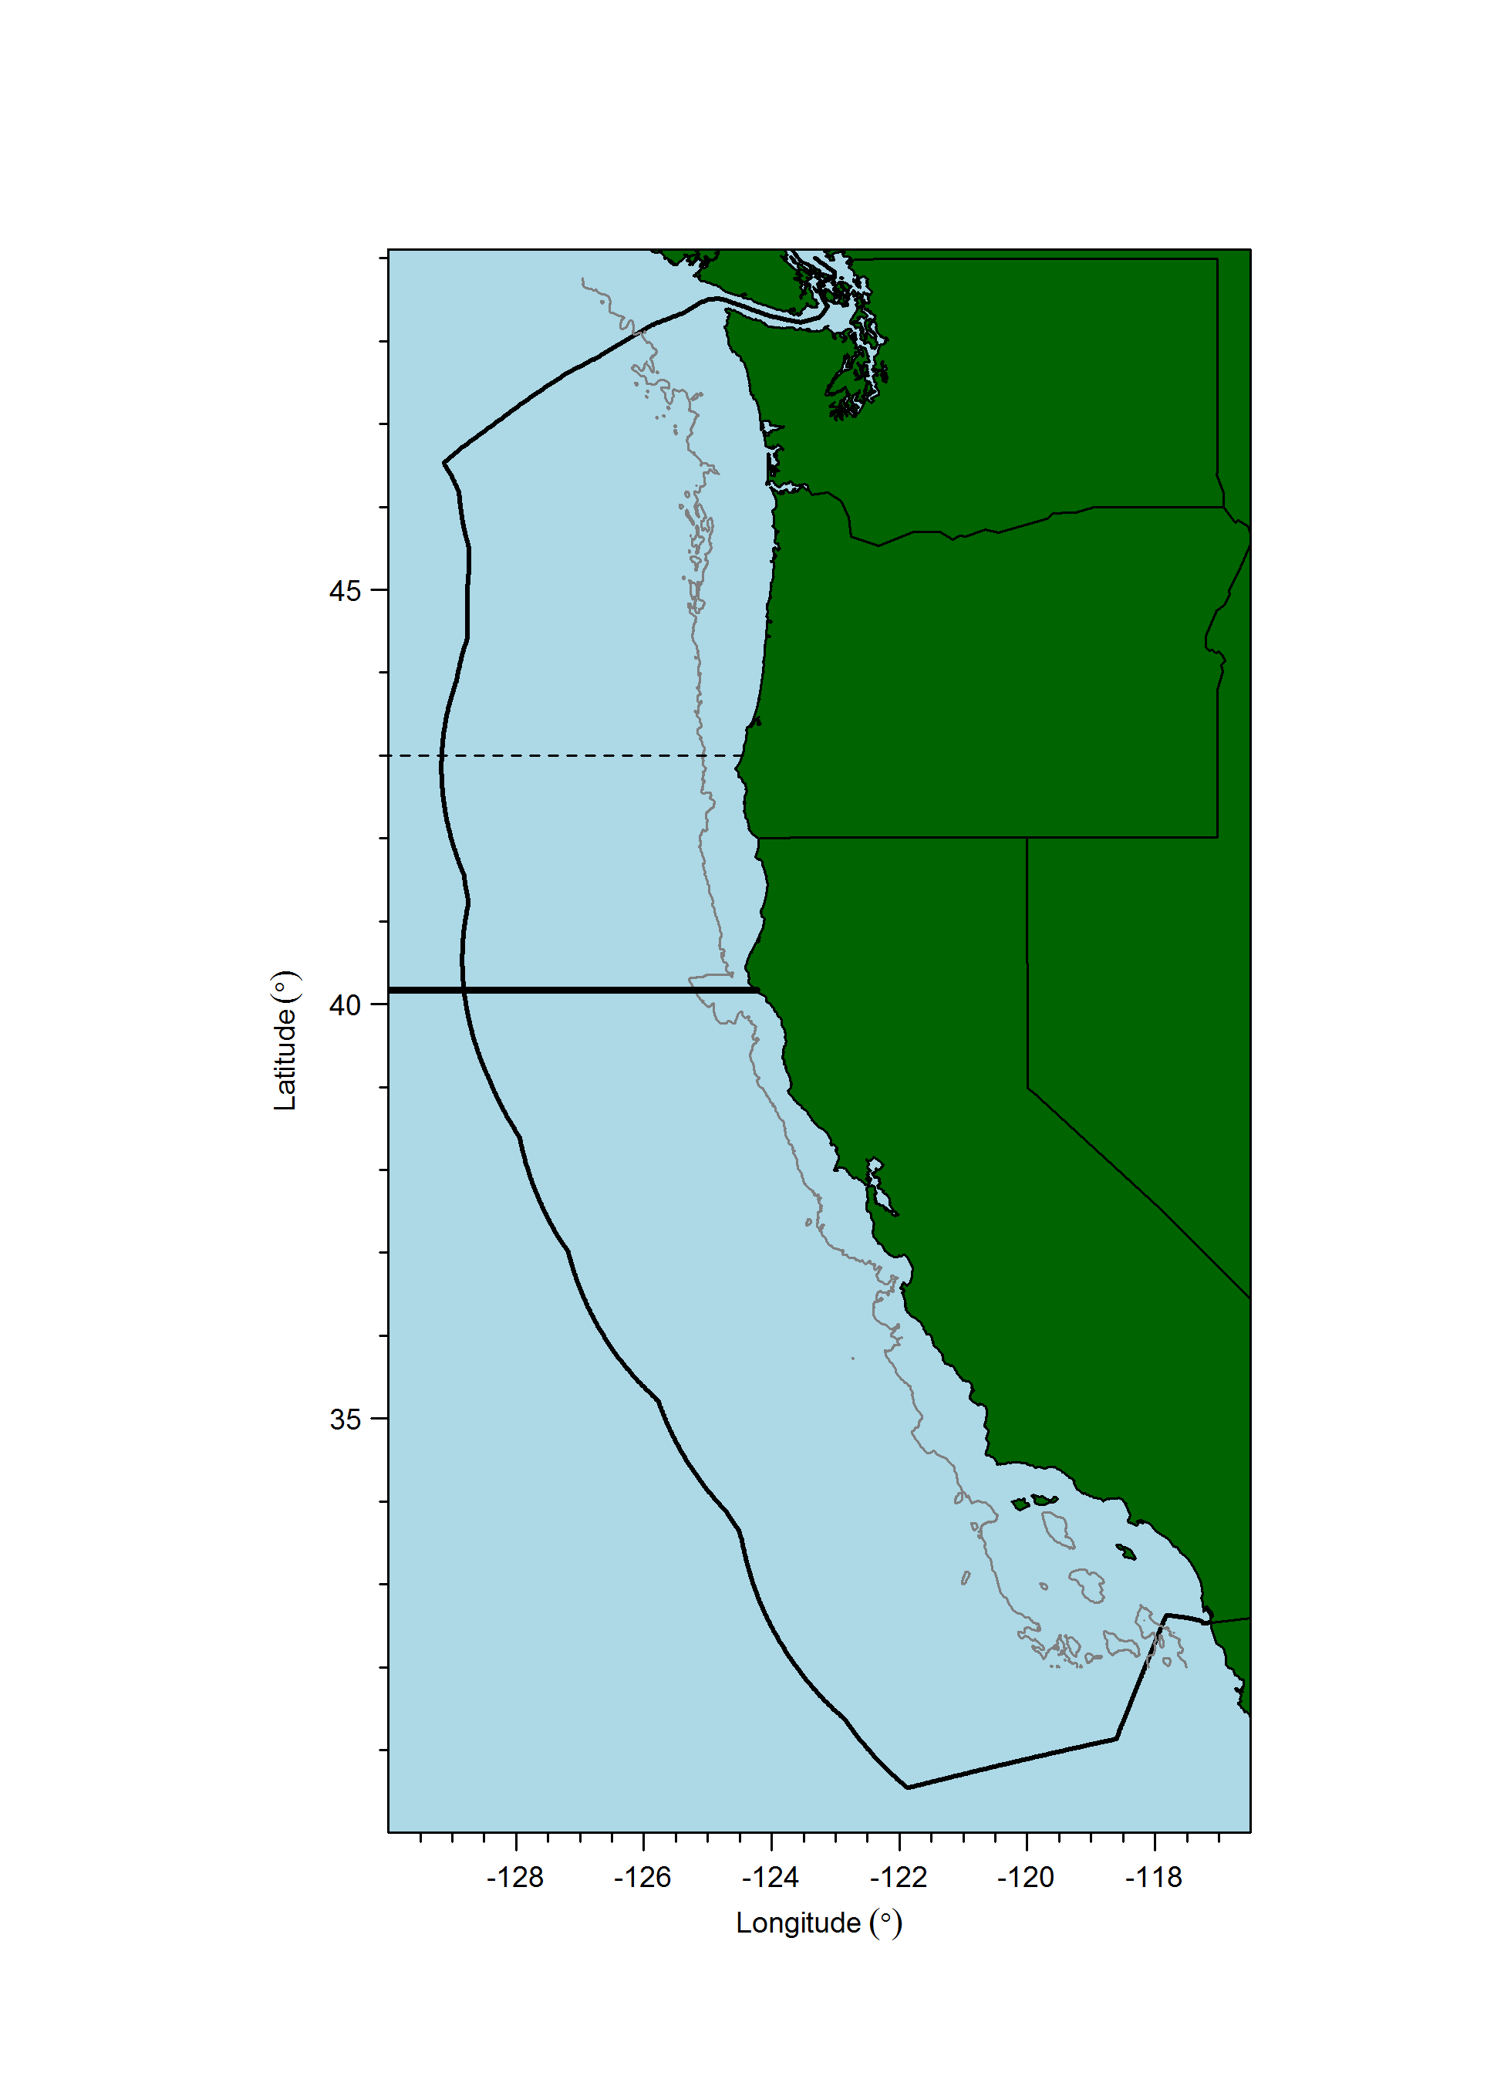

Figure : A map of the west coast of the U.S. with the EEZ and the 40° 10ꞌ line that divides management into northern and southern regions for some species (although not Widow Rockfish). The line at latitude 43° N latitude is where past assessment models have been stratified into two areas.

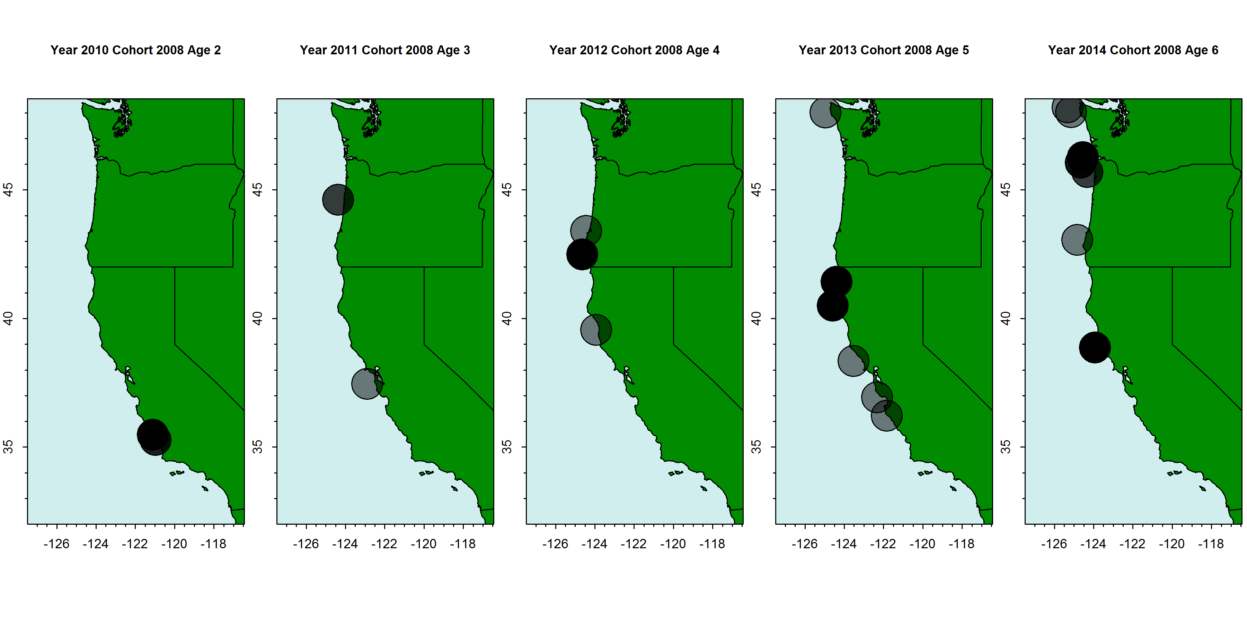

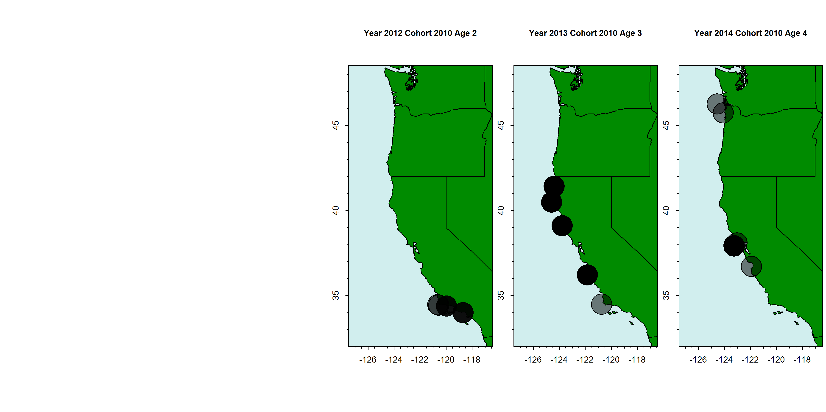

Figure : Observations of two cohorts (2008, top and 2010, bottom) from the NWFSC shelf/slope survey data. Darker circles indicate more observations (possibly within the same tow).

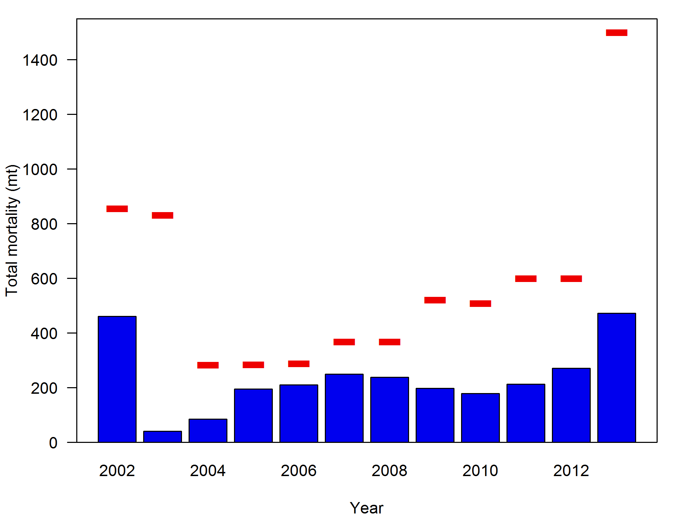

Figure : Total removals as estimated in the groundfish mortality report (pers. comm., Kayleigh Somers, WCGOP, NWFSC) for 2002 to 2013. The horizontal red lines represent the Widow Rockfish specific ACL for each year.

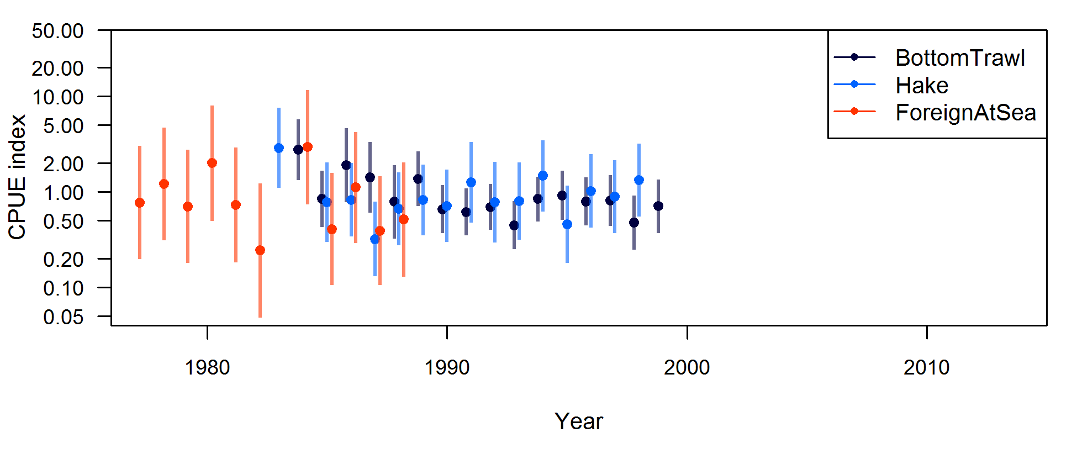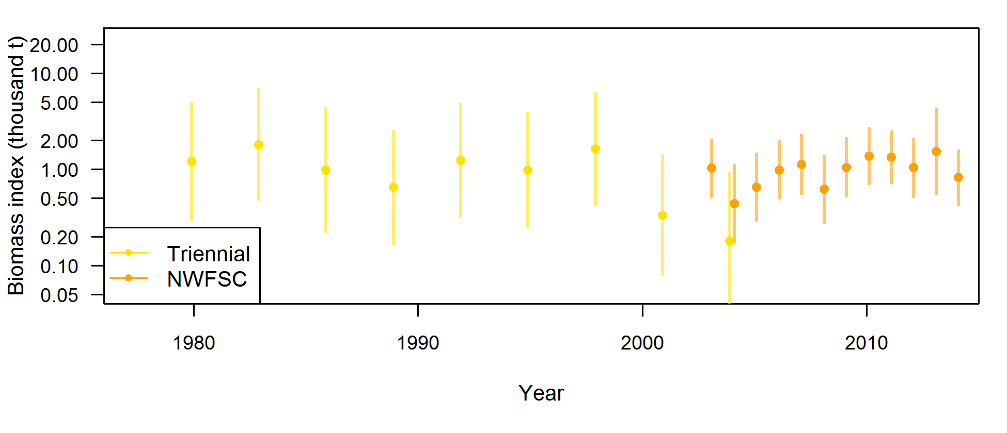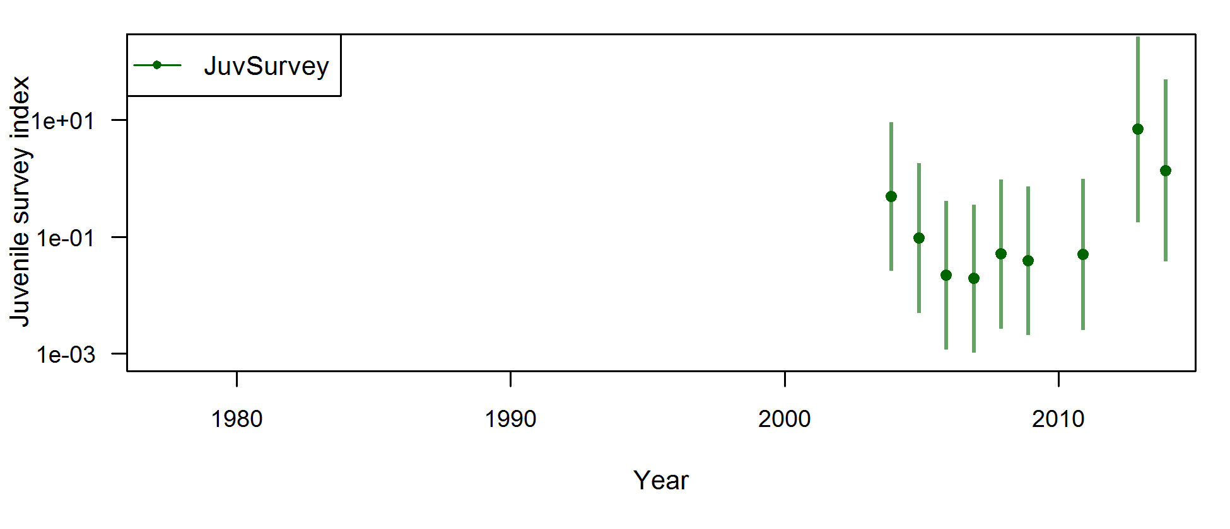

Figure : Fishery-dependent indices of abundance from the 2011 assessment (top), the bottom trawl survey indices (middle), and the juvenile survey index of young-of-the-year fish (bottom) scaled to the mean of their own series.



Figure : Survey tow locations in 2004, showing the difference in station design for the NWFSC survey relative to the Triennial trawl survey (Figure from [Stewart (2007](#_ENREF_23))).



Figure : Distribution of dates of operation for the triennial survey (1980-2004). Solid bars show the mean date for each survey year, points represent individual hauls dates, but are jittered to allow better delineation of the distribution of individual points (Figure from ([Stewart 2007](#_ENREF_23))).

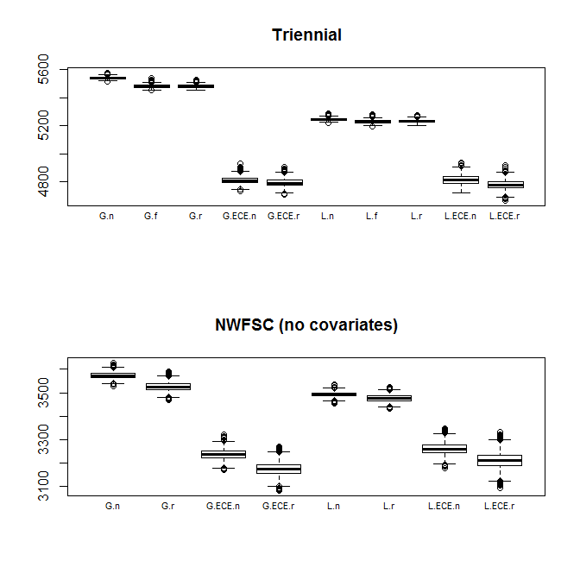

Figure : Deviance from six assumptions in the GLMM model for the five surveys. “G” refers to the gamma distribution and “L” refers to the lognormal distribution. No stratum effects, and random stratum effects are notated with “n” and “r”, respectively.

|  |  |
| --- | --- |
| Triennial survey | NWFSC shelf/slope survey |
| C:\Assessments\Widow2015\Data\Index standardization\chain_GLMM_shelf\widow_rockfish_FinalDiagnostics\Model=5\Q-Q_plot.jpg | C:\Assessments\Widow2015\Data\Index standardization\4_strata_nwfsc_no_covariates\widow rockfish_FinalDiagnostics\Model=5\Q-Q_plot.jpg |

Figure : Q-Q plots for models with an extreme catch event (ECE) mixture distribution for the Triennial survey (left) and the NWFSC shelf/slope survey (right).

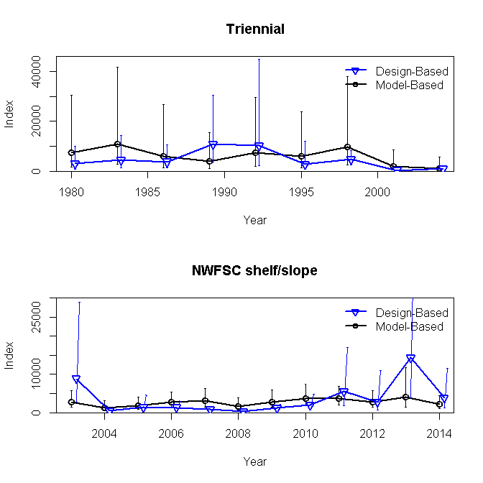

Figure : Model-based survey estimates for the Triennial and NWFSC shelf/slope surveys with estimated 95% confidence intervals. Design-based estimates and 95% confidence intervals are shown in blue for comparison.

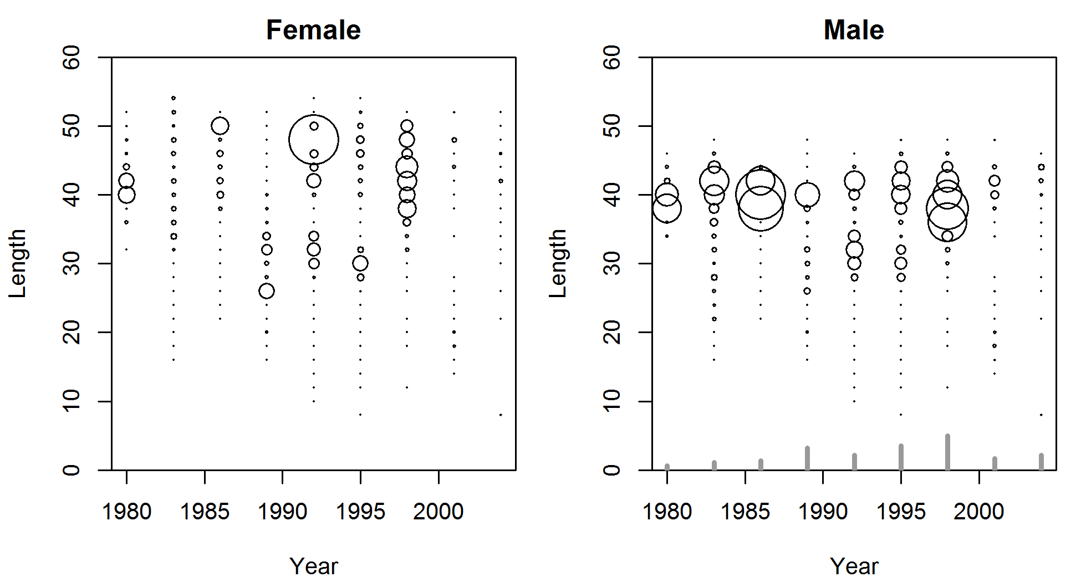

Figure : Expanded length compositions weighted by estimated numbers from the GLMM in each strata for the Triennial survey.

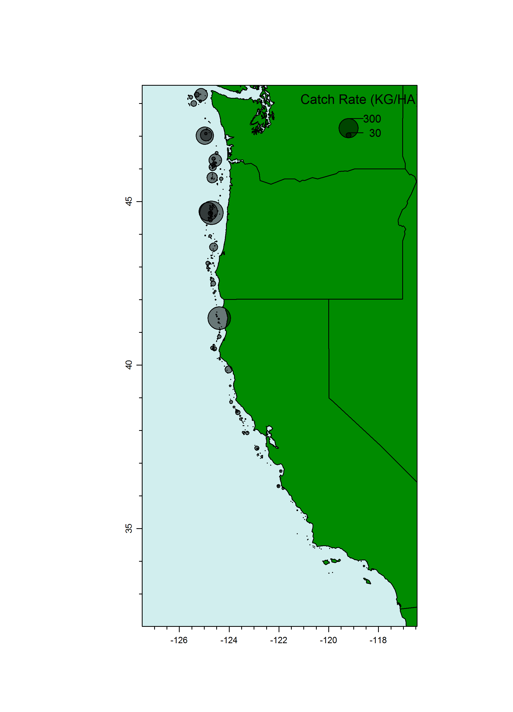

Figure : Catch-rates (gray circles) of Widow Rockfish for all years of the NWFSC shelf/slope survey.

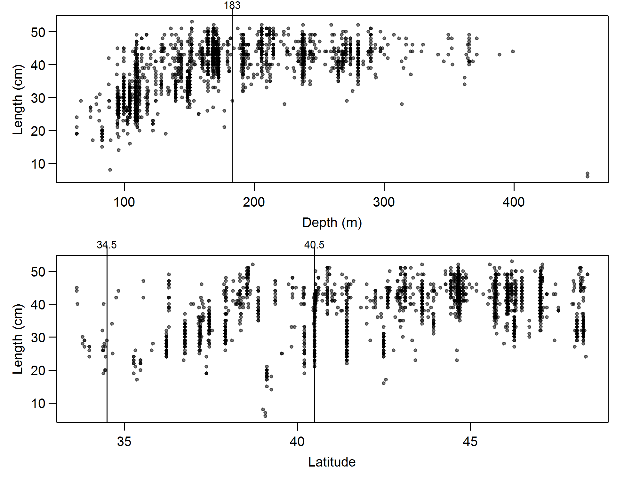

Figure : Observed Widow Rockfish lengths (cm) from the NWFSC shelf/slope survey plotted against depth (top) and latitude (bottom). Vertical lines are strata boundaries. Small fish above 400 m were removed and the few fish south of 34.5° N latitude were omitted.

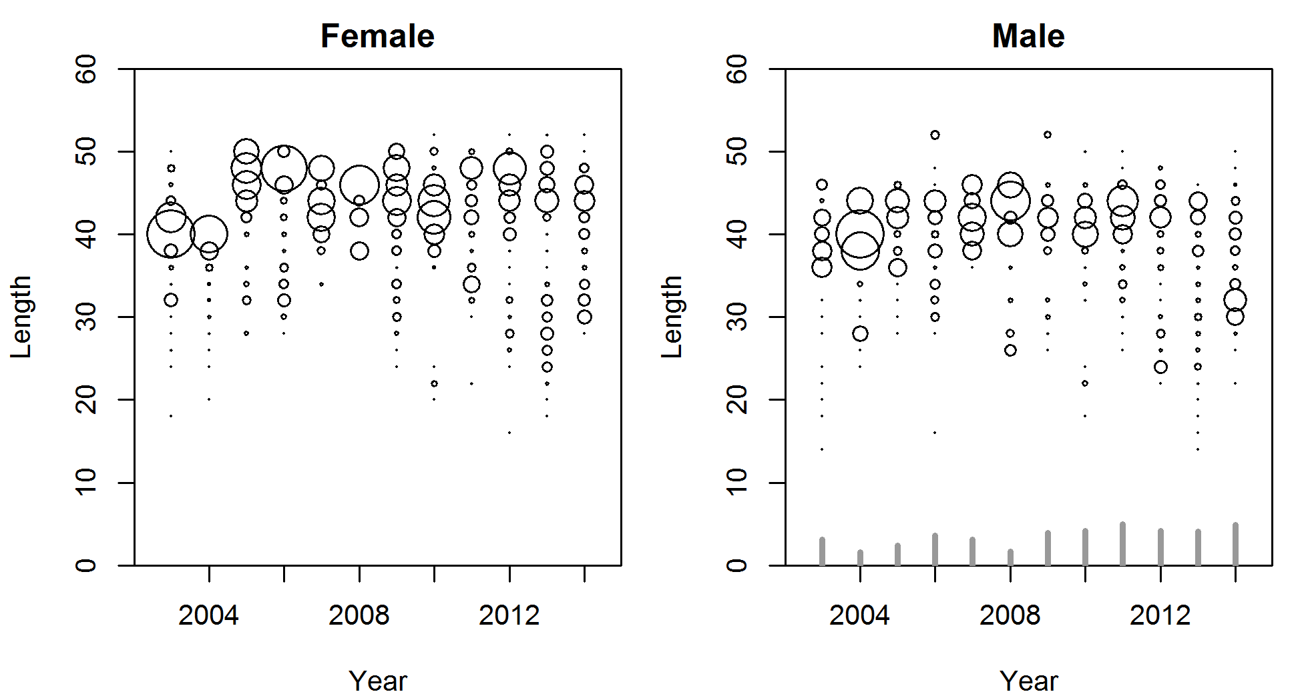

Figure : Expanded length compositions for the NWFSC shelf/slope survey weighted by estimated strata numbers from the GLMM. Gray bars in the left plot indicate relative number of tows that observed Widow Rockfish across years.

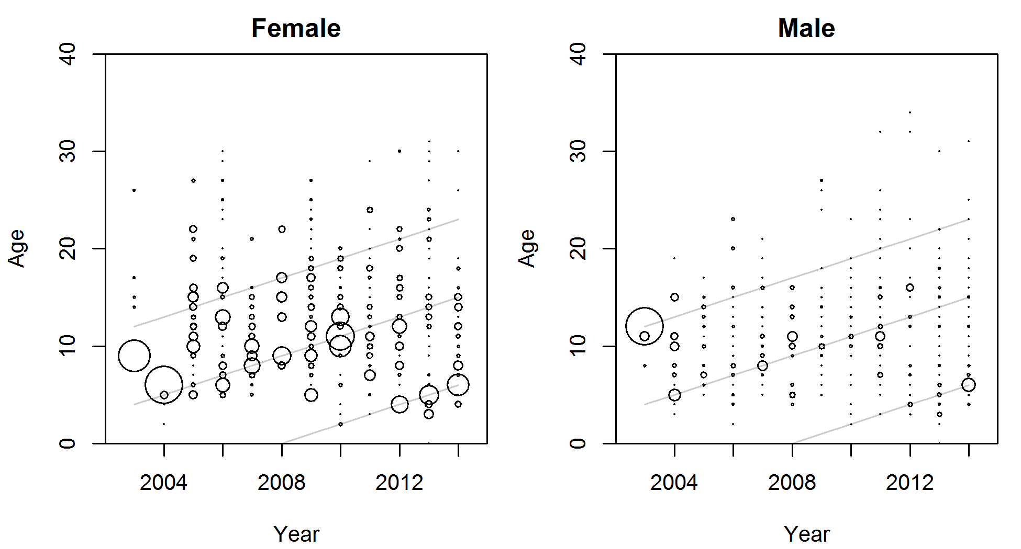

Figure : Expanded marginal age compositions from the NWFSC shelf/slope survey. Gray lines show the 1991, 1999, and 2008 cohorts, for reference.

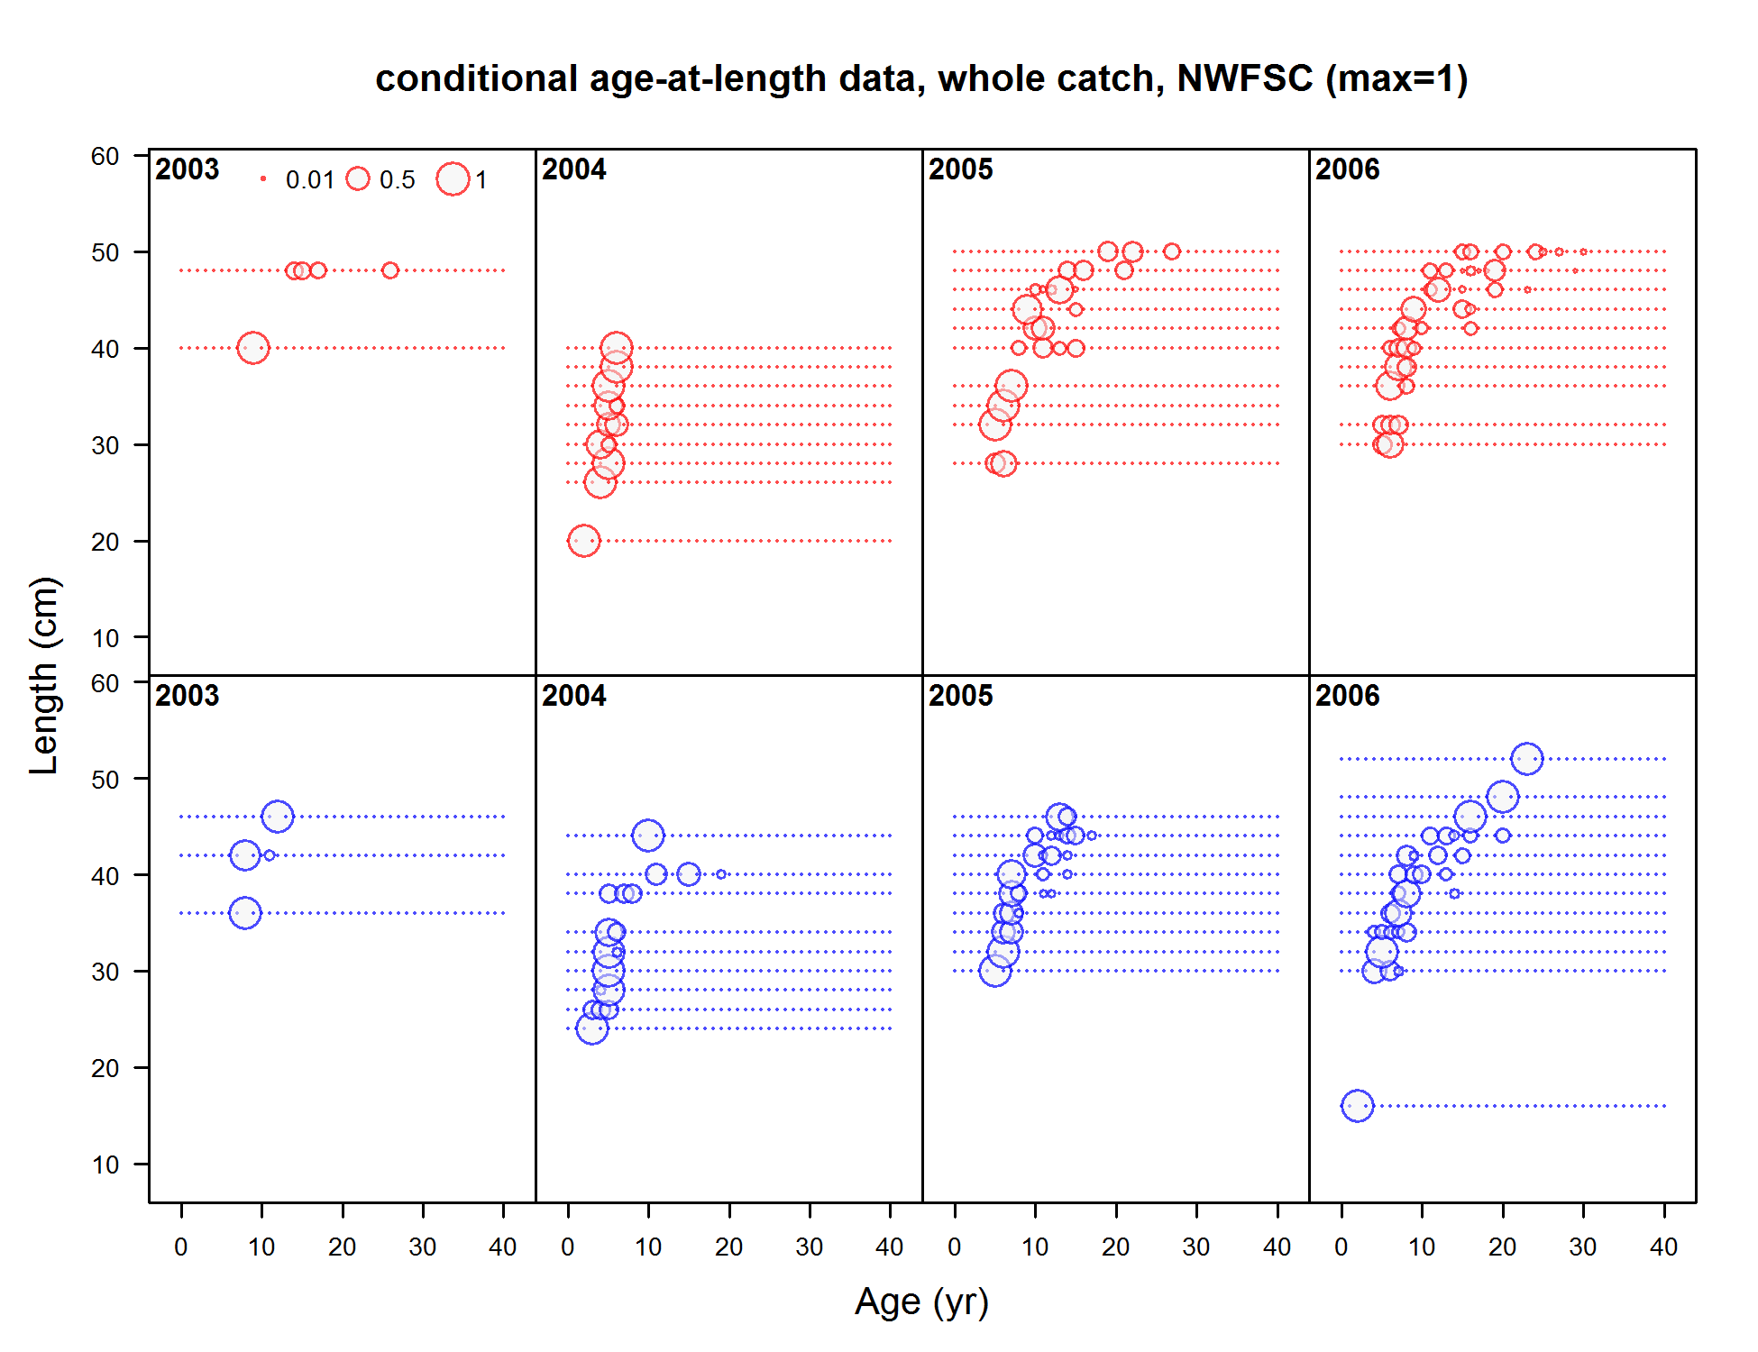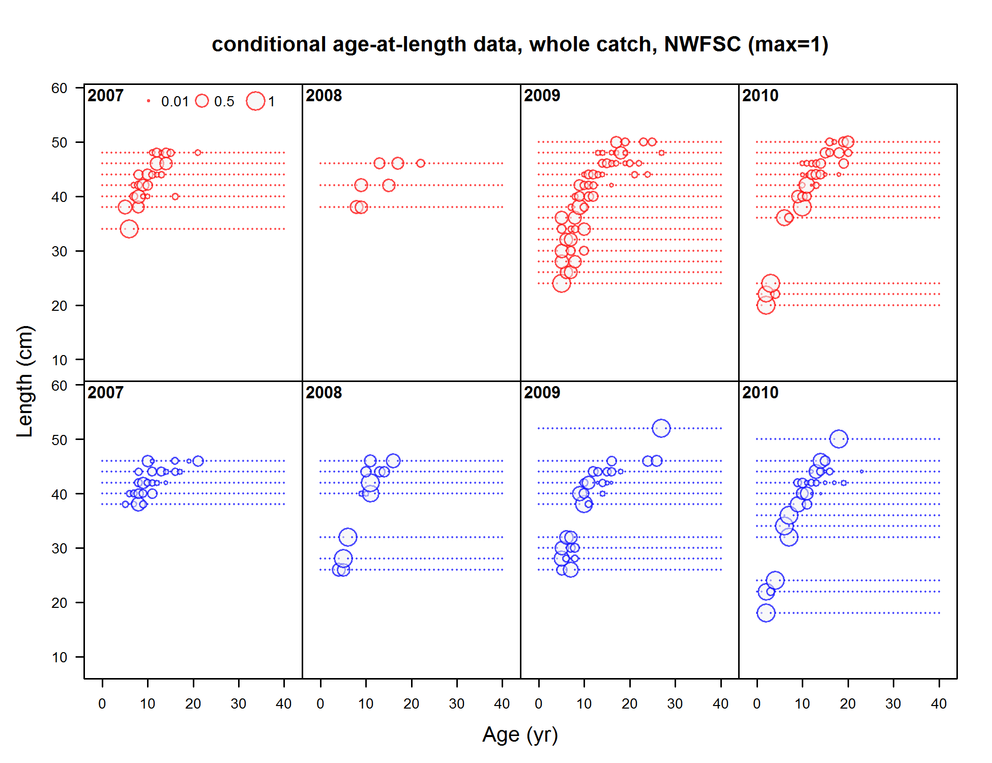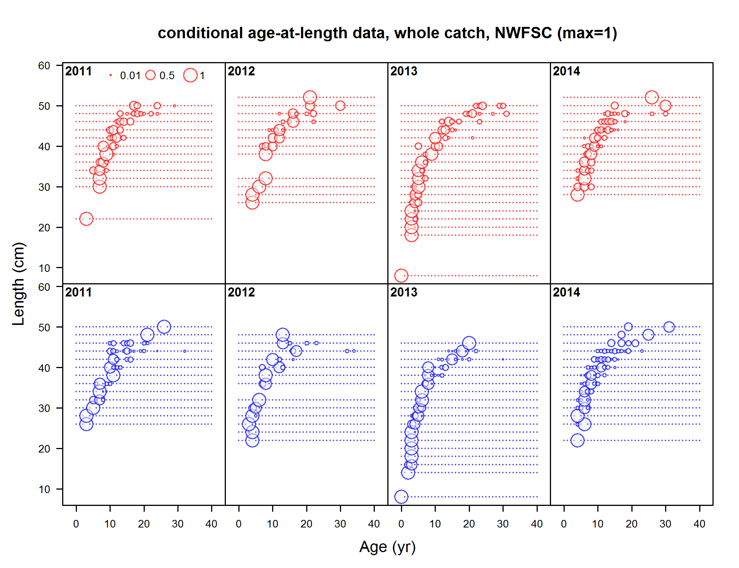

Figure : Conditional age-at-length from NWFSC shelf/slope observations for females (red) and males (blue).

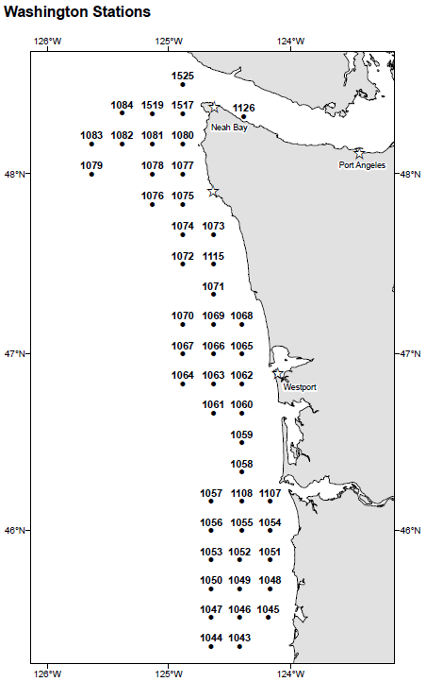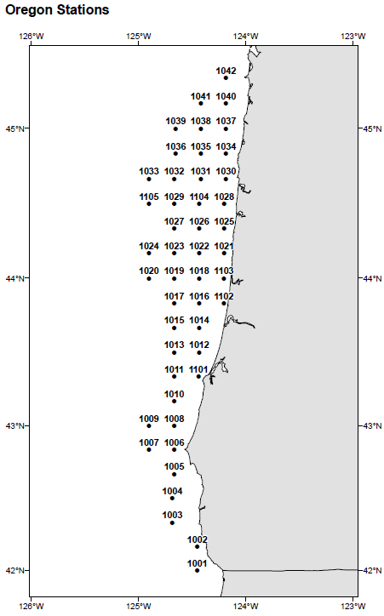

Figure : Station locations for the International Pacific Halibut Commission longline survey in Washington (left) and Oregon (right). Maps supplied by IPHC. See also http://www.iphc.int/research/37-survey-data.html.

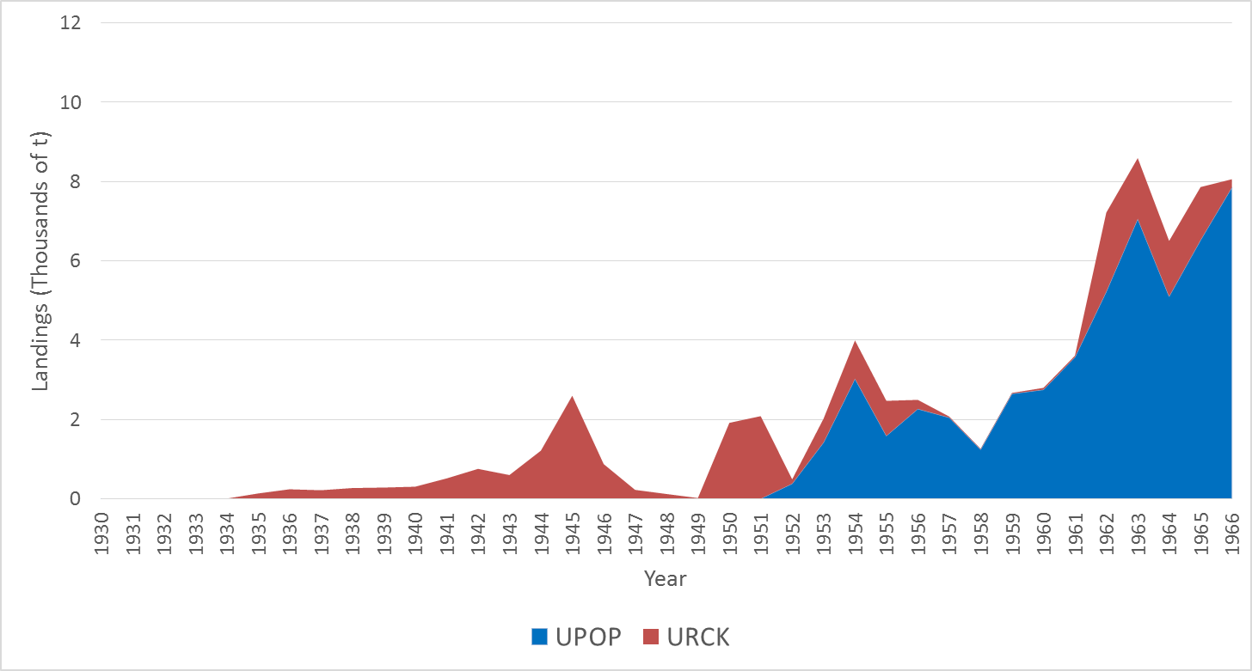

Figure : Cumulative landings of unidentified rockfish (URCK) and unidentified Pacific Ocean Perch (UPOP) from 1930–1969 from various sources used to reconstruct Widow Rockfish landings.

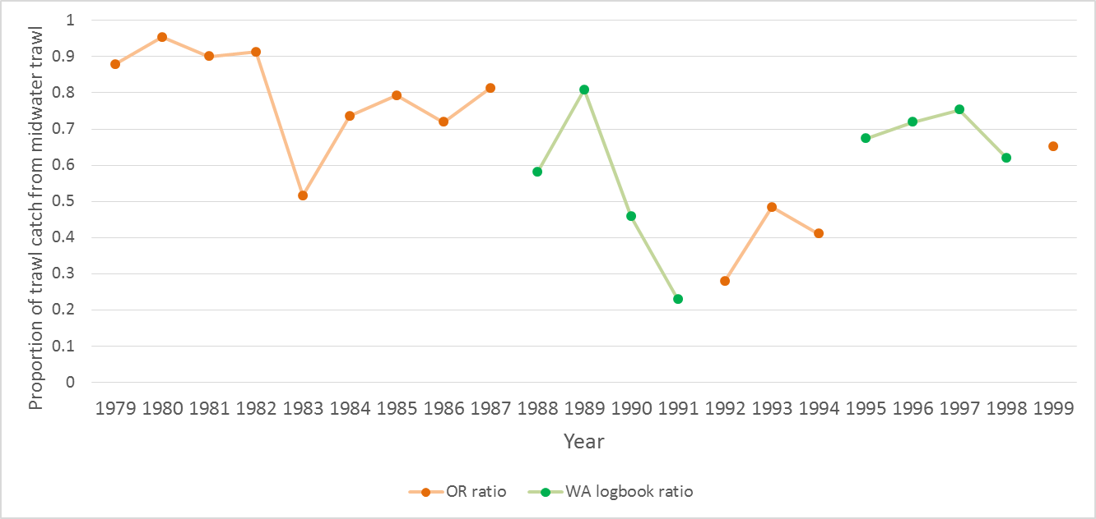

Figure : Proportion of midwater trawl catch out of the entire trawl catch used to split Washington trawl catches from 1979–1999. Orange points indicate ratios determined from Oregon trawl landings and green points indicate ratios determined from Washington logbooks.

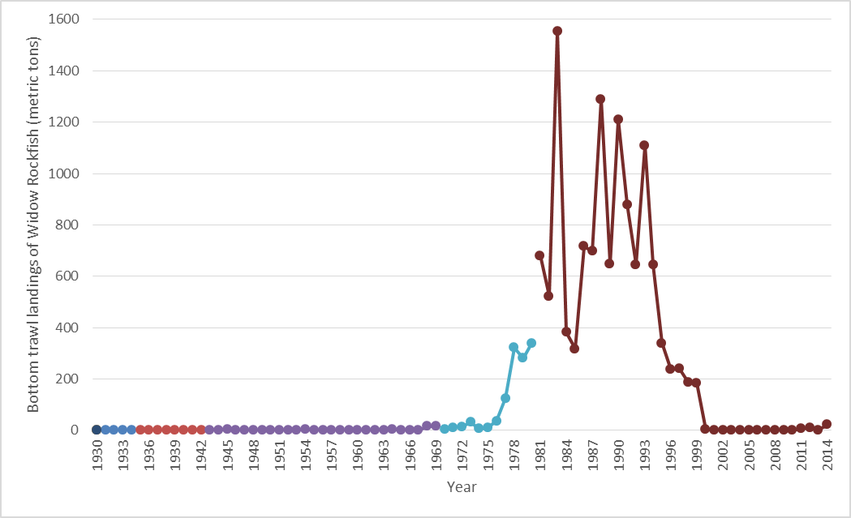

Figure : Reconstructed historical bottom trawl landings of Widow Rockfish (metric tons) in Washington from the sources described in the text. Landings after 1999 were directly compiled from the PacFIN database. The different colors show the different sources as discussed in the text.

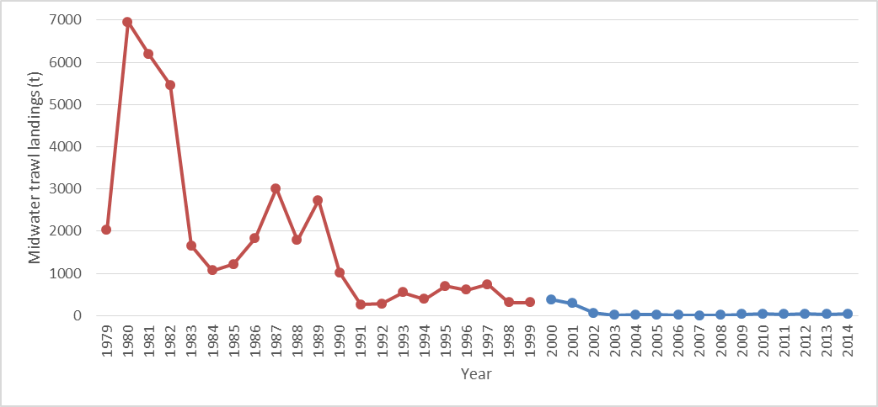

Figure : Reconstructed historical midwater trawl landings (mt) of Widow Rockfish (1979–1999) and midwater trawl landings (mt) of Widow Rockfish from the PacFIN database (2000–2014). Years in red were determined by proportioning trawls landings and the blue points were determined directly from gear codes in PacFIN.

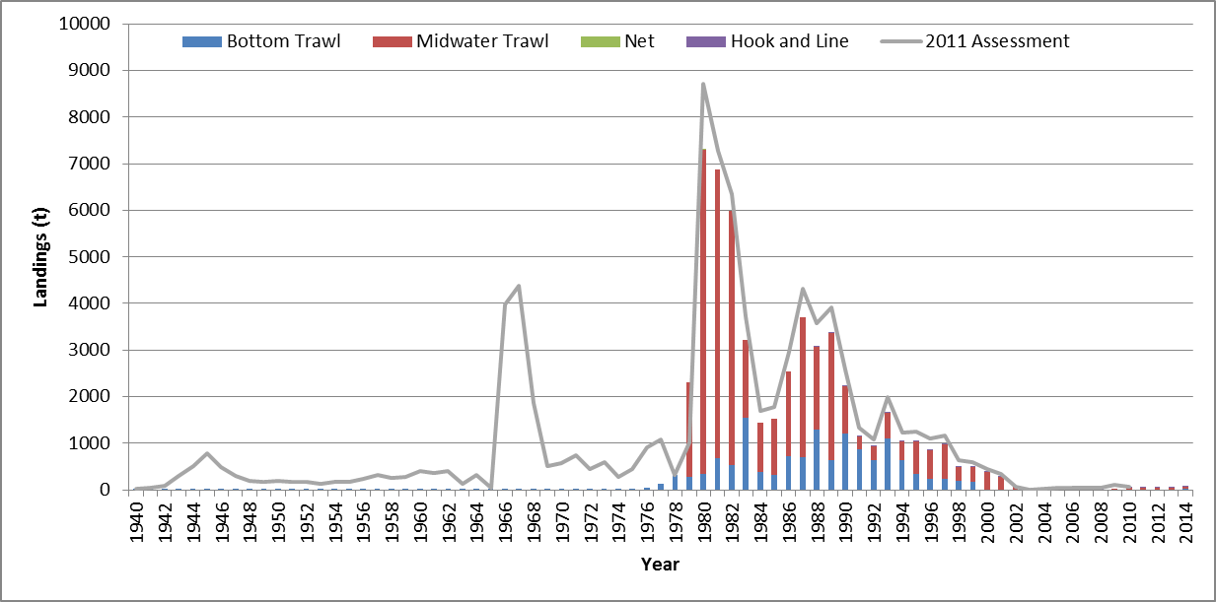

Figure : Catches in Washington from the 2011 assessment (gray line, landings plus discards) and landings reconstructed for this assessment by gear type (bars). Catches from the 2011 assessment include foreign at-sea catches which are not included as a gear type for the landings for this assessment.

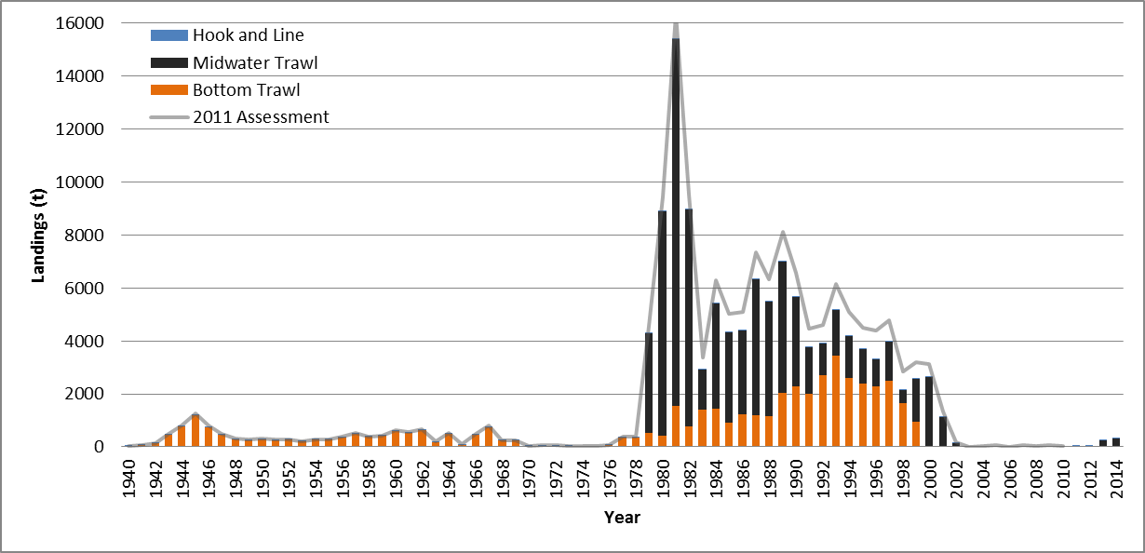

Figure : Catches in Oregon from the 2011 assessment (gray line, landings plus discards) and landings reconstructed for this assessment by gear type (bars). Catches from the 2011 assessment include foreign at-sea catches which are not included as a gear type for the landings for this assessment.

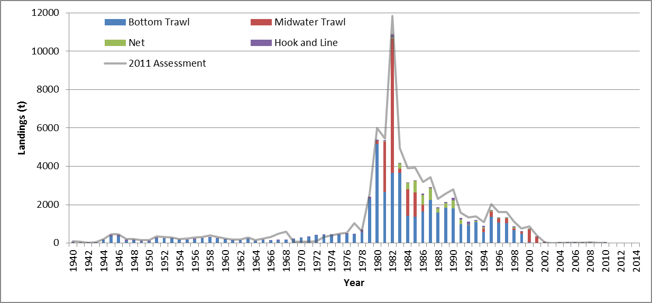

Figure : Catches in California from the 2011 assessment (gray line, landings plus discards) and landings reconstructed for this assessment by gear type (bars).

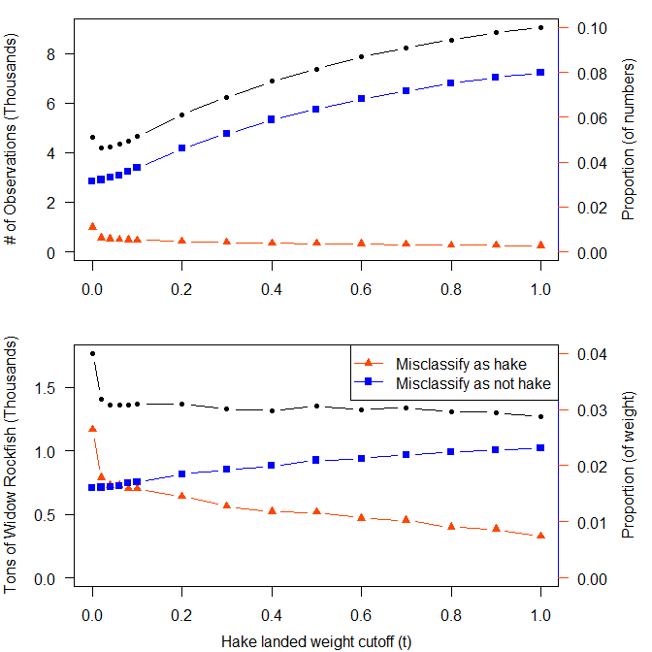

Figure : Misclassification of shoreside hake landings using a minimum weight of hake landed in tons (x-axis) and the months May–November. Total numbers of Widow Rockfish landings (top) and weight of Widow Rockfish (bottom) summed over all years from 1994–2014 are shown by the black line relative to the left axis. Proportions of misclassifying non-hake landings as hake (red) and hake landings as non-hake (blue) are shown relative to the right axis.

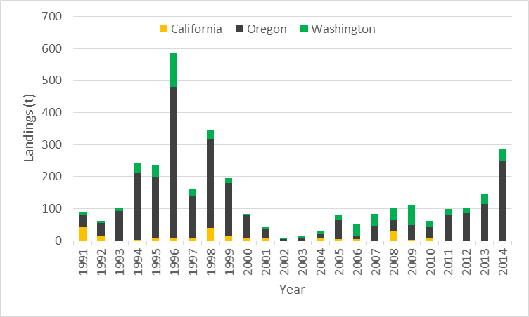

Figure : Landings of Widow Rockfish (mt) in the shoreside hake fishery.

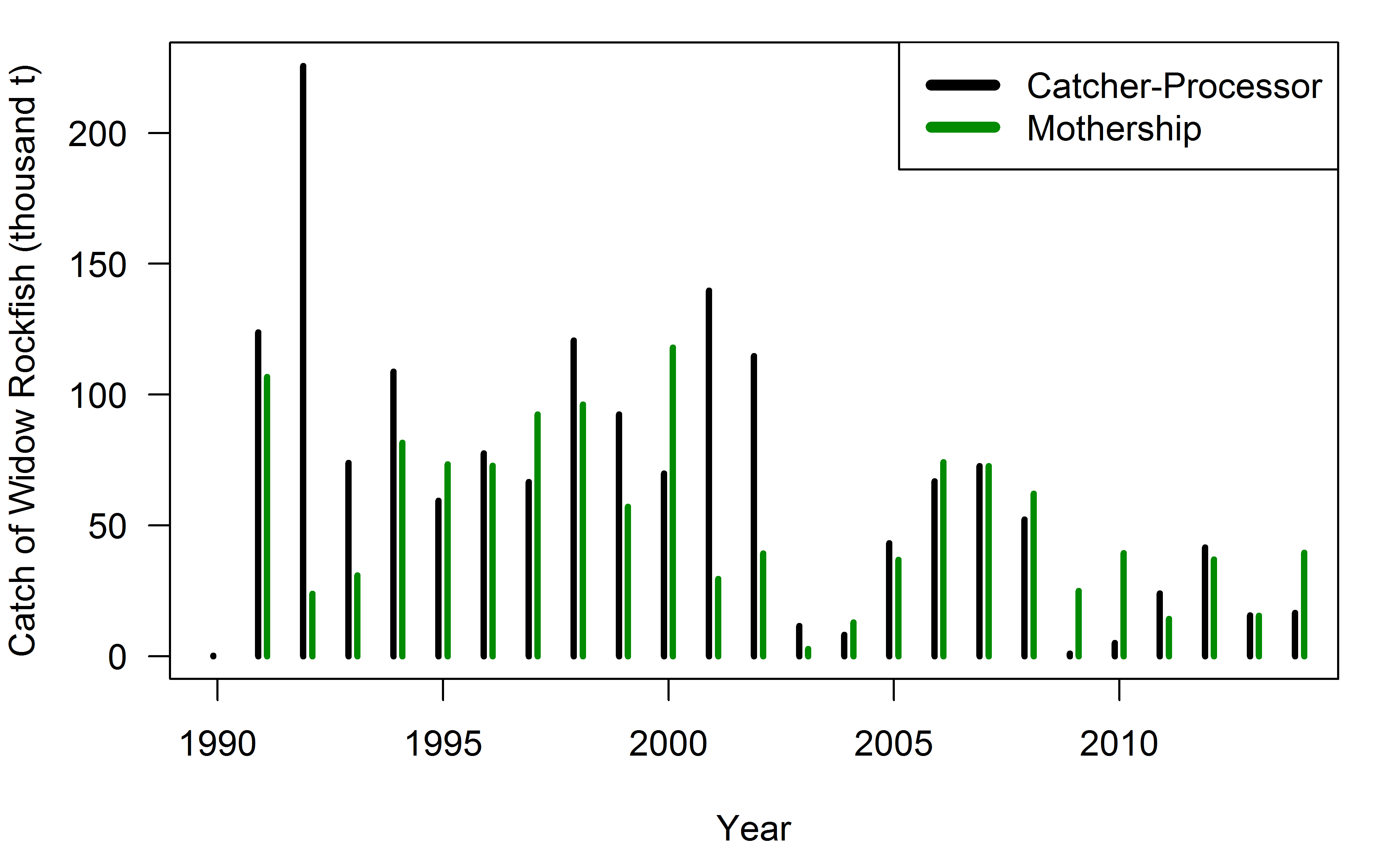

Figure : Catch of Widow Rockfish (thousands of mt) in the domestic Catcher-Processor and Mothership fleets.

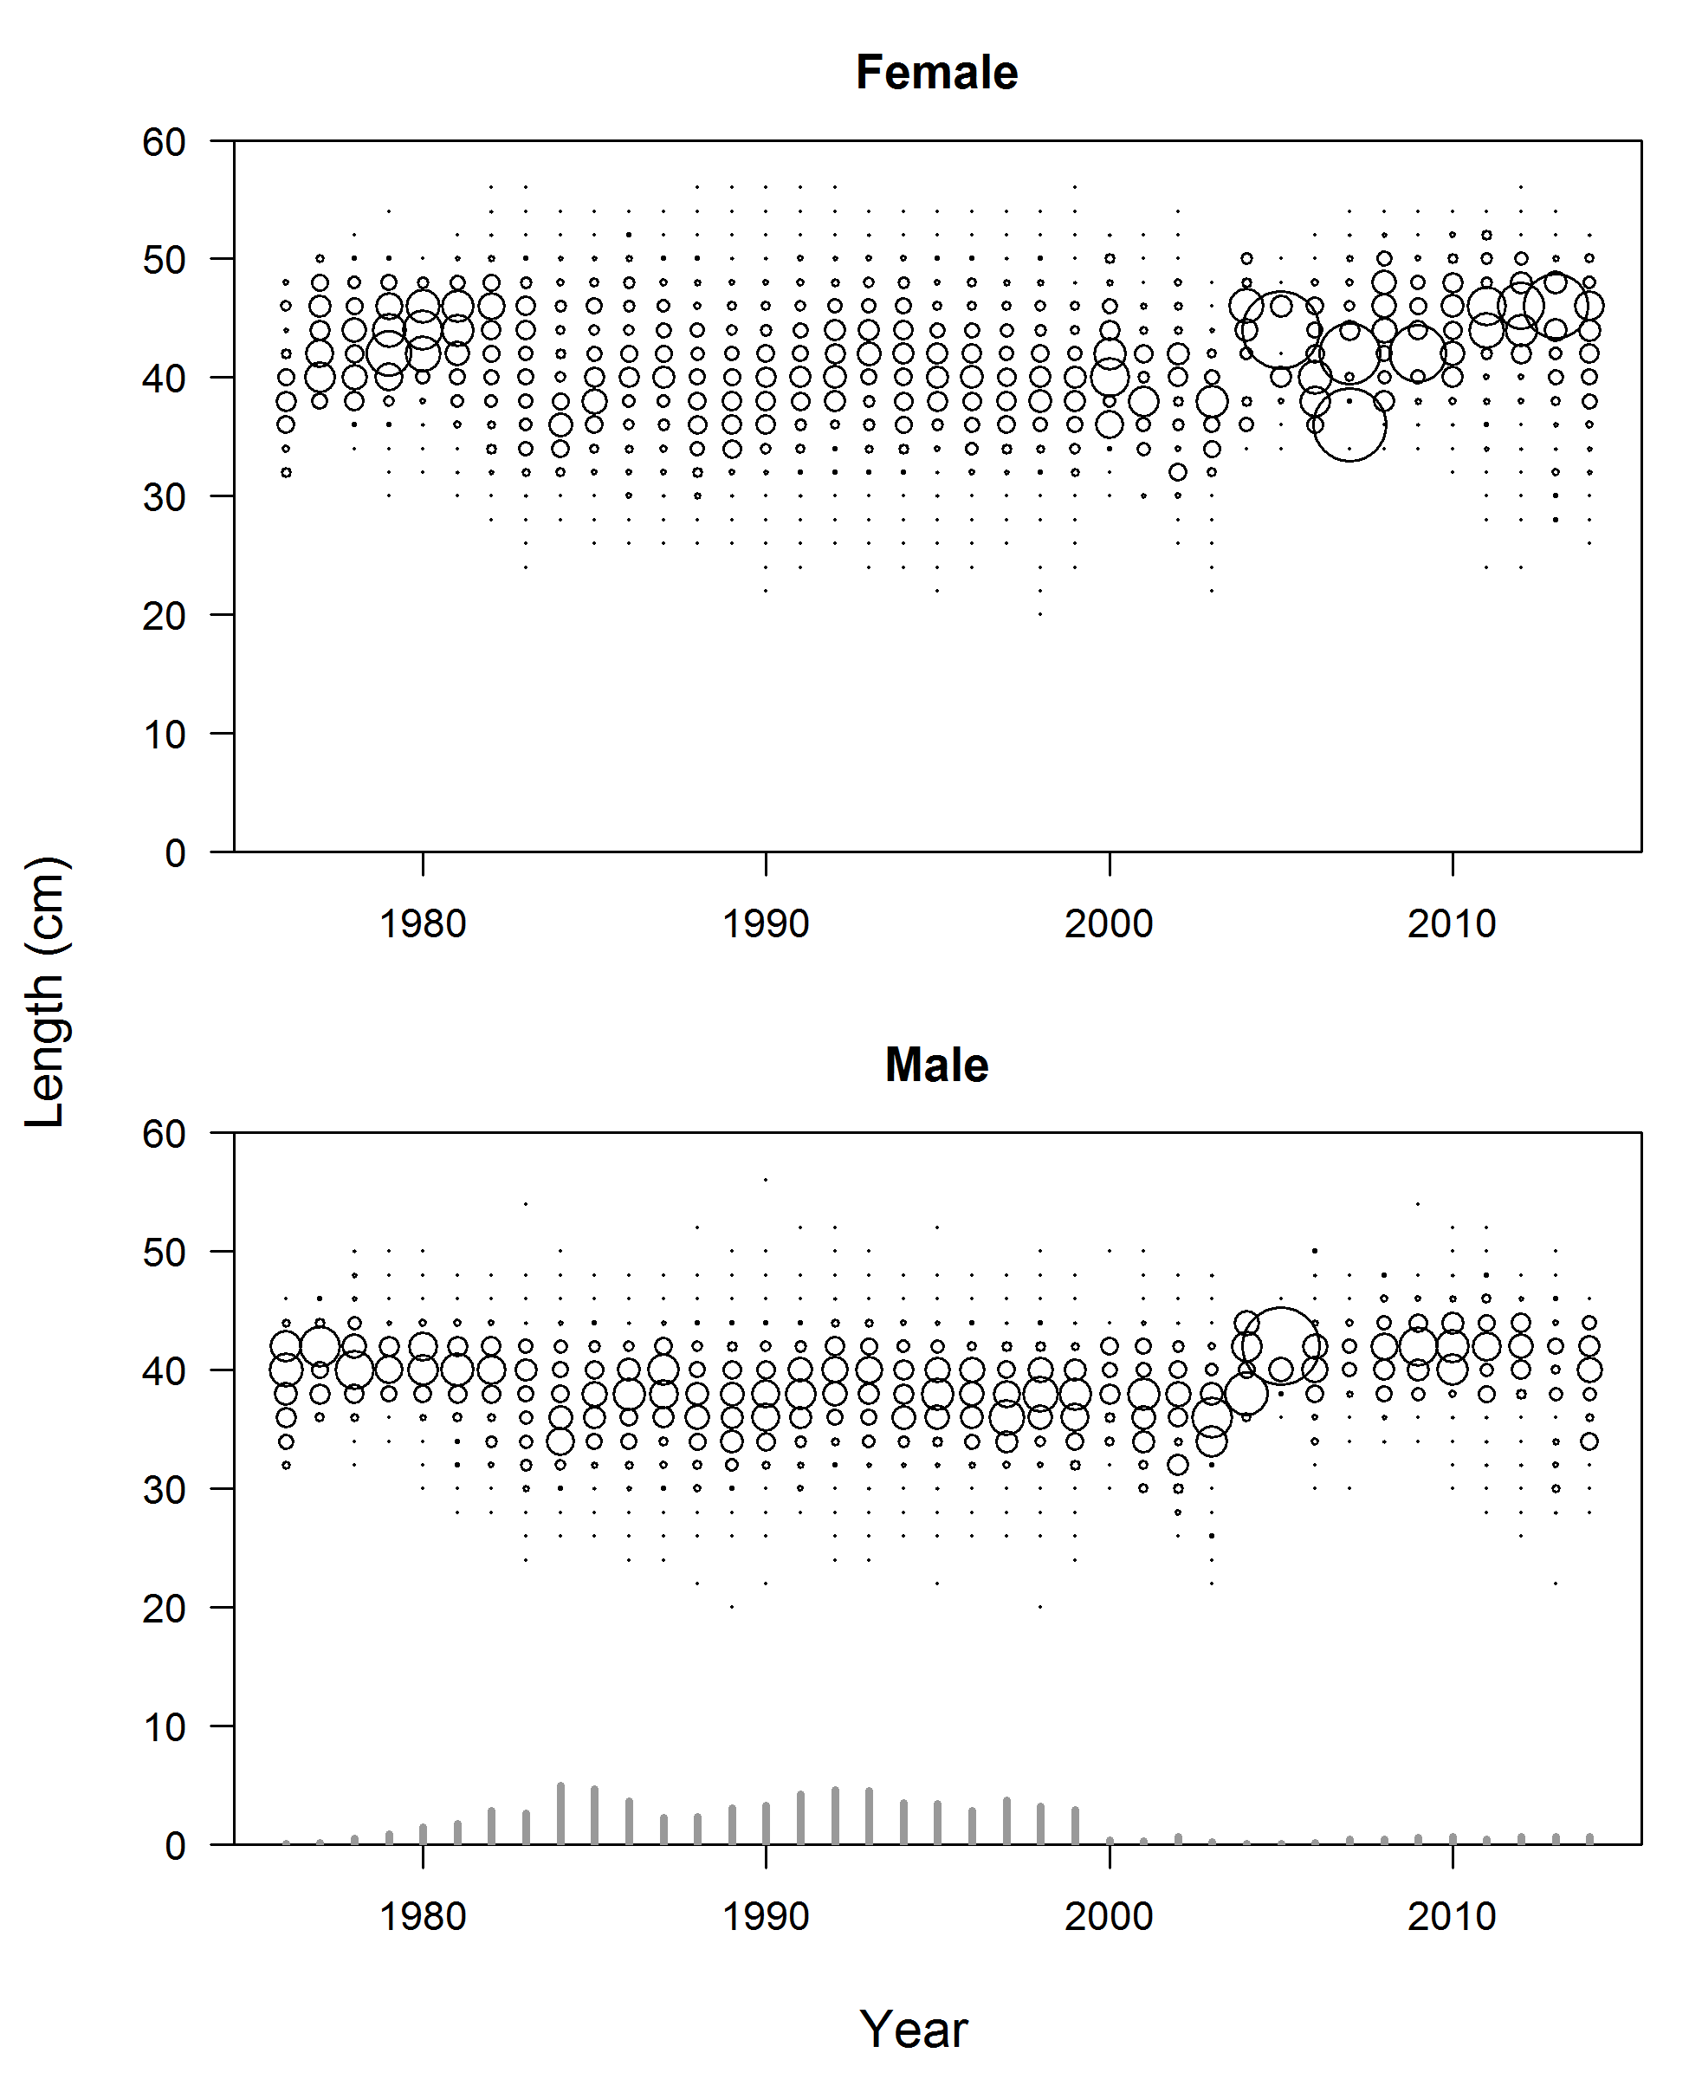

Figure : Expanded length compositions for the bottom trawl fishery. The area of the circle is proportional to the proportion-at-length. The gray bars at the bottom indicate relative number of tows.

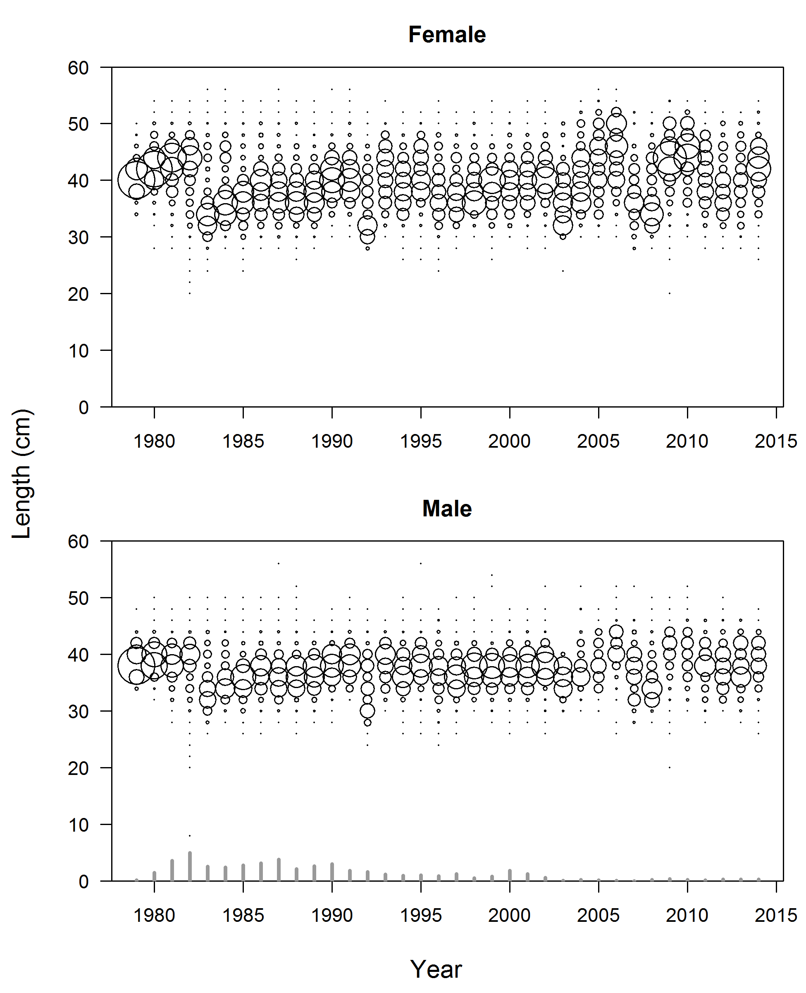

Figure : Expanded length compositions for the midwater trawl fishery. The area of the circle is proportional to the proportion-at-length. The gray bars at the bottom indicate relative number of tows.

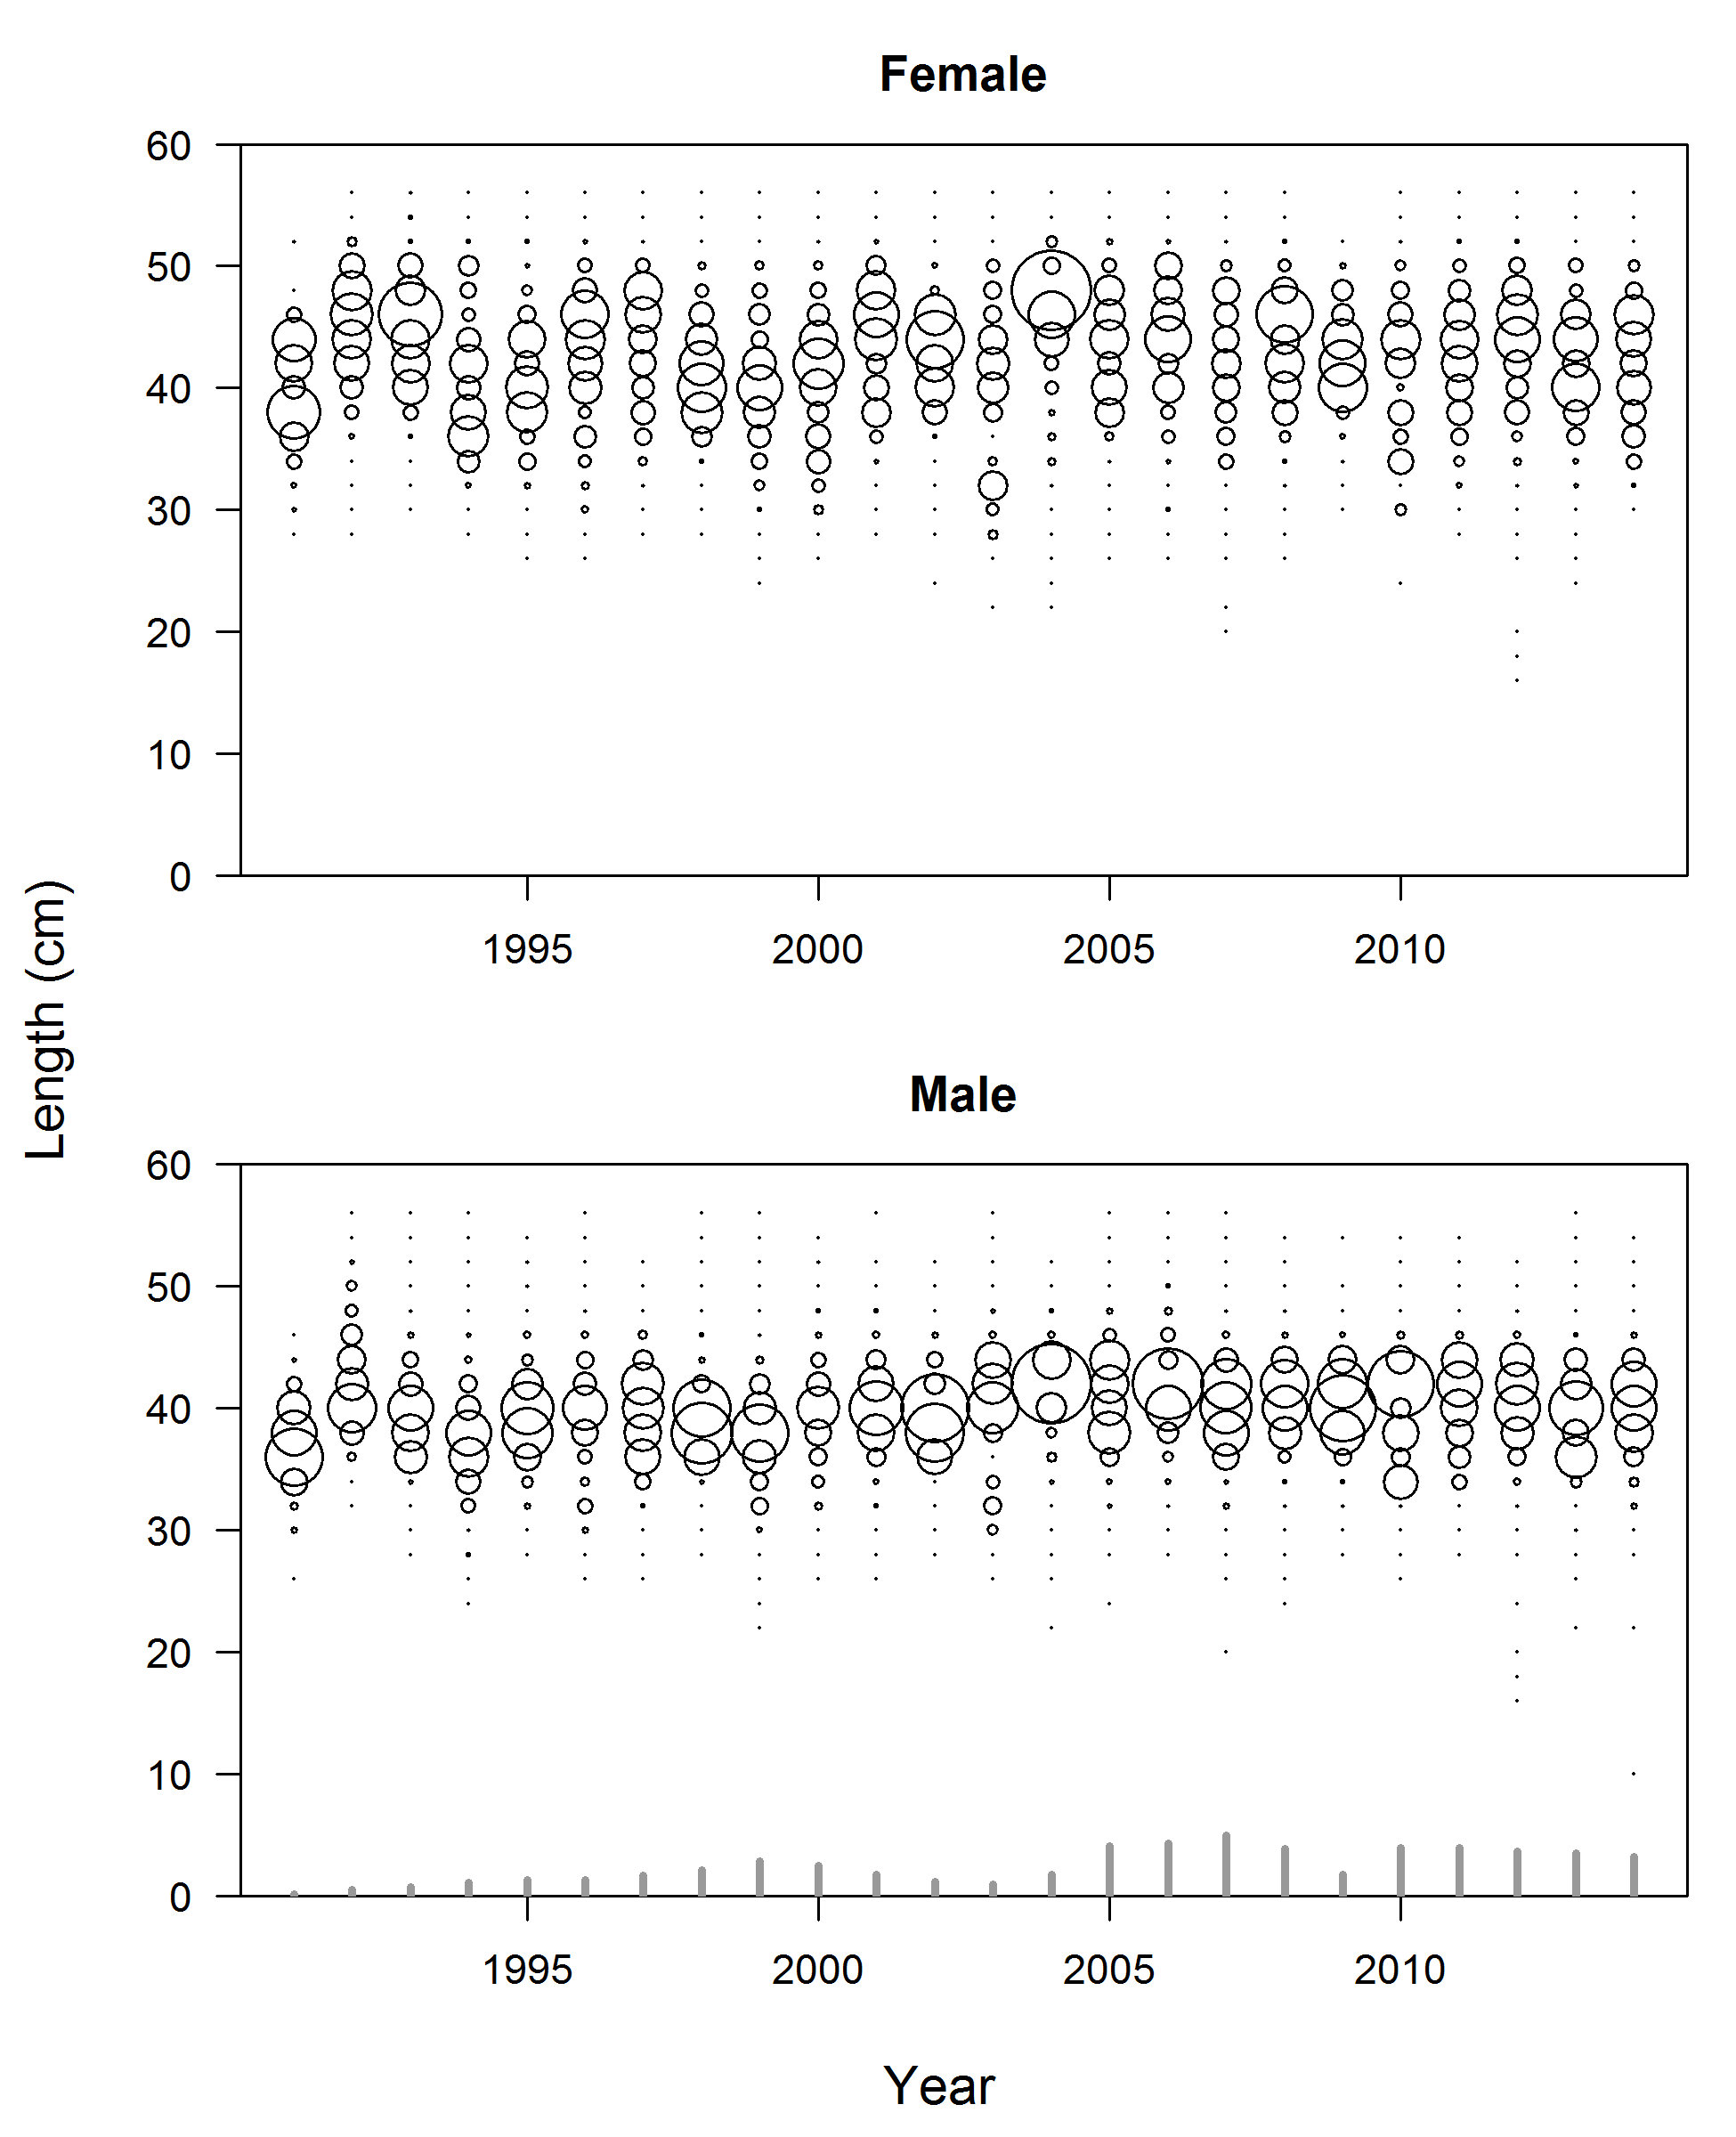

Figure : Expanded length compositions for the hake fishery. The area of the circle is proportional to the proportion-at-length. The gray bars at the bottom indicate relative number of tows.

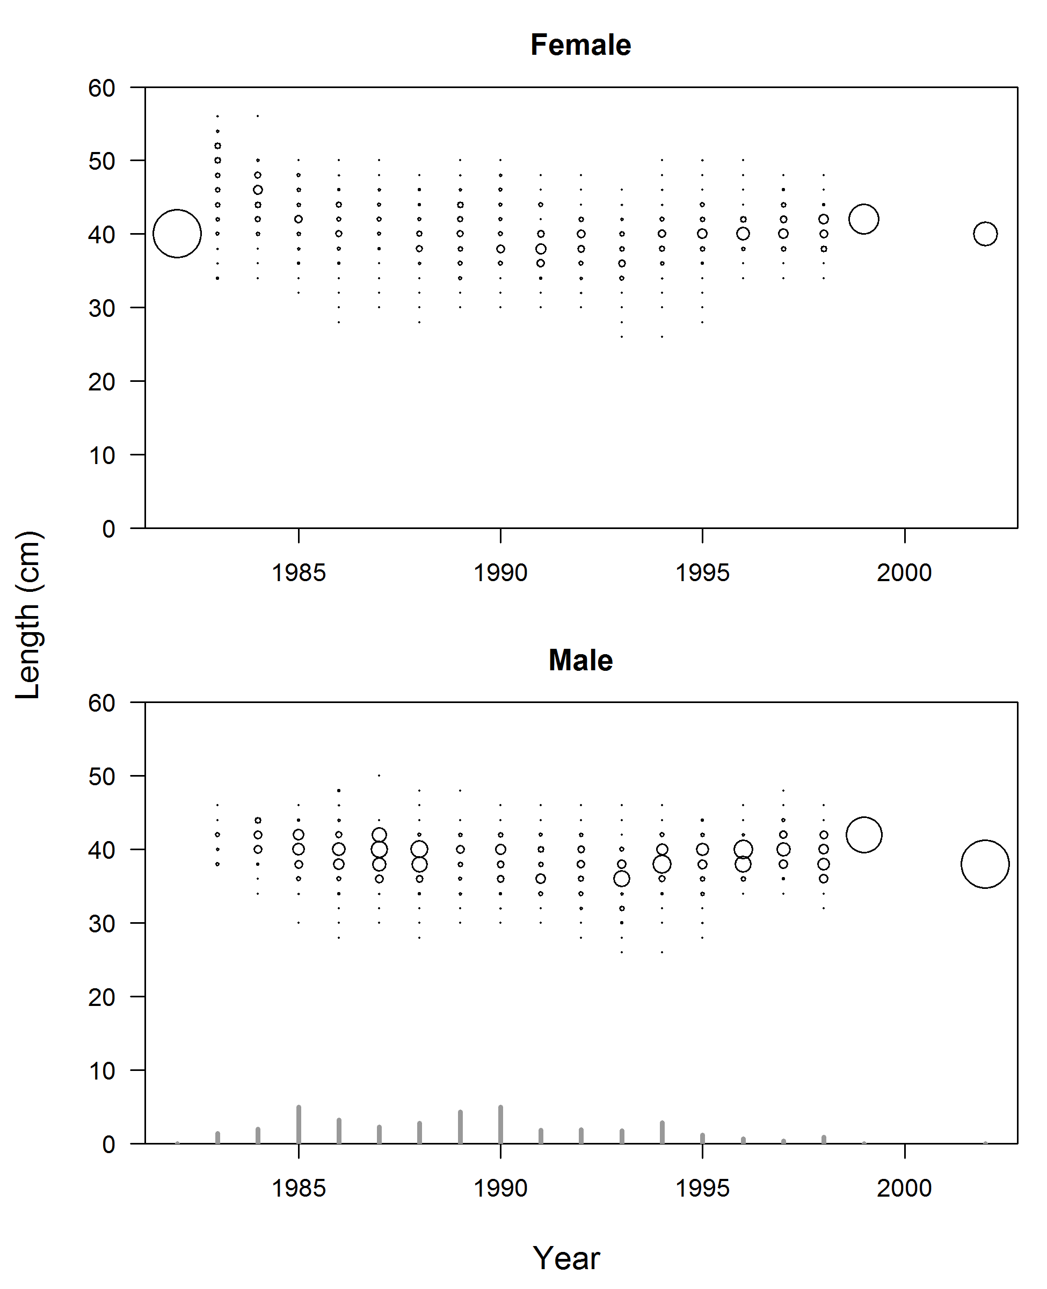

Figure : Expanded length compositions for the net fishery. The area of the circle is proportional to the proportion-at-length. The gray bars at the bottom indicate relative number of tows.

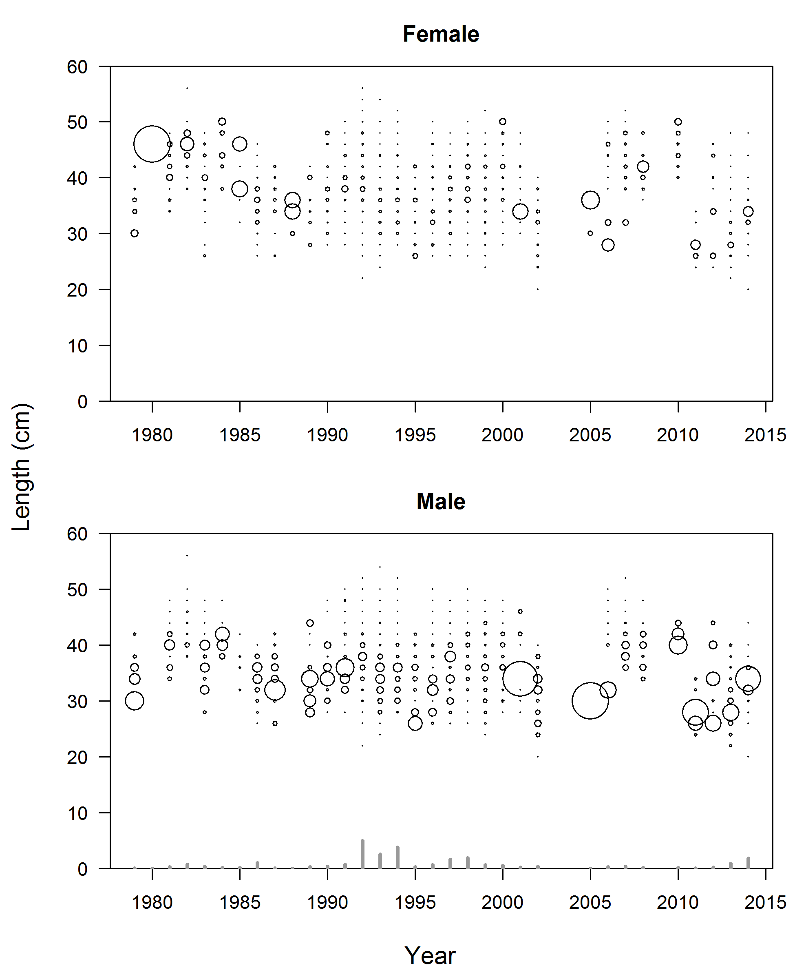

Figure : Expanded length compositions for the hook-and-line fishery. The area of the circle is proportional to the proportion-at-length. The gray bars at the bottom indicate relative number of tows.

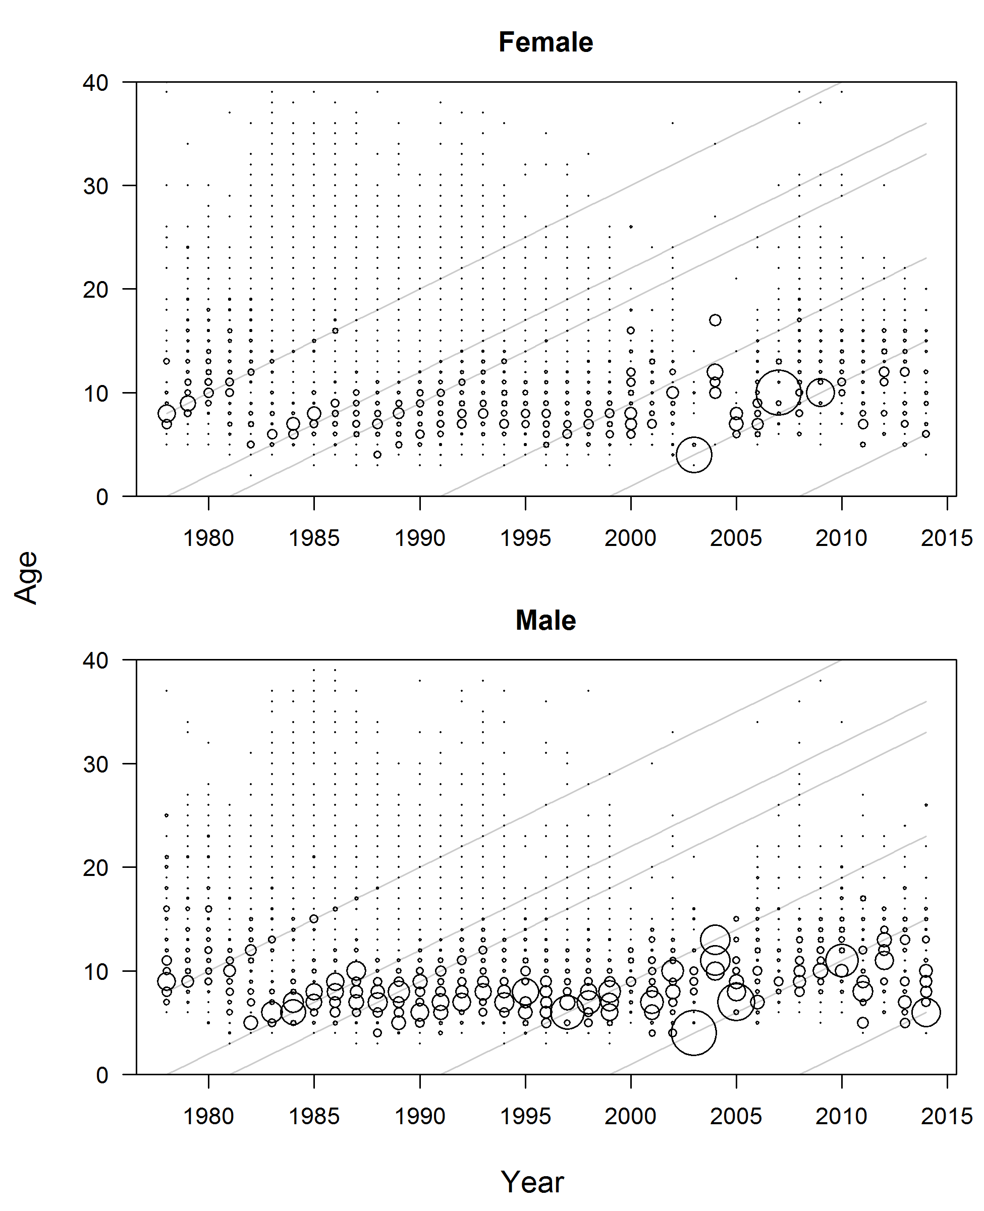

Figure : Expanded age compositions for the bottom trawl fishery. The area of the circle is proportional to the proportion-at-age. Gray lines show the 1970, 1978, 1981, 1991, 1999, and 2008 cohorts, for reference.

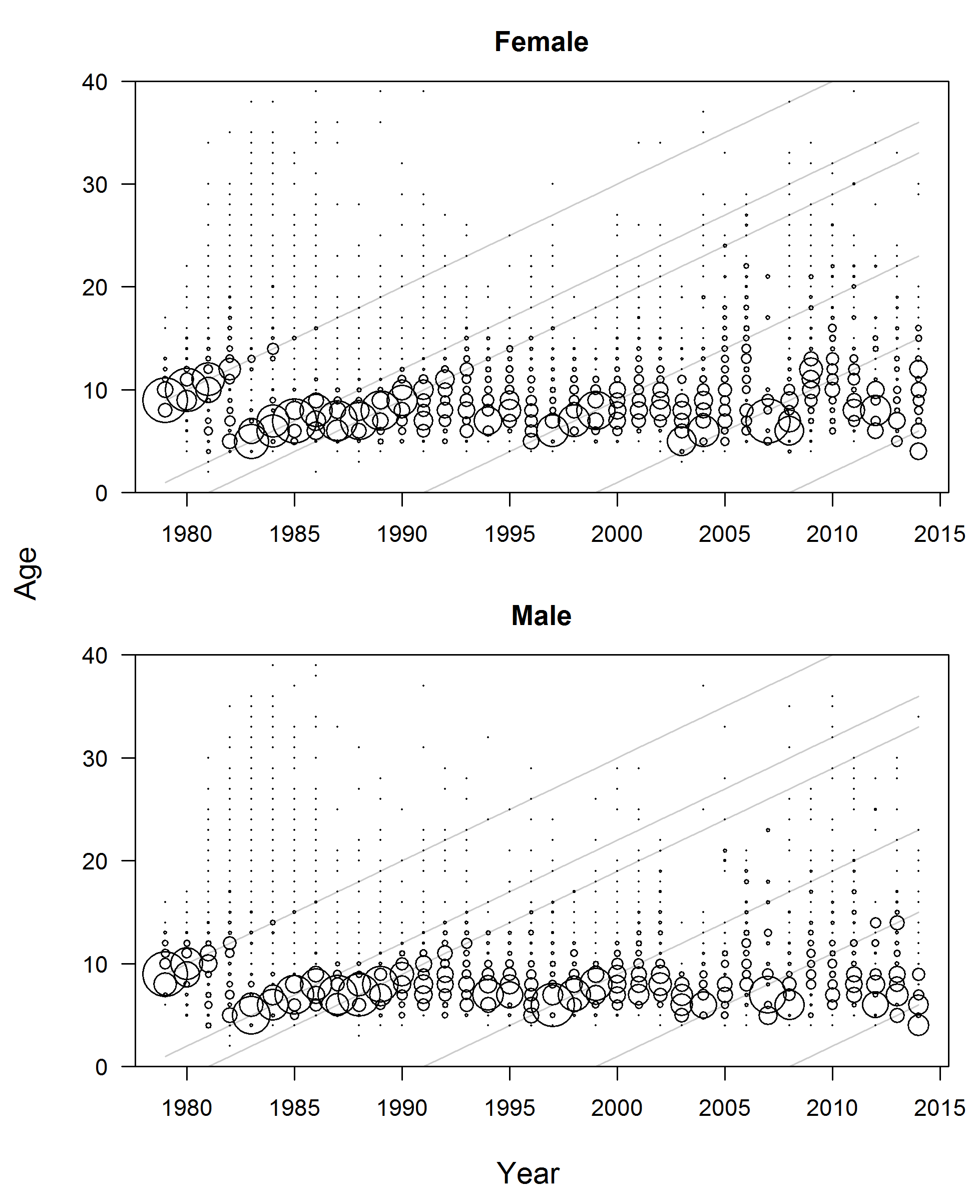

Figure : Expanded age compositions for the midwater trawl fishery. The area of the circles is proportional to the proportion-at-age. Gray lines show the 1970, 1978, 1981, 1991, 1999, and 2008 cohorts, for reference.

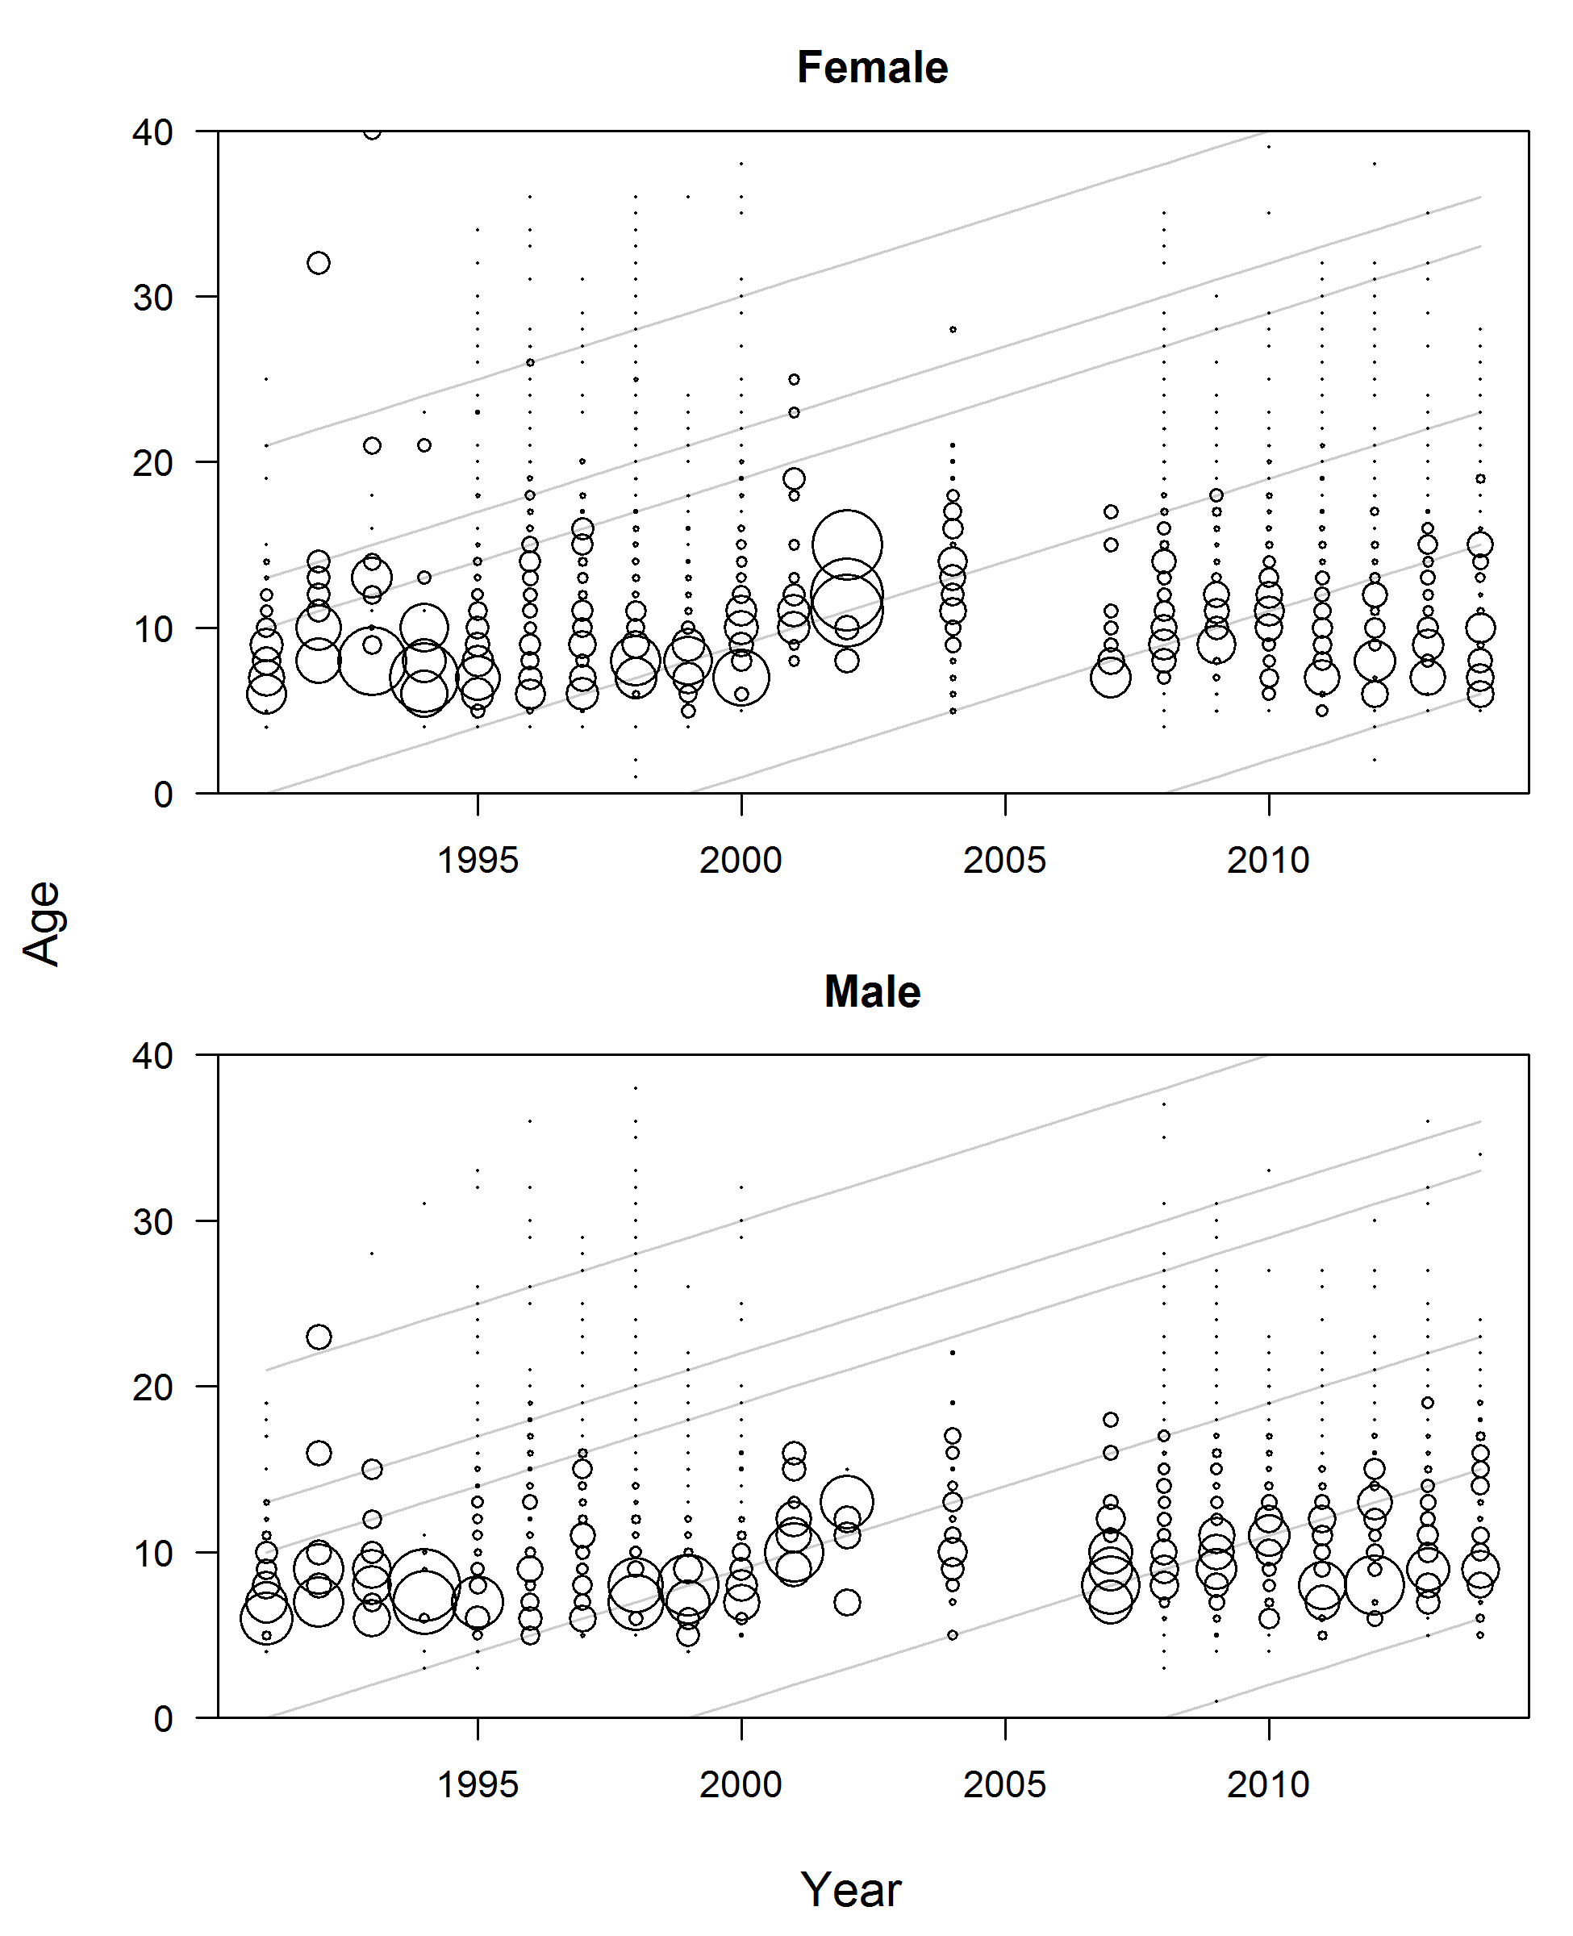

Figure : Expanded age compositions for the hake fishery. The area of the circles is proportional to the proportion-at-age. Gray lines show the 1970, 1978, 1981, 1991, 1999, and 2008 cohorts, for reference.

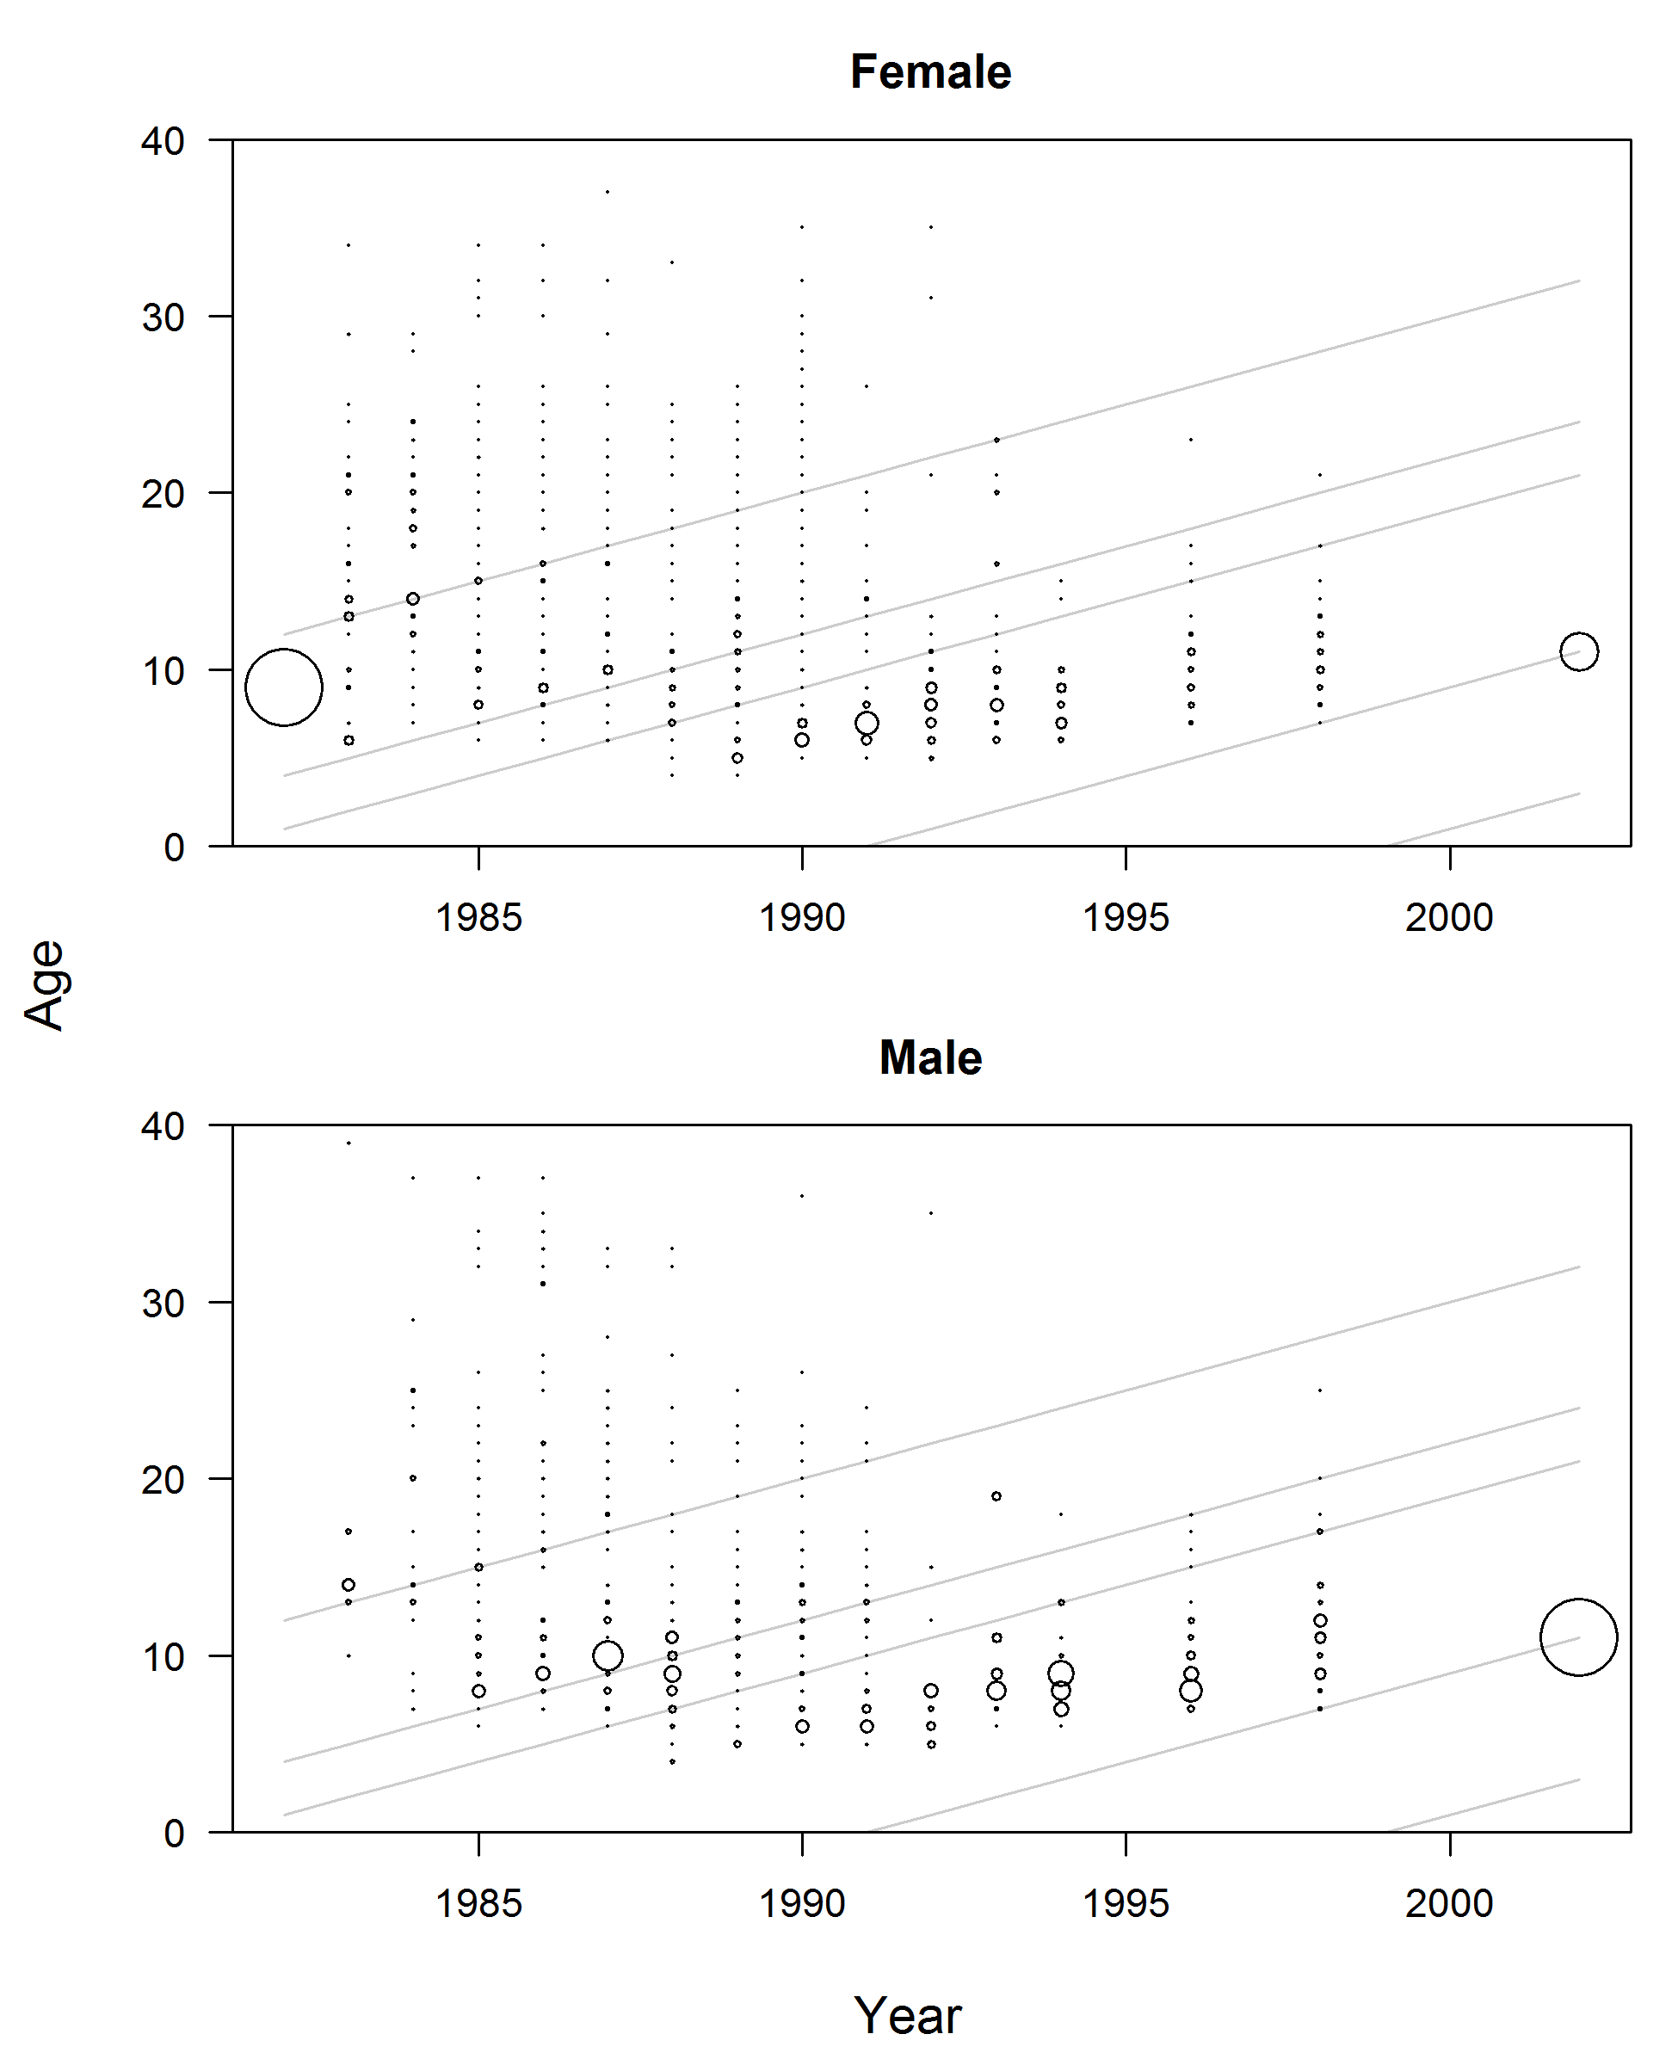

Figure : Expanded age compositions for the net fishery. The area of the circles is proportional to the proportion-at-age. Gray lines show the 1970, 1978, 1981, 1991, 1999, and 2008 cohorts, for reference.

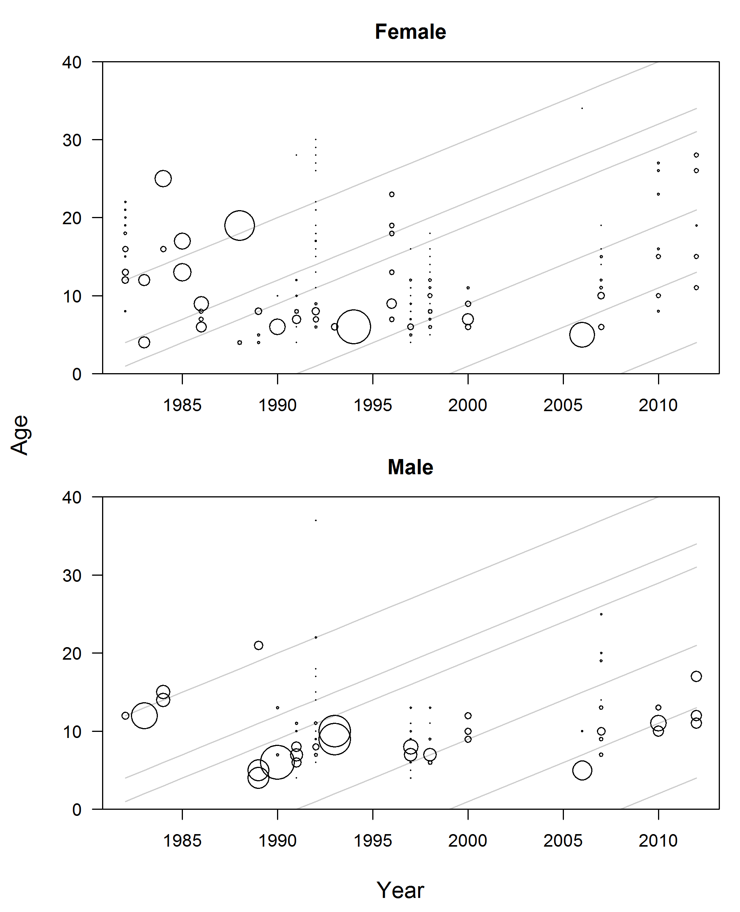

Figure : Expanded age compositions for the hook-and-line fishery. The area of the circles is proportional to the proportion-at-age. Gray lines show the 1970, 1978, 1981, 1991, 1999, and 2008 cohorts, for reference.

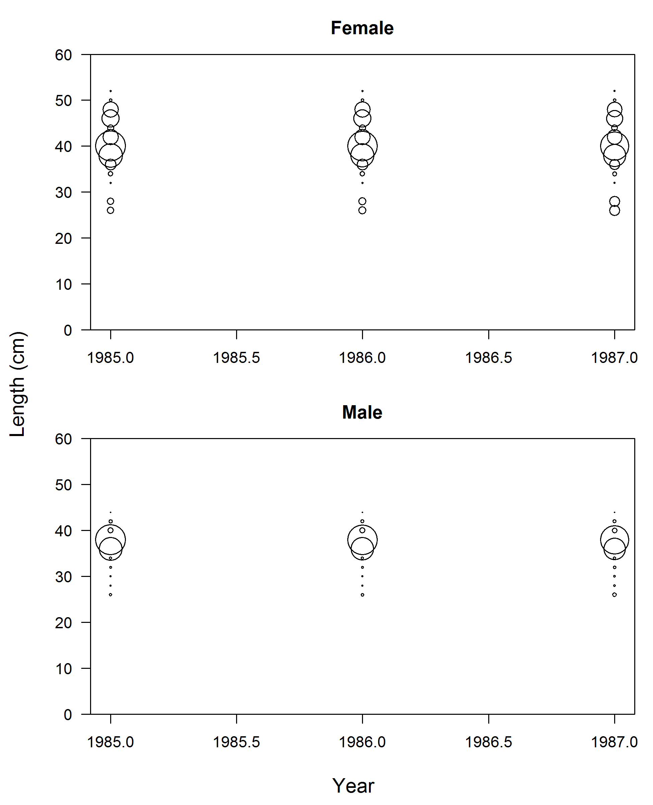

Figure : Length compositions for discards from the Pikitch study. The discard length comps were fit to in the model.

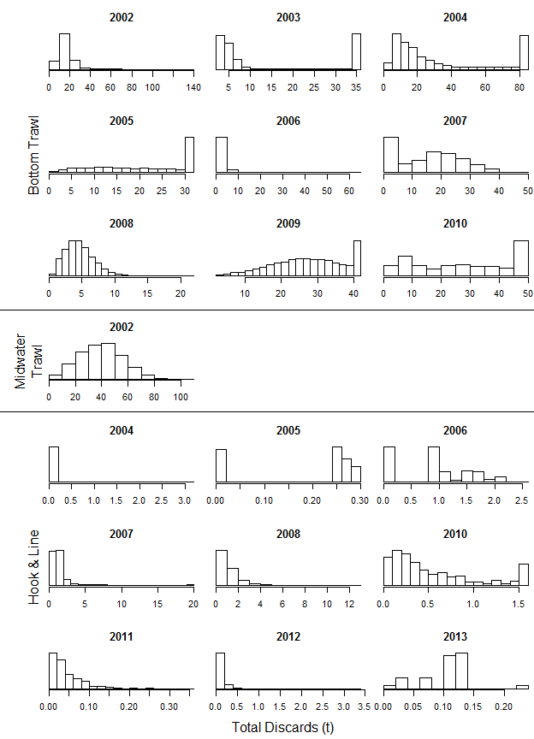

Figure : Histograms of bootstrap samples for WCGOP estimates of total discards (mt) for bottom trawl (top), midwater trawl (middle), and hook-and-line (bottom) gears.

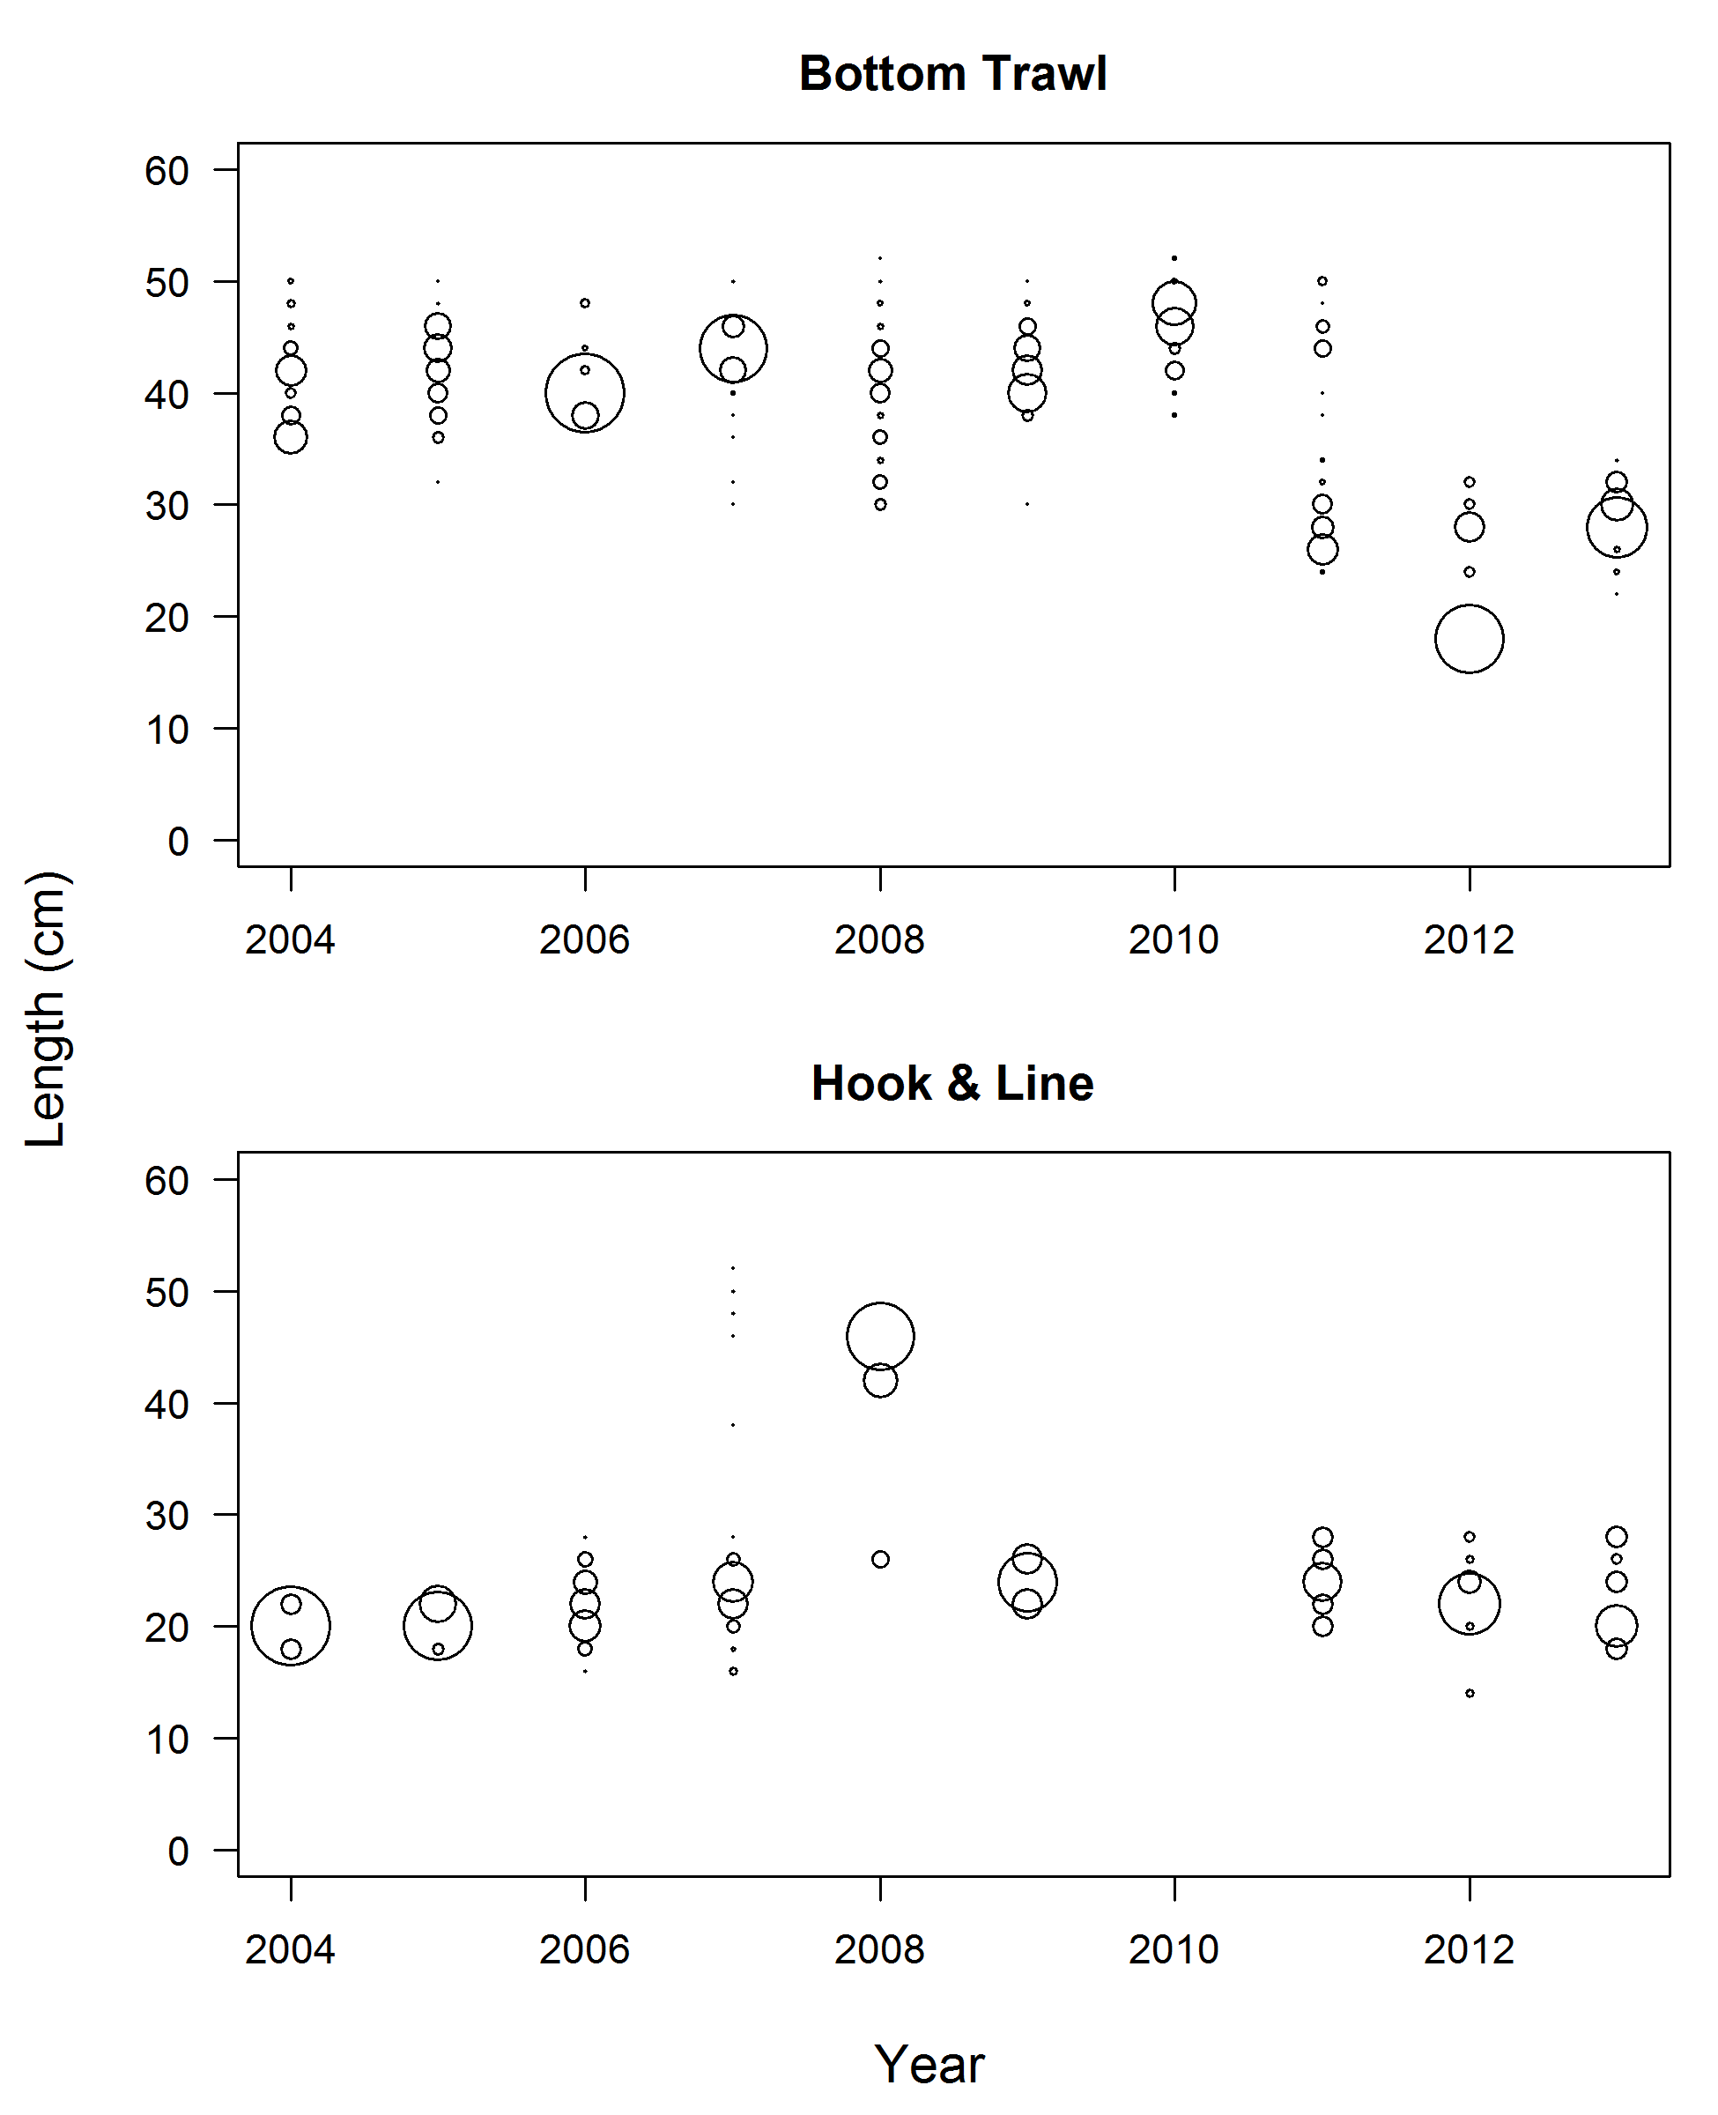

Figure : Length compositions of the discards for the bottom trawl (top) and hook-and-line (bottom) fleets.

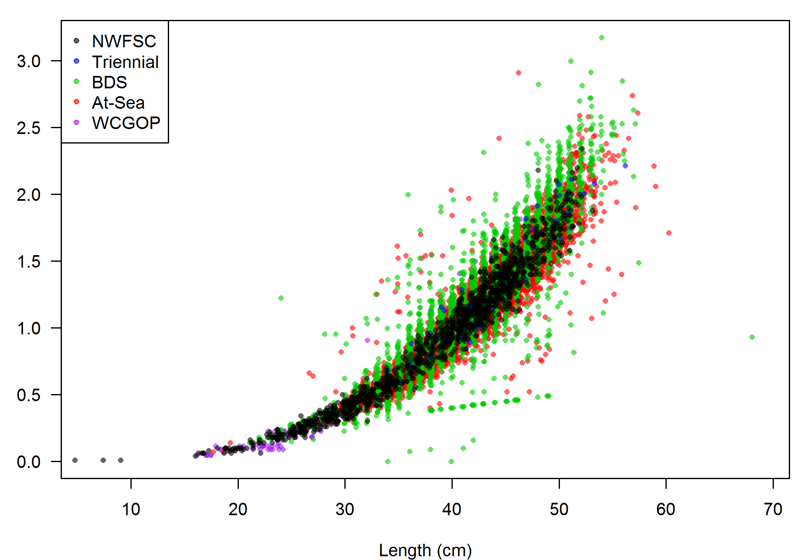

Figure : Weight-at-length observations of Widow Rockfish from different data sources.

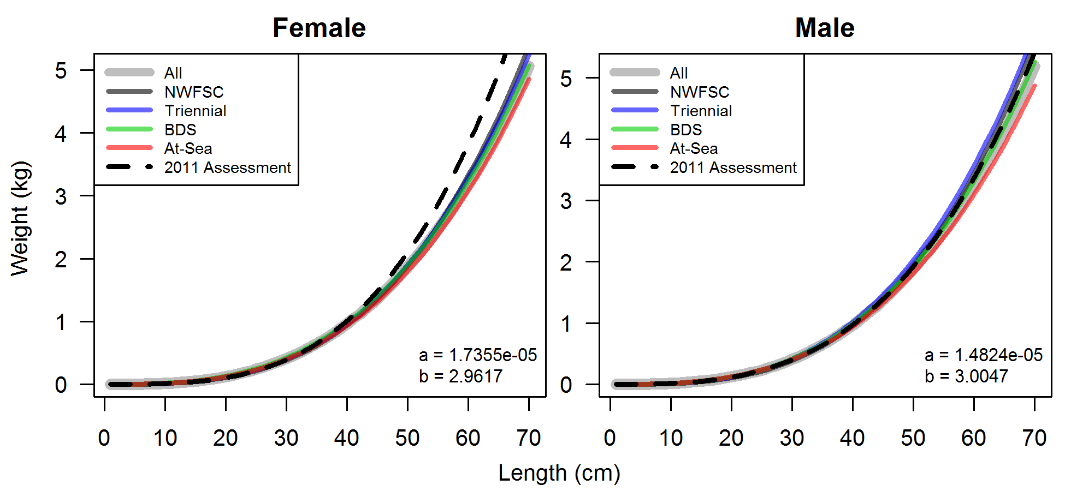

Figure : Fits to weight-at-length observations for females (left) and males (right) using observations from different data sources. The weight-at-length curve used in the 2011 assessment is shown as a dashed line. Estimates of the intercept (a) and slope (b) are show in the lower left for each sex. Observations from the WCGOP were not used due to potential biases and lack of older fish resulting in a lack of fit compared to other sources (81 observations) and length observations greater than 60 cm were removed.

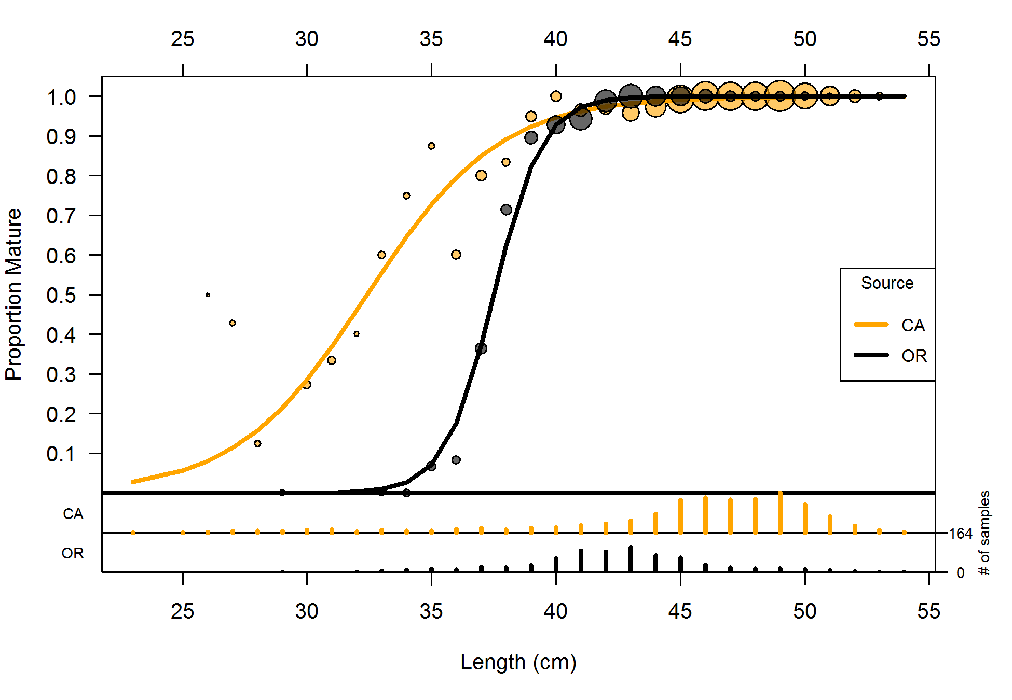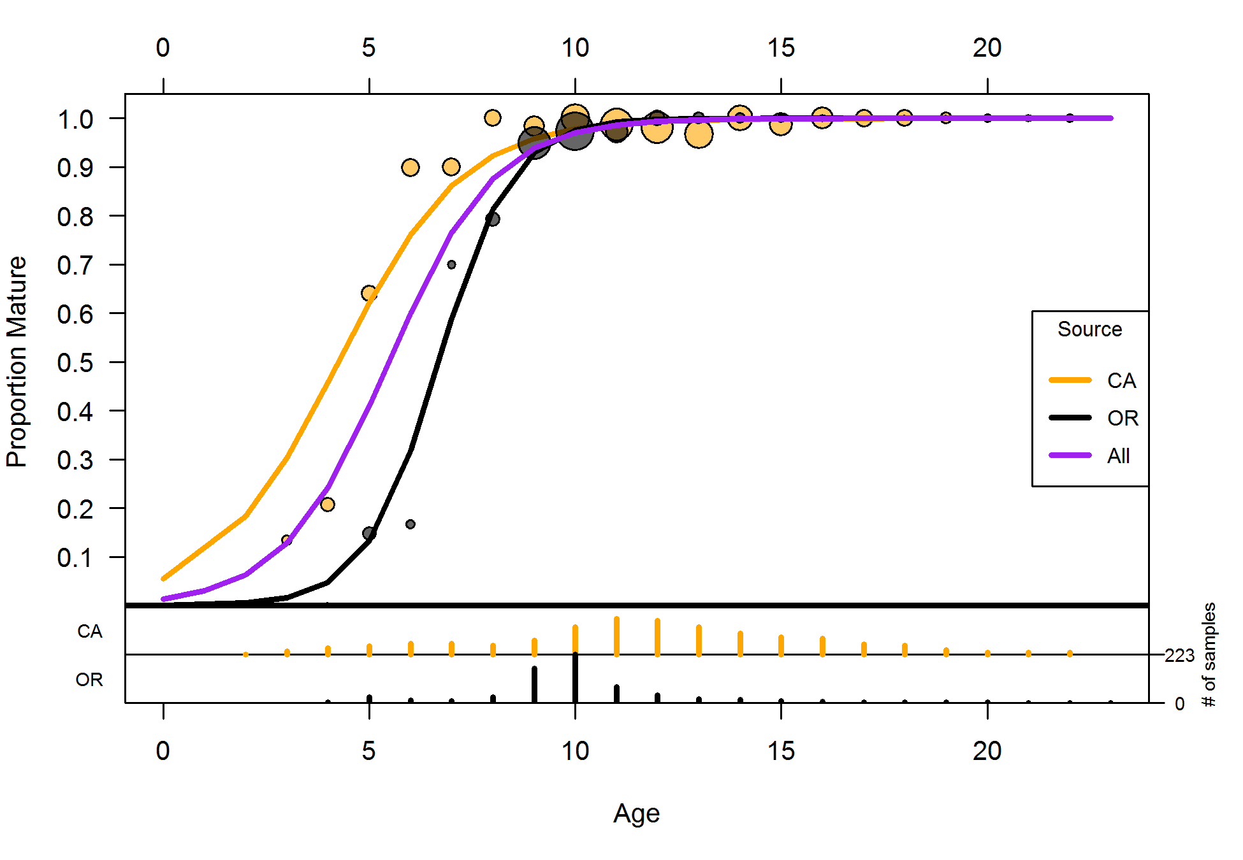

Figure : Maturity-at-length (left) and maturity-at-age (right) from data reported by Barss & Echeverria (1987). Circles are proportional to the number of observations at that length or age. Lines are estimated logistic curves fitted to the data. The bars at the bottom are the number of samples by each state. The purple line is the estimated maturity-at-age using all data with each state equally weighted, and is used in the assessment model with maturity-at-age for ages 2 and lower set equal to zero.

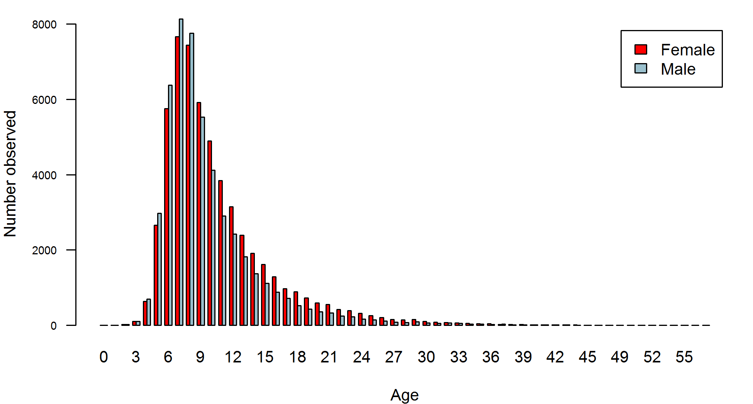

Figure : Number at age observed from all data for female and male Widow Rockfish.

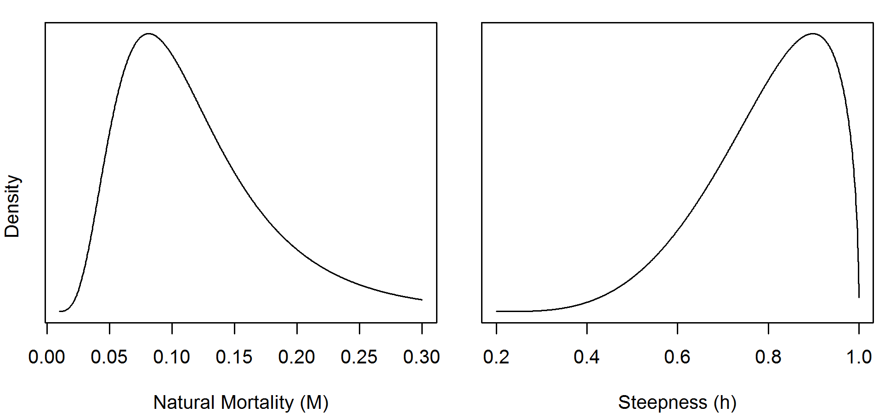

Figure : Prior distributions for natural mortality (*M*, left) and steepness (*h*, right).

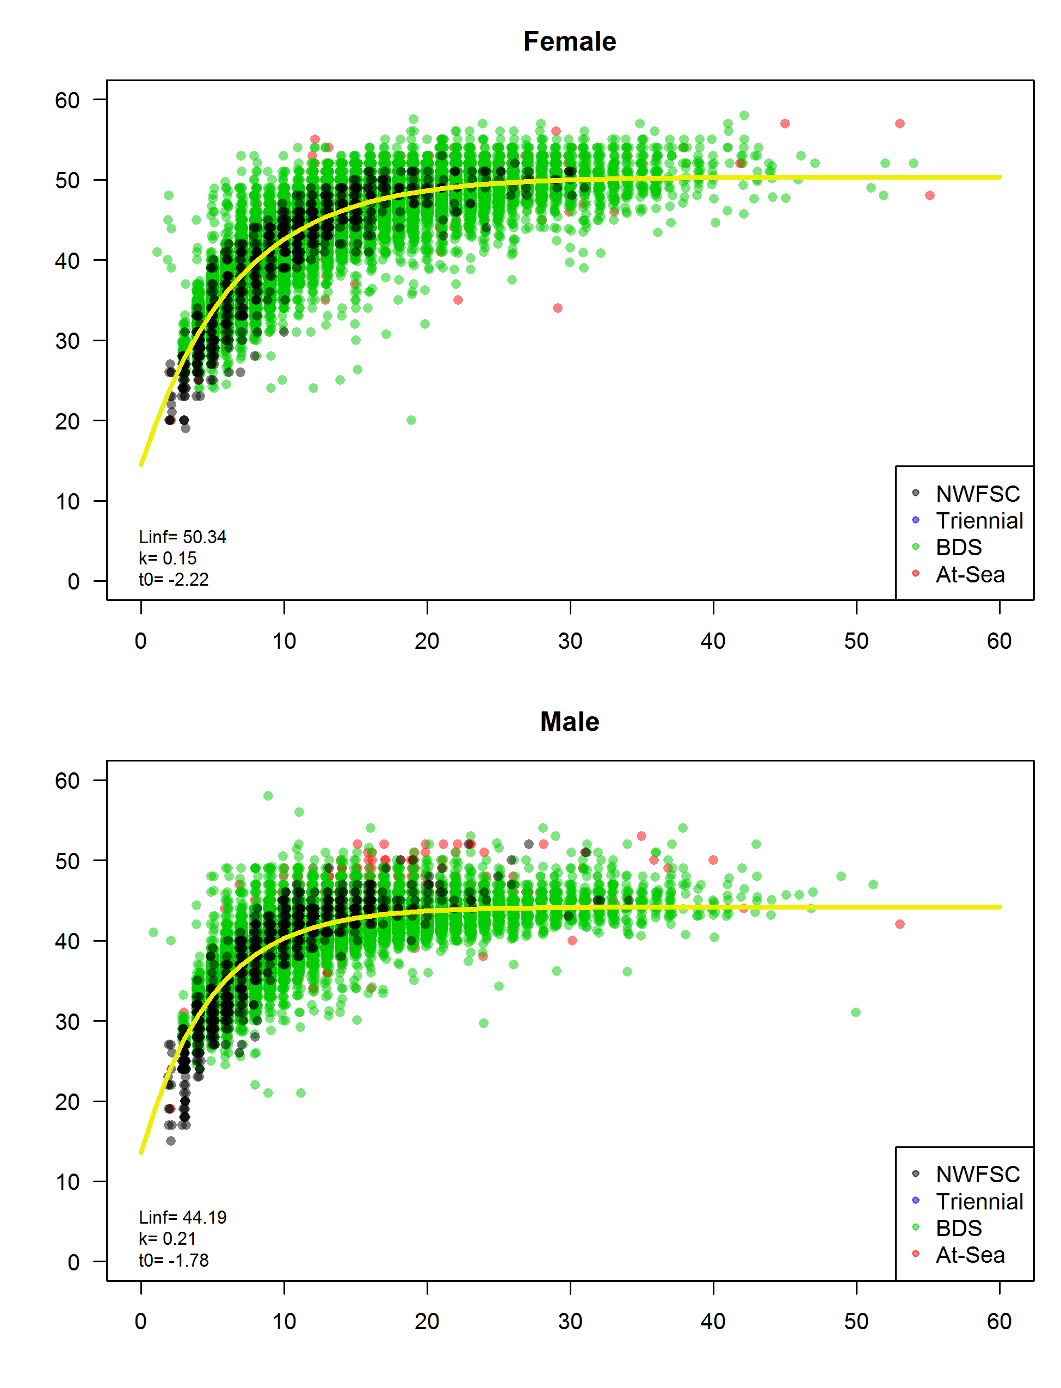

Figure : Length-at-age observations (points, slightly jittered) and predicted length-at-age von Bertalanffy curves for female (top) and male (bottom) Widow Rockfish collected from all fishery (BDS and At-Sea) and survey (Triennial and NWFSC) data.

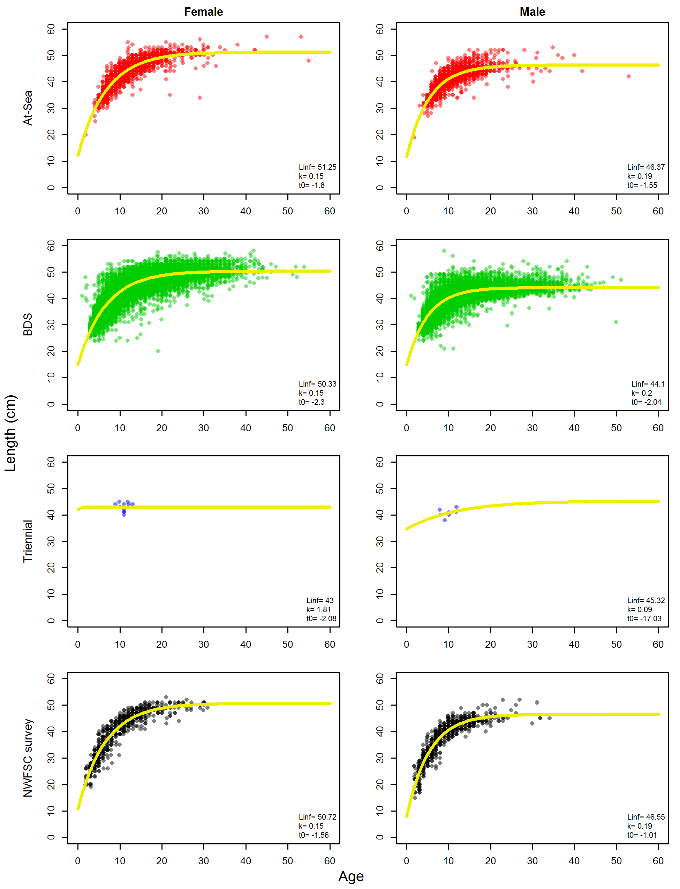

Figure : Length-at-age observations (points) and predicted length-at-age von Bertalanffy curves for female (left) and male (right) Widow Rockfish for each source.

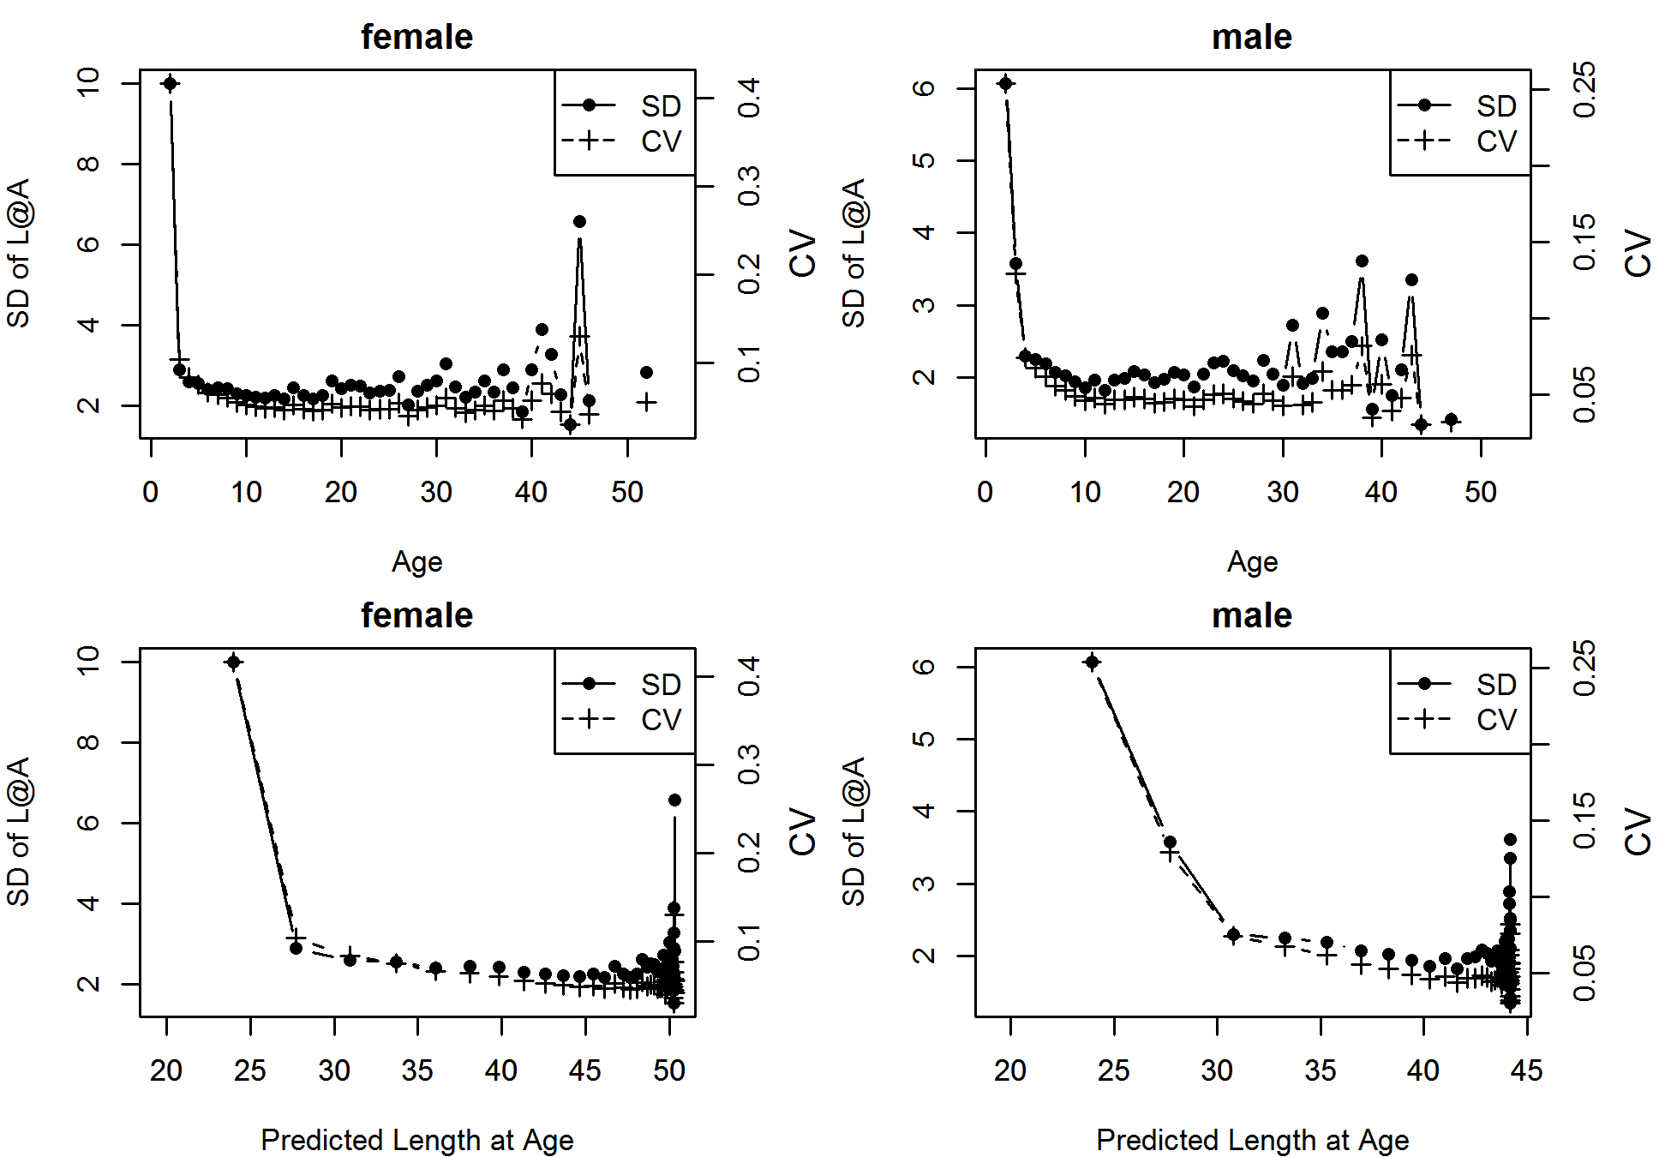

Figure : Standard deviation (SD) and coefficient of variation (CV) of length at age from all data sources as a function of age (top) and predicted length-at-age (bottom).

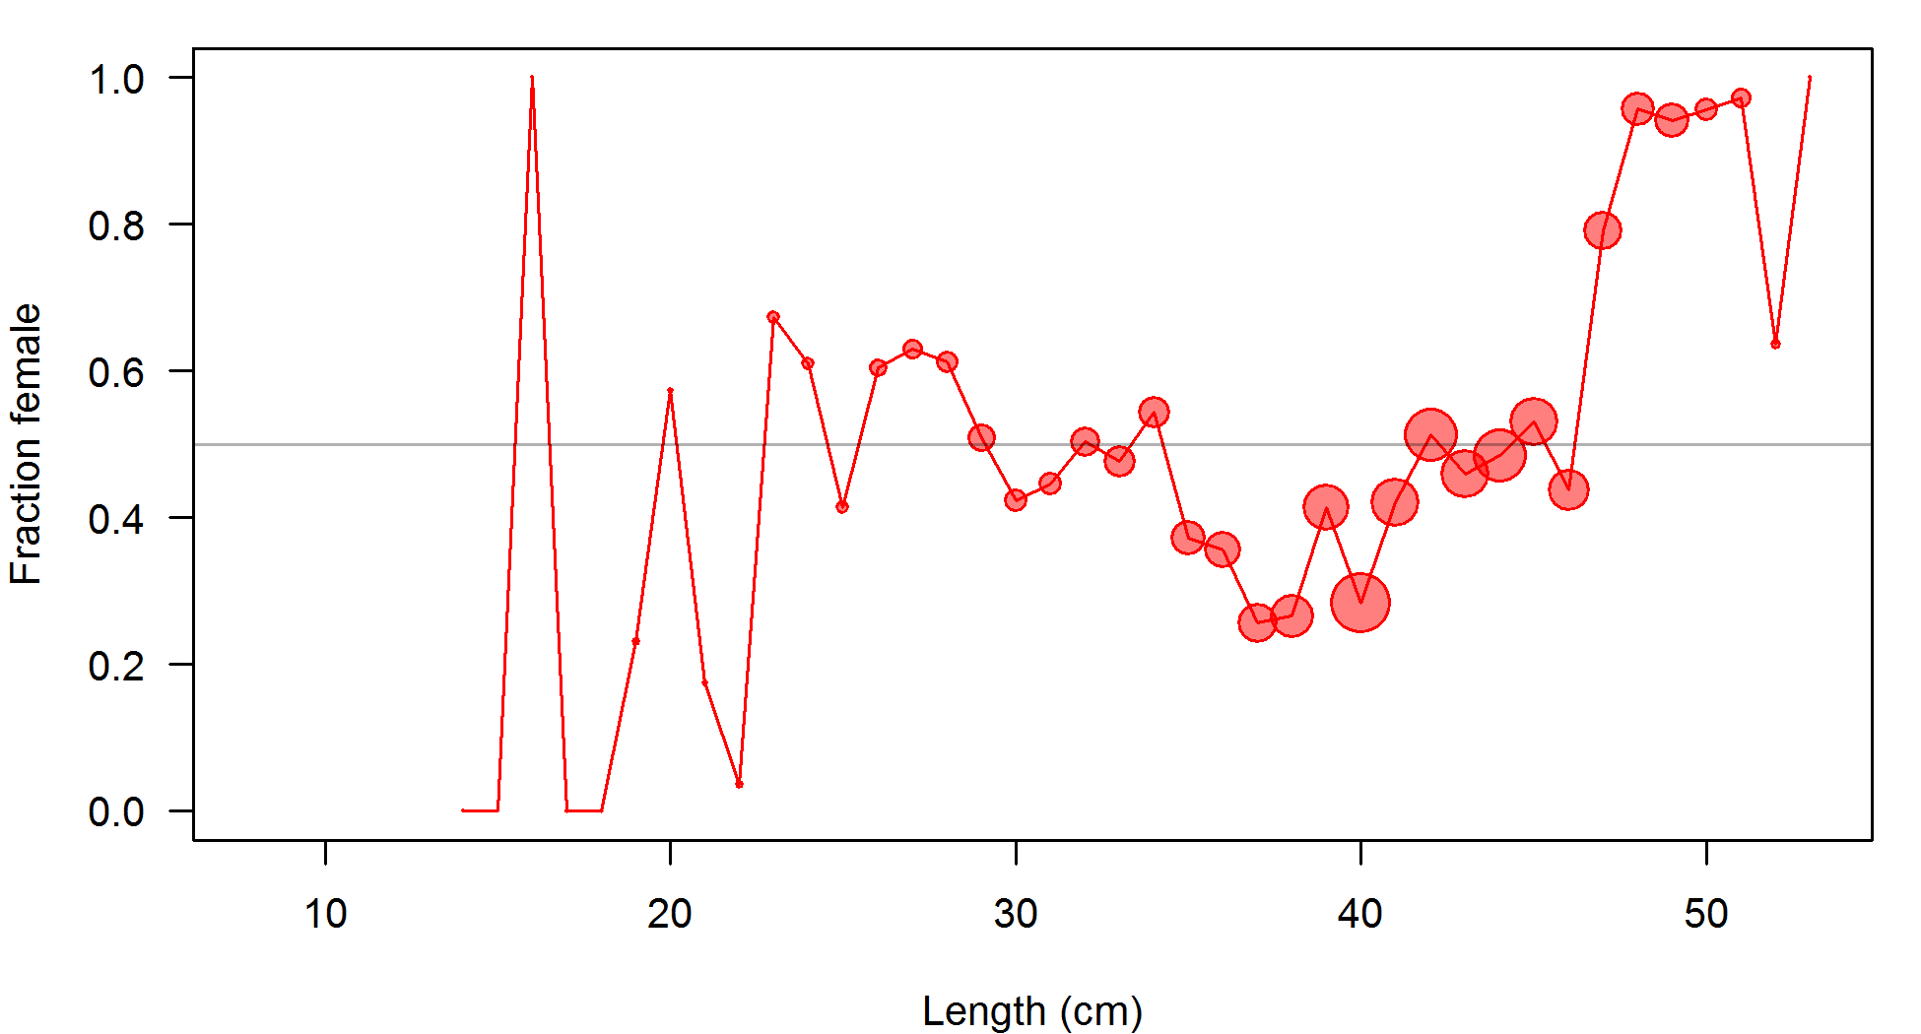

Figure : Proportion of females plotted against fish length (cm) from data collected on the NWFSC shelf/slope survey from 2003–2014. The area of the circle corresponds to the number of observations in that bin.

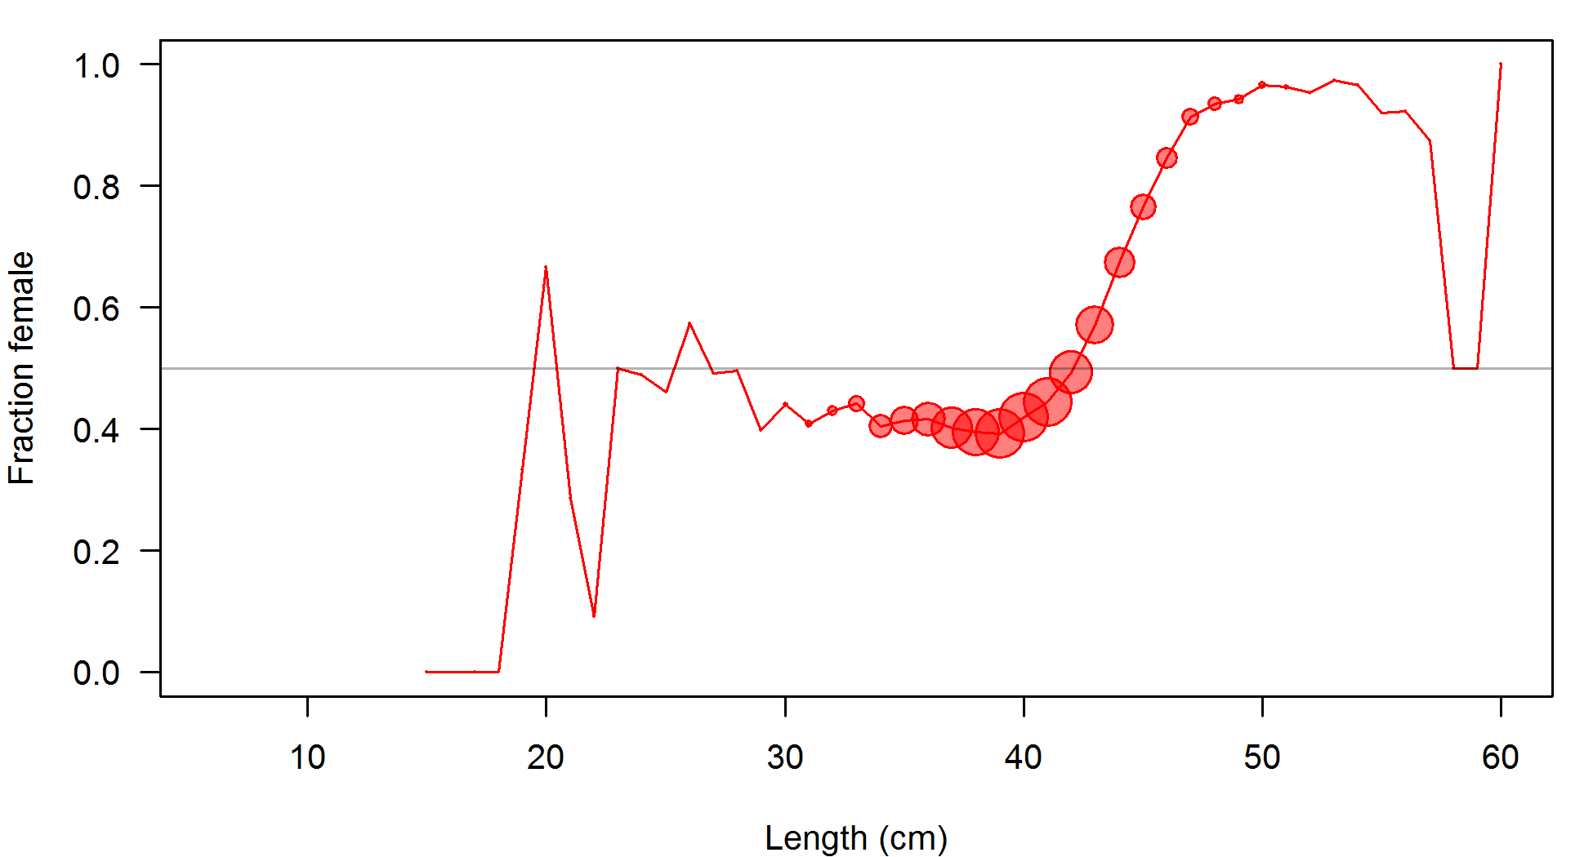

Figure : Proportion of females plotted against fish length (cm) from all data collected from fisheries and surveys. The area of the circle corresponds to the number of observations in that bin.

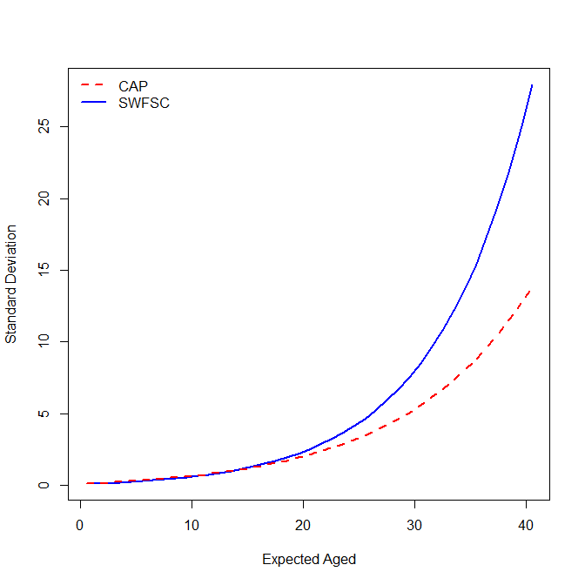

Figure : Estimated ageing error for the Cooperative Ageing Project lab and the SWFSC.

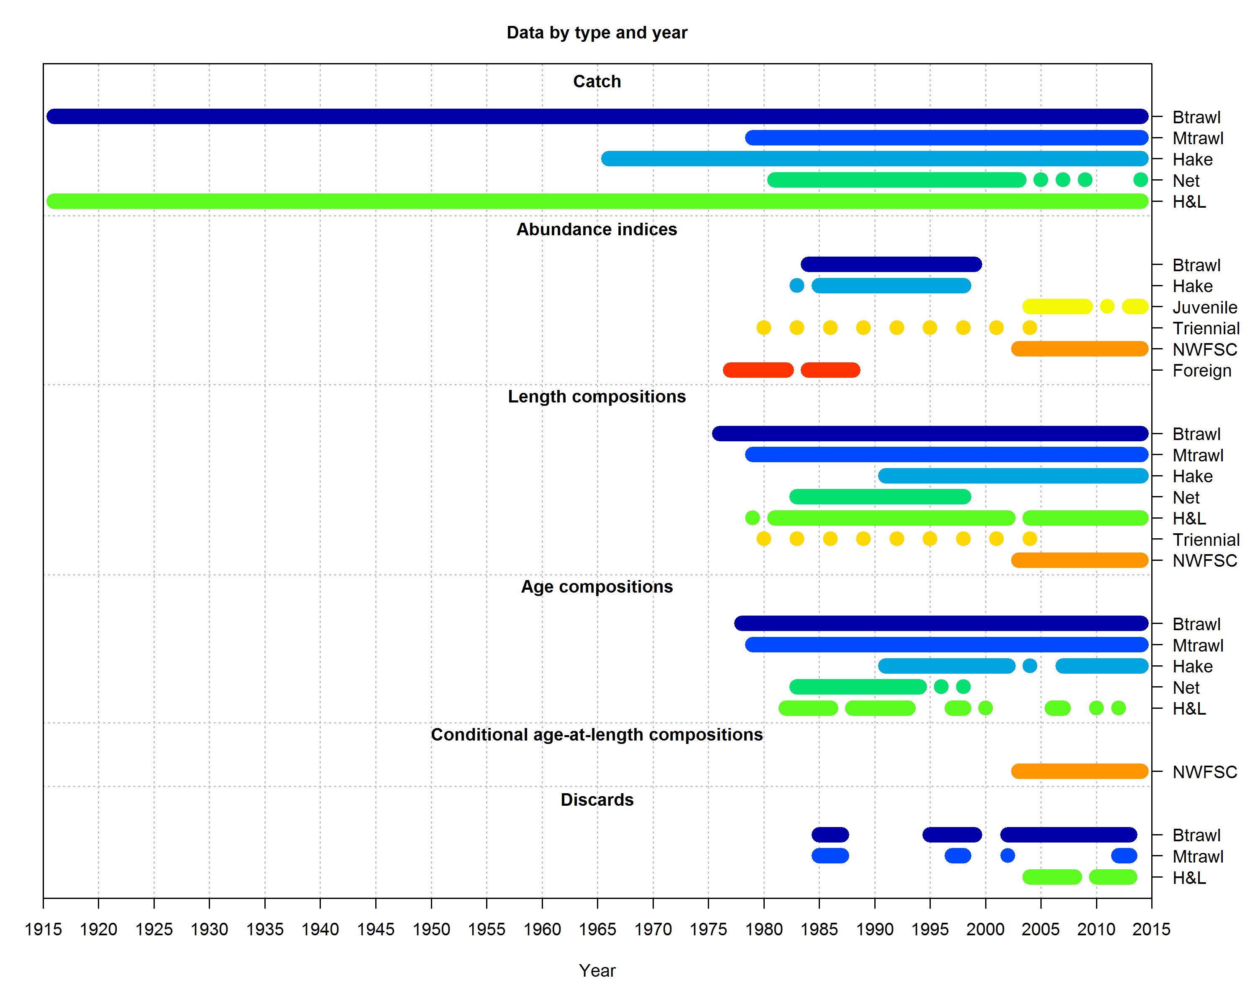

Figure : Data sources by type and year that were used in the base model.

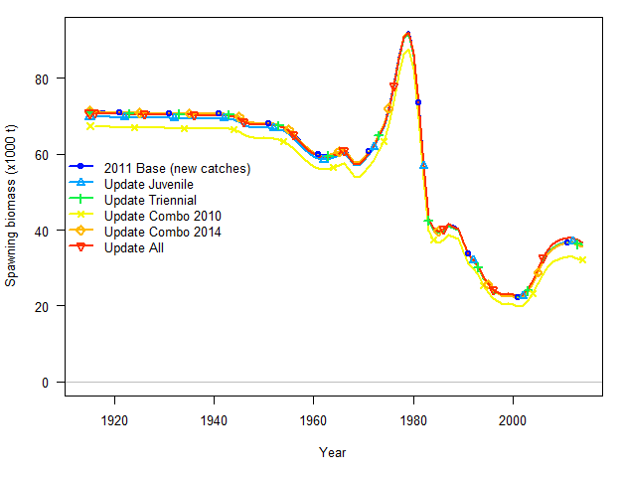

Figure : Bridging of survey indices from the 2011 assessment models with updated catches.

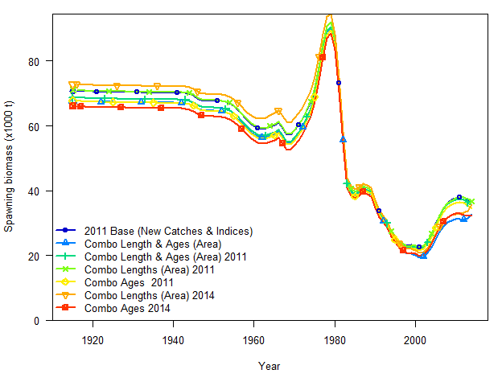

Figure : Bridging of NWFSC shelf/slope survey age and length data.

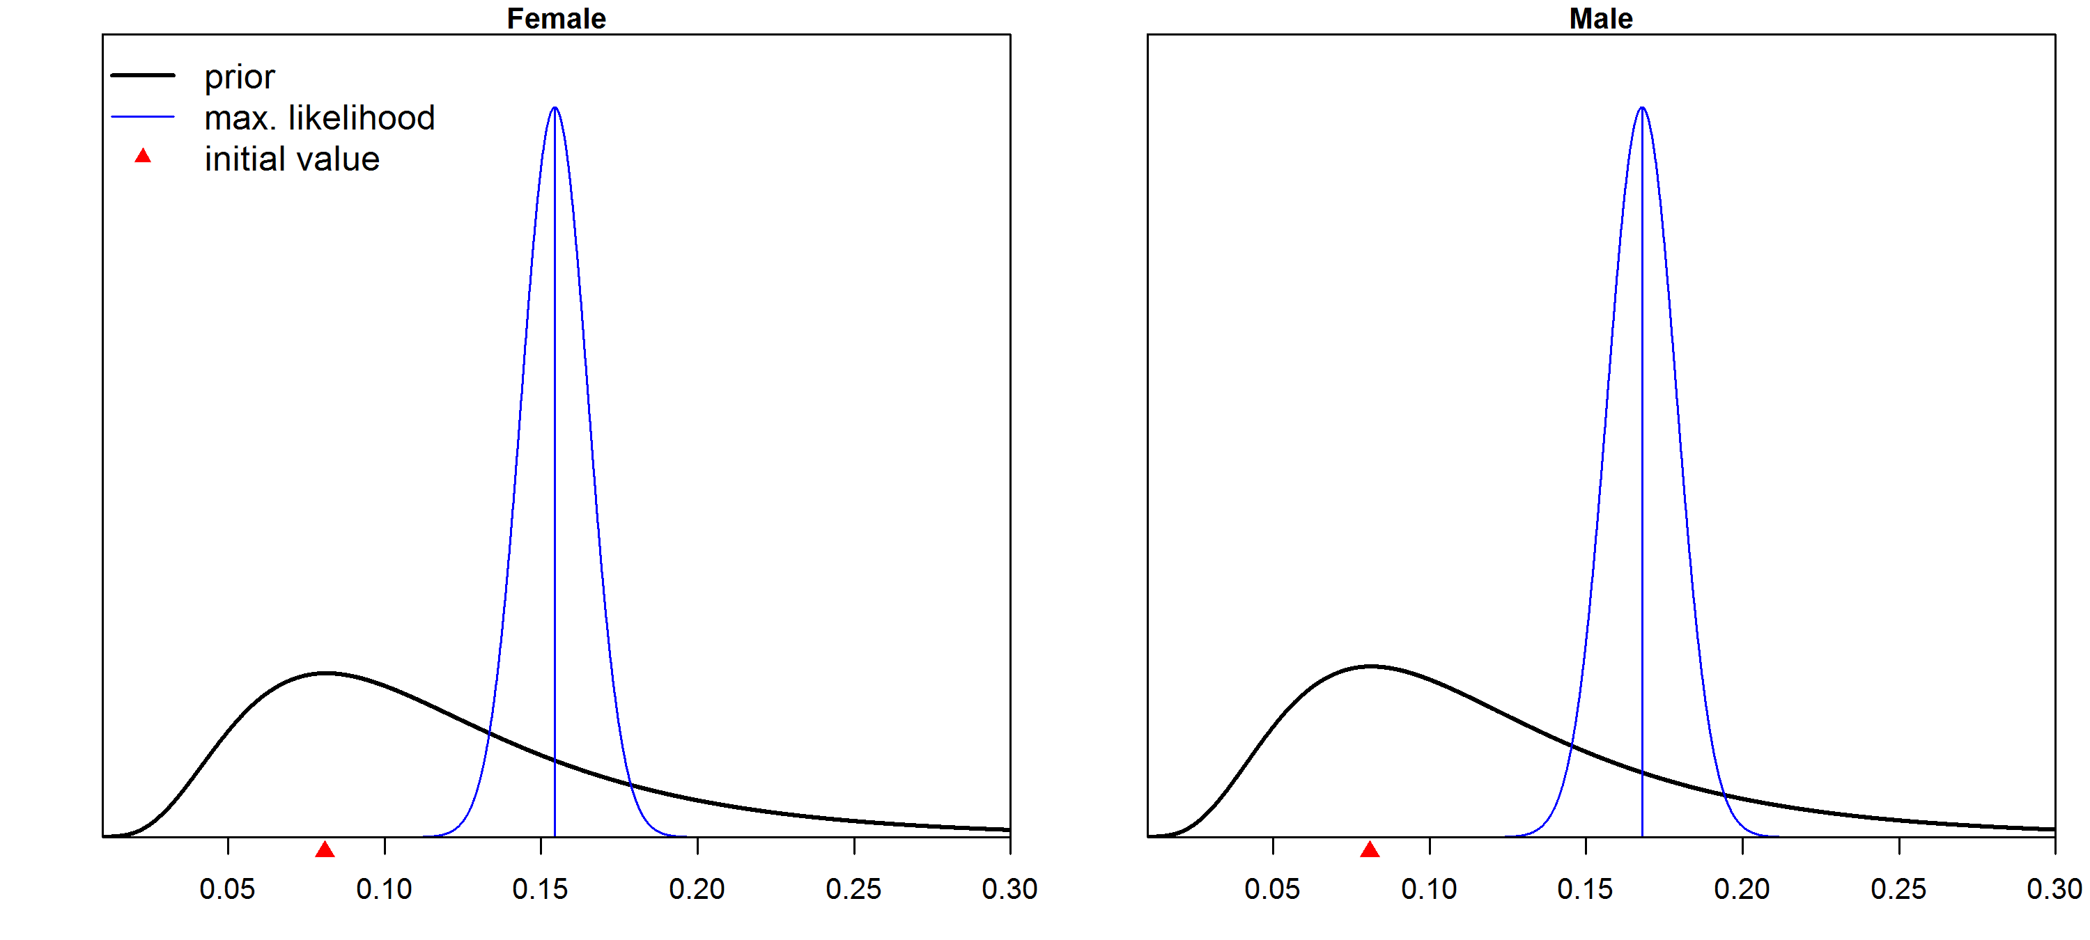

Figure : The prior for natural mortality (*M,* yr-1) and the estimated *M* for females (left) and males (right) with asymptotic uncertainty based on maximum likelihood theory. The median of the prior is shown by the red triangle and the maximum likelihood estimate is shown by the vertical blue line.

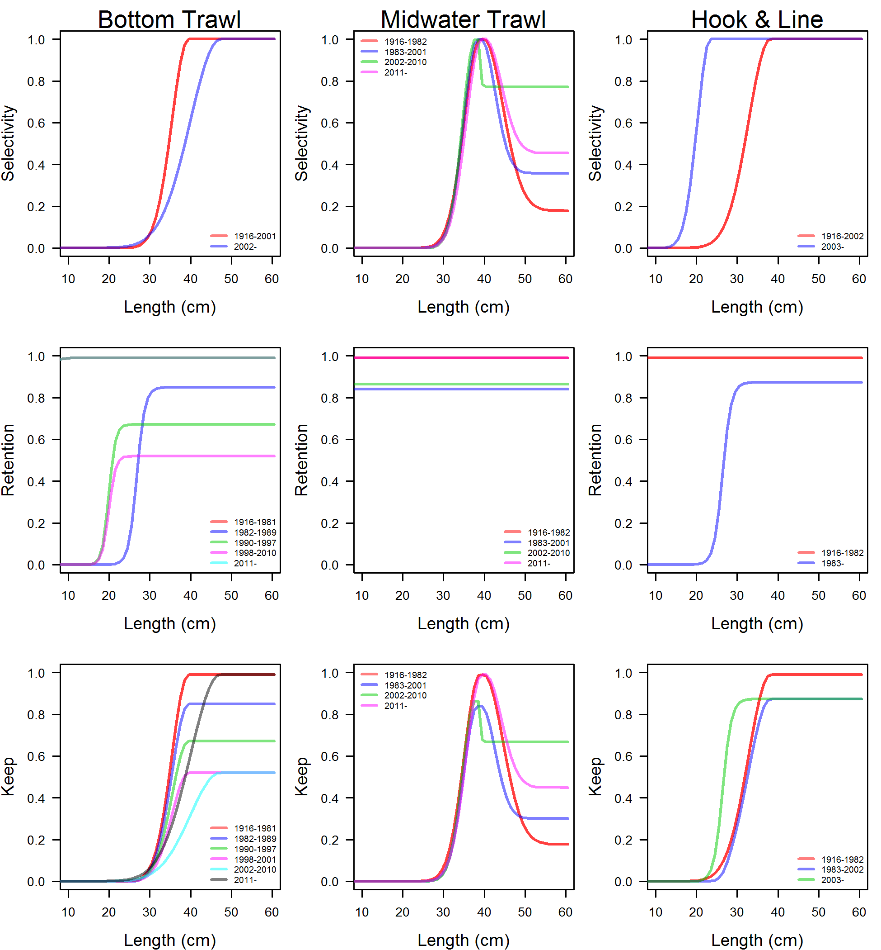

Figure : Estimated selectivity (top), retention (middle), and keep (bottom) curves for different blocks and the bottom trawl (left), midwater trawl (middle), and hook-and-line (right) fleets.

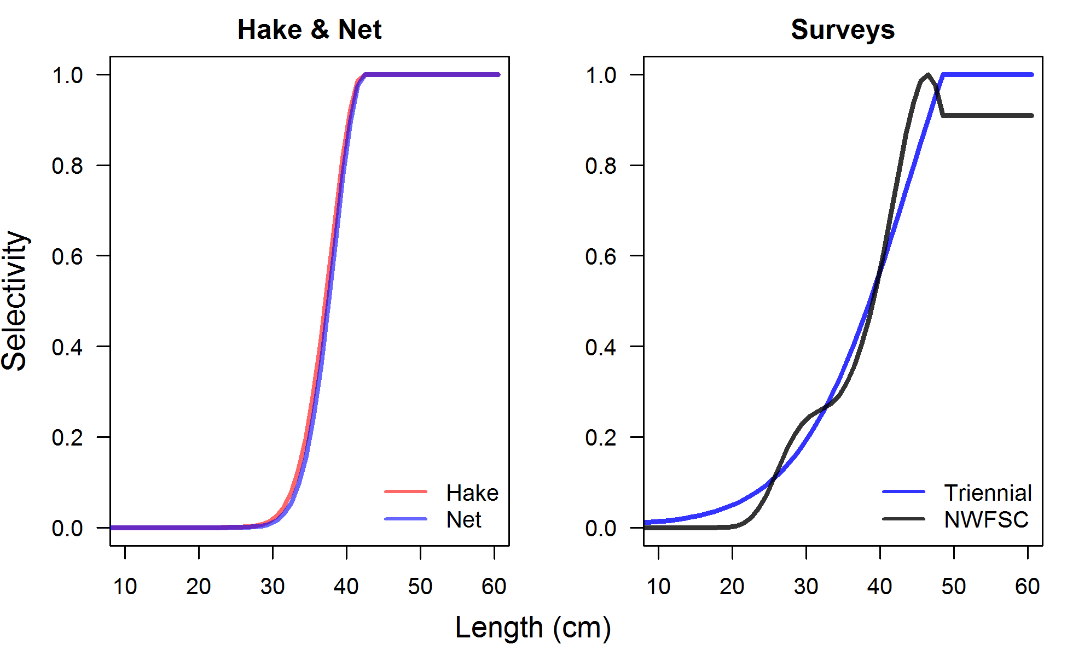

Figure : Estimated selectivity curves for the hake, net fishing fleets (left) and the fishery-independent surveys (right).

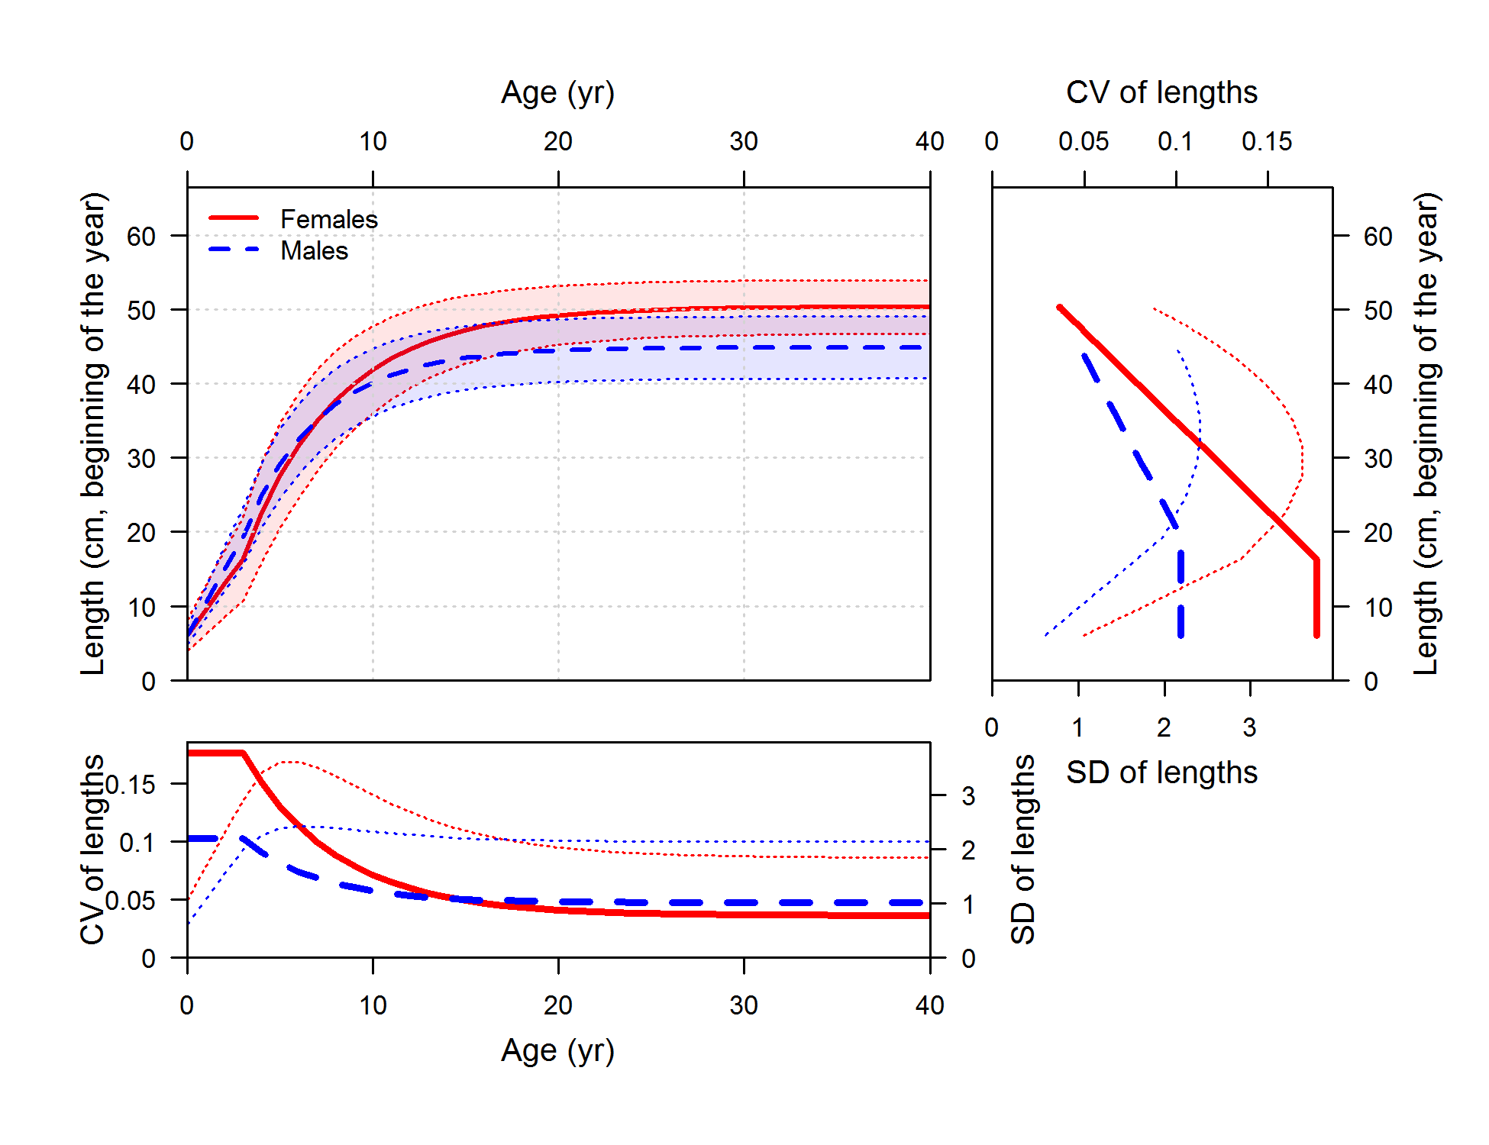

Figure : Length at age (top-left panel) with estimated coefficient of variation (CV, thick line) and calculated standard deviation (SD, thin line) versus length at age in the top-right panel and versus age in the lower-left panel.



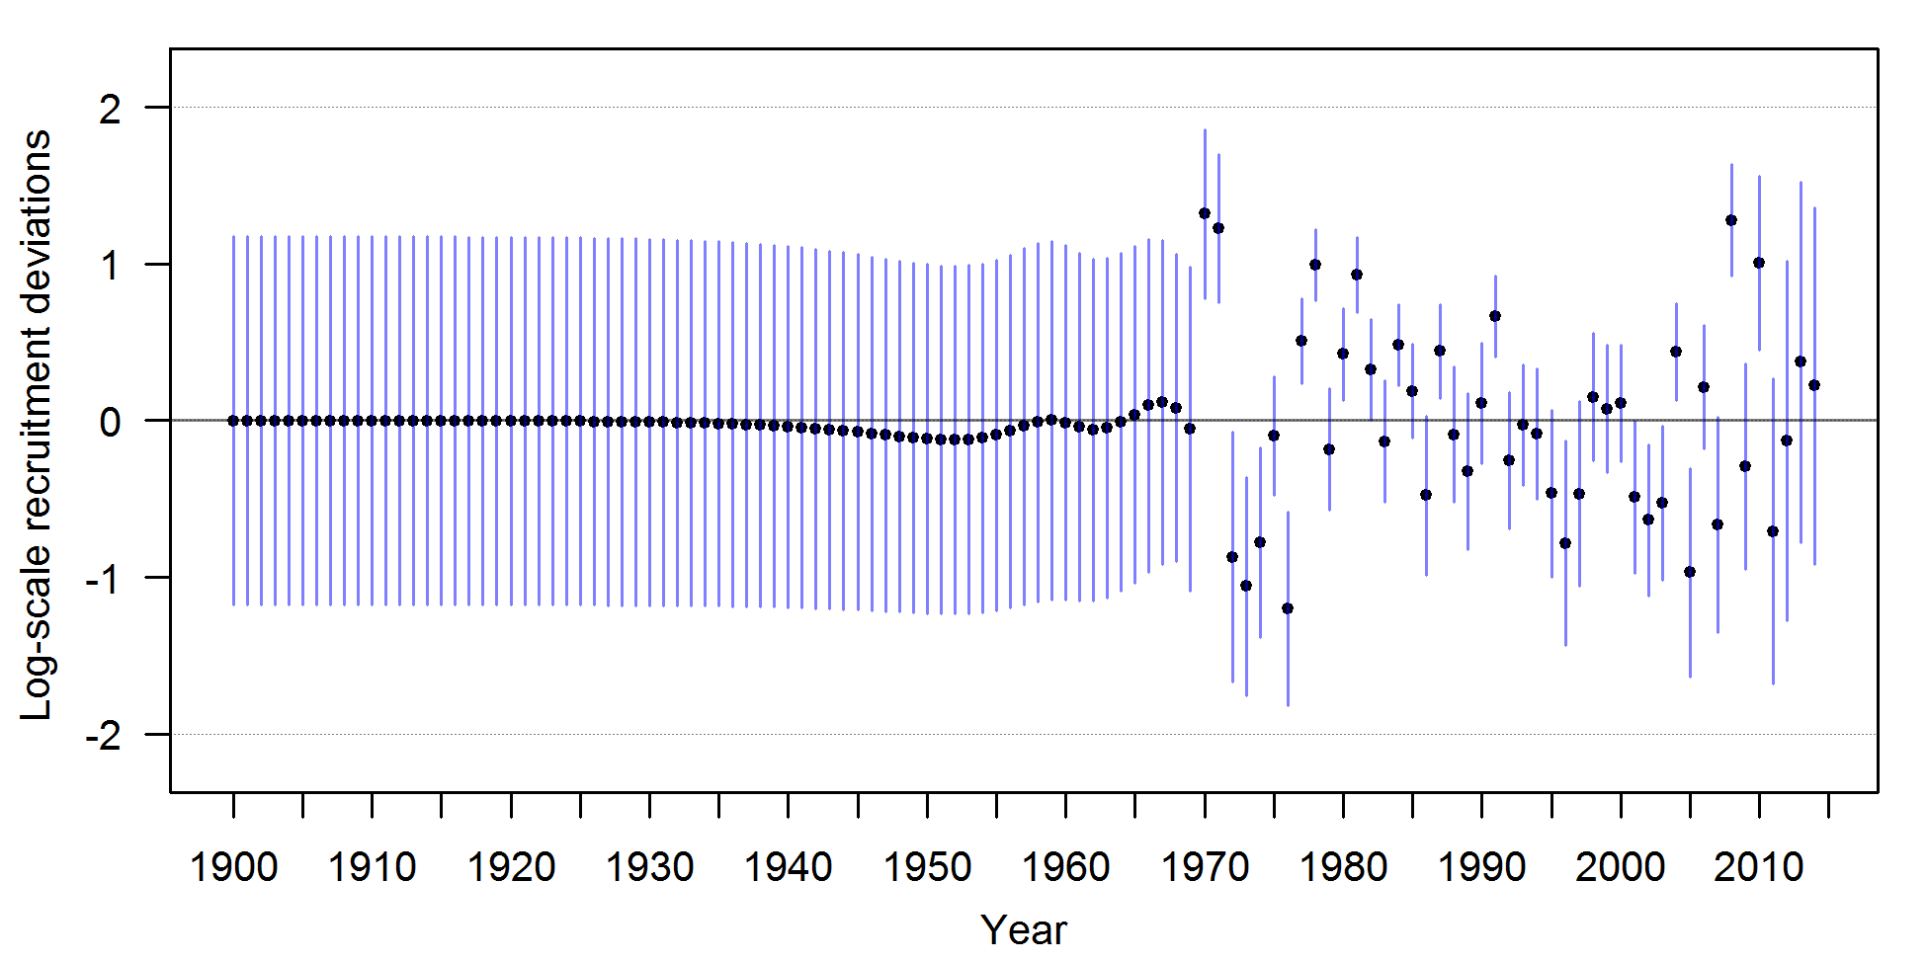

Figure : Estimates of recruitment (upper) and recruitment deviates (lower) with approximate asymptotic 95% confidence intervals (vertical lines) from the MLE estimates.

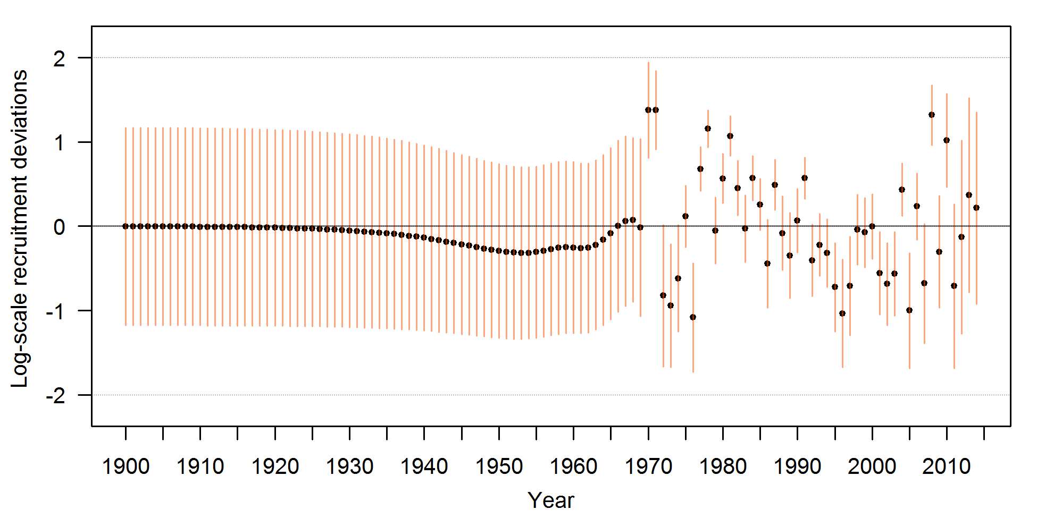

Figure : Estimates of recruitment deviations for a sensitivity model with natural mortality fixed at 0.124 and 0.129 for females and males, respectively.

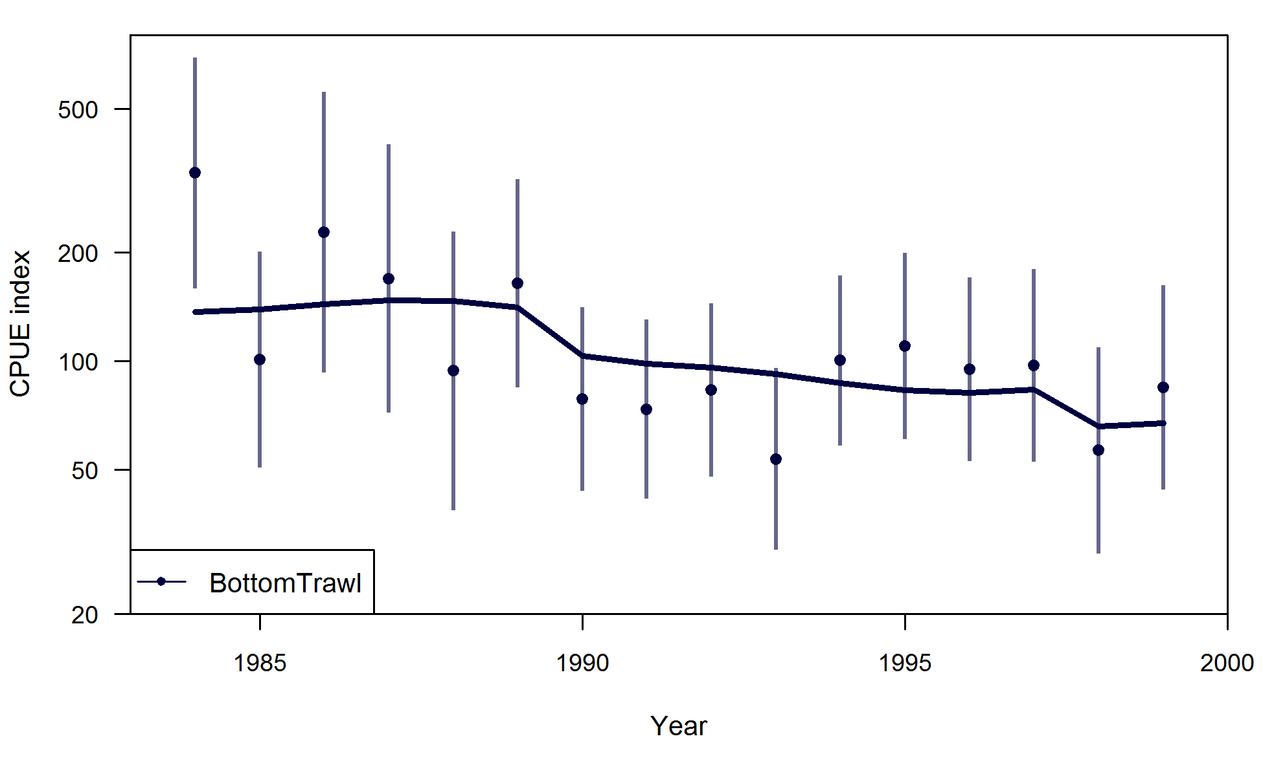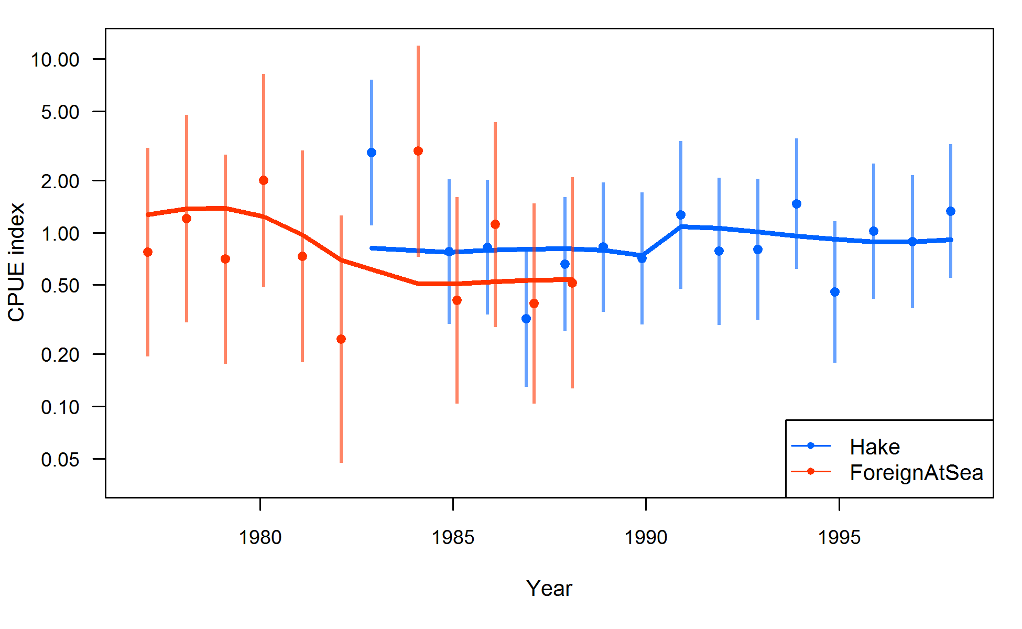

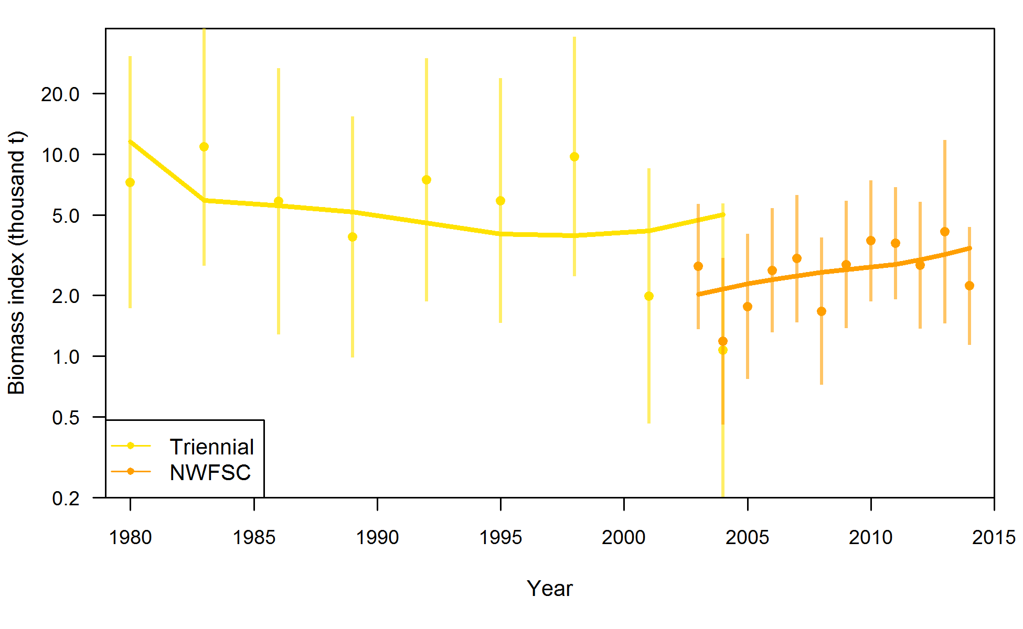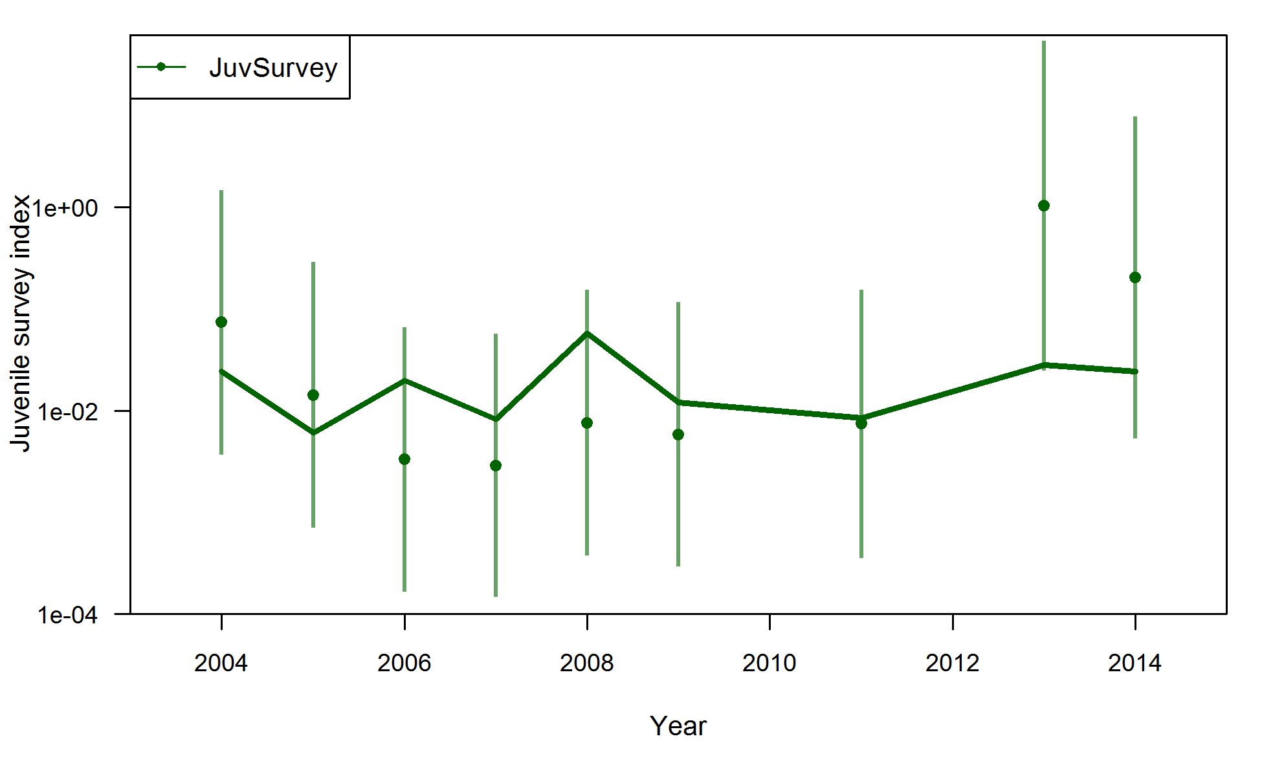

Figure : Fits (lines) to the abundance estimates (points) for the base model. Bottom trawl is in the top left, hake indices are in the top right (a separate *q* is estimated for the Hake series starting in 1991), the trawl survey indices are on the bottom left, and the juvenile survey index (in numbers) is on the bottom right. 95% confidence intervals are shown input the input standard errors, without the estimated extra variability added.

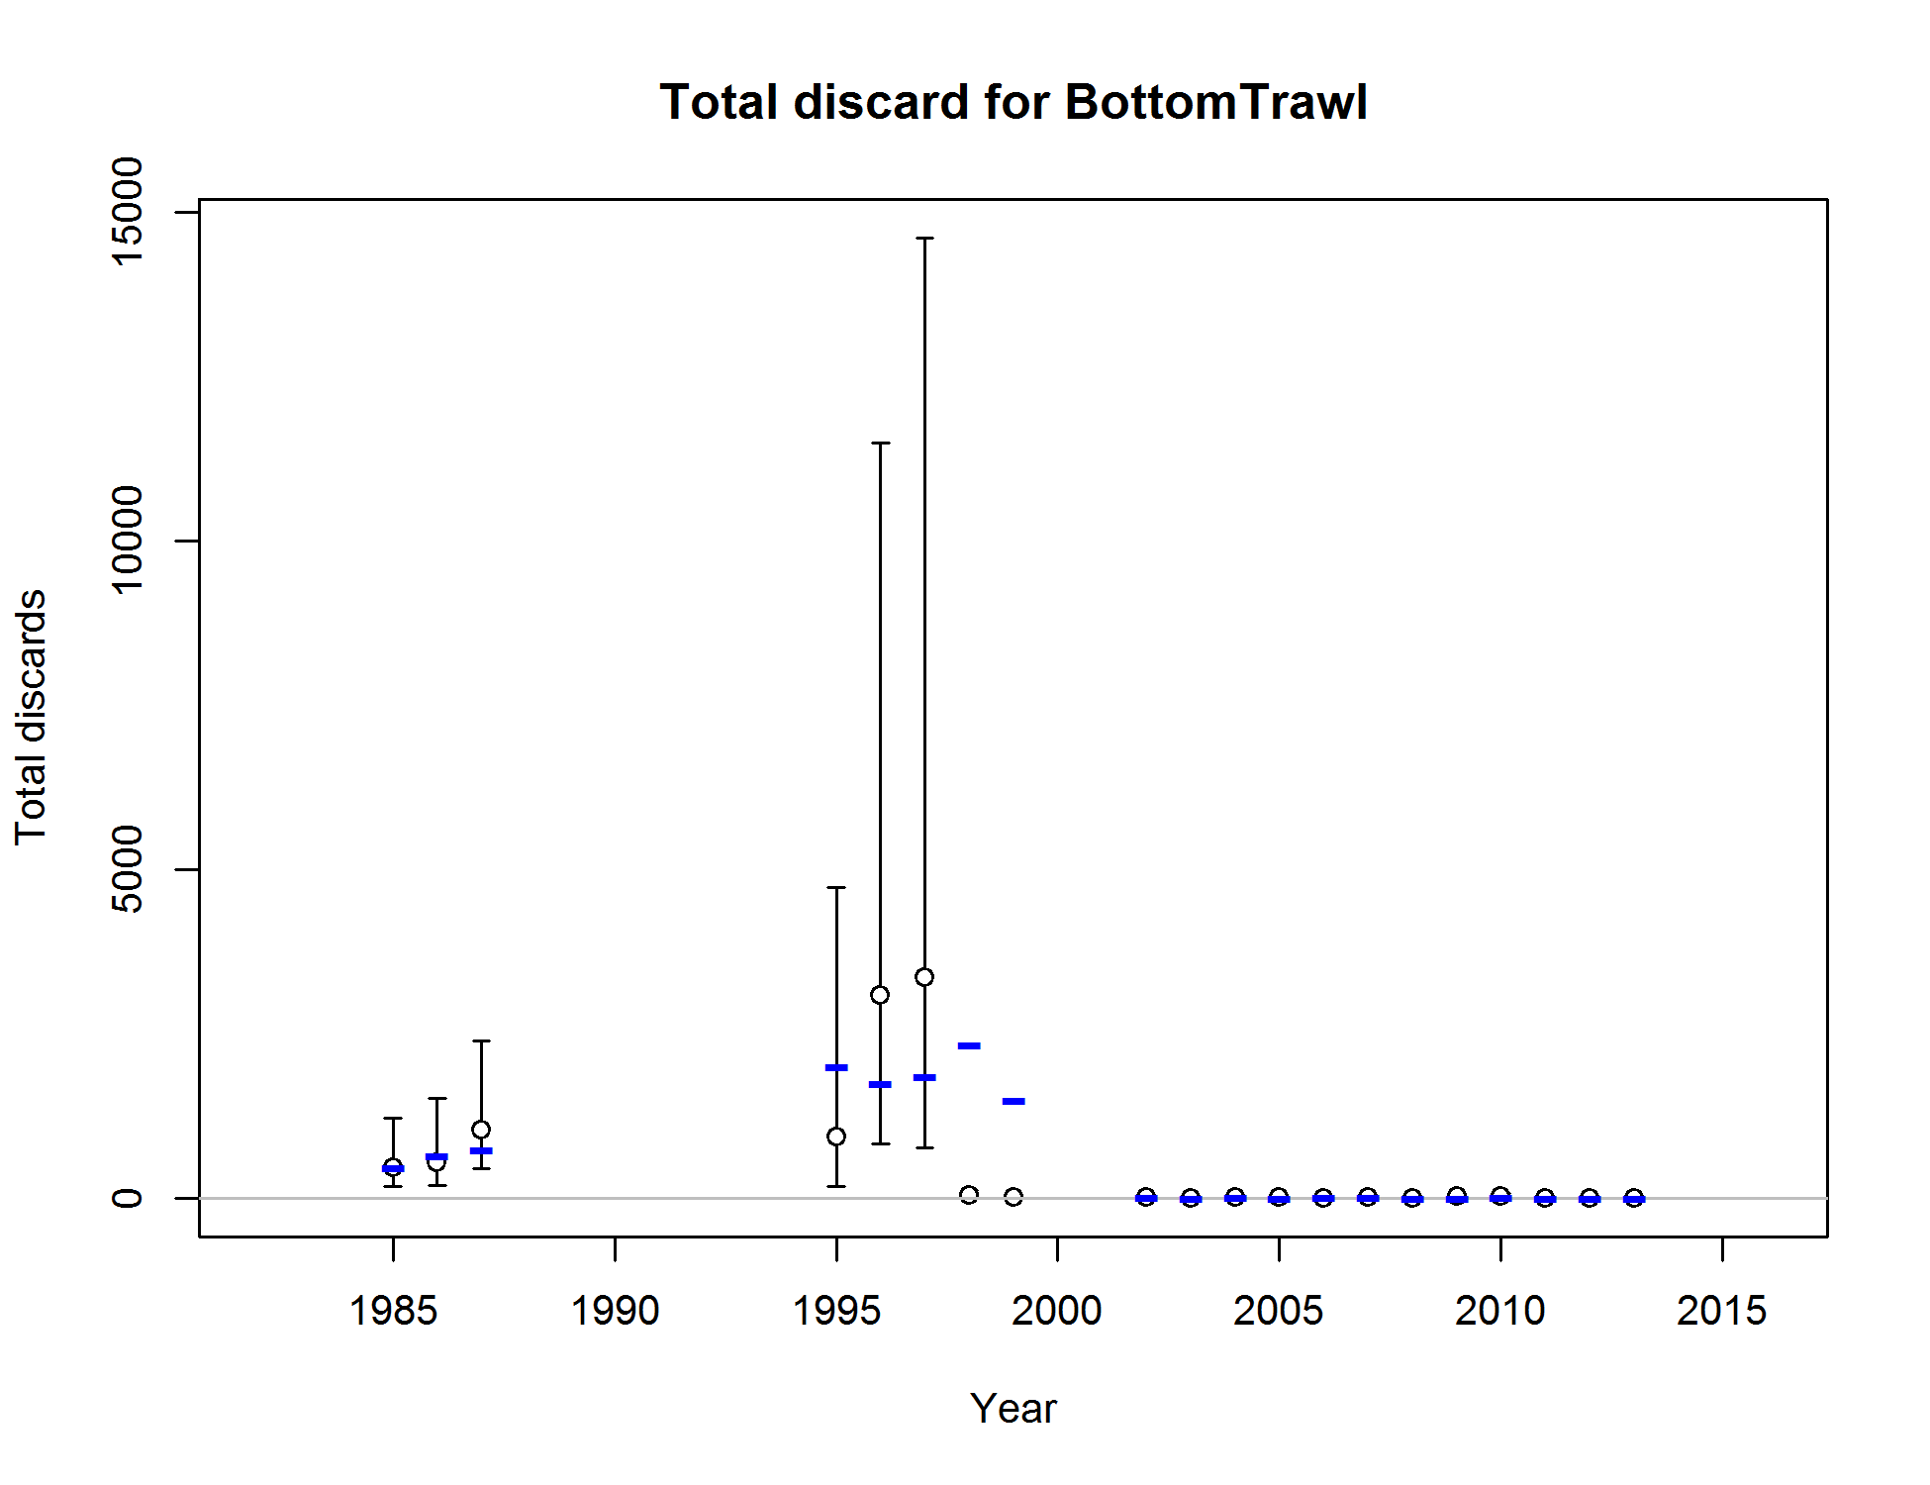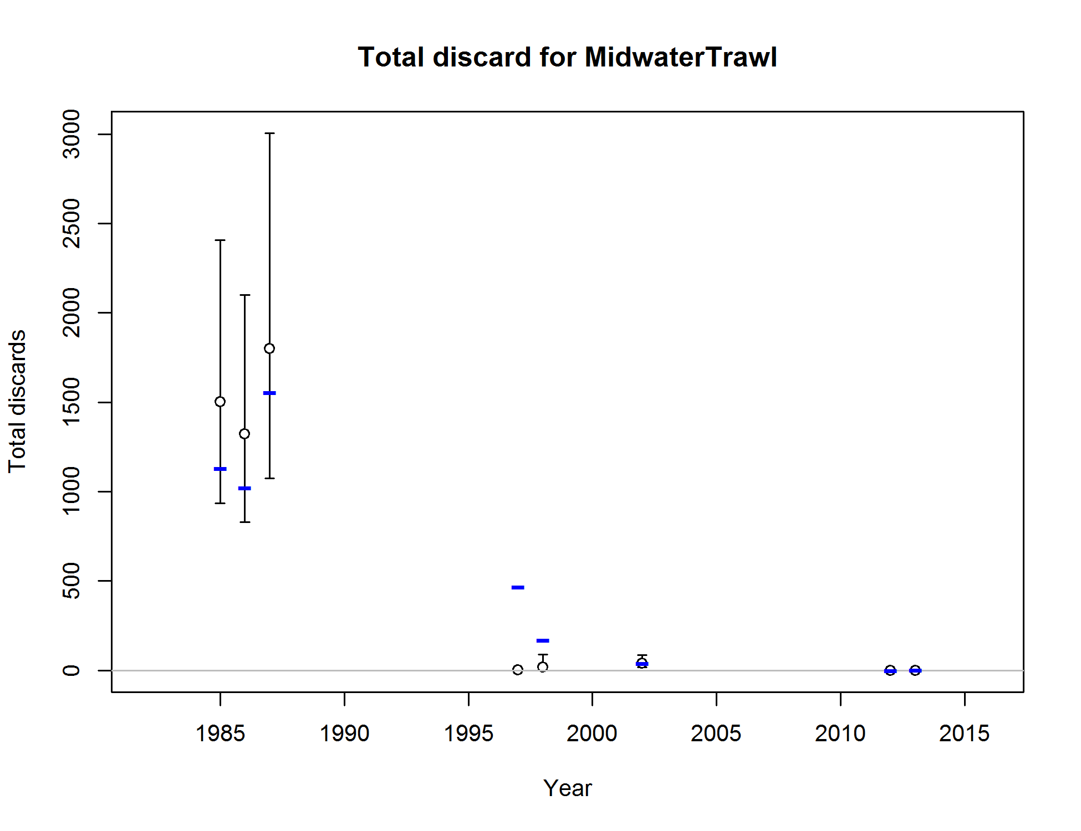

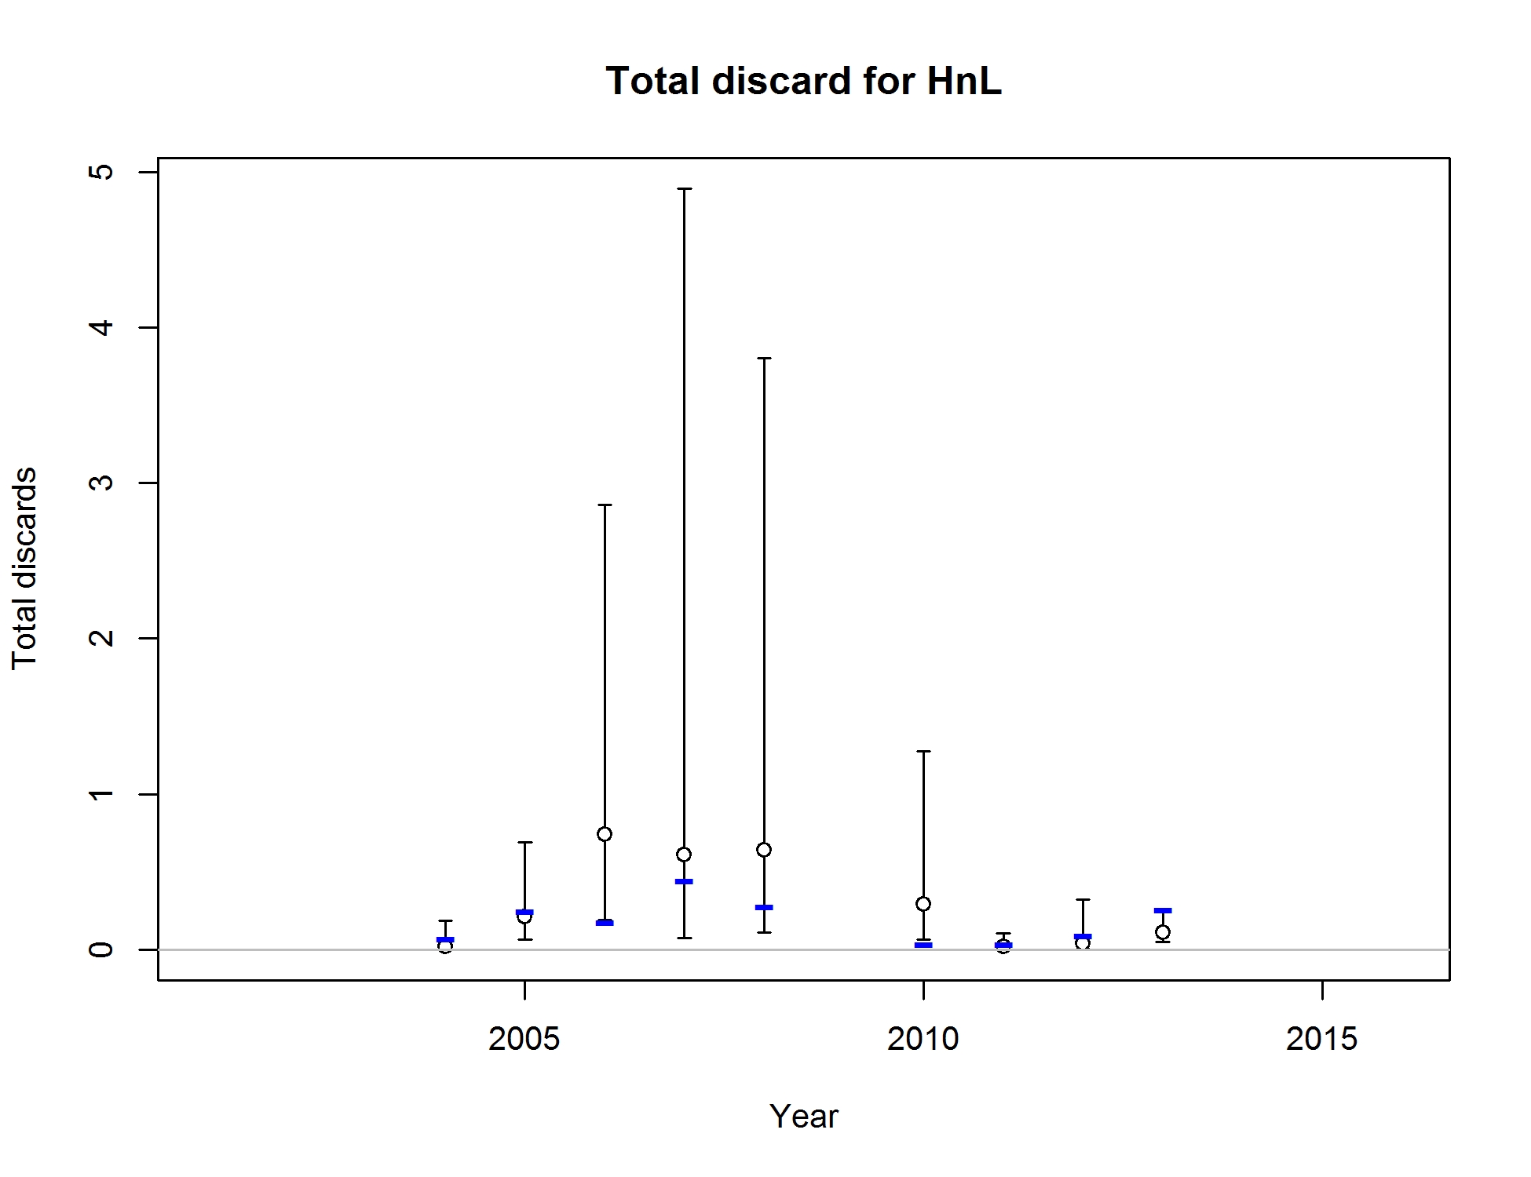

Figure : Predicted (blue line) and observed (open circles) discards for the bottom trawl (top left), midwater trawl (top right), and hook-and-line (bottom left) fleets from the base model. 95% confidence intervals are shown for the observations.

|  |  |  |
| --- | --- | --- |
|  | **Length** | **Age** |
| **Bottom Trawl** |  |  |
| **Midwater Trawl** |  |  |
| **Hake** |  |  |

Figure : Pearson residuals for fits to length frequency data (left) and age frequency data (right) for landings from the trawl commercial fleets (rows). Filled circles indicate that the fitted proportion was less than the observed proportion. Red indicates females, blue males, and gray unsexed.

|  |  |  |
| --- | --- | --- |
| **Net** |  |  |
| **Hook-and-line** |  |  |

Figure : Pearson residuals for fits to length frequency data (left) and age frequency data (right) for landings from the net and hook-and-line commercial fleets (rows). Filled circles indicate that the fitted proportion was less than the observed proportion. Red indicates females, blue males, and gray unsexed.

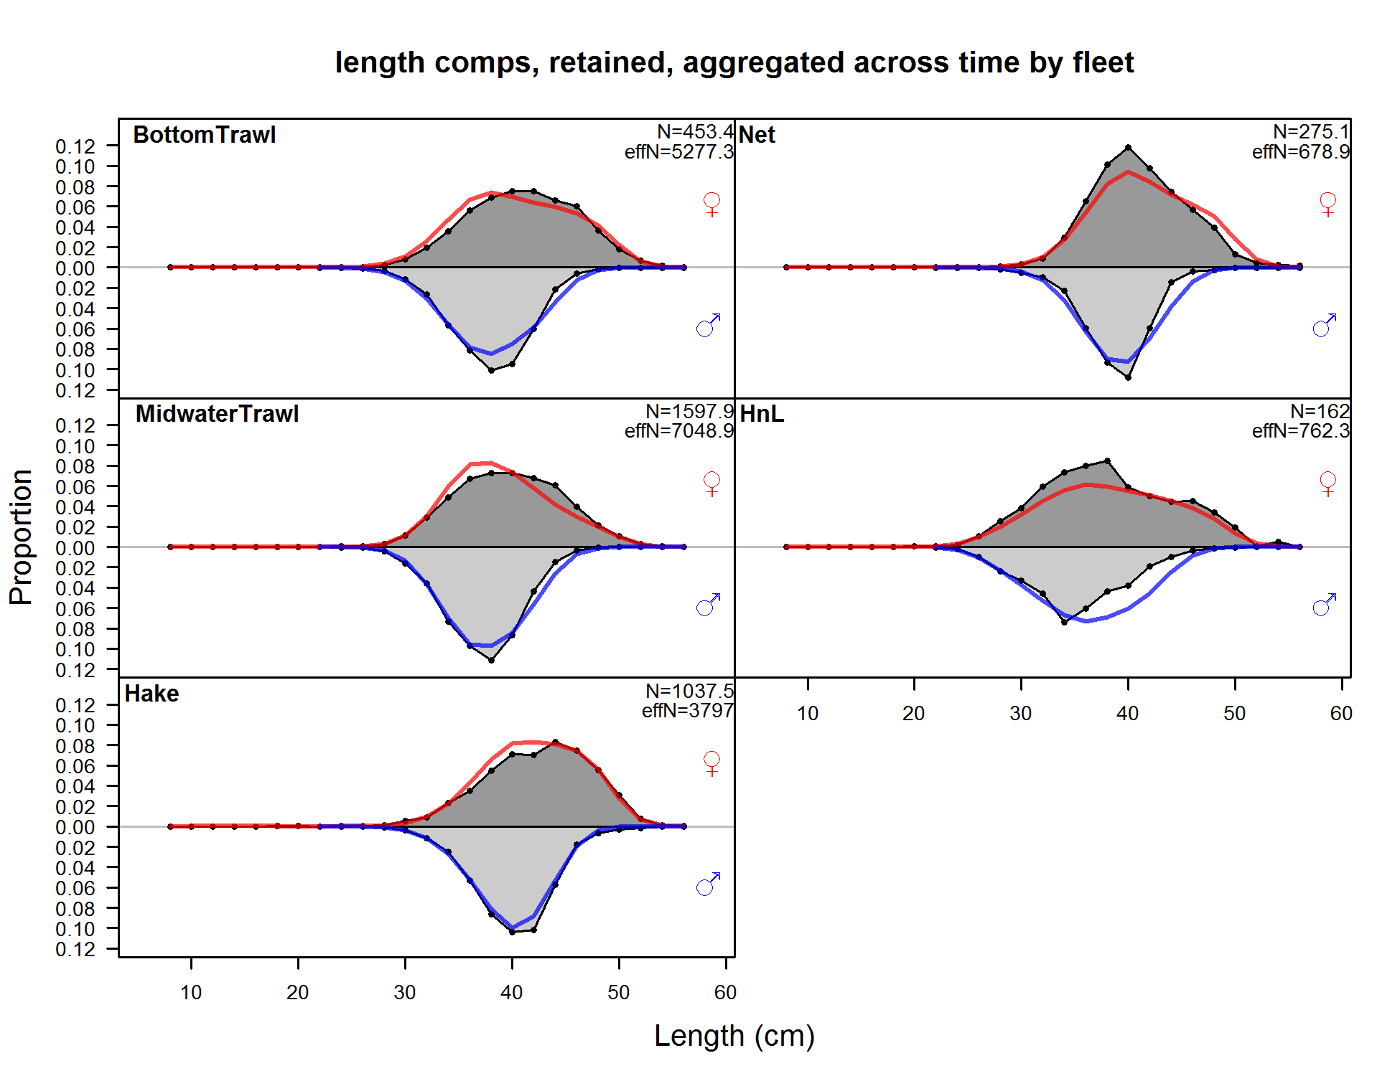

Figure : Combined length frequencies for all years from fishery length frequency data (points) for retained catch. Fits are shown by the red line (females) and blue line (males).

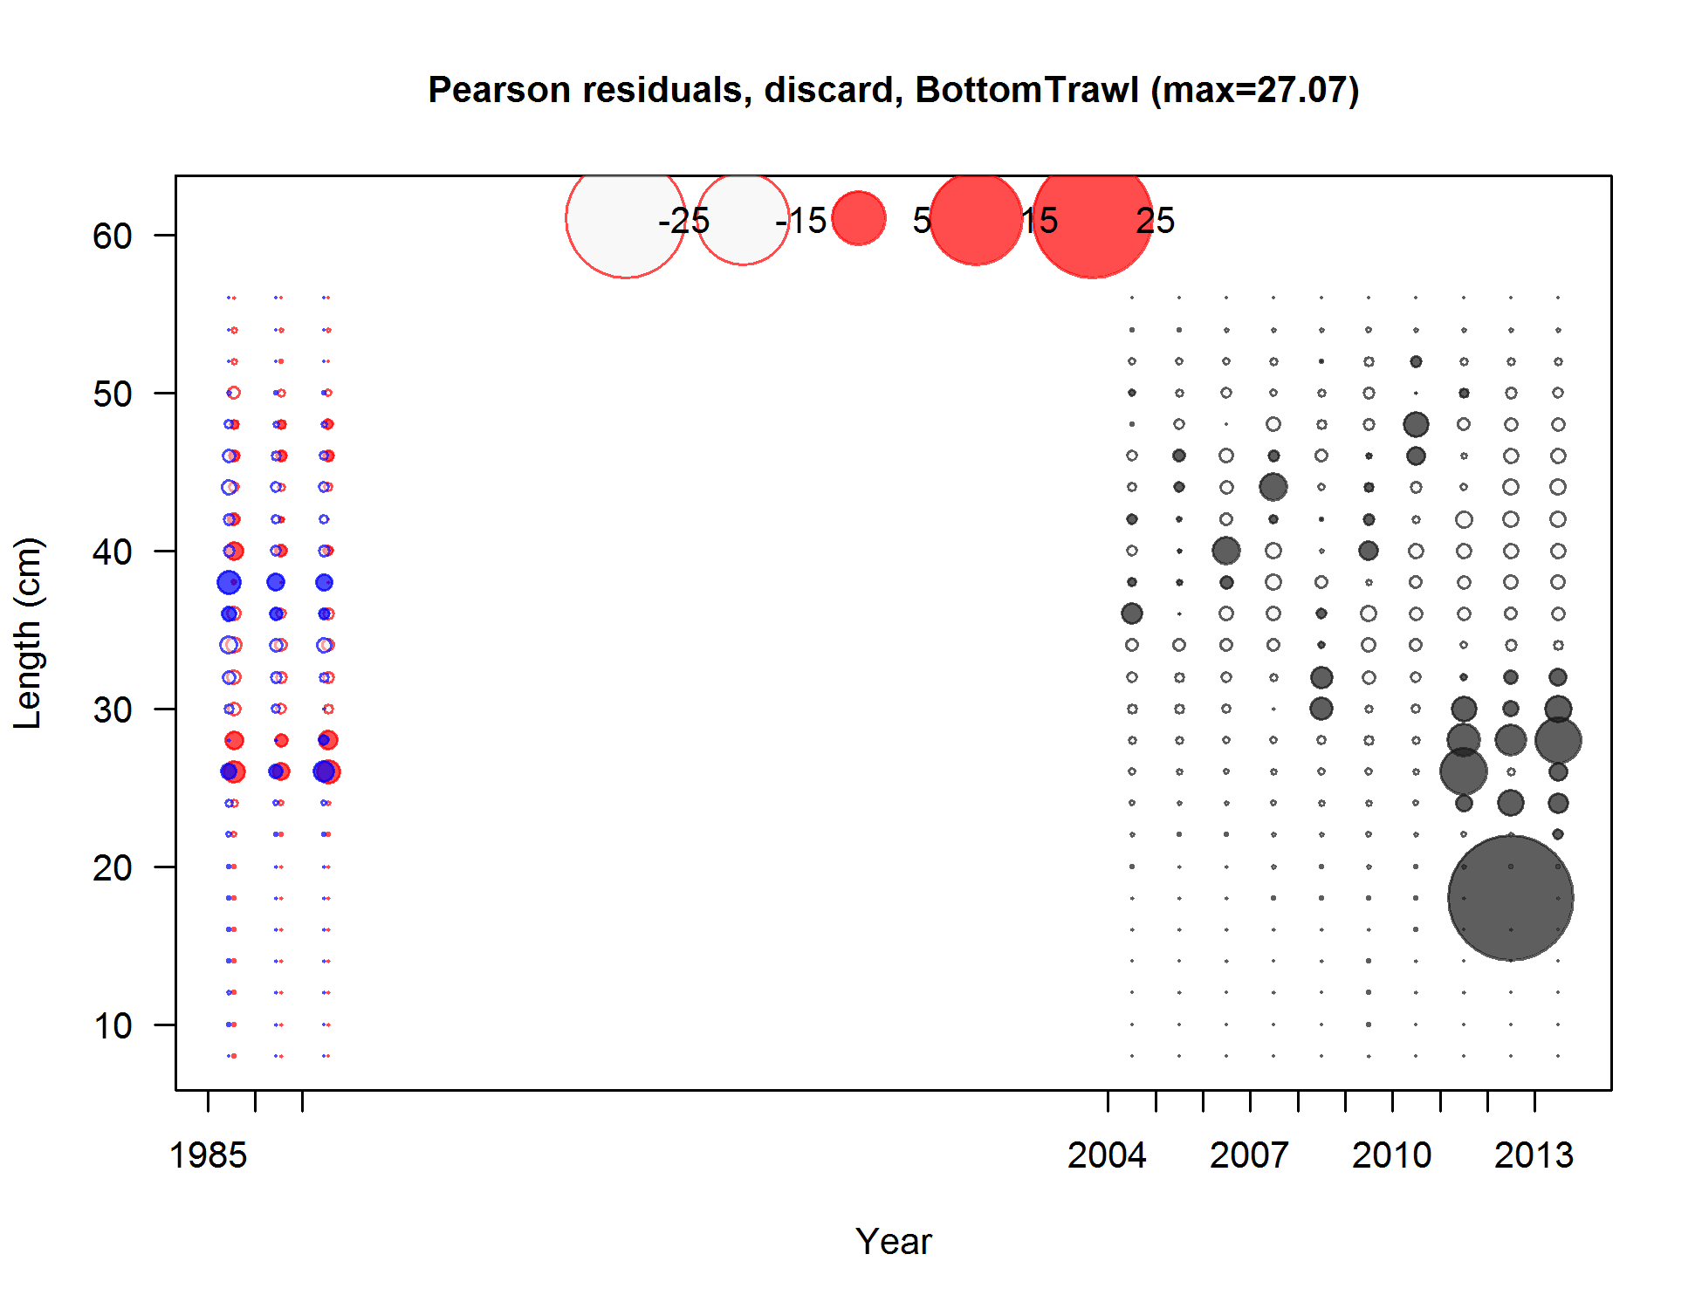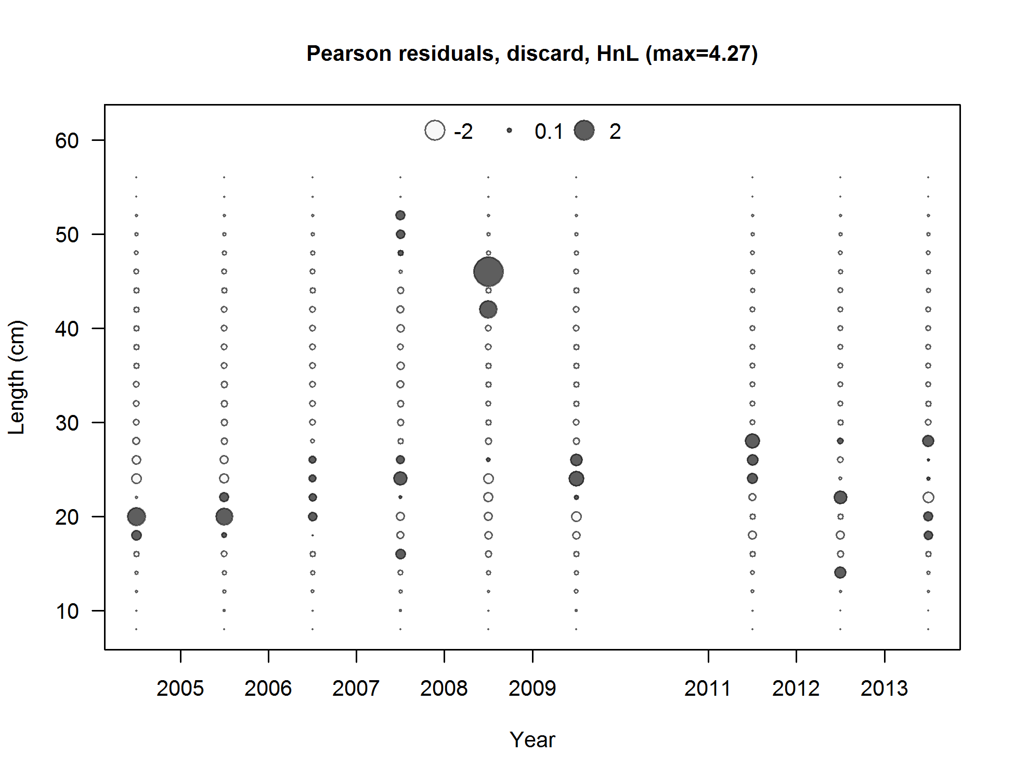

Figure : Pearson residuals for fits to the discard length frequencies from the bottom trawl (left) and hook-and-line (right) fleets. Filled circles indicate that the fitted proportion was less than the observed proportion. Red indicates females, blue males, and gray unsexed.

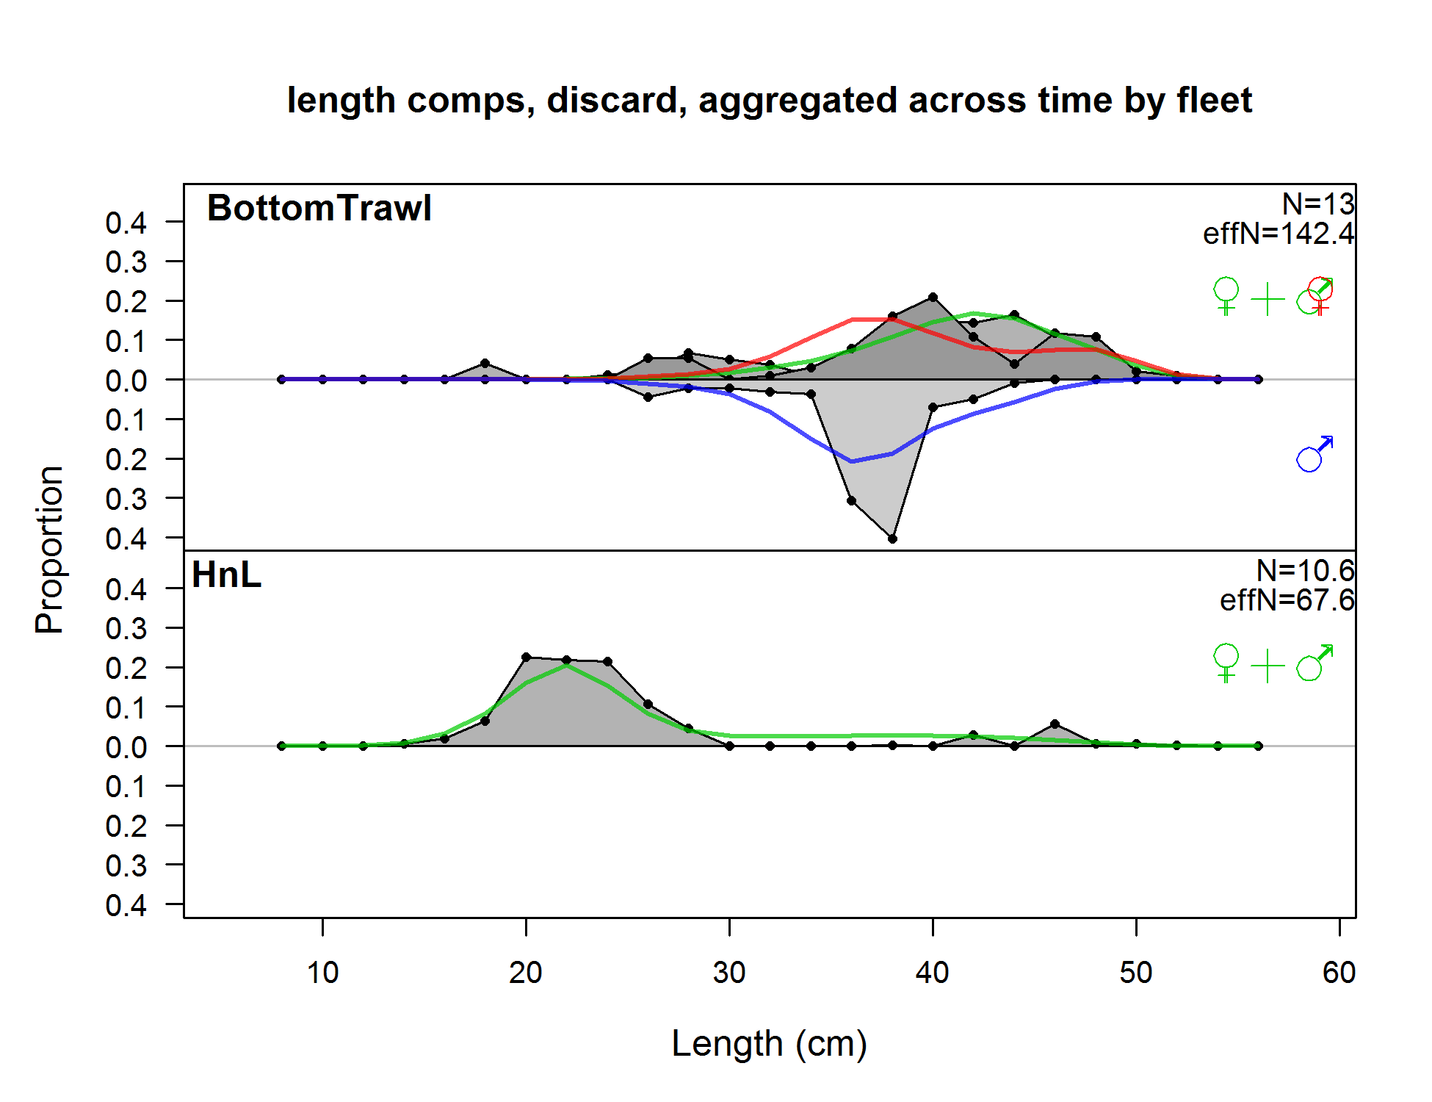

Figure : Combined length frequencies for all years from fishery discard length frequency data (points) with fits shown by the red line (females), the blue line (males), and the green line (unsexed).

|  |  |
| --- | --- |
| **Triennial** | **NWFSC shelf/slope** |
|  |  |

Figure : Pearson residuals for fits to the triennial survey length frequency data (left) and NWFSC shelf/slope survey length frequency data (right). Filled circles indicate that the fitted proportion was less than the observed proportion. Red indicates females, blue males, and gray unsexed.

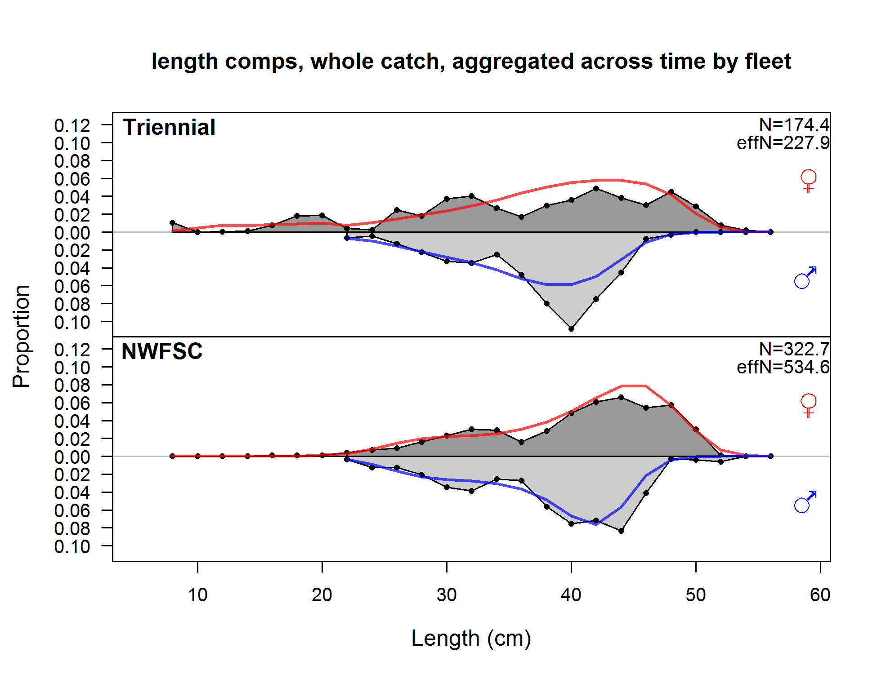

Figure : Combined length frequencies for all years from survey length frequency data (points) with fits shown by the red line (females) and the blue line (males).

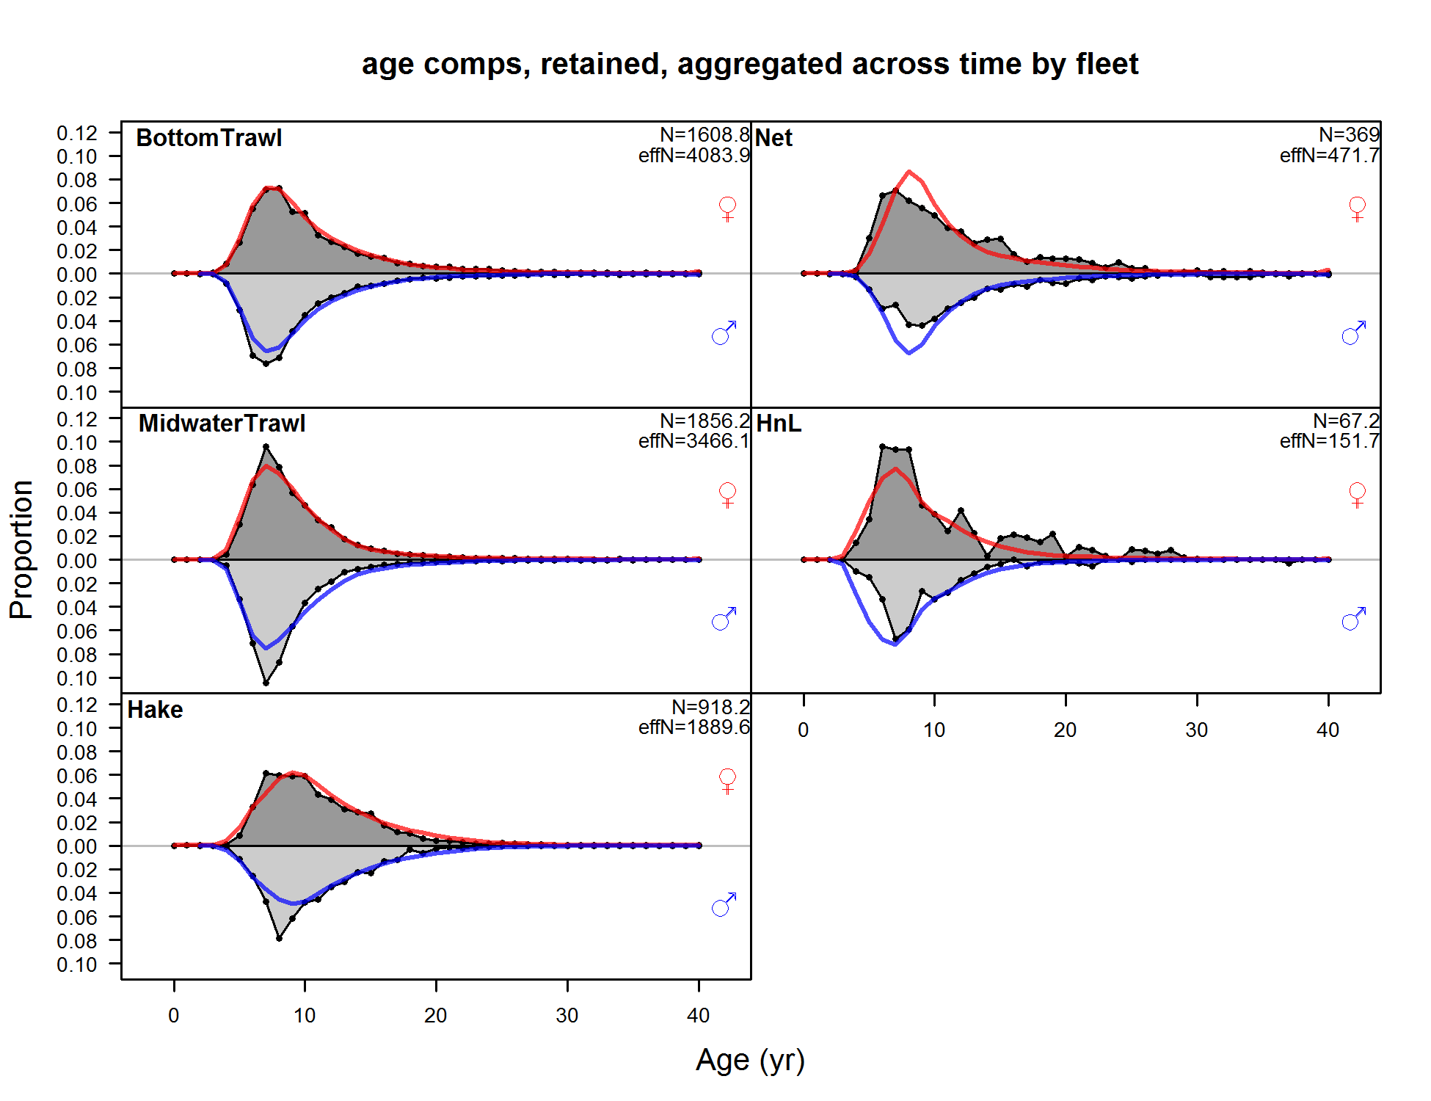

Figure : Combined age frequencies for all years from fishery age frequency data (points) for retained catch. Fits are shown by the red line (females) and blue line (males).

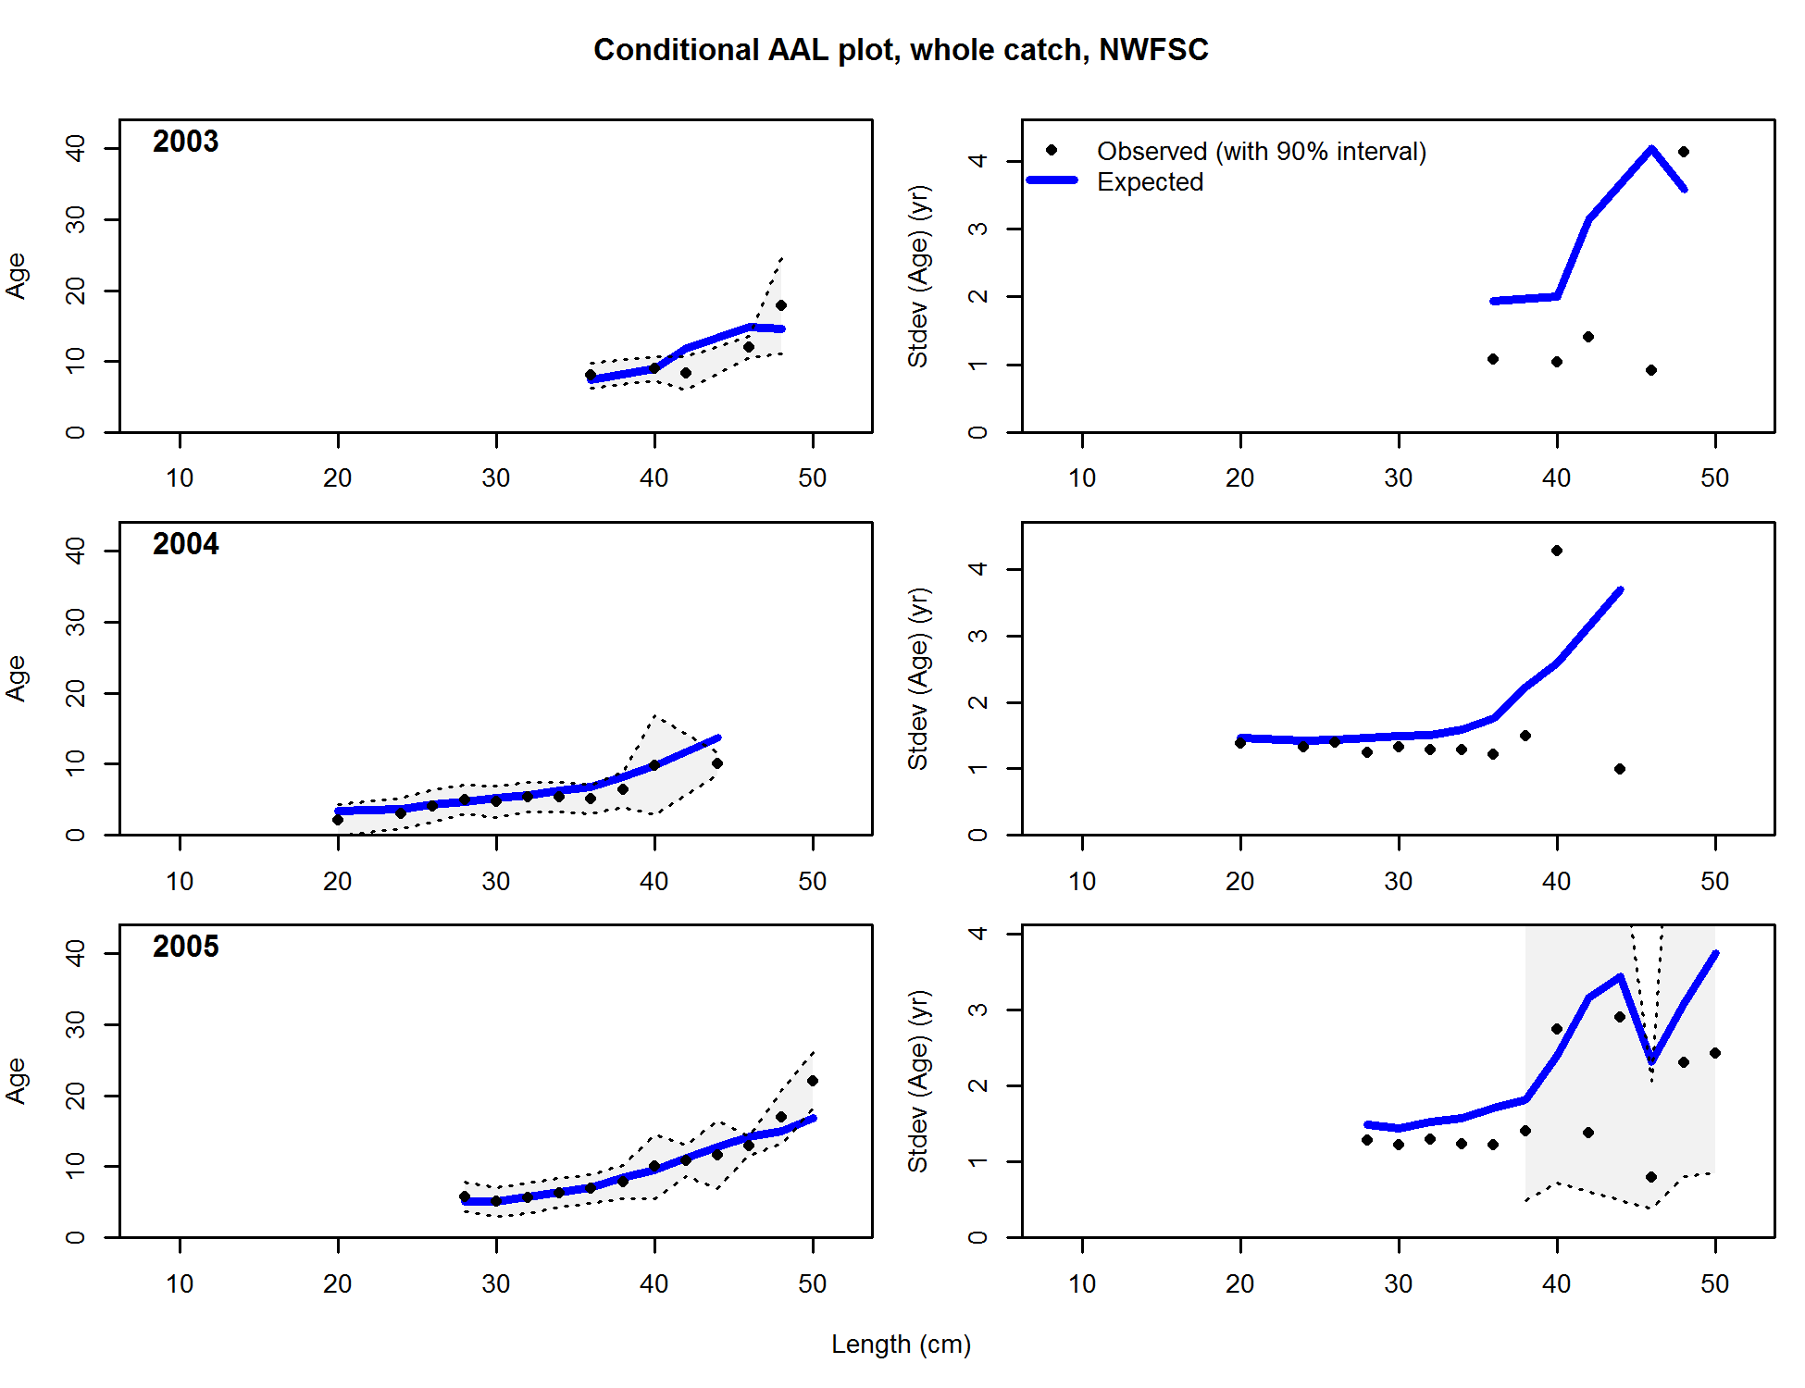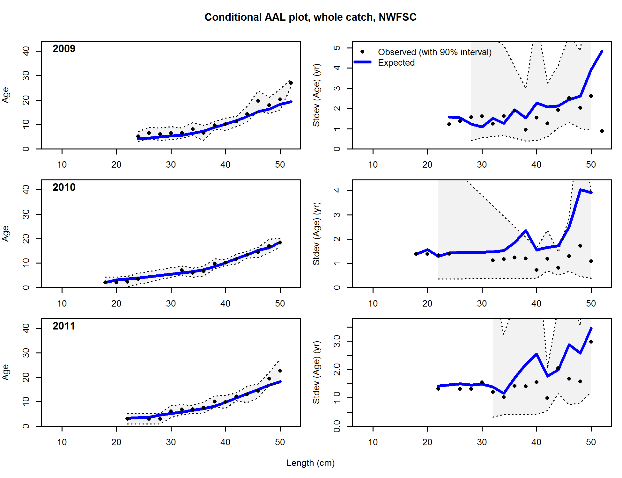

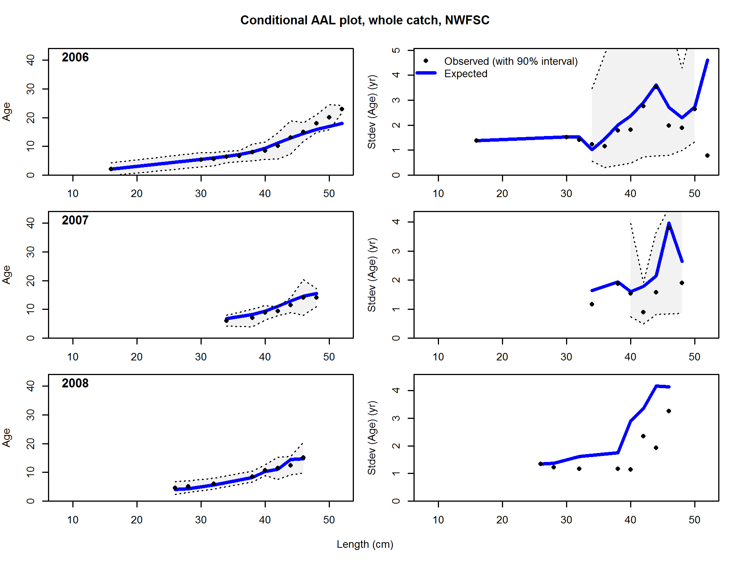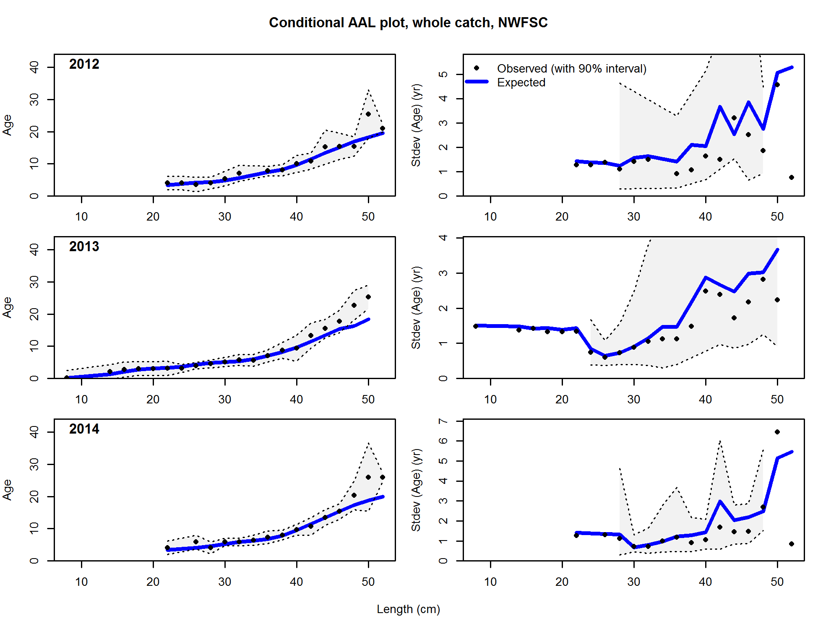

Figure : Observed and expected age-at-length with 95% confidence intervals (left) and observed and expected standard deviation of age-at-length with 95% confidence intervals (right) for the NWFSC shelf/slope survey data.

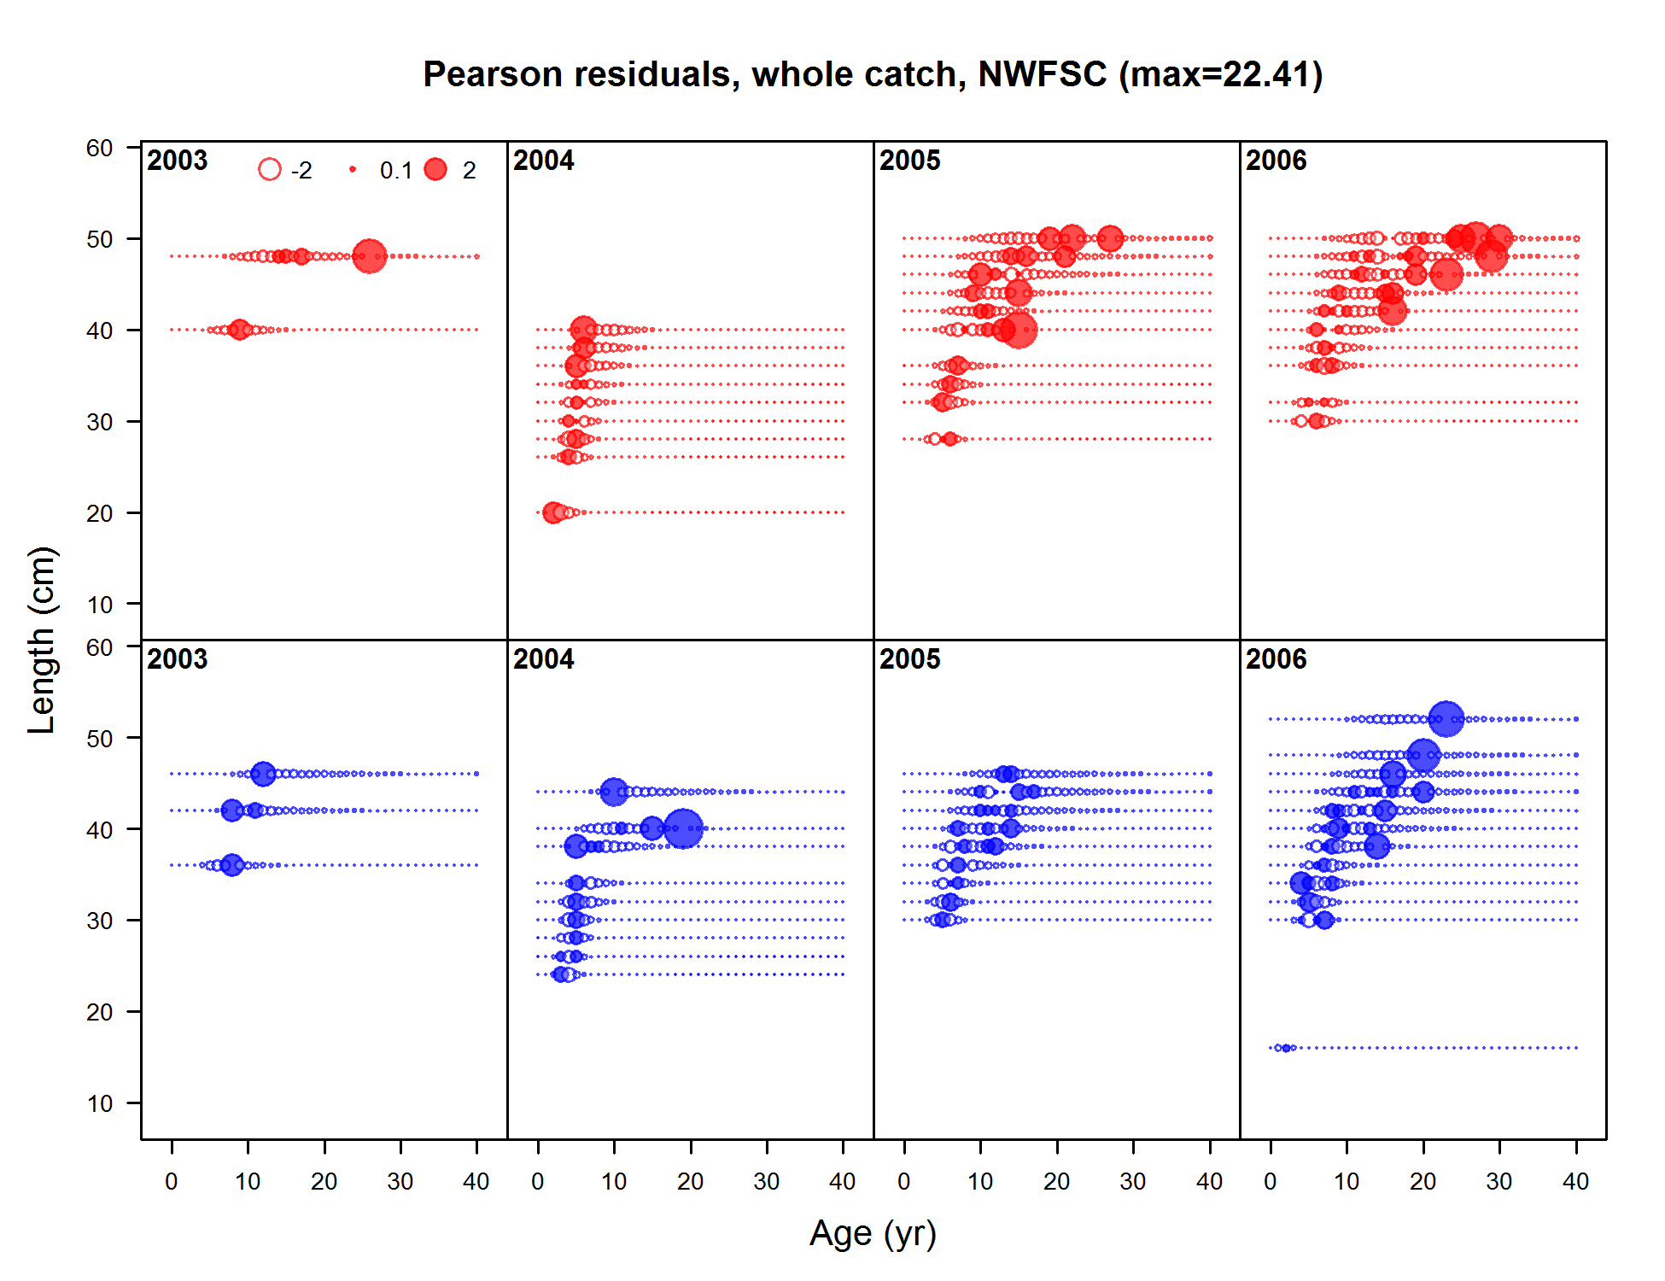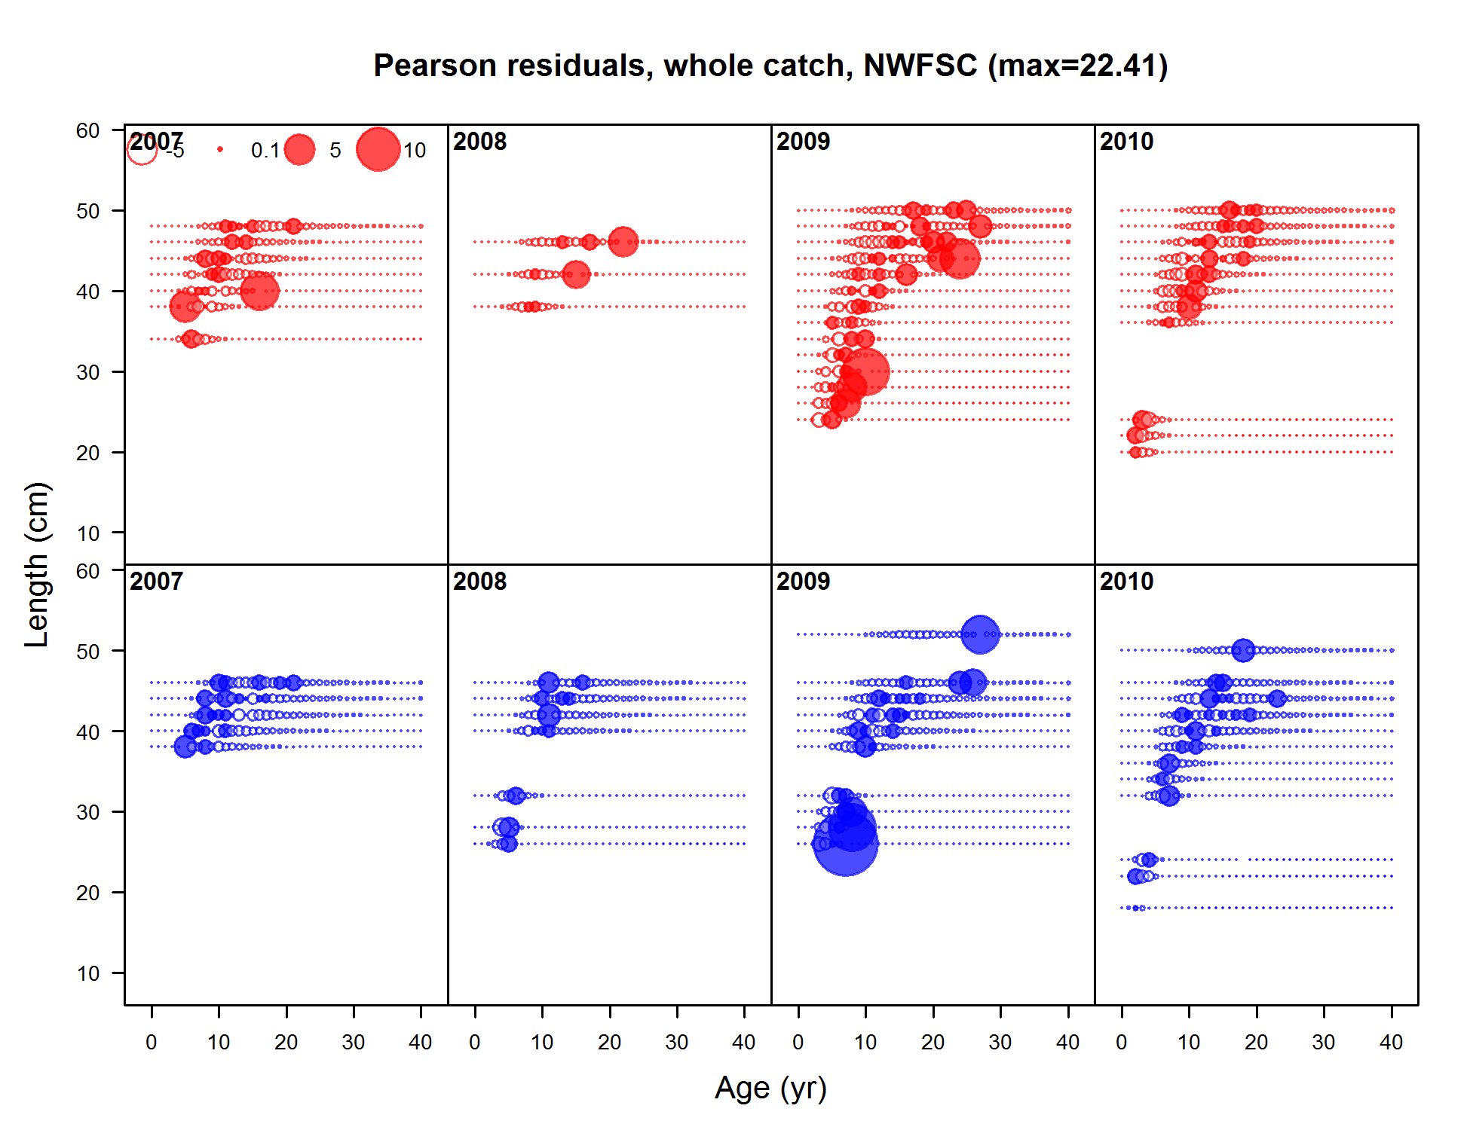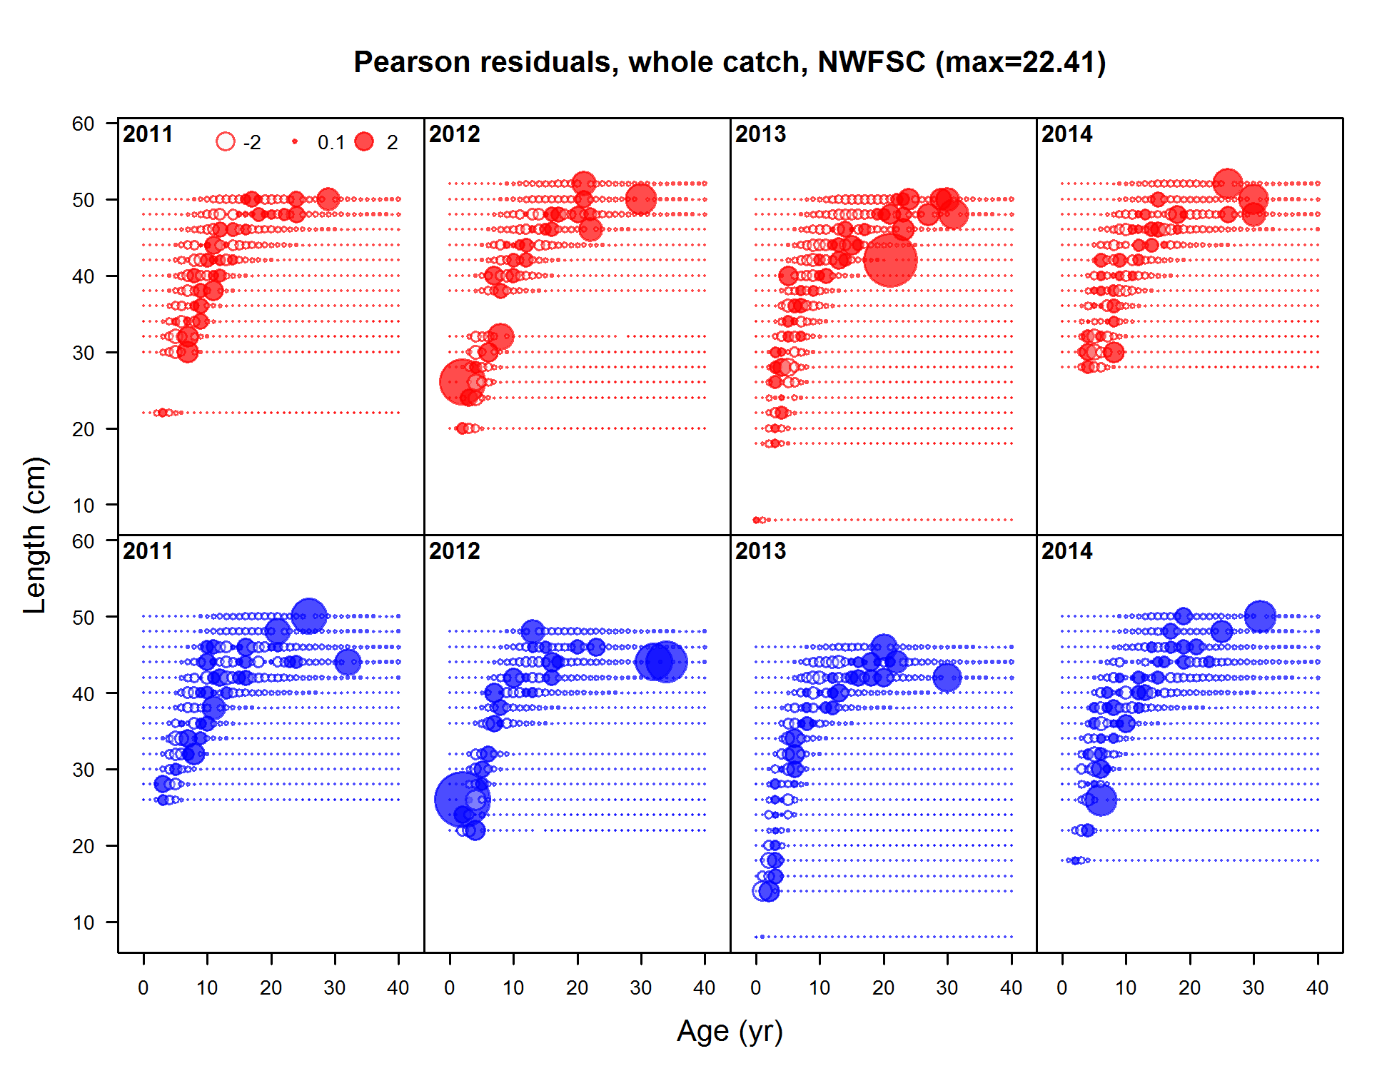

Figure : Pearson residuals for fits to age-at-length data for the NWFSC shelf/slope survey. Filled circles indicate that the fitted proportion was less than the observed proportion.



Figure : Predicted spawning biomass (thousand mt) for Widow Rockfish using the base assessment. The solid line is the MLE estimate and the shaded area depicts the approximate asymptotic 95% confidence intervals.

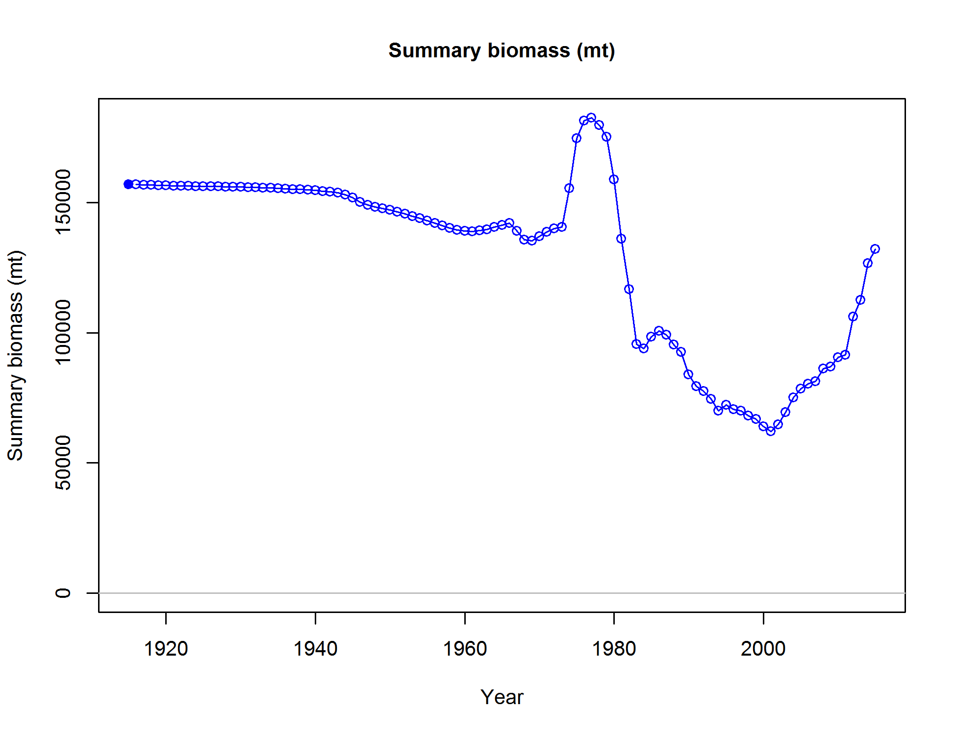

Figure : Predicted summary biomass (age 4+) from the base model.



Figure : Predicted relative spawning biomass from the Widow Rockfish base case assessment. The solid line is the MLE estimate and the shaded area depicts the approximate asymptotic 95% confidence intervals. The dashed lines show the equilibrium level (100%), the management target of 40% of unfished biomass, and the minimum stock size threshold of 25% of unfished biomass.

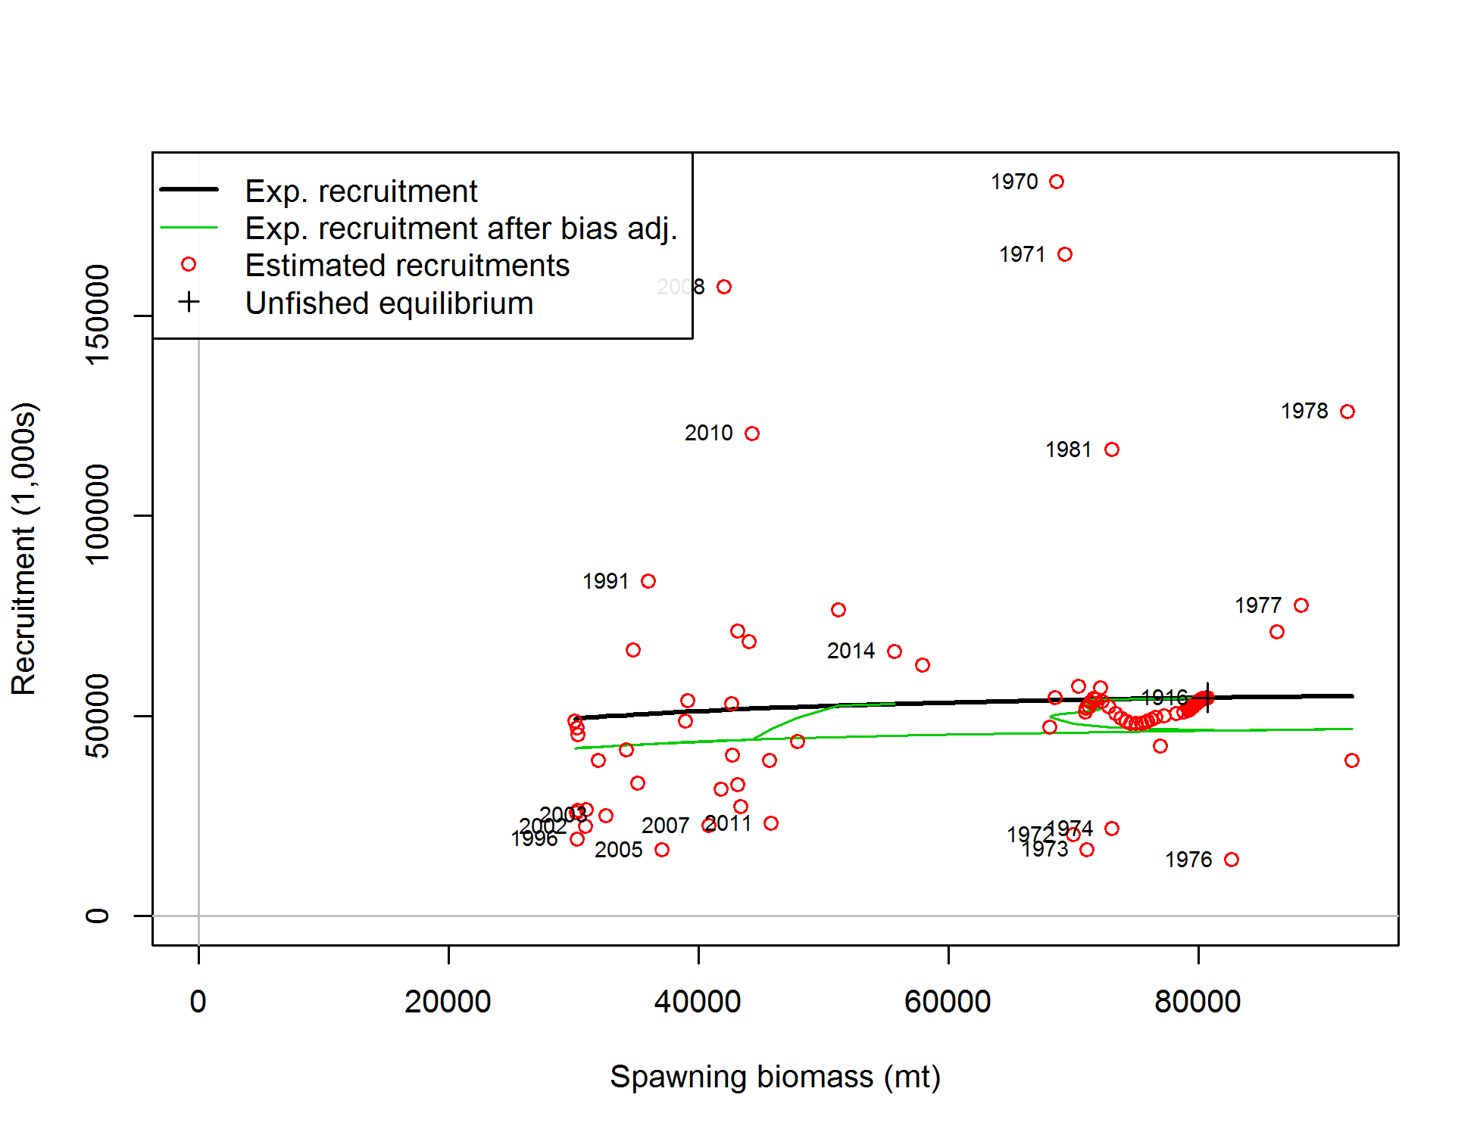

Figure : Estimated recruitment (red circles) and the assumed stock-recruit relationship (black line). The green line shows the effect of the bias correction for the lognormal distribution.

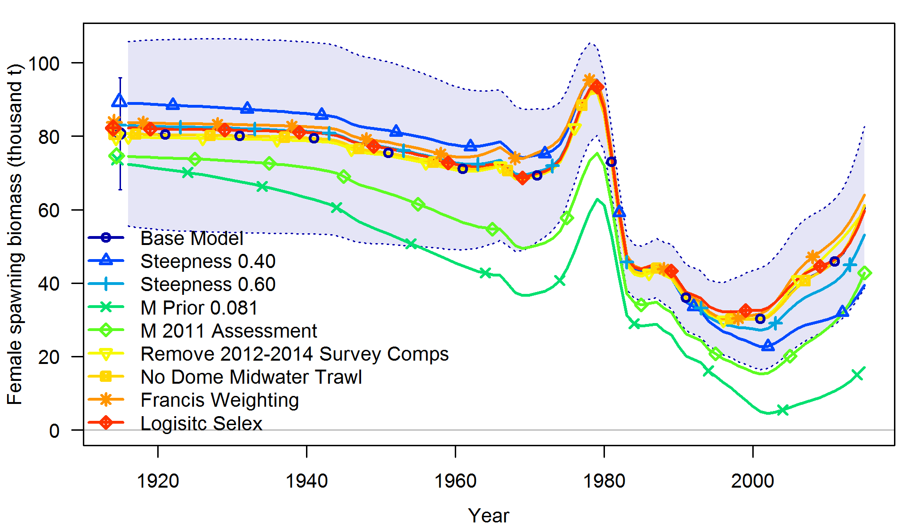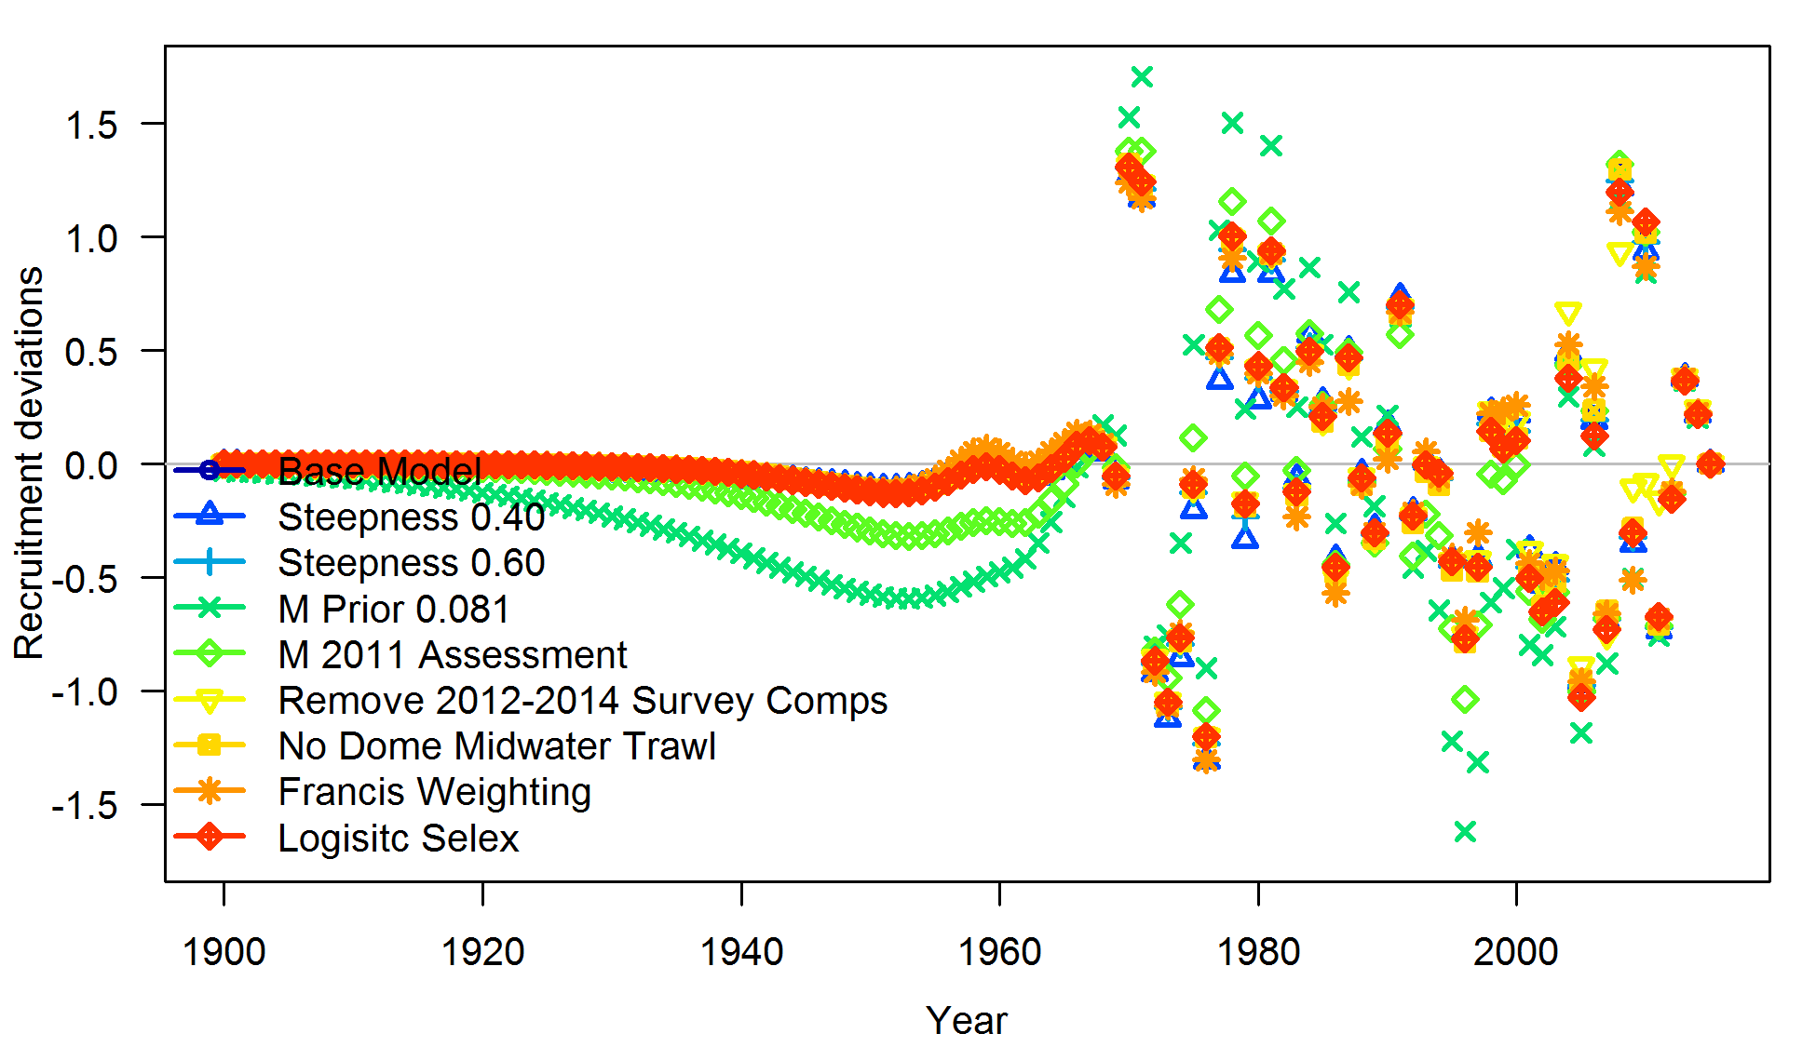

Figure : Spawning biomass (with 95% confidence interval around the base model) and recruitment deviations for the base model and sensitivity runs.

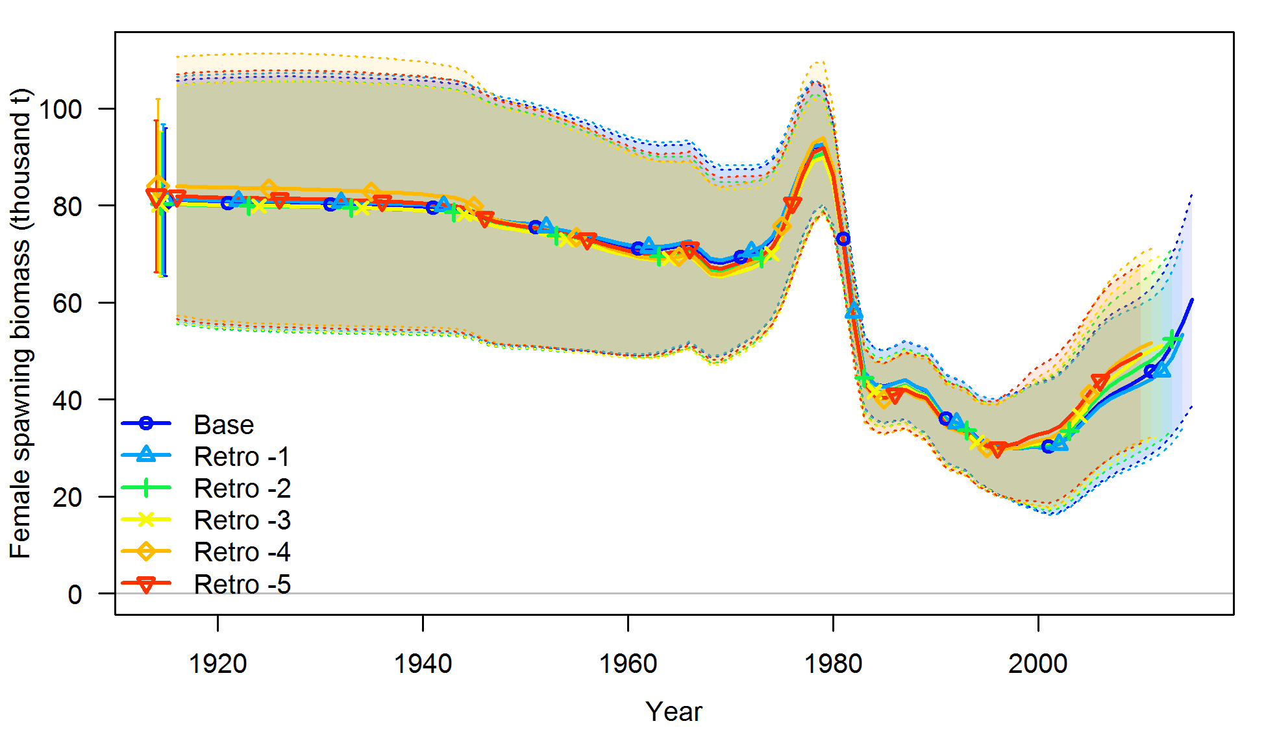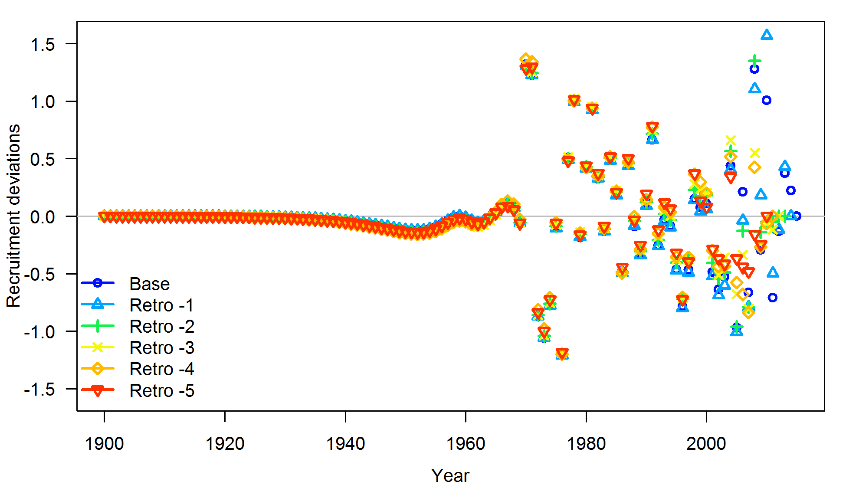

Figure : Five-year retrospective estimates of spawning biomass (top) and recruitment deviations (bottom).



Figure : Predicted spawning biomass (2011 and 2015) or spawning output (2000-2009) from past assessments.

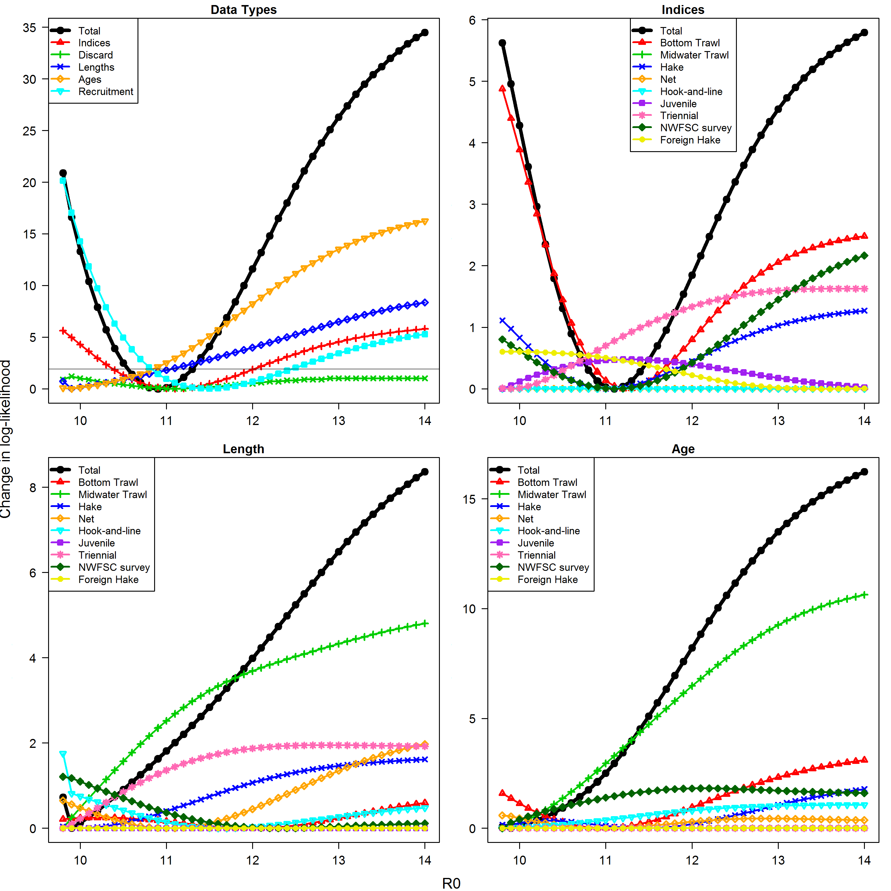

Figure : Likelihood components in the likelihood profile for unfished equilibrium recruitment (*R0*).

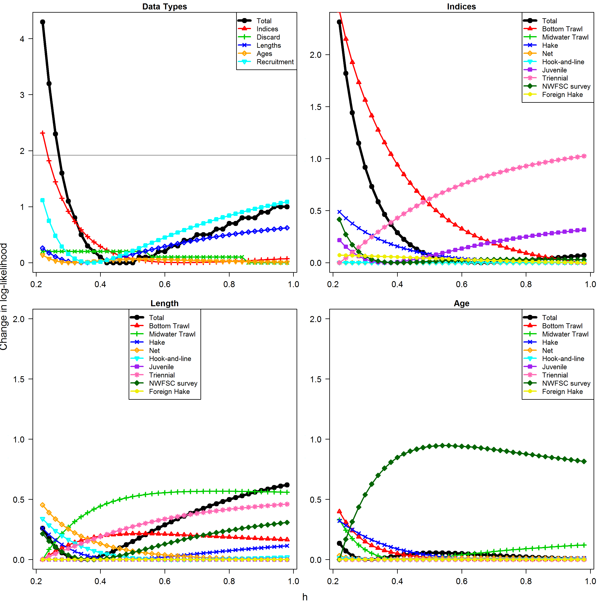

Figure : Likelihood components in the likelihood profile for steepness (*h*).

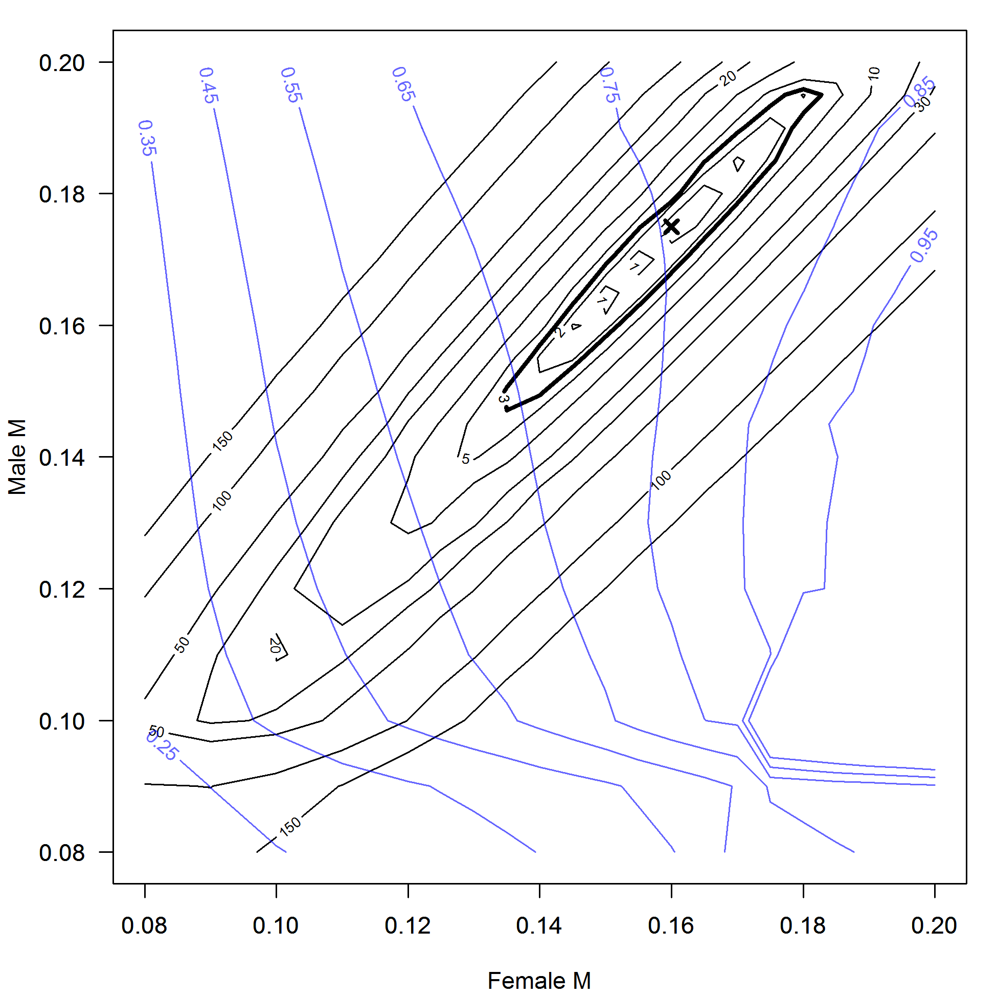

Figure : Likelihood profile (black contour lines) for female and male natural mortality (*M,* yr-1). The dark black line is at a value of 3, which is approximately the level of 95% significance. The blue contour lines show the relative spawning biomass in 2015 at different combinations of male and female natural mortality.

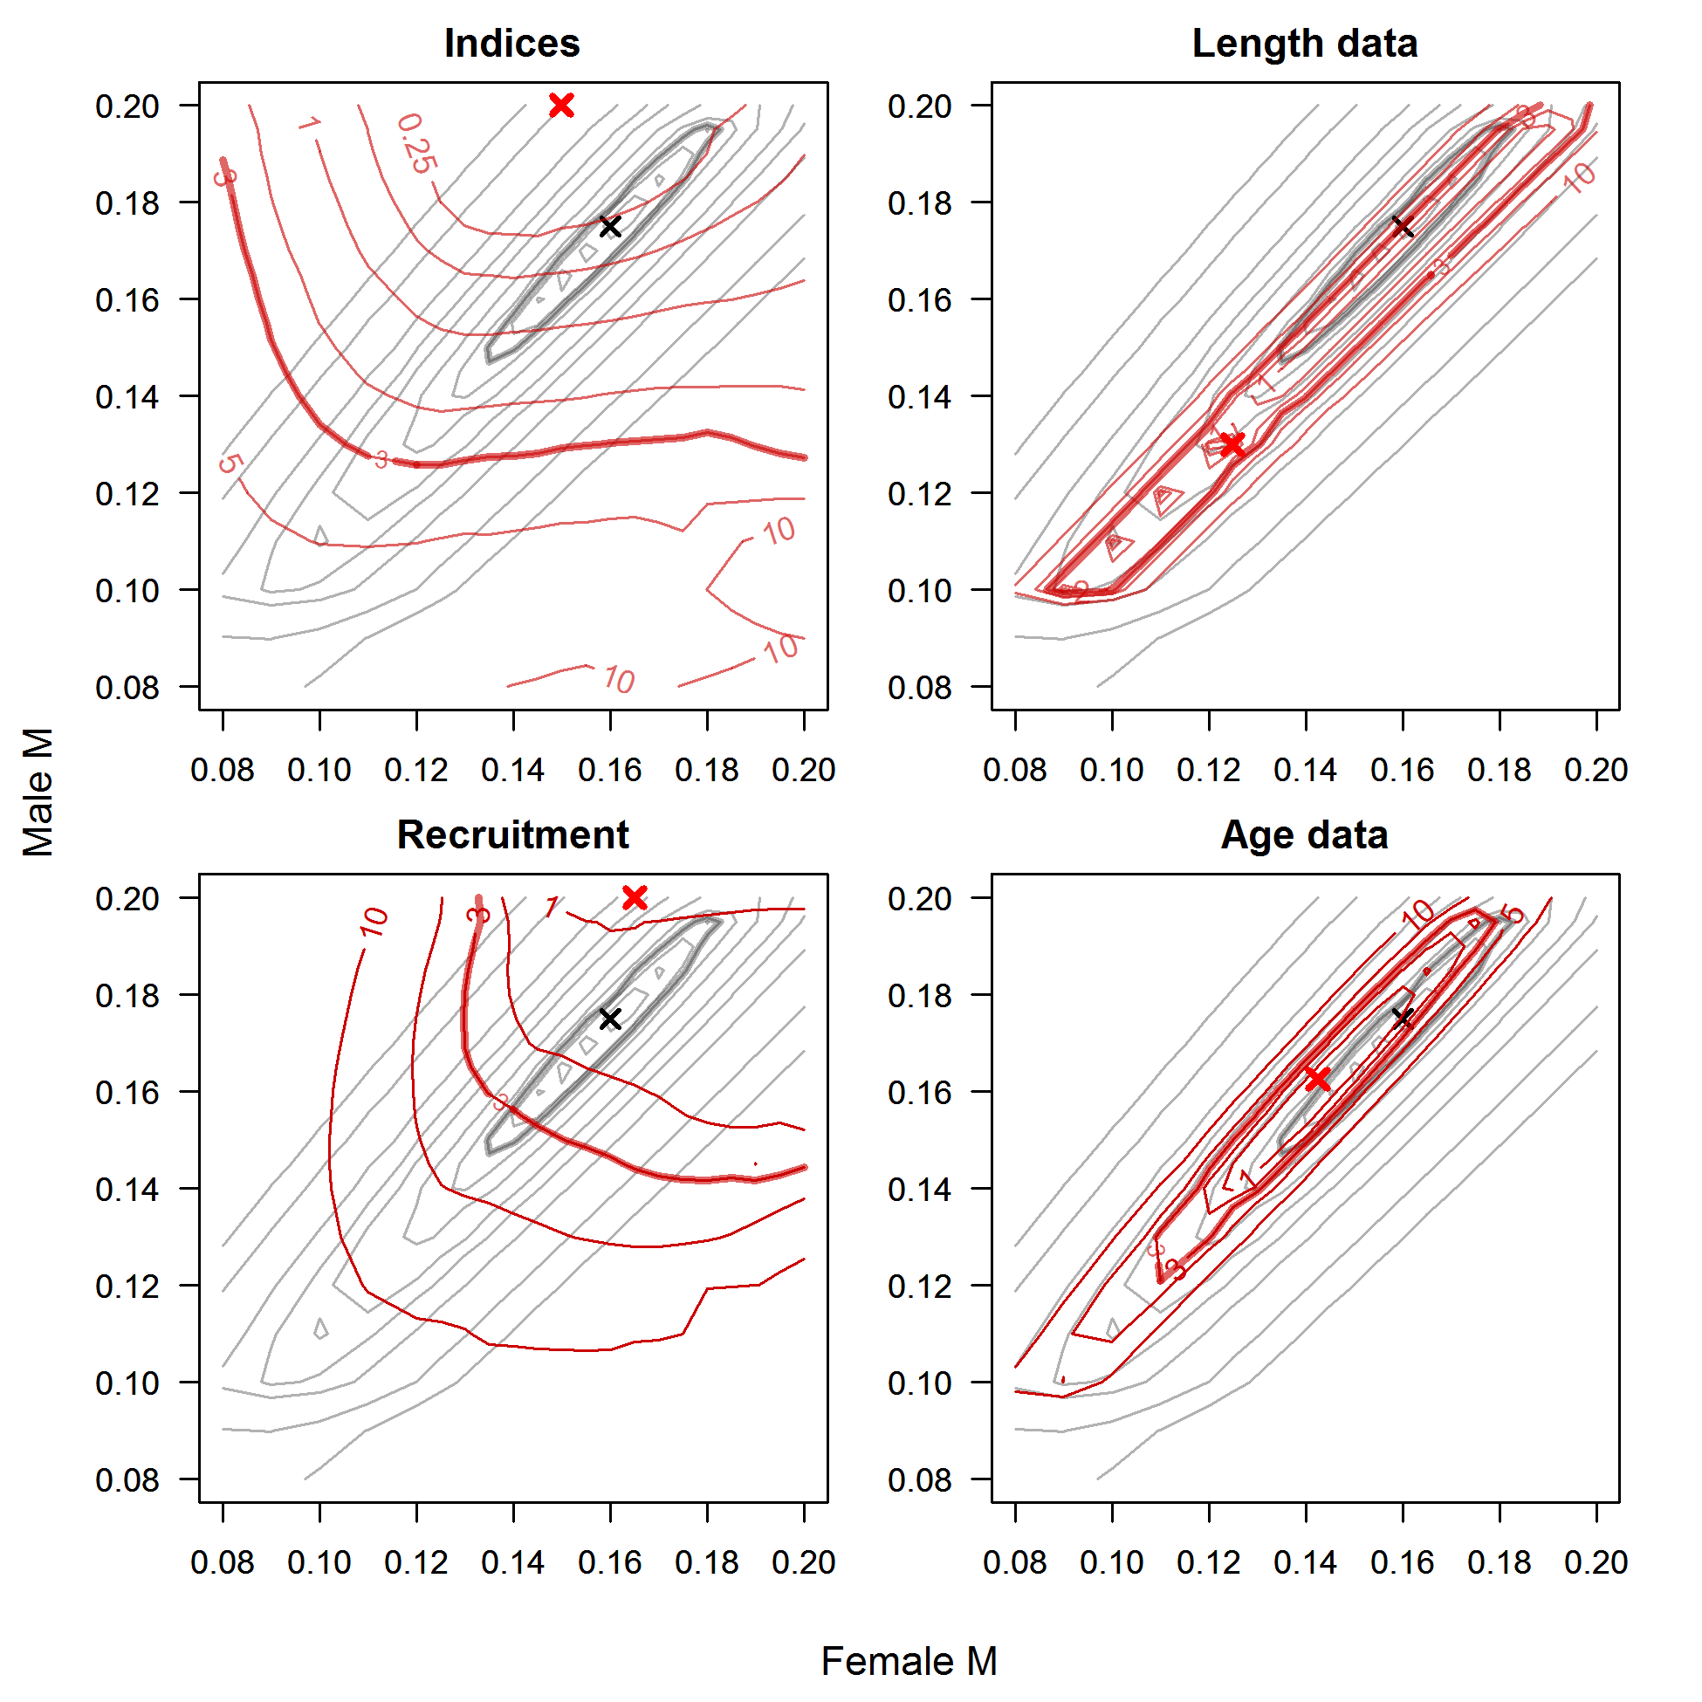

Figure : Likelihood components (red contour lines) in the bivariate likelihood profile for female and male natural mortality (*M,* yr-1). Black contour lines show the total likelihood for comparison. Dark contours are at a value of 3 which is approximately the level of 95% significance.

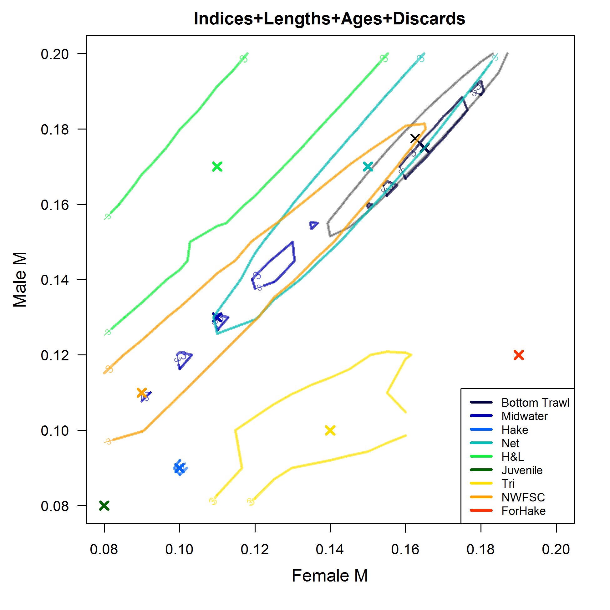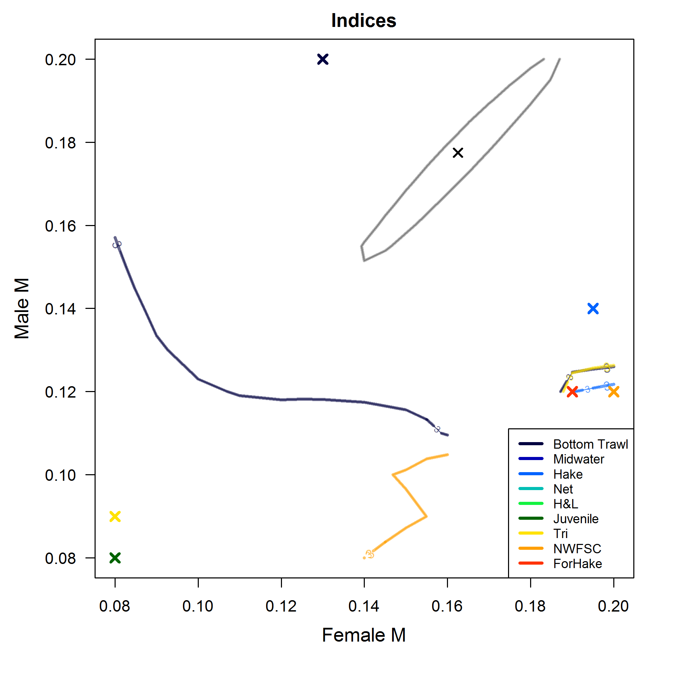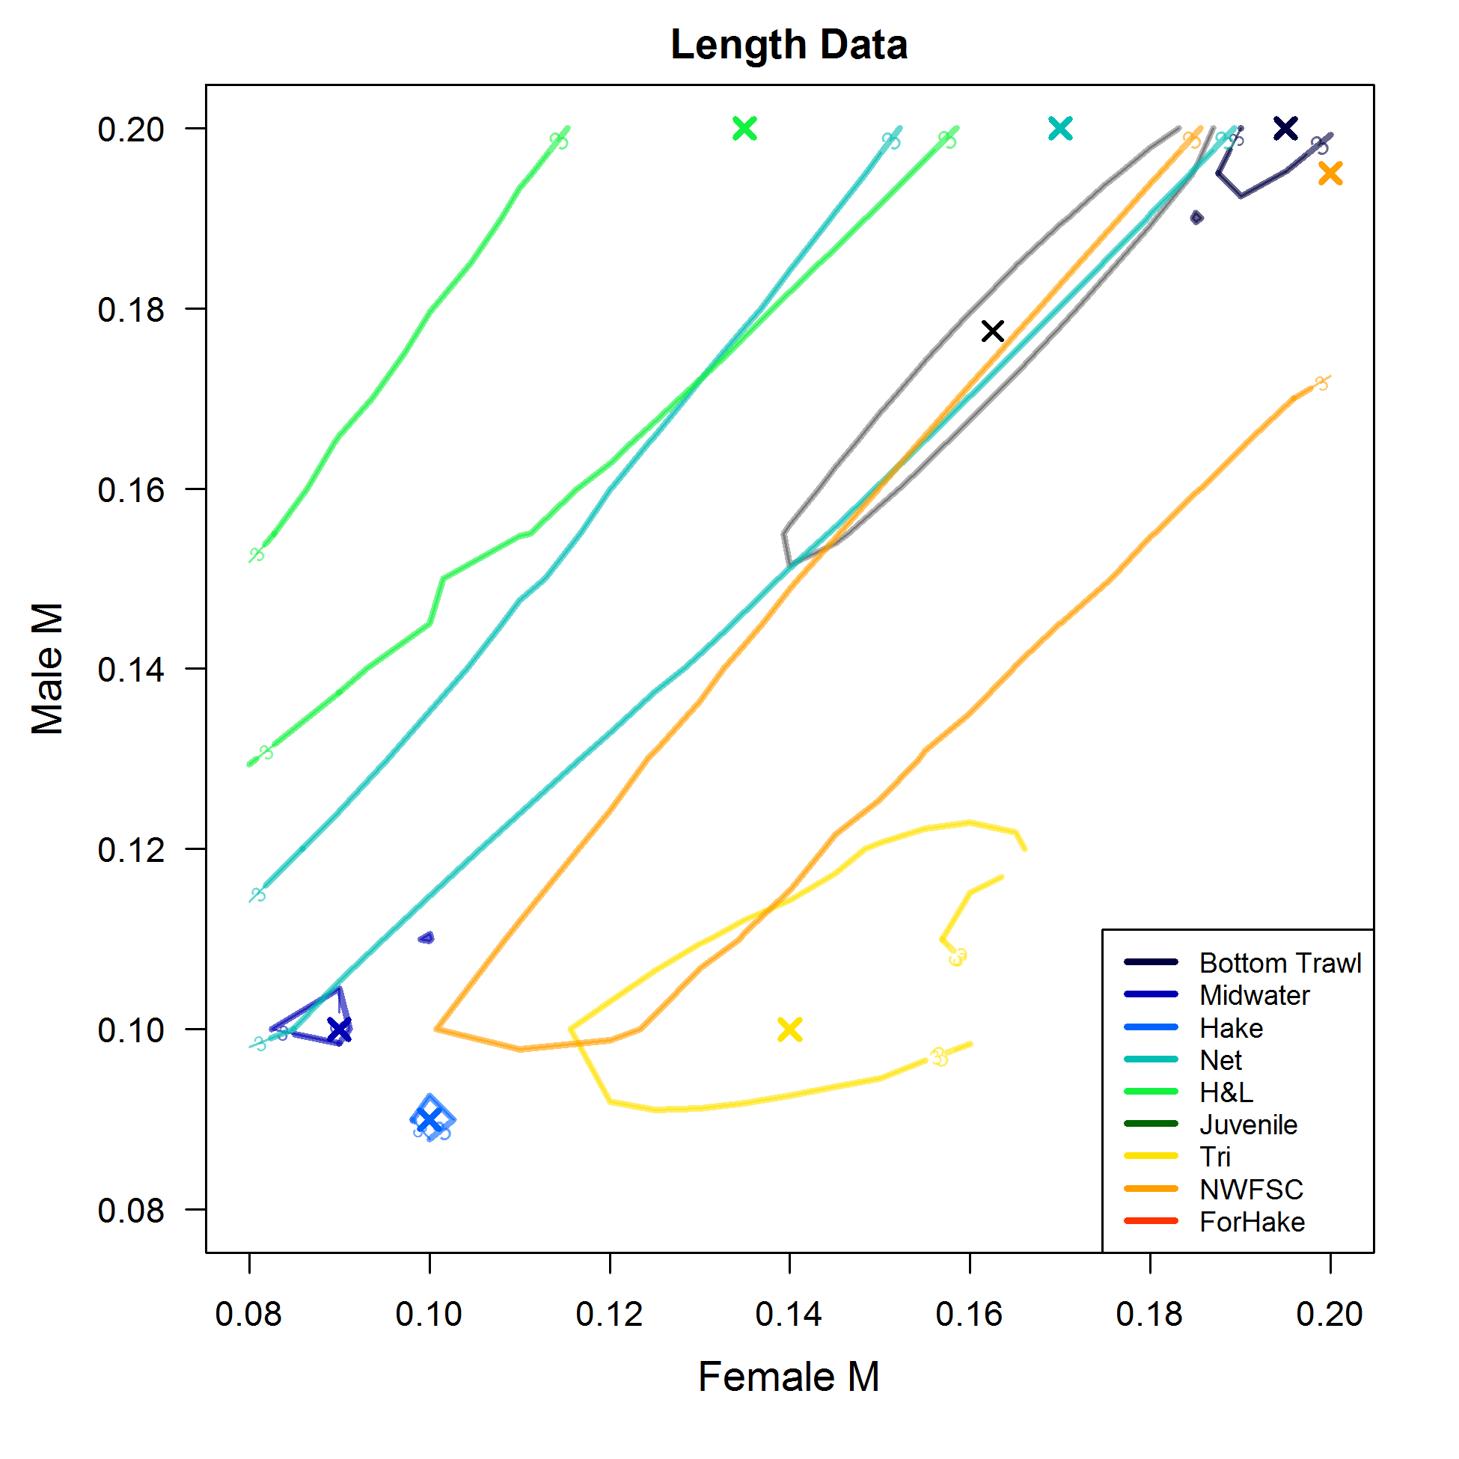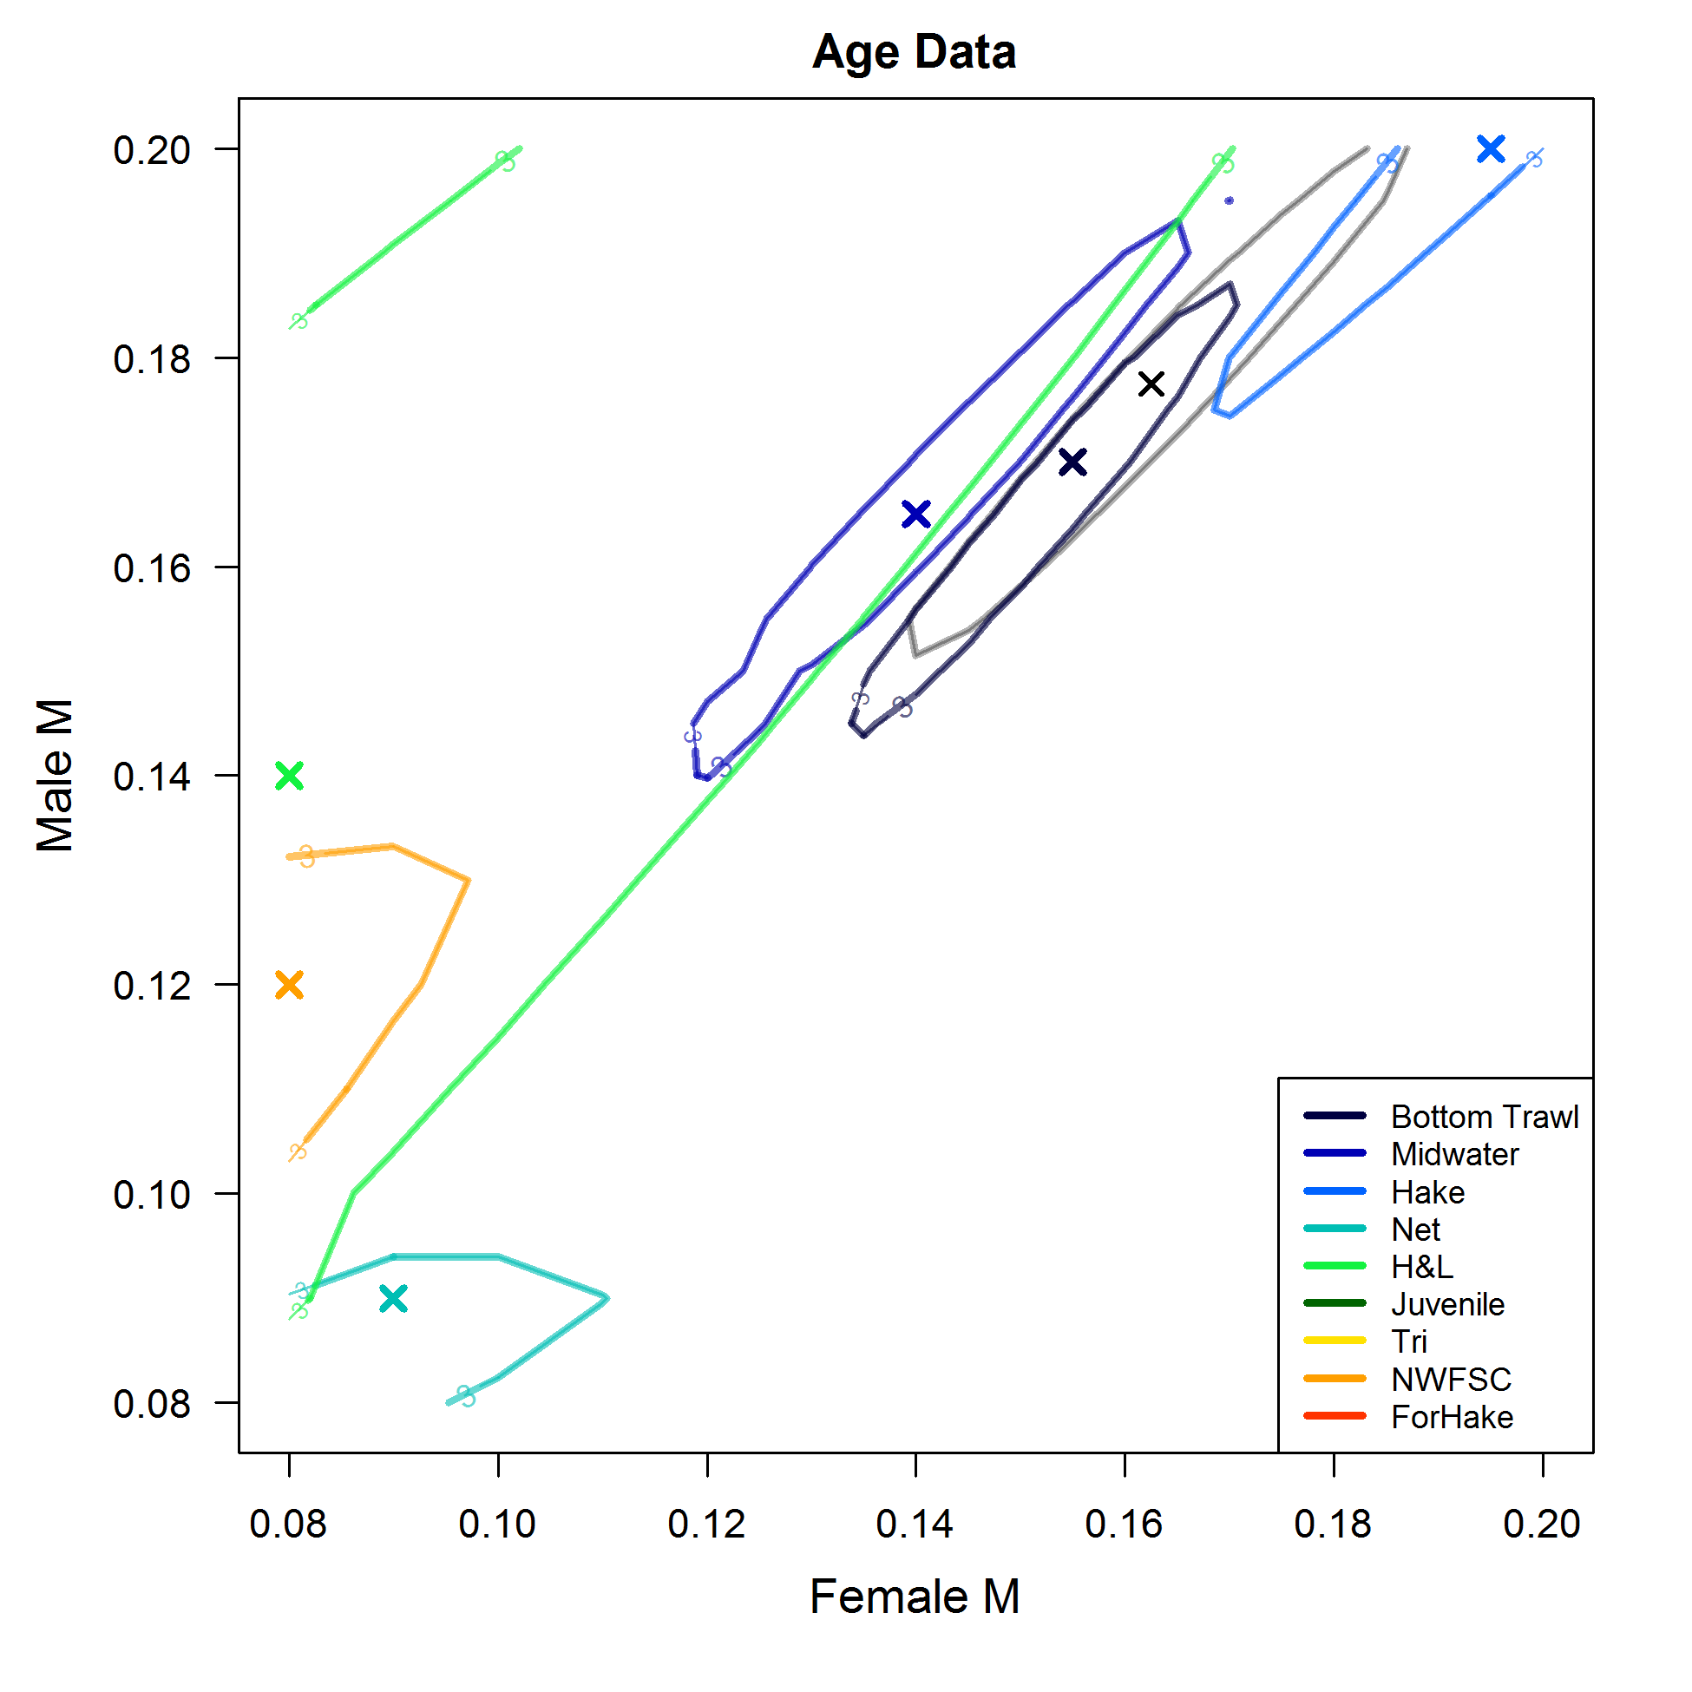

Figure : Fleet specific components of the bivariate likelihood profile for female and male natural mortality (*M,* yr-1). Each fleet is shown as a different color with an “X” indicating the minimum likelihood value for that component and the contour showing where the difference in log-likelihood is 3. The grey and small “X” and contour show the total likelihood profile for comparison.

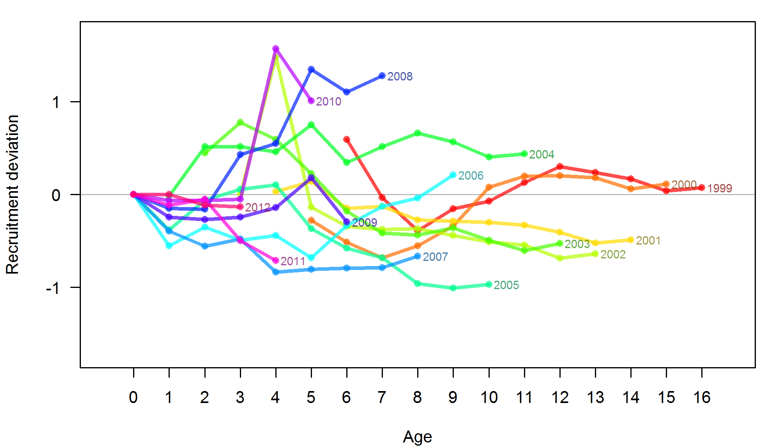

Figure : Retrospective estimates of recruitment deviations. Each line is a specific cohort and the estimated strength of it at a specific age.

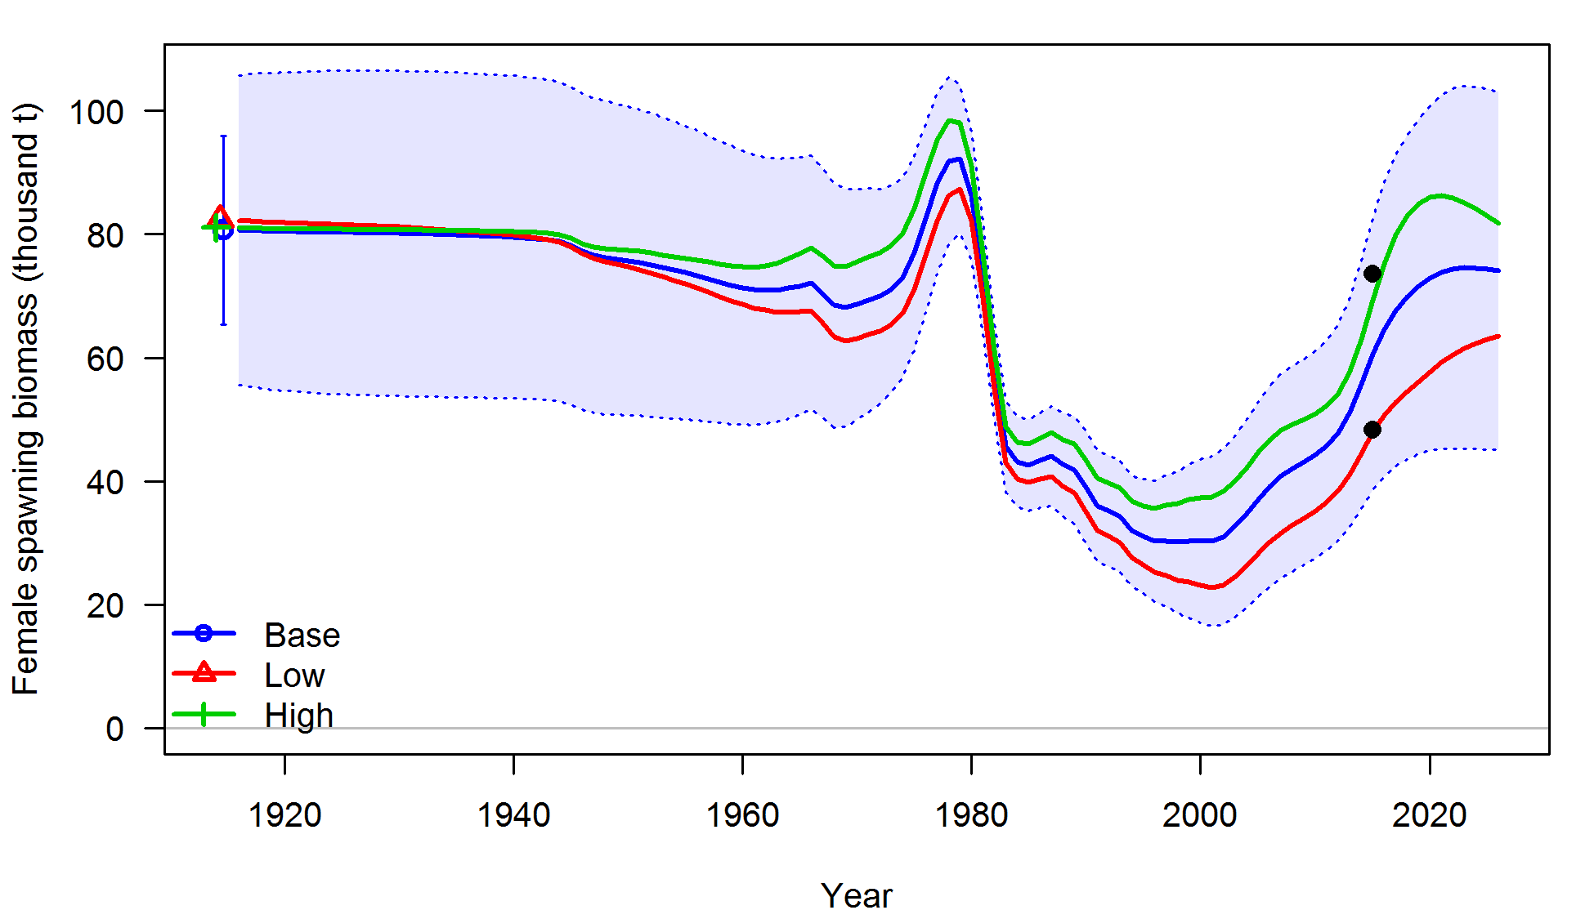

Figure : Base model, low state of nature, and high state of nature spawning biomass trajectories assuming a catch of 2,000 metric tons for 2015 to 2026. The black circles indicate the 12.5% and 87.5% lognormal quantiles of spawning biomass in 2015 from the base model.



Figure : Plot of the predicted (1-SPR) for each year of the model with 95% confidence intervals.



Figure : Phase plot of relative (1-SPR) (y-axis) and depletion (x-axis) for Widow Rockfish. The red point represent the year 2012.



Figure : Estimated plot of equilibrium yield vs relative spawning biomass (*B/B0*) with the current estimated depletion (black), the proxy 40% target biomass level (green), and the proxy 25% overfished level (red) shown as vertical lines.

1. Year-specific fits to the length compositions

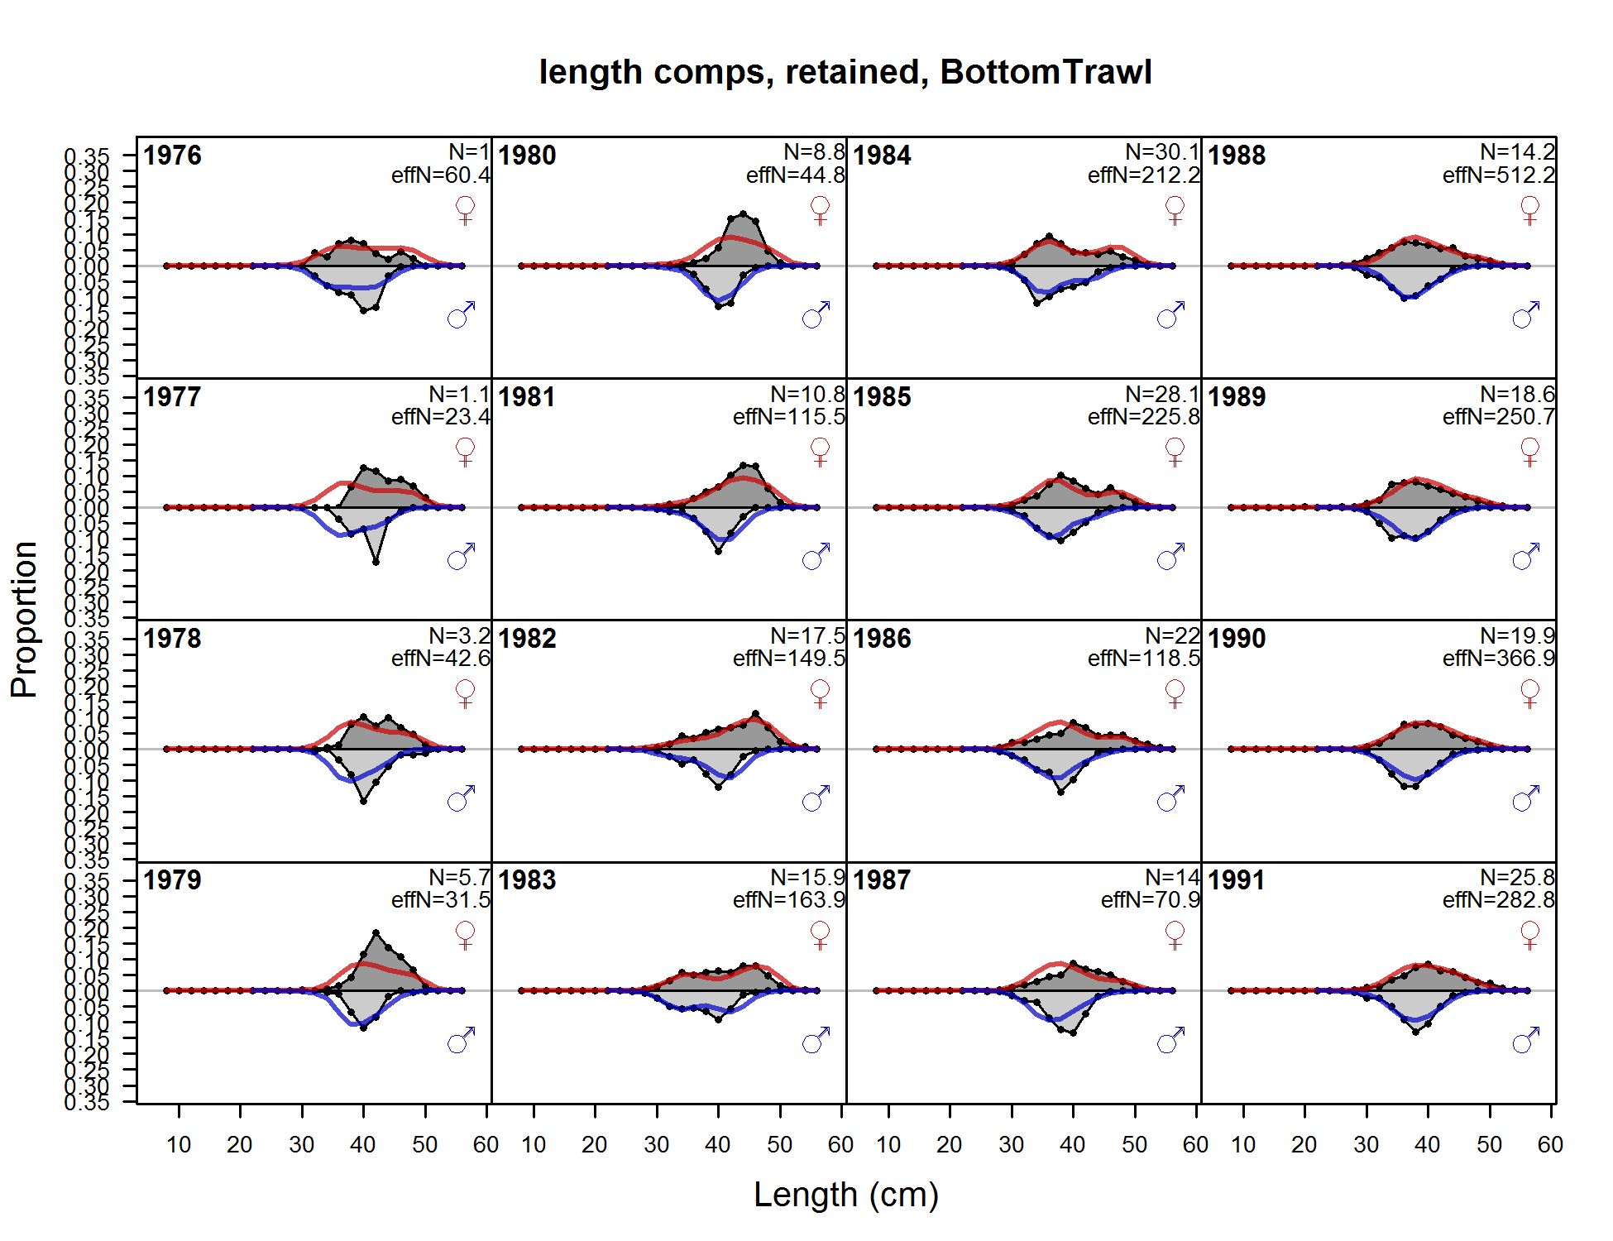

**Figure A1: Fits to the retained length compositions for the bottom trawl fleet.**

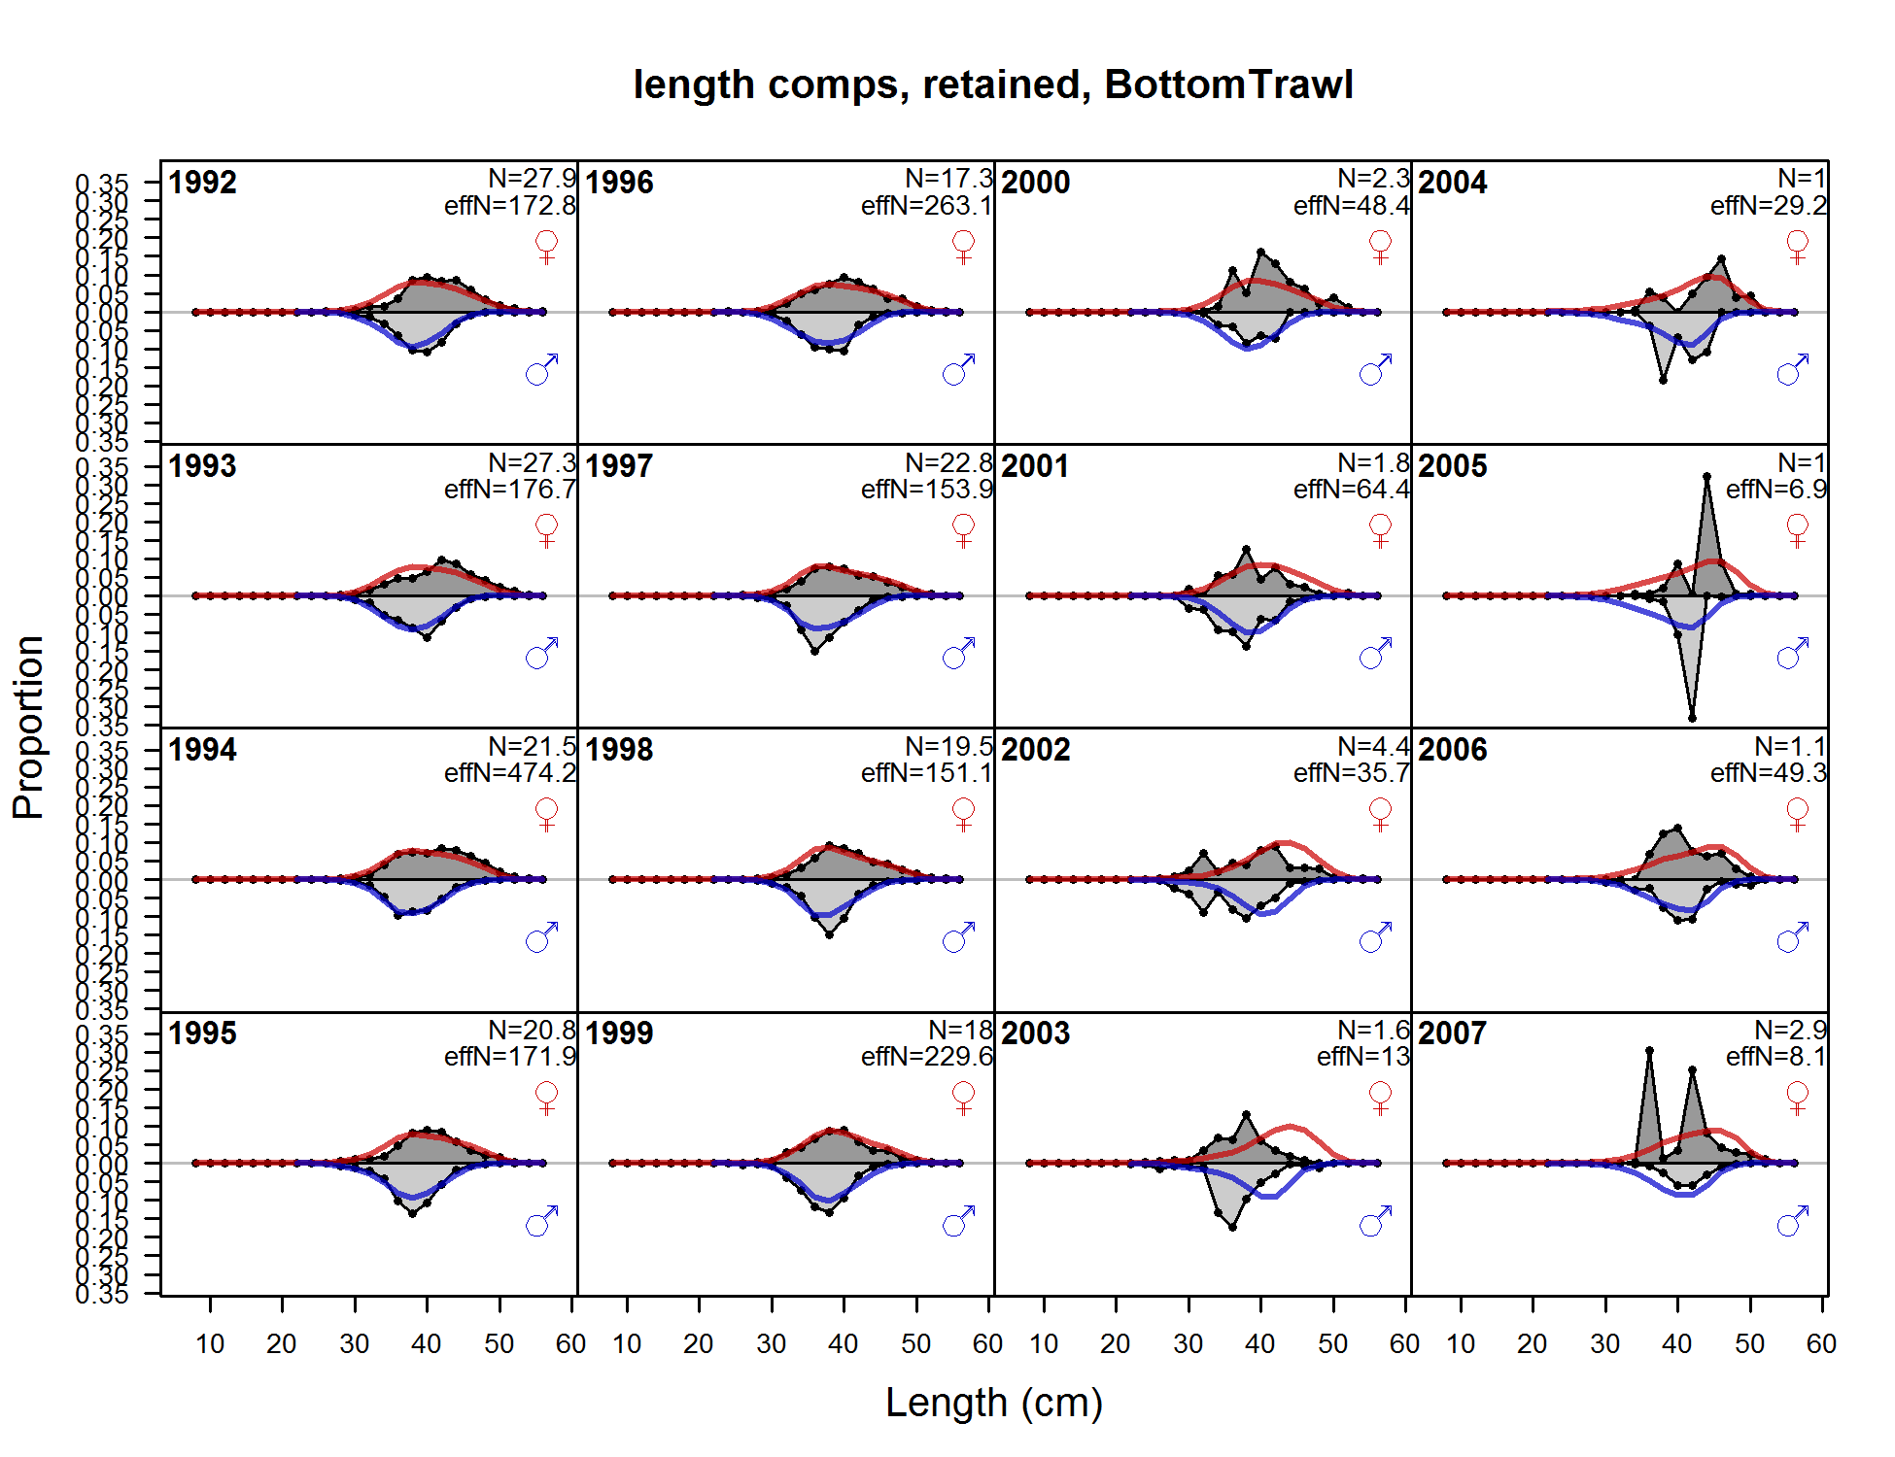

Figure A1: (continued) Fits to the retained length compositions for the bottom trawl fleet.

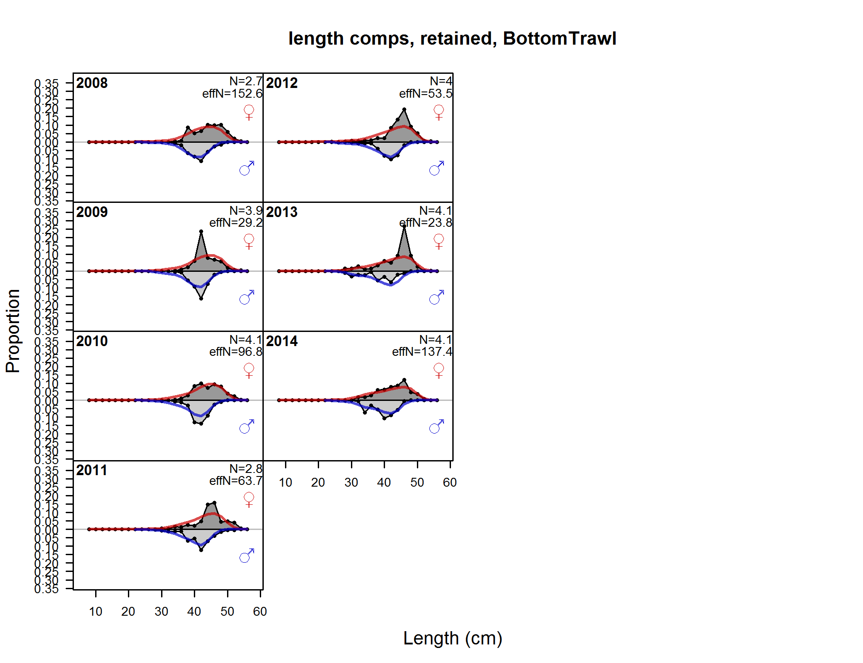

**Figure A1: (continued) Fits to the retained length compositions for the bottom trawl fleet.**

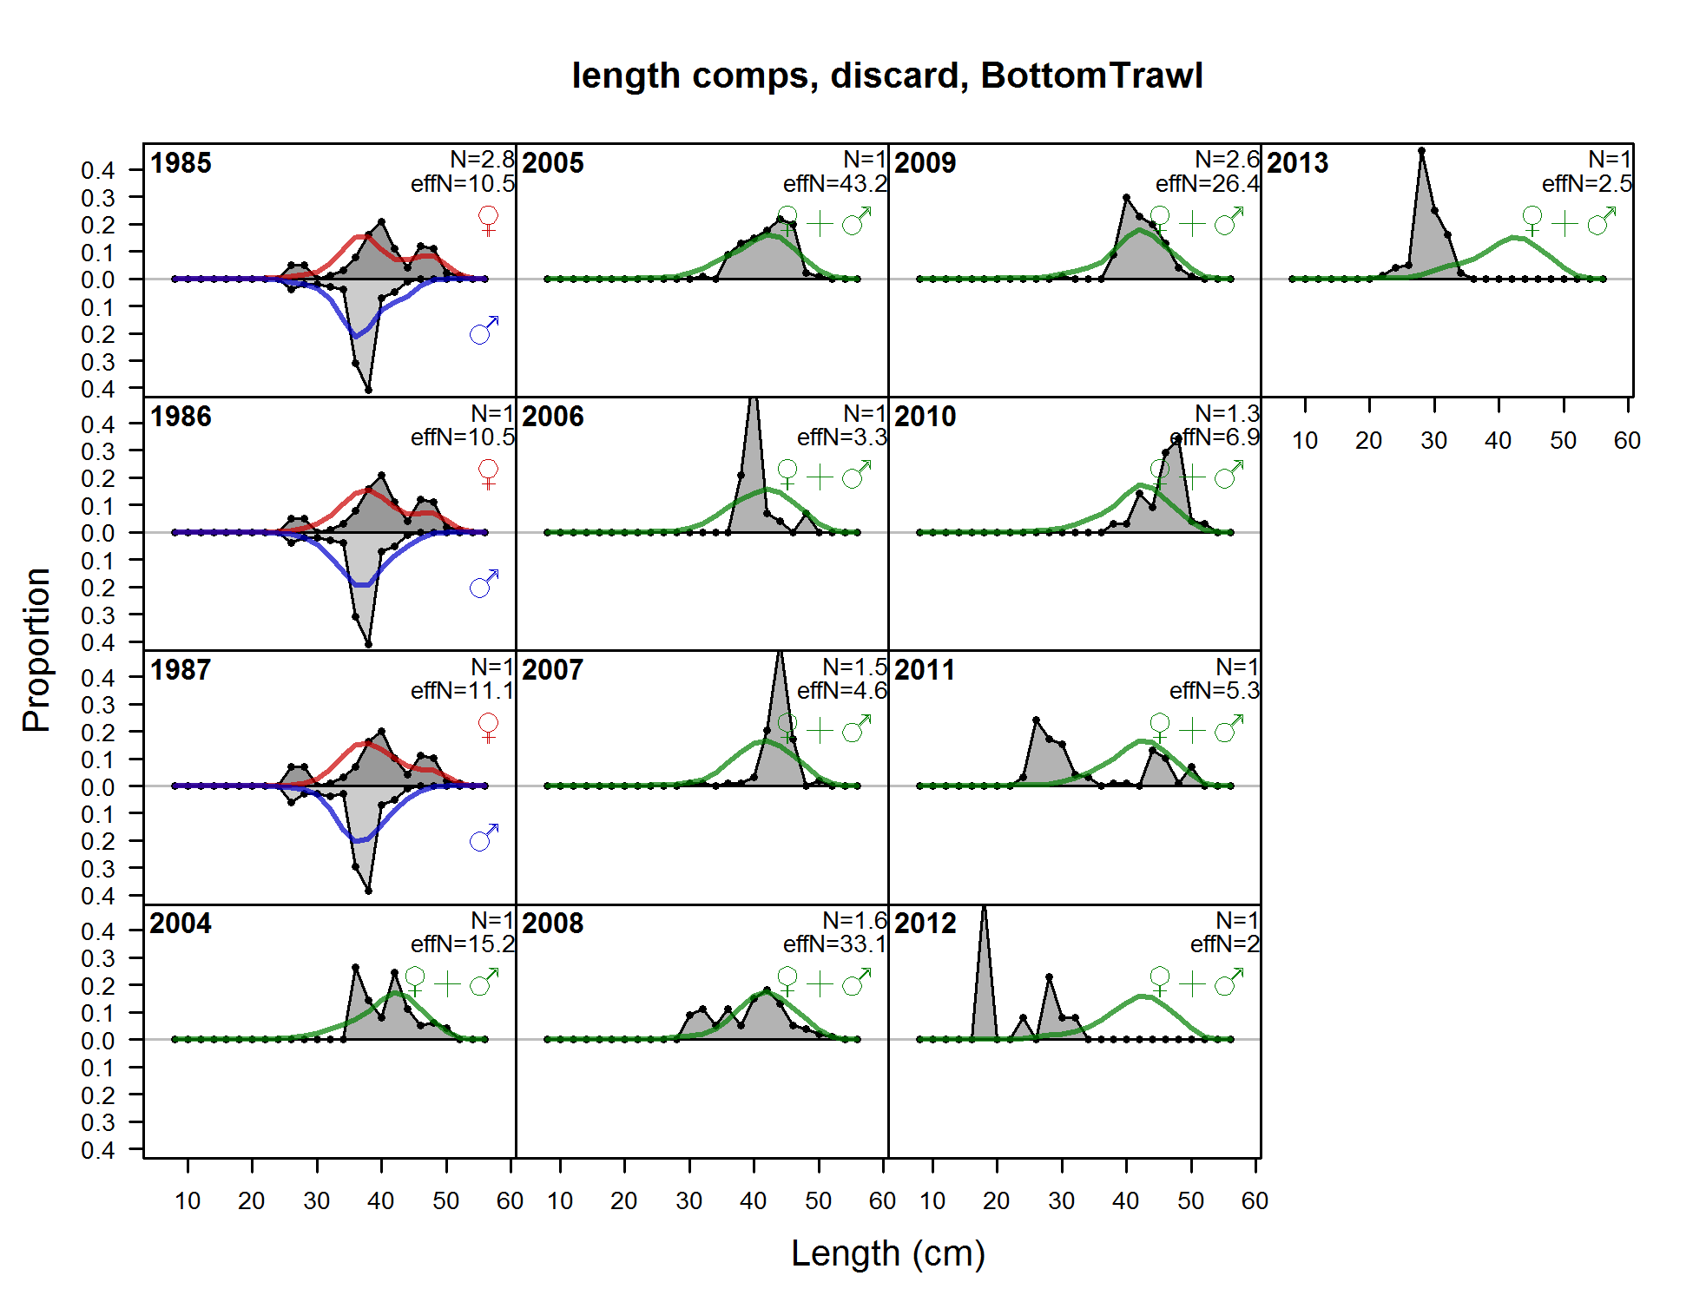

Figure A2: Fits to the discarded length compositions for the bottom trawl fleet.

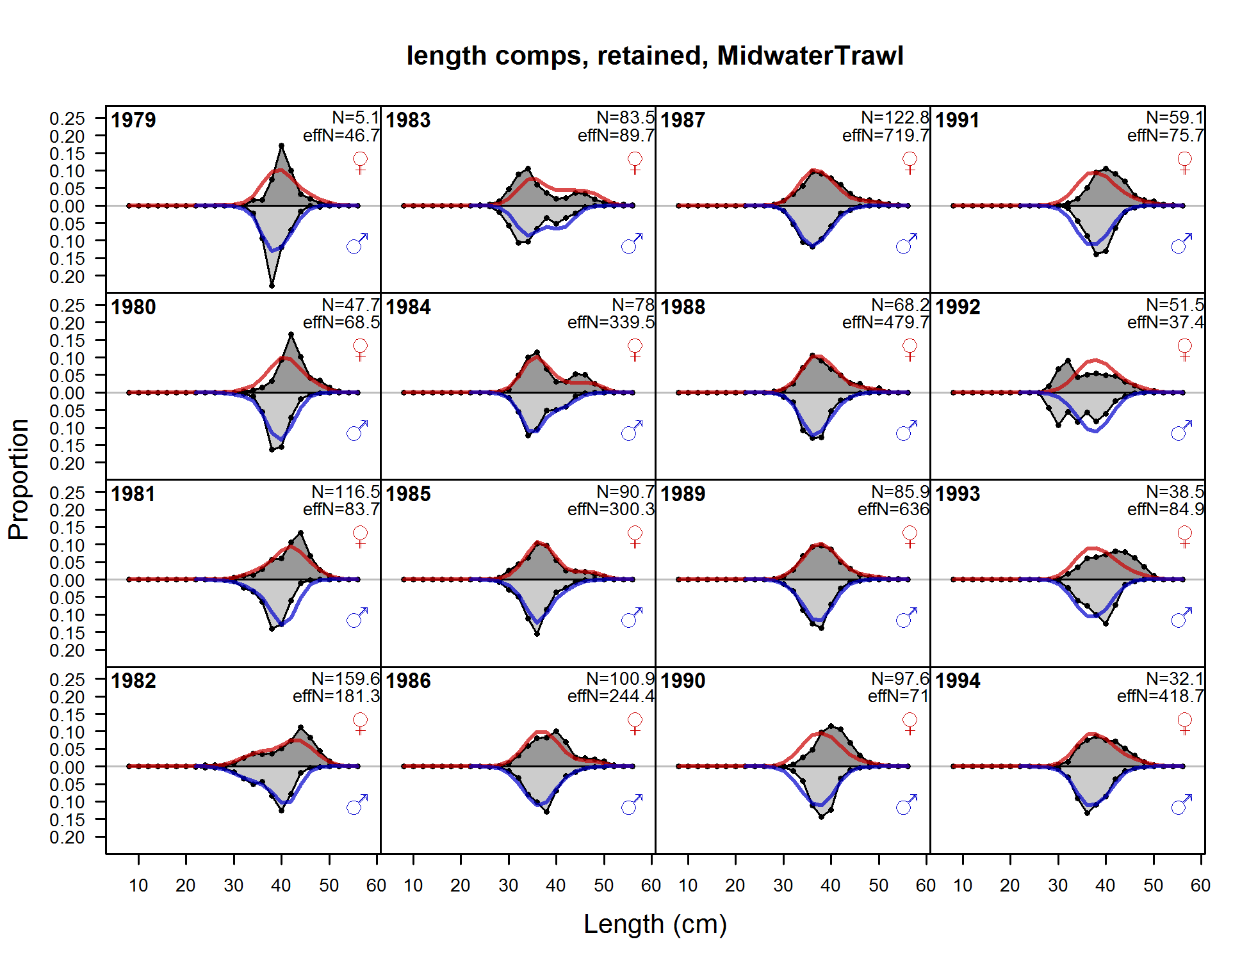

Figure A3: Fits to the retained length compositions for the midwater trawl fleet.

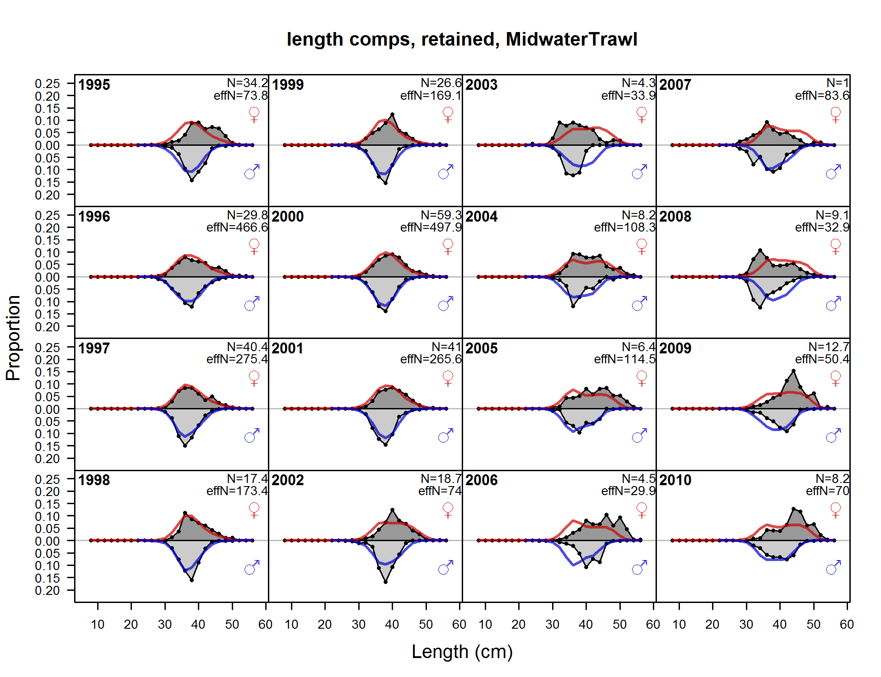

Figure A3: (continued) Fits to the retained length compositions for the midwater trawl fleet.

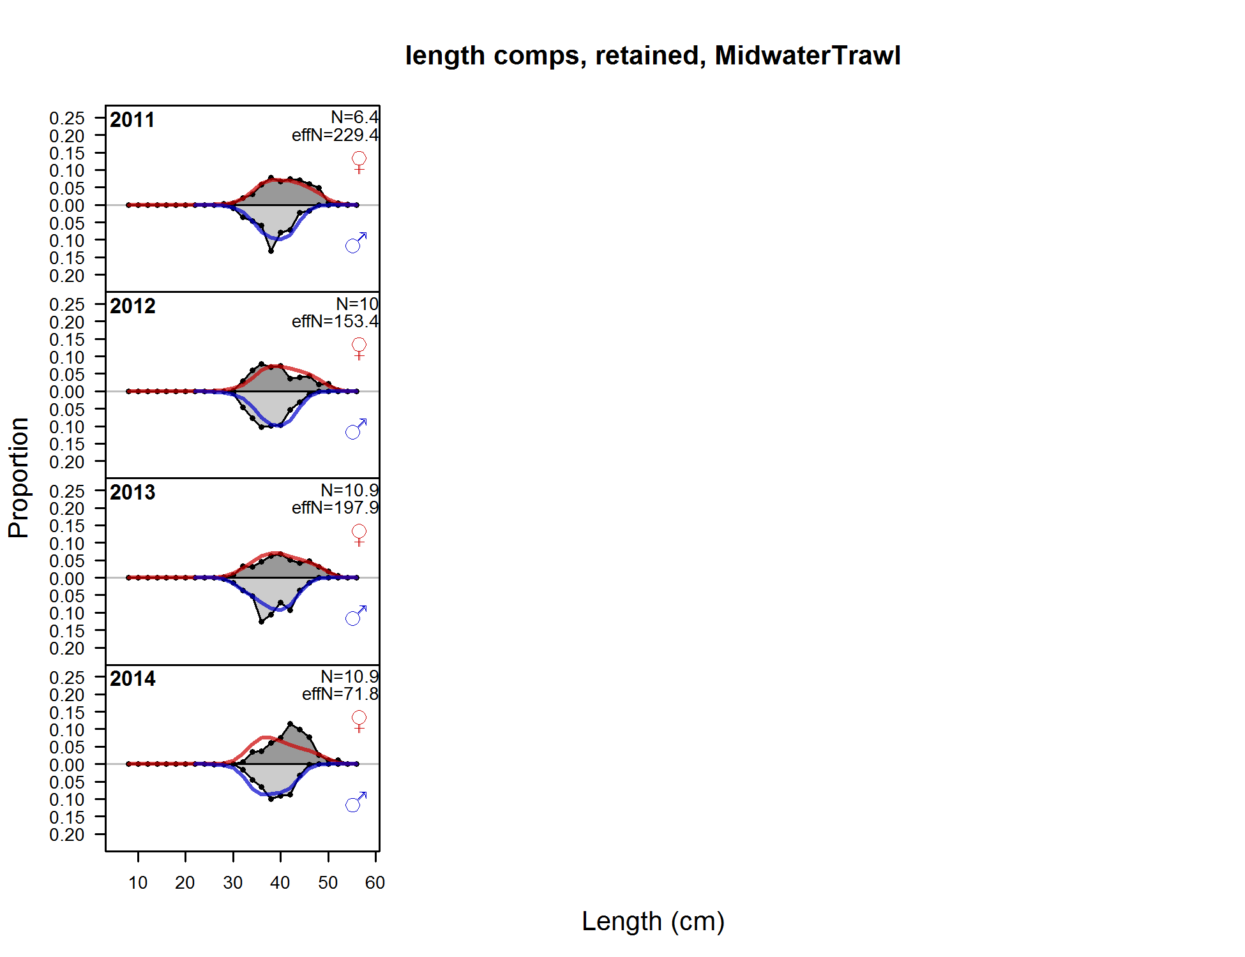

Figure A3: (continued) Fits to the retained length compositions for the midwater trawl fleet.

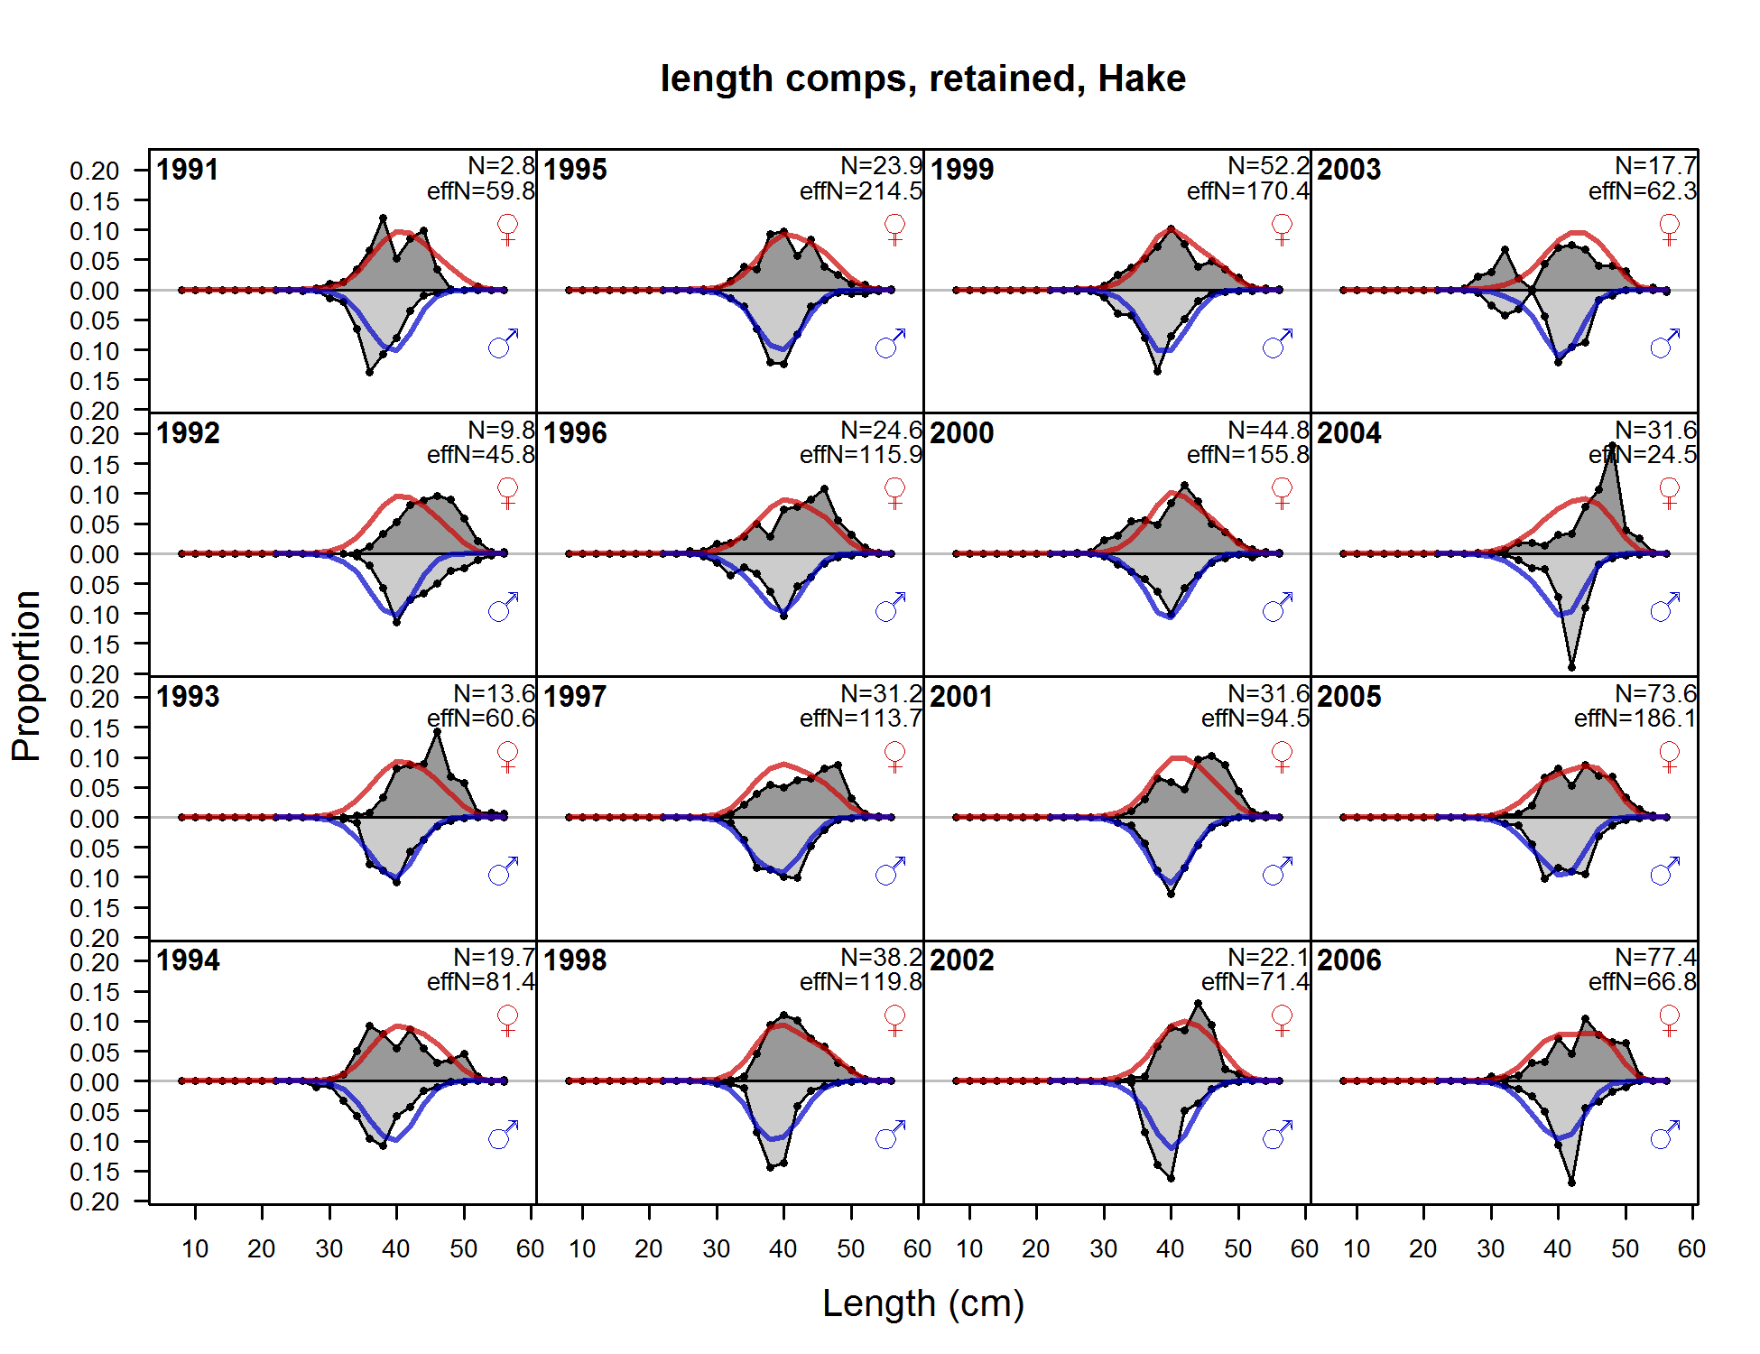

Figure A4: Fits to the retained length compositions for the hake fleet.

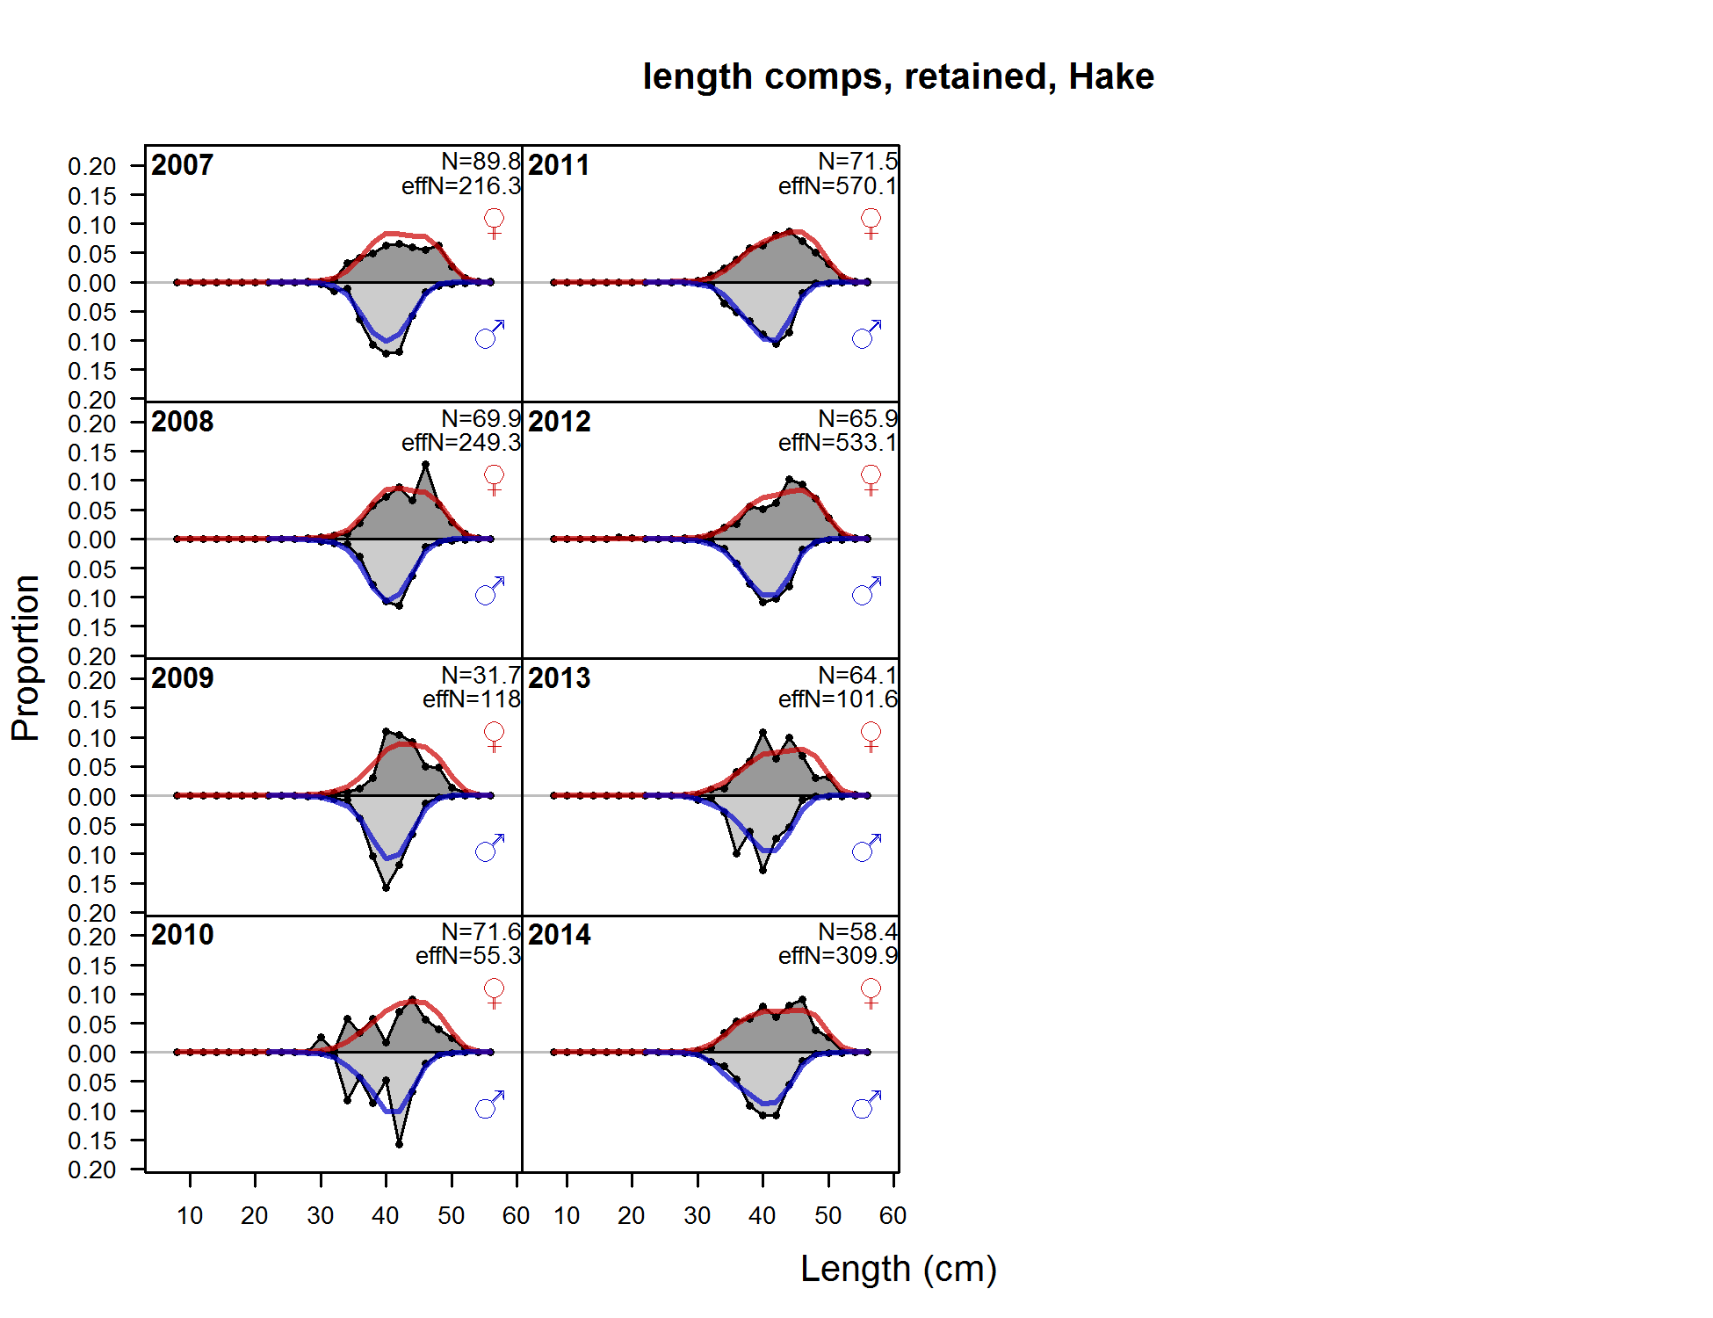

Figure A4: (continued) Fits to the retained length compositions for the hake fleet.

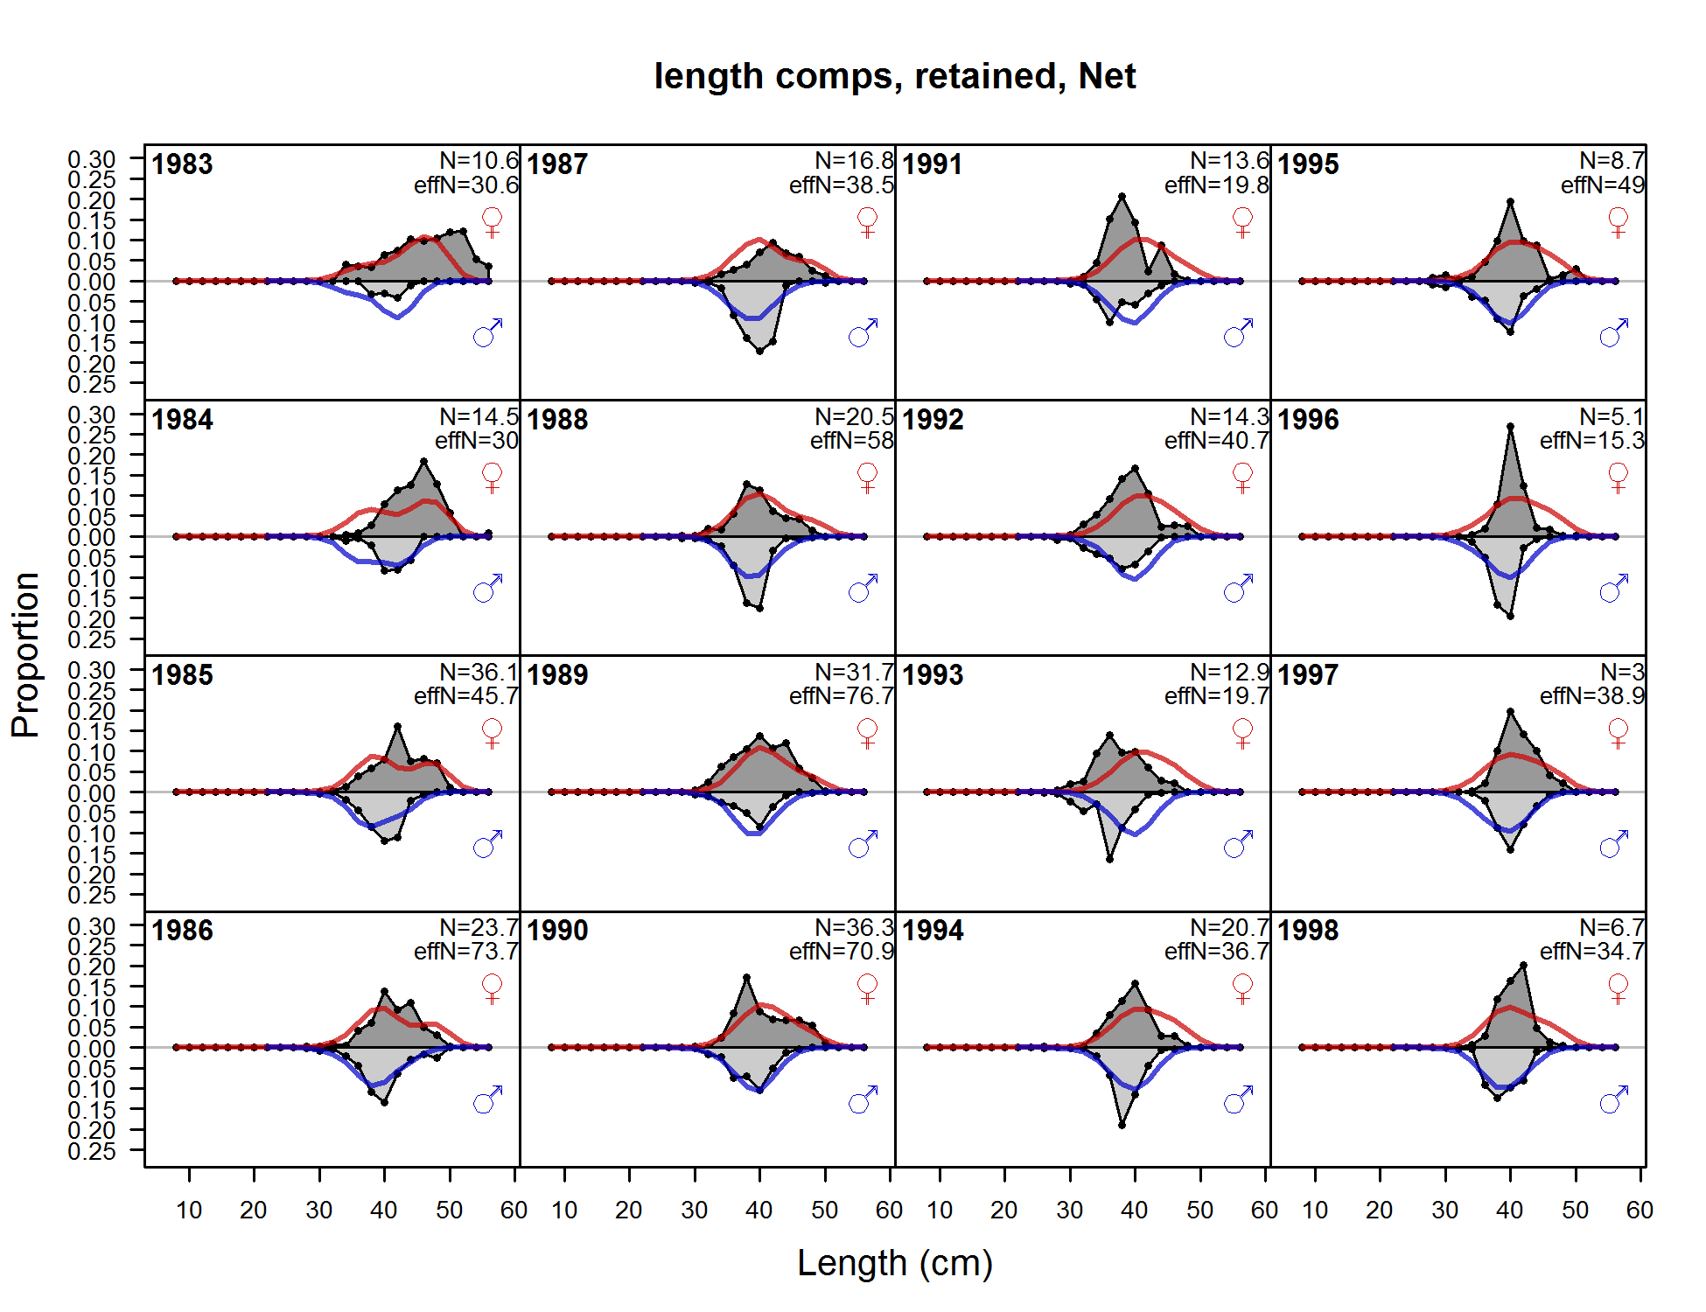

Figure A5: (continued) Fits to the retained length compositions for the net fleet.

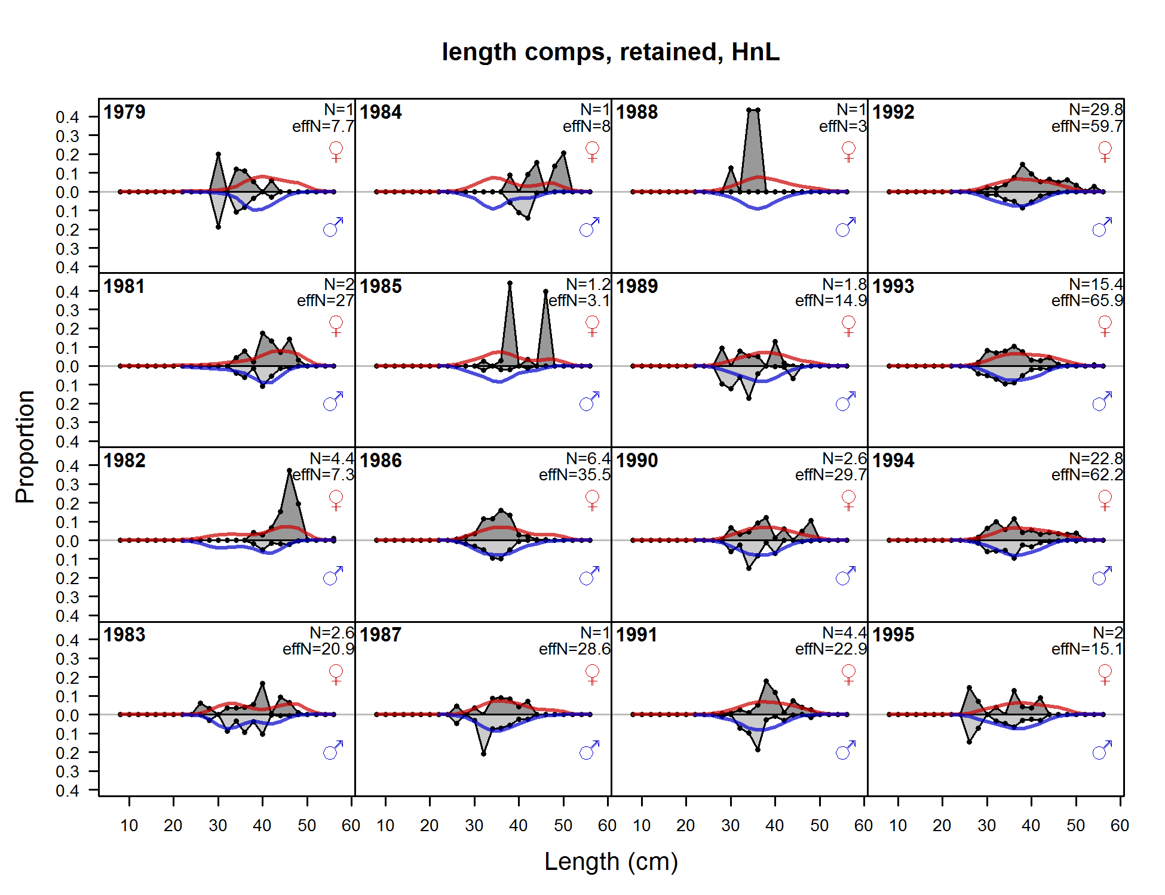

Figure A6: Fits to the retained length compositions for the hook-and-line fleet.

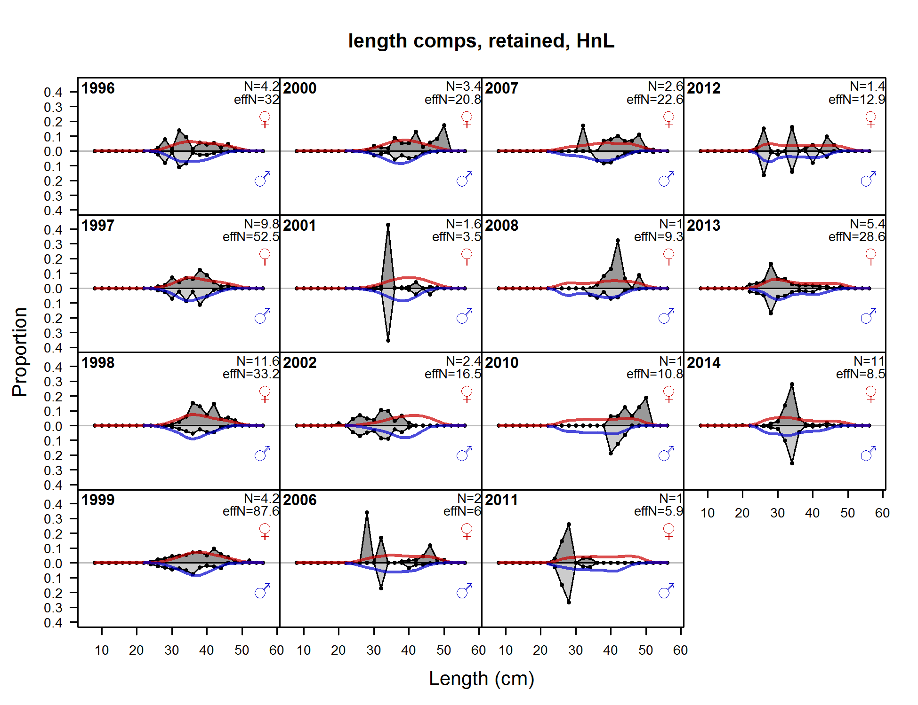

Figure A6: (continued) Fits to the retained length compositions for the hook-and-line fleet.

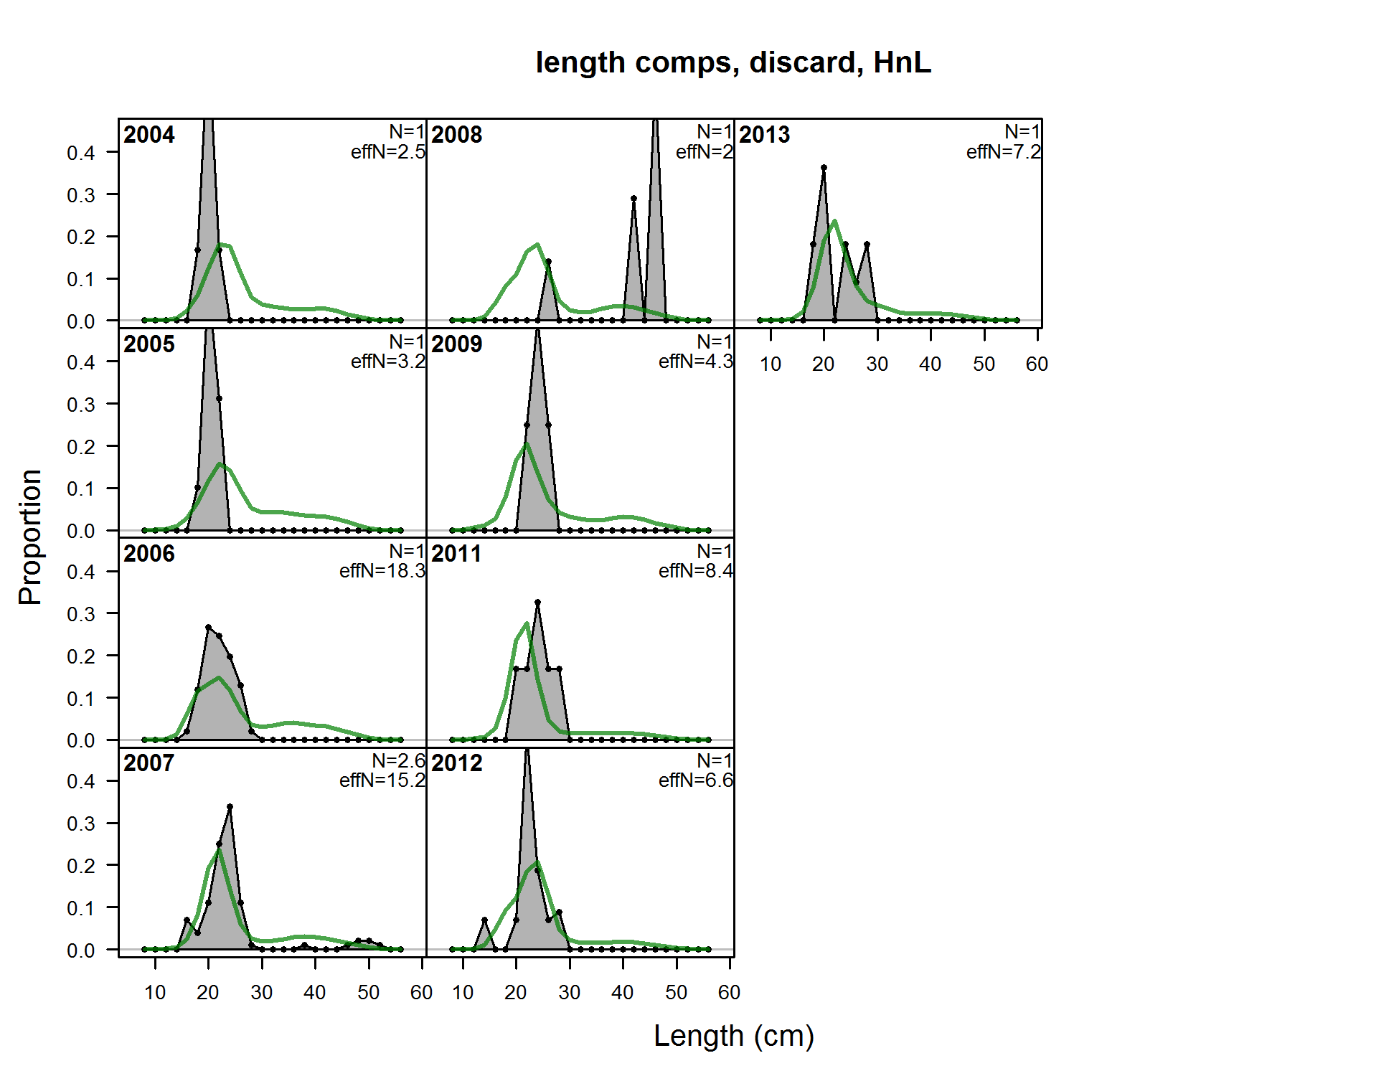

Figure A7: Fits to the discarded length compositions for the hook-and-line fleet.

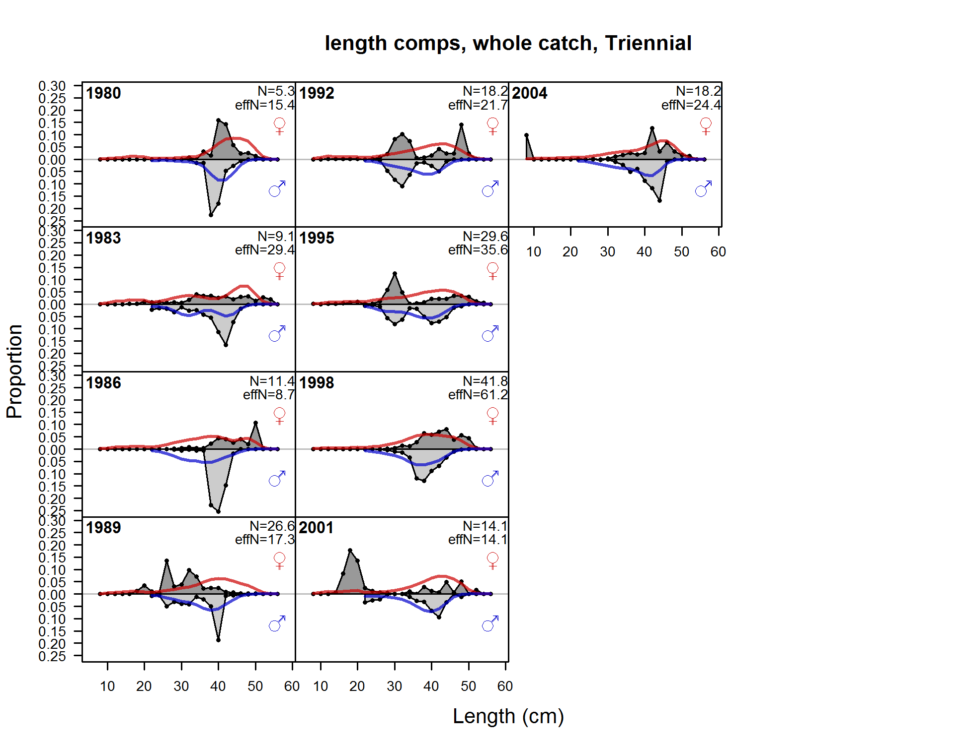

Figure A8: Fits to the length compositions for the triennial survey.

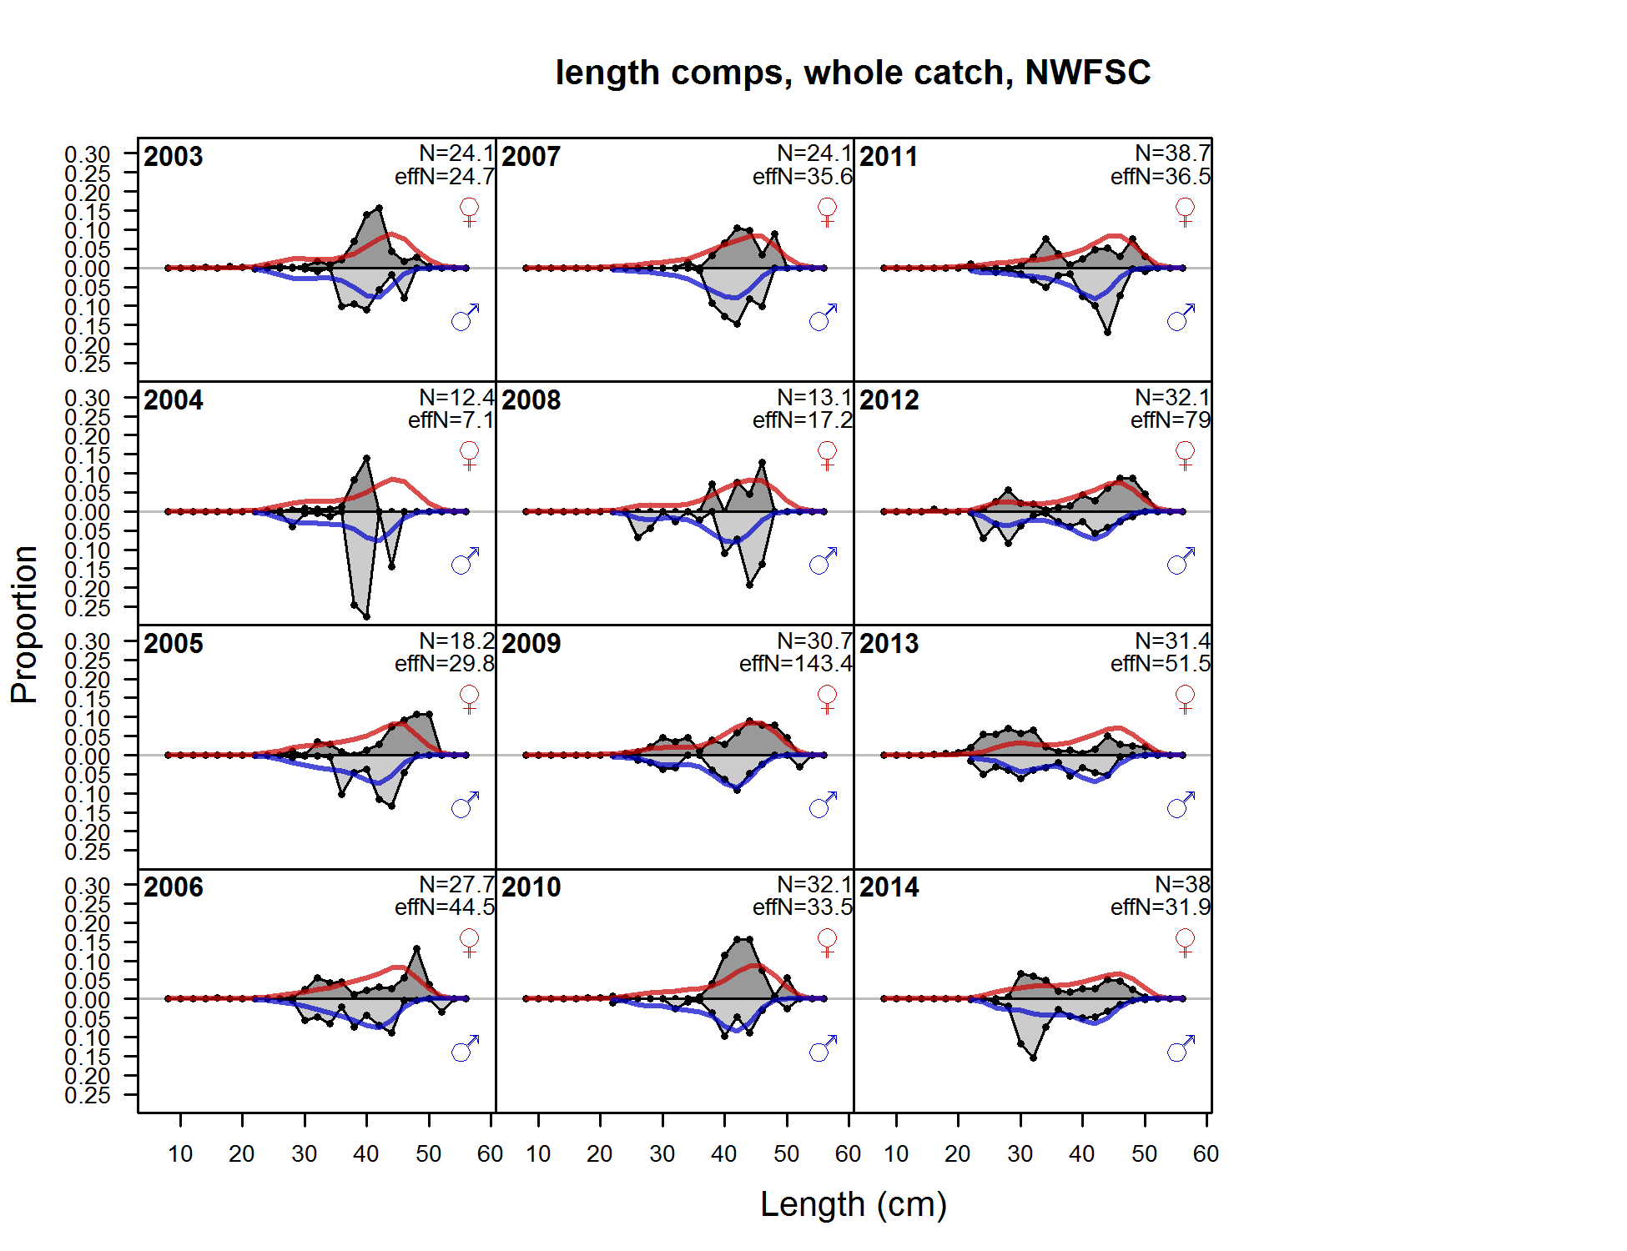

Figure A9: Fits to the length compositions for the NWFSC shelf/slope survey.

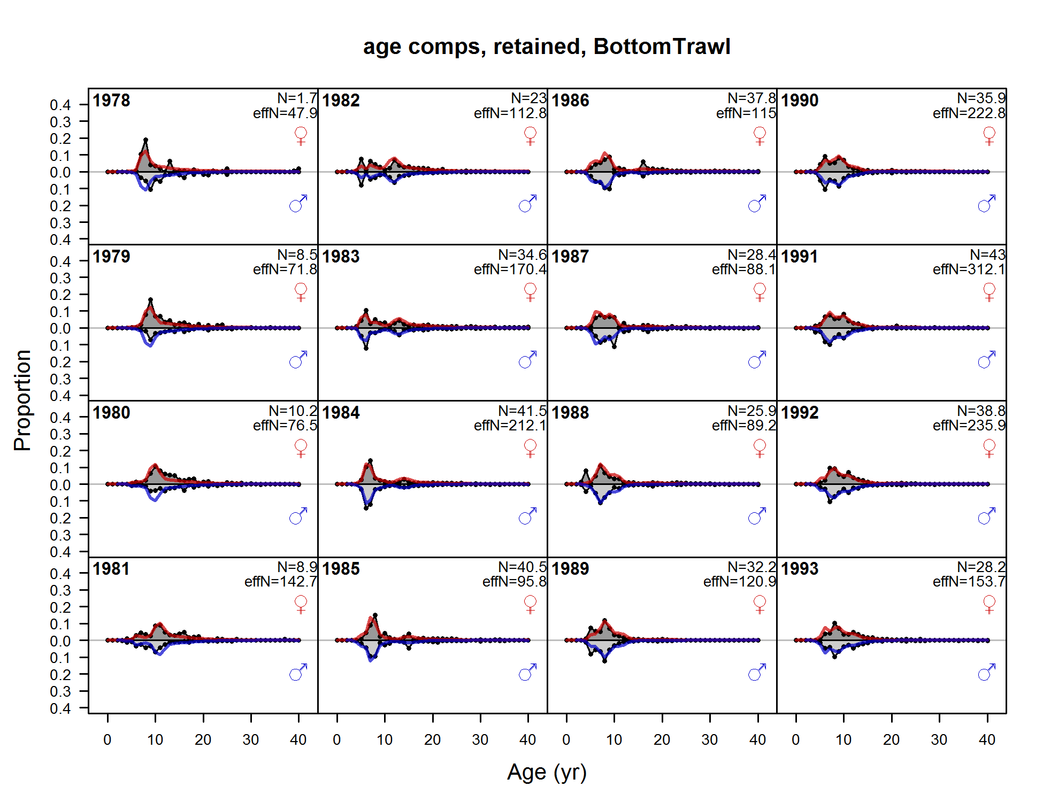

**Figure A10: Fits to the retained age compositions for the bottom trawl fleet.**

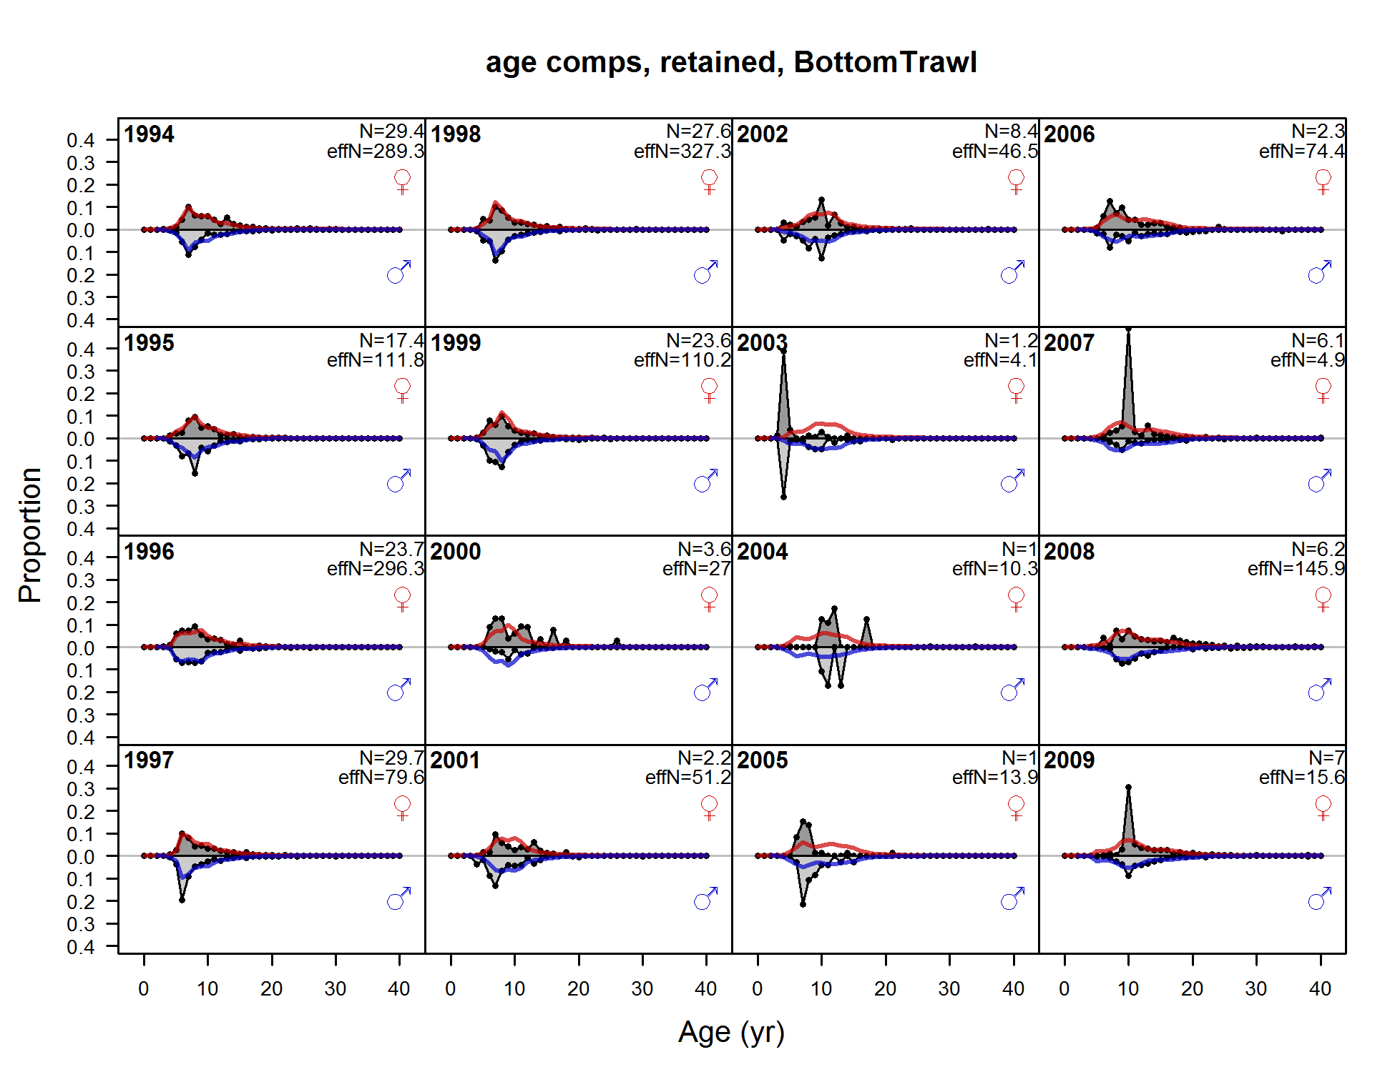

Figure A10: (continued) Fits to the retained age compositions for the bottom trawl fleet.

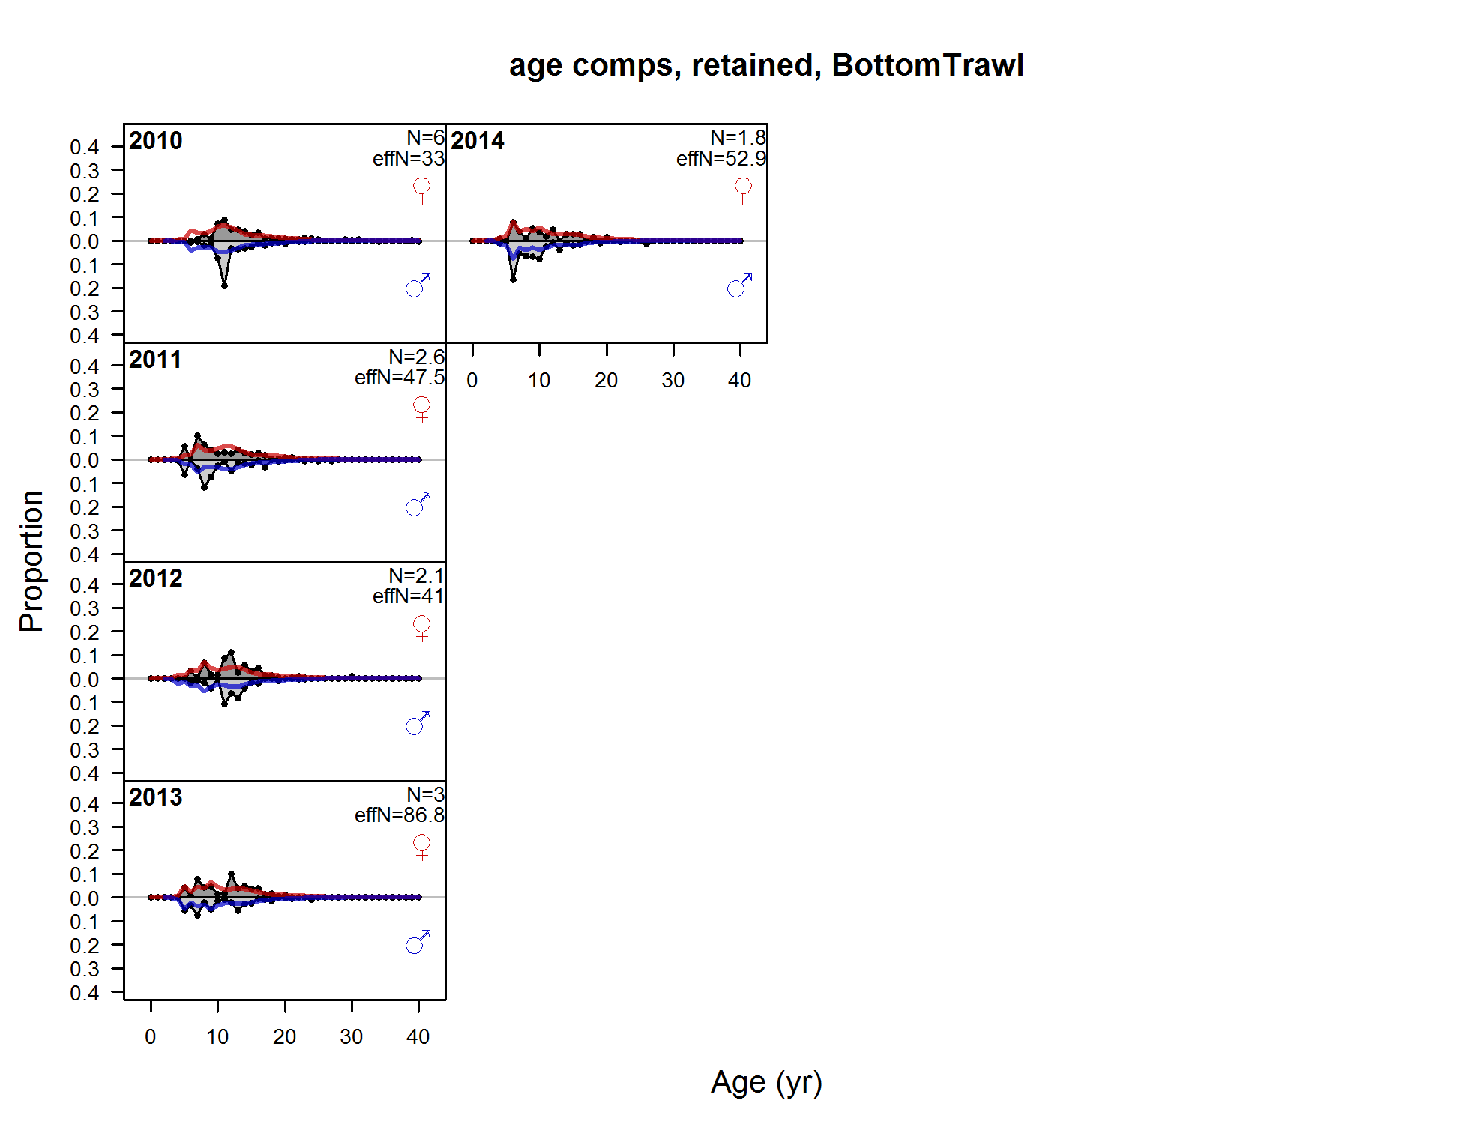

**Figure A10: (continued) Fits to the retained age compositions for the bottom trawl fleet.**

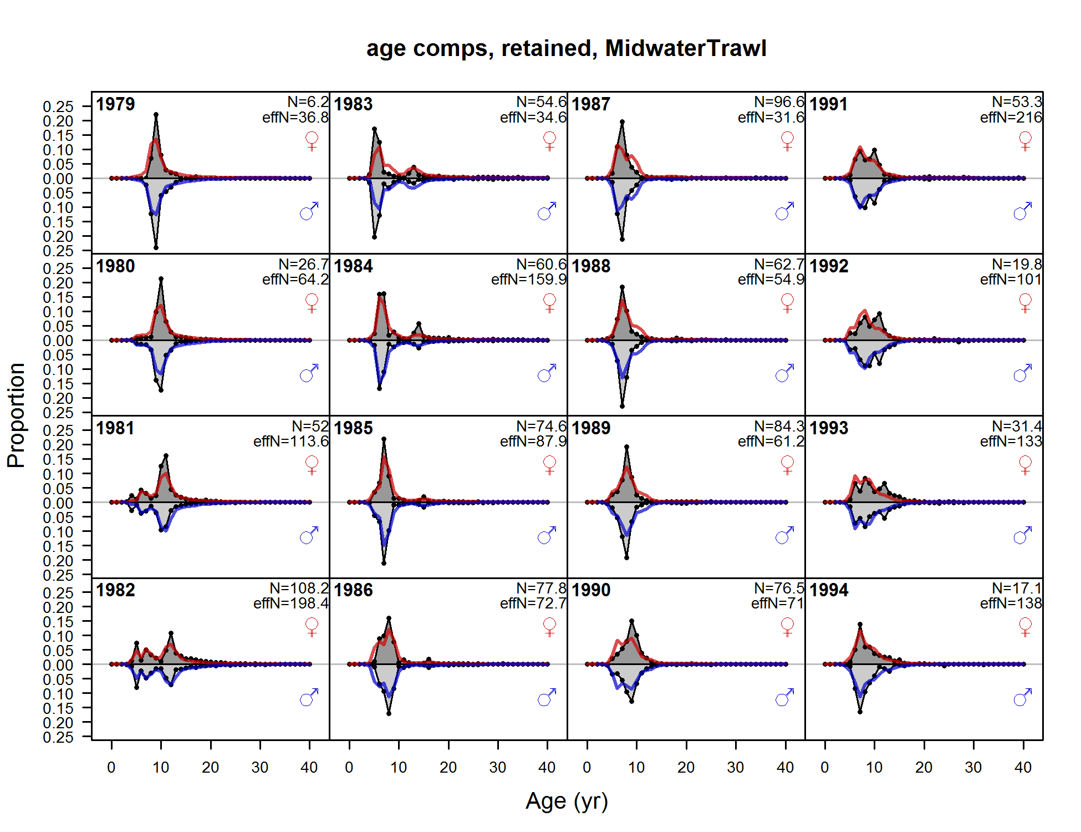

**Figure A11: Fits to the retained age compositions for the midwater trawl fleet.**

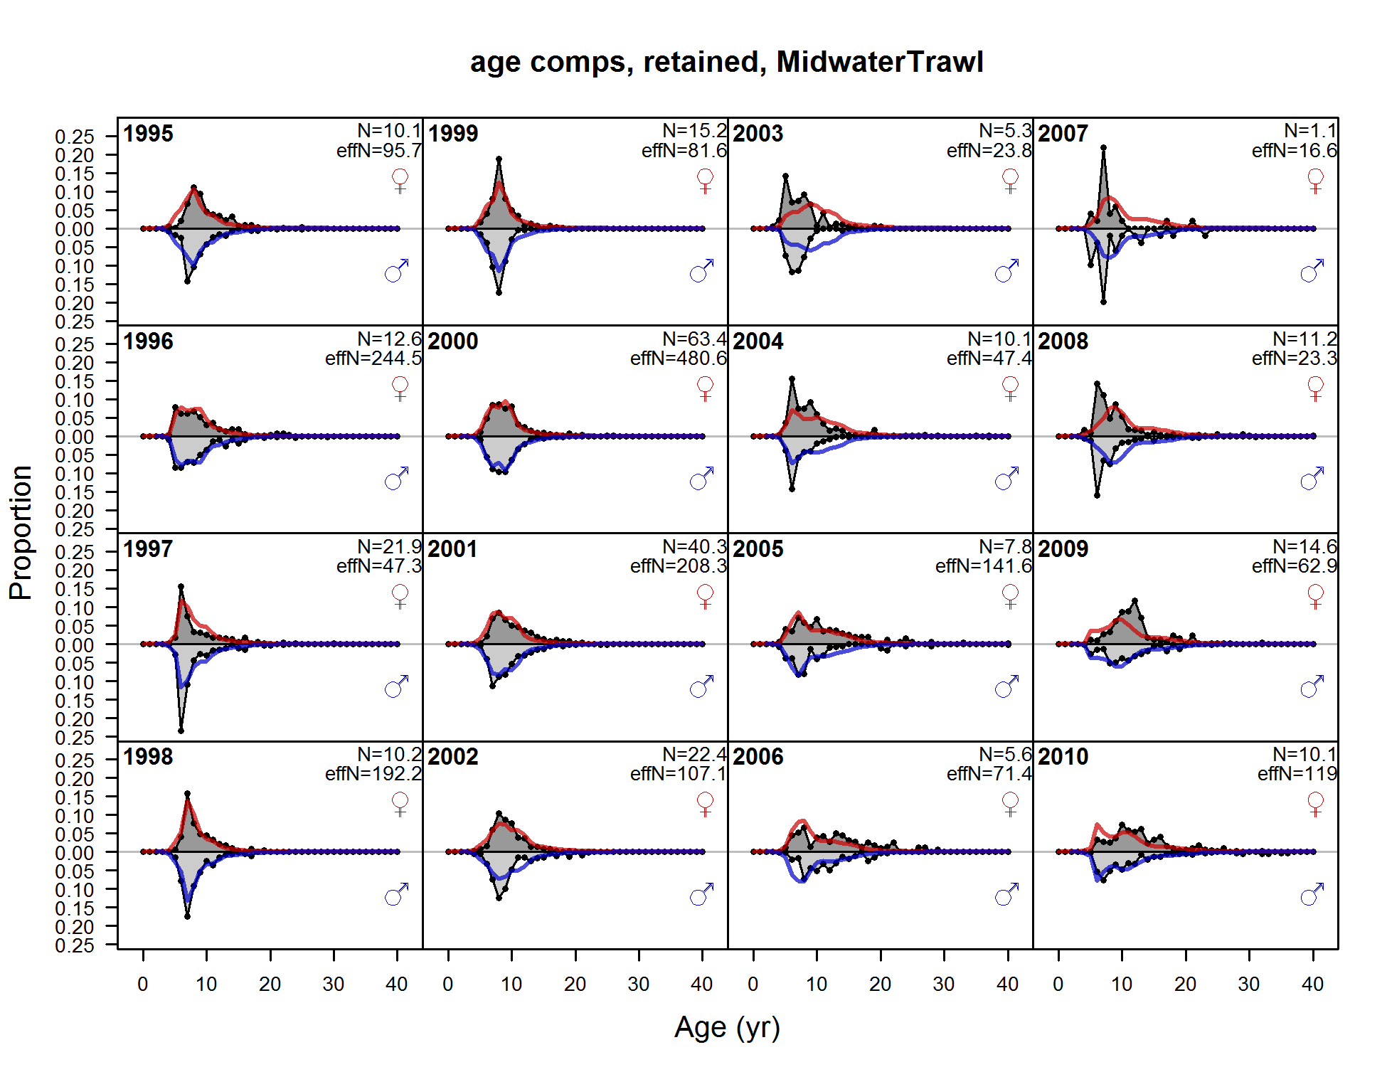

**Figure A11: (continued) Fits to the retained age compositions for the midwater trawl fleet.**

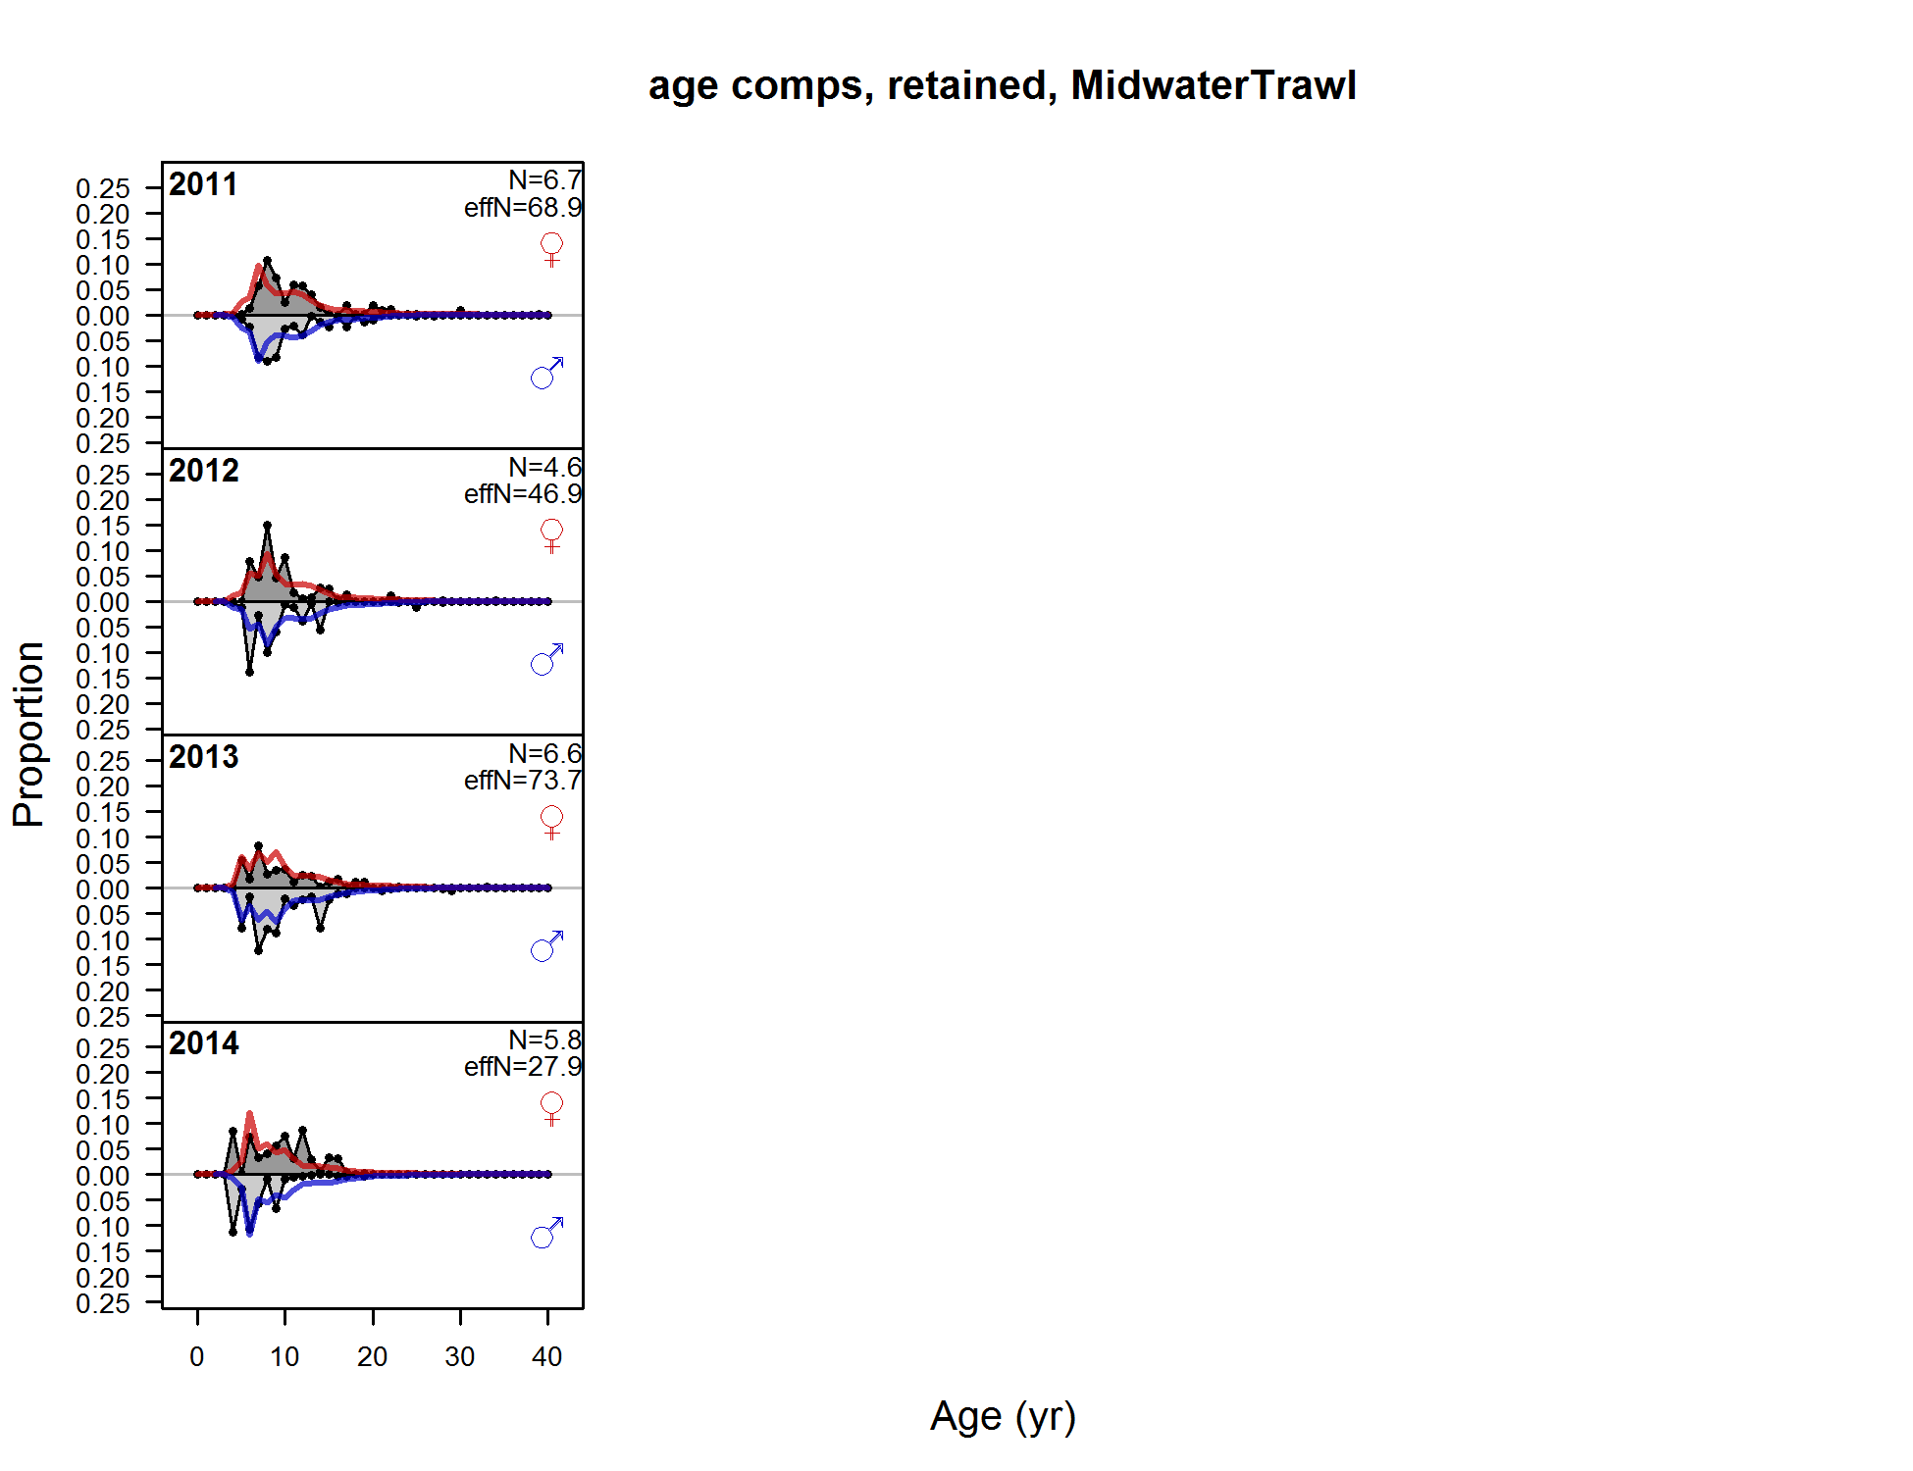

**Figure A11: (continued) Fits to the retained age compositions for the midwater trawl fleet.**

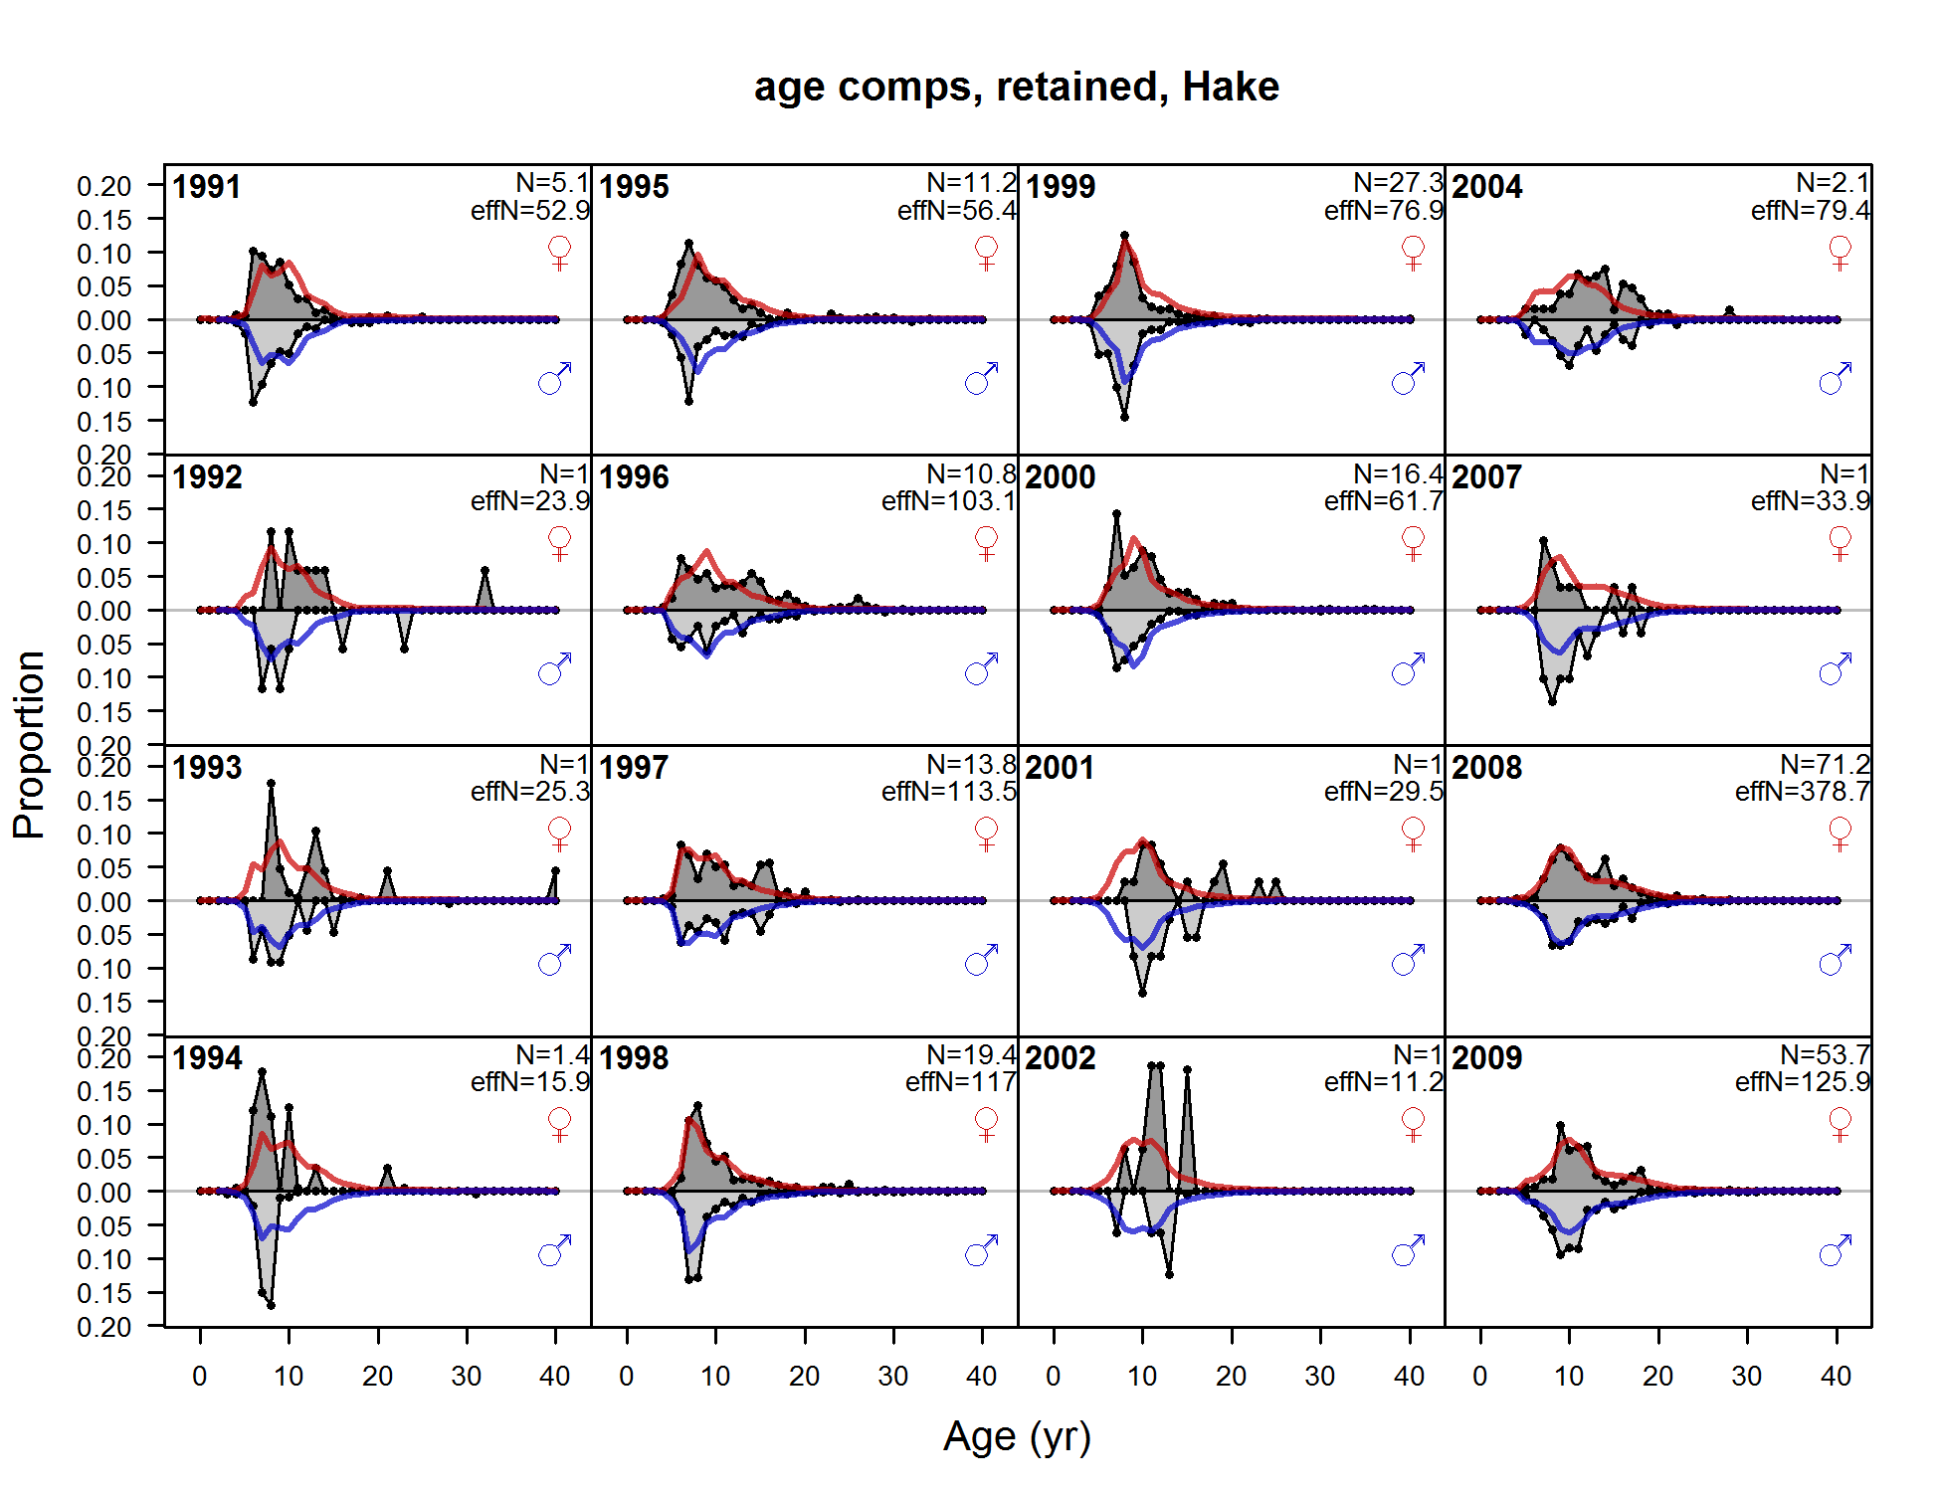

**Figure A12: Fits to the retained age compositions for the hake fleet.**

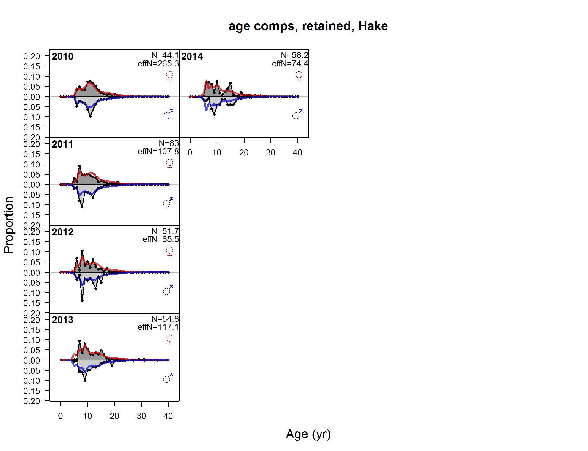

**Figure A12: (continued) Fits to the retained age compositions for the hake fleet.**

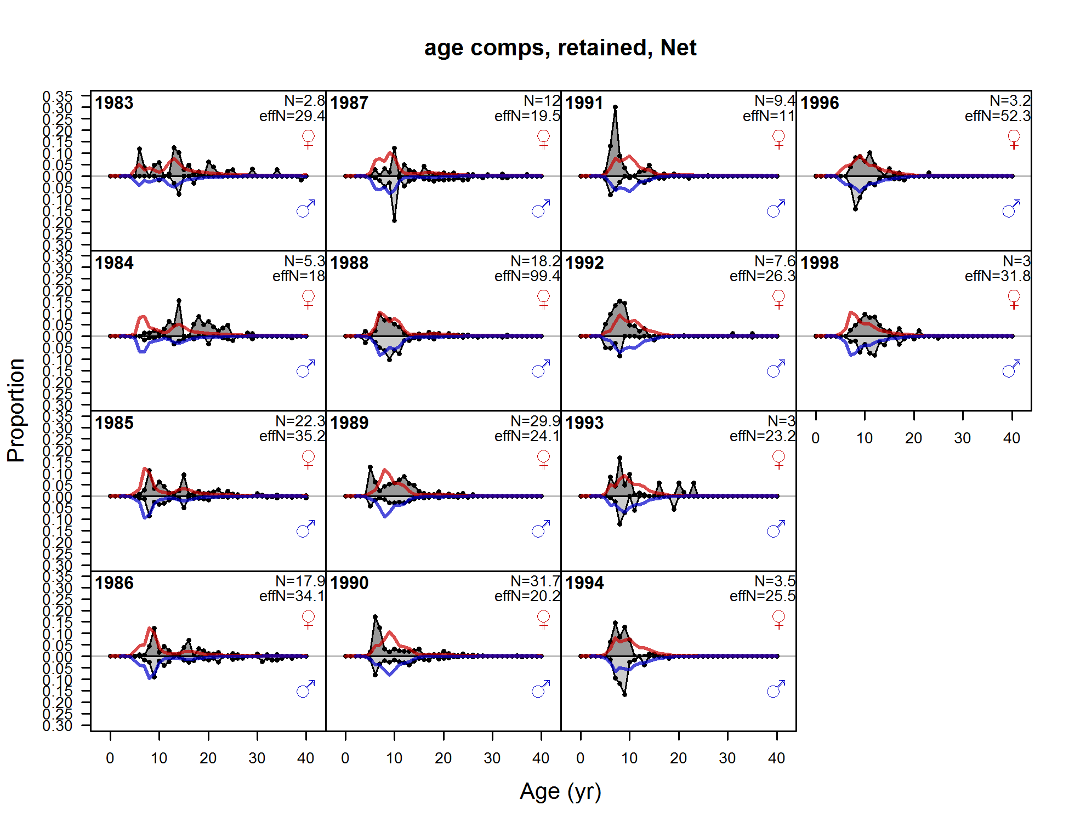

**Figure A13: Fits to the retained age compositions for the net fleet.**

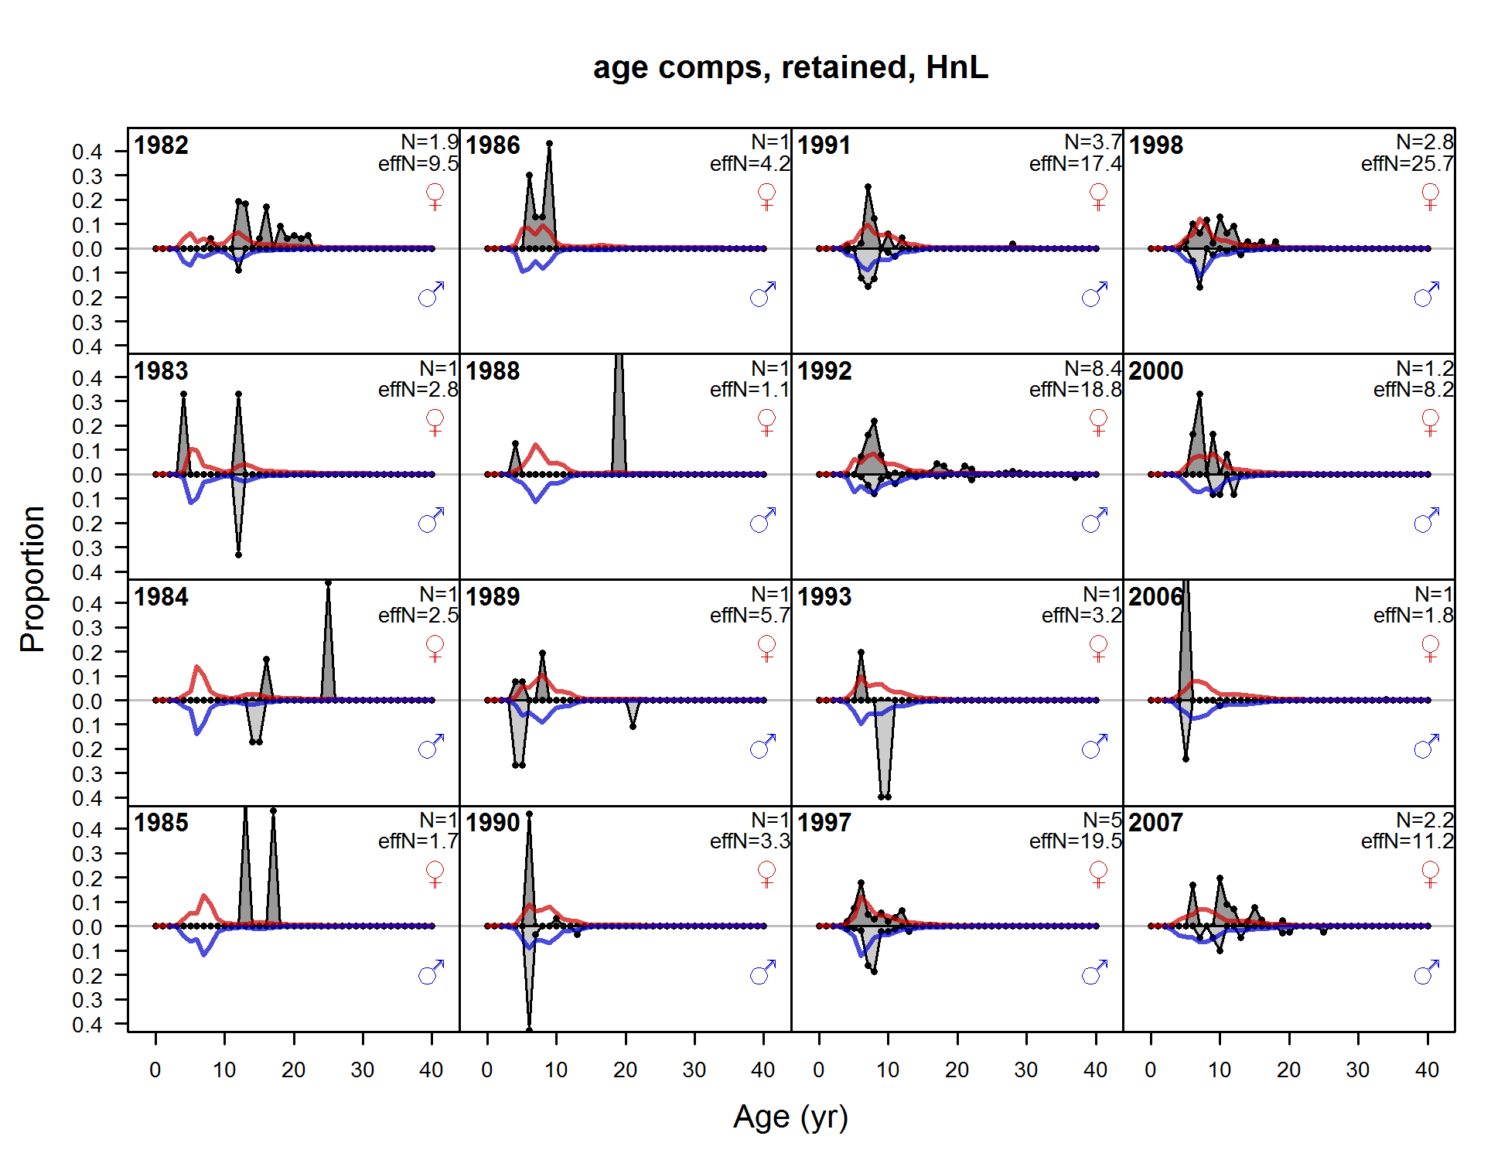

**Figure A14: Fits to the retained age compositions for the hook-and-line fleet.**

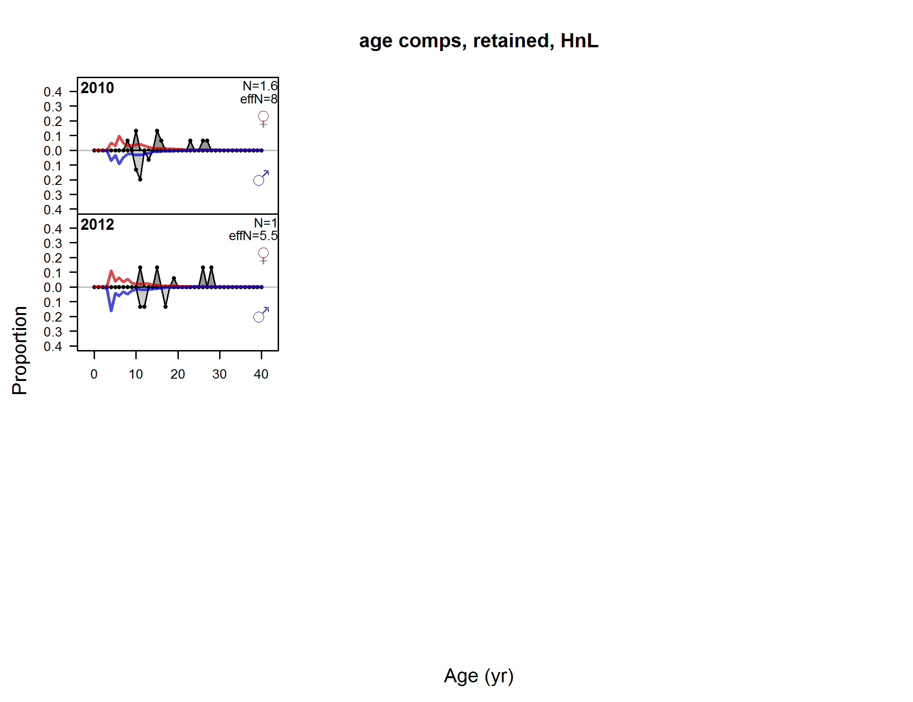

**Figure A14: (continued) Fits to the retained age compositions for the hook-and-line fleet.**

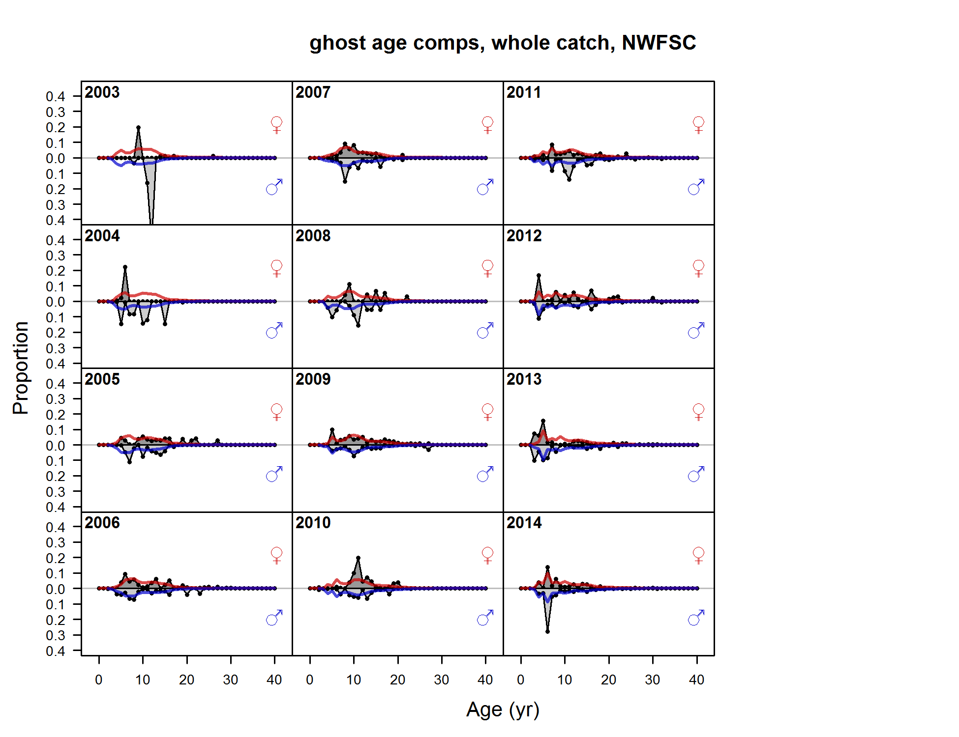

Figure A15: Implied fits to the age compositions for the NWFSC shelf/slope survey.

1. Predicted numbers-at-age

Female numbers-at-age

|  |  |  |  |  |  |  |  |  |  |  |  |  |  |  |
| --- | --- | --- | --- | --- | --- | --- | --- | --- | --- | --- | --- | --- | --- | --- |
|  |  |  |  |  |  |  | Age |  |  |  |  |  |  |  |
| Year | 0 | 1 | 2 | 3 | 4 | 5 | 6 | 7 | 8 | 9 | 10-19 | 20-29 | 30-39 | 40+ |
| 1916 | 27,195 | 23,244 | 19,866 | 16,979 | 14,511 | 12,401 | 10,598 | 9,057 | 7,740 | 6,615 | 30,795 | 6,394 | 1,327 | 59 |
| 1917 | 27,187 | 23,238 | 19,862 | 16,976 | 14,508 | 12,399 | 10,595 | 9,053 | 7,736 | 6,611 | 30,776 | 6,391 | 1,327 | 59 |
| 1918 | 27,178 | 23,231 | 19,857 | 16,972 | 14,506 | 12,396 | 10,592 | 9,048 | 7,730 | 6,605 | 30,746 | 6,385 | 1,325 | 59 |
| 1919 | 27,167 | 23,224 | 19,852 | 16,968 | 14,503 | 12,394 | 10,589 | 9,045 | 7,725 | 6,599 | 30,713 | 6,378 | 1,324 | 59 |
| 1920 | 27,156 | 23,215 | 19,845 | 16,963 | 14,500 | 12,392 | 10,588 | 9,045 | 7,724 | 6,597 | 30,691 | 6,374 | 1,323 | 59 |
| 1921 | 27,144 | 23,205 | 19,837 | 16,958 | 14,495 | 12,389 | 10,587 | 9,044 | 7,724 | 6,596 | 30,671 | 6,369 | 1,322 | 59 |
| 1922 | 27,130 | 23,195 | 19,829 | 16,951 | 14,490 | 12,386 | 10,585 | 9,043 | 7,724 | 6,597 | 30,658 | 6,365 | 1,321 | 59 |
| 1923 | 27,115 | 23,183 | 19,820 | 16,944 | 14,485 | 12,382 | 10,582 | 9,042 | 7,724 | 6,597 | 30,650 | 6,361 | 1,321 | 59 |
| 1924 | 27,098 | 23,170 | 19,810 | 16,937 | 14,479 | 12,377 | 10,578 | 9,039 | 7,723 | 6,597 | 30,643 | 6,357 | 1,320 | 59 |
| 1925 | 27,078 | 23,155 | 19,799 | 16,928 | 14,472 | 12,372 | 10,575 | 9,037 | 7,722 | 6,597 | 30,644 | 6,355 | 1,319 | 59 |
| 1926 | 27,056 | 23,139 | 19,787 | 16,919 | 14,465 | 12,366 | 10,570 | 9,034 | 7,719 | 6,595 | 30,642 | 6,351 | 1,319 | 59 |
| 1927 | 27,031 | 23,120 | 19,773 | 16,908 | 14,457 | 12,360 | 10,565 | 9,029 | 7,715 | 6,592 | 30,633 | 6,346 | 1,318 | 59 |
| 1928 | 27,003 | 23,098 | 19,756 | 16,896 | 14,448 | 12,353 | 10,560 | 9,025 | 7,711 | 6,589 | 30,627 | 6,342 | 1,317 | 59 |
| 1929 | 26,970 | 23,074 | 19,738 | 16,882 | 14,438 | 12,345 | 10,554 | 9,020 | 7,707 | 6,585 | 30,617 | 6,338 | 1,316 | 59 |
| 1930 | 26,933 | 23,046 | 19,717 | 16,866 | 14,426 | 12,336 | 10,547 | 9,015 | 7,704 | 6,582 | 30,606 | 6,334 | 1,315 | 59 |
| 1931 | 26,891 | 23,015 | 19,693 | 16,849 | 14,412 | 12,326 | 10,539 | 9,008 | 7,698 | 6,578 | 30,589 | 6,329 | 1,314 | 59 |
| 1932 | 26,844 | 22,979 | 19,667 | 16,828 | 14,397 | 12,315 | 10,530 | 9,002 | 7,693 | 6,574 | 30,574 | 6,325 | 1,313 | 59 |
| 1933 | 26,791 | 22,939 | 19,636 | 16,805 | 14,380 | 12,302 | 10,521 | 8,994 | 7,687 | 6,569 | 30,557 | 6,322 | 1,312 | 59 |
| 1934 | 26,731 | 22,893 | 19,602 | 16,779 | 14,360 | 12,287 | 10,510 | 8,987 | 7,682 | 6,565 | 30,542 | 6,320 | 1,311 | 58 |
| 1935 | 26,662 | 22,842 | 19,563 | 16,750 | 14,338 | 12,270 | 10,498 | 8,978 | 7,675 | 6,560 | 30,525 | 6,319 | 1,310 | 58 |
| 1936 | 26,585 | 22,783 | 19,519 | 16,716 | 14,313 | 12,251 | 10,483 | 8,967 | 7,667 | 6,554 | 30,505 | 6,316 | 1,309 | 58 |
| 1937 | 26,497 | 22,717 | 19,469 | 16,679 | 14,284 | 12,230 | 10,466 | 8,954 | 7,657 | 6,547 | 30,481 | 6,314 | 1,308 | 58 |
| 1938 | 26,396 | 22,642 | 19,412 | 16,636 | 14,252 | 12,205 | 10,448 | 8,940 | 7,646 | 6,538 | 30,456 | 6,311 | 1,307 | 58 |
| 1939 | 26,280 | 22,555 | 19,348 | 16,588 | 14,216 | 12,178 | 10,428 | 8,925 | 7,635 | 6,530 | 30,432 | 6,309 | 1,306 | 58 |
| 1940 | 26,148 | 22,456 | 19,274 | 16,533 | 14,175 | 12,147 | 10,405 | 8,908 | 7,623 | 6,521 | 30,407 | 6,308 | 1,305 | 58 |
| 1941 | 25,997 | 22,344 | 19,189 | 16,470 | 14,128 | 12,112 | 10,378 | 8,887 | 7,607 | 6,509 | 30,369 | 6,303 | 1,304 | 58 |
| 1942 | 25,827 | 22,215 | 19,093 | 16,398 | 14,074 | 12,072 | 10,348 | 8,864 | 7,589 | 6,494 | 30,323 | 6,299 | 1,303 | 58 |
| 1943 | 25,639 | 22,069 | 18,983 | 16,315 | 14,012 | 12,026 | 10,313 | 8,838 | 7,568 | 6,478 | 30,269 | 6,293 | 1,302 | 58 |
| 1944 | 25,437 | 21,909 | 18,858 | 16,221 | 13,941 | 11,972 | 10,270 | 8,799 | 7,532 | 6,445 | 30,128 | 6,269 | 1,297 | 58 |
| 1945 | 25,217 | 21,736 | 18,722 | 16,115 | 13,861 | 11,911 | 10,218 | 8,748 | 7,479 | 6,393 | 29,873 | 6,222 | 1,288 | 57 |
| 1946 | 24,982 | 21,548 | 18,574 | 15,998 | 13,770 | 11,840 | 10,157 | 8,684 | 7,408 | 6,318 | 29,462 | 6,141 | 1,272 | 57 |
| 1947 | 24,756 | 21,348 | 18,413 | 15,871 | 13,670 | 11,764 | 10,102 | 8,645 | 7,372 | 6,278 | 29,173 | 6,083 | 1,260 | 56 |
| 1948 | 24,537 | 21,154 | 18,242 | 15,734 | 13,562 | 11,679 | 10,043 | 8,613 | 7,360 | 6,271 | 29,025 | 6,051 | 1,254 | 56 |
| 1949 | 24,332 | 20,967 | 18,076 | 15,588 | 13,445 | 11,588 | 9,974 | 8,567 | 7,340 | 6,267 | 28,938 | 6,027 | 1,249 | 56 |
| 1950 | 24,154 | 20,792 | 17,917 | 15,446 | 13,320 | 11,488 | 9,897 | 8,511 | 7,305 | 6,255 | 28,890 | 6,007 | 1,246 | 55 |
| 1951 | 24,026 | 20,640 | 17,767 | 15,310 | 13,199 | 11,381 | 9,810 | 8,444 | 7,255 | 6,223 | 28,831 | 5,984 | 1,242 | 55 |
| 1952 | 23,975 | 20,531 | 17,637 | 15,182 | 13,083 | 11,277 | 9,717 | 8,367 | 7,192 | 6,175 | 28,727 | 5,953 | 1,237 | 55 |
| 1953 | 24,040 | 20,487 | 17,544 | 15,071 | 12,973 | 11,178 | 9,629 | 8,288 | 7,127 | 6,122 | 28,605 | 5,923 | 1,231 | 55 |
| 1954 | 24,261 | 20,543 | 17,507 | 14,991 | 12,878 | 11,085 | 9,546 | 8,215 | 7,063 | 6,069 | 28,479 | 5,895 | 1,227 | 55 |
| 1955 | 24,674 | 20,731 | 17,554 | 14,960 | 12,810 | 11,004 | 9,466 | 8,144 | 7,001 | 6,015 | 28,337 | 5,868 | 1,222 | 54 |
| 1956 | 25,295 | 21,085 | 17,715 | 15,000 | 12,783 | 10,945 | 9,397 | 8,076 | 6,940 | 5,962 | 28,170 | 5,840 | 1,217 | 54 |
| 1957 | 26,060 | 21,615 | 18,017 | 15,138 | 12,818 | 10,922 | 9,345 | 8,012 | 6,876 | 5,904 | 27,953 | 5,808 | 1,211 | 54 |
| 1958 | 26,755 | 22,269 | 18,471 | 15,396 | 12,935 | 10,951 | 9,323 | 7,963 | 6,816 | 5,842 | 27,682 | 5,771 | 1,203 | 54 |
| 1959 | 27,032 | 22,863 | 19,029 | 15,783 | 13,156 | 11,052 | 9,349 | 7,946 | 6,776 | 5,793 | 27,414 | 5,741 | 1,196 | 53 |
| 1960 | 26,658 | 23,099 | 19,537 | 16,260 | 13,487 | 11,240 | 9,435 | 7,969 | 6,763 | 5,761 | 27,154 | 5,715 | 1,188 | 53 |
| 1961 | 25,898 | 22,780 | 19,739 | 16,694 | 13,895 | 11,523 | 9,594 | 8,038 | 6,776 | 5,743 | 26,877 | 5,682 | 1,179 | 53 |
| 1962 | 25,418 | 22,130 | 19,466 | 16,867 | 14,265 | 11,871 | 9,837 | 8,178 | 6,841 | 5,760 | 26,666 | 5,654 | 1,172 | 52 |
| 1963 | 25,454 | 21,720 | 18,910 | 16,634 | 14,413 | 12,188 | 10,134 | 8,383 | 6,956 | 5,811 | 26,492 | 5,618 | 1,163 | 52 |
| 1964 | 26,137 | 21,751 | 18,560 | 16,159 | 14,214 | 12,315 | 10,408 | 8,646 | 7,144 | 5,924 | 26,475 | 5,593 | 1,158 | 52 |
| 1965 | 27,097 | 22,334 | 18,587 | 15,860 | 13,808 | 12,144 | 10,514 | 8,875 | 7,361 | 6,077 | 26,527 | 5,557 | 1,151 | 52 |
| 1966 | 28,435 | 23,155 | 19,085 | 15,882 | 13,552 | 11,798 | 10,373 | 8,976 | 7,572 | 6,278 | 26,792 | 5,534 | 1,147 | 51 |
| 1967 | 28,621 | 24,298 | 19,786 | 16,308 | 13,572 | 11,576 | 10,051 | 8,775 | 7,519 | 6,285 | 26,202 | 5,296 | 1,100 | 49 |
| 1968 | 27,281 | 24,457 | 20,763 | 16,907 | 13,935 | 11,592 | 9,855 | 8,486 | 7,326 | 6,213 | 25,614 | 5,035 | 1,050 | 47 |
| 1969 | 23,527 | 23,312 | 20,899 | 17,742 | 14,447 | 11,905 | 9,886 | 8,371 | 7,167 | 6,155 | 25,694 | 4,899 | 1,026 | 46 |
| 1970 | 91,783 | 20,104 | 19,921 | 17,858 | 15,161 | 12,344 | 10,163 | 8,425 | 7,119 | 6,085 | 26,123 | 4,841 | 1,019 | 45 |
| 1971 | 82,674 | 78,430 | 17,179 | 17,022 | 15,260 | 12,954 | 10,540 | 8,664 | 7,168 | 6,046 | 26,432 | 4,787 | 1,012 | 45 |

|  |  |  |  |  |  |  |  |  |  |  |  |  |  |  |
| --- | --- | --- | --- | --- | --- | --- | --- | --- | --- | --- | --- | --- | --- | --- |
|  |  |  |  |  |  |  | Age |  |  |  |  |  |  |  |
| Year | 0 | 1 | 2 | 3 | 4 | 5 | 6 | 7 | 8 | 9 | 10-19 | 20-29 | 30-39 | 40+ |
| 1972 | 10,066 | 70,646 | 67,020 | 14,680 | 14,546 | 13,038 | 11,058 | 8,979 | 7,362 | 6,077 | 26,606 | 4,728 | 1,002 | 44 |
| 1973 | 8,257 | 8,602 | 60,368 | 57,269 | 12,544 | 12,428 | 11,130 | 9,423 | 7,635 | 6,249 | 26,829 | 4,688 | 994 | 44 |
| 1974 | 10,830 | 7,055 | 7,350 | 51,585 | 48,937 | 10,717 | 10,608 | 9,480 | 8,004 | 6,471 | 27,101 | 4,653 | 983 | 44 |
| 1975 | 21,152 | 9,254 | 6,029 | 6,281 | 44,080 | 41,811 | 9,149 | 9,040 | 8,063 | 6,796 | 27,575 | 4,649 | 974 | 43 |
| 1976 | 6,965 | 18,075 | 7,908 | 5,152 | 5,367 | 37,662 | 35,697 | 7,799 | 7,691 | 6,849 | 28,246 | 4,674 | 964 | 43 |
| 1977 | 38,788 | 5,952 | 15,445 | 6,757 | 4,402 | 4,585 | 32,146 | 30,403 | 6,624 | 6,518 | 28,742 | 4,711 | 951 | 43 |
| 1978 | 63,060 | 33,145 | 5,086 | 13,198 | 5,774 | 3,761 | 3,914 | 27,388 | 25,851 | 5,625 | 28,941 | 4,791 | 941 | 42 |
| 1979 | 19,429 | 53,886 | 28,323 | 4,346 | 11,278 | 4,933 | 3,209 | 3,331 | 23,243 | 21,897 | 28,251 | 4,870 | 928 | 42 |
| 1980 | 35,512 | 16,602 | 46,046 | 24,202 | 3,713 | 9,620 | 4,166 | 2,656 | 2,702 | 18,627 | 39,431 | 4,802 | 891 | 41 |
| 1981 | 58,280 | 30,345 | 14,186 | 39,346 | 20,678 | 3,158 | 7,962 | 3,260 | 1,960 | 1,924 | 41,191 | 4,449 | 812 | 37 |
| 1982 | 31,265 | 49,801 | 25,929 | 12,122 | 33,614 | 17,531 | 2,556 | 5,837 | 2,145 | 1,207 | 27,527 | 3,918 | 710 | 32 |
| 1983 | 19,353 | 26,716 | 42,553 | 22,156 | 10,355 | 28,428 | 13,946 | 1,781 | 3,499 | 1,168 | 16,955 | 3,246 | 590 | 27 |
| 1984 | 35,539 | 16,537 | 22,829 | 36,361 | 18,930 | 8,809 | 23,508 | 10,857 | 1,299 | 2,448 | 12,314 | 2,753 | 497 | 22 |
| 1985 | 26,496 | 30,368 | 14,131 | 19,507 | 31,068 | 16,103 | 7,271 | 18,177 | 7,834 | 901 | 10,219 | 2,419 | 435 | 19 |
| 1986 | 13,629 | 22,641 | 25,949 | 12,075 | 16,667 | 26,446 | 13,362 | 5,709 | 13,466 | 5,612 | 7,845 | 2,170 | 391 | 17 |
| 1987 | 34,275 | 11,646 | 19,347 | 22,174 | 10,317 | 14,188 | 21,957 | 10,516 | 4,245 | 9,681 | 9,472 | 1,909 | 350 | 15 |
| 1988 | 20,056 | 29,289 | 9,951 | 16,531 | 18,945 | 8,773 | 11,678 | 16,840 | 7,478 | 2,888 | 12,944 | 1,600 | 306 | 13 |
| 1989 | 15,796 | 17,138 | 25,027 | 8,503 | 14,125 | 16,122 | 7,268 | 9,138 | 12,405 | 5,318 | 11,213 | 1,329 | 275 | 11 |
| 1990 | 24,269 | 13,498 | 14,644 | 21,385 | 7,265 | 12,009 | 13,258 | 5,561 | 6,474 | 8,405 | 10,860 | 1,479 | 239 | 10 |
| 1991 | 41,792 | 20,738 | 11,534 | 12,513 | 18,271 | 6,177 | 9,894 | 10,213 | 3,981 | 4,421 | 12,725 | 1,376 | 200 | 8 |
| 1992 | 16,565 | 35,712 | 17,721 | 9,855 | 10,692 | 15,558 | 5,150 | 7,889 | 7,756 | 2,927 | 12,453 | 1,020 | 174 | 7 |
| 1993 | 20,739 | 14,155 | 30,516 | 15,142 | 8,421 | 9,103 | 12,970 | 4,110 | 6,004 | 5,718 | 11,189 | 748 | 151 | 6 |
| 1994 | 19,411 | 17,721 | 12,095 | 26,075 | 12,937 | 7,161 | 7,522 | 10,086 | 2,990 | 4,179 | 11,606 | 531 | 125 | 5 |
| 1995 | 13,211 | 16,587 | 15,143 | 10,335 | 22,279 | 11,012 | 5,951 | 5,944 | 7,542 | 2,156 | 11,242 | 430 | 108 | 4 |
| 1996 | 9,584 | 11,289 | 14,174 | 12,939 | 8,831 | 18,958 | 9,130 | 4,669 | 4,390 | 5,355 | 9,440 | 314 | 91 | 4 |
| 1997 | 13,116 | 8,190 | 9,646 | 12,111 | 11,056 | 7,517 | 15,768 | 7,227 | 3,499 | 3,170 | 10,446 | 351 | 78 | 3 |
| 1998 | 24,318 | 11,208 | 6,998 | 8,243 | 10,348 | 9,409 | 6,239 | 12,407 | 5,367 | 2,504 | 9,482 | 473 | 65 | 3 |
| 1999 | 22,604 | 20,780 | 9,577 | 5,980 | 7,043 | 8,816 | 7,879 | 5,038 | 9,627 | 4,051 | 8,860 | 419 | 54 | 3 |
| 2000 | 23,407 | 19,316 | 17,757 | 8,184 | 5,109 | 6,002 | 7,389 | 6,377 | 3,930 | 7,339 | 9,715 | 441 | 64 | 2 |
| 2001 | 12,865 | 20,002 | 16,505 | 15,173 | 6,993 | 4,356 | 5,039 | 6,005 | 5,015 | 3,040 | 13,134 | 601 | 68 | 2 |
| 2002 | 11,134 | 10,993 | 17,092 | 14,104 | 12,965 | 5,969 | 3,691 | 4,202 | 4,929 | 4,083 | 13,104 | 665 | 57 | 2 |
| 2003 | 12,502 | 9,514 | 9,394 | 14,605 | 12,052 | 11,077 | 5,094 | 3,141 | 3,567 | 4,177 | 14,422 | 688 | 48 | 2 |
| 2004 | 33,159 | 10,684 | 8,130 | 8,027 | 12,480 | 10,298 | 9,465 | 4,351 | 2,683 | 3,046 | 15,595 | 868 | 42 | 2 |
| 2005 | 8,182 | 28,335 | 9,129 | 6,947 | 6,859 | 10,664 | 8,798 | 8,083 | 3,714 | 2,289 | 15,646 | 988 | 39 | 2 |
| 2006 | 26,851 | 6,992 | 24,213 | 7,801 | 5,936 | 5,861 | 9,110 | 7,510 | 6,893 | 3,165 | 15,118 | 992 | 34 | 2 |
| 2007 | 11,235 | 22,945 | 5,975 | 20,690 | 6,666 | 5,072 | 5,007 | 7,777 | 6,406 | 5,875 | 15,109 | 1,283 | 45 | 2 |
| 2008 | 78,610 | 9,600 | 19,606 | 5,106 | 17,680 | 5,696 | 4,333 | 4,274 | 6,633 | 5,459 | 17,544 | 1,375 | 71 | 1 |
| 2009 | 16,357 | 67,173 | 8,204 | 16,754 | 4,363 | 15,106 | 4,865 | 3,698 | 3,644 | 5,650 | 19,278 | 1,455 | 71 | 5 |
| 2010 | 60,311 | 13,977 | 57,400 | 7,010 | 14,316 | 3,728 | 12,905 | 4,154 | 3,155 | 3,107 | 20,701 | 1,756 | 82 | 4 |
| 2011 | 11,480 | 51,536 | 11,944 | 49,049 | 5,990 | 12,233 | 3,185 | 11,018 | 3,544 | 2,691 | 19,203 | 2,535 | 117 | 0 |
| 2012 | 21,722 | 9,810 | 44,039 | 10,206 | 41,913 | 5,118 | 10,450 | 2,719 | 9,400 | 3,021 | 18,157 | 2,622 | 133 | 0 |
| 2013 | 38,174 | 18,562 | 8,383 | 37,632 | 8,721 | 35,814 | 4,372 | 8,921 | 2,319 | 8,009 | 17,334 | 2,902 | 138 | 1 |
| 2014 | 33,054 | 32,621 | 15,861 | 7,163 | 32,156 | 7,451 | 30,581 | 3,728 | 7,593 | 1,971 | 20,816 | 3,125 | 174 | 1 |

Male numbers-at-age

|  |  |  |  |  |  |  |  |  |  |  |  |  |  |  |
| --- | --- | --- | --- | --- | --- | --- | --- | --- | --- | --- | --- | --- | --- | --- |
|  |  |  |  |  |  |  | Age |  |  |  |  |  |  |  |
| Year | 0 | 1 | 2 | 3 | 4 | 5 | 6 | 7 | 8 | 9 | 10-19 | 20-29 | 30-39 | 40+ |
| 1916 | 27,195 | 22,938 | 19,347 | 16,318 | 13,763 | 11,607 | 9,790 | 8,256 | 6,963 | 5,872 | 25,859 | 4,704 | 855 | 35 |
| 1917 | 27,187 | 22,933 | 19,344 | 16,315 | 13,760 | 11,605 | 9,786 | 8,252 | 6,959 | 5,869 | 25,842 | 4,701 | 855 | 35 |
| 1918 | 27,178 | 22,926 | 19,339 | 16,312 | 13,758 | 11,602 | 9,783 | 8,247 | 6,953 | 5,863 | 25,818 | 4,697 | 854 | 35 |
| 1919 | 27,167 | 22,918 | 19,333 | 16,308 | 13,755 | 11,600 | 9,780 | 8,244 | 6,949 | 5,858 | 25,790 | 4,692 | 853 | 35 |
| 1920 | 27,156 | 22,910 | 19,327 | 16,303 | 13,752 | 11,598 | 9,779 | 8,243 | 6,948 | 5,856 | 25,771 | 4,689 | 853 | 35 |
| 1921 | 27,144 | 22,900 | 19,319 | 16,298 | 13,748 | 11,596 | 9,778 | 8,243 | 6,947 | 5,855 | 25,754 | 4,685 | 852 | 35 |
| 1922 | 27,130 | 22,890 | 19,311 | 16,292 | 13,744 | 11,593 | 9,776 | 8,242 | 6,947 | 5,855 | 25,742 | 4,682 | 852 | 35 |
| 1923 | 27,115 | 22,878 | 19,303 | 16,285 | 13,738 | 11,589 | 9,774 | 8,241 | 6,947 | 5,856 | 25,735 | 4,680 | 851 | 35 |
| 1924 | 27,098 | 22,866 | 19,293 | 16,278 | 13,733 | 11,584 | 9,770 | 8,239 | 6,946 | 5,855 | 25,729 | 4,677 | 851 | 35 |
| 1925 | 27,078 | 22,851 | 19,282 | 16,270 | 13,726 | 11,580 | 9,767 | 8,237 | 6,945 | 5,855 | 25,730 | 4,675 | 850 | 35 |
| 1926 | 27,056 | 22,835 | 19,270 | 16,260 | 13,720 | 11,575 | 9,763 | 8,234 | 6,943 | 5,854 | 25,728 | 4,672 | 850 | 35 |
| 1927 | 27,031 | 22,816 | 19,256 | 16,250 | 13,712 | 11,568 | 9,758 | 8,229 | 6,939 | 5,851 | 25,721 | 4,669 | 849 | 35 |
| 1928 | 27,003 | 22,795 | 19,241 | 16,238 | 13,703 | 11,562 | 9,753 | 8,226 | 6,936 | 5,849 | 25,715 | 4,666 | 849 | 35 |
| 1929 | 26,970 | 22,771 | 19,223 | 16,225 | 13,693 | 11,555 | 9,748 | 8,221 | 6,933 | 5,846 | 25,707 | 4,663 | 848 | 35 |
| 1930 | 26,933 | 22,743 | 19,202 | 16,210 | 13,682 | 11,546 | 9,742 | 8,217 | 6,929 | 5,843 | 25,698 | 4,659 | 848 | 35 |
| 1931 | 26,891 | 22,712 | 19,179 | 16,193 | 13,669 | 11,537 | 9,734 | 8,210 | 6,924 | 5,839 | 25,683 | 4,656 | 847 | 35 |
| 1932 | 26,844 | 22,677 | 19,153 | 16,173 | 13,655 | 11,526 | 9,726 | 8,204 | 6,919 | 5,835 | 25,671 | 4,653 | 846 | 35 |
| 1933 | 26,791 | 22,637 | 19,123 | 16,151 | 13,639 | 11,514 | 9,717 | 8,198 | 6,914 | 5,831 | 25,657 | 4,651 | 846 | 35 |
| 1934 | 26,731 | 22,592 | 19,090 | 16,126 | 13,620 | 11,500 | 9,708 | 8,191 | 6,910 | 5,827 | 25,644 | 4,649 | 845 | 35 |
| 1935 | 26,662 | 22,542 | 19,052 | 16,098 | 13,599 | 11,485 | 9,696 | 8,183 | 6,904 | 5,823 | 25,630 | 4,648 | 844 | 35 |
| 1936 | 26,585 | 22,484 | 19,009 | 16,066 | 13,575 | 11,467 | 9,682 | 8,173 | 6,896 | 5,818 | 25,613 | 4,646 | 844 | 35 |
| 1937 | 26,497 | 22,419 | 18,960 | 16,030 | 13,548 | 11,446 | 9,667 | 8,161 | 6,887 | 5,811 | 25,592 | 4,644 | 843 | 35 |
| 1938 | 26,396 | 22,344 | 18,905 | 15,989 | 13,518 | 11,424 | 9,650 | 8,148 | 6,877 | 5,804 | 25,571 | 4,642 | 842 | 35 |
| 1939 | 26,280 | 22,259 | 18,843 | 15,942 | 13,483 | 11,398 | 9,632 | 8,135 | 6,868 | 5,796 | 25,551 | 4,641 | 842 | 35 |
| 1940 | 26,148 | 22,161 | 18,771 | 15,890 | 13,444 | 11,370 | 9,610 | 8,119 | 6,857 | 5,788 | 25,530 | 4,640 | 841 | 35 |
| 1941 | 25,997 | 22,050 | 18,688 | 15,829 | 13,399 | 11,336 | 9,585 | 8,100 | 6,842 | 5,777 | 25,497 | 4,637 | 841 | 35 |
| 1942 | 25,827 | 21,923 | 18,594 | 15,760 | 13,348 | 11,299 | 9,557 | 8,079 | 6,826 | 5,765 | 25,459 | 4,633 | 840 | 35 |
| 1943 | 25,639 | 21,779 | 18,487 | 15,680 | 13,290 | 11,256 | 9,526 | 8,055 | 6,807 | 5,750 | 25,413 | 4,629 | 839 | 35 |
| 1944 | 25,437 | 21,621 | 18,366 | 15,590 | 13,223 | 11,206 | 9,485 | 8,019 | 6,774 | 5,721 | 25,296 | 4,611 | 836 | 35 |
| 1945 | 25,217 | 21,450 | 18,233 | 15,488 | 13,146 | 11,148 | 9,436 | 7,971 | 6,726 | 5,675 | 25,082 | 4,577 | 830 | 34 |
| 1946 | 24,982 | 21,265 | 18,089 | 15,375 | 13,060 | 11,082 | 9,379 | 7,911 | 6,661 | 5,608 | 24,740 | 4,517 | 819 | 34 |
| 1947 | 24,756 | 21,067 | 17,932 | 15,254 | 12,966 | 11,010 | 9,328 | 7,875 | 6,627 | 5,571 | 24,498 | 4,475 | 812 | 33 |
| 1948 | 24,537 | 20,876 | 17,766 | 15,122 | 12,863 | 10,931 | 9,274 | 7,847 | 6,616 | 5,563 | 24,374 | 4,451 | 808 | 33 |
| 1949 | 24,332 | 20,692 | 17,604 | 14,981 | 12,752 | 10,846 | 9,211 | 7,807 | 6,599 | 5,560 | 24,299 | 4,433 | 805 | 33 |
| 1950 | 24,154 | 20,518 | 17,449 | 14,845 | 12,633 | 10,752 | 9,140 | 7,756 | 6,569 | 5,550 | 24,258 | 4,418 | 803 | 33 |
| 1951 | 24,026 | 20,369 | 17,303 | 14,714 | 12,519 | 10,652 | 9,061 | 7,695 | 6,524 | 5,523 | 24,208 | 4,401 | 800 | 33 |
| 1952 | 23,975 | 20,261 | 17,177 | 14,591 | 12,408 | 10,555 | 8,975 | 7,625 | 6,468 | 5,480 | 24,121 | 4,379 | 797 | 33 |
| 1953 | 24,040 | 20,218 | 17,086 | 14,485 | 12,304 | 10,462 | 8,893 | 7,553 | 6,409 | 5,433 | 24,018 | 4,357 | 793 | 33 |
| 1954 | 24,261 | 20,273 | 17,049 | 14,408 | 12,215 | 10,375 | 8,816 | 7,486 | 6,351 | 5,386 | 23,911 | 4,337 | 790 | 33 |
| 1955 | 24,674 | 20,459 | 17,096 | 14,377 | 12,150 | 10,299 | 8,743 | 7,422 | 6,296 | 5,339 | 23,789 | 4,317 | 788 | 33 |
| 1956 | 25,295 | 20,808 | 17,252 | 14,416 | 12,124 | 10,244 | 8,679 | 7,360 | 6,241 | 5,292 | 23,646 | 4,297 | 784 | 32 |
| 1957 | 26,060 | 21,331 | 17,547 | 14,549 | 12,157 | 10,222 | 8,631 | 7,302 | 6,184 | 5,240 | 23,462 | 4,273 | 780 | 32 |
| 1958 | 26,755 | 21,976 | 17,988 | 14,797 | 12,268 | 10,249 | 8,610 | 7,257 | 6,129 | 5,185 | 23,233 | 4,246 | 775 | 32 |
| 1959 | 27,032 | 22,562 | 18,532 | 15,169 | 12,478 | 10,344 | 8,634 | 7,241 | 6,093 | 5,141 | 23,008 | 4,223 | 770 | 32 |
| 1960 | 26,658 | 22,796 | 19,026 | 15,628 | 12,792 | 10,520 | 8,713 | 7,261 | 6,081 | 5,112 | 22,790 | 4,204 | 766 | 32 |
| 1961 | 25,898 | 22,480 | 19,223 | 16,045 | 13,178 | 10,785 | 8,860 | 7,324 | 6,093 | 5,096 | 22,559 | 4,180 | 760 | 31 |
| 1962 | 25,418 | 21,839 | 18,957 | 16,211 | 13,530 | 11,111 | 9,085 | 7,452 | 6,151 | 5,112 | 22,384 | 4,159 | 755 | 31 |
| 1963 | 25,454 | 21,434 | 18,417 | 15,986 | 13,670 | 11,407 | 9,359 | 7,638 | 6,255 | 5,157 | 22,241 | 4,133 | 750 | 31 |
| 1964 | 26,137 | 21,465 | 18,075 | 15,530 | 13,481 | 11,526 | 9,613 | 7,879 | 6,424 | 5,257 | 22,232 | 4,115 | 746 | 31 |
| 1965 | 27,097 | 22,041 | 18,101 | 15,243 | 13,096 | 11,366 | 9,711 | 8,087 | 6,619 | 5,393 | 22,282 | 4,087 | 742 | 31 |
| 1966 | 28,435 | 22,851 | 18,586 | 15,264 | 12,854 | 11,043 | 9,581 | 8,180 | 6,809 | 5,571 | 22,514 | 4,070 | 739 | 31 |
| 1967 | 28,621 | 23,979 | 19,269 | 15,674 | 12,872 | 10,834 | 9,282 | 8,000 | 6,771 | 5,591 | 22,071 | 3,896 | 709 | 29 |
| 1968 | 27,281 | 24,135 | 20,221 | 16,250 | 13,217 | 10,849 | 9,101 | 7,736 | 6,600 | 5,535 | 21,636 | 3,705 | 677 | 28 |
| 1969 | 23,527 | 23,006 | 20,353 | 17,052 | 13,703 | 11,142 | 9,131 | 7,629 | 6,452 | 5,479 | 21,736 | 3,605 | 662 | 27 |
| 1970 | 91,783 | 19,840 | 19,400 | 17,163 | 14,379 | 11,553 | 9,386 | 7,678 | 6,404 | 5,408 | 22,099 | 3,563 | 657 | 27 |
| 1971 | 82,674 | 77,399 | 16,731 | 16,360 | 14,473 | 12,124 | 9,735 | 7,897 | 6,448 | 5,369 | 22,349 | 3,524 | 653 | 27 |

|  |  |  |  |  |  |  |  |  |  |  |  |  |  |  |
| --- | --- | --- | --- | --- | --- | --- | --- | --- | --- | --- | --- | --- | --- | --- |
|  |  |  |  |  |  |  | Age |  |  |  |  |  |  |  |
| Year | 0 | 1 | 2 | 3 | 4 | 5 | 6 | 7 | 8 | 9 | 10-19 | 20-29 | 30-39 | 40+ |
| 1972 | 10,066 | 69,717 | 65,270 | 14,108 | 13,796 | 12,203 | 10,213 | 8,184 | 6,623 | 5,397 | 22,480 | 3,482 | 646 | 27 |
| 1973 | 8,257 | 8,489 | 58,791 | 55,041 | 11,897 | 11,632 | 10,280 | 8,588 | 6,868 | 5,550 | 22,652 | 3,454 | 641 | 26 |
| 1974 | 10,830 | 6,963 | 7,158 | 49,578 | 46,414 | 10,031 | 9,797 | 8,640 | 7,200 | 5,747 | 22,872 | 3,431 | 634 | 26 |
| 1975 | 21,152 | 9,132 | 5,871 | 6,037 | 41,808 | 39,133 | 8,450 | 8,239 | 7,252 | 6,035 | 23,265 | 3,431 | 628 | 26 |
| 1976 | 6,965 | 17,837 | 7,701 | 4,951 | 5,090 | 35,250 | 32,968 | 7,107 | 6,918 | 6,081 | 23,830 | 3,454 | 622 | 26 |
| 1977 | 38,788 | 5,874 | 15,042 | 6,494 | 4,175 | 4,292 | 29,689 | 27,708 | 5,959 | 5,788 | 24,246 | 3,487 | 614 | 25 |
| 1978 | 63,060 | 32,709 | 4,953 | 12,684 | 5,476 | 3,520 | 3,615 | 24,958 | 23,249 | 4,994 | 24,395 | 3,551 | 607 | 25 |
| 1979 | 19,429 | 53,177 | 27,583 | 4,177 | 10,696 | 4,616 | 2,963 | 3,035 | 20,901 | 19,437 | 23,773 | 3,612 | 599 | 25 |
| 1980 | 35,512 | 16,384 | 44,843 | 23,260 | 3,522 | 9,000 | 3,841 | 2,415 | 2,425 | 16,506 | 33,316 | 3,492 | 563 | 24 |
| 1981 | 58,280 | 29,946 | 13,816 | 37,815 | 19,611 | 2,953 | 7,319 | 2,945 | 1,748 | 1,695 | 33,977 | 3,035 | 481 | 20 |
| 1982 | 31,265 | 49,146 | 25,252 | 11,650 | 31,879 | 16,379 | 2,340 | 5,223 | 1,889 | 1,049 | 20,889 | 2,347 | 369 | 16 |
| 1983 | 19,353 | 26,365 | 41,442 | 21,294 | 9,820 | 26,544 | 12,725 | 1,580 | 3,038 | 998 | 11,331 | 1,632 | 256 | 11 |
| 1984 | 35,539 | 16,320 | 22,233 | 34,946 | 17,954 | 8,237 | 21,571 | 9,703 | 1,130 | 2,090 | 8,152 | 1,357 | 212 | 9 |
| 1985 | 26,496 | 29,969 | 13,762 | 18,748 | 29,466 | 15,061 | 6,681 | 16,313 | 6,848 | 766 | 6,798 | 1,151 | 179 | 7 |
| 1986 | 13,629 | 22,343 | 25,272 | 11,605 | 15,808 | 24,739 | 12,290 | 5,139 | 11,842 | 4,807 | 5,159 | 1,005 | 156 | 6 |
| 1987 | 34,275 | 11,493 | 18,841 | 21,311 | 9,785 | 13,271 | 20,198 | 9,479 | 3,747 | 8,353 | 6,847 | 865 | 137 | 5 |
| 1988 | 20,056 | 28,904 | 9,692 | 15,888 | 17,968 | 8,205 | 10,730 | 15,141 | 6,589 | 2,493 | 9,925 | 703 | 115 | 4 |
| 1989 | 15,796 | 16,913 | 24,373 | 8,173 | 13,396 | 15,079 | 6,683 | 8,222 | 10,928 | 4,594 | 8,526 | 572 | 101 | 4 |
| 1990 | 24,269 | 13,320 | 14,262 | 20,553 | 6,891 | 11,231 | 12,179 | 4,996 | 5,693 | 7,236 | 8,387 | 647 | 84 | 3 |
| 1991 | 41,792 | 20,466 | 11,232 | 12,026 | 17,328 | 5,775 | 9,089 | 9,180 | 3,505 | 3,820 | 10,127 | 609 | 69 | 3 |
| 1992 | 16,565 | 35,242 | 17,258 | 9,472 | 10,140 | 14,551 | 4,737 | 7,116 | 6,858 | 2,541 | 9,936 | 446 | 59 | 2 |
| 1993 | 20,739 | 13,969 | 29,719 | 14,553 | 7,986 | 8,512 | 11,933 | 3,712 | 5,327 | 4,987 | 8,913 | 325 | 51 | 2 |
| 1994 | 19,411 | 17,489 | 11,780 | 25,061 | 12,270 | 6,695 | 6,911 | 9,091 | 2,652 | 3,653 | 9,331 | 230 | 42 | 2 |
| 1995 | 13,211 | 16,369 | 14,747 | 9,933 | 21,130 | 10,298 | 5,472 | 5,358 | 6,681 | 1,884 | 9,049 | 192 | 35 | 1 |
| 1996 | 9,584 | 11,140 | 13,804 | 12,436 | 8,375 | 17,729 | 8,394 | 4,209 | 3,887 | 4,671 | 7,510 | 141 | 30 | 1 |
| 1997 | 13,116 | 8,082 | 9,394 | 11,640 | 10,485 | 7,031 | 14,504 | 6,521 | 3,101 | 2,768 | 8,447 | 176 | 25 | 1 |
| 1998 | 24,318 | 11,061 | 6,815 | 7,922 | 9,814 | 8,799 | 5,737 | 11,189 | 4,755 | 2,184 | 7,654 | 260 | 21 | 1 |
| 1999 | 22,604 | 20,507 | 9,327 | 5,747 | 6,679 | 8,246 | 7,253 | 4,554 | 8,551 | 3,544 | 7,169 | 233 | 17 | 1 |
| 2000 | 23,407 | 19,062 | 17,293 | 7,865 | 4,846 | 5,615 | 6,804 | 5,768 | 3,494 | 6,419 | 7,902 | 257 | 21 | 1 |
| 2001 | 12,865 | 19,739 | 16,074 | 14,583 | 6,632 | 4,076 | 4,643 | 5,431 | 4,454 | 2,652 | 10,739 | 363 | 23 | 1 |
| 2002 | 11,134 | 10,849 | 16,645 | 13,555 | 12,297 | 5,586 | 3,405 | 3,812 | 4,389 | 3,569 | 10,640 | 402 | 19 | 1 |
| 2003 | 12,502 | 9,389 | 9,148 | 14,037 | 11,431 | 10,368 | 4,704 | 2,859 | 3,192 | 3,670 | 11,788 | 419 | 16 | 1 |
| 2004 | 33,159 | 10,543 | 7,917 | 7,715 | 11,837 | 9,639 | 8,742 | 3,965 | 2,410 | 2,690 | 12,834 | 543 | 14 | 1 |
| 2005 | 8,182 | 27,962 | 8,891 | 6,677 | 6,506 | 9,981 | 8,127 | 7,367 | 3,340 | 2,029 | 12,895 | 628 | 14 | 1 |
| 2006 | 26,851 | 6,900 | 23,580 | 7,497 | 5,630 | 5,486 | 8,414 | 6,846 | 6,201 | 2,810 | 12,435 | 633 | 12 | 1 |
| 2007 | 11,235 | 22,643 | 5,819 | 19,885 | 6,322 | 4,748 | 4,625 | 7,089 | 5,763 | 5,216 | 12,488 | 845 | 18 | 1 |
| 2008 | 78,610 | 9,474 | 19,094 | 4,907 | 16,768 | 5,331 | 4,002 | 3,896 | 5,968 | 4,847 | 14,648 | 920 | 32 | 0 |
| 2009 | 16,357 | 66,290 | 7,989 | 16,102 | 4,138 | 14,139 | 4,494 | 3,371 | 3,279 | 5,018 | 16,160 | 982 | 33 | 2 |
| 2010 | 60,311 | 13,793 | 55,902 | 6,737 | 13,578 | 3,489 | 11,920 | 3,786 | 2,838 | 2,759 | 17,414 | 1,210 | 41 | 1 |
| 2011 | 11,480 | 50,859 | 11,632 | 47,141 | 5,681 | 11,450 | 2,941 | 10,043 | 3,188 | 2,389 | 16,159 | 1,799 | 61 | 0 |
| 2012 | 21,722 | 9,681 | 42,889 | 9,809 | 39,753 | 4,791 | 9,653 | 2,478 | 8,456 | 2,683 | 15,223 | 1,866 | 71 | 0 |
| 2013 | 38,174 | 18,318 | 8,164 | 36,167 | 8,271 | 33,521 | 4,039 | 8,132 | 2,086 | 7,112 | 14,518 | 2,079 | 74 | 0 |
| 2014 | 33,054 | 32,192 | 15,447 | 6,885 | 30,499 | 6,974 | 28,245 | 3,398 | 6,831 | 1,750 | 17,586 | 2,252 | 95 | 1 |

1. SS data file

#C 2015 Widow Rockfish Assessment

#C Allan C. Hicks and Chantel R. Wetzel

#C NWFSC, NOAA, Seattle, WA

1916 #\_styr

2014 #\_endyr

1 #\_nseas

12 #\_months/season

1 #\_spawn\_seas

5 #\_Nfleet

4 #\_Nsurveys

1 #\_N\_areas

BottomTrawl%MidwaterTrawl%Hake%Net%HnL%JuvSurvey%Triennial%NWFSC%ForeignAtSea

#BTr MTr Hak Net HnL JvS Tri NWS FAS

# 1 2 3 4 5 6 7 8 9

0.5 0.5 0.5 0.5 0.5 0.5 0.55 0.65 0.5 #Fleet and survey timing in season

1 1 1 1 1 1 1 1 1 #Area of each fleet and survey

1 1 1 1 1 #Units of each fleet: 1=Biomass(mt),2=Numbers(1000s)

0.01 0.01 0.01 0.01 0.01 # SE of log(catch) by fleet for equilibrium and continuous options

2 #\_Ngenders

40 #\_Nages

0 0 0 0 0 #\_init\_equil\_catch\_for\_each\_fishery

99 #\_N\_lines\_of\_catch\_to\_read

#\_catch\_biomass(mt):\_columns\_are\_fisheries,year,season

#BottomTrawl MidwaterTrawl Hake Net HnL Year Season

6.20 0.00 0.00 0.00 72.11 1916 1

9.63 0.00 0.00 0.00 112.22 1917 1

11.23 0.00 0.00 0.00 128.84 1918 1

7.80 0.00 0.00 0.00 88.90 1919 1

7.96 0.00 0.00 0.00 91.01 1920 1

6.58 0.00 0.00 0.00 75.48 1921 1

5.66 0.00 0.00 0.00 65.58 1922 1

6.14 0.00 0.00 0.00 72.10 1923 1

3.62 0.00 0.00 0.00 46.64 1924 1

3.06 0.00 0.00 0.00 59.17 1925 1

8.68 0.00 0.00 0.00 85.96 1926 1

11.74 0.00 0.00 0.00 66.81 1927 1

16.60 0.00 0.00 0.00 72.80 1928 1

23.36 0.00 0.00 0.00 63.40 1929 1

20.80 0.00 0.00 0.00 91.56 1930 1

20.39 0.00 0.00 0.00 79.52 1931 1

22.13 0.00 0.00 0.00 77.96 1932 1

34.53 0.00 0.00 0.00 51.34 1933 1

30.69 0.00 0.00 0.00 60.23 1934 1

29.76 0.00 0.00 0.00 68.36 1935 1

25.17 0.00 0.00 0.00 85.48 1936 1

35.89 0.00 0.00 0.00 67.63 1937 1

33.27 0.00 0.00 0.00 50.56 1938 1

41.69 0.00 0.00 0.00 34.89 1939 1

75.27 0.00 0.00 0.00 45.37 1940 1

93.58 0.00 0.00 0.00 35.94 1941 1

133.37 0.00 0.00 0.00 13.27 1942 1

468.72 0.00 0.00 0.00 21.91 1943 1

921.32 0.00 0.00 0.00 39.37 1944 1

1553.45 0.00 0.00 0.00 67.92 1945 1

1089.08 0.00 0.00 0.00 70.98 1946 1

551.20 0.00 0.00 0.00 92.01 1947 1

436.80 0.00 0.00 0.00 40.86 1948 1

329.83 0.00 0.00 0.00 44.52 1949 1

359.46 0.00 0.00 0.00 64.15 1950 1

504.25 0.00 0.00 0.00 49.69 1951 1

501.06 0.00 0.00 0.00 40.42 1952 1

455.27 0.00 0.00 0.00 14.03 1953 1

426.22 0.00 0.00 0.00 21.71 1954 1

446.34 0.00 0.00 0.00 18.65 1955 1

558.84 0.00 0.00 0.00 42.04 1956 1

722.76 0.00 0.00 0.00 37.97 1957 1

664.89 0.00 0.00 0.00 36.74 1958 1

642.75 0.00 0.00 0.00 28.83 1959 1

788.79 0.00 0.00 0.00 22.08 1960 1

661.65 0.00 0.00 0.00 15.44 1961 1

741.75 0.00 0.00 0.00 15.80 1962 1

413.46 0.00 0.00 0.00 19.95 1963 1

588.18 0.00 0.00 0.00 13.11 1964 1

238.71 0.00 0.00 0.00 20.75 1965 1

579.45 0.00 3670.00 0.00 37.81 1966 1

886.31 0.00 3902.00 0.00 33.03 1967 1

412.41 0.00 1956.00 0.00 20.07 1968 1

469.50 0.00 358.00 0.00 19.98 1969 1

287.99 0.00 554.00 0.00 9.86 1970 1

378.59 0.00 701.00 0.00 12.04 1971 1

477.77 0.00 421.00 0.00 20.15 1972 1

481.42 0.00 656.00 0.00 18.25 1973 1

440.23 0.00 418.00 0.00 44.40 1974 1

450.93 0.00 391.16 0.00 30.00 1975 1

559.54 0.00 718.52 0.00 41.70 1976 1

924.82 0.00 119.34 0.00 40.75 1977 1

1215.76 0.00 191.88 0.00 161.22 1978 1

3139.81 5945.77 197.90 0.00 103.47 1979 1

5924.81 15580.85 272.00 0.00 59.63 1980 1

4868.53 22672.78 227.95 15.51 71.45 1981 1

4961.49 20650.50 157.51 38.11 186.56 1982 1

6625.36 3357.17 131.46 279.96 33.73 1983 1

3244.91 6425.92 294.74 324.80 26.62 1984 1

2575.58 5919.60 182.61 585.78 27.16 1985 1

3586.53 5346.79 256.77 500.83 83.39 1986 1

4145.12 8127.60 181.31 584.62 55.12 1987 1

4028.37 6090.58 231.61 220.71 73.46 1988 1

4513.47 7684.59 211.96 253.61 45.10 1989 1

5312.38 4373.87 230.18 411.15 134.37 1990 1

3864.50 2040.17 562.23 234.80 95.20 1991 1

4273.45 1466.21 451.49 45.43 175.50 1992 1

5655.13 2255.97 275.75 51.61 108.96 1993 1

3802.73 2161.90 612.07 58.40 81.71 1994 1

4086.87 2276.82 464.72 57.58 26.32 1995 1

3586.77 1846.39 837.74 16.12 32.67 1996 1

3777.00 2442.52 378.81 16.36 37.98 1997 1

2515.61 882.72 614.99 48.73 86.57 1998 1

1612.77 2050.19 386.14 10.03 43.77 1999 1

56.65 3665.02 288.67 6.76 14.48 2000 1

39.10 1689.78 218.63 7.03 7.23 2001 1

17.21 251.40 159.98 0.02 0.57 2002 1

3.57 9.67 27.10 0.41 0.82 2003 1

8.33 28.74 49.57 0.00 0.31 2004 1

3.13 32.82 157.99 0.13 1.22 2005 1

6.01 12.86 193.19 0.00 0.88 2006 1

4.81 1.55 228.39 2.91 1.93 2007 1

2.15 42.15 217.96 0.00 1.25 2008 1

4.19 36.45 135.35 0.21 0.41 2009 1

4.73 54.67 106.35 0.00 0.15 2010 1

18.34 43.88 149.65 0.00 0.12 2011 1

41.23 47.36 181.43 0.00 0.33 2012 1

51.27 241.09 176.41 0.00 0.98 2013 1

71.28 306.62 342.16 0.03 1.84 2014 1

#################################################################

72 #\_N\_cpue\_and\_surveyabundance\_observations

#\_Units: 0=numbers; 1=biomass; 2=F

#\_Errtype: -1=normal; 0=lognormal; >0=T

#\_Fleet Units Errtype

1 1 0 # 1 Bottom Trawl

2 1 0 # 2 Midwater Trawl

3 1 0 # 3 Hake

4 1 0 # 4 Net

5 1 0 # 5 HnL

6 0 0 # 6 SCJuvSurvey

7 1 0 # 7 Triennial

8 1 0 # 8 NWFSC

9 1 0 # 9 Foreign At-sea (overlaps with JV)

#\_year seas index obs se(log)

# Oregon bottom trawl survey same as in previous assessments (yers=16)

1984 1 1 331.4700 0.2121

1985 1 1 100.8800 0.1875

1986 1 1 227.0800 0.2928

1987 1 1 169.0800 0.2730

1988 1 1 93.9700 0.2897

1989 1 1 164.1000 0.1749

1990 1 1 78.4900 0.1348

1991 1 1 73.5900 0.1275

1992 1 1 83.1600 0.1179

1993 1 1 53.5800 0.1314

1994 1 1 100.3400 0.1128

1995 1 1 109.9600 0.1387

1996 1 1 94.8100 0.1357

1997 1 1 97.2300 0.1502

1998 1 1 56.5600 0.1718

1999 1 1 84.4600 0.1684

# JV At-sea Bycatch (years=7)

1983 1 3 2.8890 0.1202

1985 1 3 0.7760 0.1165

1986 1 3 0.8230 0.0809

1987 1 3 0.3200 0.0875

1988 1 3 0.6590 0.0774

1989 1 3 0.8240 0.0635

1990 1 3 0.7100 0.0740

# Dom At-sea Bycatch (years=8)

1991 1 3 1.2640 0.1251

1992 1 3 0.7810 0.1251

1993 1 3 0.8010 0.1038

1994 1 3 1.4650 0.0685

1995 1 3 0.4550 0.1057

1996 1 3 1.0180 0.0824

1997 1 3 0.8860 0.0767

1998 1 3 1.3300 0.0786

# Juvenile survey indices copied from Ralston report supllied by Field (03/20/2015) (year=9)

2004 1 6 73.6998 0.6013

2005 1 6 14.1540 0.6089

2006 1 6 3.2871 0.6013

2007 1 6 2.8577 0.5936

2008 1 6 7.5383 0.6089

2009 1 6 5.8124 0.6013

2011 1 6 7.3891 0.6240

2013 1 6 1032.7702 0.9800

2014 1 6 204.3839 0.9340

#Triennial Survey (delta-GLMM with gamma ECE and random strata:year effect) (years=9)

1980 1 7 7255.865841 0.732

1983 1 7 10838.68441 0.690

1986 1 7 5847.209382 0.774

1989 1 7 3884.95191 0.702

1992 1 7 7441.370551 0.707

1995 1 7 5885.029811 0.712

1998 1 7 9717.837618 0.696

2001 1 7 1980.617889 0.742

2004 1 7 1069.111566 0.853

# NWFSC combo survey (delta-GLMM gamma ECE with random strata:year and no covariates) (years=12)

2003 1 8 2779.535033 0.364

2004 1 8 1182.169013 0.485

2005 1 8 1760.564208 0.423

2006 1 8 2656.898268 0.362

2007 1 8 3035.756487 0.370

2008 1 8 1668.115919 0.428

2009 1 8 2836.496094 0.370

2010 1 8 3720.149288 0.353

2011 1 8 3613.069077 0.327

2012 1 8 2814.298996 0.369

2013 1 8 4121.929003 0.534

2014 1 8 2224.452458 0.344

# Foreign At-sea Bycatch (years=11)

1977 1 9 0.7700 0.1153

1978 1 9 1.2050 0.1118

1979 1 9 0.7030 0.1186

1980 1 9 1.9930 0.1311

1981 1 9 0.7280 0.1257

1982 1 9 0.2430 0.2467

1984 1 9 2.9370 0.1254

1985 1 9 0.4070 0.1074

1986 1 9 1.1110 0.1027

1987 1 9 0.3900 0.0881

1988 1 9 0.5130 0.1243

###########################################################

# #CHECK THE DISCARD AMOUNTS

3 #\_N\_fleets\_with\_discard

# #Fleet Units Error

1 1 -2

2 1 -2

5 1 -2

37 #\_N\_discard\_obs

# #I calculated median from ptEst and SElog

# #Year Season Fleet Observation Error

# #Bottom Trawl, Pikitch (years=3, limit it to the years of the study)

1985 1 1 462.9 0.4953

1986 1 1 534.8 0.5311

1987 1 1 1035.5 0.4257

# #EDCP (years=5)

1995 1 1 924.8 0.8318

1996 1 1 3084.5 0.6707

1997 1 1 3353.3 0.7506

1998 1 1 42.6 0.4880

1999 1 1 4.8 0.6878

# #WCGOP (years=12)

2002 1 1 13.22 0.4307

2003 1 1 1.21 0.8196

2004 1 1 5.13 0.7589

2005 1 1 10.17 0.4461

2006 1 1 0.03 1.3556

2007 1 1 13.86 0.6157

2008 1 1 3.90 0.4454

2009 1 1 26.57 0.3377

2010 1 1 22.74 0.5432

2011 1 1 0.08 0.05

2012 1 1 0.01 0.05

2013 1 1 2.43 0.05

# #Midwater Trawl, Pikitch (years=3, limit to years of study)

1985 1 2 1502.0 0.2409

1986 1 2 1321.2 0.2364

1987 1 2 1798.4 0.2620

# #Midwater Trawl (years=2)

1997 1 2 1.0 0.8326

1998 1 2 18.7 0.8

# #Midwater trawl WCGOP (assume no discards for midwater trawl in catch shares) (years=3)

2002 1 2 39.4 0.4071

2012 1 2 0.01 0.05

2013 1 2 0.01 0.05

# #Hook & Line, WCGOP (years=9)

2004 1 5 0.02 1.1392

2005 1 5 0.21 0.6059

2006 1 5 0.74 0.6893

2007 1 5 0.61 1.0622

2008 1 5 0.64 0.9093

2010 1 5 0.29 0.7564

2011 1 5 0.02 0.8494

2012 1 5 0.04 1.0628

2013 1 5 0.11 0.4096

############################################################################

0 #\_N\_meanbodywt\_obs

30 #\_DF\_for\_meanbodywt\_T-distribution\_like

2 # length bin method: 1=use databins; 2=generate from width, min,max below; 3=read nbins, then vector

1 6 60

# no additional input for option 1

# read binwidth, minsize, lastbin size for option 2

# read N poplen bins, then vector of bin lower boundaries, for option 3

-1 #\_comp\_tail\_compression

0.0001 #\_add\_to\_comp

7 #\_combine males into females at or below this bin number

25 #\_N\_LengthBins

8 10 12 14 16 18 20 22 24 26 28 30 32 34 36 38 40 42 44 46 48 50 52 54 56

197 #\_N\_Length\_obs

#Length comps: 8-56cm by 2cm interval

#BOTTOM TRAWL

#year Season Fleet gender partition nSamps F8 F10 F12 F14 F16 F18 F20 F22 F24 F26 F28 F30 F32 F34 F36 F38 F40 F42 F44 F46 F48 F50 F52 F54 F56 M8 M10 M12 M14 M16 M18 M20 M22 M24 M26 M28 M30 M32 M34 M36 M38 M40 M42 M44 M46 M48 M50 M52 M54 M56

1976 1 1 3 2 14 0.00 0.00 0.00 0.00 0.00 0.00 0.00 0.00 0.00 0.00 0.00 0.00 4.08 2.72 7.04 8.08 6.96 3.92 1.92 4.32 2.32 0.00 0.00 0.00 0.00 0.00 0.00 0.00 0.00 0.00 0.00 0.00 0.00 0.00 0.00 0.00 0.00 3.36 6.32 8.40 9.44 14.24 13.28 3.28 0.32 0.00 0.00 0.00 0.00 0.00

1977 1 1 3 2 31 0.00 0.00 0.00 0.00 0.00 0.00 0.00 0.00 0.00 0.00 0.00 0.00 0.00 0.00 0.00 6.62 12.64 11.61 8.26 8.96 6.82 3.14 0.00 0.00 0.00 0.00 0.00 0.00 0.00 0.00 0.00 0.00 0.00 0.00 0.00 0.00 0.00 0.00 0.00 3.83 8.45 6.90 17.47 3.97 1.34 0.00 0.00 0.00 0.00 0.00

1978 1 1 3 2 91 0.00 0.00 0.00 0.00 0.00 0.00 0.00 0.00 0.00 0.00 0.00 0.00 0.00 0.64 1.32 7.78 10.36 7.40 9.99 6.80 4.86 1.32 0.05 0.00 0.00 0.00 0.00 0.00 0.00 0.00 0.00 0.00 0.00 0.00 0.00 0.00 0.00 0.64 0.05 3.41 8.07 16.72 10.46 5.41 1.74 1.80 1.22 0.00 0.00 0.00

1979 1 1 3 2 163 0.00 0.00 0.00 0.00 0.00 0.00 0.00 0.00 0.00 0.00 0.00 0.26 0.08 0.45 1.57 4.16 11.60 18.52 13.87 10.98 6.53 1.36 0.00 0.02 0.00 0.00 0.00 0.00 0.00 0.00 0.00 0.00 0.00 0.00 0.00 0.00 0.00 0.00 0.34 0.90 6.80 11.69 8.33 1.84 0.02 0.44 0.25 0.00 0.00 0.00

1980 1 1 3 2 252 0.00 0.00 0.00 0.00 0.00 0.00 0.00 0.00 0.00 0.00 0.00 0.00 0.24 0.37 0.90 2.29 5.57 14.85 16.43 14.11 4.76 0.82 0.00 0.00 0.00 0.00 0.00 0.00 0.00 0.00 0.00 0.00 0.00 0.00 0.00 0.00 0.04 0.10 0.57 2.71 7.41 13.00 12.00 3.09 0.57 0.02 0.17 0.00 0.00 0.00

1981 1 1 3 2 309 0.00 0.00 0.00 0.00 0.00 0.00 0.00 0.00 0.00 0.00 0.00 0.17 0.90 0.47 2.90 4.85 6.50 10.19 13.32 13.09 6.09 1.65 0.11 0.00 0.00 0.00 0.00 0.00 0.00 0.00 0.00 0.00 0.00 0.00 0.00 0.12 0.50 1.35 1.29 3.54 7.65 14.07 8.32 2.83 0.04 0.05 0.00 0.00 0.00 0.00

1982 1 1 3 2 499 0.00 0.00 0.00 0.00 0.00 0.00 0.00 0.00 0.00 0.00 0.10 0.65 1.62 4.09 3.31 5.18 6.21 6.98 7.76 11.21 6.84 2.39 1.10 0.90 0.01 0.00 0.00 0.00 0.00 0.00 0.00 0.00 0.00 0.00 0.00 0.08 0.46 2.35 4.64 3.41 7.80 12.03 8.14 2.23 0.40 0.10 0.00 0.00 0.00 0.00

1983 1 1 3 2 455 0.00 0.00 0.00 0.00 0.00 0.00 0.00 0.00 0.04 0.15 0.55 1.25 3.34 5.79 5.09 5.85 6.33 5.85 7.88 7.88 4.83 1.55 0.70 0.38 0.01 0.00 0.00 0.00 0.00 0.00 0.00 0.00 0.00 0.04 0.13 0.62 2.42 4.97 5.70 5.43 6.53 9.22 5.82 1.18 0.43 0.03 0.00 0.00 0.01 0.00

1984 1 1 3 2 859 0.00 0.00 0.00 0.00 0.00 0.00 0.00 0.00 0.00 0.00 0.09 0.88 3.62 7.08 9.51 6.89 4.47 4.09 3.60 4.70 2.87 1.62 0.37 0.02 0.00 0.00 0.00 0.00 0.00 0.00 0.00 0.00 0.00 0.00 0.01 0.32 1.50 4.49 11.95 9.93 7.36 6.63 5.37 1.90 0.58 0.06 0.08 0.00 0.00 0.00

1985 1 1 3 2 804 0.00 0.00 0.00 0.00 0.00 0.00 0.00 0.00 0.00 0.01 0.16 0.75 2.25 3.64 7.31 10.22 8.28 5.98 4.27 6.35 3.55 1.71 0.37 0.03 0.00 0.00 0.00 0.00 0.00 0.00 0.00 0.00 0.00 0.00 0.09 0.29 1.21 2.68 6.52 9.04 10.69 7.88 4.80 1.50 0.41 0.01 0.00 0.00 0.00 0.00

1986 1 1 3 2 629 0.00 0.00 0.00 0.00 0.00 0.00 0.00 0.00 0.00 0.12 0.56 2.10 2.14 3.13 4.46 5.08 8.42 6.84 4.26 4.61 4.57 2.60 1.59 0.41 0.00 0.00 0.00 0.00 0.00 0.00 0.00 0.00 0.00 0.04 0.09 0.70 1.97 3.28 6.47 7.38 13.57 9.68 4.50 0.98 0.40 0.02 0.00 0.00 0.00 0.00

1987 1 1 3 2 399 0.00 0.00 0.00 0.00 0.00 0.00 0.00 0.00 0.00 0.06 0.43 1.04 1.98 3.04 4.49 5.15 8.81 6.86 6.07 5.12 2.85 1.44 0.25 0.01 0.00 0.00 0.00 0.00 0.00 0.00 0.00 0.00 0.00 0.01 0.16 0.27 1.52 2.98 3.52 8.72 12.31 13.30 7.42 1.84 0.29 0.03 0.00 0.00 0.00 0.00

1988 1 1 3 2 406 0.00 0.00 0.00 0.00 0.00 0.00 0.00 0.00 0.00 0.12 0.68 2.38 4.03 5.82 7.66 7.25 6.49 5.31 5.59 2.97 2.38 1.57 0.42 0.02 0.01 0.00 0.00 0.00 0.00 0.00 0.00 0.00 0.04 0.00 0.04 0.58 2.93 3.86 6.92 10.34 9.57 6.53 4.39 1.46 0.41 0.14 0.00 0.09 0.00 0.00

1989 1 1 3 2 530 0.00 0.00 0.00 0.00 0.00 0.00 0.00 0.00 0.00 0.09 0.13 1.20 2.22 7.38 7.90 7.99 6.75 5.84 4.35 3.49 2.00 0.99 0.57 0.01 0.05 0.00 0.00 0.00 0.00 0.00 0.00 0.09 0.00 0.00 0.08 0.19 1.47 5.02 9.72 9.03 9.89 7.57 3.92 1.47 0.50 0.09 0.02 0.00 0.00 0.00

1990 1 1 3 2 568 0.00 0.00 0.00 0.00 0.00 0.00 0.00 0.04 0.01 0.02 0.04 0.70 1.97 4.15 7.98 7.77 8.07 7.18 4.59 3.44 2.25 1.09 0.30 0.06 0.05 0.00 0.00 0.00 0.00 0.00 0.00 0.00 0.04 0.00 0.02 0.17 0.87 3.50 7.78 11.73 11.76 7.71 4.44 1.52 0.54 0.16 0.05 0.00 0.00 0.02

1991 1 1 3 2 736 0.00 0.00 0.00 0.00 0.00 0.00 0.00 0.00 0.02 0.02 0.41 1.14 1.44 3.42 4.74 7.50 8.44 6.39 6.23 4.19 2.80 2.30 0.80 0.22 0.01 0.00 0.00 0.00 0.00 0.00 0.00 0.00 0.00 0.00 0.00 0.56 2.27 2.40 4.92 9.24 13.07 10.42 4.87 1.55 0.56 0.06 0.00 0.01 0.00 0.00

1992 1 1 3 2 796 0.00 0.00 0.00 0.00 0.00 0.00 0.00 0.00 0.00 0.03 0.16 0.40 1.36 1.59 3.61 8.57 9.27 8.27 8.50 5.90 3.36 1.73 0.82 0.28 0.09 0.00 0.00 0.00 0.00 0.00 0.00 0.00 0.00 0.07 0.07 0.07 0.81 1.49 3.31 6.48 10.47 10.89 8.15 3.15 0.97 0.04 0.04 0.03 0.00 0.00

1993 1 1 3 2 781 0.00 0.00 0.00 0.00 0.00 0.00 0.00 0.00 0.02 0.05 0.16 0.51 1.58 3.13 4.68 4.81 6.56 9.81 8.68 5.76 4.23 2.21 1.23 0.17 0.00 0.00 0.00 0.00 0.00 0.00 0.00 0.00 0.00 0.02 0.03 0.21 1.19 1.85 5.27 6.62 8.73 11.47 6.84 3.16 0.70 0.26 0.05 0.00 0.00 0.00

1994 1 1 3 2 613 0.00 0.00 0.00 0.00 0.00 0.00 0.00 0.00 0.02 0.11 0.25 0.54 1.27 3.94 6.75 7.35 7.04 8.53 7.86 6.34 4.54 2.13 0.86 0.16 0.00 0.00 0.00 0.00 0.00 0.00 0.00 0.00 0.00 0.00 0.11 0.21 0.56 1.69 4.61 9.78 8.63 8.33 5.24 2.17 0.64 0.34 0.00 0.00 0.00 0.00

1995 1 1 3 2 593 0.00 0.00 0.00 0.00 0.00 0.00 0.00 0.01 0.01 0.17 0.62 1.18 1.16 1.98 4.70 8.20 8.98 8.50 5.93 3.54 2.10 1.60 0.25 0.08 0.00 0.00 0.00 0.00 0.00 0.00 0.00 0.00 0.01 0.00 0.03 0.61 1.14 2.01 4.06 10.33 13.59 10.84 5.63 1.85 0.75 0.07 0.00 0.06 0.00 0.00

1996 1 1 3 2 495 0.00 0.00 0.00 0.00 0.00 0.00 0.00 0.00 0.11 0.02 0.22 0.71 2.30 4.84 5.92 7.55 9.45 8.06 6.23 3.47 3.46 1.38 0.39 0.23 0.00 0.00 0.00 0.00 0.00 0.00 0.00 0.00 0.00 0.00 0.03 0.31 0.68 2.55 6.12 9.53 10.18 10.52 3.64 1.44 0.36 0.28 0.00 0.00 0.00 0.00

1997 1 1 3 2 650 0.00 0.00 0.00 0.00 0.00 0.00 0.00 0.00 0.00 0.15 0.12 0.52 1.76 4.03 7.20 7.93 7.37 5.59 5.35 3.74 2.38 0.97 0.46 0.01 0.00 0.00 0.00 0.00 0.00 0.00 0.00 0.00 0.00 0.00 0.02 0.43 0.71 2.79 9.28 15.05 11.47 7.24 4.09 0.96 0.19 0.18 0.00 0.00 0.00 0.00

1998 1 1 3 2 557 0.00 0.00 0.00 0.00 0.00 0.00 0.02 0.08 0.02 0.00 0.19 0.52 1.29 3.20 5.69 9.24 8.46 6.99 4.72 4.20 2.64 1.61 0.56 0.23 0.00 0.00 0.00 0.00 0.00 0.00 0.00 0.03 0.00 0.00 0.06 0.28 0.91 2.19 4.40 10.22 15.11 10.59 4.03 1.64 0.56 0.19 0.12 0.00 0.00 0.00

1999 1 1 3 2 513 0.00 0.00 0.00 0.00 0.00 0.00 0.00 0.00 0.08 0.01 0.37 0.64 3.05 4.14 6.62 8.74 9.13 5.72 3.41 3.54 1.25 0.80 0.20 0.04 0.01 0.00 0.00 0.00 0.00 0.00 0.00 0.00 0.00 0.06 0.35 0.31 0.83 3.89 7.36 11.78 13.50 9.32 3.45 1.02 0.28 0.11 0.00 0.00 0.00 0.00

2000 1 1 3 2 67 0.00 0.00 0.00 0.00 0.00 0.00 0.00 0.00 0.00 0.00 0.00 0.04 0.28 1.58 11.31 5.09 16.28 13.13 8.19 6.11 2.36 3.90 1.17 0.00 0.00 0.00 0.00 0.00 0.00 0.00 0.00 0.00 0.00 0.00 0.00 0.00 0.15 0.39 3.60 4.03 8.54 6.40 7.23 0.15 0.00 0.00 0.06 0.00 0.00 0.00

2001 1 1 3 2 52 0.00 0.00 0.00 0.00 0.00 0.00 0.00 0.00 0.00 0.00 0.00 1.76 0.00 5.54 5.71 12.69 4.50 7.52 3.10 2.36 0.52 0.13 0.67 0.00 0.00 0.00 0.00 0.00 0.00 0.00 0.00 0.00 0.00 0.00 0.00 0.00 3.52 3.63 9.30 9.89 13.64 6.25 6.53 1.72 0.88 0.10 0.03 0.00 0.00 0.00

2002 1 1 3 2 125 0.00 0.00 0.00 0.00 0.00 0.00 0.00 0.00 0.00 0.31 0.88 2.32 7.20 2.02 4.54 4.01 7.89 8.91 3.24 3.15 2.77 0.48 0.33 0.39 0.00 0.00 0.00 0.00 0.00 0.00 0.00 0.00 0.00 0.00 0.23 2.38 3.99 8.96 3.30 8.25 10.57 7.22 4.94 0.96 0.58 0.18 0.00 0.00 0.00 0.00

2003 1 1 3 2 46 0.00 0.00 0.00 0.00 0.00 0.00 0.00 0.15 0.41 0.61 0.78 0.73 3.49 6.95 6.48 13.30 6.17 3.51 1.86 0.75 0.04 0.00 0.00 0.00 0.00 0.00 0.00 0.00 0.00 0.00 0.00 0.00 0.15 0.20 1.42 0.68 0.73 1.29 13.31 17.39 9.61 5.14 2.91 0.12 0.61 1.23 0.00 0.00 0.00 0.00

2004 1 1 3 2 13 0.00 0.00 0.00 0.00 0.00 0.00 0.00 0.00 0.00 0.00 0.00 0.00 0.00 0.32 5.56 3.84 0.00 4.90 9.49 14.31 3.84 4.49 0.00 0.00 0.00 0.00 0.00 0.00 0.00 0.00 0.00 0.00 0.00 0.00 0.00 0.00 0.00 0.00 0.00 3.84 18.54 7.01 13.00 10.85 0.00 0.00 0.00 0.00 0.00 0.00

2005 1 1 3 2 16 0.00 0.00 0.00 0.00 0.00 0.00 0.00 0.00 0.00 0.00 0.00 0.00 0.00 0.37 0.37 2.04 8.53 0.24 32.25 9.01 0.39 0.37 0.00 0.00 0.00 0.00 0.00 0.00 0.00 0.00 0.00 0.00 0.00 0.00 0.00 0.00 0.00 0.00 0.00 0.86 1.55 10.48 33.16 0.00 0.37 0.00 0.00 0.00 0.00 0.00

2006 1 1 3 2 31 0.00 0.00 0.00 0.00 0.00 0.00 0.00 0.00 0.00 0.00 0.00 0.00 0.00 0.00 6.74 12.47 13.90 7.67 6.31 7.17 2.82 0.67 0.30 0.00 0.00 0.00 0.00 0.00 0.00 0.00 0.00 0.00 0.00 0.00 0.00 0.00 0.67 0.90 2.94 2.27 7.55 10.97 10.72 2.58 0.63 1.25 1.46 0.00 0.00 0.00

2007 1 1 3 2 84 0.00 0.00 0.00 0.00 0.00 0.00 0.00 0.00 0.00 0.00 0.00 0.00 0.00 0.27 30.53 1.39 3.60 25.35 8.34 4.38 2.83 2.50 1.01 0.06 0.00 0.00 0.00 0.00 0.00 0.00 0.00 0.00 0.00 0.00 0.00 0.00 0.13 0.00 0.21 0.80 2.56 5.97 5.94 3.08 0.86 0.19 0.00 0.00 0.00 0.00

2008 1 1 3 2 77 0.00 0.00 0.00 0.00 0.00 0.00 0.00 0.00 0.00 0.00 0.00 0.00 0.00 0.37 0.64 8.52 5.29 6.43 10.30 9.88 10.19 5.99 1.96 0.33 0.00 0.00 0.00 0.00 0.00 0.00 0.00 0.00 0.00 0.00 0.00 0.00 0.00 0.00 0.94 1.93 6.61 8.90 11.31 5.99 2.79 1.61 0.00 0.00 0.00 0.00

2009 1 1 3 2 112 0.00 0.00 0.00 0.00 0.00 0.00 0.00 0.00 0.00 0.00 0.00 0.00 0.00 0.15 1.13 2.35 5.90 23.71 7.86 6.76 5.76 2.12 0.66 0.54 0.00 0.00 0.00 0.00 0.00 0.00 0.00 0.00 0.00 0.00 0.00 0.00 0.00 0.00 0.48 0.75 5.47 9.35 16.42 7.78 2.27 0.43 0.00 0.00 0.11 0.00

2010 1 1 3 2 116 0.00 0.00 0.00 0.00 0.00 0.00 0.00 0.00 0.00 0.00 0.00 0.00 0.04 0.36 0.96 2.84 8.46 10.04 7.47 9.46 8.17 3.91 2.27 0.15 0.00 0.00 0.00 0.00 0.00 0.00 0.00 0.00 0.00 0.00 0.00 0.00 0.49 0.05 0.79 1.19 3.12 13.24 14.08 9.29 2.66 0.94 0.01 0.01 0.00 0.00

2011 1 1 3 2 80 0.00 0.00 0.00 0.00 0.00 0.00 0.00 0.00 0.03 0.00 0.08 0.55 0.19 1.75 1.38 2.58 2.23 4.71 14.80 15.99 4.66 4.74 3.95 0.59 0.00 0.00 0.00 0.00 0.00 0.00 0.00 0.00 0.00 0.00 0.00 0.08 0.59 1.14 1.24 1.15 6.84 5.38 12.32 6.98 3.85 1.48 0.36 0.36 0.00 0.00

2012 1 1 3 2 114 0.00 0.00 0.00 0.00 0.00 0.00 0.00 0.00 0.03 0.00 0.20 0.65 0.35 0.93 0.86 2.25 2.31 8.30 13.42 19.42 9.10 5.27 0.58 0.53 0.01 0.00 0.00 0.00 0.00 0.00 0.00 0.00 0.00 0.00 0.22 0.11 0.28 0.95 0.79 0.86 3.91 8.23 10.25 8.09 1.98 0.11 0.00 0.00 0.00 0.00

2013 1 1 3 2 118 0.00 0.00 0.00 0.00 0.00 0.00 0.00 0.00 0.00 0.00 1.52 1.41 2.84 1.08 1.66 3.43 6.05 4.98 9.24 26.85 9.18 2.47 0.34 0.13 0.00 0.00 0.00 0.00 0.00 0.00 0.00 0.00 0.01 0.00 0.00 0.98 3.17 2.20 2.42 0.69 5.54 3.51 6.55 2.12 1.39 0.12 0.12 0.00 0.00 0.00

2014 1 1 3 2 118 0.00 0.00 0.00 0.00 0.00 0.00 0.00 0.00 0.00 0.02 0.05 0.10 1.82 1.74 2.96 6.13 6.39 7.80 8.82 12.01 4.85 3.71 0.92 0.00 0.00 0.00 0.00 0.00 0.00 0.00 0.00 0.00 0.00 0.00 0.00 0.13 0.29 0.40 7.28 3.22 5.44 10.66 8.92 5.74 0.60 0.00 0.00 0.00 0.00 0.00

#Pikitch Bottom Trawl discards

############WHAT ARE SAMPLE SIZES

1985 1 1 1 1 85 0.00 0.00 0.00 0.00 0.00 0.00 0.00 0.00 0.00 0.05 0.05 0.00 0.01 0.03 0.08 0.16 0.21 0.11 0.04 0.12 0.11 0.02 0.01 0.00 0.00 0.00 0.00 0.00 0.00 0.00 0.00 0.00 0.00 0.00 0.05 0.05 0.00 0.01 0.03 0.08 0.16 0.21 0.11 0.04 0.12 0.11 0.02 0.01 0.00 0.00

1985 1 1 2 1 80 0.00 0.00 0.00 0.00 0.00 0.00 0.00 0.00 0.00 0.04 0.02 0.02 0.03 0.04 0.31 0.41 0.07 0.05 0.01 0.00 0.00 0.00 0.00 0.00 0.00 0.00 0.00 0.00 0.00 0.00 0.00 0.00 0.00 0.00 0.04 0.02 0.02 0.03 0.04 0.31 0.41 0.07 0.05 0.01 0.00 0.00 0.00 0.00 0.00 0.00

1986 1 1 1 1 7 0.00 0.00 0.00 0.00 0.00 0.00 0.00 0.00 0.00 0.05 0.05 0.00 0.01 0.03 0.08 0.16 0.21 0.11 0.04 0.12 0.11 0.02 0.01 0.00 0.00 0.00 0.00 0.00 0.00 0.00 0.00 0.00 0.00 0.00 0.05 0.05 0.00 0.01 0.03 0.08 0.16 0.21 0.11 0.04 0.12 0.11 0.02 0.01 0.00 0.00

1986 1 1 2 1 5 0.00 0.00 0.00 0.00 0.00 0.00 0.00 0.00 0.00 0.04 0.02 0.02 0.03 0.04 0.31 0.41 0.07 0.05 0.01 0.00 0.00 0.00 0.00 0.00 0.00 0.00 0.00 0.00 0.00 0.00 0.00 0.00 0.00 0.00 0.04 0.02 0.02 0.03 0.04 0.31 0.41 0.07 0.05 0.01 0.00 0.00 0.00 0.00 0.00 0.00

1987 1 1 1 1 1 0.00 0.00 0.00 0.00 0.00 0.00 0.00 0.00 0.00 0.07 0.07 0.00 0.01 0.03 0.07 0.16 0.20 0.10 0.04 0.11 0.10 0.02 0.01 0.00 0.00 0.00 0.00 0.00 0.00 0.00 0.00 0.00 0.00 0.00 0.07 0.07 0.00 0.01 0.03 0.07 0.16 0.20 0.10 0.04 0.11 0.10 0.02 0.01 0.00 0.00

1987 1 1 2 1 1 0.00 0.00 0.00 0.00 0.00 0.00 0.00 0.00 0.00 0.06 0.03 0.03 0.04 0.03 0.30 0.39 0.07 0.05 0.01 0.00 0.00 0.00 0.00 0.00 0.00 0.00 0.00 0.00 0.00 0.00 0.00 0.00 0.00 0.00 0.06 0.03 0.03 0.04 0.03 0.30 0.39 0.07 0.05 0.01 0.00 0.00 0.00 0.00 0.00 0.00

#WCGOP dicards for HnL

2004 1 1 0 1 14 0.00 0.00 0.00 0.00 0.00 0.00 0.00 0.00 0.00 0.00 0.00 0.00 0.00 0.00 0.26 0.14 0.08 0.24 0.11 0.05 0.06 0.04 0.00 0.00 0.00 0.00 0.00 0.00 0.00 0.00 0.00 0.00 0.00 0.00 0.00 0.00 0.00 0.00 0.00 0.26 0.14 0.08 0.24 0.11 0.05 0.06 0.04 0.00 0.00 0.00

2005 1 1 0 1 24 0.00 0.00 0.00 0.00 0.00 0.00 0.00 0.00 0.00 0.00 0.00 0.00 0.01 0.00 0.09 0.13 0.15 0.18 0.22 0.20 0.02 0.01 0.00 0.00 0.00 0.00 0.00 0.00 0.00 0.00 0.00 0.00 0.00 0.00 0.00 0.00 0.00 0.01 0.00 0.09 0.13 0.15 0.18 0.22 0.20 0.02 0.01 0.00 0.00 0.00

2006 1 1 0 1 6 0.00 0.00 0.00 0.00 0.00 0.00 0.00 0.00 0.00 0.00 0.00 0.00 0.00 0.00 0.00 0.21 0.61 0.07 0.04 0.00 0.07 0.00 0.00 0.00 0.00 0.00 0.00 0.00 0.00 0.00 0.00 0.00 0.00 0.00 0.00 0.00 0.00 0.00 0.00 0.00 0.21 0.61 0.07 0.04 0.00 0.07 0.00 0.00 0.00 0.00

2007 1 1 0 1 42 0.00 0.00 0.00 0.00 0.00 0.00 0.00 0.00 0.00 0.00 0.00 0.01 0.01 0.00 0.01 0.01 0.03 0.20 0.52 0.17 0.00 0.02 0.00 0.00 0.00 0.00 0.00 0.00 0.00 0.00 0.00 0.00 0.00 0.00 0.00 0.00 0.01 0.01 0.00 0.01 0.01 0.03 0.20 0.52 0.17 0.00 0.02 0.00 0.00 0.00

2008 1 1 0 1 45 0.00 0.00 0.00 0.00 0.00 0.00 0.00 0.00 0.00 0.00 0.00 0.09 0.11 0.05 0.11 0.05 0.15 0.18 0.13 0.05 0.04 0.02 0.01 0.00 0.00 0.00 0.00 0.00 0.00 0.00 0.00 0.00 0.00 0.00 0.00 0.00 0.09 0.11 0.05 0.11 0.05 0.15 0.18 0.13 0.05 0.04 0.02 0.01 0.00 0.00

2009 1 1 0 1 75 0.00 0.00 0.00 0.00 0.00 0.00 0.00 0.00 0.00 0.00 0.00 0.01 0.00 0.00 0.00 0.09 0.30 0.23 0.20 0.13 0.04 0.01 0.00 0.00 0.00 0.00 0.00 0.00 0.00 0.00 0.00 0.00 0.00 0.00 0.00 0.00 0.01 0.00 0.00 0.00 0.09 0.30 0.23 0.20 0.13 0.04 0.01 0.00 0.00 0.00

2010 1 1 0 1 37 0.00 0.00 0.00 0.00 0.00 0.00 0.00 0.00 0.00 0.00 0.00 0.00 0.00 0.00 0.00 0.03 0.03 0.14 0.09 0.29 0.34 0.04 0.03 0.00 0.00 0.00 0.00 0.00 0.00 0.00 0.00 0.00 0.00 0.00 0.00 0.00 0.00 0.00 0.00 0.00 0.03 0.03 0.14 0.09 0.29 0.34 0.04 0.03 0.00 0.00

2011 1 1 0 1 14 0.00 0.00 0.00 0.00 0.00 0.00 0.00 0.00 0.03 0.24 0.17 0.15 0.04 0.03 0.00 0.01 0.01 0.00 0.13 0.10 0.01 0.07 0.00 0.00 0.00 0.00 0.00 0.00 0.00 0.00 0.00 0.00 0.00 0.03 0.24 0.17 0.15 0.04 0.03 0.00 0.01 0.01 0.00 0.13 0.10 0.01 0.07 0.00 0.00 0.00

2012 1 1 0 1 4 0.00 0.00 0.00 0.00 0.00 0.53 0.00 0.00 0.08 0.00 0.23 0.08 0.08 0.00 0.00 0.00 0.00 0.00 0.00 0.00 0.00 0.00 0.00 0.00 0.00 0.00 0.00 0.00 0.00 0.00 0.53 0.00 0.00 0.08 0.00 0.23 0.08 0.08 0.00 0.00 0.00 0.00 0.00 0.00 0.00 0.00 0.00 0.00 0.00 0.00

2013 1 1 0 1 21 0.00 0.00 0.00 0.00 0.00 0.00 0.00 0.01 0.04 0.05 0.47 0.25 0.16 0.02 0.00 0.00 0.00 0.00 0.00 0.00 0.00 0.00 0.00 0.00 0.00 0.00 0.00 0.00 0.00 0.00 0.00 0.00 0.01 0.04 0.05 0.47 0.25 0.16 0.02 0.00 0.00 0.00 0.00 0.00 0.00 0.00 0.00 0.00 0.00 0.00

#MIDWATER TRAWL

#year Season Fleet gender partition nSamps F8 F10 F12 F14 F16 F18 F20 F22 F24 F26 F28 F30 F32 F34 F36 F38 F40 F42 F44 F46 F48 F50 F52 F54 F56 M8 M10 M12 M14 M16 M18 M20 M22 M24 M26 M28 M30 M32 M34 M36 M38 M40 M42 M44 M46 M48 M50 M52 M54 M56

1979 1 2 3 2 39 0.00 0.00 0.00 0.00 0.00 0.00 0.00 0.00 0.00 0.00 0.00 0.00 0.00 1.49 1.51 7.40 17.19 10.10 3.21 1.91 0.71 0.50 0.00 0.00 0.00 0.00 0.00 0.00 0.00 0.00 0.00 0.00 0.00 0.00 0.00 0.00 0.00 0.00 2.29 9.36 23.07 11.96 7.09 1.70 0.00 0.50 0.00 0.00 0.00 0.00

1980 1 2 3 2 367 0.00 0.00 0.00 0.00 0.00 0.00 0.00 0.00 0.00 0.00 0.02 0.00 0.27 0.68 1.50 3.32 9.23 16.67 10.20 4.19 3.40 1.51 0.26 0.01 0.00 0.00 0.00 0.00 0.00 0.00 0.00 0.00 0.00 0.00 0.00 0.00 0.00 0.33 1.19 5.46 16.28 15.53 7.23 1.93 0.60 0.15 0.05 0.00 0.00 0.00

1981 1 2 3 2 896 0.00 0.00 0.00 0.00 0.00 0.00 0.00 0.00 0.00 0.00 0.07 0.48 1.07 1.32 2.90 5.62 6.11 10.69 13.43 6.79 2.72 1.12 0.23 0.01 0.00 0.00 0.00 0.00 0.00 0.00 0.00 0.00 0.00 0.00 0.00 0.13 0.62 2.32 3.52 6.36 14.16 12.87 6.10 1.17 0.19 0.01 0.00 0.00 0.00 0.00

1982 1 2 3 2 1228 0.00 0.00 0.00 0.00 0.00 0.00 0.01 0.01 0.33 0.33 0.38 1.01 2.39 3.71 3.45 3.76 5.25 7.43 11.22 8.20 4.39 1.49 0.23 0.04 0.00 0.02 0.00 0.00 0.00 0.00 0.00 0.01 0.10 0.30 0.29 0.44 1.51 3.37 5.04 4.39 8.33 12.59 7.76 1.76 0.39 0.06 0.01 0.00 0.00 0.00

1983 1 2 3 2 642 0.00 0.00 0.00 0.00 0.00 0.00 0.00 0.00 0.03 0.32 1.14 4.62 8.85 10.55 6.03 3.51 1.93 2.09 3.63 3.41 1.75 0.82 0.48 0.22 0.02 0.00 0.00 0.00 0.00 0.00 0.00 0.00 0.00 0.00 0.22 1.93 5.74 10.61 10.28 6.61 3.58 5.18 3.61 2.33 0.39 0.13 0.01 0.00 0.00 0.00

1984 1 2 3 2 600 0.00 0.00 0.00 0.00 0.00 0.00 0.00 0.00 0.00 0.00 0.08 0.87 4.85 10.03 11.46 6.74 3.17 3.02 5.20 5.16 2.58 0.93 0.18 0.04 0.01 0.00 0.00 0.00 0.00 0.00 0.00 0.00 0.00 0.00 0.00 0.08 1.57 5.60 12.38 10.41 5.19 4.99 3.99 1.14 0.24 0.06 0.02 0.00 0.00 0.00

1985 1 2 3 2 698 0.00 0.00 0.00 0.00 0.00 0.00 0.00 0.00 0.01 0.01 0.50 2.51 4.45 6.16 10.34 9.81 5.41 2.53 2.36 2.25 1.40 0.99 0.18 0.02 0.00 0.00 0.00 0.00 0.00 0.00 0.00 0.00 0.00 0.00 0.03 0.67 2.96 5.02 11.25 15.58 8.63 3.64 2.36 0.72 0.15 0.03 0.04 0.00 0.00 0.00

1986 1 2 3 2 776 0.00 0.00 0.00 0.00 0.00 0.00 0.00 0.00 0.00 0.00 0.15 0.91 3.10 5.89 8.10 8.34 10.12 6.93 2.54 2.45 2.05 1.46 0.38 0.05 0.00 0.00 0.00 0.00 0.00 0.00 0.00 0.00 0.00 0.00 0.05 0.04 1.25 3.21 8.06 10.23 12.92 6.87 2.75 1.51 0.46 0.14 0.04 0.00 0.00 0.00

1987 1 2 3 2 945 0.00 0.00 0.00 0.00 0.00 0.00 0.00 0.00 0.00 0.00 0.29 1.34 3.30 5.54 9.58 9.11 7.75 5.91 3.45 1.80 1.51 0.97 0.43 0.02 0.01 0.00 0.00 0.00 0.00 0.00 0.00 0.00 0.00 0.00 0.00 0.16 1.58 5.43 10.44 11.80 9.55 5.89 2.21 1.42 0.33 0.09 0.03 0.00 0.00 0.04

1988 1 2 3 2 525 0.00 0.00 0.00 0.00 0.00 0.00 0.00 0.00 0.00 0.04 0.35 0.90 2.58 7.09 10.53 9.17 6.74 4.97 2.74 2.44 0.66 1.16 0.19 0.01 0.00 0.00 0.00 0.00 0.00 0.00 0.00 0.00 0.00 0.00 0.06 0.08 1.33 2.86 10.77 13.11 12.83 5.35 2.24 1.40 0.28 0.03 0.04 0.05 0.00 0.00

1989 1 2 3 2 661 0.00 0.00 0.00 0.00 0.00 0.00 0.00 0.00 0.00 0.00 0.24 0.88 2.79 6.71 9.38 9.79 8.60 5.03 3.04 1.33 0.82 0.58 0.24 0.09 0.00 0.00 0.00 0.00 0.00 0.00 0.00 0.00 0.00 0.00 0.00 0.03 1.25 3.27 8.71 12.62 14.01 7.05 2.52 0.72 0.31 0.00 0.00 0.00 0.00 0.00

1990 1 2 3 2 751 0.00 0.00 0.00 0.00 0.00 0.00 0.00 0.00 0.00 0.00 0.00 0.02 0.50 2.61 4.76 9.73 11.61 10.72 6.85 3.10 1.15 0.46 0.15 0.00 0.05 0.00 0.00 0.00 0.00 0.00 0.00 0.00 0.00 0.00 0.00 0.01 0.06 1.20 4.24 11.20 14.36 12.33 3.44 1.10 0.24 0.10 0.00 0.00 0.00 0.00

1991 1 2 3 2 455 0.00 0.00 0.00 0.00 0.00 0.00 0.00 0.00 0.00 0.00 0.00 0.08 0.63 1.88 5.14 9.38 10.64 9.06 6.93 2.92 1.49 1.13 0.29 0.19 0.01 0.00 0.00 0.00 0.00 0.00 0.00 0.00 0.00 0.00 0.00 0.00 0.00 0.72 4.53 8.71 13.96 13.06 6.51 1.98 0.57 0.11 0.07 0.00 0.00 0.00

1992 1 2 3 2 396 0.00 0.00 0.00 0.00 0.00 0.00 0.00 0.00 0.00 0.00 1.76 6.80 9.12 4.38 5.14 5.41 4.94 4.75 3.03 1.95 0.31 0.50 0.05 0.00 0.00 0.00 0.00 0.00 0.00 0.00 0.00 0.00 0.00 0.06 0.29 4.42 9.35 5.58 8.52 5.68 8.23 6.07 2.33 1.09 0.21 0.03 0.00 0.00 0.00 0.00

1993 1 2 3 2 296 0.00 0.00 0.00 0.00 0.00 0.00 0.00 0.00 0.00 0.00 0.00 0.10 1.62 3.48 6.03 6.33 7.10 8.00 7.94 6.26 3.74 1.05 0.00 0.07 0.00 0.00 0.00 0.00 0.00 0.00 0.00 0.00 0.00 0.00 0.00 0.00 0.42 2.37 5.95 7.50 10.01 12.60 7.39 1.49 0.55 0.00 0.00 0.00 0.00 0.00

1994 1 2 3 2 247 0.00 0.00 0.00 0.00 0.00 0.00 0.00 0.00 0.00 0.03 0.07 0.51 1.25 5.81 7.57 8.59 7.52 7.25 5.18 3.18 1.34 0.44 0.06 0.00 0.00 0.00 0.00 0.00 0.00 0.00 0.00 0.00 0.00 0.00 0.03 0.06 0.68 3.09 9.07 13.41 10.94 8.52 3.60 1.27 0.50 0.04 0.02 0.00 0.00 0.00

1995 1 2 3 2 263 0.00 0.00 0.00 0.00 0.00 0.00 0.00 0.00 0.00 0.03 0.08 0.31 1.16 1.67 4.17 8.85 9.07 6.49 7.21 6.76 3.66 0.76 0.02 0.00 0.00 0.00 0.00 0.00 0.00 0.00 0.00 0.00 0.00 0.00 0.02 0.12 0.52 1.15 3.80 9.59 14.30 10.89 7.35 1.34 0.28 0.38 0.00 0.00 0.00 0.03

1996 1 2 3 2 229 0.00 0.00 0.00 0.00 0.00 0.00 0.00 0.00 0.05 0.15 0.28 1.10 3.57 5.90 8.00 6.66 6.13 5.61 3.49 3.74 2.35 0.44 0.49 0.24 0.00 0.00 0.00 0.00 0.00 0.00 0.00 0.00 0.00 0.06 0.03 1.00 2.09 4.81 7.17 10.58 12.05 6.63 3.95 2.13 0.90 0.39 0.00 0.00 0.00 0.00

1997 1 2 3 2 311 0.00 0.00 0.00 0.00 0.00 0.00 0.00 0.00 0.00 0.00 0.21 0.34 2.98 7.11 8.39 8.41 6.03 3.41 4.89 2.36 1.42 0.58 0.19 0.00 0.00 0.00 0.00 0.00 0.00 0.00 0.00 0.00 0.00 0.00 0.04 0.02 1.28 3.92 11.12 14.98 11.65 6.82 2.82 0.84 0.17 0.00 0.02 0.00 0.00 0.00

1998 1 2 3 2 134 0.00 0.00 0.00 0.00 0.00 0.00 0.00 0.00 0.00 0.00 0.00 0.07 1.40 3.61 11.24 8.64 7.22 6.09 4.30 2.81 1.05 1.22 0.10 0.00 0.00 0.00 0.00 0.00 0.00 0.00 0.00 0.00 0.00 0.00 0.00 0.00 0.28 3.00 7.68 12.24 16.10 8.90 3.30 0.50 0.11 0.08 0.05 0.00 0.00 0.00

1999 1 2 3 2 205 0.00 0.00 0.00 0.00 0.00 0.00 0.00 0.00 0.00 0.25 0.07 0.51 2.71 4.96 6.37 8.94 12.37 5.86 4.48 2.43 0.64 0.30 0.05 0.24 0.00 0.00 0.00 0.00 0.00 0.00 0.00 0.00 0.00 0.00 0.00 0.23 1.10 2.36 7.38 12.85 15.53 8.04 1.78 0.47 0.02 0.00 0.00 0.02 0.02 0.00

2000 1 2 3 2 456 0.00 0.00 0.00 0.00 0.00 0.00 0.00 0.00 0.00 0.00 0.00 0.54 2.02 4.55 6.87 8.61 9.09 7.84 4.66 2.33 1.96 0.83 0.32 0.00 0.00 0.00 0.00 0.00 0.00 0.00 0.00 0.00 0.00 0.00 0.06 0.35 0.48 2.40 6.30 11.89 14.05 9.04 4.11 1.14 0.52 0.04 0.00 0.00 0.00 0.00

2001 1 2 3 2 315 0.00 0.00 0.00 0.00 0.00 0.00 0.00 0.00 0.00 0.00 0.06 0.28 0.94 3.08 7.01 7.75 8.69 7.40 5.74 3.39 1.47 0.23 0.33 0.07 0.00 0.00 0.00 0.00 0.00 0.00 0.00 0.00 0.00 0.00 0.00 0.06 0.41 2.21 7.92 12.29 14.63 10.35 3.25 1.61 0.49 0.36 0.00 0.00 0.00 0.00

2002 1 2 3 2 144 0.00 0.00 0.00 0.00 0.00 0.00 0.00 0.00 0.00 0.00 0.19 0.23 0.86 1.64 4.40 7.35 12.47 8.14 6.77 4.00 2.54 0.48 0.23 0.13 0.00 0.00 0.00 0.00 0.00 0.00 0.00 0.00 0.00 0.00 0.18 0.38 1.11 0.92 2.49 11.06 16.86 10.82 5.65 1.05 0.02 0.01 0.00 0.01 0.00 0.00

2003 1 2 3 2 33 0.00 0.00 0.00 0.00 0.00 0.00 0.00 0.00 0.44 0.00 0.00 2.60 9.11 7.85 9.08 8.03 7.15 6.08 2.40 0.78 1.86 1.71 0.00 0.00 0.00 0.00 0.00 0.00 0.00 0.00 0.00 0.00 0.00 0.00 0.00 0.00 1.18 4.10 11.53 12.29 11.30 2.50 0.00 0.00 0.00 0.00 0.00 0.00 0.00 0.00

2004 1 2 3 2 63 0.00 0.00 0.00 0.00 0.00 0.00 0.00 0.00 0.00 0.00 0.00 0.53 1.51 4.34 9.39 9.15 7.86 7.91 8.58 4.26 3.01 3.69 1.32 0.61 0.00 0.00 0.00 0.00 0.00 0.00 0.00 0.00 0.00 0.00 0.00 0.00 0.56 1.31 3.64 11.90 8.22 4.43 4.74 1.86 0.00 1.05 0.00 0.15 0.00 0.00

2005 1 2 3 2 49 0.00 0.00 0.00 0.00 0.00 0.00 0.00 0.00 0.00 0.00 0.00 0.53 1.00 4.39 4.45 5.21 8.11 5.83 8.07 8.37 5.24 5.24 2.86 0.70 0.07 0.00 0.00 0.00 0.00 0.00 0.00 0.00 0.00 0.00 0.00 0.00 0.88 0.28 5.72 7.03 9.70 5.76 6.08 4.26 0.07 0.15 0.00 0.00 0.00 0.00

2006 1 2 3 2 35 0.00 0.00 0.00 0.00 0.00 0.00 0.00 0.00 0.00 0.00 0.00 0.30 0.37 1.35 3.08 4.50 8.05 6.66 6.65 10.50 6.03 9.36 4.56 0.37 0.32 0.00 0.00 0.00 0.00 0.00 0.00 0.00 0.00 0.00 0.08 0.08 0.00 0.71 1.18 2.20 5.18 10.81 7.49 8.78 1.30 0.06 0.05 0.01 0.00 0.00

2007 1 2 3 2 7 0.00 0.00 0.00 0.00 0.00 0.00 0.00 0.00 0.00 0.00 1.43 2.35 3.98 5.09 9.21 6.21 4.51 5.09 3.27 2.00 0.00 1.00 0.98 0.00 0.00 0.00 0.00 0.00 0.00 0.00 0.00 0.00 0.00 0.00 0.00 1.57 2.65 8.02 4.91 9.79 10.79 9.49 3.91 2.73 1.00 0.00 0.00 0.02 0.00 0.00

2008 1 2 3 2 70 0.00 0.00 0.00 0.00 0.00 0.00 0.00 0.00 0.00 0.00 0.42 1.49 7.11 10.72 7.71 4.48 4.60 4.88 5.45 3.06 1.63 0.82 0.49 0.00 0.00 0.00 0.00 0.00 0.00 0.00 0.00 0.00 0.00 0.00 0.00 0.27 1.81 9.36 12.54 7.51 6.20 4.75 2.67 1.56 0.25 0.18 0.01 0.00 0.00 0.00

2009 1 2 3 2 98 0.00 0.00 0.00 0.00 0.00 0.00 0.01 0.00 0.00 0.01 0.05 0.25 0.99 1.50 2.82 4.37 5.66 11.29 15.45 8.88 5.01 6.15 0.40 0.77 0.00 0.00 0.00 0.00 0.00 0.00 0.00 0.01 0.00 0.00 0.01 0.06 0.50 1.36 1.71 3.84 5.21 7.65 9.18 6.41 0.28 0.08 0.08 0.00 0.00 0.00

2010 1 2 3 2 63 0.00 0.00 0.00 0.00 0.00 0.00 0.00 0.00 0.00 0.00 0.00 0.06 0.81 0.98 4.28 3.99 3.96 6.42 12.79 11.71 6.15 6.58 2.23 0.39 0.00 0.00 0.00 0.00 0.00 0.00 0.00 0.00 0.00 0.00 0.00 0.00 0.09 1.88 3.13 5.81 6.70 6.71 7.64 5.93 1.58 0.10 0.07 0.01 0.00 0.00

2011 1 2 3 2 49 0.00 0.00 0.00 0.00 0.00 0.00 0.00 0.00 0.00 0.00 0.29 0.50 1.90 2.99 5.77 7.83 6.66 7.50 7.06 5.98 4.79 0.63 0.50 0.04 0.00 0.00 0.00 0.00 0.00 0.00 0.00 0.00 0.00 0.00 0.00 0.13 1.05 3.52 4.55 5.87 13.30 7.96 7.19 2.23 1.74 0.00 0.00 0.00 0.00 0.00

2012 1 2 3 2 77 0.00 0.00 0.00 0.00 0.00 0.00 0.00 0.00 0.00 0.00 0.04 0.08 2.86 6.06 7.88 6.93 7.25 3.66 3.93 4.43 1.93 2.24 0.38 0.00 0.00 0.00 0.00 0.00 0.00 0.00 0.00 0.00 0.00 0.00 0.00 0.00 0.59 4.61 7.69 10.23 9.92 9.70 5.31 3.16 0.95 0.11 0.04 0.00 0.00 0.00

2013 1 2 3 2 84 0.00 0.00 0.00 0.00 0.00 0.00 0.00 0.00 0.00 0.00 0.19 0.75 3.27 3.12 4.66 6.18 6.82 5.16 4.29 4.80 3.05 1.85 0.52 0.00 0.00 0.00 0.00 0.00 0.00 0.00 0.00 0.00 0.00 0.00 0.00 0.27 1.41 3.61 5.27 12.59 10.61 7.13 9.29 3.63 1.51 0.00 0.00 0.00 0.00 0.00

2014 1 2 3 2 84 0.00 0.00 0.00 0.00 0.00 0.00 0.00 0.00 0.00 0.07 0.07 0.07 0.64 3.53 3.72 6.00 7.47 11.55 9.89 7.78 2.65 1.07 1.14 0.01 0.00 0.00 0.00 0.00 0.00 0.00 0.00 0.00 0.00 0.00 0.13 0.20 0.01 1.54 4.62 6.57 10.04 9.18 8.77 3.23 0.05 0.02 0.00 0.00 0.00 0.00

#HAKE

#year Season Fleet gender partition nSamps F8 F10 F12 F14 F16 F18 F20 F22 F24 F26 F28 F30 F32 F34 F36 F38 F40 F42 F44 F46 F48 F50 F52 F54 F56 M8 M10 M12 M14 M16 M18 M20 M22 M24 M26 M28 M30 M32 M34 M36 M38 M40 M42 M44 M46 M48 M50 M52 M54 M56

1991 1 3 3 2 46 0.00 0.00 0.00 0.00 0.00 0.00 0.00 0.00 0.00 0.00 0.26 1.01 1.26 3.40 6.54 11.98 5.30 8.53 9.85 3.39 0.11 0.00 0.54 0.00 0.00 0.00 0.00 0.00 0.00 0.00 0.00 0.00 0.00 0.00 0.26 0.00 1.38 1.96 6.60 13.82 10.84 8.01 3.51 0.96 0.49 0.00 0.00 0.00 0.00 0.00

1992 1 3 3 2 164 0.00 0.00 0.00 0.00 0.00 0.00 0.00 0.00 0.00 0.00 0.00 0.01 0.02 0.17 1.16 3.27 5.27 8.14 8.84 9.60 8.97 5.92 2.12 0.24 0.27 0.00 0.00 0.00 0.00 0.00 0.00 0.00 0.00 0.00 0.00 0.00 0.00 0.01 0.48 2.02 5.75 11.53 7.77 6.72 5.07 2.86 2.45 1.01 0.28 0.06

1993 1 3 3 2 227 0.00 0.00 0.00 0.00 0.00 0.00 0.00 0.00 0.00 0.00 0.00 0.00 0.07 0.26 0.80 3.37 8.13 8.74 8.90 14.42 6.76 5.72 0.82 0.72 0.58 0.00 0.00 0.00 0.00 0.00 0.00 0.00 0.00 0.00 0.00 0.00 0.01 0.32 0.96 7.89 8.89 10.85 5.68 3.74 1.51 0.59 0.12 0.06 0.05 0.01

1994 1 3 3 2 328 0.00 0.00 0.00 0.00 0.00 0.00 0.00 0.00 0.00 0.00 0.01 0.12 1.15 5.01 9.25 7.96 5.53 8.62 5.52 3.05 3.54 4.63 0.71 0.09 0.19 0.00 0.00 0.00 0.00 0.00 0.00 0.00 0.00 0.00 0.00 0.94 0.71 3.32 5.82 9.61 10.88 5.83 4.29 1.68 1.02 0.16 0.11 0.03 0.06 0.17

1995 1 3 3 2 399 0.00 0.00 0.00 0.00 0.00 0.00 0.00 0.00 0.00 0.00 0.06 0.12 1.42 3.92 3.43 9.31 9.73 5.61 8.48 3.93 2.48 1.03 0.83 0.10 0.02 0.00 0.00 0.00 0.00 0.00 0.00 0.00 0.00 0.00 0.00 0.14 0.16 1.45 2.77 6.62 12.12 12.41 7.39 2.74 1.78 0.49 0.61 0.68 0.18 0.00

1996 1 3 3 2 410 0.00 0.00 0.00 0.00 0.00 0.00 0.00 0.00 0.00 0.49 0.35 1.58 1.82 2.88 5.03 2.85 7.41 7.80 9.02 10.84 5.60 3.17 0.99 0.05 0.04 0.00 0.00 0.00 0.00 0.00 0.00 0.00 0.00 0.00 0.00 0.49 1.58 3.63 2.21 3.32 6.35 10.49 5.43 3.98 1.73 0.57 0.25 0.02 0.00 0.04

1997 1 3 3 2 520 0.00 0.00 0.00 0.00 0.00 0.00 0.00 0.00 0.00 0.00 0.04 0.07 0.61 2.09 3.88 5.42 4.99 6.13 6.50 8.17 8.72 3.21 0.62 0.08 0.00 0.00 0.00 0.00 0.00 0.00 0.00 0.00 0.00 0.00 0.02 0.04 0.20 0.82 3.74 8.44 8.79 9.92 10.10 4.77 2.17 0.39 0.07 0.01 0.00 0.00

1998 1 3 3 2 637 0.00 0.00 0.00 0.00 0.00 0.00 0.00 0.00 0.00 0.00 0.00 0.04 0.15 0.83 4.57 9.41 11.01 10.14 7.20 5.73 3.03 1.86 0.29 0.01 0.02 0.00 0.00 0.00 0.00 0.00 0.00 0.00 0.00 0.00 0.00 0.00 0.37 0.42 1.13 8.58 14.50 13.73 4.18 1.56 0.86 0.27 0.08 0.01 0.00 0.00

1999 1 3 3 2 870 0.00 0.00 0.00 0.00 0.00 0.00 0.00 0.00 0.00 0.02 0.05 0.74 2.46 3.65 5.26 7.19 10.21 7.71 3.86 4.77 3.38 2.02 0.38 0.26 0.03 0.00 0.00 0.00 0.00 0.00 0.00 0.00 0.10 0.10 0.12 0.22 1.29 4.04 4.31 8.05 13.73 7.81 4.86 1.93 0.62 0.37 0.26 0.21 0.01 0.00

2000 1 3 3 2 746 0.00 0.00 0.00 0.00 0.00 0.00 0.00 0.00 0.00 0.08 0.23 2.27 2.93 5.44 5.61 4.74 8.38 11.49 8.72 5.03 3.61 1.98 0.69 0.24 0.06 0.00 0.00 0.00 0.00 0.00 0.00 0.00 0.00 0.00 0.01 0.05 0.41 1.88 2.97 4.24 6.31 10.18 5.69 3.57 1.47 0.78 0.19 0.65 0.08 0.00

2001 1 3 3 2 527 0.00 0.00 0.00 0.00 0.00 0.00 0.00 0.00 0.00 0.00 0.00 0.01 0.06 1.03 3.01 6.56 5.93 4.61 9.65 10.31 8.83 4.36 0.94 0.42 0.02 0.00 0.00 0.00 0.00 0.00 0.00 0.00 0.00 0.00 0.00 0.00 0.01 0.87 1.36 4.37 8.86 12.91 8.42 4.71 1.63 0.95 0.02 0.15 0.00 0.00

2002 1 3 3 2 368 0.00 0.00 0.00 0.00 0.00 0.00 0.00 0.00 0.00 0.00 0.01 0.01 0.05 0.46 0.72 5.72 8.89 8.44 13.05 9.40 1.93 1.22 0.19 0.04 0.05 0.00 0.00 0.00 0.00 0.00 0.00 0.00 0.00 0.00 0.00 0.00 0.01 0.02 0.26 8.55 14.00 16.33 5.01 3.73 1.38 0.45 0.05 0.01 0.00 0.00

2003 1 3 3 2 295 0.00 0.00 0.00 0.00 0.00 0.00 0.00 0.01 0.00 0.17 2.15 2.90 6.70 1.97 0.16 4.25 7.08 7.45 6.68 4.02 4.04 3.11 0.09 0.32 0.01 0.00 0.00 0.00 0.00 0.00 0.00 0.00 0.00 0.00 0.01 0.44 2.59 4.26 3.16 0.24 4.38 12.21 9.64 8.75 1.73 1.01 0.07 0.07 0.01 0.30

2004 1 3 3 2 526 0.00 0.00 0.00 0.00 0.00 0.00 0.00 0.02 0.01 0.01 0.10 0.16 0.58 1.82 1.71 1.31 3.09 3.27 7.90 10.64 18.10 3.86 2.54 0.08 0.03 0.00 0.00 0.00 0.00 0.00 0.00 0.00 0.01 0.00 0.01 0.04 0.08 0.19 1.09 2.42 2.53 7.27 19.03 9.09 1.78 0.75 0.33 0.16 0.00 0.00

2005 1 3 3 2 1226 0.00 0.00 0.00 0.00 0.00 0.00 0.00 0.00 0.00 0.01 0.03 0.17 0.26 0.65 1.97 6.68 8.10 5.28 8.78 6.94 6.84 3.30 1.33 0.25 0.04 0.00 0.00 0.00 0.00 0.00 0.00 0.00 0.00 0.01 0.00 0.01 0.04 1.00 1.36 4.54 10.22 8.42 9.11 9.45 3.19 1.40 0.49 0.07 0.02 0.01

2006 1 3 3 2 1290 0.00 0.00 0.00 0.00 0.00 0.00 0.00 0.00 0.00 0.00 0.01 0.73 0.42 0.92 3.07 3.24 7.07 4.58 10.39 7.68 6.48 6.31 0.91 0.03 0.06 0.00 0.00 0.00 0.00 0.00 0.00 0.00 0.00 0.00 0.00 0.01 0.11 0.66 1.31 2.52 5.07 10.73 16.98 4.44 3.44 1.83 0.94 0.03 0.02 0.00

2007 1 3 3 2 1496 0.00 0.00 0.00 0.00 0.00 0.00 0.00 0.00 0.00 0.00 0.04 0.04 0.44 3.34 4.10 4.90 6.27 6.58 6.03 5.53 6.27 2.59 0.67 0.08 0.05 0.00 0.00 0.00 0.00 0.00 0.00 0.00 0.00 0.00 0.01 0.06 0.33 1.49 1.03 6.41 10.72 12.35 11.96 5.79 1.66 0.66 0.35 0.19 0.03 0.03

2008 1 3 3 2 1165 0.00 0.00 0.00 0.00 0.00 0.00 0.00 0.00 0.00 0.03 0.11 0.29 0.54 0.84 2.65 5.77 7.19 8.92 6.69 12.86 5.94 2.91 0.89 0.11 0.03 0.00 0.00 0.00 0.00 0.00 0.00 0.00 0.00 0.03 0.08 0.08 0.40 0.70 0.95 3.06 7.82 10.77 11.48 6.33 1.45 0.59 0.29 0.16 0.05 0.00

2009 1 3 3 2 528 0.00 0.00 0.00 0.00 0.00 0.00 0.00 0.00 0.00 0.00 0.00 0.12 0.48 0.54 1.24 2.95 10.98 10.43 9.25 5.03 4.87 1.33 0.46 0.00 0.00 0.00 0.00 0.00 0.00 0.00 0.00 0.00 0.00 0.00 0.00 0.12 0.17 0.58 0.80 3.95 10.50 15.83 11.92 6.68 1.36 0.34 0.07 0.00 0.02 0.00

2010 1 3 3 2 1193 0.00 0.00 0.00 0.00 0.00 0.00 0.00 0.00 0.01 0.00 0.00 2.56 0.35 5.77 3.42 5.75 1.68 6.93 9.03 5.64 4.02 2.39 0.57 0.05 0.02 0.00 0.00 0.00 0.00 0.00 0.00 0.00 0.00 0.00 0.01 0.02 0.11 0.56 8.21 4.35 8.72 4.80 15.89 6.81 1.91 0.37 0.04 0.01 0.01 0.00

2011 1 3 3 2 1192 0.00 0.00 0.00 0.00 0.00 0.00 0.00 0.00 0.00 0.00 0.04 0.31 1.21 2.42 3.88 5.89 6.29 8.15 8.66 7.09 5.06 3.10 0.80 0.05 0.06 0.00 0.00 0.00 0.00 0.00 0.00 0.00 0.00 0.00 0.00 0.03 0.20 0.52 3.67 5.22 6.63 8.96 10.69 8.71 1.88 0.22 0.12 0.07 0.04 0.00

2012 1 3 3 2 1098 0.00 0.00 0.00 0.00 0.02 0.12 0.09 0.00 0.00 0.01 0.06 0.12 0.69 1.91 2.50 5.56 5.07 6.15 10.24 9.37 6.92 3.64 0.71 0.16 0.05 0.00 0.00 0.00 0.00 0.02 0.14 0.07 0.00 0.02 0.00 0.09 0.09 0.66 1.61 4.32 7.79 10.85 10.23 8.11 1.79 0.55 0.18 0.10 0.00 0.00

2013 1 3 3 2 1068 0.00 0.00 0.00 0.00 0.00 0.00 0.00 0.00 0.04 0.02 0.06 0.08 1.03 1.13 4.01 5.91 10.94 6.28 10.00 6.82 2.99 3.13 0.22 0.09 0.06 0.00 0.00 0.00 0.00 0.00 0.00 0.00 0.02 0.00 0.01 0.06 0.72 0.50 2.79 9.99 6.25 12.90 7.35 5.40 0.76 0.18 0.10 0.09 0.02 0.03

2014 1 3 3 2 973 0.00 0.00 0.00 0.00 0.00 0.00 0.00 0.00 0.00 0.00 0.00 0.26 0.76 3.35 5.31 5.71 7.82 6.03 8.10 9.09 3.80 2.62 0.15 0.01 0.02 0.00 0.02 0.00 0.00 0.00 0.00 0.00 0.01 0.00 0.00 0.06 0.19 1.57 2.31 4.70 9.15 10.79 10.80 5.51 1.44 0.31 0.07 0.04 0.01 0.00

#NET (no CALCOM)

#year Season Fleet gender partition nSamps F8 F10 F12 F14 F16 F18 F20 F22 F24 F26 F28 F30 F32 F34 F36 F38 F40 F42 F44 F46 F48 F50 F52 F54 F56 M8 M10 M12 M14 M16 M18 M20 M22 M24 M26 M28 M30 M32 M34 M36 M38 M40 M42 M44 M46 M48 M50 M52 M54 M56

-1982 1 4 3 2 1 0.00 0.00 0.00 0.00 0.00 0.00 0.00 0.00 0.00 0.00 0.00 0.00 0.00 0.00 0.00 0.00 100.00 0.00 0.00 0.00 0.00 0.00 0.00 0.00 0.00 0.00 0.00 0.00 0.00 0.00 0.00 0.00 0.00 0.00 0.00 0.00 0.00 0.00 0.00 0.00 0.00 0.00 0.00 0.00 0.00 0.00 0.00 0.00 0.00 0.00

1983 1 4 3 2 46 0.00 0.00 0.00 0.00 0.00 0.00 0.00 0.00 0.00 0.00 0.00 0.00 0.00 4.03 3.64 3.28 6.38 7.37 10.30 9.80 10.51 11.99 12.22 5.29 3.47 0.00 0.00 0.00 0.00 0.00 0.00 0.00 0.00 0.00 0.00 0.00 0.00 0.00 0.00 0.00 3.20 2.97 4.24 1.15 0.17 0.00 0.00 0.00 0.00 0.00

1984 1 4 3 2 63 0.00 0.00 0.00 0.00 0.00 0.00 0.00 0.00 0.00 0.00 0.00 0.00 0.00 0.44 0.85 2.74 7.91 11.39 12.53 18.45 12.86 5.70 0.00 0.00 0.86 0.00 0.00 0.00 0.00 0.00 0.00 0.00 0.00 0.00 0.00 0.00 0.00 0.00 1.06 0.48 2.20 8.47 8.12 5.91 0.00 0.00 0.00 0.00 0.00 0.00

1985 1 4 3 2 157 0.00 0.00 0.00 0.00 0.00 0.00 0.00 0.00 0.00 0.00 0.00 0.00 0.14 1.31 3.93 5.84 8.05 16.08 7.54 8.14 7.01 1.05 0.00 0.00 0.00 0.00 0.00 0.00 0.00 0.00 0.00 0.00 0.00 0.00 0.00 0.00 0.32 0.00 1.87 4.43 8.48 12.12 11.05 2.10 0.54 0.00 0.00 0.00 0.00 0.00

1986 1 4 3 2 103 0.00 0.00 0.00 0.00 0.00 0.00 0.00 0.00 0.00 0.00 0.16 0.20 0.93 0.52 4.09 6.16 13.72 9.30 11.07 4.99 3.07 0.23 0.00 0.00 0.00 0.00 0.00 0.00 0.00 0.00 0.00 0.00 0.00 0.00 0.00 0.18 0.85 0.38 2.00 4.42 10.97 13.41 6.39 2.93 1.62 2.42 0.00 0.00 0.00 0.00

1987 1 4 3 2 73 0.00 0.00 0.00 0.00 0.00 0.00 0.00 0.00 0.00 0.00 0.00 0.10 0.08 1.59 2.65 4.01 6.92 9.42 6.86 5.91 2.55 1.15 0.00 0.00 0.00 0.00 0.00 0.00 0.00 0.00 0.00 0.00 0.00 0.00 0.00 0.00 0.52 0.31 1.76 8.35 13.94 17.33 14.82 1.15 0.00 0.00 0.57 0.00 0.00 0.00

1988 1 4 3 2 89 0.00 0.00 0.00 0.00 0.00 0.00 0.00 0.00 0.00 0.00 0.13 0.20 1.95 1.64 5.60 12.82 11.28 6.24 4.52 4.18 1.52 0.00 0.00 0.00 0.00 0.00 0.00 0.00 0.00 0.00 0.00 0.00 0.00 0.00 0.00 0.40 0.40 0.93 2.44 7.16 16.33 17.55 3.45 0.43 0.68 0.16 0.00 0.00 0.00 0.00

1989 1 4 3 2 138 0.00 0.00 0.00 0.00 0.00 0.00 0.00 0.00 0.00 0.00 0.00 0.53 2.43 6.17 8.67 10.54 13.77 10.76 12.00 5.72 3.43 0.18 0.00 0.00 0.00 0.00 0.00 0.00 0.00 0.00 0.00 0.00 0.00 0.00 0.00 0.00 0.64 0.95 2.62 3.32 5.14 8.47 3.70 0.75 0.00 0.21 0.00 0.00 0.00 0.00

1990 1 4 3 2 158 0.00 0.00 0.00 0.00 0.00 0.00 0.00 0.00 0.00 0.00 0.00 0.33 0.14 2.44 8.47 17.21 8.82 6.82 6.63 6.66 5.42 1.21 0.00 0.00 0.00 0.00 0.00 0.00 0.00 0.00 0.00 0.00 0.00 0.00 0.00 0.00 0.20 1.74 2.36 7.42 7.09 10.41 5.04 1.14 0.46 0.00 0.00 0.00 0.00 0.00

1991 1 4 3 2 59 0.00 0.00 0.00 0.00 0.00 0.00 0.00 0.00 0.00 0.00 0.00 0.01 1.04 4.48 15.19 20.76 14.24 2.25 8.67 1.53 0.05 0.00 0.00 0.00 0.00 0.00 0.00 0.00 0.00 0.00 0.00 0.00 0.00 0.00 0.00 0.00 0.67 0.97 4.51 10.18 5.15 5.96 3.08 1.14 0.13 0.00 0.00 0.00 0.00 0.00

1992 1 4 3 2 62 0.00 0.00 0.00 0.00 0.00 0.00 0.00 0.00 0.00 0.00 0.00 0.40 3.00 5.26 9.13 14.09 16.79 10.53 2.36 2.67 2.62 0.00 0.00 0.00 0.00 0.00 0.00 0.00 0.00 0.00 0.00 0.00 0.00 0.00 0.00 0.87 0.47 2.89 4.42 5.39 7.95 7.00 3.75 0.33 0.06 0.00 0.00 0.00 0.00 0.00

1993 1 4 3 2 56 0.00 0.00 0.00 0.00 0.00 0.00 0.00 0.00 0.00 0.10 0.34 1.98 2.52 9.38 13.97 9.76 9.94 5.97 2.85 2.04 0.00 0.00 0.00 0.00 0.00 0.00 0.00 0.00 0.00 0.00 0.00 0.00 0.00 0.00 0.10 0.37 2.34 4.77 3.04 16.56 8.87 4.38 0.59 0.10 0.03 0.00 0.00 0.00 0.00 0.00

1994 1 4 3 2 90 0.00 0.00 0.00 0.00 0.00 0.00 0.00 0.00 0.00 0.17 0.00 0.11 0.18 3.45 8.07 11.43 15.80 9.24 2.90 2.87 0.40 0.13 0.00 0.00 0.00 0.00 0.00 0.00 0.00 0.00 0.00 0.00 0.00 0.00 0.16 0.00 0.13 0.22 2.10 6.80 19.04 11.45 4.42 0.49 0.43 0.00 0.00 0.00 0.00 0.00

1995 1 4 3 2 38 0.00 0.00 0.00 0.00 0.00 0.00 0.00 0.00 0.00 0.00 0.88 1.37 0.41 0.97 4.73 9.76 19.54 9.82 8.75 0.26 1.32 2.84 0.00 0.00 0.00 0.00 0.00 0.00 0.00 0.00 0.00 0.00 0.00 0.00 0.00 0.98 1.60 0.49 3.86 4.88 9.23 12.53 3.82 1.96 0.00 0.00 0.00 0.00 0.00 0.00

1996 1 4 3 2 22 0.00 0.00 0.00 0.00 0.00 0.00 0.00 0.00 0.00 0.00 0.00 0.00 0.00 0.31 1.91 7.97 27.03 12.35 2.05 1.78 0.22 0.22 0.00 0.00 0.00 0.00 0.00 0.00 0.00 0.00 0.00 0.00 0.00 0.00 0.00 0.00 0.00 0.00 1.32 5.08 16.69 19.59 2.78 0.68 0.02 0.00 0.00 0.00 0.00 0.00

1997 1 4 3 2 13 0.00 0.00 0.00 0.00 0.00 0.00 0.00 0.00 0.00 0.00 0.00 0.00 0.00 0.16 2.10 10.05 19.70 14.18 10.18 4.18 2.19 0.00 0.00 0.00 0.00 0.00 0.00 0.00 0.00 0.00 0.00 0.00 0.00 0.00 0.00 0.00 0.00 0.00 0.19 2.20 8.82 14.10 8.04 3.34 0.56 0.01 0.00 0.00 0.00 0.00

1998 1 4 3 2 29 0.00 0.00 0.00 0.00 0.00 0.00 0.00 0.00 0.00 0.00 0.00 0.00 0.00 0.74 2.77 11.75 16.40 20.24 4.85 1.38 0.49 0.00 0.00 0.00 0.00 0.00 0.00 0.00 0.00 0.00 0.00 0.00 0.00 0.00 0.00 0.00 0.00 0.43 0.27 9.15 12.46 9.81 8.17 0.92 0.16 0.00 0.00 0.00 0.00 0.00

-1999 1 4 3 2 1 0.00 0.00 0.00 0.00 0.00 0.00 0.00 0.00 0.00 0.00 0.00 0.00 0.00 0.00 0.00 0.00 0.00 62.52 0.00 0.00 0.00 0.00 0.00 0.00 0.00 0.00 0.00 0.00 0.00 0.00 0.00 0.00 0.00 0.00 0.00 0.00 0.00 0.00 0.00 0.00 0.00 0.00 37.48 0.00 0.00 0.00 0.00 0.00 0.00 0.00

-2002 1 4 3 2 1 0.00 0.00 0.00 0.00 0.00 0.00 0.00 0.00 0.00 0.00 0.00 0.00 0.00 0.00 0.00 0.00 50.00 0.00 0.00 0.00 0.00 0.00 0.00 0.00 0.00 0.00 0.00 0.00 0.00 0.00 0.00 0.00 0.00 0.00 0.00 0.00 0.00 0.00 0.00 0.00 50.00 0.00 0.00 0.00 0.00 0.00 0.00 0.00 0.00 0.00

#HNL

#year Season Fleet gender partition nSamps F8 F10 F12 F14 F16 F18 F20 F22 F24 F26 F28 F30 F32 F34 F36 F38 F40 F42 F44 F46 F48 F50 F52 F54 F56 M8 M10 M12 M14 M16 M18 M20 M22 M24 M26 M28 M30 M32 M34 M36 M38 M40 M42 M44 M46 M48 M50 M52 M54 M56

1979 1 5 3 2 3 0.00 0.00 0.00 0.00 0.00 0.00 0.00 0.00 0.00 0.00 0.00 20.09 0.00 12.11 11.15 5.33 0.00 6.03 0.00 0.00 0.00 0.00 0.00 0.00 0.00 0.00 0.00 0.00 0.00 0.00 0.00 0.00 0.00 0.00 0.00 0.00 19.05 0.00 11.08 8.42 3.72 0.00 3.02 0.00 0.00 0.00 0.00 0.00 0.00 0.00

-1980 1 5 3 2 2 0.00 0.00 0.00 0.00 0.00 0.00 0.00 0.00 0.00 0.00 0.00 0.00 0.00 0.00 0.00 0.00 0.00 0.00 0.00 100.00 0.00 0.00 0.00 0.00 0.00 0.00 0.00 0.00 0.00 0.00 0.00 0.00 0.00 0.00 0.00 0.00 0.00 0.00 0.00 0.00 0.00 0.00 0.00 0.00 0.00 0.00 0.00 0.00 0.00 0.00

1981 1 5 3 2 10 0.00 0.00 0.00 0.00 0.00 0.00 0.00 0.00 0.00 0.00 0.00 0.00 0.00 4.46 7.81 2.06 17.55 13.22 7.19 14.26 3.00 0.00 0.00 0.00 0.00 0.00 0.00 0.00 0.00 0.00 0.00 0.00 0.00 0.00 0.00 0.00 0.00 0.00 3.99 6.26 1.35 10.89 5.47 1.26 1.14 0.10 0.00 0.00 0.00 0.00

1982 1 5 3 2 22 0.00 0.00 0.00 0.00 0.00 0.00 0.00 0.00 0.00 0.00 0.00 0.00 0.00 0.00 0.00 4.09 2.82 6.73 15.29 37.34 19.33 0.24 0.00 0.00 1.07 0.00 0.00 0.00 0.00 0.00 0.00 0.00 0.00 0.00 0.00 0.00 0.00 0.00 0.00 0.00 1.80 5.00 1.54 1.84 2.22 0.42 0.02 0.00 0.00 0.26

1983 1 5 3 2 13 0.00 0.00 0.00 0.00 0.00 0.00 0.00 0.00 0.00 6.26 3.11 0.00 3.52 3.48 3.93 5.60 16.55 0.40 9.34 6.35 1.03 0.00 0.00 0.00 0.00 0.00 0.00 0.00 0.00 0.00 0.00 0.00 0.00 0.00 0.00 3.15 0.00 8.99 3.31 9.64 3.84 10.41 0.13 0.48 0.44 0.03 0.00 0.00 0.00 0.00

1984 1 5 3 2 5 0.00 0.00 0.00 0.00 0.00 0.00 0.00 0.00 0.00 0.00 0.00 0.00 0.00 0.00 0.00 8.94 0.00 9.19 15.48 0.00 13.63 20.54 0.00 0.00 0.00 0.00 0.00 0.00 0.00 0.00 0.00 0.00 0.00 0.00 0.00 0.00 0.00 0.00 0.00 0.00 5.91 11.17 14.28 0.78 0.00 0.08 0.00 0.00 0.00 0.00

1985 1 5 3 2 6 0.00 0.00 0.00 0.00 0.00 0.00 0.00 0.00 0.00 0.00 0.00 0.00 2.59 0.00 2.69 44.19 0.00 3.51 0.00 39.74 0.00 0.00 0.00 0.00 0.00 0.00 0.00 0.00 0.00 0.00 0.00 0.00 0.00 0.00 0.00 0.00 0.00 2.12 0.00 2.03 1.94 0.00 1.19 0.00 0.00 0.00 0.00 0.00 0.00 0.00

1986 1 5 3 2 32 0.00 0.00 0.00 0.00 0.00 0.00 0.00 0.00 0.00 0.62 1.98 3.61 11.59 11.40 15.96 13.57 2.89 2.19 0.27 0.27 0.00 0.00 0.00 0.00 0.00 0.00 0.00 0.00 0.00 0.00 0.00 0.00 0.00 0.00 0.62 1.99 3.25 5.04 9.43 9.89 4.98 0.46 0.00 0.00 0.00 0.00 0.00 0.00 0.00 0.00

1987 1 5 3 2 4 0.00 0.00 0.00 0.00 0.00 0.00 0.00 0.00 0.00 4.65 0.00 3.68 0.00 8.76 8.95 8.26 4.36 6.99 0.00 0.00 0.00 0.00 0.00 0.00 0.00 0.00 0.00 0.00 0.00 0.00 0.00 0.00 0.00 0.00 4.71 0.00 3.24 21.01 7.53 7.34 5.58 2.56 2.37 0.00 0.00 0.00 0.00 0.00 0.00 0.00

1988 1 5 3 2 2 0.00 0.00 0.00 0.00 0.00 0.00 0.00 0.00 0.00 0.00 0.00 12.61 0.00 43.69 43.69 0.00 0.00 0.00 0.00 0.00 0.00 0.00 0.00 0.00 0.00 0.00 0.00 0.00 0.00 0.00 0.00 0.00 0.00 0.00 0.00 0.00 0.00 0.00 0.00 0.00 0.00 0.00 0.00 0.00 0.00 0.00 0.00 0.00 0.00 0.00

1989 1 5 3 2 9 0.00 0.00 0.00 0.00 0.00 0.00 0.00 0.00 0.00 0.00 9.47 0.00 7.79 5.50 5.14 0.00 12.99 1.63 0.00 0.00 0.00 0.00 0.00 0.00 0.00 0.00 0.00 0.00 0.00 0.00 0.00 0.00 0.00 0.00 0.00 9.60 12.33 6.24 17.34 4.16 0.00 0.43 0.55 6.83 0.00 0.00 0.00 0.00 0.00 0.00

1990 1 5 3 2 13 0.00 0.00 0.00 0.00 0.00 0.00 0.00 0.00 0.00 0.00 0.45 6.56 3.20 4.53 9.24 12.04 1.22 6.02 0.00 4.89 10.64 0.00 0.00 0.00 0.00 0.00 0.00 0.00 0.00 0.00 0.00 0.00 0.00 0.00 0.00 0.45 5.97 2.61 14.86 8.14 1.12 7.12 0.00 0.00 0.60 0.35 0.00 0.00 0.00 0.00

1991 1 5 3 2 22 0.00 0.00 0.00 0.00 0.00 0.00 0.00 0.00 0.00 0.00 0.81 0.81 2.77 0.90 5.31 17.87 11.76 1.00 7.29 3.82 2.63 0.16 0.00 0.00 0.00 0.00 0.00 0.00 0.00 0.00 0.00 0.00 0.00 0.00 0.00 0.81 0.00 7.30 9.95 18.61 2.72 0.91 2.95 0.15 0.02 1.47 0.01 0.00 0.00 0.00

1992 1 5 3 2 149 0.00 0.00 0.00 0.00 0.00 0.00 0.00 0.01 0.00 0.15 0.16 2.10 1.75 3.71 7.49 14.53 9.46 5.46 6.63 5.13 6.29 3.25 0.08 2.63 0.01 0.00 0.00 0.00 0.00 0.00 0.00 0.00 0.01 0.00 0.06 0.25 1.83 1.61 4.27 5.34 8.75 5.38 2.29 0.93 0.34 0.06 0.03 0.01 0.00 0.00

1993 1 5 3 2 77 0.00 0.00 0.00 0.00 0.00 0.00 0.00 0.00 0.06 0.02 1.72 8.16 7.05 7.81 10.35 7.61 3.13 2.91 4.49 0.80 0.16 0.25 0.00 0.45 0.00 0.00 0.00 0.00 0.00 0.00 0.00 0.00 0.00 0.06 0.02 4.06 5.20 6.94 9.48 9.10 5.25 1.94 1.27 1.55 0.07 0.01 0.02 0.00 0.09 0.00

1994 1 5 3 2 114 0.00 0.00 0.00 0.00 0.00 0.00 0.00 0.00 0.00 0.00 1.71 6.54 9.90 5.86 11.39 4.00 5.37 3.22 4.30 3.60 3.12 3.87 0.10 0.00 0.00 0.00 0.00 0.00 0.00 0.00 0.00 0.00 0.00 0.00 0.00 1.72 5.98 5.75 5.25 9.45 2.69 3.36 1.38 0.72 0.34 0.11 0.28 0.01 0.00 0.00

1995 1 5 3 2 10 0.00 0.00 0.00 0.00 0.00 0.00 0.00 0.00 0.00 14.42 7.22 0.01 4.00 0.03 12.77 4.28 3.60 8.88 0.00 0.00 0.00 0.00 0.00 0.00 0.00 0.00 0.00 0.00 0.00 0.00 0.00 0.00 0.00 0.00 14.59 7.28 0.01 3.27 4.76 6.52 2.99 2.35 3.01 0.00 0.00 0.00 0.00 0.00 0.00 0.00

1996 1 5 3 2 21 0.00 0.00 0.00 0.00 0.00 0.00 0.00 0.00 0.00 2.26 8.00 1.12 13.88 9.55 1.58 5.64 4.29 5.29 2.30 4.61 1.06 0.50 0.00 0.00 0.00 0.00 0.00 0.00 0.00 0.00 0.00 0.00 0.00 0.00 2.28 8.11 1.06 11.01 8.47 1.30 2.79 2.79 1.27 0.38 0.38 0.04 0.05 0.00 0.00 0.00

1997 1 5 3 2 49 0.00 0.00 0.00 0.00 0.00 0.00 0.00 0.00 0.00 1.14 2.30 7.35 4.00 6.82 6.43 12.48 8.76 4.01 1.30 2.22 0.20 0.00 0.00 0.00 0.00 0.00 0.00 0.00 0.00 0.00 0.00 0.00 0.00 0.00 1.16 2.73 6.96 2.34 8.66 2.33 11.06 5.48 0.94 1.16 0.17 0.01 0.00 0.00 0.00 0.00

1998 1 5 3 2 58 0.00 0.00 0.00 0.00 0.00 0.00 0.00 0.00 0.00 0.02 0.18 1.06 2.51 5.96 15.21 13.03 7.31 14.77 4.61 5.57 3.46 0.59 0.00 0.00 0.00 0.00 0.00 0.00 0.00 0.00 0.00 0.00 0.00 0.00 0.02 0.19 0.97 2.32 3.84 5.49 2.39 4.45 4.58 0.78 0.54 0.10 0.06 0.00 0.00 0.00

1999 1 5 3 2 21 0.00 0.00 0.00 0.00 0.00 0.00 0.00 0.00 0.74 2.21 2.95 4.67 4.73 5.48 6.97 7.38 5.03 9.56 5.90 3.78 0.95 0.00 1.68 0.00 0.00 0.00 0.00 0.00 0.00 0.00 0.00 0.00 0.00 0.74 2.24 2.98 4.29 3.74 5.10 7.62 3.23 1.97 2.47 3.53 0.03 0.03 0.00 0.00 0.00 0.00

2000 1 5 3 2 17 0.00 0.00 0.00 0.00 0.00 0.00 0.00 0.00 0.00 0.00 0.39 3.26 2.52 1.87 8.77 5.17 5.25 12.84 2.78 5.53 8.17 17.33 0.00 0.00 0.00 0.00 0.00 0.00 0.00 0.00 0.00 0.00 0.00 0.00 0.00 0.40 2.88 2.02 0.96 5.88 2.94 4.89 4.11 1.22 0.54 0.28 0.00 0.00 0.00 0.00

2001 1 5 3 2 8 0.00 0.00 0.00 0.00 0.00 0.00 0.00 0.00 0.00 0.00 0.00 0.51 1.54 42.96 0.51 0.51 1.03 4.24 0.00 1.03 0.51 0.00 0.00 0.00 0.00 0.00 0.00 0.00 0.00 0.00 0.00 0.00 0.00 0.00 0.00 0.51 1.03 0.51 35.59 0.00 0.00 1.03 4.24 0.00 4.24 0.00 0.00 0.00 0.00 0.00

2002 1 5 3 2 12 0.00 0.00 0.00 0.00 0.00 0.00 0.80 0.00 4.59 6.94 4.80 3.71 10.68 9.83 3.26 6.77 1.99 0.00 0.00 0.00 0.00 0.00 0.00 0.00 0.00 0.00 0.00 0.00 0.00 0.00 0.00 0.80 0.00 4.57 7.00 4.86 3.36 8.64 8.99 2.62 4.49 1.30 0.00 0.00 0.00 0.00 0.00 0.00 0.00 0.00

-2005 1 5 3 2 1 0.00 0.00 0.00 0.00 0.00 0.00 0.00 0.00 0.00 0.00 0.00 12.83 0.00 0.00 50.00 0.00 0.00 0.00 0.00 0.00 0.00 0.00 0.00 0.00 0.00 0.00 0.00 0.00 0.00 0.00 0.00 0.00 0.00 0.00 0.00 0.00 37.17 0.00 0.00 0.00 0.00 0.00 0.00 0.00 0.00 0.00 0.00 0.00 0.00 0.00

2006 1 5 3 2 10 0.00 0.00 0.00 0.00 0.00 0.00 0.00 0.00 0.00 0.00 34.21 0.00 17.11 0.00 0.00 1.07 1.53 2.13 4.51 11.73 2.24 2.01 0.00 0.00 0.00 0.00 0.00 0.00 0.00 0.00 0.00 0.00 0.00 0.00 0.00 0.00 0.00 17.11 0.00 0.00 0.00 3.50 1.07 1.30 0.37 0.07 0.04 0.00 0.00 0.00

2007 1 5 3 2 13 0.00 0.00 0.00 0.00 0.00 0.00 0.00 0.00 0.00 0.00 0.00 0.00 17.03 0.00 0.00 6.85 7.92 10.16 6.50 6.75 11.05 1.75 0.88 0.00 0.00 0.00 0.00 0.00 0.00 0.00 0.00 0.00 0.00 0.00 0.00 0.00 0.00 0.00 0.00 6.33 8.28 7.92 4.27 1.58 0.97 0.88 0.00 0.88 0.00 0.00

2008 1 5 3 2 5 0.00 0.00 0.00 0.00 0.00 0.00 0.00 0.00 0.00 0.00 0.00 0.00 0.00 0.00 2.59 8.30 12.87 32.45 6.75 0.00 8.80 0.00 0.00 0.00 0.00 0.00 0.00 0.00 0.00 0.00 0.00 0.00 0.00 0.00 0.00 0.00 0.00 0.00 4.55 6.50 2.50 7.02 6.18 1.20 0.00 0.30 0.00 0.00 0.00 0.00

2010 1 5 3 2 5 0.00 0.00 0.00 0.00 0.00 0.00 0.00 0.00 0.00 0.00 0.00 0.00 0.00 0.00 0.00 0.00 6.25 6.25 12.50 6.25 12.50 18.75 0.00 0.00 0.00 0.00 0.00 0.00 0.00 0.00 0.00 0.00 0.00 0.00 0.00 0.00 0.00 0.00 0.00 0.00 0.00 18.75 12.50 6.25 0.00 0.00 0.00 0.00 0.00 0.00

2011 1 5 3 2 3 0.00 0.00 0.00 0.00 0.00 0.00 0.00 0.00 2.95 14.65 26.32 0.00 3.31 3.16 0.00 0.00 0.00 0.00 0.00 0.00 0.00 0.00 0.00 0.00 0.00 0.00 0.00 0.00 0.00 0.00 0.00 0.00 0.00 2.93 14.76 26.62 0.00 2.57 2.72 0.00 0.00 0.00 0.00 0.00 0.00 0.00 0.00 0.00 0.00 0.00

2012 1 5 3 2 7 0.00 0.00 0.00 0.00 0.00 0.00 0.00 0.00 2.35 15.06 0.00 0.00 0.00 16.31 0.00 2.19 4.04 0.00 9.91 4.04 0.00 0.00 0.00 0.00 0.00 0.00 0.00 0.00 0.00 0.00 0.00 0.00 0.00 0.00 16.44 1.18 2.35 0.00 14.01 0.00 0.00 8.08 0.00 4.04 0.00 0.00 0.00 0.00 0.00 0.00

2013 1 5 3 2 27 0.00 0.00 0.00 0.00 0.00 0.00 0.00 2.42 3.36 4.81 16.68 6.47 6.37 2.74 1.94 2.14 1.80 1.37 1.37 0.00 1.35 0.00 0.00 0.00 0.00 0.00 0.00 0.00 0.00 0.00 0.00 0.00 2.42 3.34 4.85 16.88 5.86 5.09 2.54 1.61 1.92 2.69 0.00 0.00 0.00 0.00 0.00 0.00 0.00 0.00

2014 1 5 3 2 55 0.00 0.00 0.00 0.00 0.00 0.00 0.16 0.00 0.00 0.16 1.32 2.98 13.62 28.17 4.87 0.91 0.70 0.00 1.99 0.00 0.27 0.00 0.00 0.00 0.00 0.00 0.00 0.00 0.00 0.00 0.00 0.16 0.00 0.00 0.16 1.33 2.18 10.18 25.41 4.38 0.25 0.70 0.00 0.09 0.00 0.00 0.00 0.00 0.00 0.00

#WCGOP dicards for HnL

2004 1 5 0 1 1 0.00 0.00 0.00 0.00 0.00 0.17 0.67 0.17 0.00 0.00 0.00 0.00 0.00 0.00 0.00 0.00 0.00 0.00 0.00 0.00 0.00 0.00 0.00 0.00 0.00 0.00 0.00 0.00 0.00 0.00 0.17 0.67 0.17 0.00 0.00 0.00 0.00 0.00 0.00 0.00 0.00 0.00 0.00 0.00 0.00 0.00 0.00 0.00 0.00 0.00

2005 1 5 0 1 3 0.00 0.00 0.00 0.00 0.00 0.10 0.58 0.31 0.00 0.00 0.00 0.00 0.00 0.00 0.00 0.00 0.00 0.00 0.00 0.00 0.00 0.00 0.00 0.00 0.00 0.00 0.00 0.00 0.00 0.00 0.10 0.58 0.31 0.00 0.00 0.00 0.00 0.00 0.00 0.00 0.00 0.00 0.00 0.00 0.00 0.00 0.00 0.00 0.00 0.00

2006 1 5 0 1 5 0.00 0.00 0.00 0.00 0.02 0.12 0.27 0.25 0.20 0.13 0.02 0.00 0.00 0.00 0.00 0.00 0.00 0.00 0.00 0.00 0.00 0.00 0.00 0.00 0.00 0.00 0.00 0.00 0.00 0.02 0.12 0.27 0.25 0.20 0.13 0.02 0.00 0.00 0.00 0.00 0.00 0.00 0.00 0.00 0.00 0.00 0.00 0.00 0.00 0.00

2007 1 5 0 1 13 0.00 0.00 0.00 0.00 0.07 0.04 0.11 0.25 0.34 0.11 0.01 0.00 0.00 0.00 0.00 0.01 0.00 0.00 0.00 0.01 0.02 0.02 0.01 0.00 0.00 0.00 0.00 0.00 0.00 0.07 0.04 0.11 0.25 0.34 0.11 0.01 0.00 0.00 0.00 0.00 0.01 0.00 0.00 0.00 0.01 0.02 0.02 0.01 0.00 0.00

2008 1 5 0 1 2 0.00 0.00 0.00 0.00 0.00 0.00 0.00 0.00 0.00 0.14 0.00 0.00 0.00 0.00 0.00 0.00 0.00 0.29 0.00 0.57 0.00 0.00 0.00 0.00 0.00 0.00 0.00 0.00 0.00 0.00 0.00 0.00 0.00 0.00 0.14 0.00 0.00 0.00 0.00 0.00 0.00 0.00 0.29 0.00 0.57 0.00 0.00 0.00 0.00 0.00

2009 1 5 0 1 1 0.00 0.00 0.00 0.00 0.00 0.00 0.00 0.25 0.50 0.25 0.00 0.00 0.00 0.00 0.00 0.00 0.00 0.00 0.00 0.00 0.00 0.00 0.00 0.00 0.00 0.00 0.00 0.00 0.00 0.00 0.00 0.00 0.25 0.50 0.25 0.00 0.00 0.00 0.00 0.00 0.00 0.00 0.00 0.00 0.00 0.00 0.00 0.00 0.00 0.00

2011 1 5 0 1 3 0.00 0.00 0.00 0.00 0.00 0.00 0.17 0.17 0.33 0.17 0.17 0.00 0.00 0.00 0.00 0.00 0.00 0.00 0.00 0.00 0.00 0.00 0.00 0.00 0.00 0.00 0.00 0.00 0.00 0.00 0.00 0.17 0.17 0.33 0.17 0.17 0.00 0.00 0.00 0.00 0.00 0.00 0.00 0.00 0.00 0.00 0.00 0.00 0.00 0.00

2012 1 5 0 1 4 0.00 0.00 0.00 0.07 0.00 0.00 0.07 0.52 0.19 0.07 0.09 0.00 0.00 0.00 0.00 0.00 0.00 0.00 0.00 0.00 0.00 0.00 0.00 0.00 0.00 0.00 0.00 0.00 0.07 0.00 0.00 0.07 0.52 0.19 0.07 0.09 0.00 0.00 0.00 0.00 0.00 0.00 0.00 0.00 0.00 0.00 0.00 0.00 0.00 0.00

2013 1 5 0 1 4 0.00 0.00 0.00 0.00 0.00 0.18 0.36 0.00 0.18 0.09 0.18 0.00 0.00 0.00 0.00 0.00 0.00 0.00 0.00 0.00 0.00 0.00 0.00 0.00 0.00 0.00 0.00 0.00 0.00 0.00 0.18 0.36 0.00 0.18 0.09 0.18 0.00 0.00 0.00 0.00 0.00 0.00 0.00 0.00 0.00 0.00 0.00 0.00 0.00 0.00

#Triennial survey (sample size is number of tows)

#year season fleet gender partition Nsamp F8 F10 F12 F14 F16 F18 F20 F22 F24 F26 F28 F30 F32 F34 F36 F38 F40 F42 F44 F46 F48 F50 F52 F54 F56 M8 M10 M12 M14 M16 M18 M20 M22 M24 M26 M28 M30 M32 M34 M36 M38 M40 M42 M44 M46 M48 M50 M52 M54 M56

1980 1 7 3 0 14 0.00 0.00 0.00 0.00 0.00 0.00 0.00 0.00 0.00 0.00 0.00 0.00 0.77 0.00 3.07 1.53 16.02 14.40 5.89 2.30 2.47 1.41 0.23 0.00 0.00 0.00 0.00 0.00 0.00 0.00 0.00 0.00 0.00 0.00 0.00 0.00 0.00 0.00 1.53 1.53 22.71 18.02 4.69 2.71 0.70 0.00 0.00 0.00 0.00 0.00

1983 1 7 3 0 24 0.00 0.00 0.00 0.00 0.06 0.06 0.24 0.73 0.73 0.61 0.79 0.49 1.72 3.95 3.47 3.34 2.64 3.16 1.91 2.90 3.20 1.41 2.77 2.07 0.00 0.00 0.00 0.00 0.00 0.18 0.18 0.73 2.19 1.70 1.82 3.34 1.21 2.69 2.44 4.28 5.50 11.47 16.61 7.23 1.92 0.25 0.00 0.00 0.00 0.00

1986 1 7 3 0 30 0.00 0.00 0.00 0.00 0.00 0.00 0.00 0.01 0.04 0.03 0.12 0.38 0.84 0.36 0.34 2.25 4.36 4.12 2.58 4.12 2.05 10.73 0.40 0.00 0.00 0.00 0.00 0.00 0.00 0.00 0.00 0.00 0.03 0.04 0.01 0.18 0.59 0.17 0.62 0.68 22.86 25.49 14.75 1.84 0.00 0.00 0.00 0.00 0.00 0.00

1989 1 7 3 0 70 0.00 0.00 0.00 0.00 0.03 0.60 1.86 1.02 0.50 13.71 3.12 3.95 9.83 7.05 2.32 2.42 2.39 0.78 0.74 0.27 0.29 0.19 0.02 0.00 0.00 0.00 0.00 0.00 0.00 0.08 0.71 1.64 0.75 0.46 5.08 3.17 3.97 4.17 1.10 2.27 5.04 18.79 0.78 0.52 0.30 0.05 0.00 0.00 0.00 0.00

1992 1 7 3 0 48 0.00 0.00 0.01 0.01 0.02 0.02 0.01 0.01 0.05 0.67 2.05 8.18 10.16 7.42 0.60 0.79 1.52 4.22 2.43 2.39 14.05 2.42 0.04 0.01 0.00 0.00 0.00 0.01 0.01 0.02 0.01 0.02 0.02 0.04 0.46 4.69 8.47 11.04 6.43 1.76 1.32 2.78 4.97 0.82 0.03 0.00 0.00 0.00 0.00 0.00

1995 1 7 3 0 78 0.04 0.00 0.04 0.13 0.09 0.22 0.43 0.13 0.23 1.18 5.89 12.43 4.92 0.18 0.42 0.82 2.24 2.28 2.22 3.34 3.38 2.99 1.27 0.51 0.00 0.04 0.00 0.04 0.13 0.28 0.42 0.50 0.61 0.43 1.08 5.66 8.22 6.30 1.70 1.90 5.02 7.63 7.19 5.26 1.43 0.79 0.00 0.00 0.00 0.00

1998 1 7 3 0 110 0.00 0.00 0.02 0.00 0.00 0.02 0.02 0.02 0.00 0.05 0.14 0.37 1.37 1.21 2.81 6.56 5.81 7.10 8.09 3.85 5.59 4.38 0.35 0.00 0.00 0.00 0.00 0.02 0.00 0.00 0.07 0.07 0.07 0.00 0.14 0.43 1.08 1.48 3.39 11.98 12.95 8.82 6.91 3.47 1.09 0.26 0.00 0.00 0.00 0.00

2001 1 7 3 0 37 0.00 0.00 0.00 0.48 3.69 9.29 6.70 2.42 1.29 0.70 0.48 0.00 0.00 0.97 0.00 2.92 1.29 0.63 4.87 0.63 5.16 0.00 1.72 0.00 0.00 0.00 0.00 0.00 0.16 4.65 8.66 6.96 3.39 2.59 2.11 0.16 0.00 0.00 1.19 2.87 3.25 6.75 9.37 3.44 0.00 1.18 0.00 0.00 0.00 0.00

2004 1 7 3 0 48 4.88 0.00 0.00 0.00 0.00 0.00 0.00 0.05 0.00 0.05 0.00 0.25 1.18 1.66 2.61 1.99 2.47 12.61 3.10 6.80 3.23 1.82 1.29 0.00 0.00 4.88 0.00 0.00 0.00 0.00 0.00 0.00 0.16 0.00 0.16 0.25 0.00 1.11 2.28 5.05 3.90 8.68 11.79 16.91 0.82 0.00 0.00 0.00 0.00 0.00

#NWFSC Combo survey (sample size is number of tows that caught Widow)

#year Season Fleet gender partition nSamps F8 F10 F12 F14 F16 F18 F20 F22 F24 F26 F28 F30 F32 F34 F36 F38 F40 F42 F44 F46 F48 F50 F52 F54 F56 M8 M10 M12 M14 M16 M18 M20 M22 M24 M26 M28 M30 M32 M34 M36 M38 M40 M42 M44 M46 M48 M50 M52 M54 M56

#weighted by GLMM numbers

2003 1 8 3 0 33 0.00 0.00 0.00 0.00 0.00 0.08 0.00 0.00 0.25 0.34 0.17 0.25 1.75 0.79 2.16 6.85 14.03 15.83 4.22 1.69 2.78 0.33 0.00 0.00 0.00 0.00 0.00 0.00 0.11 0.00 0.24 0.08 0.34 0.17 0.00 0.08 0.34 0.85 0.00 10.12 9.45 11.06 5.87 1.72 8.05 0.00 0.00 0.00 0.00 0.00

2004 1 8 3 0 17 0.00 0.00 0.00 0.00 0.00 0.00 0.05 0.00 0.13 0.26 0.48 0.81 0.62 0.62 1.37 8.23 14.08 0.00 0.00 0.00 0.00 0.00 0.00 0.00 0.00 0.00 0.00 0.00 0.00 0.00 0.00 0.00 0.00 0.05 0.20 3.92 0.49 0.57 1.37 0.00 24.69 27.63 0.00 14.43 0.00 0.00 0.00 0.00 0.00 0.00

2005 1 8 3 0 25 0.00 0.00 0.00 0.00 0.00 0.00 0.00 0.00 0.00 0.00 1.10 0.00 3.62 2.75 0.91 0.00 1.27 2.96 7.42 9.26 10.68 10.66 0.00 0.00 0.00 0.00 0.00 0.00 0.00 0.00 0.00 0.00 0.00 0.00 0.00 0.63 0.17 0.17 0.34 10.27 4.55 3.79 11.54 13.37 4.53 0.00 0.00 0.00 0.00 0.00

2006 1 8 3 0 38 0.00 0.00 0.00 0.00 0.00 0.00 0.00 0.00 0.00 0.00 0.34 2.41 5.51 4.14 4.35 1.08 2.23 3.16 2.71 5.54 13.14 3.72 0.00 0.00 0.00 0.00 0.00 0.00 0.00 0.31 0.00 0.00 0.00 0.00 0.00 0.34 5.66 4.82 6.48 2.24 7.39 4.32 7.00 8.98 0.37 0.37 0.00 3.40 0.00 0.00

2007 1 8 3 0 33 0.00 0.00 0.00 0.00 0.00 0.00 0.00 0.00 0.00 0.00 0.00 0.00 0.00 1.38 0.00 3.24 6.60 10.41 9.89 3.40 8.85 0.00 0.00 0.00 0.00 0.00 0.00 0.00 0.00 0.00 0.00 0.00 0.00 0.00 0.00 0.00 0.00 0.00 0.00 0.77 9.27 12.79 14.84 8.29 10.28 0.00 0.00 0.00 0.00 0.00

2008 1 8 3 0 18 0.00 0.00 0.00 0.00 0.00 0.00 0.00 0.00 0.00 0.00 0.00 0.00 0.00 0.00 0.00 7.22 0.00 7.55 4.61 12.84 0.00 0.00 0.00 0.00 0.00 0.00 0.00 0.00 0.00 0.00 0.00 0.00 0.00 0.00 6.74 4.47 0.00 2.69 0.00 2.18 0.00 11.11 7.26 19.34 13.97 0.00 0.00 0.00 0.00 0.00

2009 1 8 3 0 42 0.00 0.00 0.00 0.00 0.00 0.00 0.00 0.00 0.46 0.95 2.09 4.61 3.56 4.71 1.06 4.04 2.94 5.90 9.04 7.95 8.01 4.60 0.00 0.00 0.00 0.00 0.00 0.00 0.00 0.00 0.00 0.00 0.00 0.00 1.38 1.90 3.62 3.35 0.00 0.00 3.94 6.42 9.15 4.91 2.29 0.00 0.00 3.13 0.00 0.00

2010 1 8 3 0 44 0.00 0.00 0.00 0.00 0.00 0.00 0.20 0.79 0.20 0.00 0.00 0.00 0.00 0.00 0.38 4.10 11.53 15.54 15.56 7.58 0.65 5.48 0.13 0.00 0.00 0.00 0.00 0.00 0.00 0.00 0.20 0.00 0.98 0.20 0.00 0.00 0.00 2.52 0.83 0.38 3.57 9.86 4.74 8.97 3.10 0.00 2.52 0.00 0.00 0.00

2011 1 8 3 0 53 0.00 0.00 0.00 0.00 0.00 0.00 0.00 0.98 0.00 0.00 0.00 0.63 2.76 7.70 3.62 0.83 2.34 4.78 5.11 2.97 7.52 2.91 0.00 0.00 0.00 0.00 0.00 0.00 0.00 0.00 0.00 0.00 0.00 0.00 1.08 0.21 1.64 3.06 5.07 2.06 1.64 7.54 9.88 17.03 7.38 0.31 0.98 0.00 0.00 0.00

2012 1 8 3 0 44 0.00 0.00 0.00 0.00 0.63 0.00 0.00 0.00 0.63 2.51 5.64 2.06 1.90 0.50 1.01 1.51 4.44 2.78 6.18 8.72 8.77 4.53 0.26 0.00 0.00 0.00 0.00 0.00 0.00 0.00 0.00 0.00 0.23 7.11 3.36 8.40 3.76 1.13 0.50 2.64 3.96 2.66 5.80 4.24 2.71 1.44 0.00 0.00 0.00 0.00

2013 1 8 3 0 43 0.00 0.00 0.00 0.00 0.00 0.06 0.18 1.89 5.46 5.39 7.12 5.73 6.61 2.19 0.83 1.30 0.40 1.49 5.01 2.85 2.43 2.29 0.33 0.00 0.00 0.00 0.00 0.00 0.06 0.18 0.42 0.42 1.60 4.95 3.01 3.86 6.24 3.86 3.31 1.85 5.37 3.23 4.50 5.25 0.33 0.00 0.00 0.00 0.00 0.00

2014 1 8 3 0 52 0.00 0.00 0.00 0.00 0.00 0.00 0.00 0.00 0.00 0.00 0.44 6.61 6.03 4.85 1.95 1.76 2.63 2.61 5.14 4.71 2.56 0.43 0.13 0.00 0.00 0.00 0.00 0.00 0.00 0.00 0.00 0.00 0.10 0.00 0.77 1.97 11.87 15.49 7.43 2.76 4.55 5.00 4.75 3.26 1.54 0.43 0.22 0.00 0.00 0.00

###########################################################################################################################################################################################

41 #\_N\_age\_bins

0 1 2 3 4 5 6 7 8 9 10 11 12 13 14 15 16 17 18 19 20 21 22 23 24 25 26 27 28 29 30 31 32 33 34 35 36 37 38 39 40

2 #\_N\_ageerror\_definitions

#Ageing error for NWFSC and SWFSC

#NWFSC

0.5 1.5 2.5 3.5 4.5 5.5 6.5 7.5 8.5 9.5 10.5 11.5 12.5 13.5 14.5 15.5 16.5 17.5 18.5 19.5 20.5 21.5 22.5 23.5 24.5 25.5 26.5 27.5 28.5 29.5 30.5 31.5 32.5 33.5 34.5 35.5 36.5 37.5 38.5 39.5 40.5

0.144685 0.144685 0.186767 0.232724 0.282913 0.337724 0.397582 0.462953 0.534344 0.612309 0.697454 0.79044 0.891989 1.00289 1.124 1.25627 1.40072 1.55847 1.73074 1.91888 2.12435 2.34874 2.59379 2.86141 3.15368 3.47285 3.82143 4.2021 4.61783 5.07184 5.56766 6.10914 6.70049 7.34629 8.05157 8.8218 9.66295 10.5816 11.5848 12.6804 13.8769

#SWFSC

0.515025 1.54508 2.57513 3.60518 4.63523 5.66528 6.69533 7.72538 8.75543 9.78548 10.8155 11.8456 12.8756 13.9057 14.9357 15.9658 16.9958 18.0259 19.0559 20.086 21.116 22.1461 23.1761 24.2062 25.2362 26.2663 27.2963 28.3264 29.3564 30.3865 31.4165 32.4466 33.4766 34.5067 35.5367 36.5668 37.5968 38.6269 39.6569 40.687 41.717

0.111336 0.111336 0.147152 0.187437 0.232748 0.283712 0.341034 0.405507 0.478023 0.559587 0.651326 0.75451 0.870568 1.0011 1.14793 1.31306 1.49881 1.70772 1.9427 2.20699 2.50425 2.8386 3.21467 3.63764 4.11339 4.6485 5.25036 5.9273 6.6887 7.54509 8.50833 9.59173 10.8103 12.1809 13.7225 15.4564 17.4066 19.6001 22.0673 24.8423 27.9635

388 #number of lines with age comps

3 #\_Lbin\_method: 1=poplenbins; 2=datalenbins; 3=lengths

2 #\_combine males into females at or below this bin number

#year Season Fleet gender partition ageErr LbinLo LbinHi nSamps F0 F1 F2 F3 F4 F5 F6 F7 F8 F9 F10 F11 F12 F13 F14 F15 F16 F17 F18 F19 F20 F21 F22 F23 F24 F25 F26 F27 F28 F29 F30 F31 F32 F33 F34 F35 F36 F37 F38 F39 F40 F0.1 F1.1 F2.1 F3.1 F4.1 F5.1 F6.1 F7.1 F8.1 F9.1 F10.1 F11.1 F12.1 F13.1 F14.1 F15.1 F16.1 F17.1 F18.1 F19.1 F20.1 F21.1 F22.1 F23.1 F24.1 F25.1 F26.1 F27.1 F28.1 F29.1 F30.1 F31.1 F32.1 F33.1 F34.1 F35.1 F36.1 F37.1 F38.1 F39.1 F40.1

#Bottom Trawl (n=877)

#NWFSC survey

2003 1 8 1 0 1 40 40 1 0.00 0.00 0.00 0.00 0.00 0.00 0.00 0.00 0.00 100.00 0.00 0.00 0.00 0.00 0.00 0.00 0.00 0.00 0.00 0.00 0.00 0.00 0.00 0.00 0.00 0.00 0.00 0.00 0.00 0.00 0.00 0.00 0.00 0.00 0.00 0.00 0.00 0.00 0.00 0.00 0.00 0.00 0.00 0.00 0.00 0.00 0.00 0.00 0.00 0.00 100.00 0.00 0.00 0.00 0.00 0.00 0.00 0.00 0.00 0.00 0.00 0.00 0.00 0.00 0.00 0.00 0.00 0.00 0.00 0.00 0.00 0.00 0.00 0.00 0.00 0.00 0.00 0.00 0.00 0.00 0.00 0.00

2003 1 8 1 0 1 48 48 4 0.00 0.00 0.00 0.00 0.00 0.00 0.00 0.00 0.00 0.00 0.00 0.00 0.00 0.00 26.13 26.13 0.00 23.87 0.00 0.00 0.00 0.00 0.00 0.00 0.00 0.00 23.87 0.00 0.00 0.00 0.00 0.00 0.00 0.00 0.00 0.00 0.00 0.00 0.00 0.00 0.00 0.00 0.00 0.00 0.00 0.00 0.00 0.00 0.00 0.00 0.00 0.00 0.00 0.00 0.00 26.13 26.13 0.00 23.87 0.00 0.00 0.00 0.00 0.00 0.00 0.00 0.00 23.87 0.00 0.00 0.00 0.00 0.00 0.00 0.00 0.00 0.00 0.00 0.00 0.00 0.00 0.00

2004 1 8 1 0 1 20 20 1 0.00 0.00 100.00 0.00 0.00 0.00 0.00 0.00 0.00 0.00 0.00 0.00 0.00 0.00 0.00 0.00 0.00 0.00 0.00 0.00 0.00 0.00 0.00 0.00 0.00 0.00 0.00 0.00 0.00 0.00 0.00 0.00 0.00 0.00 0.00 0.00 0.00 0.00 0.00 0.00 0.00 0.00 0.00 100.00 0.00 0.00 0.00 0.00 0.00 0.00 0.00 0.00 0.00 0.00 0.00 0.00 0.00 0.00 0.00 0.00 0.00 0.00 0.00 0.00 0.00 0.00 0.00 0.00 0.00 0.00 0.00 0.00 0.00 0.00 0.00 0.00 0.00 0.00 0.00 0.00 0.00 0.00

2004 1 8 1 0 1 26 26 2 0.00 0.00 0.00 0.00 100.00 0.00 0.00 0.00 0.00 0.00 0.00 0.00 0.00 0.00 0.00 0.00 0.00 0.00 0.00 0.00 0.00 0.00 0.00 0.00 0.00 0.00 0.00 0.00 0.00 0.00 0.00 0.00 0.00 0.00 0.00 0.00 0.00 0.00 0.00 0.00 0.00 0.00 0.00 0.00 0.00 100.00 0.00 0.00 0.00 0.00 0.00 0.00 0.00 0.00 0.00 0.00 0.00 0.00 0.00 0.00 0.00 0.00 0.00 0.00 0.00 0.00 0.00 0.00 0.00 0.00 0.00 0.00 0.00 0.00 0.00 0.00 0.00 0.00 0.00 0.00 0.00 0.00

2004 1 8 1 0 1 28 28 3 0.00 0.00 0.00 0.00 0.00 100.00 0.00 0.00 0.00 0.00 0.00 0.00 0.00 0.00 0.00 0.00 0.00 0.00 0.00 0.00 0.00 0.00 0.00 0.00 0.00 0.00 0.00 0.00 0.00 0.00 0.00 0.00 0.00 0.00 0.00 0.00 0.00 0.00 0.00 0.00 0.00 0.00 0.00 0.00 0.00 0.00 100.00 0.00 0.00 0.00 0.00 0.00 0.00 0.00 0.00 0.00 0.00 0.00 0.00 0.00 0.00 0.00 0.00 0.00 0.00 0.00 0.00 0.00 0.00 0.00 0.00 0.00 0.00 0.00 0.00 0.00 0.00 0.00 0.00 0.00 0.00 0.00

2004 1 8 1 0 1 30 30 2 0.00 0.00 0.00 0.00 77.68 22.32 0.00 0.00 0.00 0.00 0.00 0.00 0.00 0.00 0.00 0.00 0.00 0.00 0.00 0.00 0.00 0.00 0.00 0.00 0.00 0.00 0.00 0.00 0.00 0.00 0.00 0.00 0.00 0.00 0.00 0.00 0.00 0.00 0.00 0.00 0.00 0.00 0.00 0.00 0.00 77.68 22.32 0.00 0.00 0.00 0.00 0.00 0.00 0.00 0.00 0.00 0.00 0.00 0.00 0.00 0.00 0.00 0.00 0.00 0.00 0.00 0.00 0.00 0.00 0.00 0.00 0.00 0.00 0.00 0.00 0.00 0.00 0.00 0.00 0.00 0.00 0.00

2004 1 8 1 0 1 32 32 2 0.00 0.00 0.00 0.00 0.00 50.00 50.00 0.00 0.00 0.00 0.00 0.00 0.00 0.00 0.00 0.00 0.00 0.00 0.00 0.00 0.00 0.00 0.00 0.00 0.00 0.00 0.00 0.00 0.00 0.00 0.00 0.00 0.00 0.00 0.00 0.00 0.00 0.00 0.00 0.00 0.00 0.00 0.00 0.00 0.00 0.00 50.00 50.00 0.00 0.00 0.00 0.00 0.00 0.00 0.00 0.00 0.00 0.00 0.00 0.00 0.00 0.00 0.00 0.00 0.00 0.00 0.00 0.00 0.00 0.00 0.00 0.00 0.00 0.00 0.00 0.00 0.00 0.00 0.00 0.00 0.00 0.00

2004 1 8 1 0 1 34 34 2 0.00 0.00 0.00 0.00 0.00 77.68 22.32 0.00 0.00 0.00 0.00 0.00 0.00 0.00 0.00 0.00 0.00 0.00 0.00 0.00 0.00 0.00 0.00 0.00 0.00 0.00 0.00 0.00 0.00 0.00 0.00 0.00 0.00 0.00 0.00 0.00 0.00 0.00 0.00 0.00 0.00 0.00 0.00 0.00 0.00 0.00 77.68 22.32 0.00 0.00 0.00 0.00 0.00 0.00 0.00 0.00 0.00 0.00 0.00 0.00 0.00 0.00 0.00 0.00 0.00 0.00 0.00 0.00 0.00 0.00 0.00 0.00 0.00 0.00 0.00 0.00 0.00 0.00 0.00 0.00 0.00 0.00

2004 1 8 1 0 1 36 36 2 0.00 0.00 0.00 0.00 0.00 100.00 0.00 0.00 0.00 0.00 0.00 0.00 0.00 0.00 0.00 0.00 0.00 0.00 0.00 0.00 0.00 0.00 0.00 0.00 0.00 0.00 0.00 0.00 0.00 0.00 0.00 0.00 0.00 0.00 0.00 0.00 0.00 0.00 0.00 0.00 0.00 0.00 0.00 0.00 0.00 0.00 100.00 0.00 0.00 0.00 0.00 0.00 0.00 0.00 0.00 0.00 0.00 0.00 0.00 0.00 0.00 0.00 0.00 0.00 0.00 0.00 0.00 0.00 0.00 0.00 0.00 0.00 0.00 0.00 0.00 0.00 0.00 0.00 0.00 0.00 0.00 0.00

2004 1 8 1 0 1 38 38 1 0.00 0.00 0.00 0.00 0.00 0.00 100.00 0.00 0.00 0.00 0.00 0.00 0.00 0.00 0.00 0.00 0.00 0.00 0.00 0.00 0.00 0.00 0.00 0.00 0.00 0.00 0.00 0.00 0.00 0.00 0.00 0.00 0.00 0.00 0.00 0.00 0.00 0.00 0.00 0.00 0.00 0.00 0.00 0.00 0.00 0.00 0.00 100.00 0.00 0.00 0.00 0.00 0.00 0.00 0.00 0.00 0.00 0.00 0.00 0.00 0.00 0.00 0.00 0.00 0.00 0.00 0.00 0.00 0.00 0.00 0.00 0.00 0.00 0.00 0.00 0.00 0.00 0.00 0.00 0.00 0.00 0.00

2004 1 8 1 0 1 40 40 1 0.00 0.00 0.00 0.00 0.00 0.00 100.00 0.00 0.00 0.00 0.00 0.00 0.00 0.00 0.00 0.00 0.00 0.00 0.00 0.00 0.00 0.00 0.00 0.00 0.00 0.00 0.00 0.00 0.00 0.00 0.00 0.00 0.00 0.00 0.00 0.00 0.00 0.00 0.00 0.00 0.00 0.00 0.00 0.00 0.00 0.00 0.00 100.00 0.00 0.00 0.00 0.00 0.00 0.00 0.00 0.00 0.00 0.00 0.00 0.00 0.00 0.00 0.00 0.00 0.00 0.00 0.00 0.00 0.00 0.00 0.00 0.00 0.00 0.00 0.00 0.00 0.00 0.00 0.00 0.00 0.00 0.00

2005 1 8 1 0 1 28 28 2 0.00 0.00 0.00 0.00 0.00 35.49 64.51 0.00 0.00 0.00 0.00 0.00 0.00 0.00 0.00 0.00 0.00 0.00 0.00 0.00 0.00 0.00 0.00 0.00 0.00 0.00 0.00 0.00 0.00 0.00 0.00 0.00 0.00 0.00 0.00 0.00 0.00 0.00 0.00 0.00 0.00 0.00 0.00 0.00 0.00 0.00 35.49 64.51 0.00 0.00 0.00 0.00 0.00 0.00 0.00 0.00 0.00 0.00 0.00 0.00 0.00 0.00 0.00 0.00 0.00 0.00 0.00 0.00 0.00 0.00 0.00 0.00 0.00 0.00 0.00 0.00 0.00 0.00 0.00 0.00 0.00 0.00

2005 1 8 1 0 1 32 32 2 0.00 0.00 0.00 0.00 0.00 100.00 0.00 0.00 0.00 0.00 0.00 0.00 0.00 0.00 0.00 0.00 0.00 0.00 0.00 0.00 0.00 0.00 0.00 0.00 0.00 0.00 0.00 0.00 0.00 0.00 0.00 0.00 0.00 0.00 0.00 0.00 0.00 0.00 0.00 0.00 0.00 0.00 0.00 0.00 0.00 0.00 100.00 0.00 0.00 0.00 0.00 0.00 0.00 0.00 0.00 0.00 0.00 0.00 0.00 0.00 0.00 0.00 0.00 0.00 0.00 0.00 0.00 0.00 0.00 0.00 0.00 0.00 0.00 0.00 0.00 0.00 0.00 0.00 0.00 0.00 0.00 0.00

2005 1 8 1 0 1 34 34 1 0.00 0.00 0.00 0.00 0.00 0.00 100.00 0.00 0.00 0.00 0.00 0.00 0.00 0.00 0.00 0.00 0.00 0.00 0.00 0.00 0.00 0.00 0.00 0.00 0.00 0.00 0.00 0.00 0.00 0.00 0.00 0.00 0.00 0.00 0.00 0.00 0.00 0.00 0.00 0.00 0.00 0.00 0.00 0.00 0.00 0.00 0.00 100.00 0.00 0.00 0.00 0.00 0.00 0.00 0.00 0.00 0.00 0.00 0.00 0.00 0.00 0.00 0.00 0.00 0.00 0.00 0.00 0.00 0.00 0.00 0.00 0.00 0.00 0.00 0.00 0.00 0.00 0.00 0.00 0.00 0.00 0.00

2005 1 8 1 0 1 36 36 1 0.00 0.00 0.00 0.00 0.00 0.00 0.00 100.00 0.00 0.00 0.00 0.00 0.00 0.00 0.00 0.00 0.00 0.00 0.00 0.00 0.00 0.00 0.00 0.00 0.00 0.00 0.00 0.00 0.00 0.00 0.00 0.00 0.00 0.00 0.00 0.00 0.00 0.00 0.00 0.00 0.00 0.00 0.00 0.00 0.00 0.00 0.00 0.00 100.00 0.00 0.00 0.00 0.00 0.00 0.00 0.00 0.00 0.00 0.00 0.00 0.00 0.00 0.00 0.00 0.00 0.00 0.00 0.00 0.00 0.00 0.00 0.00 0.00 0.00 0.00 0.00 0.00 0.00 0.00 0.00 0.00 0.00

2005 1 8 1 0 1 40 40 4 0.00 0.00 0.00 0.00 0.00 0.00 0.00 0.00 19.66 0.00 0.00 35.49 0.00 17.17 0.00 27.68 0.00 0.00 0.00 0.00 0.00 0.00 0.00 0.00 0.00 0.00 0.00 0.00 0.00 0.00 0.00 0.00 0.00 0.00 0.00 0.00 0.00 0.00 0.00 0.00 0.00 0.00 0.00 0.00 0.00 0.00 0.00 0.00 0.00 19.66 0.00 0.00 35.49 0.00 17.17 0.00 27.68 0.00 0.00 0.00 0.00 0.00 0.00 0.00 0.00 0.00 0.00 0.00 0.00 0.00 0.00 0.00 0.00 0.00 0.00 0.00 0.00 0.00 0.00 0.00 0.00 0.00

2005 1 8 1 0 1 42 42 2 0.00 0.00 0.00 0.00 0.00 0.00 0.00 0.00 0.00 0.00 50.00 50.00 0.00 0.00 0.00 0.00 0.00 0.00 0.00 0.00 0.00 0.00 0.00 0.00 0.00 0.00 0.00 0.00 0.00 0.00 0.00 0.00 0.00 0.00 0.00 0.00 0.00 0.00 0.00 0.00 0.00 0.00 0.00 0.00 0.00 0.00 0.00 0.00 0.00 0.00 0.00 50.00 50.00 0.00 0.00 0.00 0.00 0.00 0.00 0.00 0.00 0.00 0.00 0.00 0.00 0.00 0.00 0.00 0.00 0.00 0.00 0.00 0.00 0.00 0.00 0.00 0.00 0.00 0.00 0.00 0.00 0.00

2005 1 8 1 0 1 44 44 3 0.00 0.00 0.00 0.00 0.00 0.00 0.00 0.00 0.00 84.05 0.00 0.00 0.00 0.00 0.00 15.95 0.00 0.00 0.00 0.00 0.00 0.00 0.00 0.00 0.00 0.00 0.00 0.00 0.00 0.00 0.00 0.00 0.00 0.00 0.00 0.00 0.00 0.00 0.00 0.00 0.00 0.00 0.00 0.00 0.00 0.00 0.00 0.00 0.00 0.00 84.05 0.00 0.00 0.00 0.00 0.00 15.95 0.00 0.00 0.00 0.00 0.00 0.00 0.00 0.00 0.00 0.00 0.00 0.00 0.00 0.00 0.00 0.00 0.00 0.00 0.00 0.00 0.00 0.00 0.00 0.00 0.00

2005 1 8 1 0 1 46 46 8 0.00 0.00 0.00 0.00 0.00 0.00 0.00 0.00 0.00 0.00 12.96 4.32 8.64 70.96 0.00 3.12 0.00 0.00 0.00 0.00 0.00 0.00 0.00 0.00 0.00 0.00 0.00 0.00 0.00 0.00 0.00 0.00 0.00 0.00 0.00 0.00 0.00 0.00 0.00 0.00 0.00 0.00 0.00 0.00 0.00 0.00 0.00 0.00 0.00 0.00 0.00 12.96 4.32 8.64 70.96 0.00 3.12 0.00 0.00 0.00 0.00 0.00 0.00 0.00 0.00 0.00 0.00 0.00 0.00 0.00 0.00 0.00 0.00 0.00 0.00 0.00 0.00 0.00 0.00 0.00 0.00 0.00

2005 1 8 1 0 1 48 48 5 0.00 0.00 0.00 0.00 0.00 0.00 0.00 0.00 0.00 0.00 0.00 0.00 0.00 0.00 31.53 0.00 37.20 0.00 0.00 0.00 0.00 31.27 0.00 0.00 0.00 0.00 0.00 0.00 0.00 0.00 0.00 0.00 0.00 0.00 0.00 0.00 0.00 0.00 0.00 0.00 0.00 0.00 0.00 0.00 0.00 0.00 0.00 0.00 0.00 0.00 0.00 0.00 0.00 0.00 0.00 31.53 0.00 37.20 0.00 0.00 0.00 0.00 31.27 0.00 0.00 0.00 0.00 0.00 0.00 0.00 0.00 0.00 0.00 0.00 0.00 0.00 0.00 0.00 0.00 0.00 0.00 0.00

2005 1 8 1 0 1 50 50 5 0.00 0.00 0.00 0.00 0.00 0.00 0.00 0.00 0.00 0.00 0.00 0.00 0.00 0.00 0.00 0.00 0.00 0.00 0.00 35.83 0.00 0.00 40.52 0.00 0.00 0.00 0.00 23.65 0.00 0.00 0.00 0.00 0.00 0.00 0.00 0.00 0.00 0.00 0.00 0.00 0.00 0.00 0.00 0.00 0.00 0.00 0.00 0.00 0.00 0.00 0.00 0.00 0.00 0.00 0.00 0.00 0.00 0.00 0.00 0.00 35.83 0.00 0.00 40.52 0.00 0.00 0.00 0.00 23.65 0.00 0.00 0.00 0.00 0.00 0.00 0.00 0.00 0.00 0.00 0.00 0.00 0.00

2006 1 8 1 0 1 30 30 3 0.00 0.00 0.00 0.00 0.00 33.33 66.67 0.00 0.00 0.00 0.00 0.00 0.00 0.00 0.00 0.00 0.00 0.00 0.00 0.00 0.00 0.00 0.00 0.00 0.00 0.00 0.00 0.00 0.00 0.00 0.00 0.00 0.00 0.00 0.00 0.00 0.00 0.00 0.00 0.00 0.00 0.00 0.00 0.00 0.00 0.00 33.33 66.67 0.00 0.00 0.00 0.00 0.00 0.00 0.00 0.00 0.00 0.00 0.00 0.00 0.00 0.00 0.00 0.00 0.00 0.00 0.00 0.00 0.00 0.00 0.00 0.00 0.00 0.00 0.00 0.00 0.00 0.00 0.00 0.00 0.00 0.00

2006 1 8 1 0 1 32 32 3 0.00 0.00 0.00 0.00 0.00 33.33 33.33 33.33 0.00 0.00 0.00 0.00 0.00 0.00 0.00 0.00 0.00 0.00 0.00 0.00 0.00 0.00 0.00 0.00 0.00 0.00 0.00 0.00 0.00 0.00 0.00 0.00 0.00 0.00 0.00 0.00 0.00 0.00 0.00 0.00 0.00 0.00 0.00 0.00 0.00 0.00 33.33 33.33 33.33 0.00 0.00 0.00 0.00 0.00 0.00 0.00 0.00 0.00 0.00 0.00 0.00 0.00 0.00 0.00 0.00 0.00 0.00 0.00 0.00 0.00 0.00 0.00 0.00 0.00 0.00 0.00 0.00 0.00 0.00 0.00 0.00 0.00

2006 1 8 1 0 1 36 36 4 0.00 0.00 0.00 0.00 0.00 0.00 77.52 0.00 22.48 0.00 0.00 0.00 0.00 0.00 0.00 0.00 0.00 0.00 0.00 0.00 0.00 0.00 0.00 0.00 0.00 0.00 0.00 0.00 0.00 0.00 0.00 0.00 0.00 0.00 0.00 0.00 0.00 0.00 0.00 0.00 0.00 0.00 0.00 0.00 0.00 0.00 0.00 77.52 0.00 22.48 0.00 0.00 0.00 0.00 0.00 0.00 0.00 0.00 0.00 0.00 0.00 0.00 0.00 0.00 0.00 0.00 0.00 0.00 0.00 0.00 0.00 0.00 0.00 0.00 0.00 0.00 0.00 0.00 0.00 0.00 0.00 0.00

2006 1 8 1 0 1 38 38 3 0.00 0.00 0.00 0.00 0.00 0.00 0.00 65.95 34.05 0.00 0.00 0.00 0.00 0.00 0.00 0.00 0.00 0.00 0.00 0.00 0.00 0.00 0.00 0.00 0.00 0.00 0.00 0.00 0.00 0.00 0.00 0.00 0.00 0.00 0.00 0.00 0.00 0.00 0.00 0.00 0.00 0.00 0.00 0.00 0.00 0.00 0.00 0.00 65.95 34.05 0.00 0.00 0.00 0.00 0.00 0.00 0.00 0.00 0.00 0.00 0.00 0.00 0.00 0.00 0.00 0.00 0.00 0.00 0.00 0.00 0.00 0.00 0.00 0.00 0.00 0.00 0.00 0.00 0.00 0.00 0.00 0.00

2006 1 8 1 0 1 40 40 4 0.00 0.00 0.00 0.00 0.00 0.00 19.96 28.99 35.19 15.86 0.00 0.00 0.00 0.00 0.00 0.00 0.00 0.00 0.00 0.00 0.00 0.00 0.00 0.00 0.00 0.00 0.00 0.00 0.00 0.00 0.00 0.00 0.00 0.00 0.00 0.00 0.00 0.00 0.00 0.00 0.00 0.00 0.00 0.00 0.00 0.00 0.00 19.96 28.99 35.19 15.86 0.00 0.00 0.00 0.00 0.00 0.00 0.00 0.00 0.00 0.00 0.00 0.00 0.00 0.00 0.00 0.00 0.00 0.00 0.00 0.00 0.00 0.00 0.00 0.00 0.00 0.00 0.00 0.00 0.00 0.00 0.00

2006 1 8 1 0 1 42 42 4 0.00 0.00 0.00 0.00 0.00 0.00 0.00 17.59 50.41 0.00 14.40 0.00 0.00 0.00 0.00 0.00 17.59 0.00 0.00 0.00 0.00 0.00 0.00 0.00 0.00 0.00 0.00 0.00 0.00 0.00 0.00 0.00 0.00 0.00 0.00 0.00 0.00 0.00 0.00 0.00 0.00 0.00 0.00 0.00 0.00 0.00 0.00 0.00 17.59 50.41 0.00 14.40 0.00 0.00 0.00 0.00 0.00 17.59 0.00 0.00 0.00 0.00 0.00 0.00 0.00 0.00 0.00 0.00 0.00 0.00 0.00 0.00 0.00 0.00 0.00 0.00 0.00 0.00 0.00 0.00 0.00 0.00

2006 1 8 1 0 1 44 44 3 0.00 0.00 0.00 0.00 0.00 0.00 0.00 0.00 0.00 57.26 0.00 0.00 0.00 0.00 0.00 31.08 11.66 0.00 0.00 0.00 0.00 0.00 0.00 0.00 0.00 0.00 0.00 0.00 0.00 0.00 0.00 0.00 0.00 0.00 0.00 0.00 0.00 0.00 0.00 0.00 0.00 0.00 0.00 0.00 0.00 0.00 0.00 0.00 0.00 0.00 57.26 0.00 0.00 0.00 0.00 0.00 31.08 11.66 0.00 0.00 0.00 0.00 0.00 0.00 0.00 0.00 0.00 0.00 0.00 0.00 0.00 0.00 0.00 0.00 0.00 0.00 0.00 0.00 0.00 0.00 0.00 0.00

2006 1 8 1 0 1 46 46 6 0.00 0.00 0.00 0.00 0.00 0.00 0.00 0.00 0.00 0.00 0.00 16.71 52.84 0.00 0.00 4.82 0.00 0.00 0.00 22.14 0.00 0.00 0.00 3.48 0.00 0.00 0.00 0.00 0.00 0.00 0.00 0.00 0.00 0.00 0.00 0.00 0.00 0.00 0.00 0.00 0.00 0.00 0.00 0.00 0.00 0.00 0.00 0.00 0.00 0.00 0.00 0.00 16.71 52.84 0.00 0.00 4.82 0.00 0.00 0.00 22.14 0.00 0.00 0.00 3.48 0.00 0.00 0.00 0.00 0.00 0.00 0.00 0.00 0.00 0.00 0.00 0.00 0.00 0.00 0.00 0.00 0.00

2006 1 8 1 0 1 48 48 10 0.00 0.00 0.00 0.00 0.00 0.00 0.00 0.00 0.00 0.00 0.00 22.14 0.00 18.95 0.00 1.70 9.83 1.52 1.70 42.48 0.00 0.00 0.00 0.00 0.00 0.00 0.00 0.00 0.00 1.70 0.00 0.00 0.00 0.00 0.00 0.00 0.00 0.00 0.00 0.00 0.00 0.00 0.00 0.00 0.00 0.00 0.00 0.00 0.00 0.00 0.00 0.00 22.14 0.00 18.95 0.00 1.70 9.83 1.52 1.70 42.48 0.00 0.00 0.00 0.00 0.00 0.00 0.00 0.00 0.00 1.70 0.00 0.00 0.00 0.00 0.00 0.00 0.00 0.00 0.00 0.00 0.00

2006 1 8 1 0 1 50 50 9 0.00 0.00 0.00 0.00 0.00 0.00 0.00 0.00 0.00 0.00 0.00 0.00 0.00 0.00 0.00 20.77 20.77 0.00 0.00 0.00 20.77 0.00 0.00 0.00 20.77 6.77 0.00 6.77 0.00 0.00 3.38 0.00 0.00 0.00 0.00 0.00 0.00 0.00 0.00 0.00 0.00 0.00 0.00 0.00 0.00 0.00 0.00 0.00 0.00 0.00 0.00 0.00 0.00 0.00 0.00 0.00 20.77 20.77 0.00 0.00 0.00 20.77 0.00 0.00 0.00 20.77 6.77 0.00 6.77 0.00 0.00 3.38 0.00 0.00 0.00 0.00 0.00 0.00 0.00 0.00 0.00 0.00

2007 1 8 1 0 1 34 34 1 0.00 0.00 0.00 0.00 0.00 0.00 100.00 0.00 0.00 0.00 0.00 0.00 0.00 0.00 0.00 0.00 0.00 0.00 0.00 0.00 0.00 0.00 0.00 0.00 0.00 0.00 0.00 0.00 0.00 0.00 0.00 0.00 0.00 0.00 0.00 0.00 0.00 0.00 0.00 0.00 0.00 0.00 0.00 0.00 0.00 0.00 0.00 100.00 0.00 0.00 0.00 0.00 0.00 0.00 0.00 0.00 0.00 0.00 0.00 0.00 0.00 0.00 0.00 0.00 0.00 0.00 0.00 0.00 0.00 0.00 0.00 0.00 0.00 0.00 0.00 0.00 0.00 0.00 0.00 0.00 0.00 0.00

2007 1 8 1 0 1 38 38 3 0.00 0.00 0.00 0.00 0.00 57.85 0.00 0.00 42.15 0.00 0.00 0.00 0.00 0.00 0.00 0.00 0.00 0.00 0.00 0.00 0.00 0.00 0.00 0.00 0.00 0.00 0.00 0.00 0.00 0.00 0.00 0.00 0.00 0.00 0.00 0.00 0.00 0.00 0.00 0.00 0.00 0.00 0.00 0.00 0.00 0.00 57.85 0.00 0.00 42.15 0.00 0.00 0.00 0.00 0.00 0.00 0.00 0.00 0.00 0.00 0.00 0.00 0.00 0.00 0.00 0.00 0.00 0.00 0.00 0.00 0.00 0.00 0.00 0.00 0.00 0.00 0.00 0.00 0.00 0.00 0.00 0.00

2007 1 8 1 0 1 40 40 8 0.00 0.00 0.00 0.00 0.00 0.00 0.00 19.73 53.44 7.71 7.02 0.00 0.00 0.00 0.00 0.00 12.09 0.00 0.00 0.00 0.00 0.00 0.00 0.00 0.00 0.00 0.00 0.00 0.00 0.00 0.00 0.00 0.00 0.00 0.00 0.00 0.00 0.00 0.00 0.00 0.00 0.00 0.00 0.00 0.00 0.00 0.00 0.00 19.73 53.44 7.71 7.02 0.00 0.00 0.00 0.00 0.00 12.09 0.00 0.00 0.00 0.00 0.00 0.00 0.00 0.00 0.00 0.00 0.00 0.00 0.00 0.00 0.00 0.00 0.00 0.00 0.00 0.00 0.00 0.00 0.00 0.00

2007 1 8 1 0 1 42 42 11 0.00 0.00 0.00 0.00 0.00 0.00 0.00 11.39 20.19 42.31 26.10 0.00 0.00 0.00 0.00 0.00 0.00 0.00 0.00 0.00 0.00 0.00 0.00 0.00 0.00 0.00 0.00 0.00 0.00 0.00 0.00 0.00 0.00 0.00 0.00 0.00 0.00 0.00 0.00 0.00 0.00 0.00 0.00 0.00 0.00 0.00 0.00 0.00 11.39 20.19 42.31 26.10 0.00 0.00 0.00 0.00 0.00 0.00 0.00 0.00 0.00 0.00 0.00 0.00 0.00 0.00 0.00 0.00 0.00 0.00 0.00 0.00 0.00 0.00 0.00 0.00 0.00 0.00 0.00 0.00 0.00 0.00

2007 1 8 1 0 1 44 44 9.540129398 0.00 0.00 0.00 0.00 0.00 0.00 0.00 0.00 27.10 0.00 35.09 16.61 9.37 11.82 0.00 0.00 0.00 0.00 0.00 0.00 0.00 0.00 0.00 0.00 0.00 0.00 0.00 0.00 0.00 0.00 0.00 0.00 0.00 0.00 0.00 0.00 0.00 0.00 0.00 0.00 0.00 0.00 0.00 0.00 0.00 0.00 0.00 0.00 0.00 27.10 0.00 35.09 16.61 9.37 11.82 0.00 0.00 0.00 0.00 0.00 0.00 0.00 0.00 0.00 0.00 0.00 0.00 0.00 0.00 0.00 0.00 0.00 0.00 0.00 0.00 0.00 0.00 0.00 0.00 0.00 0.00 0.00

2007 1 8 1 0 1 46 46 2 0.00 0.00 0.00 0.00 0.00 0.00 0.00 0.00 0.00 0.00 0.00 0.00 53.18 0.00 46.82 0.00 0.00 0.00 0.00 0.00 0.00 0.00 0.00 0.00 0.00 0.00 0.00 0.00 0.00 0.00 0.00 0.00 0.00 0.00 0.00 0.00 0.00 0.00 0.00 0.00 0.00 0.00 0.00 0.00 0.00 0.00 0.00 0.00 0.00 0.00 0.00 0.00 0.00 53.18 0.00 46.82 0.00 0.00 0.00 0.00 0.00 0.00 0.00 0.00 0.00 0.00 0.00 0.00 0.00 0.00 0.00 0.00 0.00 0.00 0.00 0.00 0.00 0.00 0.00 0.00 0.00 0.00

2007 1 8 1 0 1 48 48 7 0.00 0.00 0.00 0.00 0.00 0.00 0.00 0.00 0.00 0.00 0.00 9.99 25.71 7.87 27.42 17.71 0.00 0.00 0.00 0.00 0.00 11.30 0.00 0.00 0.00 0.00 0.00 0.00 0.00 0.00 0.00 0.00 0.00 0.00 0.00 0.00 0.00 0.00 0.00 0.00 0.00 0.00 0.00 0.00 0.00 0.00 0.00 0.00 0.00 0.00 0.00 0.00 9.99 25.71 7.87 27.42 17.71 0.00 0.00 0.00 0.00 0.00 11.30 0.00 0.00 0.00 0.00 0.00 0.00 0.00 0.00 0.00 0.00 0.00 0.00 0.00 0.00 0.00 0.00 0.00 0.00 0.00

2008 1 8 1 0 1 38 38 2 0.00 0.00 0.00 0.00 0.00 0.00 0.00 0.00 52.61 47.39 0.00 0.00 0.00 0.00 0.00 0.00 0.00 0.00 0.00 0.00 0.00 0.00 0.00 0.00 0.00 0.00 0.00 0.00 0.00 0.00 0.00 0.00 0.00 0.00 0.00 0.00 0.00 0.00 0.00 0.00 0.00 0.00 0.00 0.00 0.00 0.00 0.00 0.00 0.00 52.61 47.39 0.00 0.00 0.00 0.00 0.00 0.00 0.00 0.00 0.00 0.00 0.00 0.00 0.00 0.00 0.00 0.00 0.00 0.00 0.00 0.00 0.00 0.00 0.00 0.00 0.00 0.00 0.00 0.00 0.00 0.00 0.00

2008 1 8 1 0 1 42 42 2 0.00 0.00 0.00 0.00 0.00 0.00 0.00 0.00 0.00 52.61 0.00 0.00 0.00 0.00 0.00 47.39 0.00 0.00 0.00 0.00 0.00 0.00 0.00 0.00 0.00 0.00 0.00 0.00 0.00 0.00 0.00 0.00 0.00 0.00 0.00 0.00 0.00 0.00 0.00 0.00 0.00 0.00 0.00 0.00 0.00 0.00 0.00 0.00 0.00 0.00 52.61 0.00 0.00 0.00 0.00 0.00 47.39 0.00 0.00 0.00 0.00 0.00 0.00 0.00 0.00 0.00 0.00 0.00 0.00 0.00 0.00 0.00 0.00 0.00 0.00 0.00 0.00 0.00 0.00 0.00 0.00 0.00

2008 1 8 1 0 1 46 46 3 0.00 0.00 0.00 0.00 0.00 0.00 0.00 0.00 0.00 0.00 0.00 0.00 0.00 37.53 0.00 0.00 0.00 43.15 0.00 0.00 0.00 0.00 19.31 0.00 0.00 0.00 0.00 0.00 0.00 0.00 0.00 0.00 0.00 0.00 0.00 0.00 0.00 0.00 0.00 0.00 0.00 0.00 0.00 0.00 0.00 0.00 0.00 0.00 0.00 0.00 0.00 0.00 0.00 0.00 37.53 0.00 0.00 0.00 43.15 0.00 0.00 0.00 0.00 19.31 0.00 0.00 0.00 0.00 0.00 0.00 0.00 0.00 0.00 0.00 0.00 0.00 0.00 0.00 0.00 0.00 0.00 0.00

2009 1 8 1 0 2 24 24 1 0.00 0.00 0.00 0.00 0.00 100.00 0.00 0.00 0.00 0.00 0.00 0.00 0.00 0.00 0.00 0.00 0.00 0.00 0.00 0.00 0.00 0.00 0.00 0.00 0.00 0.00 0.00 0.00 0.00 0.00 0.00 0.00 0.00 0.00 0.00 0.00 0.00 0.00 0.00 0.00 0.00 0.00 0.00 0.00 0.00 0.00 100.00 0.00 0.00 0.00 0.00 0.00 0.00 0.00 0.00 0.00 0.00 0.00 0.00 0.00 0.00 0.00 0.00 0.00 0.00 0.00 0.00 0.00 0.00 0.00 0.00 0.00 0.00 0.00 0.00 0.00 0.00 0.00 0.00 0.00 0.00 0.00

2009 1 8 1 0 2 26 26 2 0.00 0.00 0.00 0.00 0.00 0.00 48.23 51.77 0.00 0.00 0.00 0.00 0.00 0.00 0.00 0.00 0.00 0.00 0.00 0.00 0.00 0.00 0.00 0.00 0.00 0.00 0.00 0.00 0.00 0.00 0.00 0.00 0.00 0.00 0.00 0.00 0.00 0.00 0.00 0.00 0.00 0.00 0.00 0.00 0.00 0.00 0.00 48.23 51.77 0.00 0.00 0.00 0.00 0.00 0.00 0.00 0.00 0.00 0.00 0.00 0.00 0.00 0.00 0.00 0.00 0.00 0.00 0.00 0.00 0.00 0.00 0.00 0.00 0.00 0.00 0.00 0.00 0.00 0.00 0.00 0.00 0.00

2009 1 8 1 0 2 28 28 4 0.00 0.00 0.00 0.00 0.00 53.63 0.00 0.00 46.37 0.00 0.00 0.00 0.00 0.00 0.00 0.00 0.00 0.00 0.00 0.00 0.00 0.00 0.00 0.00 0.00 0.00 0.00 0.00 0.00 0.00 0.00 0.00 0.00 0.00 0.00 0.00 0.00 0.00 0.00 0.00 0.00 0.00 0.00 0.00 0.00 0.00 53.63 0.00 0.00 46.37 0.00 0.00 0.00 0.00 0.00 0.00 0.00 0.00 0.00 0.00 0.00 0.00 0.00 0.00 0.00 0.00 0.00 0.00 0.00 0.00 0.00 0.00 0.00 0.00 0.00 0.00 0.00 0.00 0.00 0.00 0.00 0.00

2009 1 8 1 0 2 30 30 5 0.00 0.00 0.00 0.00 0.00 53.63 0.00 23.19 0.00 0.00 23.19 0.00 0.00 0.00 0.00 0.00 0.00 0.00 0.00 0.00 0.00 0.00 0.00 0.00 0.00 0.00 0.00 0.00 0.00 0.00 0.00 0.00 0.00 0.00 0.00 0.00 0.00 0.00 0.00 0.00 0.00 0.00 0.00 0.00 0.00 0.00 53.63 0.00 23.19 0.00 0.00 23.19 0.00 0.00 0.00 0.00 0.00 0.00 0.00 0.00 0.00 0.00 0.00 0.00 0.00 0.00 0.00 0.00 0.00 0.00 0.00 0.00 0.00 0.00 0.00 0.00 0.00 0.00 0.00 0.00 0.00 0.00

2009 1 8 1 0 2 32 32 2 0.00 0.00 0.00 0.00 0.00 0.00 50.00 50.00 0.00 0.00 0.00 0.00 0.00 0.00 0.00 0.00 0.00 0.00 0.00 0.00 0.00 0.00 0.00 0.00 0.00 0.00 0.00 0.00 0.00 0.00 0.00 0.00 0.00 0.00 0.00 0.00 0.00 0.00 0.00 0.00 0.00 0.00 0.00 0.00 0.00 0.00 0.00 50.00 50.00 0.00 0.00 0.00 0.00 0.00 0.00 0.00 0.00 0.00 0.00 0.00 0.00 0.00 0.00 0.00 0.00 0.00 0.00 0.00 0.00 0.00 0.00 0.00 0.00 0.00 0.00 0.00 0.00 0.00 0.00 0.00 0.00 0.00

2009 1 8 1 0 2 34 34 6 0.00 0.00 0.00 0.00 0.00 24.06 0.00 12.03 17.53 0.00 46.37 0.00 0.00 0.00 0.00 0.00 0.00 0.00 0.00 0.00 0.00 0.00 0.00 0.00 0.00 0.00 0.00 0.00 0.00 0.00 0.00 0.00 0.00 0.00 0.00 0.00 0.00 0.00 0.00 0.00 0.00 0.00 0.00 0.00 0.00 0.00 24.06 0.00 12.03 17.53 0.00 46.37 0.00 0.00 0.00 0.00 0.00 0.00 0.00 0.00 0.00 0.00 0.00 0.00 0.00 0.00 0.00 0.00 0.00 0.00 0.00 0.00 0.00 0.00 0.00 0.00 0.00 0.00 0.00 0.00 0.00 0.00

2009 1 8 1 0 2 36 36 2 0.00 0.00 0.00 0.00 0.00 50.00 0.00 0.00 50.00 0.00 0.00 0.00 0.00 0.00 0.00 0.00 0.00 0.00 0.00 0.00 0.00 0.00 0.00 0.00 0.00 0.00 0.00 0.00 0.00 0.00 0.00 0.00 0.00 0.00 0.00 0.00 0.00 0.00 0.00 0.00 0.00 0.00 0.00 0.00 0.00 0.00 50.00 0.00 0.00 50.00 0.00 0.00 0.00 0.00 0.00 0.00 0.00 0.00 0.00 0.00 0.00 0.00 0.00 0.00 0.00 0.00 0.00 0.00 0.00 0.00 0.00 0.00 0.00 0.00 0.00 0.00 0.00 0.00 0.00 0.00 0.00 0.00

2009 1 8 1 0 2 38 38 6 0.00 0.00 0.00 0.00 0.00 0.00 0.00 12.96 0.00 65.47 21.57 0.00 0.00 0.00 0.00 0.00 0.00 0.00 0.00 0.00 0.00 0.00 0.00 0.00 0.00 0.00 0.00 0.00 0.00 0.00 0.00 0.00 0.00 0.00 0.00 0.00 0.00 0.00 0.00 0.00 0.00 0.00 0.00 0.00 0.00 0.00 0.00 0.00 12.96 0.00 65.47 21.57 0.00 0.00 0.00 0.00 0.00 0.00 0.00 0.00 0.00 0.00 0.00 0.00 0.00 0.00 0.00 0.00 0.00 0.00 0.00 0.00 0.00 0.00 0.00 0.00 0.00 0.00 0.00 0.00 0.00 0.00

2009 1 8 1 0 2 40 40 4 0.00 0.00 0.00 0.00 0.00 0.00 0.00 0.00 11.75 29.92 0.00 26.88 31.45 0.00 0.00 0.00 0.00 0.00 0.00 0.00 0.00 0.00 0.00 0.00 0.00 0.00 0.00 0.00 0.00 0.00 0.00 0.00 0.00 0.00 0.00 0.00 0.00 0.00 0.00 0.00 0.00 0.00 0.00 0.00 0.00 0.00 0.00 0.00 0.00 11.75 29.92 0.00 26.88 31.45 0.00 0.00 0.00 0.00 0.00 0.00 0.00 0.00 0.00 0.00 0.00 0.00 0.00 0.00 0.00 0.00 0.00 0.00 0.00 0.00 0.00 0.00 0.00 0.00 0.00 0.00 0.00 0.00

2009 1 8 1 0 2 42 42 8 0.00 0.00 0.00 0.00 0.00 0.00 0.00 0.00 0.00 37.45 21.81 18.86 17.18 0.00 0.00 0.00 4.70 0.00 0.00 0.00 0.00 0.00 0.00 0.00 0.00 0.00 0.00 0.00 0.00 0.00 0.00 0.00 0.00 0.00 0.00 0.00 0.00 0.00 0.00 0.00 0.00 0.00 0.00 0.00 0.00 0.00 0.00 0.00 0.00 0.00 37.45 21.81 18.86 17.18 0.00 0.00 0.00 4.70 0.00 0.00 0.00 0.00 0.00 0.00 0.00 0.00 0.00 0.00 0.00 0.00 0.00 0.00 0.00 0.00 0.00 0.00 0.00 0.00 0.00 0.00 0.00 0.00

2009 1 8 1 0 2 44 44 11 0.00 0.00 0.00 0.00 0.00 0.00 0.00 0.00 0.00 0.00 8.24 25.17 23.38 12.19 6.90 0.00 0.00 0.00 0.00 0.00 0.00 13.39 0.00 0.00 10.73 0.00 0.00 0.00 0.00 0.00 0.00 0.00 0.00 0.00 0.00 0.00 0.00 0.00 0.00 0.00 0.00 0.00 0.00 0.00 0.00 0.00 0.00 0.00 0.00 0.00 0.00 8.24 25.17 23.38 12.19 6.90 0.00 0.00 0.00 0.00 0.00 0.00 13.39 0.00 0.00 10.73 0.00 0.00 0.00 0.00 0.00 0.00 0.00 0.00 0.00 0.00 0.00 0.00 0.00 0.00 0.00 0.00

2009 1 8 1 0 2 46 46 10 0.00 0.00 0.00 0.00 0.00 0.00 0.00 0.00 0.00 0.00 0.00 0.00 0.00 0.00 20.03 25.45 12.28 10.97 0.00 6.87 13.73 0.00 10.67 0.00 0.00 0.00 0.00 0.00 0.00 0.00 0.00 0.00 0.00 0.00 0.00 0.00 0.00 0.00 0.00 0.00 0.00 0.00 0.00 0.00 0.00 0.00 0.00 0.00 0.00 0.00 0.00 0.00 0.00 0.00 0.00 20.03 25.45 12.28 10.97 0.00 6.87 13.73 0.00 10.67 0.00 0.00 0.00 0.00 0.00 0.00 0.00 0.00 0.00 0.00 0.00 0.00 0.00 0.00 0.00 0.00 0.00 0.00

2009 1 8 1 0 2 48 48 9 0.00 0.00 0.00 0.00 0.00 0.00 0.00 0.00 0.00 0.00 0.00 0.00 0.00 9.24 9.24 0.00 8.27 9.74 45.95 8.30 0.00 0.00 0.00 0.00 0.00 0.00 0.00 9.24 0.00 0.00 0.00 0.00 0.00 0.00 0.00 0.00 0.00 0.00 0.00 0.00 0.00 0.00 0.00 0.00 0.00 0.00 0.00 0.00 0.00 0.00 0.00 0.00 0.00 0.00 9.24 9.24 0.00 8.27 9.74 45.95 8.30 0.00 0.00 0.00 0.00 0.00 0.00 0.00 9.24 0.00 0.00 0.00 0.00 0.00 0.00 0.00 0.00 0.00 0.00 0.00 0.00 0.00

2009 1 8 1 0 2 50 50 5 0.00 0.00 0.00 0.00 0.00 0.00 0.00 0.00 0.00 0.00 0.00 0.00 0.00 0.00 0.00 0.00 0.00 41.39 0.00 18.17 0.00 0.00 0.00 20.22 0.00 20.22 0.00 0.00 0.00 0.00 0.00 0.00 0.00 0.00 0.00 0.00 0.00 0.00 0.00 0.00 0.00 0.00 0.00 0.00 0.00 0.00 0.00 0.00 0.00 0.00 0.00 0.00 0.00 0.00 0.00 0.00 0.00 0.00 41.39 0.00 18.17 0.00 0.00 0.00 20.22 0.00 20.22 0.00 0.00 0.00 0.00 0.00 0.00 0.00 0.00 0.00 0.00 0.00 0.00 0.00 0.00 0.00

2010 1 8 1 0 2 20 20 1 0.00 0.00 100.00 0.00 0.00 0.00 0.00 0.00 0.00 0.00 0.00 0.00 0.00 0.00 0.00 0.00 0.00 0.00 0.00 0.00 0.00 0.00 0.00 0.00 0.00 0.00 0.00 0.00 0.00 0.00 0.00 0.00 0.00 0.00 0.00 0.00 0.00 0.00 0.00 0.00 0.00 0.00 0.00 100.00 0.00 0.00 0.00 0.00 0.00 0.00 0.00 0.00 0.00 0.00 0.00 0.00 0.00 0.00 0.00 0.00 0.00 0.00 0.00 0.00 0.00 0.00 0.00 0.00 0.00 0.00 0.00 0.00 0.00 0.00 0.00 0.00 0.00 0.00 0.00 0.00 0.00 0.00

2010 1 8 1 0 2 22 22 4 0.00 0.00 75.03 0.00 24.97 0.00 0.00 0.00 0.00 0.00 0.00 0.00 0.00 0.00 0.00 0.00 0.00 0.00 0.00 0.00 0.00 0.00 0.00 0.00 0.00 0.00 0.00 0.00 0.00 0.00 0.00 0.00 0.00 0.00 0.00 0.00 0.00 0.00 0.00 0.00 0.00 0.00 0.00 75.03 0.00 24.97 0.00 0.00 0.00 0.00 0.00 0.00 0.00 0.00 0.00 0.00 0.00 0.00 0.00 0.00 0.00 0.00 0.00 0.00 0.00 0.00 0.00 0.00 0.00 0.00 0.00 0.00 0.00 0.00 0.00 0.00 0.00 0.00 0.00 0.00 0.00 0.00

2010 1 8 1 0 2 24 24 1 0.00 0.00 0.00 100.00 0.00 0.00 0.00 0.00 0.00 0.00 0.00 0.00 0.00 0.00 0.00 0.00 0.00 0.00 0.00 0.00 0.00 0.00 0.00 0.00 0.00 0.00 0.00 0.00 0.00 0.00 0.00 0.00 0.00 0.00 0.00 0.00 0.00 0.00 0.00 0.00 0.00 0.00 0.00 0.00 100.00 0.00 0.00 0.00 0.00 0.00 0.00 0.00 0.00 0.00 0.00 0.00 0.00 0.00 0.00 0.00 0.00 0.00 0.00 0.00 0.00 0.00 0.00 0.00 0.00 0.00 0.00 0.00 0.00 0.00 0.00 0.00 0.00 0.00 0.00 0.00 0.00 0.00

2010 1 8 1 0 2 36 36 2 0.00 0.00 0.00 0.00 0.00 0.00 76.81 23.19 0.00 0.00 0.00 0.00 0.00 0.00 0.00 0.00 0.00 0.00 0.00 0.00 0.00 0.00 0.00 0.00 0.00 0.00 0.00 0.00 0.00 0.00 0.00 0.00 0.00 0.00 0.00 0.00 0.00 0.00 0.00 0.00 0.00 0.00 0.00 0.00 0.00 0.00 0.00 76.81 23.19 0.00 0.00 0.00 0.00 0.00 0.00 0.00 0.00 0.00 0.00 0.00 0.00 0.00 0.00 0.00 0.00 0.00 0.00 0.00 0.00 0.00 0.00 0.00 0.00 0.00 0.00 0.00 0.00 0.00 0.00 0.00 0.00 0.00

2010 1 8 1 0 2 38 38 3 0.00 0.00 0.00 0.00 0.00 0.00 0.00 0.00 0.00 0.00 100.00 0.00 0.00 0.00 0.00 0.00 0.00 0.00 0.00 0.00 0.00 0.00 0.00 0.00 0.00 0.00 0.00 0.00 0.00 0.00 0.00 0.00 0.00 0.00 0.00 0.00 0.00 0.00 0.00 0.00 0.00 0.00 0.00 0.00 0.00 0.00 0.00 0.00 0.00 0.00 0.00 100.00 0.00 0.00 0.00 0.00 0.00 0.00 0.00 0.00 0.00 0.00 0.00 0.00 0.00 0.00 0.00 0.00 0.00 0.00 0.00 0.00 0.00 0.00 0.00 0.00 0.00 0.00 0.00 0.00 0.00 0.00

2010 1 8 1 0 2 40 40 10 0.00 0.00 0.00 0.00 0.00 0.00 0.00 0.00 0.00 46.46 28.23 25.32 0.00 0.00 0.00 0.00 0.00 0.00 0.00 0.00 0.00 0.00 0.00 0.00 0.00 0.00 0.00 0.00 0.00 0.00 0.00 0.00 0.00 0.00 0.00 0.00 0.00 0.00 0.00 0.00 0.00 0.00 0.00 0.00 0.00 0.00 0.00 0.00 0.00 0.00 46.46 28.23 25.32 0.00 0.00 0.00 0.00 0.00 0.00 0.00 0.00 0.00 0.00 0.00 0.00 0.00 0.00 0.00 0.00 0.00 0.00 0.00 0.00 0.00 0.00 0.00 0.00 0.00 0.00 0.00 0.00 0.00

2010 1 8 1 0 2 42 42 13 0.00 0.00 0.00 0.00 0.00 0.00 0.00 0.00 0.00 0.00 10.59 76.15 0.95 12.31 0.00 0.00 0.00 0.00 0.00 0.00 0.00 0.00 0.00 0.00 0.00 0.00 0.00 0.00 0.00 0.00 0.00 0.00 0.00 0.00 0.00 0.00 0.00 0.00 0.00 0.00 0.00 0.00 0.00 0.00 0.00 0.00 0.00 0.00 0.00 0.00 0.00 10.59 76.15 0.95 12.31 0.00 0.00 0.00 0.00 0.00 0.00 0.00 0.00 0.00 0.00 0.00 0.00 0.00 0.00 0.00 0.00 0.00 0.00 0.00 0.00 0.00 0.00 0.00 0.00 0.00 0.00 0.00

2010 1 8 1 0 2 44 44 17 0.00 0.00 0.00 0.00 0.00 0.00 0.00 0.00 0.00 0.00 6.07 3.42 26.19 31.20 24.27 4.42 0.00 0.00 4.42 0.00 0.00 0.00 0.00 0.00 0.00 0.00 0.00 0.00 0.00 0.00 0.00 0.00 0.00 0.00 0.00 0.00 0.00 0.00 0.00 0.00 0.00 0.00 0.00 0.00 0.00 0.00 0.00 0.00 0.00 0.00 0.00 6.07 3.42 26.19 31.20 24.27 4.42 0.00 0.00 4.42 0.00 0.00 0.00 0.00 0.00 0.00 0.00 0.00 0.00 0.00 0.00 0.00 0.00 0.00 0.00 0.00 0.00 0.00 0.00 0.00 0.00 0.00

2010 1 8 1 0 2 46 46 10 0.00 0.00 0.00 0.00 0.00 0.00 0.00 0.00 0.00 0.00 7.91 10.14 12.02 17.57 26.18 0.00 0.00 0.00 0.00 26.18 0.00 0.00 0.00 0.00 0.00 0.00 0.00 0.00 0.00 0.00 0.00 0.00 0.00 0.00 0.00 0.00 0.00 0.00 0.00 0.00 0.00 0.00 0.00 0.00 0.00 0.00 0.00 0.00 0.00 0.00 0.00 7.91 10.14 12.02 17.57 26.18 0.00 0.00 0.00 0.00 26.18 0.00 0.00 0.00 0.00 0.00 0.00 0.00 0.00 0.00 0.00 0.00 0.00 0.00 0.00 0.00 0.00 0.00 0.00 0.00 0.00 0.00

2010 1 8 1 0 2 48 48 4 0.00 0.00 0.00 0.00 0.00 0.00 0.00 0.00 0.00 0.00 0.00 0.00 0.00 0.00 0.00 32.57 18.18 0.00 32.57 0.00 16.67 0.00 0.00 0.00 0.00 0.00 0.00 0.00 0.00 0.00 0.00 0.00 0.00 0.00 0.00 0.00 0.00 0.00 0.00 0.00 0.00 0.00 0.00 0.00 0.00 0.00 0.00 0.00 0.00 0.00 0.00 0.00 0.00 0.00 0.00 0.00 32.57 18.18 0.00 32.57 0.00 16.67 0.00 0.00 0.00 0.00 0.00 0.00 0.00 0.00 0.00 0.00 0.00 0.00 0.00 0.00 0.00 0.00 0.00 0.00 0.00 0.00

2010 1 8 1 0 2 50 50 5 0.00 0.00 0.00 0.00 0.00 0.00 0.00 0.00 0.00 0.00 0.00 0.00 0.00 0.00 0.00 0.00 19.30 7.88 0.00 29.70 43.12 0.00 0.00 0.00 0.00 0.00 0.00 0.00 0.00 0.00 0.00 0.00 0.00 0.00 0.00 0.00 0.00 0.00 0.00 0.00 0.00 0.00 0.00 0.00 0.00 0.00 0.00 0.00 0.00 0.00 0.00 0.00 0.00 0.00 0.00 0.00 0.00 19.30 7.88 0.00 29.70 43.12 0.00 0.00 0.00 0.00 0.00 0.00 0.00 0.00 0.00 0.00 0.00 0.00 0.00 0.00 0.00 0.00 0.00 0.00 0.00 0.00

2011 1 8 1 0 1 22 22 1 0.00 0.00 0.00 100.00 0.00 0.00 0.00 0.00 0.00 0.00 0.00 0.00 0.00 0.00 0.00 0.00 0.00 0.00 0.00 0.00 0.00 0.00 0.00 0.00 0.00 0.00 0.00 0.00 0.00 0.00 0.00 0.00 0.00 0.00 0.00 0.00 0.00 0.00 0.00 0.00 0.00 0.00 0.00 0.00 100.00 0.00 0.00 0.00 0.00 0.00 0.00 0.00 0.00 0.00 0.00 0.00 0.00 0.00 0.00 0.00 0.00 0.00 0.00 0.00 0.00 0.00 0.00 0.00 0.00 0.00 0.00 0.00 0.00 0.00 0.00 0.00 0.00 0.00 0.00 0.00 0.00 0.00

2011 1 8 1 0 1 30 30 1 0.00 0.00 0.00 0.00 0.00 0.00 0.00 100.00 0.00 0.00 0.00 0.00 0.00 0.00 0.00 0.00 0.00 0.00 0.00 0.00 0.00 0.00 0.00 0.00 0.00 0.00 0.00 0.00 0.00 0.00 0.00 0.00 0.00 0.00 0.00 0.00 0.00 0.00 0.00 0.00 0.00 0.00 0.00 0.00 0.00 0.00 0.00 0.00 100.00 0.00 0.00 0.00 0.00 0.00 0.00 0.00 0.00 0.00 0.00 0.00 0.00 0.00 0.00 0.00 0.00 0.00 0.00 0.00 0.00 0.00 0.00 0.00 0.00 0.00 0.00 0.00 0.00 0.00 0.00 0.00 0.00 0.00

2011 1 8 1 0 1 32 32 4 0.00 0.00 0.00 0.00 0.00 0.00 0.00 100.00 0.00 0.00 0.00 0.00 0.00 0.00 0.00 0.00 0.00 0.00 0.00 0.00 0.00 0.00 0.00 0.00 0.00 0.00 0.00 0.00 0.00 0.00 0.00 0.00 0.00 0.00 0.00 0.00 0.00 0.00 0.00 0.00 0.00 0.00 0.00 0.00 0.00 0.00 0.00 0.00 100.00 0.00 0.00 0.00 0.00 0.00 0.00 0.00 0.00 0.00 0.00 0.00 0.00 0.00 0.00 0.00 0.00 0.00 0.00 0.00 0.00 0.00 0.00 0.00 0.00 0.00 0.00 0.00 0.00 0.00 0.00 0.00 0.00 0.00

2011 1 8 1 0 1 34 34 6 0.00 0.00 0.00 0.00 0.00 29.70 0.00 58.98 0.00 11.32 0.00 0.00 0.00 0.00 0.00 0.00 0.00 0.00 0.00 0.00 0.00 0.00 0.00 0.00 0.00 0.00 0.00 0.00 0.00 0.00 0.00 0.00 0.00 0.00 0.00 0.00 0.00 0.00 0.00 0.00 0.00 0.00 0.00 0.00 0.00 0.00 29.70 0.00 58.98 0.00 11.32 0.00 0.00 0.00 0.00 0.00 0.00 0.00 0.00 0.00 0.00 0.00 0.00 0.00 0.00 0.00 0.00 0.00 0.00 0.00 0.00 0.00 0.00 0.00 0.00 0.00 0.00 0.00 0.00 0.00 0.00 0.00

2011 1 8 1 0 1 36 36 3 0.00 0.00 0.00 0.00 0.00 0.00 0.00 33.93 54.75 11.32 0.00 0.00 0.00 0.00 0.00 0.00 0.00 0.00 0.00 0.00 0.00 0.00 0.00 0.00 0.00 0.00 0.00 0.00 0.00 0.00 0.00 0.00 0.00 0.00 0.00 0.00 0.00 0.00 0.00 0.00 0.00 0.00 0.00 0.00 0.00 0.00 0.00 0.00 33.93 54.75 11.32 0.00 0.00 0.00 0.00 0.00 0.00 0.00 0.00 0.00 0.00 0.00 0.00 0.00 0.00 0.00 0.00 0.00 0.00 0.00 0.00 0.00 0.00 0.00 0.00 0.00 0.00 0.00 0.00 0.00 0.00 0.00

2011 1 8 1 0 1 38 38 2 0.00 0.00 0.00 0.00 0.00 0.00 0.00 0.00 0.00 96.02 0.00 3.98 0.00 0.00 0.00 0.00 0.00 0.00 0.00 0.00 0.00 0.00 0.00 0.00 0.00 0.00 0.00 0.00 0.00 0.00 0.00 0.00 0.00 0.00 0.00 0.00 0.00 0.00 0.00 0.00 0.00 0.00 0.00 0.00 0.00 0.00 0.00 0.00 0.00 0.00 96.02 0.00 3.98 0.00 0.00 0.00 0.00 0.00 0.00 0.00 0.00 0.00 0.00 0.00 0.00 0.00 0.00 0.00 0.00 0.00 0.00 0.00 0.00 0.00 0.00 0.00 0.00 0.00 0.00 0.00 0.00 0.00

2011 1 8 1 0 1 40 40 4 0.00 0.00 0.00 0.00 0.00 0.00 0.00 0.00 62.57 0.00 0.00 29.81 7.62 0.00 0.00 0.00 0.00 0.00 0.00 0.00 0.00 0.00 0.00 0.00 0.00 0.00 0.00 0.00 0.00 0.00 0.00 0.00 0.00 0.00 0.00 0.00 0.00 0.00 0.00 0.00 0.00 0.00 0.00 0.00 0.00 0.00 0.00 0.00 0.00 62.57 0.00 0.00 29.81 7.62 0.00 0.00 0.00 0.00 0.00 0.00 0.00 0.00 0.00 0.00 0.00 0.00 0.00 0.00 0.00 0.00 0.00 0.00 0.00 0.00 0.00 0.00 0.00 0.00 0.00 0.00 0.00 0.00

2011 1 8 1 0 1 42 42 12 0.00 0.00 0.00 0.00 0.00 0.00 0.00 0.66 0.00 0.00 17.45 23.71 42.50 0.00 15.69 0.00 0.00 0.00 0.00 0.00 0.00 0.00 0.00 0.00 0.00 0.00 0.00 0.00 0.00 0.00 0.00 0.00 0.00 0.00 0.00 0.00 0.00 0.00 0.00 0.00 0.00 0.00 0.00 0.00 0.00 0.00 0.00 0.00 0.66 0.00 0.00 17.45 23.71 42.50 0.00 15.69 0.00 0.00 0.00 0.00 0.00 0.00 0.00 0.00 0.00 0.00 0.00 0.00 0.00 0.00 0.00 0.00 0.00 0.00 0.00 0.00 0.00 0.00 0.00 0.00 0.00 0.00

2011 1 8 1 0 1 44 44 12 0.00 0.00 0.00 0.00 0.00 0.00 0.00 0.00 0.00 1.05 27.47 46.55 0.85 24.08 0.00 0.00 0.00 0.00 0.00 0.00 0.00 0.00 0.00 0.00 0.00 0.00 0.00 0.00 0.00 0.00 0.00 0.00 0.00 0.00 0.00 0.00 0.00 0.00 0.00 0.00 0.00 0.00 0.00 0.00 0.00 0.00 0.00 0.00 0.00 0.00 1.05 27.47 46.55 0.85 24.08 0.00 0.00 0.00 0.00 0.00 0.00 0.00 0.00 0.00 0.00 0.00 0.00 0.00 0.00 0.00 0.00 0.00 0.00 0.00 0.00 0.00 0.00 0.00 0.00 0.00 0.00 0.00

2011 1 8 1 0 1 46 46 7 0.00 0.00 0.00 0.00 0.00 0.00 0.00 0.00 0.00 0.00 0.00 0.00 10.33 28.61 32.46 0.00 28.61 0.00 0.00 0.00 0.00 0.00 0.00 0.00 0.00 0.00 0.00 0.00 0.00 0.00 0.00 0.00 0.00 0.00 0.00 0.00 0.00 0.00 0.00 0.00 0.00 0.00 0.00 0.00 0.00 0.00 0.00 0.00 0.00 0.00 0.00 0.00 0.00 10.33 28.61 32.46 0.00 28.61 0.00 0.00 0.00 0.00 0.00 0.00 0.00 0.00 0.00 0.00 0.00 0.00 0.00 0.00 0.00 0.00 0.00 0.00 0.00 0.00 0.00 0.00 0.00 0.00

2011 1 8 1 0 1 48 48 10 0.00 0.00 0.00 0.00 0.00 0.00 0.00 0.00 0.00 0.00 0.00 0.00 0.00 19.38 0.00 5.56 0.75 14.14 21.28 13.40 5.56 0.00 13.40 0.00 6.54 0.00 0.00 0.00 0.00 0.00 0.00 0.00 0.00 0.00 0.00 0.00 0.00 0.00 0.00 0.00 0.00 0.00 0.00 0.00 0.00 0.00 0.00 0.00 0.00 0.00 0.00 0.00 0.00 0.00 19.38 0.00 5.56 0.75 14.14 21.28 13.40 5.56 0.00 13.40 0.00 6.54 0.00 0.00 0.00 0.00 0.00 0.00 0.00 0.00 0.00 0.00 0.00 0.00 0.00 0.00 0.00 0.00

2011 1 8 1 0 1 50 50 6 0.00 0.00 0.00 0.00 0.00 0.00 0.00 0.00 0.00 0.00 0.00 0.00 0.00 0.00 0.00 0.00 3.06 45.13 23.98 0.00 0.00 0.00 0.00 0.00 23.98 0.00 0.00 0.00 0.00 3.84 0.00 0.00 0.00 0.00 0.00 0.00 0.00 0.00 0.00 0.00 0.00 0.00 0.00 0.00 0.00 0.00 0.00 0.00 0.00 0.00 0.00 0.00 0.00 0.00 0.00 0.00 0.00 3.06 45.13 23.98 0.00 0.00 0.00 0.00 0.00 23.98 0.00 0.00 0.00 0.00 3.84 0.00 0.00 0.00 0.00 0.00 0.00 0.00 0.00 0.00 0.00 0.00

2012 1 8 1 0 1 26 26 3 0.00 0.00 0.00 0.00 100.00 0.00 0.00 0.00 0.00 0.00 0.00 0.00 0.00 0.00 0.00 0.00 0.00 0.00 0.00 0.00 0.00 0.00 0.00 0.00 0.00 0.00 0.00 0.00 0.00 0.00 0.00 0.00 0.00 0.00 0.00 0.00 0.00 0.00 0.00 0.00 0.00 0.00 0.00 0.00 0.00 100.00 0.00 0.00 0.00 0.00 0.00 0.00 0.00 0.00 0.00 0.00 0.00 0.00 0.00 0.00 0.00 0.00 0.00 0.00 0.00 0.00 0.00 0.00 0.00 0.00 0.00 0.00 0.00 0.00 0.00 0.00 0.00 0.00 0.00 0.00 0.00 0.00

2012 1 8 1 0 1 28 28 4 0.00 0.00 0.00 0.00 100.00 0.00 0.00 0.00 0.00 0.00 0.00 0.00 0.00 0.00 0.00 0.00 0.00 0.00 0.00 0.00 0.00 0.00 0.00 0.00 0.00 0.00 0.00 0.00 0.00 0.00 0.00 0.00 0.00 0.00 0.00 0.00 0.00 0.00 0.00 0.00 0.00 0.00 0.00 0.00 0.00 100.00 0.00 0.00 0.00 0.00 0.00 0.00 0.00 0.00 0.00 0.00 0.00 0.00 0.00 0.00 0.00 0.00 0.00 0.00 0.00 0.00 0.00 0.00 0.00 0.00 0.00 0.00 0.00 0.00 0.00 0.00 0.00 0.00 0.00 0.00 0.00 0.00

2012 1 8 1 0 1 30 30 1 0.00 0.00 0.00 0.00 0.00 0.00 100.00 0.00 0.00 0.00 0.00 0.00 0.00 0.00 0.00 0.00 0.00 0.00 0.00 0.00 0.00 0.00 0.00 0.00 0.00 0.00 0.00 0.00 0.00 0.00 0.00 0.00 0.00 0.00 0.00 0.00 0.00 0.00 0.00 0.00 0.00 0.00 0.00 0.00 0.00 0.00 0.00 100.00 0.00 0.00 0.00 0.00 0.00 0.00 0.00 0.00 0.00 0.00 0.00 0.00 0.00 0.00 0.00 0.00 0.00 0.00 0.00 0.00 0.00 0.00 0.00 0.00 0.00 0.00 0.00 0.00 0.00 0.00 0.00 0.00 0.00 0.00

2012 1 8 1 0 1 32 32 1 0.00 0.00 0.00 0.00 0.00 0.00 0.00 0.00 100.00 0.00 0.00 0.00 0.00 0.00 0.00 0.00 0.00 0.00 0.00 0.00 0.00 0.00 0.00 0.00 0.00 0.00 0.00 0.00 0.00 0.00 0.00 0.00 0.00 0.00 0.00 0.00 0.00 0.00 0.00 0.00 0.00 0.00 0.00 0.00 0.00 0.00 0.00 0.00 0.00 100.00 0.00 0.00 0.00 0.00 0.00 0.00 0.00 0.00 0.00 0.00 0.00 0.00 0.00 0.00 0.00 0.00 0.00 0.00 0.00 0.00 0.00 0.00 0.00 0.00 0.00 0.00 0.00 0.00 0.00 0.00 0.00 0.00

2012 1 8 1 0 1 38 38 1 0.00 0.00 0.00 0.00 0.00 0.00 0.00 0.00 100.00 0.00 0.00 0.00 0.00 0.00 0.00 0.00 0.00 0.00 0.00 0.00 0.00 0.00 0.00 0.00 0.00 0.00 0.00 0.00 0.00 0.00 0.00 0.00 0.00 0.00 0.00 0.00 0.00 0.00 0.00 0.00 0.00 0.00 0.00 0.00 0.00 0.00 0.00 0.00 0.00 100.00 0.00 0.00 0.00 0.00 0.00 0.00 0.00 0.00 0.00 0.00 0.00 0.00 0.00 0.00 0.00 0.00 0.00 0.00 0.00 0.00 0.00 0.00 0.00 0.00 0.00 0.00 0.00 0.00 0.00 0.00 0.00 0.00

2012 1 8 1 0 1 40 40 6 0.00 0.00 0.00 0.00 0.00 0.00 0.00 19.90 33.61 0.00 46.49 0.00 0.00 0.00 0.00 0.00 0.00 0.00 0.00 0.00 0.00 0.00 0.00 0.00 0.00 0.00 0.00 0.00 0.00 0.00 0.00 0.00 0.00 0.00 0.00 0.00 0.00 0.00 0.00 0.00 0.00 0.00 0.00 0.00 0.00 0.00 0.00 0.00 19.90 33.61 0.00 46.49 0.00 0.00 0.00 0.00 0.00 0.00 0.00 0.00 0.00 0.00 0.00 0.00 0.00 0.00 0.00 0.00 0.00 0.00 0.00 0.00 0.00 0.00 0.00 0.00 0.00 0.00 0.00 0.00 0.00 0.00

2012 1 8 1 0 1 42 42 2 0.00 0.00 0.00 0.00 0.00 0.00 0.00 0.00 0.00 0.00 46.96 0.00 53.04 0.00 0.00 0.00 0.00 0.00 0.00 0.00 0.00 0.00 0.00 0.00 0.00 0.00 0.00 0.00 0.00 0.00 0.00 0.00 0.00 0.00 0.00 0.00 0.00 0.00 0.00 0.00 0.00 0.00 0.00 0.00 0.00 0.00 0.00 0.00 0.00 0.00 0.00 46.96 0.00 53.04 0.00 0.00 0.00 0.00 0.00 0.00 0.00 0.00 0.00 0.00 0.00 0.00 0.00 0.00 0.00 0.00 0.00 0.00 0.00 0.00 0.00 0.00 0.00 0.00 0.00 0.00 0.00 0.00

2012 1 8 1 0 1 44 44 8 0.00 0.00 0.00 0.00 0.00 0.00 0.00 0.00 0.00 5.60 5.91 11.94 70.90 5.66 0.00 0.00 0.00 0.00 0.00 0.00 0.00 0.00 0.00 0.00 0.00 0.00 0.00 0.00 0.00 0.00 0.00 0.00 0.00 0.00 0.00 0.00 0.00 0.00 0.00 0.00 0.00 0.00 0.00 0.00 0.00 0.00 0.00 0.00 0.00 0.00 5.60 5.91 11.94 70.90 5.66 0.00 0.00 0.00 0.00 0.00 0.00 0.00 0.00 0.00 0.00 0.00 0.00 0.00 0.00 0.00 0.00 0.00 0.00 0.00 0.00 0.00 0.00 0.00 0.00 0.00 0.00 0.00

2012 1 8 1 0 1 46 46 4 0.00 0.00 0.00 0.00 0.00 0.00 0.00 0.00 0.00 0.00 0.00 0.00 0.00 9.48 0.00 7.73 74.24 0.00 0.00 0.00 0.00 0.00 8.55 0.00 0.00 0.00 0.00 0.00 0.00 0.00 0.00 0.00 0.00 0.00 0.00 0.00 0.00 0.00 0.00 0.00 0.00 0.00 0.00 0.00 0.00 0.00 0.00 0.00 0.00 0.00 0.00 0.00 0.00 0.00 9.48 0.00 7.73 74.24 0.00 0.00 0.00 0.00 0.00 8.55 0.00 0.00 0.00 0.00 0.00 0.00 0.00 0.00 0.00 0.00 0.00 0.00 0.00 0.00 0.00 0.00 0.00 0.00

2012 1 8 1 0 1 48 48 9 0.00 0.00 0.00 0.00 0.00 0.00 0.00 0.00 0.00 0.00 0.00 0.00 4.52 0.00 0.00 3.92 49.49 8.46 0.00 0.00 8.85 0.00 24.75 0.00 0.00 0.00 0.00 0.00 0.00 0.00 0.00 0.00 0.00 0.00 0.00 0.00 0.00 0.00 0.00 0.00 0.00 0.00 0.00 0.00 0.00 0.00 0.00 0.00 0.00 0.00 0.00 0.00 0.00 4.52 0.00 0.00 3.92 49.49 8.46 0.00 0.00 8.85 0.00 24.75 0.00 0.00 0.00 0.00 0.00 0.00 0.00 0.00 0.00 0.00 0.00 0.00 0.00 0.00 0.00 0.00 0.00 0.00

2012 1 8 1 0 1 50 50 2 0.00 0.00 0.00 0.00 0.00 0.00 0.00 0.00 0.00 0.00 0.00 0.00 0.00 0.00 0.00 0.00 0.00 0.00 0.00 0.00 0.00 50.00 0.00 0.00 0.00 0.00 0.00 0.00 0.00 0.00 50.00 0.00 0.00 0.00 0.00 0.00 0.00 0.00 0.00 0.00 0.00 0.00 0.00 0.00 0.00 0.00 0.00 0.00 0.00 0.00 0.00 0.00 0.00 0.00 0.00 0.00 0.00 0.00 0.00 0.00 0.00 0.00 50.00 0.00 0.00 0.00 0.00 0.00 0.00 0.00 0.00 50.00 0.00 0.00 0.00 0.00 0.00 0.00 0.00 0.00 0.00 0.00

2012 1 8 1 0 1 52 52 1 0.00 0.00 0.00 0.00 0.00 0.00 0.00 0.00 0.00 0.00 0.00 0.00 0.00 0.00 0.00 0.00 0.00 0.00 0.00 0.00 0.00 100.00 0.00 0.00 0.00 0.00 0.00 0.00 0.00 0.00 0.00 0.00 0.00 0.00 0.00 0.00 0.00 0.00 0.00 0.00 0.00 0.00 0.00 0.00 0.00 0.00 0.00 0.00 0.00 0.00 0.00 0.00 0.00 0.00 0.00 0.00 0.00 0.00 0.00 0.00 0.00 0.00 100.00 0.00 0.00 0.00 0.00 0.00 0.00 0.00 0.00 0.00 0.00 0.00 0.00 0.00 0.00 0.00 0.00 0.00 0.00 0.00

2013 1 8 1 0 1 8 8 0.5 100.00 0.00 0.00 0.00 0.00 0.00 0.00 0.00 0.00 0.00 0.00 0.00 0.00 0.00 0.00 0.00 0.00 0.00 0.00 0.00 0.00 0.00 0.00 0.00 0.00 0.00 0.00 0.00 0.00 0.00 0.00 0.00 0.00 0.00 0.00 0.00 0.00 0.00 0.00 0.00 0.00 100.00 0.00 0.00 0.00 0.00 0.00 0.00 0.00 0.00 0.00 0.00 0.00 0.00 0.00 0.00 0.00 0.00 0.00 0.00 0.00 0.00 0.00 0.00 0.00 0.00 0.00 0.00 0.00 0.00 0.00 0.00 0.00 0.00 0.00 0.00 0.00 0.00 0.00 0.00 0.00 0.00

2013 1 8 1 0 1 18 18 1 0.00 0.00 0.00 100.00 0.00 0.00 0.00 0.00 0.00 0.00 0.00 0.00 0.00 0.00 0.00 0.00 0.00 0.00 0.00 0.00 0.00 0.00 0.00 0.00 0.00 0.00 0.00 0.00 0.00 0.00 0.00 0.00 0.00 0.00 0.00 0.00 0.00 0.00 0.00 0.00 0.00 0.00 0.00 0.00 100.00 0.00 0.00 0.00 0.00 0.00 0.00 0.00 0.00 0.00 0.00 0.00 0.00 0.00 0.00 0.00 0.00 0.00 0.00 0.00 0.00 0.00 0.00 0.00 0.00 0.00 0.00 0.00 0.00 0.00 0.00 0.00 0.00 0.00 0.00 0.00 0.00 0.00

2013 1 8 1 0 1 20 20 3 0.00 0.00 0.00 100.00 0.00 0.00 0.00 0.00 0.00 0.00 0.00 0.00 0.00 0.00 0.00 0.00 0.00 0.00 0.00 0.00 0.00 0.00 0.00 0.00 0.00 0.00 0.00 0.00 0.00 0.00 0.00 0.00 0.00 0.00 0.00 0.00 0.00 0.00 0.00 0.00 0.00 0.00 0.00 0.00 100.00 0.00 0.00 0.00 0.00 0.00 0.00 0.00 0.00 0.00 0.00 0.00 0.00 0.00 0.00 0.00 0.00 0.00 0.00 0.00 0.00 0.00 0.00 0.00 0.00 0.00 0.00 0.00 0.00 0.00 0.00 0.00 0.00 0.00 0.00 0.00 0.00 0.00

2013 1 8 1 0 1 22 22 3 0.00 0.00 0.00 86.57 13.43 0.00 0.00 0.00 0.00 0.00 0.00 0.00 0.00 0.00 0.00 0.00 0.00 0.00 0.00 0.00 0.00 0.00 0.00 0.00 0.00 0.00 0.00 0.00 0.00 0.00 0.00 0.00 0.00 0.00 0.00 0.00 0.00 0.00 0.00 0.00 0.00 0.00 0.00 0.00 86.57 13.43 0.00 0.00 0.00 0.00 0.00 0.00 0.00 0.00 0.00 0.00 0.00 0.00 0.00 0.00 0.00 0.00 0.00 0.00 0.00 0.00 0.00 0.00 0.00 0.00 0.00 0.00 0.00 0.00 0.00 0.00 0.00 0.00 0.00 0.00 0.00 0.00

2013 1 8 1 0 1 24 24 10 0.00 0.00 0.00 95.22 2.85 1.93 0.00 0.00 0.00 0.00 0.00 0.00 0.00 0.00 0.00 0.00 0.00 0.00 0.00 0.00 0.00 0.00 0.00 0.00 0.00 0.00 0.00 0.00 0.00 0.00 0.00 0.00 0.00 0.00 0.00 0.00 0.00 0.00 0.00 0.00 0.00 0.00 0.00 0.00 95.22 2.85 1.93 0.00 0.00 0.00 0.00 0.00 0.00 0.00 0.00 0.00 0.00 0.00 0.00 0.00 0.00 0.00 0.00 0.00 0.00 0.00 0.00 0.00 0.00 0.00 0.00 0.00 0.00 0.00 0.00 0.00 0.00 0.00 0.00 0.00 0.00 0.00

2013 1 8 1 0 1 26 26 17 0.00 0.00 0.00 10.77 58.17 31.06 0.00 0.00 0.00 0.00 0.00 0.00 0.00 0.00 0.00 0.00 0.00 0.00 0.00 0.00 0.00 0.00 0.00 0.00 0.00 0.00 0.00 0.00 0.00 0.00 0.00 0.00 0.00 0.00 0.00 0.00 0.00 0.00 0.00 0.00 0.00 0.00 0.00 0.00 10.77 58.17 31.06 0.00 0.00 0.00 0.00 0.00 0.00 0.00 0.00 0.00 0.00 0.00 0.00 0.00 0.00 0.00 0.00 0.00 0.00 0.00 0.00 0.00 0.00 0.00 0.00 0.00 0.00 0.00 0.00 0.00 0.00 0.00 0.00 0.00 0.00 0.00

2013 1 8 1 0 1 28 28 11 0.00 0.00 0.00 6.43 64.72 28.86 0.00 0.00 0.00 0.00 0.00 0.00 0.00 0.00 0.00 0.00 0.00 0.00 0.00 0.00 0.00 0.00 0.00 0.00 0.00 0.00 0.00 0.00 0.00 0.00 0.00 0.00 0.00 0.00 0.00 0.00 0.00 0.00 0.00 0.00 0.00 0.00 0.00 0.00 6.43 64.72 28.86 0.00 0.00 0.00 0.00 0.00 0.00 0.00 0.00 0.00 0.00 0.00 0.00 0.00 0.00 0.00 0.00 0.00 0.00 0.00 0.00 0.00 0.00 0.00 0.00 0.00 0.00 0.00 0.00 0.00 0.00 0.00 0.00 0.00 0.00 0.00

2013 1 8 1 0 1 30 30 7 0.00 0.00 0.00 3.08 6.16 90.75 0.00 0.00 0.00 0.00 0.00 0.00 0.00 0.00 0.00 0.00 0.00 0.00 0.00 0.00 0.00 0.00 0.00 0.00 0.00 0.00 0.00 0.00 0.00 0.00 0.00 0.00 0.00 0.00 0.00 0.00 0.00 0.00 0.00 0.00 0.00 0.00 0.00 0.00 3.08 6.16 90.75 0.00 0.00 0.00 0.00 0.00 0.00 0.00 0.00 0.00 0.00 0.00 0.00 0.00 0.00 0.00 0.00 0.00 0.00 0.00 0.00 0.00 0.00 0.00 0.00 0.00 0.00 0.00 0.00 0.00 0.00 0.00 0.00 0.00 0.00 0.00

2013 1 8 1 0 1 32 32 5 0.00 0.00 0.00 0.00 0.00 80.00 0.00 20.00 0.00 0.00 0.00 0.00 0.00 0.00 0.00 0.00 0.00 0.00 0.00 0.00 0.00 0.00 0.00 0.00 0.00 0.00 0.00 0.00 0.00 0.00 0.00 0.00 0.00 0.00 0.00 0.00 0.00 0.00 0.00 0.00 0.00 0.00 0.00 0.00 0.00 0.00 80.00 0.00 20.00 0.00 0.00 0.00 0.00 0.00 0.00 0.00 0.00 0.00 0.00 0.00 0.00 0.00 0.00 0.00 0.00 0.00 0.00 0.00 0.00 0.00 0.00 0.00 0.00 0.00 0.00 0.00 0.00 0.00 0.00 0.00 0.00 0.00

2013 1 8 1 0 1 34 34 4 0.00 0.00 0.00 0.00 0.00 87.10 12.90 0.00 0.00 0.00 0.00 0.00 0.00 0.00 0.00 0.00 0.00 0.00 0.00 0.00 0.00 0.00 0.00 0.00 0.00 0.00 0.00 0.00 0.00 0.00 0.00 0.00 0.00 0.00 0.00 0.00 0.00 0.00 0.00 0.00 0.00 0.00 0.00 0.00 0.00 0.00 87.10 12.90 0.00 0.00 0.00 0.00 0.00 0.00 0.00 0.00 0.00 0.00 0.00 0.00 0.00 0.00 0.00 0.00 0.00 0.00 0.00 0.00 0.00 0.00 0.00 0.00 0.00 0.00 0.00 0.00 0.00 0.00 0.00 0.00 0.00 0.00

2013 1 8 1 0 1 36 36 5 0.00 0.00 0.00 0.00 0.00 0.00 87.17 12.83 0.00 0.00 0.00 0.00 0.00 0.00 0.00 0.00 0.00 0.00 0.00 0.00 0.00 0.00 0.00 0.00 0.00 0.00 0.00 0.00 0.00 0.00 0.00 0.00 0.00 0.00 0.00 0.00 0.00 0.00 0.00 0.00 0.00 0.00 0.00 0.00 0.00 0.00 0.00 87.17 12.83 0.00 0.00 0.00 0.00 0.00 0.00 0.00 0.00 0.00 0.00 0.00 0.00 0.00 0.00 0.00 0.00 0.00 0.00 0.00 0.00 0.00 0.00 0.00 0.00 0.00 0.00 0.00 0.00 0.00 0.00 0.00 0.00 0.00

2013 1 8 1 0 1 38 38 2 0.00 0.00 0.00 0.00 0.00 0.00 0.00 13.43 0.00 86.57 0.00 0.00 0.00 0.00 0.00 0.00 0.00 0.00 0.00 0.00 0.00 0.00 0.00 0.00 0.00 0.00 0.00 0.00 0.00 0.00 0.00 0.00 0.00 0.00 0.00 0.00 0.00 0.00 0.00 0.00 0.00 0.00 0.00 0.00 0.00 0.00 0.00 0.00 13.43 0.00 86.57 0.00 0.00 0.00 0.00 0.00 0.00 0.00 0.00 0.00 0.00 0.00 0.00 0.00 0.00 0.00 0.00 0.00 0.00 0.00 0.00 0.00 0.00 0.00 0.00 0.00 0.00 0.00 0.00 0.00 0.00 0.00

2013 1 8 1 0 1 40 40 3 0.00 0.00 0.00 0.00 0.00 23.36 0.00 0.00 0.00 0.00 38.32 38.32 0.00 0.00 0.00 0.00 0.00 0.00 0.00 0.00 0.00 0.00 0.00 0.00 0.00 0.00 0.00 0.00 0.00 0.00 0.00 0.00 0.00 0.00 0.00 0.00 0.00 0.00 0.00 0.00 0.00 0.00 0.00 0.00 0.00 0.00 23.36 0.00 0.00 0.00 0.00 38.32 38.32 0.00 0.00 0.00 0.00 0.00 0.00 0.00 0.00 0.00 0.00 0.00 0.00 0.00 0.00 0.00 0.00 0.00 0.00 0.00 0.00 0.00 0.00 0.00 0.00 0.00 0.00 0.00 0.00 0.00

2013 1 8 1 0 1 42 42 6 0.00 0.00 0.00 0.00 0.00 0.00 0.00 0.00 0.00 0.00 73.30 0.00 0.00 15.93 5.39 0.00 0.00 0.00 0.00 0.00 0.00 5.39 0.00 0.00 0.00 0.00 0.00 0.00 0.00 0.00 0.00 0.00 0.00 0.00 0.00 0.00 0.00 0.00 0.00 0.00 0.00 0.00 0.00 0.00 0.00 0.00 0.00 0.00 0.00 0.00 0.00 73.30 0.00 0.00 15.93 5.39 0.00 0.00 0.00 0.00 0.00 0.00 5.39 0.00 0.00 0.00 0.00 0.00 0.00 0.00 0.00 0.00 0.00 0.00 0.00 0.00 0.00 0.00 0.00 0.00 0.00 0.00

2013 1 8 1 0 1 44 44 9 0.00 0.00 0.00 0.00 0.00 0.00 0.00 0.00 0.00 0.00 0.00 0.00 40.52 44.39 0.00 11.63 3.47 0.00 0.00 0.00 0.00 0.00 0.00 0.00 0.00 0.00 0.00 0.00 0.00 0.00 0.00 0.00 0.00 0.00 0.00 0.00 0.00 0.00 0.00 0.00 0.00 0.00 0.00 0.00 0.00 0.00 0.00 0.00 0.00 0.00 0.00 0.00 0.00 40.52 44.39 0.00 11.63 3.47 0.00 0.00 0.00 0.00 0.00 0.00 0.00 0.00 0.00 0.00 0.00 0.00 0.00 0.00 0.00 0.00 0.00 0.00 0.00 0.00 0.00 0.00 0.00 0.00

2013 1 8 1 0 1 46 46 7 0.00 0.00 0.00 0.00 0.00 0.00 0.00 0.00 0.00 0.00 0.00 0.00 14.51 0.00 43.52 14.51 0.00 14.51 0.00 0.00 0.00 0.00 0.00 12.97 0.00 0.00 0.00 0.00 0.00 0.00 0.00 0.00 0.00 0.00 0.00 0.00 0.00 0.00 0.00 0.00 0.00 0.00 0.00 0.00 0.00 0.00 0.00 0.00 0.00 0.00 0.00 0.00 0.00 14.51 0.00 43.52 14.51 0.00 14.51 0.00 0.00 0.00 0.00 0.00 12.97 0.00 0.00 0.00 0.00 0.00 0.00 0.00 0.00 0.00 0.00 0.00 0.00 0.00 0.00 0.00 0.00 0.00

2013 1 8 1 0 1 48 48 7 0.00 0.00 0.00 0.00 0.00 0.00 0.00 0.00 0.00 0.00 0.00 0.00 0.00 0.00 0.00 0.00 0.00 0.00 0.00 17.41 17.41 34.81 0.00 6.48 0.00 0.00 0.00 6.48 0.00 0.00 0.00 17.41 0.00 0.00 0.00 0.00 0.00 0.00 0.00 0.00 0.00 0.00 0.00 0.00 0.00 0.00 0.00 0.00 0.00 0.00 0.00 0.00 0.00 0.00 0.00 0.00 0.00 0.00 0.00 0.00 17.41 17.41 34.81 0.00 6.48 0.00 0.00 0.00 6.48 0.00 0.00 0.00 17.41 0.00 0.00 0.00 0.00 0.00 0.00 0.00 0.00 0.00

2013 1 8 1 0 1 50 50 6 0.00 0.00 0.00 0.00 0.00 0.00 0.00 0.00 0.00 0.00 0.00 0.00 0.00 0.00 0.00 0.00 0.00 0.00 0.00 0.00 0.00 0.00 16.67 16.67 33.33 0.00 0.00 0.00 0.00 16.67 16.67 0.00 0.00 0.00 0.00 0.00 0.00 0.00 0.00 0.00 0.00 0.00 0.00 0.00 0.00 0.00 0.00 0.00 0.00 0.00 0.00 0.00 0.00 0.00 0.00 0.00 0.00 0.00 0.00 0.00 0.00 0.00 0.00 16.67 16.67 33.33 0.00 0.00 0.00 0.00 16.67 16.67 0.00 0.00 0.00 0.00 0.00 0.00 0.00 0.00 0.00 0.00

2014 1 8 1 0 1 28 28 4 0.00 0.00 0.00 0.00 100.00 0.00 0.00 0.00 0.00 0.00 0.00 0.00 0.00 0.00 0.00 0.00 0.00 0.00 0.00 0.00 0.00 0.00 0.00 0.00 0.00 0.00 0.00 0.00 0.00 0.00 0.00 0.00 0.00 0.00 0.00 0.00 0.00 0.00 0.00 0.00 0.00 0.00 0.00 0.00 0.00 100.00 0.00 0.00 0.00 0.00 0.00 0.00 0.00 0.00 0.00 0.00 0.00 0.00 0.00 0.00 0.00 0.00 0.00 0.00 0.00 0.00 0.00 0.00 0.00 0.00 0.00 0.00 0.00 0.00 0.00 0.00 0.00 0.00 0.00 0.00 0.00 0.00

2014 1 8 1 0 1 30 30 16 0.00 0.00 0.00 0.00 33.83 0.00 44.12 0.00 22.06 0.00 0.00 0.00 0.00 0.00 0.00 0.00 0.00 0.00 0.00 0.00 0.00 0.00 0.00 0.00 0.00 0.00 0.00 0.00 0.00 0.00 0.00 0.00 0.00 0.00 0.00 0.00 0.00 0.00 0.00 0.00 0.00 0.00 0.00 0.00 0.00 33.83 0.00 44.12 0.00 22.06 0.00 0.00 0.00 0.00 0.00 0.00 0.00 0.00 0.00 0.00 0.00 0.00 0.00 0.00 0.00 0.00 0.00 0.00 0.00 0.00 0.00 0.00 0.00 0.00 0.00 0.00 0.00 0.00 0.00 0.00 0.00 0.00

2014 1 8 1 0 1 32 32 10 0.00 0.00 0.00 0.00 9.38 0.00 90.62 0.00 0.00 0.00 0.00 0.00 0.00 0.00 0.00 0.00 0.00 0.00 0.00 0.00 0.00 0.00 0.00 0.00 0.00 0.00 0.00 0.00 0.00 0.00 0.00 0.00 0.00 0.00 0.00 0.00 0.00 0.00 0.00 0.00 0.00 0.00 0.00 0.00 0.00 9.38 0.00 90.62 0.00 0.00 0.00 0.00 0.00 0.00 0.00 0.00 0.00 0.00 0.00 0.00 0.00 0.00 0.00 0.00 0.00 0.00 0.00 0.00 0.00 0.00 0.00 0.00 0.00 0.00 0.00 0.00 0.00 0.00 0.00 0.00 0.00 0.00

2014 1 8 1 0 1 34 34 7 0.00 0.00 0.00 0.00 8.96 4.49 51.93 17.31 17.31 0.00 0.00 0.00 0.00 0.00 0.00 0.00 0.00 0.00 0.00 0.00 0.00 0.00 0.00 0.00 0.00 0.00 0.00 0.00 0.00 0.00 0.00 0.00 0.00 0.00 0.00 0.00 0.00 0.00 0.00 0.00 0.00 0.00 0.00 0.00 0.00 8.96 4.49 51.93 17.31 17.31 0.00 0.00 0.00 0.00 0.00 0.00 0.00 0.00 0.00 0.00 0.00 0.00 0.00 0.00 0.00 0.00 0.00 0.00 0.00 0.00 0.00 0.00 0.00 0.00 0.00 0.00 0.00 0.00 0.00 0.00 0.00 0.00

2014 1 8 1 0 1 36 36 6 0.00 0.00 0.00 0.00 0.00 6.47 60.50 0.00 33.04 0.00 0.00 0.00 0.00 0.00 0.00 0.00 0.00 0.00 0.00 0.00 0.00 0.00 0.00 0.00 0.00 0.00 0.00 0.00 0.00 0.00 0.00 0.00 0.00 0.00 0.00 0.00 0.00 0.00 0.00 0.00 0.00 0.00 0.00 0.00 0.00 0.00 6.47 60.50 0.00 33.04 0.00 0.00 0.00 0.00 0.00 0.00 0.00 0.00 0.00 0.00 0.00 0.00 0.00 0.00 0.00 0.00 0.00 0.00 0.00 0.00 0.00 0.00 0.00 0.00 0.00 0.00 0.00 0.00 0.00 0.00 0.00 0.00

2014 1 8 1 0 1 38 38 9 0.00 0.00 0.00 0.00 0.00 0.69 2.77 29.73 66.80 0.00 0.00 0.00 0.00 0.00 0.00 0.00 0.00 0.00 0.00 0.00 0.00 0.00 0.00 0.00 0.00 0.00 0.00 0.00 0.00 0.00 0.00 0.00 0.00 0.00 0.00 0.00 0.00 0.00 0.00 0.00 0.00 0.00 0.00 0.00 0.00 0.00 0.69 2.77 29.73 66.80 0.00 0.00 0.00 0.00 0.00 0.00 0.00 0.00 0.00 0.00 0.00 0.00 0.00 0.00 0.00 0.00 0.00 0.00 0.00 0.00 0.00 0.00 0.00 0.00 0.00 0.00 0.00 0.00 0.00 0.00 0.00 0.00

2014 1 8 1 0 1 40 40 13 0.00 0.00 0.00 0.00 0.00 0.00 6.95 17.64 9.74 54.38 5.22 6.08 0.00 0.00 0.00 0.00 0.00 0.00 0.00 0.00 0.00 0.00 0.00 0.00 0.00 0.00 0.00 0.00 0.00 0.00 0.00 0.00 0.00 0.00 0.00 0.00 0.00 0.00 0.00 0.00 0.00 0.00 0.00 0.00 0.00 0.00 0.00 6.95 17.64 9.74 54.38 5.22 6.08 0.00 0.00 0.00 0.00 0.00 0.00 0.00 0.00 0.00 0.00 0.00 0.00 0.00 0.00 0.00 0.00 0.00 0.00 0.00 0.00 0.00 0.00 0.00 0.00 0.00 0.00 0.00 0.00 0.00

2014 1 8 1 0 1 42 42 5 0.00 0.00 0.00 0.00 0.00 0.00 3.47 0.00 0.00 55.95 25.72 0.00 14.87 0.00 0.00 0.00 0.00 0.00 0.00 0.00 0.00 0.00 0.00 0.00 0.00 0.00 0.00 0.00 0.00 0.00 0.00 0.00 0.00 0.00 0.00 0.00 0.00 0.00 0.00 0.00 0.00 0.00 0.00 0.00 0.00 0.00 0.00 3.47 0.00 0.00 55.95 25.72 0.00 14.87 0.00 0.00 0.00 0.00 0.00 0.00 0.00 0.00 0.00 0.00 0.00 0.00 0.00 0.00 0.00 0.00 0.00 0.00 0.00 0.00 0.00 0.00 0.00 0.00 0.00 0.00 0.00 0.00

2014 1 8 1 0 1 44 44 14 0.00 0.00 0.00 0.00 0.00 0.00 0.00 0.00 0.00 1.97 22.50 24.29 8.65 28.17 8.65 2.88 2.88 0.00 0.00 0.00 0.00 0.00 0.00 0.00 0.00 0.00 0.00 0.00 0.00 0.00 0.00 0.00 0.00 0.00 0.00 0.00 0.00 0.00 0.00 0.00 0.00 0.00 0.00 0.00 0.00 0.00 0.00 0.00 0.00 0.00 1.97 22.50 24.29 8.65 28.17 8.65 2.88 2.88 0.00 0.00 0.00 0.00 0.00 0.00 0.00 0.00 0.00 0.00 0.00 0.00 0.00 0.00 0.00 0.00 0.00 0.00 0.00 0.00 0.00 0.00 0.00 0.00

2014 1 8 1 0 1 46 46 14 0.00 0.00 0.00 0.00 0.00 0.00 0.00 0.00 0.00 0.00 0.00 17.15 18.24 24.05 24.62 12.75 0.00 0.00 3.19 0.00 0.00 0.00 0.00 0.00 0.00 0.00 0.00 0.00 0.00 0.00 0.00 0.00 0.00 0.00 0.00 0.00 0.00 0.00 0.00 0.00 0.00 0.00 0.00 0.00 0.00 0.00 0.00 0.00 0.00 0.00 0.00 0.00 17.15 18.24 24.05 24.62 12.75 0.00 0.00 3.19 0.00 0.00 0.00 0.00 0.00 0.00 0.00 0.00 0.00 0.00 0.00 0.00 0.00 0.00 0.00 0.00 0.00 0.00 0.00 0.00 0.00 0.00

2014 1 8 1 0 1 48 48 12 0.00 0.00 0.00 0.00 0.00 0.00 0.00 0.00 0.00 0.00 0.00 0.00 6.52 20.15 8.46 7.76 6.52 0.00 24.18 4.70 0.00 0.00 0.00 0.00 0.00 0.00 9.31 0.00 0.00 0.00 12.39 0.00 0.00 0.00 0.00 0.00 0.00 0.00 0.00 0.00 0.00 0.00 0.00 0.00 0.00 0.00 0.00 0.00 0.00 0.00 0.00 0.00 0.00 6.52 20.15 8.46 7.76 6.52 0.00 24.18 4.70 0.00 0.00 0.00 0.00 0.00 0.00 9.31 0.00 0.00 0.00 12.39 0.00 0.00 0.00 0.00 0.00 0.00 0.00 0.00 0.00 0.00

2014 1 8 1 0 1 50 50 2 0.00 0.00 0.00 0.00 0.00 0.00 0.00 0.00 0.00 0.00 0.00 0.00 0.00 0.00 0.00 30.80 0.00 0.00 0.00 0.00 0.00 0.00 0.00 0.00 0.00 0.00 0.00 0.00 0.00 0.00 69.20 0.00 0.00 0.00 0.00 0.00 0.00 0.00 0.00 0.00 0.00 0.00 0.00 0.00 0.00 0.00 0.00 0.00 0.00 0.00 0.00 0.00 0.00 0.00 0.00 0.00 30.80 0.00 0.00 0.00 0.00 0.00 0.00 0.00 0.00 0.00 0.00 0.00 0.00 0.00 0.00 69.20 0.00 0.00 0.00 0.00 0.00 0.00 0.00 0.00 0.00 0.00

2014 1 8 1 0 1 52 52 1 0.00 0.00 0.00 0.00 0.00 0.00 0.00 0.00 0.00 0.00 0.00 0.00 0.00 0.00 0.00 0.00 0.00 0.00 0.00 0.00 0.00 0.00 0.00 0.00 0.00 0.00 100.00 0.00 0.00 0.00 0.00 0.00 0.00 0.00 0.00 0.00 0.00 0.00 0.00 0.00 0.00 0.00 0.00 0.00 0.00 0.00 0.00 0.00 0.00 0.00 0.00 0.00 0.00 0.00 0.00 0.00 0.00 0.00 0.00 0.00 0.00 0.00 0.00 0.00 0.00 0.00 0.00 100.00 0.00 0.00 0.00 0.00 0.00 0.00 0.00 0.00 0.00 0.00 0.00 0.00 0.00 0.00

2003 1 8 2 0 1 36 36 2 0.000 0.000 0.000 0.000 0.000 0.000 0.000 0.000 100.000 0.000 0.000 0.000 0.000 0.000 0.000 0.000 0.000 0.000 0.000 0.000 0.000 0.000 0.000 0.000 0.000 0.000 0.000 0.000 0.000 0.000 0.000 0.000 0.000 0.000 0.000 0.000 0.000 0.000 0.000 0.000 0.000 0.000 0.000 0.000 0.000 0.000 0.000 0.000 0.000 100.000 0.000 0.000 0.000 0.000 0.000 0.000 0.000 0.000 0.000 0.000 0.000 0.000 0.000 0.000 0.000 0.000 0.000 0.000 0.000 0.000 0.000 0.000 0.000 0.000 0.000 0.000 0.000 0.000 0.000 0.000 0.000 0.000

2003 1 8 2 0 1 42 42 2 0.000 0.000 0.000 0.000 0.000 0.000 0.000 0.000 89.448 0.000 0.000 10.552 0.000 0.000 0.000 0.000 0.000 0.000 0.000 0.000 0.000 0.000 0.000 0.000 0.000 0.000 0.000 0.000 0.000 0.000 0.000 0.000 0.000 0.000 0.000 0.000 0.000 0.000 0.000 0.000 0.000 0.000 0.000 0.000 0.000 0.000 0.000 0.000 0.000 89.448 0.000 0.000 10.552 0.000 0.000 0.000 0.000 0.000 0.000 0.000 0.000 0.000 0.000 0.000 0.000 0.000 0.000 0.000 0.000 0.000 0.000 0.000 0.000 0.000 0.000 0.000 0.000 0.000 0.000 0.000 0.000 0.000

2003 1 8 2 0 1 46 46 1 0.000 0.000 0.000 0.000 0.000 0.000 0.000 0.000 0.000 0.000 0.000 0.000 100.000 0.000 0.000 0.000 0.000 0.000 0.000 0.000 0.000 0.000 0.000 0.000 0.000 0.000 0.000 0.000 0.000 0.000 0.000 0.000 0.000 0.000 0.000 0.000 0.000 0.000 0.000 0.000 0.000 0.000 0.000 0.000 0.000 0.000 0.000 0.000 0.000 0.000 0.000 0.000 0.000 100.000 0.000 0.000 0.000 0.000 0.000 0.000 0.000 0.000 0.000 0.000 0.000 0.000 0.000 0.000 0.000 0.000 0.000 0.000 0.000 0.000 0.000 0.000 0.000 0.000 0.000 0.000 0.000 0.000

2004 1 8 2 0 1 24 24 1 0.000 0.000 0.000 100.000 0.000 0.000 0.000 0.000 0.000 0.000 0.000 0.000 0.000 0.000 0.000 0.000 0.000 0.000 0.000 0.000 0.000 0.000 0.000 0.000 0.000 0.000 0.000 0.000 0.000 0.000 0.000 0.000 0.000 0.000 0.000 0.000 0.000 0.000 0.000 0.000 0.000 0.000 0.000 0.000 100.000 0.000 0.000 0.000 0.000 0.000 0.000 0.000 0.000 0.000 0.000 0.000 0.000 0.000 0.000 0.000 0.000 0.000 0.000 0.000 0.000 0.000 0.000 0.000 0.000 0.000 0.000 0.000 0.000 0.000 0.000 0.000 0.000 0.000 0.000 0.000 0.000 0.000

2004 1 8 2 0 1 26 26 3 0.000 0.000 0.000 33.333 33.333 33.333 0.000 0.000 0.000 0.000 0.000 0.000 0.000 0.000 0.000 0.000 0.000 0.000 0.000 0.000 0.000 0.000 0.000 0.000 0.000 0.000 0.000 0.000 0.000 0.000 0.000 0.000 0.000 0.000 0.000 0.000 0.000 0.000 0.000 0.000 0.000 0.000 0.000 0.000 33.333 33.333 33.333 0.000 0.000 0.000 0.000 0.000 0.000 0.000 0.000 0.000 0.000 0.000 0.000 0.000 0.000 0.000 0.000 0.000 0.000 0.000 0.000 0.000 0.000 0.000 0.000 0.000 0.000 0.000 0.000 0.000 0.000 0.000 0.000 0.000 0.000 0.000

2004 1 8 2 0 1 28 28 3 0.000 0.000 0.000 0.000 9.095 90.905 0.000 0.000 0.000 0.000 0.000 0.000 0.000 0.000 0.000 0.000 0.000 0.000 0.000 0.000 0.000 0.000 0.000 0.000 0.000 0.000 0.000 0.000 0.000 0.000 0.000 0.000 0.000 0.000 0.000 0.000 0.000 0.000 0.000 0.000 0.000 0.000 0.000 0.000 0.000 9.095 90.905 0.000 0.000 0.000 0.000 0.000 0.000 0.000 0.000 0.000 0.000 0.000 0.000 0.000 0.000 0.000 0.000 0.000 0.000 0.000 0.000 0.000 0.000 0.000 0.000 0.000 0.000 0.000 0.000 0.000 0.000 0.000 0.000 0.000 0.000 0.000

2004 1 8 2 0 1 30 30 3 0.000 0.000 0.000 0.000 0.000 100.000 0.000 0.000 0.000 0.000 0.000 0.000 0.000 0.000 0.000 0.000 0.000 0.000 0.000 0.000 0.000 0.000 0.000 0.000 0.000 0.000 0.000 0.000 0.000 0.000 0.000 0.000 0.000 0.000 0.000 0.000 0.000 0.000 0.000 0.000 0.000 0.000 0.000 0.000 0.000 0.000 100.000 0.000 0.000 0.000 0.000 0.000 0.000 0.000 0.000 0.000 0.000 0.000 0.000 0.000 0.000 0.000 0.000 0.000 0.000 0.000 0.000 0.000 0.000 0.000 0.000 0.000 0.000 0.000 0.000 0.000 0.000 0.000 0.000 0.000 0.000 0.000

2004 1 8 2 0 1 32 32 6 0.000 0.000 0.000 0.000 0.000 90.877 9.123 0.000 0.000 0.000 0.000 0.000 0.000 0.000 0.000 0.000 0.000 0.000 0.000 0.000 0.000 0.000 0.000 0.000 0.000 0.000 0.000 0.000 0.000 0.000 0.000 0.000 0.000 0.000 0.000 0.000 0.000 0.000 0.000 0.000 0.000 0.000 0.000 0.000 0.000 0.000 90.877 9.123 0.000 0.000 0.000 0.000 0.000 0.000 0.000 0.000 0.000 0.000 0.000 0.000 0.000 0.000 0.000 0.000 0.000 0.000 0.000 0.000 0.000 0.000 0.000 0.000 0.000 0.000 0.000 0.000 0.000 0.000 0.000 0.000 0.000 0.000

2004 1 8 2 0 1 34 34 3 0.000 0.000 0.000 0.000 0.000 70.377 29.623 0.000 0.000 0.000 0.000 0.000 0.000 0.000 0.000 0.000 0.000 0.000 0.000 0.000 0.000 0.000 0.000 0.000 0.000 0.000 0.000 0.000 0.000 0.000 0.000 0.000 0.000 0.000 0.000 0.000 0.000 0.000 0.000 0.000 0.000 0.000 0.000 0.000 0.000 0.000 70.377 29.623 0.000 0.000 0.000 0.000 0.000 0.000 0.000 0.000 0.000 0.000 0.000 0.000 0.000 0.000 0.000 0.000 0.000 0.000 0.000 0.000 0.000 0.000 0.000 0.000 0.000 0.000 0.000 0.000 0.000 0.000 0.000 0.000 0.000 0.000

2004 1 8 2 0 1 38 38 3 0.000 0.000 0.000 0.000 0.000 33.333 0.000 33.333 33.333 0.000 0.000 0.000 0.000 0.000 0.000 0.000 0.000 0.000 0.000 0.000 0.000 0.000 0.000 0.000 0.000 0.000 0.000 0.000 0.000 0.000 0.000 0.000 0.000 0.000 0.000 0.000 0.000 0.000 0.000 0.000 0.000 0.000 0.000 0.000 0.000 0.000 33.333 0.000 33.333 33.333 0.000 0.000 0.000 0.000 0.000 0.000 0.000 0.000 0.000 0.000 0.000 0.000 0.000 0.000 0.000 0.000 0.000 0.000 0.000 0.000 0.000 0.000 0.000 0.000 0.000 0.000 0.000 0.000 0.000 0.000 0.000 0.000

2004 1 8 2 0 1 40 40 3 0.000 0.000 0.000 0.000 0.000 0.000 0.000 0.000 0.000 0.000 0.000 42.651 0.000 0.000 0.000 50.144 0.000 0.000 0.000 7.205 0.000 0.000 0.000 0.000 0.000 0.000 0.000 0.000 0.000 0.000 0.000 0.000 0.000 0.000 0.000 0.000 0.000 0.000 0.000 0.000 0.000 0.000 0.000 0.000 0.000 0.000 0.000 0.000 0.000 0.000 0.000 0.000 42.651 0.000 0.000 0.000 50.144 0.000 0.000 0.000 7.205 0.000 0.000 0.000 0.000 0.000 0.000 0.000 0.000 0.000 0.000 0.000 0.000 0.000 0.000 0.000 0.000 0.000 0.000 0.000 0.000 0.000

2004 1 8 2 0 1 44 44 1 0.000 0.000 0.000 0.000 0.000 0.000 0.000 0.000 0.000 0.000 100.000 0.000 0.000 0.000 0.000 0.000 0.000 0.000 0.000 0.000 0.000 0.000 0.000 0.000 0.000 0.000 0.000 0.000 0.000 0.000 0.000 0.000 0.000 0.000 0.000 0.000 0.000 0.000 0.000 0.000 0.000 0.000 0.000 0.000 0.000 0.000 0.000 0.000 0.000 0.000 0.000 100.000 0.000 0.000 0.000 0.000 0.000 0.000 0.000 0.000 0.000 0.000 0.000 0.000 0.000 0.000 0.000 0.000 0.000 0.000 0.000 0.000 0.000 0.000 0.000 0.000 0.000 0.000 0.000 0.000 0.000 0.000

2005 1 8 2 0 1 30 30 1 0.000 0.000 0.000 0.000 0.000 100.000 0.000 0.000 0.000 0.000 0.000 0.000 0.000 0.000 0.000 0.000 0.000 0.000 0.000 0.000 0.000 0.000 0.000 0.000 0.000 0.000 0.000 0.000 0.000 0.000 0.000 0.000 0.000 0.000 0.000 0.000 0.000 0.000 0.000 0.000 0.000 0.000 0.000 0.000 0.000 0.000 100.000 0.000 0.000 0.000 0.000 0.000 0.000 0.000 0.000 0.000 0.000 0.000 0.000 0.000 0.000 0.000 0.000 0.000 0.000 0.000 0.000 0.000 0.000 0.000 0.000 0.000 0.000 0.000 0.000 0.000 0.000 0.000 0.000 0.000 0.000 0.000

2005 1 8 2 0 1 32 32 1 0.000 0.000 0.000 0.000 0.000 0.000 100.000 0.000 0.000 0.000 0.000 0.000 0.000 0.000 0.000 0.000 0.000 0.000 0.000 0.000 0.000 0.000 0.000 0.000 0.000 0.000 0.000 0.000 0.000 0.000 0.000 0.000 0.000 0.000 0.000 0.000 0.000 0.000 0.000 0.000 0.000 0.000 0.000 0.000 0.000 0.000 0.000 100.000 0.000 0.000 0.000 0.000 0.000 0.000 0.000 0.000 0.000 0.000 0.000 0.000 0.000 0.000 0.000 0.000 0.000 0.000 0.000 0.000 0.000 0.000 0.000 0.000 0.000 0.000 0.000 0.000 0.000 0.000 0.000 0.000 0.000 0.000

2005 1 8 2 0 1 34 34 2 0.000 0.000 0.000 0.000 0.000 0.000 50.000 50.000 0.000 0.000 0.000 0.000 0.000 0.000 0.000 0.000 0.000 0.000 0.000 0.000 0.000 0.000 0.000 0.000 0.000 0.000 0.000 0.000 0.000 0.000 0.000 0.000 0.000 0.000 0.000 0.000 0.000 0.000 0.000 0.000 0.000 0.000 0.000 0.000 0.000 0.000 0.000 50.000 50.000 0.000 0.000 0.000 0.000 0.000 0.000 0.000 0.000 0.000 0.000 0.000 0.000 0.000 0.000 0.000 0.000 0.000 0.000 0.000 0.000 0.000 0.000 0.000 0.000 0.000 0.000 0.000 0.000 0.000 0.000 0.000 0.000 0.000

2005 1 8 2 0 1 36 36 7 0.000 0.000 0.000 0.000 0.000 0.000 40.980 51.690 7.330 0.000 0.000 0.000 0.000 0.000 0.000 0.000 0.000 0.000 0.000 0.000 0.000 0.000 0.000 0.000 0.000 0.000 0.000 0.000 0.000 0.000 0.000 0.000 0.000 0.000 0.000 0.000 0.000 0.000 0.000 0.000 0.000 0.000 0.000 0.000 0.000 0.000 0.000 40.980 51.690 7.330 0.000 0.000 0.000 0.000 0.000 0.000 0.000 0.000 0.000 0.000 0.000 0.000 0.000 0.000 0.000 0.000 0.000 0.000 0.000 0.000 0.000 0.000 0.000 0.000 0.000 0.000 0.000 0.000 0.000 0.000 0.000 0.000

2005 1 8 2 0 1 38 38 5 0.000 0.000 0.000 0.000 0.000 0.000 0.000 62.541 25.594 0.000 0.000 6.017 5.848 0.000 0.000 0.000 0.000 0.000 0.000 0.000 0.000 0.000 0.000 0.000 0.000 0.000 0.000 0.000 0.000 0.000 0.000 0.000 0.000 0.000 0.000 0.000 0.000 0.000 0.000 0.000 0.000 0.000 0.000 0.000 0.000 0.000 0.000 0.000 62.541 25.594 0.000 0.000 6.017 5.848 0.000 0.000 0.000 0.000 0.000 0.000 0.000 0.000 0.000 0.000 0.000 0.000 0.000 0.000 0.000 0.000 0.000 0.000 0.000 0.000 0.000 0.000 0.000 0.000 0.000 0.000 0.000 0.000

2005 1 8 2 0 1 40 40 3 0.000 0.000 0.000 0.000 0.000 0.000 0.000 77.275 0.000 0.000 0.000 14.660 0.000 0.000 8.065 0.000 0.000 0.000 0.000 0.000 0.000 0.000 0.000 0.000 0.000 0.000 0.000 0.000 0.000 0.000 0.000 0.000 0.000 0.000 0.000 0.000 0.000 0.000 0.000 0.000 0.000 0.000 0.000 0.000 0.000 0.000 0.000 0.000 77.275 0.000 0.000 0.000 14.660 0.000 0.000 8.065 0.000 0.000 0.000 0.000 0.000 0.000 0.000 0.000 0.000 0.000 0.000 0.000 0.000 0.000 0.000 0.000 0.000 0.000 0.000 0.000 0.000 0.000 0.000 0.000 0.000 0.000

2005 1 8 2 0 1 42 42 4 0.000 0.000 0.000 0.000 0.000 0.000 0.000 0.000 0.000 0.000 51.542 7.973 32.512 0.000 7.973 0.000 0.000 0.000 0.000 0.000 0.000 0.000 0.000 0.000 0.000 0.000 0.000 0.000 0.000 0.000 0.000 0.000 0.000 0.000 0.000 0.000 0.000 0.000 0.000 0.000 0.000 0.000 0.000 0.000 0.000 0.000 0.000 0.000 0.000 0.000 0.000 51.542 7.973 32.512 0.000 7.973 0.000 0.000 0.000 0.000 0.000 0.000 0.000 0.000 0.000 0.000 0.000 0.000 0.000 0.000 0.000 0.000 0.000 0.000 0.000 0.000 0.000 0.000 0.000 0.000 0.000 0.000

2005 1 8 2 0 1 44 44 7 0.000 0.000 0.000 0.000 0.000 0.000 0.000 0.000 0.000 0.000 25.037 0.000 7.260 7.260 24.055 29.129 0.000 7.260 0.000 0.000 0.000 0.000 0.000 0.000 0.000 0.000 0.000 0.000 0.000 0.000 0.000 0.000 0.000 0.000 0.000 0.000 0.000 0.000 0.000 0.000 0.000 0.000 0.000 0.000 0.000 0.000 0.000 0.000 0.000 0.000 0.000 25.037 0.000 7.260 7.260 24.055 29.129 0.000 7.260 0.000 0.000 0.000 0.000 0.000 0.000 0.000 0.000 0.000 0.000 0.000 0.000 0.000 0.000 0.000 0.000 0.000 0.000 0.000 0.000 0.000 0.000 0.000

2005 1 8 2 0 1 46 46 2 0.000 0.000 0.000 0.000 0.000 0.000 0.000 0.000 0.000 0.000 0.000 0.000 0.000 70.961 29.039 0.000 0.000 0.000 0.000 0.000 0.000 0.000 0.000 0.000 0.000 0.000 0.000 0.000 0.000 0.000 0.000 0.000 0.000 0.000 0.000 0.000 0.000 0.000 0.000 0.000 0.000 0.000 0.000 0.000 0.000 0.000 0.000 0.000 0.000 0.000 0.000 0.000 0.000 0.000 70.961 29.039 0.000 0.000 0.000 0.000 0.000 0.000 0.000 0.000 0.000 0.000 0.000 0.000 0.000 0.000 0.000 0.000 0.000 0.000 0.000 0.000 0.000 0.000 0.000 0.000 0.000 0.000

2006 1 8 2 0 1 16 16 1 0.000 0.000 100.000 0.000 0.000 0.000 0.000 0.000 0.000 0.000 0.000 0.000 0.000 0.000 0.000 0.000 0.000 0.000 0.000 0.000 0.000 0.000 0.000 0.000 0.000 0.000 0.000 0.000 0.000 0.000 0.000 0.000 0.000 0.000 0.000 0.000 0.000 0.000 0.000 0.000 0.000 0.000 0.000 100.000 0.000 0.000 0.000 0.000 0.000 0.000 0.000 0.000 0.000 0.000 0.000 0.000 0.000 0.000 0.000 0.000 0.000 0.000 0.000 0.000 0.000 0.000 0.000 0.000 0.000 0.000 0.000 0.000 0.000 0.000 0.000 0.000 0.000 0.000 0.000 0.000 0.000 0.000

2006 1 8 2 0 1 30 30 3 0.000 0.000 0.000 0.000 55.861 0.000 35.186 8.952 0.000 0.000 0.000 0.000 0.000 0.000 0.000 0.000 0.000 0.000 0.000 0.000 0.000 0.000 0.000 0.000 0.000 0.000 0.000 0.000 0.000 0.000 0.000 0.000 0.000 0.000 0.000 0.000 0.000 0.000 0.000 0.000 0.000 0.000 0.000 0.000 0.000 55.861 0.000 35.186 8.952 0.000 0.000 0.000 0.000 0.000 0.000 0.000 0.000 0.000 0.000 0.000 0.000 0.000 0.000 0.000 0.000 0.000 0.000 0.000 0.000 0.000 0.000 0.000 0.000 0.000 0.000 0.000 0.000 0.000 0.000 0.000 0.000 0.000

2006 1 8 2 0 1 32 32 1 0.000 0.000 0.000 0.000 0.000 100.000 0.000 0.000 0.000 0.000 0.000 0.000 0.000 0.000 0.000 0.000 0.000 0.000 0.000 0.000 0.000 0.000 0.000 0.000 0.000 0.000 0.000 0.000 0.000 0.000 0.000 0.000 0.000 0.000 0.000 0.000 0.000 0.000 0.000 0.000 0.000 0.000 0.000 0.000 0.000 0.000 100.000 0.000 0.000 0.000 0.000 0.000 0.000 0.000 0.000 0.000 0.000 0.000 0.000 0.000 0.000 0.000 0.000 0.000 0.000 0.000 0.000 0.000 0.000 0.000 0.000 0.000 0.000 0.000 0.000 0.000 0.000 0.000 0.000 0.000 0.000 0.000

2006 1 8 2 0 1 34 34 7 0.000 0.000 0.000 0.000 15.438 18.500 17.593 15.438 33.031 0.000 0.000 0.000 0.000 0.000 0.000 0.000 0.000 0.000 0.000 0.000 0.000 0.000 0.000 0.000 0.000 0.000 0.000 0.000 0.000 0.000 0.000 0.000 0.000 0.000 0.000 0.000 0.000 0.000 0.000 0.000 0.000 0.000 0.000 0.000 0.000 15.438 18.500 17.593 15.438 33.031 0.000 0.000 0.000 0.000 0.000 0.000 0.000 0.000 0.000 0.000 0.000 0.000 0.000 0.000 0.000 0.000 0.000 0.000 0.000 0.000 0.000 0.000 0.000 0.000 0.000 0.000 0.000 0.000 0.000 0.000 0.000 0.000

2006 1 8 2 0 1 36 36 3 0.000 0.000 0.000 0.000 0.000 0.000 32.407 67.593 0.000 0.000 0.000 0.000 0.000 0.000 0.000 0.000 0.000 0.000 0.000 0.000 0.000 0.000 0.000 0.000 0.000 0.000 0.000 0.000 0.000 0.000 0.000 0.000 0.000 0.000 0.000 0.000 0.000 0.000 0.000 0.000 0.000 0.000 0.000 0.000 0.000 0.000 0.000 32.407 67.593 0.000 0.000 0.000 0.000 0.000 0.000 0.000 0.000 0.000 0.000 0.000 0.000 0.000 0.000 0.000 0.000 0.000 0.000 0.000 0.000 0.000 0.000 0.000 0.000 0.000 0.000 0.000 0.000 0.000 0.000 0.000 0.000 0.000

2006 1 8 2 0 1 38 38 6 0.000 0.000 0.000 0.000 0.000 0.000 0.000 19.997 70.958 0.000 0.000 0.000 0.000 0.000 9.045 0.000 0.000 0.000 0.000 0.000 0.000 0.000 0.000 0.000 0.000 0.000 0.000 0.000 0.000 0.000 0.000 0.000 0.000 0.000 0.000 0.000 0.000 0.000 0.000 0.000 0.000 0.000 0.000 0.000 0.000 0.000 0.000 0.000 19.997 70.958 0.000 0.000 0.000 0.000 0.000 9.045 0.000 0.000 0.000 0.000 0.000 0.000 0.000 0.000 0.000 0.000 0.000 0.000 0.000 0.000 0.000 0.000 0.000 0.000 0.000 0.000 0.000 0.000 0.000 0.000 0.000 0.000

2006 1 8 2 0 1 40 40 6 0.000 0.000 0.000 0.000 0.000 0.000 0.000 28.629 0.000 27.200 28.629 0.000 0.000 15.542 0.000 0.000 0.000 0.000 0.000 0.000 0.000 0.000 0.000 0.000 0.000 0.000 0.000 0.000 0.000 0.000 0.000 0.000 0.000 0.000 0.000 0.000 0.000 0.000 0.000 0.000 0.000 0.000 0.000 0.000 0.000 0.000 0.000 0.000 28.629 0.000 27.200 28.629 0.000 0.000 15.542 0.000 0.000 0.000 0.000 0.000 0.000 0.000 0.000 0.000 0.000 0.000 0.000 0.000 0.000 0.000 0.000 0.000 0.000 0.000 0.000 0.000 0.000 0.000 0.000 0.000 0.000 0.000

2006 1 8 2 0 1 42 42 5 0.000 0.000 0.000 0.000 0.000 0.000 0.000 0.000 40.781 8.303 0.000 0.000 28.776 0.000 0.000 22.139 0.000 0.000 0.000 0.000 0.000 0.000 0.000 0.000 0.000 0.000 0.000 0.000 0.000 0.000 0.000 0.000 0.000 0.000 0.000 0.000 0.000 0.000 0.000 0.000 0.000 0.000 0.000 0.000 0.000 0.000 0.000 0.000 0.000 40.781 8.303 0.000 0.000 28.776 0.000 0.000 22.139 0.000 0.000 0.000 0.000 0.000 0.000 0.000 0.000 0.000 0.000 0.000 0.000 0.000 0.000 0.000 0.000 0.000 0.000 0.000 0.000 0.000 0.000 0.000 0.000 0.000

2006 1 8 2 0 1 44 44 5 0.000 0.000 0.000 0.000 0.000 0.000 0.000 0.000 0.000 0.000 0.000 26.189 0.000 26.189 10.664 0.000 18.479 0.000 0.000 0.000 18.479 0.000 0.000 0.000 0.000 0.000 0.000 0.000 0.000 0.000 0.000 0.000 0.000 0.000 0.000 0.000 0.000 0.000 0.000 0.000 0.000 0.000 0.000 0.000 0.000 0.000 0.000 0.000 0.000 0.000 0.000 0.000 26.189 0.000 26.189 10.664 0.000 18.479 0.000 0.000 0.000 18.479 0.000 0.000 0.000 0.000 0.000 0.000 0.000 0.000 0.000 0.000 0.000 0.000 0.000 0.000 0.000 0.000 0.000 0.000 0.000 0.000

2006 1 8 2 0 1 46 46 1 0.000 0.000 0.000 0.000 0.000 0.000 0.000 0.000 0.000 0.000 0.000 0.000 0.000 0.000 0.000 0.000 100.000 0.000 0.000 0.000 0.000 0.000 0.000 0.000 0.000 0.000 0.000 0.000 0.000 0.000 0.000 0.000 0.000 0.000 0.000 0.000 0.000 0.000 0.000 0.000 0.000 0.000 0.000 0.000 0.000 0.000 0.000 0.000 0.000 0.000 0.000 0.000 0.000 0.000 0.000 0.000 0.000 100.000 0.000 0.000 0.000 0.000 0.000 0.000 0.000 0.000 0.000 0.000 0.000 0.000 0.000 0.000 0.000 0.000 0.000 0.000 0.000 0.000 0.000 0.000 0.000 0.000

2006 1 8 2 0 1 48 48 1 0.000 0.000 0.000 0.000 0.000 0.000 0.000 0.000 0.000 0.000 0.000 0.000 0.000 0.000 0.000 0.000 0.000 0.000 0.000 0.000 100.000 0.000 0.000 0.000 0.000 0.000 0.000 0.000 0.000 0.000 0.000 0.000 0.000 0.000 0.000 0.000 0.000 0.000 0.000 0.000 0.000 0.000 0.000 0.000 0.000 0.000 0.000 0.000 0.000 0.000 0.000 0.000 0.000 0.000 0.000 0.000 0.000 0.000 0.000 0.000 0.000 100.000 0.000 0.000 0.000 0.000 0.000 0.000 0.000 0.000 0.000 0.000 0.000 0.000 0.000 0.000 0.000 0.000 0.000 0.000 0.000 0.000

2006 1 8 2 0 1 52 52 1 0.000 0.000 0.000 0.000 0.000 0.000 0.000 0.000 0.000 0.000 0.000 0.000 0.000 0.000 0.000 0.000 0.000 0.000 0.000 0.000 0.000 0.000 0.000 100.000 0.000 0.000 0.000 0.000 0.000 0.000 0.000 0.000 0.000 0.000 0.000 0.000 0.000 0.000 0.000 0.000 0.000 0.000 0.000 0.000 0.000 0.000 0.000 0.000 0.000 0.000 0.000 0.000 0.000 0.000 0.000 0.000 0.000 0.000 0.000 0.000 0.000 0.000 0.000 0.000 100.000 0.000 0.000 0.000 0.000 0.000 0.000 0.000 0.000 0.000 0.000 0.000 0.000 0.000 0.000 0.000 0.000 0.000

2007 1 8 2 0 1 38 38 7 0.000 0.000 0.000 0.000 0.000 12.831 0.000 11.345 58.112 17.711 0.000 0.000 0.000 0.000 0.000 0.000 0.000 0.000 0.000 0.000 0.000 0.000 0.000 0.000 0.000 0.000 0.000 0.000 0.000 0.000 0.000 0.000 0.000 0.000 0.000 0.000 0.000 0.000 0.000 0.000 0.000 0.000 0.000 0.000 0.000 0.000 12.831 0.000 11.345 58.112 17.711 0.000 0.000 0.000 0.000 0.000 0.000 0.000 0.000 0.000 0.000 0.000 0.000 0.000 0.000 0.000 0.000 0.000 0.000 0.000 0.000 0.000 0.000 0.000 0.000 0.000 0.000 0.000 0.000 0.000 0.000 0.000

2007 1 8 2 0 1 40 40 10 0.000 0.000 0.000 0.000 0.000 0.000 12.704 15.292 26.144 18.499 0.000 27.361 0.000 0.000 0.000 0.000 0.000 0.000 0.000 0.000 0.000 0.000 0.000 0.000 0.000 0.000 0.000 0.000 0.000 0.000 0.000 0.000 0.000 0.000 0.000 0.000 0.000 0.000 0.000 0.000 0.000 0.000 0.000 0.000 0.000 0.000 0.000 12.704 15.292 26.144 18.499 0.000 27.361 0.000 0.000 0.000 0.000 0.000 0.000 0.000 0.000 0.000 0.000 0.000 0.000 0.000 0.000 0.000 0.000 0.000 0.000 0.000 0.000 0.000 0.000 0.000 0.000 0.000 0.000 0.000 0.000 0.000

2007 1 8 2 0 1 42 42 11 0.000 0.000 0.000 0.000 0.000 0.000 0.000 0.000 18.086 39.952 14.063 12.999 9.609 0.000 5.292 0.000 0.000 0.000 0.000 0.000 0.000 0.000 0.000 0.000 0.000 0.000 0.000 0.000 0.000 0.000 0.000 0.000 0.000 0.000 0.000 0.000 0.000 0.000 0.000 0.000 0.000 0.000 0.000 0.000 0.000 0.000 0.000 0.000 0.000 18.086 39.952 14.063 12.999 9.609 0.000 5.292 0.000 0.000 0.000 0.000 0.000 0.000 0.000 0.000 0.000 0.000 0.000 0.000 0.000 0.000 0.000 0.000 0.000 0.000 0.000 0.000 0.000 0.000 0.000 0.000 0.000 0.000

2007 1 8 2 0 1 44 44 7.459870602 0.000 0.000 0.000 0.000 0.000 0.000 0.000 0.000 16.331 0.000 0.000 24.620 0.000 23.402 9.078 0.000 17.492 9.078 0.000 0.000 0.000 0.000 0.000 0.000 0.000 0.000 0.000 0.000 0.000 0.000 0.000 0.000 0.000 0.000 0.000 0.000 0.000 0.000 0.000 0.000 0.000 0.000 0.000 0.000 0.000 0.000 0.000 0.000 0.000 16.331 0.000 0.000 24.620 0.000 23.402 9.078 0.000 17.492 9.078 0.000 0.000 0.000 0.000 0.000 0.000 0.000 0.000 0.000 0.000 0.000 0.000 0.000 0.000 0.000 0.000 0.000 0.000 0.000 0.000 0.000 0.000 0.000

2007 1 8 2 0 1 46 46 6 0.000 0.000 0.000 0.000 0.000 0.000 0.000 0.000 0.000 0.000 38.345 6.052 0.000 0.000 0.000 0.000 15.728 0.000 0.000 6.052 0.000 33.822 0.000 0.000 0.000 0.000 0.000 0.000 0.000 0.000 0.000 0.000 0.000 0.000 0.000 0.000 0.000 0.000 0.000 0.000 0.000 0.000 0.000 0.000 0.000 0.000 0.000 0.000 0.000 0.000 0.000 38.345 6.052 0.000 0.000 0.000 0.000 15.728 0.000 0.000 6.052 0.000 33.822 0.000 0.000 0.000 0.000 0.000 0.000 0.000 0.000 0.000 0.000 0.000 0.000 0.000 0.000 0.000 0.000 0.000 0.000 0.000

2008 1 8 2 0 1 26 26 2 0.000 0.000 0.000 0.000 52.607 47.393 0.000 0.000 0.000 0.000 0.000 0.000 0.000 0.000 0.000 0.000 0.000 0.000 0.000 0.000 0.000 0.000 0.000 0.000 0.000 0.000 0.000 0.000 0.000 0.000 0.000 0.000 0.000 0.000 0.000 0.000 0.000 0.000 0.000 0.000 0.000 0.000 0.000 0.000 0.000 52.607 47.393 0.000 0.000 0.000 0.000 0.000 0.000 0.000 0.000 0.000 0.000 0.000 0.000 0.000 0.000 0.000 0.000 0.000 0.000 0.000 0.000 0.000 0.000 0.000 0.000 0.000 0.000 0.000 0.000 0.000 0.000 0.000 0.000 0.000 0.000 0.000

2008 1 8 2 0 1 28 28 1 0.000 0.000 0.000 0.000 0.000 100.000 0.000 0.000 0.000 0.000 0.000 0.000 0.000 0.000 0.000 0.000 0.000 0.000 0.000 0.000 0.000 0.000 0.000 0.000 0.000 0.000 0.000 0.000 0.000 0.000 0.000 0.000 0.000 0.000 0.000 0.000 0.000 0.000 0.000 0.000 0.000 0.000 0.000 0.000 0.000 0.000 100.000 0.000 0.000 0.000 0.000 0.000 0.000 0.000 0.000 0.000 0.000 0.000 0.000 0.000 0.000 0.000 0.000 0.000 0.000 0.000 0.000 0.000 0.000 0.000 0.000 0.000 0.000 0.000 0.000 0.000 0.000 0.000 0.000 0.000 0.000 0.000

2008 1 8 2 0 1 32 32 1 0.000 0.000 0.000 0.000 0.000 0.000 100.000 0.000 0.000 0.000 0.000 0.000 0.000 0.000 0.000 0.000 0.000 0.000 0.000 0.000 0.000 0.000 0.000 0.000 0.000 0.000 0.000 0.000 0.000 0.000 0.000 0.000 0.000 0.000 0.000 0.000 0.000 0.000 0.000 0.000 0.000 0.000 0.000 0.000 0.000 0.000 0.000 100.000 0.000 0.000 0.000 0.000 0.000 0.000 0.000 0.000 0.000 0.000 0.000 0.000 0.000 0.000 0.000 0.000 0.000 0.000 0.000 0.000 0.000 0.000 0.000 0.000 0.000 0.000 0.000 0.000 0.000 0.000 0.000 0.000 0.000 0.000

2008 1 8 2 0 1 40 40 3 0.000 0.000 0.000 0.000 0.000 0.000 0.000 0.000 0.000 9.657 9.657 80.686 0.000 0.000 0.000 0.000 0.000 0.000 0.000 0.000 0.000 0.000 0.000 0.000 0.000 0.000 0.000 0.000 0.000 0.000 0.000 0.000 0.000 0.000 0.000 0.000 0.000 0.000 0.000 0.000 0.000 0.000 0.000 0.000 0.000 0.000 0.000 0.000 0.000 0.000 9.657 9.657 80.686 0.000 0.000 0.000 0.000 0.000 0.000 0.000 0.000 0.000 0.000 0.000 0.000 0.000 0.000 0.000 0.000 0.000 0.000 0.000 0.000 0.000 0.000 0.000 0.000 0.000 0.000 0.000 0.000 0.000

2008 1 8 2 0 1 42 42 1 0.000 0.000 0.000 0.000 0.000 0.000 0.000 0.000 0.000 0.000 0.000 100.000 0.000 0.000 0.000 0.000 0.000 0.000 0.000 0.000 0.000 0.000 0.000 0.000 0.000 0.000 0.000 0.000 0.000 0.000 0.000 0.000 0.000 0.000 0.000 0.000 0.000 0.000 0.000 0.000 0.000 0.000 0.000 0.000 0.000 0.000 0.000 0.000 0.000 0.000 0.000 0.000 100.000 0.000 0.000 0.000 0.000 0.000 0.000 0.000 0.000 0.000 0.000 0.000 0.000 0.000 0.000 0.000 0.000 0.000 0.000 0.000 0.000 0.000 0.000 0.000 0.000 0.000 0.000 0.000 0.000 0.000

2008 1 8 2 0 1 44 44 3 0.000 0.000 0.000 0.000 0.000 0.000 0.000 0.000 0.000 0.000 34.213 0.000 0.000 32.893 32.893 0.000 0.000 0.000 0.000 0.000 0.000 0.000 0.000 0.000 0.000 0.000 0.000 0.000 0.000 0.000 0.000 0.000 0.000 0.000 0.000 0.000 0.000 0.000 0.000 0.000 0.000 0.000 0.000 0.000 0.000 0.000 0.000 0.000 0.000 0.000 0.000 34.213 0.000 0.000 32.893 32.893 0.000 0.000 0.000 0.000 0.000 0.000 0.000 0.000 0.000 0.000 0.000 0.000 0.000 0.000 0.000 0.000 0.000 0.000 0.000 0.000 0.000 0.000 0.000 0.000 0.000 0.000

2008 1 8 2 0 1 46 46 2 0.000 0.000 0.000 0.000 0.000 0.000 0.000 0.000 0.000 0.000 0.000 42.615 0.000 0.000 0.000 0.000 57.385 0.000 0.000 0.000 0.000 0.000 0.000 0.000 0.000 0.000 0.000 0.000 0.000 0.000 0.000 0.000 0.000 0.000 0.000 0.000 0.000 0.000 0.000 0.000 0.000 0.000 0.000 0.000 0.000 0.000 0.000 0.000 0.000 0.000 0.000 0.000 42.615 0.000 0.000 0.000 0.000 57.385 0.000 0.000 0.000 0.000 0.000 0.000 0.000 0.000 0.000 0.000 0.000 0.000 0.000 0.000 0.000 0.000 0.000 0.000 0.000 0.000 0.000 0.000 0.000 0.000

2009 1 8 2 0 2 26 26 3 0.000 0.000 0.000 0.000 0.000 33.333 0.000 66.667 0.000 0.000 0.000 0.000 0.000 0.000 0.000 0.000 0.000 0.000 0.000 0.000 0.000 0.000 0.000 0.000 0.000 0.000 0.000 0.000 0.000 0.000 0.000 0.000 0.000 0.000 0.000 0.000 0.000 0.000 0.000 0.000 0.000 0.000 0.000 0.000 0.000 0.000 33.333 0.000 66.667 0.000 0.000 0.000 0.000 0.000 0.000 0.000 0.000 0.000 0.000 0.000 0.000 0.000 0.000 0.000 0.000 0.000 0.000 0.000 0.000 0.000 0.000 0.000 0.000 0.000 0.000 0.000 0.000 0.000 0.000 0.000 0.000 0.000

2009 1 8 2 0 2 28 28 4 0.000 0.000 0.000 0.000 0.000 69.084 15.458 0.000 15.458 0.000 0.000 0.000 0.000 0.000 0.000 0.000 0.000 0.000 0.000 0.000 0.000 0.000 0.000 0.000 0.000 0.000 0.000 0.000 0.000 0.000 0.000 0.000 0.000 0.000 0.000 0.000 0.000 0.000 0.000 0.000 0.000 0.000 0.000 0.000 0.000 0.000 69.084 15.458 0.000 15.458 0.000 0.000 0.000 0.000 0.000 0.000 0.000 0.000 0.000 0.000 0.000 0.000 0.000 0.000 0.000 0.000 0.000 0.000 0.000 0.000 0.000 0.000 0.000 0.000 0.000 0.000 0.000 0.000 0.000 0.000 0.000 0.000

2009 1 8 2 0 2 30 30 4 0.000 0.000 0.000 0.000 0.000 53.626 0.000 23.187 23.187 0.000 0.000 0.000 0.000 0.000 0.000 0.000 0.000 0.000 0.000 0.000 0.000 0.000 0.000 0.000 0.000 0.000 0.000 0.000 0.000 0.000 0.000 0.000 0.000 0.000 0.000 0.000 0.000 0.000 0.000 0.000 0.000 0.000 0.000 0.000 0.000 0.000 53.626 0.000 23.187 23.187 0.000 0.000 0.000 0.000 0.000 0.000 0.000 0.000 0.000 0.000 0.000 0.000 0.000 0.000 0.000 0.000 0.000 0.000 0.000 0.000 0.000 0.000 0.000 0.000 0.000 0.000 0.000 0.000 0.000 0.000 0.000 0.000

2009 1 8 2 0 2 32 32 3 0.000 0.000 0.000 0.000 0.000 0.000 53.626 46.374 0.000 0.000 0.000 0.000 0.000 0.000 0.000 0.000 0.000 0.000 0.000 0.000 0.000 0.000 0.000 0.000 0.000 0.000 0.000 0.000 0.000 0.000 0.000 0.000 0.000 0.000 0.000 0.000 0.000 0.000 0.000 0.000 0.000 0.000 0.000 0.000 0.000 0.000 0.000 53.626 46.374 0.000 0.000 0.000 0.000 0.000 0.000 0.000 0.000 0.000 0.000 0.000 0.000 0.000 0.000 0.000 0.000 0.000 0.000 0.000 0.000 0.000 0.000 0.000 0.000 0.000 0.000 0.000 0.000 0.000 0.000 0.000 0.000 0.000

2009 1 8 2 0 2 38 38 5 0.000 0.000 0.000 0.000 0.000 0.000 0.000 0.000 0.000 0.000 84.749 15.251 0.000 0.000 0.000 0.000 0.000 0.000 0.000 0.000 0.000 0.000 0.000 0.000 0.000 0.000 0.000 0.000 0.000 0.000 0.000 0.000 0.000 0.000 0.000 0.000 0.000 0.000 0.000 0.000 0.000 0.000 0.000 0.000 0.000 0.000 0.000 0.000 0.000 0.000 0.000 84.749 15.251 0.000 0.000 0.000 0.000 0.000 0.000 0.000 0.000 0.000 0.000 0.000 0.000 0.000 0.000 0.000 0.000 0.000 0.000 0.000 0.000 0.000 0.000 0.000 0.000 0.000 0.000 0.000 0.000 0.000

2009 1 8 2 0 2 40 40 8 0.000 0.000 0.000 0.000 0.000 0.000 0.000 0.000 0.000 61.326 29.278 0.000 0.000 0.000 9.396 0.000 0.000 0.000 0.000 0.000 0.000 0.000 0.000 0.000 0.000 0.000 0.000 0.000 0.000 0.000 0.000 0.000 0.000 0.000 0.000 0.000 0.000 0.000 0.000 0.000 0.000 0.000 0.000 0.000 0.000 0.000 0.000 0.000 0.000 0.000 61.326 29.278 0.000 0.000 0.000 9.396 0.000 0.000 0.000 0.000 0.000 0.000 0.000 0.000 0.000 0.000 0.000 0.000 0.000 0.000 0.000 0.000 0.000 0.000 0.000 0.000 0.000 0.000 0.000 0.000 0.000 0.000

2009 1 8 2 0 2 42 42 12 0.000 0.000 0.000 0.000 0.000 0.000 0.000 0.000 0.000 0.000 18.840 51.061 0.000 2.974 17.907 6.243 2.974 0.000 0.000 0.000 0.000 0.000 0.000 0.000 0.000 0.000 0.000 0.000 0.000 0.000 0.000 0.000 0.000 0.000 0.000 0.000 0.000 0.000 0.000 0.000 0.000 0.000 0.000 0.000 0.000 0.000 0.000 0.000 0.000 0.000 0.000 18.840 51.061 0.000 2.974 17.907 6.243 2.974 0.000 0.000 0.000 0.000 0.000 0.000 0.000 0.000 0.000 0.000 0.000 0.000 0.000 0.000 0.000 0.000 0.000 0.000 0.000 0.000 0.000 0.000 0.000 0.000

2009 1 8 2 0 2 44 44 6 0.000 0.000 0.000 0.000 0.000 0.000 0.000 0.000 0.000 0.000 0.000 0.000 29.326 20.964 0.000 21.040 20.964 0.000 7.706 0.000 0.000 0.000 0.000 0.000 0.000 0.000 0.000 0.000 0.000 0.000 0.000 0.000 0.000 0.000 0.000 0.000 0.000 0.000 0.000 0.000 0.000 0.000 0.000 0.000 0.000 0.000 0.000 0.000 0.000 0.000 0.000 0.000 0.000 29.326 20.964 0.000 21.040 20.964 0.000 7.706 0.000 0.000 0.000 0.000 0.000 0.000 0.000 0.000 0.000 0.000 0.000 0.000 0.000 0.000 0.000 0.000 0.000 0.000 0.000 0.000 0.000 0.000

2009 1 8 2 0 2 46 46 3 0.000 0.000 0.000 0.000 0.000 0.000 0.000 0.000 0.000 0.000 0.000 0.000 0.000 0.000 0.000 0.000 27.468 0.000 0.000 0.000 0.000 0.000 0.000 0.000 34.538 0.000 37.994 0.000 0.000 0.000 0.000 0.000 0.000 0.000 0.000 0.000 0.000 0.000 0.000 0.000 0.000 0.000 0.000 0.000 0.000 0.000 0.000 0.000 0.000 0.000 0.000 0.000 0.000 0.000 0.000 0.000 0.000 27.468 0.000 0.000 0.000 0.000 0.000 0.000 0.000 34.538 0.000 37.994 0.000 0.000 0.000 0.000 0.000 0.000 0.000 0.000 0.000 0.000 0.000 0.000 0.000 0.000

2009 1 8 2 0 2 52 52 1 0.000 0.000 0.000 0.000 0.000 0.000 0.000 0.000 0.000 0.000 0.000 0.000 0.000 0.000 0.000 0.000 0.000 0.000 0.000 0.000 0.000 0.000 0.000 0.000 0.000 0.000 0.000 100.000 0.000 0.000 0.000 0.000 0.000 0.000 0.000 0.000 0.000 0.000 0.000 0.000 0.000 0.000 0.000 0.000 0.000 0.000 0.000 0.000 0.000 0.000 0.000 0.000 0.000 0.000 0.000 0.000 0.000 0.000 0.000 0.000 0.000 0.000 0.000 0.000 0.000 0.000 0.000 0.000 100.000 0.000 0.000 0.000 0.000 0.000 0.000 0.000 0.000 0.000 0.000 0.000 0.000 0.000

2010 1 8 2 0 2 18 18 1 0.000 0.000 100.000 0.000 0.000 0.000 0.000 0.000 0.000 0.000 0.000 0.000 0.000 0.000 0.000 0.000 0.000 0.000 0.000 0.000 0.000 0.000 0.000 0.000 0.000 0.000 0.000 0.000 0.000 0.000 0.000 0.000 0.000 0.000 0.000 0.000 0.000 0.000 0.000 0.000 0.000 0.000 0.000 100.000 0.000 0.000 0.000 0.000 0.000 0.000 0.000 0.000 0.000 0.000 0.000 0.000 0.000 0.000 0.000 0.000 0.000 0.000 0.000 0.000 0.000 0.000 0.000 0.000 0.000 0.000 0.000 0.000 0.000 0.000 0.000 0.000 0.000 0.000 0.000 0.000 0.000 0.000

2010 1 8 2 0 2 22 22 5 0.000 0.000 80.013 19.987 0.000 0.000 0.000 0.000 0.000 0.000 0.000 0.000 0.000 0.000 0.000 0.000 0.000 0.000 0.000 0.000 0.000 0.000 0.000 0.000 0.000 0.000 0.000 0.000 0.000 0.000 0.000 0.000 0.000 0.000 0.000 0.000 0.000 0.000 0.000 0.000 0.000 0.000 0.000 80.013 19.987 0.000 0.000 0.000 0.000 0.000 0.000 0.000 0.000 0.000 0.000 0.000 0.000 0.000 0.000 0.000 0.000 0.000 0.000 0.000 0.000 0.000 0.000 0.000 0.000 0.000 0.000 0.000 0.000 0.000 0.000 0.000 0.000 0.000 0.000 0.000 0.000 0.000

2010 1 8 2 0 2 24 24 1 0.000 0.000 0.000 0.000 100.000 0.000 0.000 0.000 0.000 0.000 0.000 0.000 0.000 0.000 0.000 0.000 0.000 0.000 0.000 0.000 0.000 0.000 0.000 0.000 0.000 0.000 0.000 0.000 0.000 0.000 0.000 0.000 0.000 0.000 0.000 0.000 0.000 0.000 0.000 0.000 0.000 0.000 0.000 0.000 0.000 100.000 0.000 0.000 0.000 0.000 0.000 0.000 0.000 0.000 0.000 0.000 0.000 0.000 0.000 0.000 0.000 0.000 0.000 0.000 0.000 0.000 0.000 0.000 0.000 0.000 0.000 0.000 0.000 0.000 0.000 0.000 0.000 0.000 0.000 0.000 0.000 0.000

2010 1 8 2 0 2 32 32 1 0.000 0.000 0.000 0.000 0.000 0.000 0.000 100.000 0.000 0.000 0.000 0.000 0.000 0.000 0.000 0.000 0.000 0.000 0.000 0.000 0.000 0.000 0.000 0.000 0.000 0.000 0.000 0.000 0.000 0.000 0.000 0.000 0.000 0.000 0.000 0.000 0.000 0.000 0.000 0.000 0.000 0.000 0.000 0.000 0.000 0.000 0.000 0.000 100.000 0.000 0.000 0.000 0.000 0.000 0.000 0.000 0.000 0.000 0.000 0.000 0.000 0.000 0.000 0.000 0.000 0.000 0.000 0.000 0.000 0.000 0.000 0.000 0.000 0.000 0.000 0.000 0.000 0.000 0.000 0.000 0.000 0.000

2010 1 8 2 0 2 34 34 1 0.000 0.000 0.000 0.000 0.000 0.000 100.000 0.000 0.000 0.000 0.000 0.000 0.000 0.000 0.000 0.000 0.000 0.000 0.000 0.000 0.000 0.000 0.000 0.000 0.000 0.000 0.000 0.000 0.000 0.000 0.000 0.000 0.000 0.000 0.000 0.000 0.000 0.000 0.000 0.000 0.000 0.000 0.000 0.000 0.000 0.000 0.000 100.000 0.000 0.000 0.000 0.000 0.000 0.000 0.000 0.000 0.000 0.000 0.000 0.000 0.000 0.000 0.000 0.000 0.000 0.000 0.000 0.000 0.000 0.000 0.000 0.000 0.000 0.000 0.000 0.000 0.000 0.000 0.000 0.000 0.000 0.000

2010 1 8 2 0 2 36 36 1 0.000 0.000 0.000 0.000 0.000 0.000 0.000 100.000 0.000 0.000 0.000 0.000 0.000 0.000 0.000 0.000 0.000 0.000 0.000 0.000 0.000 0.000 0.000 0.000 0.000 0.000 0.000 0.000 0.000 0.000 0.000 0.000 0.000 0.000 0.000 0.000 0.000 0.000 0.000 0.000 0.000 0.000 0.000 0.000 0.000 0.000 0.000 0.000 100.000 0.000 0.000 0.000 0.000 0.000 0.000 0.000 0.000 0.000 0.000 0.000 0.000 0.000 0.000 0.000 0.000 0.000 0.000 0.000 0.000 0.000 0.000 0.000 0.000 0.000 0.000 0.000 0.000 0.000 0.000 0.000 0.000 0.000

2010 1 8 2 0 2 38 38 2 0.000 0.000 0.000 0.000 0.000 0.000 0.000 0.000 0.000 72.819 0.000 27.181 0.000 0.000 0.000 0.000 0.000 0.000 0.000 0.000 0.000 0.000 0.000 0.000 0.000 0.000 0.000 0.000 0.000 0.000 0.000 0.000 0.000 0.000 0.000 0.000 0.000 0.000 0.000 0.000 0.000 0.000 0.000 0.000 0.000 0.000 0.000 0.000 0.000 0.000 72.819 0.000 27.181 0.000 0.000 0.000 0.000 0.000 0.000 0.000 0.000 0.000 0.000 0.000 0.000 0.000 0.000 0.000 0.000 0.000 0.000 0.000 0.000 0.000 0.000 0.000 0.000 0.000 0.000 0.000 0.000 0.000

2010 1 8 2 0 2 40 40 11 0.000 0.000 0.000 0.000 0.000 0.000 0.000 0.000 0.000 1.396 44.153 50.611 1.783 0.000 2.057 0.000 0.000 0.000 0.000 0.000 0.000 0.000 0.000 0.000 0.000 0.000 0.000 0.000 0.000 0.000 0.000 0.000 0.000 0.000 0.000 0.000 0.000 0.000 0.000 0.000 0.000 0.000 0.000 0.000 0.000 0.000 0.000 0.000 0.000 0.000 1.396 44.153 50.611 1.783 0.000 2.057 0.000 0.000 0.000 0.000 0.000 0.000 0.000 0.000 0.000 0.000 0.000 0.000 0.000 0.000 0.000 0.000 0.000 0.000 0.000 0.000 0.000 0.000 0.000 0.000 0.000 0.000

2010 1 8 2 0 2 42 42 11 0.000 0.000 0.000 0.000 0.000 0.000 0.000 0.000 0.000 19.927 26.286 7.205 14.078 13.256 0.000 4.393 0.000 5.295 0.000 9.559 0.000 0.000 0.000 0.000 0.000 0.000 0.000 0.000 0.000 0.000 0.000 0.000 0.000 0.000 0.000 0.000 0.000 0.000 0.000 0.000 0.000 0.000 0.000 0.000 0.000 0.000 0.000 0.000 0.000 0.000 19.927 26.286 7.205 14.078 13.256 0.000 4.393 0.000 5.295 0.000 9.559 0.000 0.000 0.000 0.000 0.000 0.000 0.000 0.000 0.000 0.000 0.000 0.000 0.000 0.000 0.000 0.000 0.000 0.000 0.000 0.000 0.000

2010 1 8 2 0 2 44 44 8 0.000 0.000 0.000 0.000 0.000 0.000 0.000 0.000 0.000 0.000 0.000 0.000 4.239 57.461 19.597 2.399 14.037 0.000 0.000 0.000 0.000 0.000 0.000 2.267 0.000 0.000 0.000 0.000 0.000 0.000 0.000 0.000 0.000 0.000 0.000 0.000 0.000 0.000 0.000 0.000 0.000 0.000 0.000 0.000 0.000 0.000 0.000 0.000 0.000 0.000 0.000 0.000 0.000 4.239 57.461 19.597 2.399 14.037 0.000 0.000 0.000 0.000 0.000 0.000 2.267 0.000 0.000 0.000 0.000 0.000 0.000 0.000 0.000 0.000 0.000 0.000 0.000 0.000 0.000 0.000 0.000 0.000

2010 1 8 2 0 2 46 46 2 0.000 0.000 0.000 0.000 0.000 0.000 0.000 0.000 0.000 0.000 0.000 0.000 0.000 0.000 69.033 30.967 0.000 0.000 0.000 0.000 0.000 0.000 0.000 0.000 0.000 0.000 0.000 0.000 0.000 0.000 0.000 0.000 0.000 0.000 0.000 0.000 0.000 0.000 0.000 0.000 0.000 0.000 0.000 0.000 0.000 0.000 0.000 0.000 0.000 0.000 0.000 0.000 0.000 0.000 0.000 69.033 30.967 0.000 0.000 0.000 0.000 0.000 0.000 0.000 0.000 0.000 0.000 0.000 0.000 0.000 0.000 0.000 0.000 0.000 0.000 0.000 0.000 0.000 0.000 0.000 0.000 0.000

2010 1 8 2 0 2 50 50 1 0.000 0.000 0.000 0.000 0.000 0.000 0.000 0.000 0.000 0.000 0.000 0.000 0.000 0.000 0.000 0.000 0.000 0.000 100.000 0.000 0.000 0.000 0.000 0.000 0.000 0.000 0.000 0.000 0.000 0.000 0.000 0.000 0.000 0.000 0.000 0.000 0.000 0.000 0.000 0.000 0.000 0.000 0.000 0.000 0.000 0.000 0.000 0.000 0.000 0.000 0.000 0.000 0.000 0.000 0.000 0.000 0.000 0.000 0.000 100.000 0.000 0.000 0.000 0.000 0.000 0.000 0.000 0.000 0.000 0.000 0.000 0.000 0.000 0.000 0.000 0.000 0.000 0.000 0.000 0.000 0.000 0.000

2011 1 8 2 0 1 26 26 1 0.000 0.000 0.000 100.000 0.000 0.000 0.000 0.000 0.000 0.000 0.000 0.000 0.000 0.000 0.000 0.000 0.000 0.000 0.000 0.000 0.000 0.000 0.000 0.000 0.000 0.000 0.000 0.000 0.000 0.000 0.000 0.000 0.000 0.000 0.000 0.000 0.000 0.000 0.000 0.000 0.000 0.000 0.000 0.000 100.000 0.000 0.000 0.000 0.000 0.000 0.000 0.000 0.000 0.000 0.000 0.000 0.000 0.000 0.000 0.000 0.000 0.000 0.000 0.000 0.000 0.000 0.000 0.000 0.000 0.000 0.000 0.000 0.000 0.000 0.000 0.000 0.000 0.000 0.000 0.000 0.000 0.000

2011 1 8 2 0 1 28 28 1 0.000 0.000 0.000 100.000 0.000 0.000 0.000 0.000 0.000 0.000 0.000 0.000 0.000 0.000 0.000 0.000 0.000 0.000 0.000 0.000 0.000 0.000 0.000 0.000 0.000 0.000 0.000 0.000 0.000 0.000 0.000 0.000 0.000 0.000 0.000 0.000 0.000 0.000 0.000 0.000 0.000 0.000 0.000 0.000 100.000 0.000 0.000 0.000 0.000 0.000 0.000 0.000 0.000 0.000 0.000 0.000 0.000 0.000 0.000 0.000 0.000 0.000 0.000 0.000 0.000 0.000 0.000 0.000 0.000 0.000 0.000 0.000 0.000 0.000 0.000 0.000 0.000 0.000 0.000 0.000 0.000 0.000

2011 1 8 2 0 1 30 30 1 0.000 0.000 0.000 0.000 0.000 100.000 0.000 0.000 0.000 0.000 0.000 0.000 0.000 0.000 0.000 0.000 0.000 0.000 0.000 0.000 0.000 0.000 0.000 0.000 0.000 0.000 0.000 0.000 0.000 0.000 0.000 0.000 0.000 0.000 0.000 0.000 0.000 0.000 0.000 0.000 0.000 0.000 0.000 0.000 0.000 0.000 100.000 0.000 0.000 0.000 0.000 0.000 0.000 0.000 0.000 0.000 0.000 0.000 0.000 0.000 0.000 0.000 0.000 0.000 0.000 0.000 0.000 0.000 0.000 0.000 0.000 0.000 0.000 0.000 0.000 0.000 0.000 0.000 0.000 0.000 0.000 0.000

2011 1 8 2 0 1 32 32 5 0.000 0.000 0.000 0.000 0.000 34.157 0.000 58.293 7.550 0.000 0.000 0.000 0.000 0.000 0.000 0.000 0.000 0.000 0.000 0.000 0.000 0.000 0.000 0.000 0.000 0.000 0.000 0.000 0.000 0.000 0.000 0.000 0.000 0.000 0.000 0.000 0.000 0.000 0.000 0.000 0.000 0.000 0.000 0.000 0.000 0.000 34.157 0.000 58.293 7.550 0.000 0.000 0.000 0.000 0.000 0.000 0.000 0.000 0.000 0.000 0.000 0.000 0.000 0.000 0.000 0.000 0.000 0.000 0.000 0.000 0.000 0.000 0.000 0.000 0.000 0.000 0.000 0.000 0.000 0.000 0.000 0.000

2011 1 8 2 0 1 34 34 10 0.000 0.000 0.000 0.000 0.000 0.000 0.000 97.462 1.269 1.269 0.000 0.000 0.000 0.000 0.000 0.000 0.000 0.000 0.000 0.000 0.000 0.000 0.000 0.000 0.000 0.000 0.000 0.000 0.000 0.000 0.000 0.000 0.000 0.000 0.000 0.000 0.000 0.000 0.000 0.000 0.000 0.000 0.000 0.000 0.000 0.000 0.000 0.000 97.462 1.269 1.269 0.000 0.000 0.000 0.000 0.000 0.000 0.000 0.000 0.000 0.000 0.000 0.000 0.000 0.000 0.000 0.000 0.000 0.000 0.000 0.000 0.000 0.000 0.000 0.000 0.000 0.000 0.000 0.000 0.000 0.000 0.000

2011 1 8 2 0 1 36 36 5 0.000 0.000 0.000 0.000 0.000 0.000 8.171 72.966 0.000 9.432 9.432 0.000 0.000 0.000 0.000 0.000 0.000 0.000 0.000 0.000 0.000 0.000 0.000 0.000 0.000 0.000 0.000 0.000 0.000 0.000 0.000 0.000 0.000 0.000 0.000 0.000 0.000 0.000 0.000 0.000 0.000 0.000 0.000 0.000 0.000 0.000 0.000 8.171 72.966 0.000 9.432 9.432 0.000 0.000 0.000 0.000 0.000 0.000 0.000 0.000 0.000 0.000 0.000 0.000 0.000 0.000 0.000 0.000 0.000 0.000 0.000 0.000 0.000 0.000 0.000 0.000 0.000 0.000 0.000 0.000 0.000 0.000

2011 1 8 2 0 1 38 38 2 0.000 0.000 0.000 0.000 0.000 0.000 0.000 0.000 0.000 0.000 0.000 100.000 0.000 0.000 0.000 0.000 0.000 0.000 0.000 0.000 0.000 0.000 0.000 0.000 0.000 0.000 0.000 0.000 0.000 0.000 0.000 0.000 0.000 0.000 0.000 0.000 0.000 0.000 0.000 0.000 0.000 0.000 0.000 0.000 0.000 0.000 0.000 0.000 0.000 0.000 0.000 0.000 100.000 0.000 0.000 0.000 0.000 0.000 0.000 0.000 0.000 0.000 0.000 0.000 0.000 0.000 0.000 0.000 0.000 0.000 0.000 0.000 0.000 0.000 0.000 0.000 0.000 0.000 0.000 0.000 0.000 0.000

2011 1 8 2 0 1 40 40 10 0.000 0.000 0.000 0.000 0.000 0.000 0.000 0.000 0.000 0.787 70.108 9.866 9.396 9.843 0.000 0.000 0.000 0.000 0.000 0.000 0.000 0.000 0.000 0.000 0.000 0.000 0.000 0.000 0.000 0.000 0.000 0.000 0.000 0.000 0.000 0.000 0.000 0.000 0.000 0.000 0.000 0.000 0.000 0.000 0.000 0.000 0.000 0.000 0.000 0.000 0.787 70.108 9.866 9.396 9.843 0.000 0.000 0.000 0.000 0.000 0.000 0.000 0.000 0.000 0.000 0.000 0.000 0.000 0.000 0.000 0.000 0.000 0.000 0.000 0.000 0.000 0.000 0.000 0.000 0.000 0.000 0.000

2011 1 8 2 0 1 42 42 15 0.000 0.000 0.000 0.000 0.000 0.000 0.000 0.000 0.000 0.270 0.000 58.282 12.182 0.000 0.000 11.367 17.899 0.000 0.000 0.000 0.000 0.000 0.000 0.000 0.000 0.000 0.000 0.000 0.000 0.000 0.000 0.000 0.000 0.000 0.000 0.000 0.000 0.000 0.000 0.000 0.000 0.000 0.000 0.000 0.000 0.000 0.000 0.000 0.000 0.000 0.270 0.000 58.282 12.182 0.000 0.000 11.367 17.899 0.000 0.000 0.000 0.000 0.000 0.000 0.000 0.000 0.000 0.000 0.000 0.000 0.000 0.000 0.000 0.000 0.000 0.000 0.000 0.000 0.000 0.000 0.000 0.000

2011 1 8 2 0 1 44 44 22 0.000 0.000 0.000 0.000 0.000 0.000 0.000 0.000 0.000 0.000 20.970 14.116 6.215 0.742 5.360 24.450 5.311 4.086 0.000 5.360 7.333 0.000 0.000 0.869 0.987 0.000 0.000 0.000 0.000 0.000 0.000 0.000 4.201 0.000 0.000 0.000 0.000 0.000 0.000 0.000 0.000 0.000 0.000 0.000 0.000 0.000 0.000 0.000 0.000 0.000 0.000 20.970 14.116 6.215 0.742 5.360 24.450 5.311 4.086 0.000 5.360 7.333 0.000 0.000 0.869 0.987 0.000 0.000 0.000 0.000 0.000 0.000 0.000 4.201 0.000 0.000 0.000 0.000 0.000 0.000 0.000 0.000

2011 1 8 2 0 1 46 46 10 0.000 0.000 0.000 0.000 0.000 0.000 0.000 0.000 0.000 0.000 8.697 17.396 0.000 0.000 17.640 17.816 23.742 0.000 0.000 0.000 8.697 6.012 0.000 0.000 0.000 0.000 0.000 0.000 0.000 0.000 0.000 0.000 0.000 0.000 0.000 0.000 0.000 0.000 0.000 0.000 0.000 0.000 0.000 0.000 0.000 0.000 0.000 0.000 0.000 0.000 0.000 8.697 17.396 0.000 0.000 17.640 17.816 23.742 0.000 0.000 0.000 8.697 6.012 0.000 0.000 0.000 0.000 0.000 0.000 0.000 0.000 0.000 0.000 0.000 0.000 0.000 0.000 0.000 0.000 0.000 0.000 0.000

2011 1 8 2 0 1 48 48 1 0.000 0.000 0.000 0.000 0.000 0.000 0.000 0.000 0.000 0.000 0.000 0.000 0.000 0.000 0.000 0.000 0.000 0.000 0.000 0.000 0.000 100.000 0.000 0.000 0.000 0.000 0.000 0.000 0.000 0.000 0.000 0.000 0.000 0.000 0.000 0.000 0.000 0.000 0.000 0.000 0.000 0.000 0.000 0.000 0.000 0.000 0.000 0.000 0.000 0.000 0.000 0.000 0.000 0.000 0.000 0.000 0.000 0.000 0.000 0.000 0.000 0.000 100.000 0.000 0.000 0.000 0.000 0.000 0.000 0.000 0.000 0.000 0.000 0.000 0.000 0.000 0.000 0.000 0.000 0.000 0.000 0.000

2011 1 8 2 0 1 50 50 1 0.000 0.000 0.000 0.000 0.000 0.000 0.000 0.000 0.000 0.000 0.000 0.000 0.000 0.000 0.000 0.000 0.000 0.000 0.000 0.000 0.000 0.000 0.000 0.000 0.000 0.000 100.000 0.000 0.000 0.000 0.000 0.000 0.000 0.000 0.000 0.000 0.000 0.000 0.000 0.000 0.000 0.000 0.000 0.000 0.000 0.000 0.000 0.000 0.000 0.000 0.000 0.000 0.000 0.000 0.000 0.000 0.000 0.000 0.000 0.000 0.000 0.000 0.000 0.000 0.000 0.000 0.000 100.000 0.000 0.000 0.000 0.000 0.000 0.000 0.000 0.000 0.000 0.000 0.000 0.000 0.000 0.000

2012 1 8 2 0 1 22 22 1 0.000 0.000 0.000 0.000 100.000 0.000 0.000 0.000 0.000 0.000 0.000 0.000 0.000 0.000 0.000 0.000 0.000 0.000 0.000 0.000 0.000 0.000 0.000 0.000 0.000 0.000 0.000 0.000 0.000 0.000 0.000 0.000 0.000 0.000 0.000 0.000 0.000 0.000 0.000 0.000 0.000 0.000 0.000 0.000 0.000 100.000 0.000 0.000 0.000 0.000 0.000 0.000 0.000 0.000 0.000 0.000 0.000 0.000 0.000 0.000 0.000 0.000 0.000 0.000 0.000 0.000 0.000 0.000 0.000 0.000 0.000 0.000 0.000 0.000 0.000 0.000 0.000 0.000 0.000 0.000 0.000 0.000

2012 1 8 2 0 1 24 24 3 0.000 0.000 0.000 2.828 97.172 0.000 0.000 0.000 0.000 0.000 0.000 0.000 0.000 0.000 0.000 0.000 0.000 0.000 0.000 0.000 0.000 0.000 0.000 0.000 0.000 0.000 0.000 0.000 0.000 0.000 0.000 0.000 0.000 0.000 0.000 0.000 0.000 0.000 0.000 0.000 0.000 0.000 0.000 0.000 2.828 97.172 0.000 0.000 0.000 0.000 0.000 0.000 0.000 0.000 0.000 0.000 0.000 0.000 0.000 0.000 0.000 0.000 0.000 0.000 0.000 0.000 0.000 0.000 0.000 0.000 0.000 0.000 0.000 0.000 0.000 0.000 0.000 0.000 0.000 0.000 0.000 0.000

2012 1 8 2 0 1 26 26 1 0.000 0.000 0.000 100.000 0.000 0.000 0.000 0.000 0.000 0.000 0.000 0.000 0.000 0.000 0.000 0.000 0.000 0.000 0.000 0.000 0.000 0.000 0.000 0.000 0.000 0.000 0.000 0.000 0.000 0.000 0.000 0.000 0.000 0.000 0.000 0.000 0.000 0.000 0.000 0.000 0.000 0.000 0.000 0.000 100.000 0.000 0.000 0.000 0.000 0.000 0.000 0.000 0.000 0.000 0.000 0.000 0.000 0.000 0.000 0.000 0.000 0.000 0.000 0.000 0.000 0.000 0.000 0.000 0.000 0.000 0.000 0.000 0.000 0.000 0.000 0.000 0.000 0.000 0.000 0.000 0.000 0.000

2012 1 8 2 0 1 28 28 3 0.000 0.000 0.000 0.000 95.012 4.988 0.000 0.000 0.000 0.000 0.000 0.000 0.000 0.000 0.000 0.000 0.000 0.000 0.000 0.000 0.000 0.000 0.000 0.000 0.000 0.000 0.000 0.000 0.000 0.000 0.000 0.000 0.000 0.000 0.000 0.000 0.000 0.000 0.000 0.000 0.000 0.000 0.000 0.000 0.000 95.012 4.988 0.000 0.000 0.000 0.000 0.000 0.000 0.000 0.000 0.000 0.000 0.000 0.000 0.000 0.000 0.000 0.000 0.000 0.000 0.000 0.000 0.000 0.000 0.000 0.000 0.000 0.000 0.000 0.000 0.000 0.000 0.000 0.000 0.000 0.000 0.000

2012 1 8 2 0 1 30 30 3 0.000 0.000 0.000 0.000 33.333 66.667 0.000 0.000 0.000 0.000 0.000 0.000 0.000 0.000 0.000 0.000 0.000 0.000 0.000 0.000 0.000 0.000 0.000 0.000 0.000 0.000 0.000 0.000 0.000 0.000 0.000 0.000 0.000 0.000 0.000 0.000 0.000 0.000 0.000 0.000 0.000 0.000 0.000 0.000 0.000 33.333 66.667 0.000 0.000 0.000 0.000 0.000 0.000 0.000 0.000 0.000 0.000 0.000 0.000 0.000 0.000 0.000 0.000 0.000 0.000 0.000 0.000 0.000 0.000 0.000 0.000 0.000 0.000 0.000 0.000 0.000 0.000 0.000 0.000 0.000 0.000 0.000

2012 1 8 2 0 1 32 32 1 0.000 0.000 0.000 0.000 0.000 0.000 100.000 0.000 0.000 0.000 0.000 0.000 0.000 0.000 0.000 0.000 0.000 0.000 0.000 0.000 0.000 0.000 0.000 0.000 0.000 0.000 0.000 0.000 0.000 0.000 0.000 0.000 0.000 0.000 0.000 0.000 0.000 0.000 0.000 0.000 0.000 0.000 0.000 0.000 0.000 0.000 0.000 100.000 0.000 0.000 0.000 0.000 0.000 0.000 0.000 0.000 0.000 0.000 0.000 0.000 0.000 0.000 0.000 0.000 0.000 0.000 0.000 0.000 0.000 0.000 0.000 0.000 0.000 0.000 0.000 0.000 0.000 0.000 0.000 0.000 0.000 0.000

2012 1 8 2 0 1 36 36 5 0.000 0.000 0.000 0.000 0.000 0.000 0.000 25.775 74.225 0.000 0.000 0.000 0.000 0.000 0.000 0.000 0.000 0.000 0.000 0.000 0.000 0.000 0.000 0.000 0.000 0.000 0.000 0.000 0.000 0.000 0.000 0.000 0.000 0.000 0.000 0.000 0.000 0.000 0.000 0.000 0.000 0.000 0.000 0.000 0.000 0.000 0.000 0.000 25.775 74.225 0.000 0.000 0.000 0.000 0.000 0.000 0.000 0.000 0.000 0.000 0.000 0.000 0.000 0.000 0.000 0.000 0.000 0.000 0.000 0.000 0.000 0.000 0.000 0.000 0.000 0.000 0.000 0.000 0.000 0.000 0.000 0.000

2012 1 8 2 0 1 38 38 1 0.000 0.000 0.000 0.000 0.000 0.000 0.000 0.000 100.000 0.000 0.000 0.000 0.000 0.000 0.000 0.000 0.000 0.000 0.000 0.000 0.000 0.000 0.000 0.000 0.000 0.000 0.000 0.000 0.000 0.000 0.000 0.000 0.000 0.000 0.000 0.000 0.000 0.000 0.000 0.000 0.000 0.000 0.000 0.000 0.000 0.000 0.000 0.000 0.000 100.000 0.000 0.000 0.000 0.000 0.000 0.000 0.000 0.000 0.000 0.000 0.000 0.000 0.000 0.000 0.000 0.000 0.000 0.000 0.000 0.000 0.000 0.000 0.000 0.000 0.000 0.000 0.000 0.000 0.000 0.000 0.000 0.000

2012 1 8 2 0 1 40 40 4 0.000 0.000 0.000 0.000 0.000 0.000 0.000 18.974 0.000 0.000 0.000 0.000 68.147 12.879 0.000 0.000 0.000 0.000 0.000 0.000 0.000 0.000 0.000 0.000 0.000 0.000 0.000 0.000 0.000 0.000 0.000 0.000 0.000 0.000 0.000 0.000 0.000 0.000 0.000 0.000 0.000 0.000 0.000 0.000 0.000 0.000 0.000 0.000 18.974 0.000 0.000 0.000 0.000 68.147 12.879 0.000 0.000 0.000 0.000 0.000 0.000 0.000 0.000 0.000 0.000 0.000 0.000 0.000 0.000 0.000 0.000 0.000 0.000 0.000 0.000 0.000 0.000 0.000 0.000 0.000 0.000 0.000

2012 1 8 2 0 1 42 42 4 0.000 0.000 0.000 0.000 0.000 0.000 0.000 0.000 0.000 0.000 83.160 0.000 13.568 0.000 0.000 0.000 3.272 0.000 0.000 0.000 0.000 0.000 0.000 0.000 0.000 0.000 0.000 0.000 0.000 0.000 0.000 0.000 0.000 0.000 0.000 0.000 0.000 0.000 0.000 0.000 0.000 0.000 0.000 0.000 0.000 0.000 0.000 0.000 0.000 0.000 0.000 83.160 0.000 13.568 0.000 0.000 0.000 3.272 0.000 0.000 0.000 0.000 0.000 0.000 0.000 0.000 0.000 0.000 0.000 0.000 0.000 0.000 0.000 0.000 0.000 0.000 0.000 0.000 0.000 0.000 0.000 0.000

2012 1 8 2 0 1 44 44 5 0.000 0.000 0.000 0.000 0.000 0.000 0.000 0.000 0.000 0.000 0.000 0.000 0.000 0.000 0.000 0.000 18.901 69.128 0.000 0.000 0.000 0.000 0.000 0.000 0.000 0.000 0.000 0.000 0.000 0.000 0.000 0.000 6.858 0.000 5.113 0.000 0.000 0.000 0.000 0.000 0.000 0.000 0.000 0.000 0.000 0.000 0.000 0.000 0.000 0.000 0.000 0.000 0.000 0.000 0.000 0.000 0.000 18.901 69.128 0.000 0.000 0.000 0.000 0.000 0.000 0.000 0.000 0.000 0.000 0.000 0.000 0.000 0.000 6.858 0.000 5.113 0.000 0.000 0.000 0.000 0.000 0.000

2012 1 8 2 0 1 46 46 4 0.000 0.000 0.000 0.000 0.000 0.000 0.000 0.000 0.000 0.000 0.000 0.000 0.000 74.241 0.000 8.454 0.000 0.000 0.000 0.000 9.322 0.000 0.000 7.983 0.000 0.000 0.000 0.000 0.000 0.000 0.000 0.000 0.000 0.000 0.000 0.000 0.000 0.000 0.000 0.000 0.000 0.000 0.000 0.000 0.000 0.000 0.000 0.000 0.000 0.000 0.000 0.000 0.000 0.000 74.241 0.000 8.454 0.000 0.000 0.000 0.000 9.322 0.000 0.000 7.983 0.000 0.000 0.000 0.000 0.000 0.000 0.000 0.000 0.000 0.000 0.000 0.000 0.000 0.000 0.000 0.000 0.000

2012 1 8 2 0 1 48 48 1 0.000 0.000 0.000 0.000 0.000 0.000 0.000 0.000 0.000 0.000 0.000 0.000 0.000 100.000 0.000 0.000 0.000 0.000 0.000 0.000 0.000 0.000 0.000 0.000 0.000 0.000 0.000 0.000 0.000 0.000 0.000 0.000 0.000 0.000 0.000 0.000 0.000 0.000 0.000 0.000 0.000 0.000 0.000 0.000 0.000 0.000 0.000 0.000 0.000 0.000 0.000 0.000 0.000 0.000 100.000 0.000 0.000 0.000 0.000 0.000 0.000 0.000 0.000 0.000 0.000 0.000 0.000 0.000 0.000 0.000 0.000 0.000 0.000 0.000 0.000 0.000 0.000 0.000 0.000 0.000 0.000 0.000

2013 1 8 2 0 1 8 8 0.5 100.000 0.000 0.000 0.000 0.000 0.000 0.000 0.000 0.000 0.000 0.000 0.000 0.000 0.000 0.000 0.000 0.000 0.000 0.000 0.000 0.000 0.000 0.000 0.000 0.000 0.000 0.000 0.000 0.000 0.000 0.000 0.000 0.000 0.000 0.000 0.000 0.000 0.000 0.000 0.000 0.000 100.000 0.000 0.000 0.000 0.000 0.000 0.000 0.000 0.000 0.000 0.000 0.000 0.000 0.000 0.000 0.000 0.000 0.000 0.000 0.000 0.000 0.000 0.000 0.000 0.000 0.000 0.000 0.000 0.000 0.000 0.000 0.000 0.000 0.000 0.000 0.000 0.000 0.000 0.000 0.000 0.000

2013 1 8 2 0 1 14 14 1 0.000 0.000 100.000 0.000 0.000 0.000 0.000 0.000 0.000 0.000 0.000 0.000 0.000 0.000 0.000 0.000 0.000 0.000 0.000 0.000 0.000 0.000 0.000 0.000 0.000 0.000 0.000 0.000 0.000 0.000 0.000 0.000 0.000 0.000 0.000 0.000 0.000 0.000 0.000 0.000 0.000 0.000 0.000 100.000 0.000 0.000 0.000 0.000 0.000 0.000 0.000 0.000 0.000 0.000 0.000 0.000 0.000 0.000 0.000 0.000 0.000 0.000 0.000 0.000 0.000 0.000 0.000 0.000 0.000 0.000 0.000 0.000 0.000 0.000 0.000 0.000 0.000 0.000 0.000 0.000 0.000 0.000

2013 1 8 2 0 1 16 16 3 0.000 0.000 34.735 65.265 0.000 0.000 0.000 0.000 0.000 0.000 0.000 0.000 0.000 0.000 0.000 0.000 0.000 0.000 0.000 0.000 0.000 0.000 0.000 0.000 0.000 0.000 0.000 0.000 0.000 0.000 0.000 0.000 0.000 0.000 0.000 0.000 0.000 0.000 0.000 0.000 0.000 0.000 0.000 34.735 65.265 0.000 0.000 0.000 0.000 0.000 0.000 0.000 0.000 0.000 0.000 0.000 0.000 0.000 0.000 0.000 0.000 0.000 0.000 0.000 0.000 0.000 0.000 0.000 0.000 0.000 0.000 0.000 0.000 0.000 0.000 0.000 0.000 0.000 0.000 0.000 0.000 0.000

2013 1 8 2 0 1 18 18 7 0.000 0.000 0.000 100.000 0.000 0.000 0.000 0.000 0.000 0.000 0.000 0.000 0.000 0.000 0.000 0.000 0.000 0.000 0.000 0.000 0.000 0.000 0.000 0.000 0.000 0.000 0.000 0.000 0.000 0.000 0.000 0.000 0.000 0.000 0.000 0.000 0.000 0.000 0.000 0.000 0.000 0.000 0.000 0.000 100.000 0.000 0.000 0.000 0.000 0.000 0.000 0.000 0.000 0.000 0.000 0.000 0.000 0.000 0.000 0.000 0.000 0.000 0.000 0.000 0.000 0.000 0.000 0.000 0.000 0.000 0.000 0.000 0.000 0.000 0.000 0.000 0.000 0.000 0.000 0.000 0.000 0.000

2013 1 8 2 0 1 20 20 6 0.000 0.000 0.000 100.000 0.000 0.000 0.000 0.000 0.000 0.000 0.000 0.000 0.000 0.000 0.000 0.000 0.000 0.000 0.000 0.000 0.000 0.000 0.000 0.000 0.000 0.000 0.000 0.000 0.000 0.000 0.000 0.000 0.000 0.000 0.000 0.000 0.000 0.000 0.000 0.000 0.000 0.000 0.000 0.000 100.000 0.000 0.000 0.000 0.000 0.000 0.000 0.000 0.000 0.000 0.000 0.000 0.000 0.000 0.000 0.000 0.000 0.000 0.000 0.000 0.000 0.000 0.000 0.000 0.000 0.000 0.000 0.000 0.000 0.000 0.000 0.000 0.000 0.000 0.000 0.000 0.000 0.000

2013 1 8 2 0 1 22 22 2 0.000 0.000 0.000 100.000 0.000 0.000 0.000 0.000 0.000 0.000 0.000 0.000 0.000 0.000 0.000 0.000 0.000 0.000 0.000 0.000 0.000 0.000 0.000 0.000 0.000 0.000 0.000 0.000 0.000 0.000 0.000 0.000 0.000 0.000 0.000 0.000 0.000 0.000 0.000 0.000 0.000 0.000 0.000 0.000 100.000 0.000 0.000 0.000 0.000 0.000 0.000 0.000 0.000 0.000 0.000 0.000 0.000 0.000 0.000 0.000 0.000 0.000 0.000 0.000 0.000 0.000 0.000 0.000 0.000 0.000 0.000 0.000 0.000 0.000 0.000 0.000 0.000 0.000 0.000 0.000 0.000 0.000

2013 1 8 2 0 1 24 24 21 0.000 0.000 0.000 98.833 1.167 0.000 0.000 0.000 0.000 0.000 0.000 0.000 0.000 0.000 0.000 0.000 0.000 0.000 0.000 0.000 0.000 0.000 0.000 0.000 0.000 0.000 0.000 0.000 0.000 0.000 0.000 0.000 0.000 0.000 0.000 0.000 0.000 0.000 0.000 0.000 0.000 0.000 0.000 0.000 98.833 1.167 0.000 0.000 0.000 0.000 0.000 0.000 0.000 0.000 0.000 0.000 0.000 0.000 0.000 0.000 0.000 0.000 0.000 0.000 0.000 0.000 0.000 0.000 0.000 0.000 0.000 0.000 0.000 0.000 0.000 0.000 0.000 0.000 0.000 0.000 0.000 0.000

2013 1 8 2 0 1 26 26 11 0.000 0.000 0.000 40.278 59.722 0.000 0.000 0.000 0.000 0.000 0.000 0.000 0.000 0.000 0.000 0.000 0.000 0.000 0.000 0.000 0.000 0.000 0.000 0.000 0.000 0.000 0.000 0.000 0.000 0.000 0.000 0.000 0.000 0.000 0.000 0.000 0.000 0.000 0.000 0.000 0.000 0.000 0.000 0.000 40.278 59.722 0.000 0.000 0.000 0.000 0.000 0.000 0.000 0.000 0.000 0.000 0.000 0.000 0.000 0.000 0.000 0.000 0.000 0.000 0.000 0.000 0.000 0.000 0.000 0.000 0.000 0.000 0.000 0.000 0.000 0.000 0.000 0.000 0.000 0.000 0.000 0.000

2013 1 8 2 0 1 28 28 14 0.000 0.000 0.000 4.699 23.991 69.713 1.596 0.000 0.000 0.000 0.000 0.000 0.000 0.000 0.000 0.000 0.000 0.000 0.000 0.000 0.000 0.000 0.000 0.000 0.000 0.000 0.000 0.000 0.000 0.000 0.000 0.000 0.000 0.000 0.000 0.000 0.000 0.000 0.000 0.000 0.000 0.000 0.000 0.000 4.699 23.991 69.713 1.596 0.000 0.000 0.000 0.000 0.000 0.000 0.000 0.000 0.000 0.000 0.000 0.000 0.000 0.000 0.000 0.000 0.000 0.000 0.000 0.000 0.000 0.000 0.000 0.000 0.000 0.000 0.000 0.000 0.000 0.000 0.000 0.000 0.000 0.000

2013 1 8 2 0 1 30 30 10 0.000 0.000 0.000 0.000 7.999 54.901 37.100 0.000 0.000 0.000 0.000 0.000 0.000 0.000 0.000 0.000 0.000 0.000 0.000 0.000 0.000 0.000 0.000 0.000 0.000 0.000 0.000 0.000 0.000 0.000 0.000 0.000 0.000 0.000 0.000 0.000 0.000 0.000 0.000 0.000 0.000 0.000 0.000 0.000 0.000 7.999 54.901 37.100 0.000 0.000 0.000 0.000 0.000 0.000 0.000 0.000 0.000 0.000 0.000 0.000 0.000 0.000 0.000 0.000 0.000 0.000 0.000 0.000 0.000 0.000 0.000 0.000 0.000 0.000 0.000 0.000 0.000 0.000 0.000 0.000 0.000 0.000

2013 1 8 2 0 1 32 32 5 0.000 0.000 0.000 0.000 0.000 8.524 91.476 0.000 0.000 0.000 0.000 0.000 0.000 0.000 0.000 0.000 0.000 0.000 0.000 0.000 0.000 0.000 0.000 0.000 0.000 0.000 0.000 0.000 0.000 0.000 0.000 0.000 0.000 0.000 0.000 0.000 0.000 0.000 0.000 0.000 0.000 0.000 0.000 0.000 0.000 0.000 8.524 91.476 0.000 0.000 0.000 0.000 0.000 0.000 0.000 0.000 0.000 0.000 0.000 0.000 0.000 0.000 0.000 0.000 0.000 0.000 0.000 0.000 0.000 0.000 0.000 0.000 0.000 0.000 0.000 0.000 0.000 0.000 0.000 0.000 0.000 0.000

2013 1 8 2 0 1 34 34 2 0.000 0.000 0.000 0.000 0.000 0.000 100.000 0.000 0.000 0.000 0.000 0.000 0.000 0.000 0.000 0.000 0.000 0.000 0.000 0.000 0.000 0.000 0.000 0.000 0.000 0.000 0.000 0.000 0.000 0.000 0.000 0.000 0.000 0.000 0.000 0.000 0.000 0.000 0.000 0.000 0.000 0.000 0.000 0.000 0.000 0.000 0.000 100.000 0.000 0.000 0.000 0.000 0.000 0.000 0.000 0.000 0.000 0.000 0.000 0.000 0.000 0.000 0.000 0.000 0.000 0.000 0.000 0.000 0.000 0.000 0.000 0.000 0.000 0.000 0.000 0.000 0.000 0.000 0.000 0.000 0.000 0.000

2013 1 8 2 0 1 36 36 5 0.000 0.000 0.000 0.000 0.000 0.000 0.000 24.616 73.179 2.204 0.000 0.000 0.000 0.000 0.000 0.000 0.000 0.000 0.000 0.000 0.000 0.000 0.000 0.000 0.000 0.000 0.000 0.000 0.000 0.000 0.000 0.000 0.000 0.000 0.000 0.000 0.000 0.000 0.000 0.000 0.000 0.000 0.000 0.000 0.000 0.000 0.000 0.000 24.616 73.179 2.204 0.000 0.000 0.000 0.000 0.000 0.000 0.000 0.000 0.000 0.000 0.000 0.000 0.000 0.000 0.000 0.000 0.000 0.000 0.000 0.000 0.000 0.000 0.000 0.000 0.000 0.000 0.000 0.000 0.000 0.000 0.000

2013 1 8 2 0 1 38 38 7 0.000 0.000 0.000 0.000 0.000 0.000 0.000 1.125 75.675 5.105 5.105 3.111 9.878 0.000 0.000 0.000 0.000 0.000 0.000 0.000 0.000 0.000 0.000 0.000 0.000 0.000 0.000 0.000 0.000 0.000 0.000 0.000 0.000 0.000 0.000 0.000 0.000 0.000 0.000 0.000 0.000 0.000 0.000 0.000 0.000 0.000 0.000 0.000 1.125 75.675 5.105 5.105 3.111 9.878 0.000 0.000 0.000 0.000 0.000 0.000 0.000 0.000 0.000 0.000 0.000 0.000 0.000 0.000 0.000 0.000 0.000 0.000 0.000 0.000 0.000 0.000 0.000 0.000 0.000 0.000 0.000 0.000

2013 1 8 2 0 1 40 40 5 0.000 0.000 0.000 0.000 0.000 0.000 0.000 0.000 67.910 0.000 0.927 0.000 10.312 20.850 0.000 0.000 0.000 0.000 0.000 0.000 0.000 0.000 0.000 0.000 0.000 0.000 0.000 0.000 0.000 0.000 0.000 0.000 0.000 0.000 0.000 0.000 0.000 0.000 0.000 0.000 0.000 0.000 0.000 0.000 0.000 0.000 0.000 0.000 0.000 67.910 0.000 0.927 0.000 10.312 20.850 0.000 0.000 0.000 0.000 0.000 0.000 0.000 0.000 0.000 0.000 0.000 0.000 0.000 0.000 0.000 0.000 0.000 0.000 0.000 0.000 0.000 0.000 0.000 0.000 0.000 0.000 0.000

2013 1 8 2 0 1 42 42 17 0.000 0.000 0.000 0.000 0.000 0.000 0.000 0.000 0.000 0.000 0.000 5.105 6.012 0.324 2.844 68.537 4.918 0.000 3.168 0.000 8.053 0.000 0.000 0.000 0.000 0.000 0.000 0.000 0.000 0.000 1.037 0.000 0.000 0.000 0.000 0.000 0.000 0.000 0.000 0.000 0.000 0.000 0.000 0.000 0.000 0.000 0.000 0.000 0.000 0.000 0.000 0.000 5.105 6.012 0.324 2.844 68.537 4.918 0.000 3.168 0.000 8.053 0.000 0.000 0.000 0.000 0.000 0.000 0.000 0.000 0.000 1.037 0.000 0.000 0.000 0.000 0.000 0.000 0.000 0.000 0.000 0.000

2013 1 8 2 0 1 44 44 12 0.000 0.000 0.000 0.000 0.000 0.000 0.000 0.000 0.000 0.000 0.000 0.000 0.000 0.000 2.584 1.733 5.168 2.584 78.447 1.733 0.000 0.000 7.752 0.000 0.000 0.000 0.000 0.000 0.000 0.000 0.000 0.000 0.000 0.000 0.000 0.000 0.000 0.000 0.000 0.000 0.000 0.000 0.000 0.000 0.000 0.000 0.000 0.000 0.000 0.000 0.000 0.000 0.000 0.000 0.000 2.584 1.733 5.168 2.584 78.447 1.733 0.000 0.000 7.752 0.000 0.000 0.000 0.000 0.000 0.000 0.000 0.000 0.000 0.000 0.000 0.000 0.000 0.000 0.000 0.000 0.000 0.000

2013 1 8 2 0 1 46 46 1 0.000 0.000 0.000 0.000 0.000 0.000 0.000 0.000 0.000 0.000 0.000 0.000 0.000 0.000 0.000 0.000 0.000 0.000 0.000 0.000 100.000 0.000 0.000 0.000 0.000 0.000 0.000 0.000 0.000 0.000 0.000 0.000 0.000 0.000 0.000 0.000 0.000 0.000 0.000 0.000 0.000 0.000 0.000 0.000 0.000 0.000 0.000 0.000 0.000 0.000 0.000 0.000 0.000 0.000 0.000 0.000 0.000 0.000 0.000 0.000 0.000 100.000 0.000 0.000 0.000 0.000 0.000 0.000 0.000 0.000 0.000 0.000 0.000 0.000 0.000 0.000 0.000 0.000 0.000 0.000 0.000 0.000

2014 1 8 2 0 1 22 22 1 0.000 0.000 0.000 0.000 100.000 0.000 0.000 0.000 0.000 0.000 0.000 0.000 0.000 0.000 0.000 0.000 0.000 0.000 0.000 0.000 0.000 0.000 0.000 0.000 0.000 0.000 0.000 0.000 0.000 0.000 0.000 0.000 0.000 0.000 0.000 0.000 0.000 0.000 0.000 0.000 0.000 0.000 0.000 0.000 0.000 100.000 0.000 0.000 0.000 0.000 0.000 0.000 0.000 0.000 0.000 0.000 0.000 0.000 0.000 0.000 0.000 0.000 0.000 0.000 0.000 0.000 0.000 0.000 0.000 0.000 0.000 0.000 0.000 0.000 0.000 0.000 0.000 0.000 0.000 0.000 0.000 0.000

2014 1 8 2 0 1 26 26 2 0.000 0.000 0.000 0.000 9.383 0.000 90.617 0.000 0.000 0.000 0.000 0.000 0.000 0.000 0.000 0.000 0.000 0.000 0.000 0.000 0.000 0.000 0.000 0.000 0.000 0.000 0.000 0.000 0.000 0.000 0.000 0.000 0.000 0.000 0.000 0.000 0.000 0.000 0.000 0.000 0.000 0.000 0.000 0.000 0.000 9.383 0.000 90.617 0.000 0.000 0.000 0.000 0.000 0.000 0.000 0.000 0.000 0.000 0.000 0.000 0.000 0.000 0.000 0.000 0.000 0.000 0.000 0.000 0.000 0.000 0.000 0.000 0.000 0.000 0.000 0.000 0.000 0.000 0.000 0.000 0.000 0.000

2014 1 8 2 0 1 28 28 5 0.000 0.000 0.000 0.000 100.000 0.000 0.000 0.000 0.000 0.000 0.000 0.000 0.000 0.000 0.000 0.000 0.000 0.000 0.000 0.000 0.000 0.000 0.000 0.000 0.000 0.000 0.000 0.000 0.000 0.000 0.000 0.000 0.000 0.000 0.000 0.000 0.000 0.000 0.000 0.000 0.000 0.000 0.000 0.000 0.000 100.000 0.000 0.000 0.000 0.000 0.000 0.000 0.000 0.000 0.000 0.000 0.000 0.000 0.000 0.000 0.000 0.000 0.000 0.000 0.000 0.000 0.000 0.000 0.000 0.000 0.000 0.000 0.000 0.000 0.000 0.000 0.000 0.000 0.000 0.000 0.000 0.000

2014 1 8 2 0 1 30 30 27 0.000 0.000 0.000 0.000 8.796 8.824 74.141 8.238 0.000 0.000 0.000 0.000 0.000 0.000 0.000 0.000 0.000 0.000 0.000 0.000 0.000 0.000 0.000 0.000 0.000 0.000 0.000 0.000 0.000 0.000 0.000 0.000 0.000 0.000 0.000 0.000 0.000 0.000 0.000 0.000 0.000 0.000 0.000 0.000 0.000 8.796 8.824 74.141 8.238 0.000 0.000 0.000 0.000 0.000 0.000 0.000 0.000 0.000 0.000 0.000 0.000 0.000 0.000 0.000 0.000 0.000 0.000 0.000 0.000 0.000 0.000 0.000 0.000 0.000 0.000 0.000 0.000 0.000 0.000 0.000 0.000 0.000

2014 1 8 2 0 1 32 32 23 0.000 0.000 0.000 0.000 6.686 5.927 82.104 5.283 0.000 0.000 0.000 0.000 0.000 0.000 0.000 0.000 0.000 0.000 0.000 0.000 0.000 0.000 0.000 0.000 0.000 0.000 0.000 0.000 0.000 0.000 0.000 0.000 0.000 0.000 0.000 0.000 0.000 0.000 0.000 0.000 0.000 0.000 0.000 0.000 0.000 6.686 5.927 82.104 5.283 0.000 0.000 0.000 0.000 0.000 0.000 0.000 0.000 0.000 0.000 0.000 0.000 0.000 0.000 0.000 0.000 0.000 0.000 0.000 0.000 0.000 0.000 0.000 0.000 0.000 0.000 0.000 0.000 0.000 0.000 0.000 0.000 0.000

2014 1 8 2 0 1 34 34 9 0.000 0.000 0.000 0.000 0.000 6.469 63.792 14.869 14.869 0.000 0.000 0.000 0.000 0.000 0.000 0.000 0.000 0.000 0.000 0.000 0.000 0.000 0.000 0.000 0.000 0.000 0.000 0.000 0.000 0.000 0.000 0.000 0.000 0.000 0.000 0.000 0.000 0.000 0.000 0.000 0.000 0.000 0.000 0.000 0.000 0.000 6.469 63.792 14.869 14.869 0.000 0.000 0.000 0.000 0.000 0.000 0.000 0.000 0.000 0.000 0.000 0.000 0.000 0.000 0.000 0.000 0.000 0.000 0.000 0.000 0.000 0.000 0.000 0.000 0.000 0.000 0.000 0.000 0.000 0.000 0.000 0.000

2014 1 8 2 0 1 36 36 10 0.000 0.000 0.000 0.000 0.000 2.467 8.493 7.260 66.028 7.260 8.493 0.000 0.000 0.000 0.000 0.000 0.000 0.000 0.000 0.000 0.000 0.000 0.000 0.000 0.000 0.000 0.000 0.000 0.000 0.000 0.000 0.000 0.000 0.000 0.000 0.000 0.000 0.000 0.000 0.000 0.000 0.000 0.000 0.000 0.000 0.000 2.467 8.493 7.260 66.028 7.260 8.493 0.000 0.000 0.000 0.000 0.000 0.000 0.000 0.000 0.000 0.000 0.000 0.000 0.000 0.000 0.000 0.000 0.000 0.000 0.000 0.000 0.000 0.000 0.000 0.000 0.000 0.000 0.000 0.000 0.000 0.000

2014 1 8 2 0 1 38 38 14 0.000 0.000 0.000 0.000 0.000 1.156 1.156 22.050 54.990 1.156 11.783 0.000 7.711 0.000 0.000 0.000 0.000 0.000 0.000 0.000 0.000 0.000 0.000 0.000 0.000 0.000 0.000 0.000 0.000 0.000 0.000 0.000 0.000 0.000 0.000 0.000 0.000 0.000 0.000 0.000 0.000 0.000 0.000 0.000 0.000 0.000 1.156 1.156 22.050 54.990 1.156 11.783 0.000 7.711 0.000 0.000 0.000 0.000 0.000 0.000 0.000 0.000 0.000 0.000 0.000 0.000 0.000 0.000 0.000 0.000 0.000 0.000 0.000 0.000 0.000 0.000 0.000 0.000 0.000 0.000 0.000 0.000

2014 1 8 2 0 1 40 40 17 0.000 0.000 0.000 0.000 0.000 0.000 0.000 9.112 6.176 9.717 3.926 45.440 10.950 10.753 0.000 3.926 0.000 0.000 0.000 0.000 0.000 0.000 0.000 0.000 0.000 0.000 0.000 0.000 0.000 0.000 0.000 0.000 0.000 0.000 0.000 0.000 0.000 0.000 0.000 0.000 0.000 0.000 0.000 0.000 0.000 0.000 0.000 0.000 9.112 6.176 9.717 3.926 45.440 10.950 10.753 0.000 3.926 0.000 0.000 0.000 0.000 0.000 0.000 0.000 0.000 0.000 0.000 0.000 0.000 0.000 0.000 0.000 0.000 0.000 0.000 0.000 0.000 0.000 0.000 0.000 0.000 0.000

2014 1 8 2 0 1 42 42 16 0.000 0.000 0.000 0.000 0.000 0.000 0.000 0.000 0.000 18.188 11.832 22.496 15.595 16.140 2.305 11.287 2.157 0.000 0.000 0.000 0.000 0.000 0.000 0.000 0.000 0.000 0.000 0.000 0.000 0.000 0.000 0.000 0.000 0.000 0.000 0.000 0.000 0.000 0.000 0.000 0.000 0.000 0.000 0.000 0.000 0.000 0.000 0.000 0.000 0.000 18.188 11.832 22.496 15.595 16.140 2.305 11.287 2.157 0.000 0.000 0.000 0.000 0.000 0.000 0.000 0.000 0.000 0.000 0.000 0.000 0.000 0.000 0.000 0.000 0.000 0.000 0.000 0.000 0.000 0.000 0.000 0.000

2014 1 8 2 0 1 44 44 17 0.000 0.000 0.000 0.000 0.000 0.000 0.000 0.000 0.000 0.000 7.075 7.602 13.589 7.602 8.468 16.070 9.335 7.075 4.055 14.677 0.000 0.000 0.000 4.451 0.000 0.000 0.000 0.000 0.000 0.000 0.000 0.000 0.000 0.000 0.000 0.000 0.000 0.000 0.000 0.000 0.000 0.000 0.000 0.000 0.000 0.000 0.000 0.000 0.000 0.000 0.000 7.075 7.602 13.589 7.602 8.468 16.070 9.335 7.075 4.055 14.677 0.000 0.000 0.000 4.451 0.000 0.000 0.000 0.000 0.000 0.000 0.000 0.000 0.000 0.000 0.000 0.000 0.000 0.000 0.000 0.000 0.000

2014 1 8 2 0 1 46 46 4 0.000 0.000 0.000 0.000 0.000 0.000 0.000 0.000 0.000 0.000 0.000 0.000 0.000 0.000 28.960 0.000 0.000 28.960 0.000 16.200 0.000 25.881 0.000 0.000 0.000 0.000 0.000 0.000 0.000 0.000 0.000 0.000 0.000 0.000 0.000 0.000 0.000 0.000 0.000 0.000 0.000 0.000 0.000 0.000 0.000 0.000 0.000 0.000 0.000 0.000 0.000 0.000 0.000 0.000 0.000 28.960 0.000 0.000 28.960 0.000 16.200 0.000 25.881 0.000 0.000 0.000 0.000 0.000 0.000 0.000 0.000 0.000 0.000 0.000 0.000 0.000 0.000 0.000 0.000 0.000 0.000 0.000

2014 1 8 2 0 1 48 48 2 0.000 0.000 0.000 0.000 0.000 0.000 0.000 0.000 0.000 0.000 0.000 0.000 0.000 0.000 0.000 0.000 0.000 30.799 0.000 0.000 0.000 0.000 0.000 0.000 0.000 69.201 0.000 0.000 0.000 0.000 0.000 0.000 0.000 0.000 0.000 0.000 0.000 0.000 0.000 0.000 0.000 0.000 0.000 0.000 0.000 0.000 0.000 0.000 0.000 0.000 0.000 0.000 0.000 0.000 0.000 0.000 0.000 0.000 30.799 0.000 0.000 0.000 0.000 0.000 0.000 0.000 69.201 0.000 0.000 0.000 0.000 0.000 0.000 0.000 0.000 0.000 0.000 0.000 0.000 0.000 0.000 0.000

2014 1 8 2 0 1 50 50 2 0.000 0.000 0.000 0.000 0.000 0.000 0.000 0.000 0.000 0.000 0.000 0.000 0.000 0.000 0.000 0.000 0.000 0.000 0.000 35.873 0.000 0.000 0.000 0.000 0.000 0.000 0.000 0.000 0.000 0.000 0.000 64.127 0.000 0.000 0.000 0.000 0.000 0.000 0.000 0.000 0.000 0.000 0.000 0.000 0.000 0.000 0.000 0.000 0.000 0.000 0.000 0.000 0.000 0.000 0.000 0.000 0.000 0.000 0.000 0.000 35.873 0.000 0.000 0.000 0.000 0.000 0.000 0.000 0.000 0.000 0.000 0.000 64.127 0.000 0.000 0.000 0.000 0.000 0.000 0.000 0.000 0.000

#MARGINAL AGE COMPS (not fitted to if conditionals are in)

#year Season Fleet gender partition ageErr LbinLo LbinHi nSamps F0 F1 F2 F3 F4 F5 F6 F7 F8 F9 F10 F11 F12 F13 F14 F15 F16 F17 F18 F19 F20 F21 F22 F23 F24 F25 F26 F27 F28 F29 F30 F31 F32 F33 F34 F35 F36 F37 F38 F39 F40 F0.1 F1.1 F2.1 F3.1 F4.1 F5.1 F6.1 F7.1 F8.1 F9.1 F10.1 F11.1 F12.1 F13.1 F14.1 F15.1 F16.1 F17.1 F18.1 F19.1 F20.1 F21.1 F22.1 F23.1 F24.1 F25.1 F26.1 F27.1 F28.1 F29.1 F30.1 F31.1 F32.1 F33.1 F34.1 F35.1 F36.1 F37.1 F38.1 F39.1 F40.1

#Bottom Trawl

1978 1 1 3 2 2 -1 -1 21 0.00 0.00 0.00 0.00 0.00 0.02 0.49 10.50 18.97 4.02 3.50 1.79 0.00 6.35 0.04 0.50 0.49 0.00 1.01 0.02 0.00 0.00 0.49 0.00 0.13 1.75 0.02 0.00 0.00 0.00 0.02 0.00 0.00 0.00 0.00 0.00 0.00 0.00 0.00 0.49 1.75 0.00 0.00 0.00 0.00 0.00 0.00 0.13 3.67 5.46 10.52 4.51 5.73 1.98 1.75 0.50 1.88 3.50 0.02 1.75 0.17 1.75 2.06 0.00 0.35 0.00 1.75 0.00 0.00 0.00 0.00 0.00 0.00 0.00 0.00 0.00 0.00 0.00 0.18 0.00 0.00 0.00

1979 1 1 3 2 2 -1 -1 106 0.00 0.00 0.00 0.00 0.00 0.14 0.10 1.72 7.94 16.93 6.84 6.97 3.49 4.33 2.02 2.92 3.08 1.99 1.02 2.32 0.49 1.58 0.19 1.66 1.94 0.00 0.17 0.00 0.00 0.00 0.40 0.00 0.00 0.00 0.38 0.00 0.00 0.00 0.00 0.00 0.00 0.00 0.00 0.00 0.00 0.00 0.00 0.10 1.37 2.09 7.04 3.09 3.06 2.27 1.24 2.34 0.43 2.44 1.18 0.80 0.01 0.40 1.32 0.28 0.38 0.37 0.40 0.59 0.19 0.00 0.00 0.00 0.00 0.00 0.01 0.01 0.00 0.00 0.00 0.00 0.00 0.00

1980 1 1 3 2 2 -1 -1 127 0.00 0.00 0.00 0.00 0.00 0.40 1.29 0.62 2.22 6.49 10.65 7.86 6.03 5.44 5.19 2.63 2.17 2.92 3.17 0.70 1.20 1.53 0.31 0.03 0.12 1.11 0.72 0.28 0.59 0.00 0.28 0.00 0.00 0.00 0.00 0.00 0.00 0.00 0.00 0.00 0.00 0.00 0.00 0.00 0.00 0.00 1.07 0.56 0.54 1.38 4.00 3.95 2.58 4.21 2.41 2.34 1.23 3.78 0.49 1.80 0.81 0.45 1.21 0.28 1.07 0.67 0.01 0.40 0.23 0.14 0.00 0.00 0.00 0.17 0.00 0.00 0.00 0.00 0.00 0.00 0.00 0.28

1981 1 1 3 2 2 -1 -1 111 0.00 0.00 0.00 0.00 1.08 0.49 2.80 4.68 3.47 2.73 8.67 8.95 4.92 3.19 3.01 4.00 4.90 1.71 1.98 2.30 0.09 0.37 0.14 1.12 0.56 0.00 0.00 0.56 0.00 0.13 0.00 0.00 0.00 0.00 0.00 0.00 0.00 0.56 0.00 0.00 0.00 0.00 0.00 0.00 0.35 1.19 0.94 3.57 2.35 4.55 3.45 6.91 4.54 2.62 1.28 0.86 0.76 0.67 1.05 0.13 0.14 0.16 0.56 0.08 0.63 0.12 0.13 0.56 0.00 0.00 0.00 0.00 0.00 0.00 0.00 0.00 0.00 0.00 0.00 0.00 0.00 0.00

1982 1 1 3 2 2 -1 -1 287 0.00 0.00 0.11 0.00 0.62 7.41 1.31 6.22 4.29 2.73 1.27 2.08 7.05 3.71 2.68 3.12 2.12 1.96 2.02 1.93 0.87 0.96 1.33 0.26 0.24 0.21 0.24 0.57 0.28 0.30 0.11 0.08 0.03 0.17 0.00 0.00 0.02 0.00 0.00 0.00 0.00 0.00 0.00 0.00 0.00 0.68 8.19 0.90 4.44 3.52 2.17 1.58 3.19 6.44 2.73 2.34 1.92 1.00 0.46 0.79 0.44 0.70 0.48 0.45 0.28 0.25 0.26 0.00 0.34 0.09 0.00 0.00 0.04 0.00 0.00 0.00 0.00 0.00 0.00 0.00 0.00 0.02

1983 1 1 3 2 2 -1 -1 433 0.00 0.00 0.00 0.00 0.83 4.54 10.49 2.43 5.08 2.91 3.04 1.38 2.83 4.52 2.30 1.17 1.73 0.92 1.69 1.89 0.84 1.04 0.81 0.68 0.86 0.75 0.09 0.48 0.92 0.61 0.13 0.40 0.21 0.49 0.01 0.16 0.12 0.18 0.10 0.20 0.45 0.00 0.00 0.00 0.00 0.34 4.71 12.27 2.81 2.90 1.56 0.77 0.63 1.96 4.10 0.91 1.11 1.29 0.65 1.27 0.86 0.26 0.47 0.38 0.55 0.60 0.42 0.51 0.05 0.18 0.25 0.21 0.08 0.04 0.03 0.00 0.14 0.01 0.19 0.00 0.00 0.20

1984 1 1 3 2 2 -1 -1 519 0.00 0.00 0.00 0.00 0.00 2.52 10.18 14.07 3.39 2.27 1.56 1.02 0.64 1.33 2.89 1.34 0.71 0.80 0.52 0.78 1.12 0.69 0.53 0.49 0.65 0.19 0.55 0.15 0.09 0.43 0.01 0.12 0.01 0.04 0.02 0.04 0.01 0.00 0.09 0.00 0.04 0.00 0.00 0.00 0.00 0.00 3.25 14.56 12.19 3.20 2.96 1.64 0.92 0.62 1.42 2.00 1.65 0.92 0.98 0.72 0.53 0.47 0.31 0.17 0.07 0.29 0.15 0.45 0.04 0.03 0.42 0.01 0.02 0.17 0.07 0.37 0.00 0.02 0.01 0.00 0.00 0.11

1985 1 1 3 2 2 -1 -1 506 0.00 0.00 0.00 0.01 0.02 0.74 4.62 8.99 15.05 2.15 4.37 1.55 0.71 0.15 2.11 4.05 0.39 0.92 1.39 0.83 1.00 1.06 0.87 0.66 0.88 0.69 0.22 0.04 0.17 0.05 0.26 0.03 0.06 0.39 0.29 0.06 0.03 0.00 0.00 0.04 0.03 0.00 0.00 0.00 0.00 0.38 1.69 4.47 9.47 9.56 1.57 2.64 1.81 0.38 0.62 1.35 4.81 0.41 0.40 0.58 0.44 0.81 1.11 0.30 0.21 0.39 0.22 0.23 0.13 0.06 0.00 0.40 0.05 0.23 0.07 0.09 0.08 0.03 0.01 0.01 0.01 0.06

1986 1 1 3 2 2 -1 -1 472 0.00 0.00 0.00 0.00 0.33 2.57 4.48 5.47 7.20 8.81 1.42 2.10 1.45 0.31 0.14 0.54 5.92 1.94 1.75 1.07 1.38 0.97 0.36 0.47 0.52 0.20 0.29 0.04 0.12 0.16 0.04 0.48 0.25 0.43 0.14 0.24 0.29 0.00 0.22 0.00 0.23 0.00 0.00 0.00 0.00 0.59 2.67 5.86 6.36 9.67 10.38 0.80 2.06 1.68 0.16 0.10 0.44 2.73 0.59 0.27 0.52 0.38 0.58 0.17 0.27 0.16 0.17 0.36 0.19 0.10 0.05 0.01 0.18 0.00 0.01 0.06 0.02 0.00 0.05 0.01 0.04 0.00

1987 1 1 3 2 2 -1 -1 355 0.00 0.00 0.00 0.26 0.08 0.97 5.94 7.78 6.46 6.57 6.44 0.63 2.69 0.71 1.01 0.10 1.64 1.68 0.79 0.54 0.36 0.24 0.94 0.22 0.28 0.84 0.29 0.23 0.23 0.02 0.21 0.01 0.10 0.00 0.02 0.02 0.02 0.05 0.00 0.00 0.27 0.00 0.00 0.00 0.26 0.03 1.24 4.94 8.78 7.45 5.37 11.13 0.52 2.36 1.61 0.06 0.00 1.00 2.19 0.79 0.58 0.40 0.83 0.11 0.19 0.48 0.00 0.03 0.01 0.04 0.12 0.21 0.00 0.08 0.05 0.11 0.09 0.00 0.24 0.00 0.00 0.05

1988 1 1 3 2 2 -1 -1 324 0.00 0.00 0.00 1.24 7.92 0.76 4.66 10.89 6.87 4.35 3.19 3.17 1.03 0.98 0.88 0.40 0.35 0.48 1.02 0.57 0.42 0.35 0.51 1.02 0.60 0.53 0.17 0.40 0.19 0.01 0.21 0.00 0.00 0.01 0.00 0.00 0.00 0.00 0.00 0.11 0.00 0.00 0.00 0.00 0.29 4.60 1.30 5.58 11.32 8.02 4.99 1.84 2.46 0.65 0.48 0.51 0.20 0.16 0.64 1.22 0.34 0.23 0.07 0.11 0.36 0.42 0.09 0.02 0.06 0.01 0.02 0.01 0.29 0.00 0.03 0.19 0.00 0.00 0.00 0.00 0.00 0.16

1989 1 1 3 2 2 -1 -1 402 0.00 0.00 0.00 0.00 0.95 7.38 5.49 5.17 12.04 7.03 3.19 2.75 1.64 0.74 0.57 0.63 0.28 0.17 0.27 0.48 0.59 0.25 0.18 0.12 0.19 0.19 0.16 0.07 0.04 0.14 0.00 0.02 0.16 0.07 0.04 0.00 0.13 0.00 0.00 0.00 0.00 0.00 0.00 0.00 0.00 1.30 8.18 5.71 6.52 12.56 5.65 2.98 1.68 0.88 0.63 0.62 0.39 0.02 0.10 0.31 0.53 0.25 0.22 0.15 0.03 0.04 0.07 0.02 0.02 0.00 0.00 0.01 0.00 0.00 0.00 0.00 0.00 0.00 0.00 0.00 0.00 0.00

1990 1 1 3 2 2 -1 -1 449 0.00 0.00 0.00 0.08 0.27 4.24 9.20 4.97 5.40 8.25 7.04 3.03 1.95 1.49 0.74 0.83 0.20 0.19 0.17 0.30 0.98 0.31 0.10 0.13 0.24 0.07 0.11 0.04 0.01 0.00 0.02 0.06 0.00 0.00 0.00 0.00 0.00 0.00 0.00 0.00 0.00 0.00 0.00 0.00 0.09 0.29 5.20 10.73 4.83 5.54 8.61 4.10 2.22 1.92 1.57 0.97 0.41 0.62 0.37 0.05 0.15 0.63 0.18 0.12 0.33 0.13 0.09 0.09 0.00 0.03 0.06 0.16 0.00 0.00 0.05 0.00 0.00 0.00 0.00 0.06 0.00 0.00

1991 1 1 3 2 2 -1 -1 537 0.00 0.00 0.00 0.05 1.37 2.25 6.75 7.48 5.47 5.55 8.11 4.21 2.75 2.54 0.88 0.65 0.56 0.36 0.07 0.32 0.31 1.13 0.32 0.34 0.32 0.26 0.03 0.08 0.02 0.23 0.02 0.05 0.00 0.00 0.01 0.00 0.21 0.00 0.06 0.00 0.00 0.00 0.00 0.00 0.00 2.49 2.13 8.42 9.95 5.93 3.86 6.27 2.98 1.11 1.35 0.56 0.14 0.57 0.10 0.07 0.09 0.13 0.36 0.19 0.14 0.03 0.07 0.00 0.03 0.06 0.00 0.13 0.05 0.00 0.03 0.00 0.00 0.00 0.00 0.00 0.00 0.00

1992 1 1 3 2 2 -1 -1 485 0.00 0.00 0.00 0.00 0.01 1.12 2.14 9.72 9.36 5.90 4.44 6.98 3.84 2.90 2.21 1.16 0.35 0.40 0.12 0.24 0.30 0.46 0.55 0.29 0.28 0.32 0.16 0.08 0.08 0.01 0.02 0.16 0.09 0.02 0.01 0.00 0.00 0.15 0.00 0.00 0.01 0.00 0.00 0.00 0.00 0.08 1.90 2.94 10.52 7.42 5.00 2.74 5.19 2.27 2.42 1.40 0.68 0.47 0.63 0.15 0.22 0.40 0.18 0.60 0.26 0.03 0.04 0.12 0.00 0.03 0.26 0.00 0.00 0.12 0.00 0.00 0.00 0.04 0.01 0.00 0.00 0.00

1993 1 1 3 2 2 -1 -1 352 0.00 0.00 0.00 0.00 0.01 0.36 3.98 4.34 10.21 7.05 3.67 3.50 5.02 3.64 2.25 1.53 1.57 0.73 0.81 0.55 0.31 0.28 0.39 0.76 0.27 0.05 0.60 0.01 0.13 0.11 0.02 0.00 0.09 0.02 0.00 0.04 0.00 0.02 0.00 0.00 0.04 0.00 0.00 0.00 0.00 0.00 1.45 4.60 4.04 9.82 6.71 3.70 2.79 4.70 2.74 2.10 1.40 0.59 0.38 0.49 0.06 0.28 0.02 0.08 0.61 0.06 0.20 0.16 0.17 0.04 0.04 0.01 0.00 0.05 0.04 0.12 0.01 0.00 0.00 0.08 0.00 0.12

1994 1 1 3 2 2 -1 -1 368 0.00 0.00 0.00 0.14 0.26 1.06 4.36 10.01 6.33 5.84 5.92 4.28 2.31 5.44 2.57 1.82 1.19 1.25 0.55 0.56 0.26 0.33 0.04 0.14 0.41 0.05 0.41 0.10 0.01 0.15 0.04 0.00 0.00 0.00 0.00 0.00 0.03 0.00 0.00 0.00 0.00 0.00 0.00 0.00 0.14 0.32 1.31 5.51 11.32 7.67 4.60 1.78 2.41 2.48 2.16 0.80 0.65 0.71 0.85 0.31 0.03 0.42 0.04 0.01 0.07 0.11 0.01 0.00 0.02 0.20 0.13 0.00 0.04 0.00 0.00 0.04 0.00 0.00 0.01 0.00 0.00 0.00

1995 1 1 3 2 2 -1 -1 217 0.00 0.00 0.00 0.00 1.27 2.29 2.41 8.10 9.51 4.80 5.40 4.00 1.59 1.56 1.72 0.47 0.33 0.64 0.25 0.19 0.34 0.14 0.14 0.09 0.06 0.03 0.00 0.01 0.00 0.00 0.00 0.01 0.06 0.00 0.00 0.00 0.00 0.00 0.00 0.00 0.00 0.00 0.00 0.00 0.00 1.41 3.36 8.19 6.68 15.61 4.06 5.65 3.19 1.27 1.63 1.07 1.21 0.32 0.38 0.37 0.00 0.00 0.00 0.05 0.13 0.00 0.00 0.00 0.00 0.00 0.00 0.00 0.00 0.00 0.00 0.00 0.00 0.00 0.00 0.00 0.00 0.00

1996 1 1 3 2 2 -1 -1 296 0.00 0.00 0.00 0.29 0.94 5.97 7.37 7.36 9.18 5.55 3.40 3.84 3.13 1.37 0.88 2.76 0.09 0.16 0.72 0.22 0.10 0.44 0.00 0.06 0.06 0.11 0.12 0.00 0.00 0.00 0.00 0.00 0.06 0.00 0.00 0.06 0.00 0.00 0.00 0.00 0.00 0.00 0.00 0.00 0.10 0.31 5.44 7.08 6.85 7.18 6.48 2.53 2.10 2.15 1.12 0.27 1.49 0.42 0.57 0.55 0.35 0.00 0.06 0.00 0.16 0.06 0.00 0.27 0.00 0.00 0.00 0.00 0.09 0.12 0.00 0.00 0.00 0.01 0.00 0.00 0.00 0.00

1997 1 1 3 2 2 -1 -1 371 0.00 0.00 0.00 0.01 0.76 2.68 10.08 7.98 4.37 4.52 3.22 3.37 2.24 1.73 1.63 0.82 1.61 0.70 0.23 0.37 0.31 0.06 0.27 0.18 0.01 0.01 0.15 0.13 0.01 0.04 0.00 0.01 0.01 0.00 0.00 0.00 0.00 0.00 0.00 0.00 0.00 0.00 0.00 0.00 0.00 0.62 3.65 19.69 9.20 4.74 3.90 2.61 1.67 2.16 1.02 0.85 0.27 0.76 0.25 0.32 0.09 0.18 0.11 0.03 0.01 0.14 0.00 0.00 0.00 0.01 0.00 0.08 0.05 0.00 0.00 0.00 0.00 0.00 0.00 0.00 0.00 0.07

1998 1 1 3 2 2 -1 -1 345 0.00 0.00 0.00 0.00 0.10 4.60 4.10 10.15 8.60 5.29 3.12 2.97 2.48 1.96 1.27 1.41 0.43 1.04 0.20 0.17 0.10 0.55 0.09 0.02 0.02 0.00 0.00 0.00 0.00 0.09 0.00 0.00 0.00 0.03 0.00 0.00 0.00 0.00 0.00 0.00 0.00 0.00 0.00 0.00 0.00 0.76 4.85 5.22 13.84 9.69 4.57 2.99 2.35 1.84 1.33 1.19 0.41 0.20 0.62 0.03 0.15 0.26 0.16 0.12 0.28 0.00 0.15 0.00 0.00 0.03 0.00 0.00 0.00 0.00 0.00 0.00 0.00 0.00 0.18 0.00 0.00 0.00

1999 1 1 3 2 2 -1 -1 295 0.00 0.00 0.00 0.01 0.37 2.53 8.04 5.99 9.84 5.51 3.46 2.35 1.75 2.22 0.91 1.09 0.67 0.15 0.37 0.17 0.20 0.04 0.14 0.09 0.11 0.02 0.01 0.00 0.00 0.00 0.00 0.00 0.00 0.00 0.00 0.00 0.00 0.00 0.00 0.00 0.00 0.00 0.00 0.00 0.03 0.44 3.24 9.89 10.64 13.02 6.24 2.89 1.68 0.81 1.08 0.91 0.35 0.30 0.20 0.51 0.28 0.55 0.29 0.16 0.11 0.04 0.23 0.05 0.00 0.00 0.02 0.00 0.00 0.00 0.00 0.00 0.00 0.00 0.00 0.00 0.00 0.02

2000 1 1 3 2 2 -1 -1 45 0.00 0.00 0.00 0.00 0.00 0.11 9.10 12.86 12.89 3.83 5.99 9.26 9.06 0.88 3.56 0.02 7.62 0.00 2.89 0.00 0.01 0.00 0.00 0.00 0.00 0.00 2.75 0.00 0.00 0.00 0.00 0.00 0.00 0.00 0.00 0.00 0.00 0.00 0.00 0.00 0.00 0.00 0.00 0.00 0.00 0.00 0.11 1.09 1.97 2.13 5.55 1.24 3.14 2.96 0.42 0.14 0.28 0.14 0.00 0.02 0.00 0.00 0.00 0.00 0.00 0.00 0.00 0.00 0.00 0.00 0.00 0.00 0.00 0.00 0.00 0.00 0.00 0.00 0.00 0.00 0.00 0.00

2001 1 1 3 2 2 -1 -1 27 0.00 0.00 0.00 0.00 0.00 1.81 1.81 9.64 5.69 4.14 2.69 3.80 2.93 6.29 2.38 1.39 0.98 0.00 1.67 0.00 0.00 0.00 0.00 0.00 0.13 0.00 0.00 0.00 0.00 0.00 0.00 0.00 0.00 0.00 0.00 0.00 0.00 0.00 0.00 0.00 0.00 0.00 0.00 0.00 0.00 3.82 1.81 8.82 13.46 6.71 3.93 4.29 4.12 1.03 3.53 1.96 0.14 0.00 0.00 0.00 0.13 0.69 0.00 0.00 0.00 0.00 0.00 0.00 0.00 0.00 0.00 0.21 0.00 0.00 0.00 0.00 0.00 0.00 0.00 0.00 0.00 0.00

2002 1 1 3 2 2 -1 -1 105 0.00 0.00 0.00 0.00 2.97 2.07 1.19 3.36 4.44 5.19 13.41 1.68 6.61 2.62 1.30 1.01 0.31 0.28 0.29 0.12 0.08 0.08 0.08 0.08 0.42 0.00 0.00 0.00 0.00 0.00 0.00 0.00 0.00 0.00 0.00 0.00 0.08 0.00 0.00 0.00 0.00 0.00 0.00 0.00 0.00 4.80 1.99 2.89 4.92 8.47 4.42 13.01 3.73 2.60 1.95 0.77 0.83 0.46 0.70 0.00 0.36 0.00 0.00 0.20 0.08 0.00 0.08 0.00 0.00 0.00 0.00 0.00 0.00 0.00 0.08 0.00 0.00 0.00 0.00 0.00 0.00 0.00

2003 1 1 3 2 2 -1 -1 15 0.00 0.00 0.00 1.26 39.05 3.78 0.00 0.00 1.26 0.73 2.71 0.73 0.00 0.00 1.26 0.00 0.00 0.00 0.00 0.00 0.00 0.00 0.00 0.00 0.00 0.00 0.00 0.00 0.00 0.00 0.00 0.00 0.00 0.00 0.00 0.00 0.00 0.00 0.00 0.00 0.00 0.00 0.00 0.00 0.00 26.46 1.26 0.73 1.45 3.97 4.70 4.70 0.00 1.99 0.00 0.73 1.26 1.26 0.00 0.00 0.00 0.00 0.73 0.00 0.00 0.00 0.00 0.00 0.00 0.00 0.00 0.00 0.00 0.00 0.00 0.00 0.00 0.00 0.00 0.00 0.00 0.00

2004 1 1 3 2 2 -1 -1 5 0.00 0.00 0.00 0.00 0.00 0.45 0.00 0.00 0.00 0.00 12.35 10.95 17.35 0.00 0.00 0.00 0.00 12.35 0.00 0.00 0.00 0.00 0.00 0.00 0.00 0.00 0.00 0.45 0.00 0.00 0.00 0.00 0.00 0.00 0.45 0.00 0.00 0.00 0.00 0.00 0.00 0.00 0.00 0.00 0.00 0.00 0.00 0.00 0.00 0.00 0.00 10.95 17.35 0.00 17.35 0.00 0.00 0.00 0.00 0.00 0.00 0.00 0.00 0.00 0.00 0.00 0.00 0.00 0.00 0.00 0.00 0.00 0.00 0.00 0.00 0.00 0.00 0.00 0.00 0.00 0.00 0.00

2005 1 1 3 2 2 -1 -1 8 0.00 0.00 0.00 0.00 0.00 0.00 8.46 15.34 13.71 1.21 1.21 0.00 0.00 0.00 1.21 0.00 0.00 0.00 0.00 0.00 0.00 1.21 0.00 0.00 0.00 0.00 0.00 0.00 0.00 0.00 0.00 0.00 0.00 0.00 0.00 0.00 0.00 0.00 0.00 0.00 0.00 0.00 0.00 0.00 0.00 0.00 0.00 2.82 21.77 10.89 8.46 4.03 4.03 0.00 2.82 0.00 2.82 0.00 0.00 0.00 0.00 0.00 0.00 0.00 0.00 0.00 0.00 0.00 0.00 0.00 0.00 0.00 0.00 0.00 0.00 0.00 0.00 0.00 0.00 0.00 0.00 0.00

2006 1 1 3 2 2 -1 -1 29 0.00 0.00 0.00 0.00 0.00 0.71 6.02 12.60 7.09 9.93 4.30 4.22 2.19 2.10 2.69 2.61 1.00 0.99 0.99 0.00 0.00 0.00 0.00 0.00 1.01 0.30 0.00 0.00 0.00 0.00 0.00 0.00 0.00 0.00 0.00 0.00 0.00 0.00 0.00 0.00 0.00 0.00 0.00 0.00 0.00 0.00 1.80 2.13 8.23 2.44 3.02 5.17 1.30 3.09 2.14 1.72 1.91 1.98 0.71 0.99 1.46 0.99 0.73 0.73 0.00 0.00 0.00 0.00 0.00 0.00 0.00 0.00 0.00 0.00 0.00 0.70 0.00 0.00 0.00 0.00 0.00 0.00

2007 1 1 3 2 2 -1 -1 76 0.00 0.00 0.00 0.00 0.00 0.00 0.96 2.41 3.62 5.49 49.29 2.77 1.35 5.77 1.80 1.49 1.05 0.45 0.13 0.61 0.26 0.00 0.71 0.00 0.17 0.00 0.00 0.00 0.00 0.00 0.12 0.00 0.00 0.00 0.00 0.00 0.00 0.00 0.00 0.00 0.12 0.00 0.00 0.00 0.00 0.00 0.00 0.44 1.58 2.82 5.26 1.36 1.81 2.14 0.98 0.65 0.78 1.12 0.00 0.71 1.02 0.00 0.12 0.19 0.00 0.00 0.35 0.12 0.00 0.00 0.00 0.00 0.00 0.00 0.00 0.00 0.00 0.00 0.00 0.00 0.00 0.00

2008 1 1 3 2 2 -1 -1 77 0.00 0.00 0.00 0.00 0.00 0.00 4.19 0.58 7.48 3.39 7.47 4.85 3.59 3.26 2.44 2.84 2.13 4.31 2.82 2.33 1.58 1.59 1.32 0.95 0.21 0.61 0.12 0.65 0.00 0.24 0.20 0.25 0.00 0.00 0.00 0.00 0.20 0.00 0.00 0.21 0.12 0.00 0.00 0.00 0.00 0.00 0.00 0.27 0.94 5.57 7.27 6.71 5.03 2.77 3.91 2.18 1.56 0.20 0.00 0.00 0.12 0.90 0.00 0.68 0.20 0.22 0.00 0.57 0.21 0.24 0.24 0.00 0.00 0.12 0.00 0.00 0.00 0.12 0.00 0.00 0.00 0.00

2009 1 1 3 2 2 -1 -1 87 0.00 0.00 0.00 0.00 0.00 0.15 0.23 1.11 0.37 3.02 30.88 5.33 3.43 3.24 2.54 2.69 2.47 1.15 1.53 0.91 1.19 0.71 0.44 0.57 0.25 0.31 0.54 0.00 0.00 0.00 0.23 0.14 0.00 0.00 0.00 0.00 0.00 0.00 0.26 0.00 0.00 0.00 0.00 0.00 0.00 0.00 0.15 0.17 0.88 2.62 3.82 8.84 4.51 3.98 3.32 2.60 1.97 0.86 0.61 0.31 0.59 0.29 0.00 0.65 0.00 0.00 0.00 0.00 0.00 0.00 0.00 0.00 0.00 0.00 0.00 0.00 0.00 0.00 0.00 0.11 0.00 0.00

2010 1 1 3 2 2 -1 -1 75 0.00 0.00 0.00 0.00 0.00 0.00 0.00 0.42 2.77 0.69 7.34 8.72 4.63 4.70 4.06 2.37 3.31 0.87 1.01 0.88 0.87 0.66 0.66 1.25 0.69 0.66 0.00 0.00 0.00 0.37 0.29 0.58 0.00 0.00 0.00 0.00 0.00 0.00 0.00 0.11 0.00 0.00 0.00 0.00 0.00 0.00 0.00 0.78 0.58 1.97 1.80 7.59 19.23 3.17 3.61 3.15 2.77 0.93 1.89 1.09 0.88 1.28 0.00 0.40 0.29 0.00 0.00 0.00 0.00 0.00 0.00 0.00 0.00 0.00 0.00 0.29 0.00 0.00 0.00 0.00 0.00 0.37

2011 1 1 3 2 1 -1 -1 32 0.00 0.00 0.00 0.00 0.00 5.55 0.00 10.14 6.31 4.05 2.38 3.08 2.60 4.01 2.94 2.34 2.75 1.84 0.33 0.33 0.94 0.94 0.00 0.33 0.00 0.00 0.00 0.00 0.00 0.00 0.00 0.00 0.00 0.00 0.00 0.00 0.00 0.00 0.00 0.00 0.00 0.00 0.00 0.00 0.00 0.29 6.44 0.00 3.77 11.74 7.31 2.53 0.94 4.81 1.21 1.54 2.15 0.29 3.36 0.00 0.61 0.34 0.00 0.00 0.61 0.00 0.61 0.00 0.61 0.00 0.00 0.00 0.00 0.00 0.00 0.00 0.00 0.00 0.00 0.00 0.00 0.00

2012 1 1 3 2 1 -1 -1 26 0.00 0.00 0.00 0.00 0.00 0.00 3.36 0.39 6.75 1.70 1.56 8.73 11.18 2.63 5.85 3.34 4.34 1.32 1.42 0.39 0.00 0.39 1.03 0.39 0.00 0.00 0.00 0.00 0.00 0.00 0.93 0.00 0.00 0.00 0.00 0.00 0.00 0.00 0.00 0.00 0.00 0.00 0.00 0.00 0.00 0.00 0.00 1.81 0.78 1.88 4.11 0.00 10.92 6.43 8.39 4.28 1.70 2.35 0.00 0.00 0.93 0.00 0.00 0.39 0.32 0.00 0.00 0.00 0.00 0.00 0.00 0.00 0.00 0.00 0.00 0.00 0.00 0.00 0.00 0.00 0.00 0.00

2013 1 1 3 2 1 -1 -1 37 0.00 0.00 0.00 0.00 0.00 4.30 0.67 7.71 4.13 4.40 1.42 1.82 10.01 3.83 4.81 3.47 4.02 1.46 1.64 0.50 1.15 0.10 0.10 0.00 0.00 0.00 0.00 0.00 0.00 0.00 0.00 0.00 0.00 0.00 0.00 0.00 0.00 0.00 0.00 0.00 0.10 0.00 0.00 0.00 0.00 0.00 5.67 3.50 7.69 2.27 5.20 1.42 0.80 2.27 5.58 2.78 2.51 0.65 0.90 1.64 0.00 0.20 0.40 0.00 0.00 0.87 0.00 0.00 0.00 0.00 0.00 0.00 0.00 0.00 0.00 0.00 0.00 0.00 0.00 0.00 0.00 0.00

2014 1 1 3 2 1 -1 -1 22 0.00 0.00 0.00 0.00 0.91 0.00 7.73 3.92 0.91 5.17 3.83 1.82 4.54 0.00 2.83 2.74 2.83 0.00 1.42 0.00 1.42 0.00 0.00 0.00 0.00 0.00 0.00 0.00 0.00 0.00 0.00 0.00 0.00 0.00 0.00 0.00 0.00 0.00 0.00 0.00 0.00 0.00 0.00 0.00 0.00 0.91 0.00 16.80 5.42 6.64 6.96 7.67 2.47 0.80 4.04 1.05 1.94 1.85 0.53 0.00 0.91 0.00 0.00 0.53 0.00 0.00 0.00 1.42 0.00 0.00 0.00 0.00 0.00 0.00 0.00 0.00 0.00 0.00 0.00 0.00 0.00 0.00

#Midwater Trawl

1979 1 2 3 2 2 -1 -1 39 0.00 0.00 0.00 0.00 0.00 0.00 0.00 0.00 6.82 22.27 7.99 2.91 1.91 1.42 0.00 0.00 0.21 0.50 0.00 0.00 0.00 0.00 0.00 0.00 0.00 0.00 0.00 0.00 0.00 0.00 0.00 0.00 0.00 0.00 0.00 0.00 0.00 0.00 0.00 0.00 0.00 0.00 0.00 0.00 0.00 0.00 0.00 0.31 2.48 12.42 24.37 6.02 4.70 3.19 1.49 0.50 0.00 0.50 0.00 0.00 0.00 0.00 0.00 0.00 0.00 0.00 0.00 0.00 0.00 0.00 0.00 0.00 0.00 0.00 0.00 0.00 0.00 0.00 0.00 0.00 0.00 0.00

1980 1 2 3 2 2 -1 -1 167 0.00 0.00 0.00 0.00 0.08 0.81 0.91 0.89 1.18 9.78 21.53 6.58 2.93 1.09 1.04 0.89 0.51 0.00 0.43 0.32 0.19 0.00 0.13 0.00 0.00 0.00 0.00 0.00 0.00 0.00 0.00 0.00 0.00 0.00 0.00 0.00 0.00 0.00 0.00 0.00 0.00 0.00 0.00 0.00 0.00 0.00 1.13 1.42 1.65 3.34 13.90 17.41 5.30 3.44 1.18 0.48 0.88 0.32 0.25 0.00 0.00 0.00 0.00 0.00 0.00 0.00 0.00 0.00 0.00 0.00 0.00 0.00 0.00 0.00 0.00 0.00 0.00 0.00 0.00 0.00 0.00 0.00

1981 1 2 3 2 2 -1 -1 325 0.00 0.00 0.03 0.16 2.26 1.20 4.31 3.05 1.26 2.33 12.65 16.32 4.38 2.56 1.77 1.23 0.86 0.83 0.48 0.68 0.40 0.31 0.12 0.09 0.09 0.00 0.03 0.00 0.08 0.00 0.03 0.00 0.00 0.00 0.03 0.00 0.00 0.00 0.00 0.00 0.00 0.00 0.00 0.00 0.00 2.86 1.04 3.94 3.09 1.34 3.57 9.72 8.58 2.89 1.47 1.06 0.76 0.48 0.45 0.22 0.24 0.12 0.19 0.11 0.14 0.02 0.08 0.00 0.06 0.00 0.00 0.02 0.00 0.00 0.00 0.00 0.00 0.00 0.00 0.00 0.00 0.00

1982 1 2 3 2 2 -1 -1 676 0.00 0.00 0.00 0.00 1.12 7.31 1.37 5.11 3.26 2.12 1.04 4.97 10.80 3.99 2.99 2.05 1.91 1.61 1.27 1.09 0.76 0.61 0.66 0.36 0.32 0.30 0.31 0.20 0.11 0.17 0.02 0.00 0.00 0.00 0.00 0.03 0.00 0.00 0.00 0.00 0.00 0.00 0.00 0.01 0.12 0.79 8.13 2.20 4.85 3.14 1.51 1.52 4.78 7.08 1.85 1.75 1.34 0.77 1.12 0.57 0.57 0.27 0.50 0.18 0.19 0.24 0.21 0.06 0.12 0.01 0.15 0.00 0.05 0.03 0.00 0.00 0.02 0.00 0.00 0.00 0.00 0.00

1983 1 2 3 2 2 -1 -1 341 0.00 0.00 0.00 0.00 1.20 17.18 12.58 2.11 1.39 0.65 0.63 0.15 1.66 3.78 1.01 0.80 0.49 0.37 0.66 0.27 0.21 0.35 0.14 0.40 0.16 0.16 0.27 0.30 0.32 0.40 0.30 0.03 0.08 0.06 0.26 0.18 0.00 0.00 0.01 0.00 0.21 0.00 0.00 0.00 0.00 1.55 20.54 13.08 2.00 3.38 1.34 0.83 0.07 1.25 1.74 0.53 1.02 0.40 0.28 0.30 0.29 0.04 0.40 0.09 0.04 0.03 0.22 0.19 0.04 0.21 0.42 0.15 0.18 0.30 0.08 0.04 0.18 0.02 0.00 0.00 0.00 0.00

1984 1 2 3 2 2 -1 -1 379 0.00 0.00 0.00 0.00 0.10 2.19 16.03 16.19 1.70 2.94 0.87 0.61 0.32 2.56 5.75 1.41 0.91 0.75 0.75 0.54 0.96 0.09 0.31 0.24 0.19 0.06 0.00 0.23 0.07 0.30 0.13 0.11 0.12 0.10 0.09 0.09 0.00 0.00 0.06 0.00 0.03 0.00 0.00 0.00 0.00 0.15 1.77 16.91 11.09 1.30 2.28 0.75 0.76 0.59 1.30 2.75 0.33 0.60 0.32 0.22 0.15 0.45 0.22 0.15 0.19 0.06 0.08 0.16 0.11 0.01 0.29 0.00 0.03 0.03 0.05 0.02 0.06 0.03 0.00 0.00 0.03 0.00

1985 1 2 3 2 2 -1 -1 466 0.00 0.00 0.00 0.00 0.00 3.58 6.73 22.08 9.04 1.44 1.41 0.79 0.03 0.10 0.59 1.92 0.41 0.22 0.22 0.30 0.17 0.15 0.27 0.16 0.05 0.06 0.10 0.09 0.00 0.00 0.06 0.00 0.05 0.03 0.00 0.00 0.00 0.00 0.00 0.00 0.00 0.00 0.00 0.00 0.00 0.20 4.67 6.81 21.21 9.87 1.02 0.94 0.49 0.13 0.24 0.69 1.66 0.21 0.34 0.15 0.06 0.14 0.20 0.14 0.15 0.09 0.12 0.07 0.08 0.00 0.08 0.03 0.02 0.02 0.03 0.00 0.00 0.00 0.04 0.00 0.00 0.03

1986 1 2 3 2 2 -1 -1 486 0.00 0.00 0.10 0.00 0.00 0.96 9.00 9.87 16.09 7.79 0.67 1.61 0.66 0.02 0.08 0.46 1.84 0.19 0.24 0.24 0.29 0.16 0.15 0.26 0.18 0.07 0.15 0.01 0.06 0.07 0.00 0.18 0.00 0.00 0.04 0.02 0.04 0.00 0.00 0.03 0.01 0.00 0.00 0.00 0.00 0.00 0.89 6.89 9.40 17.14 8.56 0.73 1.17 0.53 0.03 0.04 0.18 1.13 0.35 0.16 0.09 0.30 0.22 0.12 0.09 0.05 0.18 0.14 0.04 0.00 0.00 0.03 0.00 0.00 0.02 0.02 0.00 0.00 0.00 0.02 0.01 0.01

1987 1 2 3 2 2 -1 -1 604 0.00 0.00 0.00 0.00 0.13 1.61 10.98 19.78 8.12 3.75 2.14 0.20 0.52 0.28 0.02 0.07 0.20 0.19 0.13 0.03 0.00 0.02 0.00 0.07 0.00 0.00 0.00 0.00 0.04 0.00 0.00 0.00 0.00 0.00 0.06 0.00 0.06 0.00 0.00 0.00 0.00 0.00 0.00 0.00 0.00 0.00 1.48 12.52 21.42 7.29 4.31 2.36 0.28 0.32 0.30 0.05 0.03 0.30 0.44 0.00 0.17 0.16 0.05 0.00 0.00 0.00 0.11 0.00 0.00 0.00 0.00 0.00 0.00 0.00 0.05 0.00 0.00 0.00 0.00 0.00 0.00 0.00

1988 1 2 3 2 2 -1 -1 392 0.00 0.00 0.00 0.11 0.47 1.39 7.40 18.54 10.17 2.99 2.15 1.14 0.67 0.55 0.14 0.12 0.01 0.22 0.65 0.35 0.00 0.23 0.00 0.09 0.06 0.00 0.00 0.00 0.09 0.00 0.00 0.00 0.00 0.00 0.00 0.00 0.00 0.00 0.00 0.00 0.00 0.00 0.00 0.00 0.05 0.13 1.30 7.28 23.13 12.92 3.43 2.18 0.88 0.01 0.12 0.05 0.09 0.00 0.27 0.22 0.00 0.07 0.18 0.10 0.00 0.00 0.00 0.00 0.01 0.00 0.00 0.00 0.08 0.00 0.00 0.00 0.00 0.00 0.00 0.00 0.00 0.00

1989 1 2 3 2 2 -1 -1 527 0.00 0.00 0.00 0.00 0.45 2.65 3.67 7.81 19.46 8.66 2.56 1.32 0.57 0.47 0.24 0.07 0.14 0.11 0.21 0.12 0.12 0.21 0.12 0.00 0.00 0.14 0.00 0.00 0.00 0.00 0.00 0.00 0.00 0.00 0.00 0.00 0.07 0.00 0.00 0.01 0.00 0.00 0.00 0.00 0.00 0.57 1.89 5.40 12.05 19.44 6.83 1.72 0.98 0.27 0.08 0.11 0.05 0.07 0.21 0.17 0.39 0.28 0.00 0.12 0.07 0.00 0.00 0.06 0.00 0.07 0.00 0.00 0.00 0.00 0.00 0.00 0.00 0.00 0.00 0.00 0.00 0.00

1990 1 2 3 2 2 -1 -1 478 0.00 0.00 0.00 0.00 0.00 1.91 3.60 5.38 8.02 15.18 10.03 3.99 2.15 0.80 0.28 0.19 0.06 0.08 0.00 0.00 0.04 0.29 0.00 0.07 0.00 0.00 0.04 0.00 0.00 0.04 0.00 0.00 0.08 0.00 0.00 0.00 0.00 0.00 0.00 0.00 0.00 0.00 0.00 0.00 0.00 0.33 3.36 3.22 5.58 9.55 13.00 6.65 3.07 1.44 0.77 0.34 0.00 0.14 0.00 0.17 0.00 0.06 0.00 0.00 0.00 0.00 0.09 0.00 0.00 0.00 0.00 0.00 0.00 0.00 0.00 0.00 0.00 0.00 0.00 0.00 0.00 0.00

1991 1 2 3 2 2 -1 -1 333 0.00 0.00 0.00 0.00 0.02 1.05 6.46 9.43 6.25 6.76 9.89 4.57 1.28 1.11 0.34 0.31 0.16 0.08 0.05 0.14 0.31 0.43 0.08 0.18 0.15 0.09 0.17 0.00 0.23 0.09 0.00 0.00 0.00 0.00 0.00 0.00 0.00 0.00 0.00 0.05 0.00 0.00 0.00 0.00 0.00 0.00 0.86 6.38 9.84 10.34 6.25 8.84 3.92 1.00 1.01 0.31 0.24 0.16 0.08 0.00 0.03 0.19 0.42 0.14 0.10 0.00 0.00 0.00 0.00 0.00 0.00 0.00 0.06 0.00 0.00 0.00 0.00 0.00 0.15 0.00 0.00 0.00

1992 1 2 3 2 2 -1 -1 124 0.00 0.00 0.00 0.00 0.00 2.45 2.20 6.03 8.04 4.73 7.14 9.29 3.53 1.57 0.80 0.21 0.21 0.23 0.22 0.07 0.20 0.00 0.50 0.12 0.00 0.00 0.00 0.07 0.00 0.00 0.00 0.00 0.00 0.00 0.00 0.00 0.00 0.00 0.00 0.00 0.00 0.00 0.00 0.00 0.00 0.00 3.30 2.97 6.77 8.90 8.84 4.76 8.15 3.25 2.36 1.50 0.00 0.26 0.00 0.00 0.14 0.07 0.07 0.22 0.18 0.00 0.00 0.00 0.52 0.00 0.12 0.00 0.00 0.00 0.00 0.00 0.00 0.00 0.00 0.00 0.00 0.00

1993 1 2 3 2 2 -1 -1 196 0.00 0.00 0.00 0.00 0.07 1.06 6.66 3.85 8.41 6.51 3.71 4.57 6.67 3.19 2.24 1.97 1.03 0.40 0.51 0.18 0.12 0.00 0.00 0.12 0.00 0.27 0.12 0.00 0.00 0.00 0.00 0.00 0.00 0.00 0.00 0.00 0.00 0.00 0.00 0.00 0.00 0.00 0.00 0.00 0.00 0.00 1.63 7.31 5.53 8.57 5.00 3.90 3.28 5.64 2.48 1.74 1.40 0.63 0.00 0.24 0.12 0.00 0.12 0.11 0.43 0.00 0.00 0.12 0.00 0.12 0.00 0.00 0.00 0.00 0.00 0.00 0.00 0.00 0.00 0.00 0.00 0.00

1994 1 2 3 2 2 -1 -1 107 0.00 0.00 0.00 0.00 0.00 0.74 5.10 13.89 6.06 5.99 3.71 3.17 2.62 2.34 1.22 1.65 0.38 0.00 0.00 0.21 0.23 0.00 0.00 0.00 0.00 0.00 0.00 0.00 0.00 0.00 0.00 0.00 0.00 0.00 0.00 0.00 0.00 0.00 0.00 0.00 0.00 0.00 0.00 0.00 0.00 0.19 0.79 8.41 16.66 9.70 6.56 4.01 0.99 1.58 2.48 0.00 0.14 0.46 0.00 0.00 0.00 0.00 0.00 0.00 0.00 0.57 0.00 0.00 0.00 0.00 0.00 0.00 0.00 0.15 0.00 0.00 0.00 0.00 0.00 0.00 0.00 0.00

1995 1 2 3 2 2 -1 -1 63 0.00 0.00 0.00 0.00 0.42 0.15 2.12 6.70 11.25 9.42 4.53 3.89 3.41 2.15 3.23 0.78 0.82 0.84 0.24 0.00 0.00 0.00 0.13 0.00 0.00 0.39 0.00 0.00 0.00 0.00 0.00 0.00 0.00 0.00 0.00 0.00 0.00 0.00 0.00 0.00 0.00 0.00 0.00 0.00 0.00 0.83 1.72 2.55 14.32 10.44 7.11 4.24 2.40 1.54 1.90 0.64 0.00 0.00 0.56 0.71 0.00 0.00 0.25 0.00 0.00 0.00 0.33 0.00 0.00 0.00 0.00 0.00 0.00 0.00 0.00 0.00 0.00 0.00 0.00 0.00 0.00 0.00

1996 1 2 3 2 2 -1 -1 79 0.00 0.00 0.00 0.00 0.28 7.93 6.19 6.16 6.67 5.20 3.06 3.62 1.97 1.27 1.81 1.95 0.52 0.00 0.23 0.07 0.25 0.78 0.72 0.25 0.00 0.00 0.00 0.00 0.00 0.00 0.00 0.00 0.00 0.00 0.00 0.00 0.00 0.00 0.00 0.00 0.00 0.00 0.00 0.00 0.00 0.93 8.46 8.51 7.00 7.19 5.12 3.63 1.33 1.02 2.77 0.94 1.95 0.94 0.00 0.06 0.45 0.00 0.16 0.00 0.00 0.39 0.00 0.06 0.00 0.00 0.16 0.00 0.00 0.00 0.00 0.00 0.00 0.00 0.00 0.00 0.00 0.00

1997 1 2 3 2 2 -1 -1 137 0.00 0.00 0.00 0.00 0.21 1.75 15.72 7.52 3.28 3.11 2.61 1.77 1.74 1.47 1.34 0.49 1.82 0.15 0.49 0.21 0.03 0.00 0.31 0.03 0.10 0.00 0.09 0.00 0.00 0.00 0.18 0.00 0.00 0.00 0.00 0.00 0.00 0.00 0.00 0.00 0.00 0.00 0.00 0.00 0.00 0.25 2.84 23.59 11.12 4.36 2.63 3.02 1.73 1.53 1.07 0.19 1.11 1.45 0.00 0.00 0.28 0.30 0.00 0.09 0.00 0.03 0.00 0.00 0.00 0.00 0.00 0.00 0.00 0.00 0.00 0.00 0.00 0.00 0.00 0.00 0.00 0.00

1998 1 2 3 2 2 -1 -1 64 0.00 0.00 0.00 0.00 0.00 0.60 4.11 15.89 7.88 4.91 4.42 3.36 2.18 1.80 1.05 0.19 0.00 0.78 0.00 0.35 0.00 0.00 0.00 0.00 0.00 0.00 0.00 0.00 0.00 0.00 0.00 0.00 0.00 0.00 0.00 0.00 0.00 0.00 0.00 0.00 0.00 0.00 0.00 0.00 0.00 0.00 1.45 7.93 17.64 9.15 5.50 2.56 3.70 1.57 0.65 0.54 0.19 0.51 1.12 0.00 0.00 0.00 0.00 0.00 0.00 0.00 0.00 0.00 0.00 0.00 0.00 0.00 0.00 0.00 0.00 0.00 0.00 0.00 0.00 0.00 0.00 0.00

1999 1 2 3 2 2 -1 -1 95 0.00 0.00 0.00 0.00 0.00 1.62 4.08 8.01 18.95 7.97 4.93 3.33 0.71 1.36 0.76 0.00 0.68 0.33 0.03 0.00 0.00 0.00 0.00 0.00 0.00 0.00 0.00 0.00 0.00 0.00 0.00 0.00 0.00 0.00 0.00 0.00 0.00 0.00 0.00 0.00 0.00 0.00 0.00 0.00 0.00 0.09 1.52 3.90 10.57 17.49 8.97 2.98 0.49 0.41 0.07 0.27 0.04 0.00 0.04 0.05 0.29 0.00 0.00 0.04 0.00 0.00 0.00 0.01 0.00 0.00 0.00 0.00 0.00 0.00 0.00 0.00 0.00 0.00 0.00 0.00 0.00 0.00

2000 1 2 3 2 2 -1 -1 396 0.00 0.00 0.00 0.00 0.00 1.17 4.79 8.42 8.59 7.57 8.11 3.19 2.38 1.56 0.96 0.97 0.55 0.33 0.14 0.65 0.18 0.35 0.01 0.05 0.00 0.20 0.06 0.01 0.00 0.00 0.00 0.00 0.00 0.00 0.00 0.00 0.00 0.00 0.00 0.00 0.00 0.00 0.00 0.00 0.00 0.00 0.95 5.59 8.89 9.75 9.68 6.36 3.51 2.23 0.81 0.40 0.56 0.28 0.27 0.13 0.05 0.09 0.00 0.00 0.00 0.00 0.01 0.00 0.08 0.00 0.10 0.00 0.00 0.00 0.00 0.00 0.00 0.00 0.00 0.00 0.00 0.00

2001 1 2 3 2 2 -1 -1 252 0.00 0.00 0.00 0.00 0.00 0.16 2.12 6.88 8.61 6.58 5.04 4.72 3.72 3.00 1.93 1.26 0.86 1.08 0.79 0.83 0.11 0.29 0.04 0.00 0.00 0.00 0.04 0.00 0.00 0.00 0.00 0.00 0.00 0.00 0.04 0.00 0.00 0.00 0.00 0.00 0.00 0.00 0.00 0.00 0.00 0.00 0.35 3.99 11.34 8.87 8.34 5.40 3.29 3.09 2.34 1.44 1.27 0.65 0.25 0.55 0.27 0.12 0.04 0.00 0.00 0.14 0.10 0.00 0.00 0.00 0.06 0.00 0.00 0.00 0.00 0.00 0.00 0.00 0.00 0.00 0.00 0.00

2002 1 2 3 2 2 -1 -1 140 0.00 0.00 0.00 0.00 0.18 0.81 1.52 6.12 10.40 8.76 7.73 3.82 3.73 1.48 1.48 0.87 0.81 0.31 0.04 0.18 0.03 0.04 0.01 0.10 0.00 0.10 0.01 0.00 0.00 0.00 0.00 0.00 0.00 0.00 0.06 0.00 0.00 0.00 0.00 0.00 0.00 0.00 0.00 0.00 0.00 0.56 0.59 3.15 7.41 12.52 10.08 4.88 1.40 1.43 2.53 1.64 1.51 0.42 1.07 0.01 1.28 0.00 0.82 0.11 0.00 0.00 0.00 0.00 0.00 0.00 0.00 0.00 0.00 0.00 0.00 0.00 0.00 0.00 0.00 0.00 0.00 0.00

2003 1 2 3 2 2 -1 -1 33 0.00 0.00 0.00 0.44 2.16 14.26 7.09 7.54 9.22 6.57 0.70 4.23 0.26 1.29 1.08 0.54 0.54 0.00 0.00 0.63 0.54 0.00 0.00 0.00 0.00 0.00 0.00 0.00 0.00 0.00 0.00 0.00 0.00 0.00 0.00 0.00 0.00 0.00 0.00 0.00 0.00 0.00 0.00 0.00 0.00 0.13 7.46 11.79 11.56 7.88 2.80 0.64 0.00 0.00 0.00 0.64 0.00 0.00 0.00 0.00 0.00 0.00 0.00 0.00 0.00 0.00 0.00 0.00 0.00 0.00 0.00 0.00 0.00 0.00 0.00 0.00 0.00 0.00 0.00 0.00 0.00 0.00

2004 1 2 3 2 2 -1 -1 63 0.00 0.00 0.00 0.00 0.26 3.62 15.58 7.44 7.58 9.19 5.97 3.40 1.58 2.04 1.54 0.31 0.31 0.00 0.32 1.62 0.00 0.04 0.07 0.00 0.16 0.16 0.16 0.42 0.00 0.16 0.00 0.00 0.00 0.00 0.00 0.07 0.00 0.16 0.00 0.00 0.00 0.00 0.00 0.00 0.00 0.00 3.99 14.38 5.88 4.36 4.18 1.99 1.46 0.88 0.14 0.11 0.24 0.00 0.00 0.00 0.00 0.00 0.00 0.00 0.00 0.00 0.07 0.00 0.00 0.00 0.00 0.00 0.00 0.00 0.00 0.00 0.00 0.00 0.16 0.00 0.00 0.00

2005 1 2 3 2 2 -1 -1 49 0.00 0.00 0.00 0.00 0.55 4.14 3.52 7.11 5.90 4.69 6.77 3.54 3.81 3.70 2.87 2.53 1.88 1.96 2.03 0.07 0.00 1.25 0.00 0.60 1.62 0.60 0.00 0.00 0.49 0.00 0.00 0.00 0.00 0.29 0.00 0.00 0.00 0.00 0.00 0.00 0.15 0.00 0.00 0.00 0.00 0.69 3.83 3.95 8.26 8.05 1.36 4.08 3.02 0.94 0.68 0.57 0.00 0.00 0.00 0.00 0.07 1.20 1.80 0.00 0.00 0.60 0.00 0.00 0.00 0.60 0.00 0.00 0.00 0.00 0.07 0.00 0.00 0.00 0.00 0.00 0.00 0.15

2006 1 2 3 2 2 -1 -1 35 0.00 0.00 0.00 0.00 0.00 1.23 4.40 5.26 6.60 1.32 3.85 4.30 2.80 5.04 4.51 3.07 2.67 1.38 2.47 1.85 0.98 1.32 2.50 0.06 0.00 0.06 1.18 1.18 0.06 0.59 0.00 0.00 0.00 0.00 0.00 0.00 0.00 0.00 0.00 0.00 0.00 0.00 0.00 0.00 0.00 0.08 0.17 2.02 1.78 7.27 4.47 5.17 3.29 4.92 3.07 1.29 1.88 1.18 0.00 2.56 1.58 0.30 0.30 0.00 0.00 0.00 0.00 0.00 0.00 0.00 0.00 0.00 0.00 0.00 0.00 0.00 0.00 0.00 0.00 0.00 0.00 0.00

2007 1 2 3 2 2 -1 -1 7 0.00 0.00 0.00 0.00 0.00 4.00 2.00 22.00 4.00 6.00 2.00 0.00 0.00 0.00 0.00 0.00 0.00 2.00 0.00 0.00 0.00 2.00 0.00 0.00 0.00 0.00 0.00 0.00 0.00 0.00 0.00 0.00 0.00 0.00 0.00 0.00 0.00 0.00 0.00 0.00 0.00 0.00 0.00 0.00 0.00 0.00 10.00 4.00 20.00 2.00 6.00 2.00 0.00 2.00 4.00 0.00 0.00 2.00 0.00 2.00 0.00 0.00 0.00 0.00 2.00 0.00 0.00 0.00 0.00 0.00 0.00 0.00 0.00 0.00 0.00 0.00 0.00 0.00 0.00 0.00 0.00 0.00

2008 1 2 3 2 2 -1 -1 70 0.00 0.00 0.00 0.00 1.67 0.98 14.33 11.12 4.85 8.63 5.43 1.88 1.72 1.58 0.39 1.14 0.44 0.13 0.53 0.00 0.05 0.08 0.44 0.09 0.04 0.53 0.04 0.09 0.00 0.48 0.09 0.00 0.04 0.04 0.00 0.00 0.00 0.00 0.04 0.00 0.08 0.00 0.00 0.00 0.00 0.51 1.27 16.06 6.59 7.50 3.33 1.78 1.63 1.05 0.65 0.04 1.10 0.00 0.22 0.22 0.00 0.00 0.40 0.40 0.00 0.04 0.00 0.09 0.00 0.00 0.00 0.00 0.13 0.00 0.00 0.00 0.04 0.00 0.00 0.00 0.00 0.00

2009 1 2 3 2 2 -1 -1 91 0.00 0.00 0.00 0.00 0.04 1.08 0.99 2.69 3.31 6.19 8.68 8.97 11.74 7.16 1.82 1.07 1.18 0.60 2.26 1.57 0.08 2.25 0.26 0.02 0.22 0.24 0.12 0.15 0.08 0.00 0.00 0.00 0.29 0.00 0.04 0.00 0.00 0.00 0.00 0.00 0.00 0.00 0.00 0.00 0.00 0.11 2.71 1.44 1.30 5.20 5.08 3.95 4.51 3.32 2.72 1.84 0.53 0.21 1.90 0.24 1.27 0.24 0.04 0.00 0.00 0.21 0.03 0.01 0.04 0.00 0.00 0.00 0.00 0.00 0.00 0.00 0.00 0.00 0.00 0.00 0.00 0.00

2010 1 2 3 2 2 -1 -1 63 0.00 0.00 0.00 0.00 0.00 0.00 3.26 2.79 2.52 3.76 7.35 5.79 5.50 6.14 2.34 3.29 4.05 1.67 1.04 0.48 0.54 0.93 1.69 0.52 0.38 0.26 0.93 0.00 0.26 0.12 0.00 0.13 0.26 0.00 0.00 0.00 0.00 0.00 0.00 0.00 0.00 0.00 0.00 0.00 0.00 0.04 0.18 5.39 7.74 5.14 3.39 4.77 3.07 3.21 0.68 2.01 1.30 1.23 0.62 0.56 0.54 0.45 0.72 0.00 0.32 0.13 0.00 0.00 0.00 0.32 0.53 0.00 0.00 0.45 0.58 0.00 0.32 0.32 0.00 0.00 0.00 0.00

2011 1 2 3 2 1 -1 -1 42 0.00 0.00 0.00 0.00 0.00 0.07 1.33 5.75 10.77 7.29 2.50 5.86 5.72 4.03 1.41 0.17 0.00 1.93 0.05 0.12 1.88 0.94 1.04 0.00 0.08 0.05 0.00 0.00 0.00 0.00 0.94 0.00 0.00 0.00 0.00 0.00 0.00 0.00 0.00 0.08 0.00 0.00 0.00 0.00 0.00 0.00 0.78 2.48 8.42 9.10 8.30 2.69 2.10 3.85 0.22 1.36 2.46 0.35 2.39 0.23 1.45 0.97 0.05 0.00 0.00 0.00 0.25 0.08 0.25 0.08 0.08 0.08 0.00 0.00 0.00 0.00 0.00 0.00 0.00 0.00 0.00 0.00

2012 1 2 3 2 1 -1 -1 29 0.00 0.00 0.00 0.00 0.00 0.00 7.93 4.73 15.10 4.70 8.61 1.61 0.61 0.64 2.68 2.49 0.44 1.30 0.00 0.00 0.00 0.00 1.15 0.14 0.00 0.00 0.00 0.00 0.15 0.00 0.00 0.00 0.00 0.00 0.14 0.00 0.00 0.00 0.00 0.00 0.00 0.00 0.00 0.00 0.00 0.14 1.15 13.96 2.74 10.13 6.11 0.65 1.15 3.81 0.43 5.73 0.00 0.15 0.00 0.00 0.00 0.00 0.00 0.00 0.15 0.00 1.15 0.00 0.00 0.15 0.00 0.00 0.00 0.00 0.00 0.00 0.00 0.00 0.00 0.00 0.00 0.00

2013 1 2 3 2 1 -1 -1 41 0.00 0.00 0.00 0.00 0.00 5.50 1.71 8.42 2.71 3.39 3.66 1.12 2.53 2.40 0.12 1.25 1.74 0.16 1.15 1.15 0.00 0.06 0.06 0.10 0.03 0.00 0.00 0.00 0.00 0.00 0.00 0.00 0.00 0.10 0.00 0.00 0.00 0.00 0.00 0.00 0.00 0.00 0.00 0.00 0.00 0.00 7.98 1.65 12.31 8.14 8.99 2.11 3.42 2.24 1.74 7.89 2.31 1.12 1.12 0.00 0.03 0.00 0.59 0.15 0.00 0.00 0.03 0.00 0.00 0.20 0.59 0.03 0.00 0.00 0.00 0.00 0.00 0.00 0.00 0.00 0.00 0.00

2014 1 2 3 2 1 -1 -1 36 0.00 0.00 0.00 0.00 8.52 0.00 7.39 3.27 4.19 5.65 7.56 3.05 8.79 3.01 0.67 3.30 3.07 0.35 0.09 0.25 0.03 0.00 0.00 0.00 0.00 0.00 0.00 0.00 0.00 0.03 0.02 0.00 0.00 0.00 0.00 0.00 0.00 0.00 0.00 0.00 0.00 0.00 0.00 0.00 0.00 11.31 2.82 10.76 5.70 0.85 6.65 0.83 0.51 0.37 0.05 0.04 0.00 0.27 0.24 0.00 0.27 0.03 0.02 0.00 0.02 0.00 0.00 0.00 0.00 0.00 0.00 0.00 0.00 0.00 0.00 0.03 0.00 0.00 0.00 0.00 0.00 0.00

#Hake (shoreside and at-sea, weighted by catch, see hakeComps.xls)

1991 1 3 3 2 2 -1 -1 46 0.00 0.00 0.00 0.00 0.68 0.57 10.23 9.42 7.35 8.57 5.08 3.07 3.09 0.95 1.45 0.42 0.00 0.00 0.00 0.34 0.00 0.54 0.00 0.00 0.00 0.42 0.00 0.00 0.00 0.00 0.00 0.00 0.00 0.00 0.00 0.00 0.00 0.00 0.00 0.00 0.00 0.00 0.00 0.00 0.00 0.52 2.15 12.46 9.78 6.55 4.84 5.17 2.08 1.02 1.32 0.00 0.42 0.00 0.54 0.42 0.54 0.00 0.00 0.00 0.00 0.00 0.00 0.00 0.00 0.00 0.00 0.00 0.00 0.00 0.00 0.00 0.00 0.00 0.00 0.00 0.00 0.00

1992 1 3 3 2 2 -1 -1 3 0.00 0.00 0.00 0.00 0.00 0.00 0.00 0.00 11.76 0.00 11.76 5.88 5.88 5.88 5.88 0.00 0.00 0.00 0.00 0.00 0.00 0.00 0.00 0.00 0.00 0.00 0.00 0.00 0.00 0.00 0.00 0.00 5.88 0.00 0.00 0.00 0.00 0.00 0.00 0.00 0.00 0.00 0.00 0.00 0.00 0.00 0.00 0.00 11.76 5.88 11.76 5.88 0.00 0.00 0.00 0.00 0.00 5.88 0.00 0.00 0.00 0.00 0.00 0.00 5.88 0.00 0.00 0.00 0.00 0.00 0.00 0.00 0.00 0.00 0.00 0.00 0.00 0.00 0.00 0.00 0.00 0.00

1993 1 3 3 2 2 -1 -1 7 0.00 0.00 0.00 0.00 0.00 0.00 0.00 0.00 17.64 4.82 1.24 0.41 4.82 10.47 4.41 0.00 0.41 0.00 0.41 0.00 0.00 4.41 0.00 0.00 0.00 0.00 0.00 0.00 0.00 0.00 0.00 0.00 0.00 0.00 0.00 0.00 0.00 0.00 0.00 0.00 4.41 0.00 0.00 0.00 0.00 0.00 0.00 8.82 4.41 9.23 9.23 5.23 0.00 4.41 0.00 0.00 4.82 0.00 0.00 0.00 0.00 0.00 0.00 0.00 0.00 0.00 0.00 0.00 0.00 0.41 0.00 0.00 0.00 0.00 0.00 0.00 0.00 0.00 0.00 0.00 0.00 0.00

1994 1 3 3 2 2 -1 -1 13 0.00 0.00 0.00 0.00 0.45 0.00 12.12 17.99 11.22 0.00 12.54 0.45 0.00 3.43 0.00 0.00 0.00 0.00 0.00 0.00 0.00 3.43 0.00 0.45 0.00 0.00 0.00 0.00 0.00 0.00 0.00 0.00 0.00 0.00 0.00 0.00 0.00 0.00 0.00 0.00 0.00 0.00 0.00 0.00 0.45 0.45 0.00 2.26 15.12 17.17 1.01 0.90 0.12 0.00 0.00 0.00 0.00 0.00 0.00 0.00 0.00 0.00 0.00 0.00 0.00 0.00 0.00 0.00 0.00 0.00 0.00 0.00 0.45 0.00 0.00 0.00 0.00 0.00 0.00 0.00 0.00 0.00

1995 1 3 3 2 2 -1 -1 102 0.00 0.00 0.00 0.00 0.30 3.60 8.31 11.47 8.18 6.27 5.82 4.84 2.87 1.60 2.18 1.00 0.09 0.00 1.01 0.16 0.03 0.01 0.00 0.89 0.17 0.00 0.02 0.18 0.41 0.02 0.17 0.00 0.01 0.00 0.04 0.00 0.00 0.00 0.00 0.00 0.00 0.00 0.00 0.00 0.04 0.55 2.26 5.68 12.23 4.07 3.00 1.65 2.36 2.34 2.63 0.70 1.19 0.62 0.21 0.10 0.10 0.01 0.00 0.02 0.08 0.02 0.01 0.03 0.00 0.00 0.00 0.00 0.00 0.41 0.01 0.00 0.00 0.00 0.00 0.00 0.00 0.00

1996 1 3 3 2 2 -1 -1 98 0.00 0.00 0.00 0.00 0.38 1.70 7.72 6.02 4.65 5.52 3.20 3.69 3.54 3.93 5.47 4.24 1.62 1.47 2.40 1.34 0.63 0.12 0.01 0.19 0.45 0.44 1.80 0.53 0.28 0.00 0.00 0.11 0.00 0.01 0.04 0.00 0.01 0.00 0.00 0.00 0.03 0.00 0.00 0.00 0.00 0.00 4.35 5.56 4.27 2.41 6.14 2.47 1.62 0.79 3.40 1.56 0.82 1.32 1.33 0.69 0.88 0.04 0.20 0.00 0.00 0.00 0.03 0.04 0.00 0.00 0.29 0.01 0.00 0.21 0.00 0.00 0.00 0.01 0.00 0.00 0.00 0.01

1997 1 3 3 2 2 -1 -1 125 0.00 0.00 0.00 0.00 0.26 0.77 8.41 6.85 3.27 6.98 5.08 5.37 2.26 2.71 2.22 5.37 5.61 0.83 1.41 0.00 1.27 0.00 0.00 0.19 0.01 0.00 0.15 0.01 0.01 0.01 0.00 0.01 0.00 0.00 0.00 0.00 0.00 0.00 0.00 0.00 0.00 0.00 0.00 0.00 0.00 0.00 0.87 6.25 3.78 4.56 2.69 3.30 5.95 2.14 1.76 1.90 4.61 2.12 0.14 0.21 0.36 0.01 0.00 0.02 0.03 0.13 0.03 0.00 0.01 0.03 0.03 0.00 0.00 0.00 0.00 0.00 0.00 0.00 0.00 0.00 0.00 0.01

1998 1 3 3 2 2 -1 -1 176 0.00 0.01 0.01 0.00 0.01 0.00 1.92 10.64 12.85 7.16 4.57 5.26 1.69 1.85 1.76 1.18 1.47 0.90 0.26 0.56 0.01 0.15 0.56 0.57 0.21 1.10 0.07 0.06 0.09 0.12 0.02 0.02 0.01 0.03 0.01 0.01 0.01 0.00 0.00 0.00 0.01 0.00 0.00 0.00 0.00 0.00 0.05 3.16 13.23 12.95 3.79 2.61 1.57 2.16 1.04 1.62 0.63 0.23 0.18 0.44 0.15 0.10 0.32 0.04 0.02 0.24 0.00 0.04 0.01 0.06 0.02 0.03 0.04 0.02 0.01 0.00 0.01 0.06 0.00 0.01 0.00 0.00

1999 1 3 3 2 2 -1 -1 248 0.00 0.00 0.00 0.00 0.09 3.46 4.60 8.06 12.54 8.54 3.26 1.91 1.47 1.55 0.85 0.43 0.75 0.24 0.60 0.00 0.01 0.01 0.12 0.12 0.07 0.00 0.00 0.00 0.00 0.00 0.00 0.00 0.00 0.00 0.00 0.00 0.01 0.00 0.00 0.00 0.09 0.00 0.00 0.00 0.00 0.56 5.25 5.17 10.24 14.58 6.86 2.09 1.50 1.54 0.35 0.39 0.53 0.27 0.32 0.46 0.02 0.25 0.34 0.44 0.00 0.00 0.00 0.04 0.00 0.00 0.00 0.00 0.00 0.00 0.00 0.00 0.00 0.00 0.00 0.00 0.00 0.00

2000 1 3 3 2 2 -1 -1 149 0.00 0.00 0.00 0.00 0.00 0.29 3.47 14.49 5.18 6.35 8.85 7.99 4.66 2.50 2.70 2.60 1.67 0.34 0.98 0.93 1.02 0.06 0.03 0.02 0.01 0.03 0.00 0.01 0.00 0.02 0.15 0.08 0.00 0.00 0.00 0.12 0.14 0.00 0.01 0.00 0.00 0.00 0.00 0.00 0.00 0.00 0.80 2.93 8.62 7.40 5.42 4.25 2.10 1.31 0.17 0.09 0.82 0.83 0.14 0.03 0.16 0.04 0.00 0.00 0.00 0.01 0.02 0.00 0.00 0.00 0.06 0.12 0.00 0.01 0.00 0.00 0.00 0.00 0.00 0.00 0.00 0.00

2001 1 3 3 2 2 -1 -1 5 0.00 0.00 0.00 0.00 0.00 0.00 0.00 0.00 2.78 2.78 8.33 8.33 5.56 2.78 0.00 2.78 0.00 0.00 2.78 5.56 0.00 0.00 0.00 2.78 0.00 2.78 0.00 0.00 0.00 0.00 0.00 0.00 0.00 0.00 0.00 0.00 0.00 0.00 0.00 0.00 0.00 0.00 0.00 0.00 0.00 0.00 0.00 0.00 0.00 0.00 8.33 13.89 8.33 8.33 2.78 0.00 5.56 5.56 0.00 0.00 0.00 0.00 0.00 0.00 0.00 0.00 0.00 0.00 0.00 0.00 0.00 0.00 0.00 0.00 0.00 0.00 0.00 0.00 0.00 0.00 0.00 0.00

2002 1 3 3 2 2 -1 -1 3 0.00 0.00 0.00 0.00 0.00 0.00 0.00 0.00 6.25 0.00 6.25 18.75 18.75 0.00 0.00 18.14 0.00 0.00 0.00 0.00 0.00 0.00 0.00 0.00 0.00 0.00 0.00 0.00 0.00 0.00 0.00 0.00 0.00 0.00 0.00 0.00 0.00 0.00 0.00 0.00 0.00 0.00 0.00 0.00 0.00 0.00 0.00 0.00 6.25 0.00 0.00 0.00 6.25 6.25 12.50 0.00 0.61 0.00 0.00 0.00 0.00 0.00 0.00 0.00 0.00 0.00 0.00 0.00 0.00 0.00 0.00 0.00 0.00 0.00 0.00 0.00 0.00 0.00 0.00 0.00 0.00 0.00

2004 1 3 3 2 2 -1 -1 19 0.00 0.00 0.00 0.00 0.00 1.56 1.54 1.56 1.54 3.88 3.88 6.84 5.93 6.57 7.47 1.42 5.30 4.64 3.10 0.78 0.78 0.78 0.00 0.00 0.00 0.00 0.00 0.00 1.42 0.00 0.00 0.00 0.00 0.00 0.00 0.00 0.00 0.00 0.00 0.00 0.00 0.00 0.00 0.00 0.00 0.00 2.32 0.00 1.56 3.10 5.42 6.96 3.86 1.56 4.62 2.32 0.78 3.08 3.86 0.00 0.78 0.00 0.00 0.78 0.00 0.00 0.00 0.00 0.00 0.00 0.00 0.00 0.00 0.00 0.00 0.00 0.00 0.00 0.00 0.00 0.00 0.00

2007 1 3 3 2 2 -1 -1 5 0.00 0.00 0.00 0.00 0.00 0.00 0.00 10.34 6.90 3.45 3.45 3.45 0.00 0.00 0.00 3.45 0.00 3.45 0.00 0.00 0.00 0.00 0.00 0.00 0.00 0.00 0.00 0.00 0.00 0.00 0.00 0.00 0.00 0.00 0.00 0.00 0.00 0.00 0.00 0.00 0.00 0.00 0.00 0.00 0.00 0.00 0.00 0.00 10.34 13.79 10.34 10.34 3.45 6.90 3.45 0.00 0.00 3.45 0.00 3.45 0.00 0.00 0.00 0.00 0.00 0.00 0.00 0.00 0.00 0.00 0.00 0.00 0.00 0.00 0.00 0.00 0.00 0.00 0.00 0.00 0.00 0.00

2008 1 3 3 2 2 -1 -1 647 0.00 0.00 0.00 0.00 0.30 0.16 0.45 3.34 6.18 7.92 6.57 5.12 3.53 3.57 6.25 2.22 3.34 1.94 1.21 0.57 0.55 0.35 0.68 0.20 0.09 0.35 0.04 0.04 0.09 0.04 0.00 0.00 0.04 0.04 0.04 0.04 0.00 0.00 0.00 0.00 0.00 0.00 0.00 0.00 0.04 0.30 0.35 0.97 2.52 6.76 6.75 6.17 3.11 3.29 2.89 3.48 2.61 0.87 2.67 0.35 0.33 0.34 0.44 0.09 0.04 0.00 0.04 0.09 0.07 0.04 0.00 0.00 0.04 0.00 0.00 0.00 0.04 0.00 0.04 0.00 0.00 0.00

2009 1 3 3 2 2 -1 -1 488 0.00 0.00 0.00 0.00 0.00 0.63 0.61 1.77 1.82 9.92 6.08 6.54 6.75 2.44 1.52 0.96 1.47 2.31 3.23 0.28 0.17 0.14 0.09 0.15 0.11 0.00 0.06 0.00 0.12 0.00 0.06 0.00 0.00 0.00 0.00 0.00 0.00 0.00 0.00 0.00 0.06 0.00 0.02 0.00 0.00 0.02 0.67 1.71 3.61 5.72 9.57 8.43 8.65 2.80 2.78 1.60 2.66 2.11 1.23 0.12 0.20 0.03 0.09 0.14 0.10 0.23 0.03 0.05 0.03 0.00 0.06 0.04 0.03 0.00 0.00 0.00 0.00 0.00 0.00 0.00 0.00 0.00

2010 1 3 3 2 2 -1 -1 401 0.00 0.00 0.00 0.00 0.00 0.11 3.37 4.82 3.17 3.40 7.17 7.61 6.80 5.01 3.03 1.96 1.35 0.96 1.39 0.36 1.07 0.61 0.09 0.03 0.00 0.11 0.00 0.19 0.01 0.07 0.00 0.00 0.00 0.00 0.00 0.01 0.00 0.00 0.00 0.01 0.03 0.00 0.00 0.00 0.00 0.03 0.32 4.75 2.13 2.89 3.31 6.24 9.69 6.44 3.60 1.99 1.18 1.29 1.39 0.40 0.57 0.57 0.07 0.02 0.36 0.00 0.00 0.00 0.01 0.00 0.00 0.00 0.00 0.00 0.01 0.00 0.00 0.00 0.00 0.00 0.00 0.00

2011 1 3 3 2 1 -1 -1 573 0.00 0.00 0.00 0.00 0.00 2.95 1.39 9.10 4.82 4.76 5.15 4.45 3.66 3.45 1.38 1.97 1.34 0.78 0.45 0.75 0.40 1.00 0.25 0.17 0.12 0.28 0.17 0.11 0.14 0.12 0.14 0.05 0.06 0.00 0.00 0.00 0.00 0.00 0.00 0.00 0.05 0.00 0.00 0.00 0.00 0.00 2.11 1.52 8.12 11.23 3.81 3.84 4.69 6.58 3.36 1.76 1.54 0.50 0.48 0.19 0.10 0.22 0.07 0.19 0.00 0.05 0.00 0.05 0.04 0.00 0.00 0.00 0.00 0.00 0.00 0.00 0.00 0.00 0.00 0.00 0.00 0.11

2012 1 3 3 2 1 -1 -1 470 0.00 0.00 0.20 0.00 0.03 0.28 6.98 1.03 10.54 3.07 5.25 2.29 6.36 2.79 1.51 1.85 0.27 1.98 0.59 0.18 0.25 0.17 0.24 0.00 0.04 0.19 0.02 0.06 0.01 0.04 0.18 0.20 0.03 0.00 0.00 0.00 0.00 0.00 0.05 0.00 0.00 0.00 0.00 0.00 0.00 0.00 0.00 3.57 1.41 14.05 3.19 4.08 2.94 5.15 8.18 2.26 4.99 0.70 1.11 0.37 0.44 0.15 0.13 0.18 0.09 0.00 0.00 0.06 0.06 0.00 0.00 0.22 0.00 0.00 0.00 0.00 0.00 0.00 0.00 0.00 0.00 0.00

2013 1 3 3 2 1 -1 -1 498 0.00 0.00 0.00 0.00 0.00 0.24 0.35 9.24 3.42 8.04 5.48 2.81 2.73 3.66 2.81 4.94 2.91 0.88 0.41 0.26 0.21 0.37 0.15 0.26 0.08 0.00 0.00 0.03 0.00 0.25 0.00 0.25 0.08 0.00 0.00 0.08 0.00 0.00 0.00 0.00 0.07 0.00 0.00 0.00 0.00 0.00 0.65 0.46 5.58 5.91 10.06 4.84 4.87 3.35 3.53 2.98 1.64 0.94 0.88 0.32 2.68 0.38 0.12 0.21 0.15 0.10 0.08 0.00 0.14 0.00 0.00 0.00 0.03 0.03 0.00 0.00 0.00 0.03 0.00 0.00 0.00 0.00

2014 1 3 3 2 1 -1 -1 511 0.00 0.00 0.00 0.00 0.00 0.03 6.85 7.13 6.26 1.84 7.70 1.78 1.04 2.46 3.91 6.61 1.01 0.41 0.34 2.22 0.39 0.51 0.51 0.25 0.47 0.18 0.43 0.02 0.03 0.00 0.00 0.00 0.00 0.00 0.00 0.00 0.00 0.00 0.00 0.00 0.03 0.00 0.00 0.00 0.00 0.00 1.56 1.96 0.92 6.11 8.91 4.17 4.05 1.18 1.38 4.12 4.08 4.06 2.13 0.71 1.12 0.25 0.07 0.41 0.29 0.03 0.00 0.00 0.00 0.00 0.00 0.00 0.00 0.00 0.00 0.03 0.00 0.00 0.00 0.00 0.00 0.03

#Net

-1982 1 -4 3 2 2 -1 -1 1 0.00 0.00 0.00 0.00 0.00 0.00 0.00 0.00 0.00 100.00 0.00 0.00 0.00 0.00 0.00 0.00 0.00 0.00 0.00 0.00 0.00 0.00 0.00 0.00 0.00 0.00 0.00 0.00 0.00 0.00 0.00 0.00 0.00 0.00 0.00 0.00 0.00 0.00 0.00 0.00 0.00 0.00 0.00 0.00 0.00 0.00 0.00 0.00 0.00 0.00 0.00 0.00 0.00 0.00 0.00 0.00 0.00 0.00 0.00 0.00 0.00 0.00 0.00 0.00 0.00 0.00 0.00 0.00 0.00 0.00 0.00 0.00 0.00 0.00 0.00 0.00 0.00 0.00 0.00 0.00 0.00 0.00

1983 1 4 3 2 2 -1 -1 12 0.00 0.00 0.00 0.00 0.00 0.00 11.88 3.69 0.00 4.79 5.86 0.00 0.97 12.35 10.19 2.73 4.79 0.97 1.93 0.00 6.26 4.10 0.97 0.00 2.16 2.73 0.00 0.00 0.00 3.13 0.00 0.00 0.00 0.00 2.73 0.00 0.00 0.00 0.00 0.00 0.00 0.00 0.00 0.00 0.00 0.00 0.00 0.00 0.00 0.00 0.00 1.66 0.00 0.00 3.13 8.02 0.00 0.00 3.31 0.00 0.00 0.00 0.00 0.00 0.00 0.00 0.00 0.00 0.00 0.00 0.00 0.00 0.00 0.00 0.00 0.00 0.00 0.00 0.00 0.00 1.66 0.00

1984 1 4 3 2 2 -1 -1 23 0.00 0.00 0.00 0.00 0.00 0.00 0.00 1.33 1.33 2.27 1.30 3.07 6.48 4.87 15.58 0.00 0.00 5.34 8.56 5.02 6.50 4.00 2.48 3.54 4.82 0.00 0.00 0.00 1.33 1.14 0.00 0.00 0.00 0.00 0.00 0.00 0.00 0.00 0.00 0.00 0.00 0.00 0.00 0.00 0.00 0.00 0.00 0.00 1.62 0.87 0.65 0.00 0.00 0.65 3.42 2.20 1.14 0.00 1.14 0.00 0.00 3.32 0.00 0.00 0.65 1.33 2.01 0.00 0.00 0.00 1.33 0.00 0.00 0.00 0.00 0.00 0.00 0.00 0.65 0.00 0.00 0.00

1985 1 4 3 2 2 -1 -1 97 0.00 0.00 0.00 0.00 0.00 0.00 0.90 2.75 11.44 3.34 6.17 4.24 1.49 1.29 2.44 9.34 0.63 1.32 2.13 1.29 1.44 2.04 2.84 0.64 2.19 0.92 0.81 0.00 0.00 0.00 1.24 0.57 0.09 0.00 0.57 0.00 0.00 0.00 0.00 0.00 0.14 0.00 0.00 0.00 0.00 0.00 0.00 0.91 1.15 8.61 2.56 3.50 3.11 1.77 0.65 1.11 5.03 0.71 1.04 0.89 1.13 1.75 0.11 0.13 0.29 0.38 0.00 0.39 0.00 0.00 0.00 0.00 0.00 0.57 0.14 0.65 0.00 0.00 0.57 0.00 0.00 0.61

1986 1 4 3 2 2 -1 -1 78 0.00 0.00 0.00 0.00 0.00 0.00 0.78 0.64 4.41 12.46 1.74 4.37 2.56 0.41 1.01 3.89 7.14 0.00 3.53 2.34 1.24 1.06 1.70 0.16 0.23 1.20 0.78 0.00 0.00 0.00 0.97 0.00 0.78 0.00 0.78 0.00 0.00 0.00 0.00 0.00 0.00 0.00 0.00 0.00 0.00 0.00 0.00 0.00 1.74 2.70 9.05 2.07 4.14 2.39 0.00 0.00 1.52 2.69 1.82 0.51 1.06 1.56 0.97 2.56 0.00 0.00 1.30 0.97 0.78 0.00 0.00 0.00 2.34 0.78 1.56 1.56 0.78 0.00 1.01 0.00 0.00 0.00

1987 1 4 3 2 2 -1 -1 52 0.00 0.00 0.00 0.00 0.00 0.00 2.83 0.22 3.16 1.53 12.32 0.22 4.96 2.56 1.77 0.00 4.25 1.52 0.71 0.92 1.42 0.71 1.42 0.11 0.00 0.71 0.71 0.00 0.00 0.71 0.00 0.00 0.82 0.00 0.00 0.00 0.00 0.71 0.00 0.00 0.00 0.00 0.00 0.00 0.00 0.00 0.00 0.71 2.12 4.60 3.05 19.68 0.71 4.36 2.13 1.42 0.00 1.17 1.42 2.23 1.42 1.88 1.42 1.42 0.71 1.77 1.42 0.00 0.00 0.71 0.00 0.00 0.00 0.71 0.71 0.00 0.00 0.00 0.00 0.00 0.00 0.00

1988 1 4 3 2 2 -1 -1 79 0.00 0.00 0.00 0.00 2.23 0.46 2.42 9.38 6.95 7.50 5.24 4.17 1.47 0.00 0.46 0.87 0.41 1.73 0.83 1.22 0.00 1.20 0.46 0.37 0.37 0.46 0.00 0.00 0.00 0.00 0.00 0.00 0.00 0.46 0.00 0.00 0.00 0.00 0.00 0.00 0.00 0.00 0.00 0.00 0.00 2.81 0.15 2.70 5.03 6.41 10.47 6.37 7.79 1.86 1.84 0.69 1.18 0.00 0.53 1.17 0.00 0.00 0.37 0.36 0.00 0.55 0.00 0.00 0.46 0.00 0.00 0.00 0.00 0.46 0.16 0.00 0.00 0.00 0.00 0.00 0.00 0.00

1989 1 4 3 2 2 -1 -1 130 0.00 0.00 0.00 0.00 0.35 12.81 6.29 2.43 4.43 5.35 5.76 7.29 8.60 5.61 4.85 2.16 1.11 0.82 0.81 1.92 0.15 0.99 0.17 0.68 1.27 0.10 0.70 0.00 0.00 0.00 0.00 0.00 0.00 0.00 0.00 0.00 0.00 0.00 0.00 0.00 0.00 0.00 0.00 0.00 0.00 0.00 4.20 1.58 0.68 1.35 2.82 2.81 2.55 2.95 2.14 1.23 0.35 0.61 0.35 0.00 0.62 0.00 0.20 0.16 0.35 0.00 0.41 0.00 0.00 0.00 0.00 0.00 0.00 0.00 0.00 0.00 0.00 0.00 0.00 0.00 0.00 0.00

1990 1 4 3 2 2 -1 -1 138 0.00 0.00 0.00 0.00 0.00 1.98 17.50 12.64 3.11 1.94 3.19 2.53 2.13 2.27 2.52 3.24 0.30 0.45 0.75 0.66 2.23 1.19 0.51 0.21 0.96 0.37 0.51 0.36 0.37 0.14 0.14 0.00 0.14 0.00 0.00 0.23 0.00 0.00 0.00 0.00 0.00 0.00 0.00 0.00 0.00 0.00 1.48 8.11 3.38 1.78 2.49 1.65 2.41 2.77 3.83 2.06 0.91 1.44 1.62 0.00 1.11 0.95 0.55 0.23 0.23 0.00 0.00 0.23 0.00 0.00 0.00 0.00 0.00 0.00 0.00 0.00 0.00 0.20 0.00 0.00 0.00 0.00

1991 1 4 3 2 2 -1 -1 41 0.00 0.00 0.00 0.00 0.00 1.72 13.18 30.32 8.76 3.57 0.00 0.13 1.92 2.28 4.66 1.67 0.00 0.79 0.00 0.93 0.05 0.00 0.00 0.00 0.00 0.00 0.05 0.00 0.00 0.00 0.00 0.00 0.00 0.00 0.00 0.00 0.00 0.00 0.00 0.00 0.00 0.00 0.00 0.00 0.00 0.00 1.43 8.20 5.63 2.66 0.16 0.85 0.19 2.56 3.06 1.86 0.32 0.93 0.93 0.00 0.00 0.00 0.13 0.93 0.00 0.13 0.00 0.00 0.00 0.00 0.00 0.00 0.00 0.00 0.00 0.00 0.00 0.00 0.00 0.00 0.00 0.00

1992 1 4 3 2 2 -1 -1 33 0.00 0.00 0.00 0.00 0.00 5.22 9.50 13.52 15.41 14.30 4.75 4.50 2.22 3.37 0.00 0.00 0.00 0.00 0.00 0.00 0.00 0.16 0.00 0.00 0.00 0.00 0.00 0.00 0.00 0.00 0.00 1.13 0.00 0.00 0.00 1.13 0.00 0.00 0.00 0.00 0.00 0.00 0.00 0.00 0.00 0.00 5.06 5.28 3.19 8.74 0.00 0.00 0.00 0.44 0.00 0.00 1.69 0.00 0.00 0.00 0.00 0.00 0.00 0.00 0.00 0.00 0.00 0.00 0.00 0.00 0.00 0.00 0.00 0.00 0.00 0.00 0.40 0.00 0.00 0.00 0.00 0.00

1993 1 4 3 2 2 -1 -1 13 0.00 0.00 0.00 0.00 0.00 0.00 8.35 4.29 16.96 4.83 9.67 0.67 1.34 0.67 0.00 0.00 5.69 0.00 0.00 0.00 5.69 1.65 0.00 5.69 0.00 0.00 0.00 0.00 0.00 0.00 0.00 0.00 0.00 0.00 0.00 0.00 0.00 0.00 0.00 0.00 0.00 0.00 0.00 0.00 0.00 0.00 0.00 0.65 2.32 12.32 7.17 0.00 6.36 0.00 0.00 0.00 0.00 0.00 0.00 0.00 5.69 0.00 0.00 0.00 0.00 0.00 0.00 0.00 0.00 0.00 0.00 0.00 0.00 0.00 0.00 0.00 0.00 0.00 0.00 0.00 0.00 0.00

1994 1 4 3 2 2 -1 -1 15 0.00 0.00 0.00 0.00 0.00 0.00 6.33 14.66 8.48 12.75 7.33 0.00 0.00 0.00 0.91 0.91 0.00 0.00 0.00 0.00 0.00 0.00 0.00 0.00 0.00 0.00 0.00 0.00 0.00 0.00 0.00 0.00 0.00 0.00 0.00 0.00 0.00 0.00 0.00 0.00 0.00 0.00 0.00 0.00 0.00 0.00 0.00 1.27 9.56 12.07 16.71 2.59 1.68 0.00 3.83 0.00 0.00 0.00 0.00 0.91 0.00 0.00 0.00 0.00 0.00 0.00 0.00 0.00 0.00 0.00 0.00 0.00 0.00 0.00 0.00 0.00 0.00 0.00 0.00 0.00 0.00 0.00

1996 1 4 3 2 2 -1 -1 14 0.00 0.00 0.00 0.00 0.00 0.00 0.00 4.10 8.15 8.62 6.31 10.37 4.95 2.69 0.00 3.16 0.90 1.37 0.00 0.00 0.00 0.00 0.00 1.37 0.00 0.00 0.00 0.00 0.00 0.00 0.00 0.00 0.00 0.00 0.00 0.00 0.00 0.00 0.00 0.00 0.00 0.00 0.00 0.00 0.00 0.00 0.00 0.00 4.52 14.52 9.57 5.42 3.16 4.05 1.37 0.00 0.90 1.37 1.37 1.79 0.00 0.00 0.00 0.00 0.00 0.00 0.00 0.00 0.00 0.00 0.00 0.00 0.00 0.00 0.00 0.00 0.00 0.00 0.00 0.00 0.00 0.00

1998 1 4 3 2 2 -1 -1 13 0.00 0.00 0.00 0.00 0.00 0.00 0.00 2.56 4.89 6.78 9.56 8.06 8.28 4.89 2.33 2.33 0.00 3.39 0.00 0.00 0.00 2.33 0.00 0.00 0.00 0.00 0.00 0.00 0.00 0.00 0.00 0.00 0.00 0.00 0.00 0.00 0.00 0.00 0.00 0.00 0.00 0.00 0.00 0.00 0.00 0.00 0.00 0.00 2.33 2.11 7.00 3.61 7.44 8.50 2.56 3.83 0.00 0.00 3.61 1.28 0.00 1.28 0.00 0.00 0.00 0.00 1.06 0.00 0.00 0.00 0.00 0.00 0.00 0.00 0.00 0.00 0.00 0.00 0.00 0.00 0.00 0.00

-2002 1 -4 3 2 2 -1 -1 1 0.00 0.00 0.00 0.00 0.00 0.00 0.00 0.00 0.00 0.00 0.00 50.00 0.00 0.00 0.00 0.00 0.00 0.00 0.00 0.00 0.00 0.00 0.00 0.00 0.00 0.00 0.00 0.00 0.00 0.00 0.00 0.00 0.00 0.00 0.00 0.00 0.00 0.00 0.00 0.00 0.00 0.00 0.00 0.00 0.00 0.00 0.00 0.00 0.00 0.00 0.00 0.00 50.00 0.00 0.00 0.00 0.00 0.00 0.00 0.00 0.00 0.00 0.00 0.00 0.00 0.00 0.00 0.00 0.00 0.00 0.00 0.00 0.00 0.00 0.00 0.00 0.00 0.00 0.00 0.00 0.00 0.00

#HookAndLine

1982 1 5 3 2 2 -1 -1 6 0.00 0.00 0.00 0.00 0.00 0.00 0.00 0.00 4.04 0.00 0.00 0.00 19.52 18.44 0.00 4.04 17.22 0.00 9.15 4.04 5.18 4.04 5.18 0.00 0.00 0.00 0.00 0.00 0.00 0.00 0.00 0.00 0.00 0.00 0.00 0.00 0.00 0.00 0.00 0.00 0.00 0.00 0.00 0.00 0.00 0.00 0.00 0.00 0.00 0.00 0.00 0.00 0.00 9.15 0.00 0.00 0.00 0.00 0.00 0.00 0.00 0.00 0.00 0.00 0.00 0.00 0.00 0.00 0.00 0.00 0.00 0.00 0.00 0.00 0.00 0.00 0.00 0.00 0.00 0.00 0.00 0.00

1983 1 5 3 2 2 -1 -1 2 0.00 0.00 0.00 0.00 33.33 0.00 0.00 0.00 0.00 0.00 0.00 0.00 33.33 0.00 0.00 0.00 0.00 0.00 0.00 0.00 0.00 0.00 0.00 0.00 0.00 0.00 0.00 0.00 0.00 0.00 0.00 0.00 0.00 0.00 0.00 0.00 0.00 0.00 0.00 0.00 0.00 0.00 0.00 0.00 0.00 0.00 0.00 0.00 0.00 0.00 0.00 0.00 0.00 33.33 0.00 0.00 0.00 0.00 0.00 0.00 0.00 0.00 0.00 0.00 0.00 0.00 0.00 0.00 0.00 0.00 0.00 0.00 0.00 0.00 0.00 0.00 0.00 0.00 0.00 0.00 0.00 0.00

1984 1 5 3 2 2 -1 -1 2 0.00 0.00 0.00 0.00 0.00 0.00 0.00 0.00 0.00 0.00 0.00 0.00 0.00 0.00 0.00 0.00 17.12 0.00 0.00 0.00 0.00 0.00 0.00 0.00 0.00 48.63 0.00 0.00 0.00 0.00 0.00 0.00 0.00 0.00 0.00 0.00 0.00 0.00 0.00 0.00 0.00 0.00 0.00 0.00 0.00 0.00 0.00 0.00 0.00 0.00 0.00 0.00 0.00 0.00 0.00 17.12 17.12 0.00 0.00 0.00 0.00 0.00 0.00 0.00 0.00 0.00 0.00 0.00 0.00 0.00 0.00 0.00 0.00 0.00 0.00 0.00 0.00 0.00 0.00 0.00 0.00 0.00

1985 1 5 3 2 2 -1 -1 2 0.00 0.00 0.00 0.00 0.00 0.00 0.00 0.00 0.00 0.00 0.00 0.00 0.00 52.11 0.00 0.00 0.00 47.89 0.00 0.00 0.00 0.00 0.00 0.00 0.00 0.00 0.00 0.00 0.00 0.00 0.00 0.00 0.00 0.00 0.00 0.00 0.00 0.00 0.00 0.00 0.00 0.00 0.00 0.00 0.00 0.00 0.00 0.00 0.00 0.00 0.00 0.00 0.00 0.00 0.00 0.00 0.00 0.00 0.00 0.00 0.00 0.00 0.00 0.00 0.00 0.00 0.00 0.00 0.00 0.00 0.00 0.00 0.00 0.00 0.00 0.00 0.00 0.00 0.00 0.00 0.00 0.00

1986 1 5 3 2 2 -1 -1 3 0.00 0.00 0.00 0.00 0.00 0.00 30.33 13.11 13.11 43.44 0.00 0.00 0.00 0.00 0.00 0.00 0.00 0.00 0.00 0.00 0.00 0.00 0.00 0.00 0.00 0.00 0.00 0.00 0.00 0.00 0.00 0.00 0.00 0.00 0.00 0.00 0.00 0.00 0.00 0.00 0.00 0.00 0.00 0.00 0.00 0.00 0.00 0.00 0.00 0.00 0.00 0.00 0.00 0.00 0.00 0.00 0.00 0.00 0.00 0.00 0.00 0.00 0.00 0.00 0.00 0.00 0.00 0.00 0.00 0.00 0.00 0.00 0.00 0.00 0.00 0.00 0.00 0.00 0.00 0.00 0.00 0.00

1988 1 5 3 2 2 -1 -1 2 0.00 0.00 0.00 0.00 12.61 0.00 0.00 0.00 0.00 0.00 0.00 0.00 0.00 0.00 0.00 0.00 0.00 0.00 0.00 87.39 0.00 0.00 0.00 0.00 0.00 0.00 0.00 0.00 0.00 0.00 0.00 0.00 0.00 0.00 0.00 0.00 0.00 0.00 0.00 0.00 0.00 0.00 0.00 0.00 0.00 0.00 0.00 0.00 0.00 0.00 0.00 0.00 0.00 0.00 0.00 0.00 0.00 0.00 0.00 0.00 0.00 0.00 0.00 0.00 0.00 0.00 0.00 0.00 0.00 0.00 0.00 0.00 0.00 0.00 0.00 0.00 0.00 0.00 0.00 0.00 0.00 0.00

1989 1 5 3 2 2 -1 -1 3 0.00 0.00 0.00 0.00 7.77 7.77 0.00 0.00 19.61 0.00 0.00 0.00 0.00 0.00 0.00 0.00 0.00 0.00 0.00 0.00 0.00 0.00 0.00 0.00 0.00 0.00 0.00 0.00 0.00 0.00 0.00 0.00 0.00 0.00 0.00 0.00 0.00 0.00 0.00 0.00 0.00 0.00 0.00 0.00 0.00 27.00 27.00 0.00 0.00 0.00 0.00 0.00 0.00 0.00 0.00 0.00 0.00 0.00 0.00 0.00 0.00 0.00 10.87 0.00 0.00 0.00 0.00 0.00 0.00 0.00 0.00 0.00 0.00 0.00 0.00 0.00 0.00 0.00 0.00 0.00 0.00 0.00

1990 1 5 3 2 2 -1 -1 3 0.00 0.00 0.00 0.00 0.00 0.00 46.59 0.00 0.00 0.00 3.41 0.00 0.00 0.00 0.00 0.00 0.00 0.00 0.00 0.00 0.00 0.00 0.00 0.00 0.00 0.00 0.00 0.00 0.00 0.00 0.00 0.00 0.00 0.00 0.00 0.00 0.00 0.00 0.00 0.00 0.00 0.00 0.00 0.00 0.00 0.00 0.00 43.18 3.41 0.00 0.00 0.00 0.00 0.00 3.41 0.00 0.00 0.00 0.00 0.00 0.00 0.00 0.00 0.00 0.00 0.00 0.00 0.00 0.00 0.00 0.00 0.00 0.00 0.00 0.00 0.00 0.00 0.00 0.00 0.00 0.00 0.00

1991 1 5 3 2 2 -1 -1 12 0.00 0.00 0.00 0.00 1.00 0.00 2.00 25.67 12.46 0.00 5.99 0.00 4.35 0.00 0.00 0.00 0.00 0.00 0.00 0.00 0.00 0.00 0.00 0.00 0.00 0.00 0.00 0.00 1.79 0.00 0.00 0.00 0.00 0.00 0.00 0.00 0.00 0.00 0.00 0.00 0.00 0.00 0.00 0.00 0.00 1.00 0.00 12.22 15.87 12.46 0.00 1.79 3.41 0.00 0.00 0.00 0.00 0.00 0.00 0.00 0.00 0.00 0.00 0.00 0.00 0.00 0.00 0.00 0.00 0.00 0.00 0.00 0.00 0.00 0.00 0.00 0.00 0.00 0.00 0.00 0.00 0.00

1992 1 5 3 2 2 -1 -1 27 0.00 0.00 0.00 0.00 0.00 0.00 7.34 16.32 22.11 8.06 0.00 0.70 0.00 0.95 0.00 0.36 0.70 4.34 3.31 0.44 0.00 3.48 2.28 0.00 0.00 0.00 0.36 0.71 1.14 0.70 0.36 0.00 0.00 0.00 0.00 0.00 0.00 0.00 0.00 0.00 0.00 0.00 0.00 0.00 0.00 0.00 0.00 0.88 4.40 8.08 2.10 0.80 3.91 0.00 0.00 1.14 0.17 0.00 0.71 0.70 0.00 0.00 0.00 2.25 0.00 0.00 0.00 0.00 0.00 0.00 0.00 0.00 0.00 0.00 0.00 0.00 0.00 0.00 1.21 0.00 0.00 0.00

1993 1 5 3 2 2 -1 -1 3 0.00 0.00 0.00 0.00 0.00 0.00 19.87 0.00 0.00 0.00 0.00 0.00 0.00 0.00 0.00 0.00 0.00 0.00 0.00 0.00 0.00 0.00 0.00 0.00 0.00 0.00 0.00 0.00 0.00 0.00 0.00 0.00 0.00 0.00 0.00 0.00 0.00 0.00 0.00 0.00 0.00 0.00 0.00 0.00 0.00 0.00 0.00 0.00 0.00 0.00 40.07 40.07 0.00 0.00 0.00 0.00 0.00 0.00 0.00 0.00 0.00 0.00 0.00 0.00 0.00 0.00 0.00 0.00 0.00 0.00 0.00 0.00 0.00 0.00 0.00 0.00 0.00 0.00 0.00 0.00 0.00 0.00

-1994 1 -5 3 2 2 -1 -1 1 0.00 0.00 0.00 0.00 0.00 0.00 100.00 0.00 0.00 0.00 0.00 0.00 0.00 0.00 0.00 0.00 0.00 0.00 0.00 0.00 0.00 0.00 0.00 0.00 0.00 0.00 0.00 0.00 0.00 0.00 0.00 0.00 0.00 0.00 0.00 0.00 0.00 0.00 0.00 0.00 0.00 0.00 0.00 0.00 0.00 0.00 0.00 0.00 0.00 0.00 0.00 0.00 0.00 0.00 0.00 0.00 0.00 0.00 0.00 0.00 0.00 0.00 0.00 0.00 0.00 0.00 0.00 0.00 0.00 0.00 0.00 0.00 0.00 0.00 0.00 0.00 0.00 0.00 0.00 0.00 0.00 0.00

-1996 1 -5 3 2 2 -1 -1 1 0.00 0.00 0.00 0.00 0.00 0.00 0.00 14.29 0.00 28.57 0.00 0.00 0.00 14.29 0.00 0.00 0.00 0.00 14.29 14.29 0.00 0.00 0.00 14.29 0.00 0.00 0.00 0.00 0.00 0.00 0.00 0.00 0.00 0.00 0.00 0.00 0.00 0.00 0.00 0.00 0.00 0.00 0.00 0.00 0.00 0.00 0.00 0.00 0.00 0.00 0.00 0.00 0.00 0.00 0.00 0.00 0.00 0.00 0.00 0.00 0.00 0.00 0.00 0.00 0.00 0.00 0.00 0.00 0.00 0.00 0.00 0.00 0.00 0.00 0.00 0.00 0.00 0.00 0.00 0.00 0.00 0.00

1997 1 5 3 2 2 -1 -1 16 0.00 0.00 0.00 0.00 1.95 7.35 18.00 4.83 3.04 5.38 2.01 3.69 6.42 0.00 0.00 0.00 0.24 0.00 0.00 0.00 0.00 0.00 0.00 0.00 0.00 0.00 0.00 0.00 0.00 0.00 0.00 0.00 0.00 0.00 0.00 0.00 0.00 0.00 0.00 0.00 0.00 0.00 0.00 0.00 0.00 1.28 0.98 1.92 16.41 18.73 2.06 2.26 1.28 0.00 2.16 0.00 0.00 0.00 0.00 0.00 0.00 0.00 0.00 0.00 0.00 0.00 0.00 0.00 0.00 0.00 0.00 0.00 0.00 0.00 0.00 0.00 0.00 0.00 0.00 0.00 0.00 0.00

1998 1 5 3 2 2 -1 -1 9 0.00 0.00 0.00 0.00 0.00 2.62 10.24 6.38 11.73 2.27 13.08 6.13 9.21 1.14 2.62 1.14 2.73 0.00 2.73 0.00 0.00 0.00 0.00 0.00 0.00 0.00 0.00 0.00 0.00 0.00 0.00 0.00 0.00 0.00 0.00 0.00 0.00 0.00 0.00 0.00 0.00 0.00 0.00 0.00 0.00 0.00 0.00 5.35 16.15 0.00 2.73 0.00 1.14 0.00 2.62 0.00 0.00 0.00 0.00 0.00 0.00 0.00 0.00 0.00 0.00 0.00 0.00 0.00 0.00 0.00 0.00 0.00 0.00 0.00 0.00 0.00 0.00 0.00 0.00 0.00 0.00 0.00

2000 1 5 3 2 2 -1 -1 4 0.00 0.00 0.00 0.00 0.00 0.00 16.69 33.32 0.00 16.65 0.00 8.33 0.00 0.00 0.00 0.00 0.00 0.00 0.00 0.00 0.00 0.00 0.00 0.00 0.00 0.00 0.00 0.00 0.00 0.00 0.00 0.00 0.00 0.00 0.00 0.00 0.00 0.00 0.00 0.00 0.00 0.00 0.00 0.00 0.00 0.00 0.00 0.00 0.00 0.00 8.34 8.33 0.00 8.34 0.00 0.00 0.00 0.00 0.00 0.00 0.00 0.00 0.00 0.00 0.00 0.00 0.00 0.00 0.00 0.00 0.00 0.00 0.00 0.00 0.00 0.00 0.00 0.00 0.00 0.00 0.00 0.00

2006 1 5 3 2 2 -1 -1 3 0.00 0.00 0.00 0.00 0.00 73.18 0.00 0.00 0.00 0.00 0.00 0.00 0.00 0.00 0.00 0.00 0.00 0.00 0.00 0.00 0.00 0.00 0.00 0.00 0.00 0.00 0.00 0.00 0.00 0.00 0.00 0.00 0.00 0.00 0.31 0.00 0.00 0.00 0.00 0.00 0.00 0.00 0.00 0.00 0.00 0.00 24.39 0.00 0.00 0.00 0.00 2.12 0.00 0.00 0.00 0.00 0.00 0.00 0.00 0.00 0.00 0.00 0.00 0.00 0.00 0.00 0.00 0.00 0.00 0.00 0.00 0.00 0.00 0.00 0.00 0.00 0.00 0.00 0.00 0.00 0.00 0.00

2007 1 5 3 2 2 -1 -1 7 0.00 0.00 0.00 0.00 0.00 0.00 17.03 0.00 0.00 0.00 19.85 9.17 7.13 0.00 1.89 7.61 2.54 0.00 0.00 2.19 0.00 0.00 0.00 0.00 0.00 0.00 0.00 0.00 0.00 0.00 0.00 0.00 0.00 0.00 0.00 0.00 0.00 0.00 0.00 0.00 0.00 0.00 0.00 0.00 0.00 0.00 0.00 0.00 4.59 0.00 4.59 10.21 0.00 0.00 4.59 0.65 0.00 0.00 0.00 0.00 2.88 2.54 0.00 0.00 0.00 0.00 2.54 0.00 0.00 0.00 0.00 0.00 0.00 0.00 0.00 0.00 0.00 0.00 0.00 0.00 0.00 0.00

2010 1 5 3 2 2 -1 -1 5 0.00 0.00 0.00 0.00 0.00 0.00 0.00 0.00 6.67 0.00 13.33 0.00 0.00 0.00 0.00 13.33 6.67 0.00 0.00 0.00 0.00 0.00 0.00 6.67 0.00 0.00 6.67 6.67 0.00 0.00 0.00 0.00 0.00 0.00 0.00 0.00 0.00 0.00 0.00 0.00 0.00 0.00 0.00 0.00 0.00 0.00 0.00 0.00 0.00 0.00 0.00 13.33 20.00 0.00 6.67 0.00 0.00 0.00 0.00 0.00 0.00 0.00 0.00 0.00 0.00 0.00 0.00 0.00 0.00 0.00 0.00 0.00 0.00 0.00 0.00 0.00 0.00 0.00 0.00 0.00 0.00 0.00

2012 1 5 3 2 1 -1 -1 3 0.00 0.00 0.00 0.00 0.00 0.00 0.00 0.00 0.00 0.00 0.00 13.42 0.00 0.00 0.00 13.42 0.00 0.00 0.00 6.09 0.00 0.00 0.00 0.00 0.00 0.00 13.42 0.00 13.42 0.00 0.00 0.00 0.00 0.00 0.00 0.00 0.00 0.00 0.00 0.00 0.00 0.00 0.00 0.00 0.00 0.00 0.00 0.00 0.00 0.00 0.00 0.00 13.42 13.42 0.00 0.00 0.00 0.00 13.42 0.00 0.00 0.00 0.00 0.00 0.00 0.00 0.00 0.00 0.00 0.00 0.00 0.00 0.00 0.00 0.00 0.00 0.00 0.00 0.00 0.00 0.00 0.00

#NWFSC (weighted by strata biomass)

2003 1 -8 3 0 1 -1 -1 6 0.00 0.00 0.00 0.00 0.00 0.00 0.00 0.00 0.00 19.85 0.00 0.00 0.00 0.00 1.30 1.30 0.00 1.18 0.00 0.00 0.00 0.00 0.00 0.00 0.00 0.00 1.18 0.00 0.00 0.00 0.00 0.00 0.00 0.00 0.00 0.00 0.00 0.00 0.00 0.00 0.00 0.00 0.00 0.00 0.00 0.00 0.00 0.00 0.00 3.69 0.00 0.00 16.50 55.00 0.00 0.00 0.00 0.00 0.00 0.00 0.00 0.00 0.00 0.00 0.00 0.00 0.00 0.00 0.00 0.00 0.00 0.00 0.00 0.00 0.00 0.00 0.00 0.00 0.00 0.00 0.00 0.00

2004 1 -8 3 0 1 -1 -1 15 0.00 0.00 0.05 0.00 0.46 2.29 22.49 0.00 0.00 0.00 0.00 0.00 0.00 0.00 0.00 0.00 0.00 0.00 0.00 0.00 0.00 0.00 0.00 0.00 0.00 0.00 0.00 0.00 0.00 0.00 0.00 0.00 0.00 0.00 0.00 0.00 0.00 0.00 0.00 0.00 0.00 0.00 0.00 0.00 0.37 0.41 14.66 0.74 8.23 8.23 0.00 14.43 12.13 0.00 0.00 0.00 14.86 0.00 0.00 0.00 0.64 0.00 0.00 0.00 0.00 0.00 0.00 0.00 0.00 0.00 0.00 0.00 0.00 0.00 0.00 0.00 0.00 0.00 0.00 0.00 0.00 0.00

2005 1 -8 3 0 1 -1 -1 24 0.00 0.00 0.00 0.00 0.00 4.54 2.92 0.17 0.12 3.73 5.45 3.59 2.72 3.26 2.84 4.11 4.23 0.00 0.00 3.73 0.00 2.75 4.11 0.00 0.00 0.00 0.00 2.75 0.00 0.00 0.00 0.00 0.00 0.00 0.00 0.00 0.00 0.00 0.00 0.00 0.00 0.00 0.00 0.00 0.00 0.00 0.17 4.84 11.28 2.29 0.00 7.51 1.82 4.28 5.06 6.25 4.11 0.00 1.36 0.00 0.00 0.00 0.00 0.00 0.00 0.00 0.00 0.00 0.00 0.00 0.00 0.00 0.00 0.00 0.00 0.00 0.00 0.00 0.00 0.00 0.00 0.00

2006 1 -8 3 0 1 -1 -1 32 0.00 0.00 0.00 0.00 0.00 3.86 9.42 4.42 5.91 2.23 0.55 1.36 3.65 6.15 0.00 2.45 5.13 0.41 0.46 1.99 0.55 0.00 0.00 0.33 0.55 0.92 0.00 0.92 0.00 0.46 0.46 0.00 0.00 0.00 0.00 0.00 0.00 0.00 0.00 0.00 0.00 0.00 0.00 0.31 0.00 3.86 4.24 2.75 6.59 7.39 2.26 0.55 0.55 3.10 1.53 1.43 1.96 3.94 0.00 0.00 0.00 3.94 0.00 0.00 3.40 0.00 0.00 0.00 0.00 0.00 0.00 0.00 0.00 0.00 0.00 0.00 0.00 0.00 0.00 0.00 0.00 0.00

2007 1 -8 3 0 1 -1 -1 32 0.00 0.00 0.00 0.00 0.00 1.69 1.38 3.40 9.15 5.53 8.29 3.32 3.46 2.67 2.17 2.65 1.23 0.00 0.00 0.00 0.00 1.69 0.00 0.00 0.00 0.00 0.00 0.00 0.00 0.00 0.00 0.00 0.00 0.00 0.00 0.00 0.00 0.00 0.00 0.00 0.00 0.00 0.00 0.00 0.00 0.00 1.69 1.41 3.28 15.43 6.21 3.23 6.84 1.23 2.43 2.25 0.00 5.84 1.00 0.00 1.00 0.00 1.51 0.00 0.00 0.00 0.00 0.00 0.00 0.00 0.00 0.00 0.00 0.00 0.00 0.00 0.00 0.00 0.00 0.00 0.00 0.00

2008 1 -8 3 0 1 -1 -1 18 0.00 0.00 0.00 0.00 0.00 0.00 0.00 0.00 4.22 11.20 0.00 0.00 0.00 4.57 0.00 6.66 0.00 5.26 0.00 0.00 0.00 0.00 3.01 0.00 0.00 0.00 0.00 0.00 0.00 0.00 0.00 0.00 0.00 0.00 0.00 0.00 0.00 0.00 0.00 0.00 0.00 0.00 0.00 0.00 0.00 4.05 10.43 5.96 0.00 0.00 3.01 8.88 15.82 0.00 5.64 5.64 0.00 5.64 0.00 0.00 0.00 0.00 0.00 0.00 0.00 0.00 0.00 0.00 0.00 0.00 0.00 0.00 0.00 0.00 0.00 0.00 0.00 0.00 0.00 0.00 0.00 0.00

2009 1 -8 3 0 2 -1 -1 40 0.00 0.00 0.00 0.00 0.00 10.00 0.92 3.17 4.00 5.83 3.58 4.10 5.02 1.51 3.35 1.80 2.26 3.66 2.57 2.38 1.41 0.71 0.75 0.93 0.57 0.93 0.00 0.93 0.00 0.00 0.00 0.00 0.00 0.00 0.00 0.00 0.00 0.00 0.00 0.00 0.00 0.00 0.00 0.00 0.00 0.00 3.92 2.87 2.08 0.92 3.17 7.41 3.99 1.55 1.50 2.58 2.14 2.21 0.00 0.58 0.00 0.00 0.00 0.00 0.00 0.75 0.00 0.83 3.13 0.00 0.00 0.00 0.00 0.00 0.00 0.00 0.00 0.00 0.00 0.00 0.00 0.00

2010 1 -8 3 0 2 -1 -1 36 0.00 0.00 0.79 0.20 0.20 0.00 0.88 0.27 0.00 3.89 10.15 19.90 4.58 7.18 4.57 1.14 0.52 0.15 1.14 3.42 3.83 0.00 0.00 0.00 0.00 0.00 0.00 0.00 0.00 0.00 0.00 0.00 0.00 0.00 0.00 0.00 0.00 0.00 0.00 0.00 0.00 0.00 0.00 0.98 0.20 0.20 0.00 0.44 3.80 0.00 4.25 5.30 6.09 0.76 6.72 2.68 0.78 0.88 0.10 3.69 0.18 0.00 0.00 0.00 0.14 0.00 0.00 0.00 0.00 0.00 0.00 0.00 0.00 0.00 0.00 0.00 0.00 0.00 0.00 0.00 0.00 0.00

2011 1 -8 3 0 1 -1 -1 41 0.00 0.00 0.00 0.98 0.00 1.85 0.00 8.66 2.01 2.40 3.02 4.45 1.79 2.76 1.96 0.49 0.61 1.89 2.87 0.68 0.49 0.00 0.68 0.00 2.88 0.00 0.00 0.00 0.00 0.07 0.00 0.00 0.00 0.00 0.00 0.00 0.00 0.00 0.00 0.00 0.00 0.00 0.00 0.00 1.45 0.00 1.39 0.06 8.29 1.41 1.12 8.66 14.12 5.43 1.51 1.04 4.93 4.24 0.75 0.00 0.98 1.47 0.73 0.00 0.06 0.07 0.00 0.98 0.00 0.00 0.00 0.00 0.00 0.77 0.00 0.00 0.00 0.00 0.00 0.00 0.00 0.00

2012 1 -8 3 0 1 -1 -1 38 0.00 0.00 0.00 0.00 16.87 0.00 0.18 1.20 5.96 0.22 4.07 0.95 5.65 1.45 0.00 1.38 6.84 1.56 0.00 0.00 1.63 2.54 3.00 0.00 0.00 0.00 0.00 0.00 0.00 0.00 2.28 0.00 0.00 0.00 0.00 0.00 0.00 0.00 0.00 0.00 0.00 0.00 0.00 0.00 1.59 11.23 5.07 2.28 2.01 3.78 0.00 0.85 0.00 3.08 3.95 0.00 0.72 5.02 2.28 0.00 0.00 0.80 0.00 0.00 0.68 0.00 0.00 0.00 0.00 0.00 0.00 0.00 0.00 0.68 0.00 0.17 0.00 0.00 0.00 0.00 0.00 0.00

2013 1 -8 3 0 1 -1 -1 35 0.03 0.00 0.00 7.37 6.24 15.60 1.56 1.73 0.00 0.06 0.59 0.11 2.18 2.71 1.68 1.68 0.24 0.42 0.00 0.42 0.42 1.26 0.42 0.89 0.84 0.00 0.00 0.24 0.00 0.42 0.42 0.42 0.00 0.00 0.00 0.00 0.00 0.00 0.00 0.00 0.00 0.03 0.00 0.12 10.37 4.60 9.98 8.47 0.58 4.54 0.16 0.15 0.35 1.73 0.58 0.84 2.41 1.73 0.42 2.65 0.24 0.59 0.00 1.26 0.00 0.00 0.00 0.00 0.00 0.00 0.00 0.24 0.00 0.00 0.00 0.00 0.00 0.00 0.00 0.00 0.00 0.00

2014 1 -8 3 0 1 -1 -1 46 0.00 0.00 0.00 0.00 3.85 0.37 13.89 1.72 6.02 1.56 1.06 1.49 2.78 0.46 2.87 2.62 0.90 0.00 1.46 0.32 0.00 0.00 0.00 0.00 0.00 0.00 0.23 0.00 0.00 0.00 0.26 0.00 0.00 0.00 0.00 0.00 0.00 0.00 0.00 0.00 0.00 0.00 0.00 0.00 0.00 3.57 3.14 27.96 5.24 4.25 1.20 1.84 1.58 2.29 1.22 0.63 2.08 0.59 0.89 0.26 0.69 0.00 0.13 0.00 0.28 0.00 0.13 0.00 0.00 0.00 0.00 0.00 0.15 0.00 0.00 0.00 0.00 0.00 0.00 0.00 0.00 0.00

-1 #\_N\_MeanSize-at-Age\_obs

#Yr Seas Flt/Svy Gender Part Ageerr Ignore datavector(female-male) samplesize(female-male)

0 #\_N\_environ\_variables

0 #\_N\_environ\_obs

0 # no wtfreq data

0 # no tag data

0 # no morphcomp data

999

ENDDATA

1. SS control file

# 2015 Widow Rockfish Assessment

# Allan C. Hicks and Chantel R. Wetzel

# NWFSC, NOAA, Seattle, WA

1 #\_N\_Growth\_Patterns

1 #\_N\_Morphs\_Within\_GrowthPattern

7 #\_Nblock\_Designs

3 2 1 1 1 1 3#\_blocks\_per\_pattern

1982 1989 1990 1997 1998 2010 # Block Years for Bottom Trawl Retention large trip limits 1982, smaller trip limits 1985, serious trip limits on bottom trawl, bottom trawl landings greatly declined (pre-1982 same as post-2010)

1982 1989 1990 2010 # Block Years for BT Retention large trip limits 1982, smaller trip limits 1985, RCA in 2002 (does it matter for midwater?) & midwater trawl landings greatly declined (pre-1982 same as post-2010)

1916 1982 # retention in HnL. Unknown pre 2004. 1983 is when trip limits went into affect for the entire year.

1916 2001 # Block Years for before RCA's (Bottom Trawl)

1916 2002 # HnL before RCA's

1995 2012 # Block Pattern for Triennial Selectivity when they started going deeper

1916 1982 1983 2001 2002 2010 #blocks for MWT selex and retention based on changes in catch

0.5 #\_fracfemale

0 #\_natM\_type:\_0=1Parm; 1=N\_breakpoints;\_2=Lorenzen;\_3=agespecific;\_4=agespec\_withseasinterpolate

1 # GrowthModel: 1=vonBert with L1&L2; 2=vonBert with A0&Linf; 3=Richards; 4=readvector

3 #\_Growth\_Age\_for\_L1

40 #\_Growth\_Age\_for\_L2 (999 to use as Linf)

0 #\_SD\_add\_to\_LAA (set to 0.1 for SS2 V1.x compatibility)

0 #\_CV\_Growth\_Pattern: 0 CV=f(LAA); 1 CV=F(A); 2 SD=F(LAA); 3 SD=F(A); 4 logSD=F(A)

2 #\_maturity\_option: 1=length logistic; 2=age logistic; 3=read age-maturity for each female GP; 4=read age-fecundity for each female GP

3 #\_First\_Mature\_Age (from Barss & Echecverria 1987)

1 #\_fecundity option:(1)eggs=Wt\*(a+b\*Wt);(2)eggs=a\*L^b;(3)eggs=a\*Wt^b;(4)eggs=a+b\*L;(5)eggs=a+B\*W

0 #\_hermaphroditism option: 0=none; 1=age-specific fxn

1 #\_parameter\_offset\_approach (1=none, 2= M, G, CV\_G as offset from female-GP1, 3=like SS2 V1.x)

2 #\_env/block/dev\_adjust\_method (1=standard; 2=logistic transform keeps in base parm bounds; 3=standard w/ no bound check)

#Biology parameters

#\_LO HI INIT PRIOR PR\_type SD PHASE env usdev dminyr dmaxyr dev\_std Block Block\_Fxn

0.01 0.3 0.12 -2.51 3 0.52 5 0 0 0 0 0 0 0 # NatM\_p\_1\_Fem\_GP\_1

10 40 20.0 27 -1 99 3 0 0 0 0 0 0 0 # L\_at\_Amin\_Fem\_GP\_1

35 60 50 50 -1 99 2 0 0 0 0 0 0 0 # L\_at\_Amax\_Fem\_GP\_1

0.01 0.4 0.19 0.15 -1 99 2 0 0 0 0 0 0 0 # VonBert\_K\_Fem\_GP\_1

0.01 0.4 0.10 0.07 -1 99 2 0 0 0 0 0 0 0 # CV\_young\_Fem\_GP\_1

0.01 0.4 0.04 0.04 -1 99 3 0 0 0 0 0 0 0 # CV\_old\_Fem\_GP\_1

0.01 0.3 0.12 -2.51 3 0.52 5 0 0 0 0 0 0 0 # NatM\_p\_1\_Male\_GP\_1

10 40 20.0 27 -1 99 3 0 0 0 0 0 0 0 # L\_at\_Amin\_Male\_GP\_2

35 60 45 45 -1 99 2 0 0 0 0 0 0 0 # L\_at\_Amax\_Male\_GP\_2

0.01 0.4 0.24 0.19 -1 99 2 0 0 0 0 0 0 0 # VonBert\_K\_Male\_GP\_2

0.01 0.4 0.10 0.07 -1 99 2 0 0 0 0 0 0 0 # CV\_young\_Male\_GP\_2

0.01 0.4 0.04 0.04 -1 99 3 0 0 0 0 0 0 0 # CV\_old\_Male\_GP\_2

-3 3 0.00001736 0.0 -1 99 -99 0 0 0 0 0 0 0 # Wtlen1\_Fem

-3 10 2.962 2.962 -1 99 -99 0 0 0 0 0 0 0 # Wtlen2\_Fem

#Maturity from CA and OR samples from Barss & Echeverria 1987

-3 50 5.47 7 -1 99 -99 0 0 0 0 0 0 0 # Mat50\_Fem

-3 3 -0.7747 -1 -1 99 -99 0 0 0 0 0 0 0 # Mat\_slope\_Fem

#proportional using option 1 (Dick's results show non-significant slope)

-1 1 1 1 -1 99 -99 0 0 0 0 0 0 0 # Eggs/kg\_inter\_Fem

0 1 0 0 -1 99 -99 0 0 0 0 0 0 0 # Eggs/kg\_slope\_wt\_Fem

-3 3 0.00001484 0.0 -1 99 -99 0 0 0 0 0 0 0 # Wtlen1\_Mal

-3 10 3.005 3.005 -1 99 -99 0 0 0 0 0 0 0 # Wtlen2\_Mal

# Unused recruitment interactions

0 2 1 1 -1 99 -99 0 0 0 0 0 0 0 #RecrDist\_GP\_1

0 2 1 1 -1 99 -99 0 0 0 0 0 0 0 #RecrDist\_Area

0 2 1 1 -1 99 -99 0 0 0 0 0 0 0 #RecrDist\_Seas

0 2 1 1 -1 99 -99 0 0 0 0 0 0 0 #CohortGrowDev

#\_seasonal\_effects\_on\_biology\_parms

#\_femwtlen1 femwtlen2 mat1 mat2 fec1 fec2 Malewtlen1 malewtlen2 L1 K

0 0 0 0 0 0 0 0 0 0

#\_Spawner-Recruitment

#\_SR functions: 1=Beverton Holt with flat-top beyond Bzero; 2=Ricker; 3= Standard BH; 4=SCAA; 5=Hockey; 6=Shepard\_3Parm

3 #\_SR\_function

#\_LO HI INIT PRIOR PR\_type SD PHASE

1 20 11.0 10 -1 99 1 # SR\_R0

0.2 1 0.798 0.798 2 0.132 -5 # SR\_steep: Thorson's new prior for 2015 assessments without widow

0 2 0.60 0.65 -1 99 -50 # SR\_sigmaR

-5 5 0 0 -1 1 -99 # SR\_envlink

-5 5 0 0 -1 1 -99 # SR\_R1\_offset

0 0.5 0 0 -1 99 -99 # SR\_autocorr

0 #\_SR\_env\_link

0 #\_SR\_env\_target\_0=none;1=devs;\_2=R0;\_3=steepness

1 # do\_recdev: 0=none; 1=devvector; 2=simple deviations

1970 # first year of main recr\_devs; early devs can preceed this era

2010 # last year of main recr\_devs; forecast devs start in following year

2 #\_recdev phase

1 # (0/1) to read 13 advanced options

1900 #\_recdev\_early\_start (0=none; neg value makes relative to recdev\_start)

4 #\_recdev\_early\_phase

0 #\_forecast\_recruitment phase (incl. late recr) (0 value resets to maxphase+1)

1 #\_lambda for forecast recr dev occurring before endyr+1

1962 #\_last\_early\_yr\_nobias\_adj\_in\_MPD

1976 #\_first\_yr\_fullbias\_adj\_in\_MPD

2010 #\_last\_yr\_fullbias\_adj\_in\_MPD

2013 #\_first\_recent\_yr\_nobias\_adj\_in\_MPD

0.90 # Max bias adjustment

0 #\_period of cycles in recruitment (N parms read below)

-5 #min rec\_dev

5 #max rec\_dev

0 #\_read\_recdevs

#\_end of advanced SR options

#Fishing Mortality info

0.05 # F ballpark for tuning early phases

-1982 # F ballpark year (neg value to disable)

1 # F\_Method: 1=Pope; 2=instan. F; 3=hybrid (hybrid is recommended)

0.9 # max F or harvest rate, depends on F\_Method

# no additional F input needed for Fmethod 1

#\_initial\_F\_parms

#\_LO HI INIT PRIOR PR\_type SD PHASE

0 0.5 0 0 -1 99 -99 # InitF\_1 BottomTrawl

0 0.5 0 0 -1 99 -99 # InitF\_2 MidwaterTrawl

0 0.5 0 0 -1 99 -99 # InitF\_3 Hake

0 0.5 0 0 -1 99 -99 # InitF\_4 Net

0 0.5 0 0 -1 99 -99 # InitF\_5 HnL

#\_Q\_setup

# Q\_type options: <0=mirror, 0=median\_float, 1=mean\_float, 2=parameter, 3=parm\_w\_random\_dev, 4=parm\_w\_randwalk, 5=mean\_unbiased\_float\_assign\_to\_parm

#Den-dep env-var extra\_se Q\_type

0 0 1 0 # 1 BottomTrawl

0 0 0 0 # 2 MidwaterTrawl

0 0 1 4 # 3 Hake #Q type 4 to break JV and Domestic

0 0 0 0 # 4 Net

0 0 0 0 # 5 HnL

0 0 1 0 # 6 JuvSurvey

0 0 1 4 # 7 Triennial

0 0 1 0 # 8 NWFSCcombo

0 0 1 0 # 9 ForeignAtSea

1 # Par setup: 0=read one parm for each fleet with random q; 1=read a parm for each year of index

#\_Cond 0 #\_If q has random component, then 0=read one parm for each fleet with random q; 1=read a parm for each year of index

#\_Q\_parms(if\_any)

#Extra SD parameters for surveys

#Lo Hi Init Prior Prior Prior Phase

0 2 0.15 0 -1 99 2 #BottomTrawl

0 2 0.15 0 -1 99 2 #Hake

0 2 0.25 0 -1 99 2 #JuvSurvey

0 2 0.00 0 -1 99 -2 #Triennial

0 2 0.00 0 -1 99 -2 #NWFSC\_combo

0 2 0.15 0 -1 99 2 #ForeignAtSea

# Lo Hi Init Prior PrType PrSD Phase

# Early period

-20 2 -10 0 -1 99 1 # Hake JV and Domestic (log) base parameter (1983)

-4 4 0 0 -1 99 -50 # Hake JV and Domestic 1985 deviation

-4 4 0 0 -1 99 -50 # Hake JV and Domestic 1986 deviation

-4 4 0 0 -1 99 -50 # Hake JV and Domestic 1987 deviation

-4 4 0 0 -1 99 -50 # Hake JV and Domestic 1988 deviation

-4 4 0 0 -1 99 -50 # Hake JV and Domestic 1989 deviation

-4 4 0 0 -1 99 -50 # Hake JV and Domestic 1990 deviation

# Late period

-4 4 0.4 0 -1 99 1 # Hake JV and Domestic 1991 deviation

-4 4 0 0 -1 99 -50 # Hake JV and Domestic 1992 deviation

-4 4 0 0 -1 99 -50 # Hake JV and Domestic 1993 deviation

-4 4 0 0 -1 99 -50 # Hake JV and Domestic 1994 deviation

-4 4 0 0 -1 99 -50 # Hake JV and Domestic 1995 deviation

-4 4 0 0 -1 99 -50 # Hake JV and Domestic 1996 deviation

-4 4 0 0 -1 99 -50 # Hake JV and Domestic 1997 deviation

-4 4 0 0 -1 99 -50 # Hake JV and Domestic 1998 deviation

# Lo Hi Init Prior PrType PrSD Phase

# Early period

-10 2 -2 0 -1 99 1 # Triennial (log) base parameter (1980)

-4 4 0 0 -1 99 -50 # Triennial 1983 deviation

-4 4 0 0 -1 99 -50 # Triennial 1986 deviation

-4 4 0 0 -1 99 -50 # Triennial 1989 deviation

-4 4 0 0 -1 99 -50 # Triennial 1992 deviation

# Late period

-4 4 0 0 -1 99 -1 # Triennial 1995 deviation

-4 4 0 0 -1 99 -50 # Triennial 1998 deviation

-4 4 0 0 -1 99 -50 # Triennial 2001 deviation

-4 4 0 0 -1 99 -50 # Triennial 2004 deviation

#\_size\_selex\_Setup

#\_SelPattern Do\_retain Do\_male Special

24 1 0 0 # 1 BottomTrawl

24 1 0 0 # 2 MidwaterTrawl

24 0 0 0 # 3 Hake

24 0 0 0 # 4 Net

24 1 0 0 # 5 HnL

0 0 0 0 # 6 JuvSurvey

27 0 0 3 # 7 Triennial 8-56 with

27 0 0 3 # 8 NWFSCcombo

5 0 0 3 # 9 ForeignAtSea mirrors Hake

#\_age\_selex\_Setup

#\_SelPattern Do\_retain Do\_male Special

10 0 0 0 # 1 BottomTrawl

10 0 0 0 # 2 MidwaterTrawl

10 0 0 0 # 3 Hake

10 0 0 0 # 4 Net

10 0 0 0 # 5 HnL

11 0 0 0 # 6 JuvSurvey (selects age 0)

10 0 0 0 # 7 Triennial

11 0 0 0 # 8 NWFSCcombo (type 11 to select age 0)

10 0 0 0 # 9 ForeignAtSea

# double normal parameter comments

# P1=PEAL: beginning size for the plateau; P2=TOP: width of plateau, as logistic between PEAK and MAXLENG

# P3=ASC-WIDTH: ln(width); P4=DESC-WIDTH: ln(width); P5=INIT: logistive between 0 and 1; P6=FINAL: logistic between 0 and 1

# for initial P5 parameter: -999 or -1000: ignore the inital selectivity algorithm and simply decay small fish according to P3

#LO HI INIT PRIOR PRtype SD PHASE env-var use\_dev dev\_minyr dev\_maxyr dev\_stddev Block Block\_Fxn

########### Bottom Trawl

10 59 45.0 45.0 -1 0.05 1 0 0 0 0 0.5 4 2 #PEAK

-5.0 10.0 2.5 5.0 -1 0.05 3 0 0 0 0 0.5 0 0 #TOP\_WIDTH

-4.0 12.0 4.5 3.0 -1 0.05 2 0 0 0 0 0.5 4 2 #ASC\_WIDTH

-2.0 10.0 9.0 10.0 -1 0.05 -4 0 0 0 0 0.5 0 0 #DESC\_WIDTH

-9 10.0 -9 0.5 -1 0.05 -3 0 0 0 0 0.5 0 0 #INIT

-9 9.0 8 0.5 -1 0.05 -4 0 0 0 0 0.5 0 0 #FINAL

#-999 5.0 -999 -999 -1 0.05 -3 0 0 0 0 0.5 0 0 #INIT

#-999 10.0 -999 5.0 -1 0.05 -4 0 0 0 0 0.5 0 0 #FINAL

#RETENTION Bottom Trawl (discard comps may suggest Horizontal line/constant)

-5 60 2 0 -1 99 4 0 0 0 0 0 2 2 #inflection

0.01 8 1.0 1.0 -1 99 4 0 0 0 0 0 2 2 #slope

0.2 1 0.99 1 -1 99 -2 0 0 0 0 0 1 2 #asymptote

-10 10 0.0 0.0 -1 99 -99 0 0 0 0 0 0 0 #male offset to inflection (arithmetic)

############ Midwater Trawl

10 59 38.0 45.0 -1 0.05 1 0 0 0 0 0.5 7 2 #PEAK

-10.0 10.0 -5.0 5.0 -1 0.05 3 0 0 0 0 0.5 0 0 #TOP\_WIDTH

-4.0 12.0 3.0 3.0 -1 0.05 2 0 0 0 0 0.5 7 2 #ASC\_WIDTH

-2.0 10.0 5.0 10.0 -1 0.05 4 0 0 0 0 0.5 7 2 #DESC\_WIDTH

-9 10.0 -9 0.5 -1 0.05 -3 0 0 0 0 0.5 0 0 #INIT

-9 9.0 8 0.5 -1 0.05 4 0 0 0 0 0.5 7 2 #FINAL

#RETENTION MIDWATER TRAWL (Horizontal line/constant because no comps)

-5 60 -5 0 -1 99 -9 0 0 0 0 0 0 0 #inflection

0.01 8 1.2 1.0 -1 99 -9 0 0 0 0 0 0 0 #slope

0.2 1 0.99 1 -1 99 -2 0 0 0 0 0 7 2 #asymptote

-10 10 0.0 0.0 -1 99 -99 0 0 0 0 0 0 0 #male offset to inflection (arithmetic)

######### Hake

10 59 40.0 45.0 -1 0.05 1 0 0 0 0 0.5 0 0 #PEAK

-5.0 10.0 2.5 5.0 -1 0.05 3 0 0 0 0 0.5 0 0 #TOP\_WIDTH

-4.0 12.0 3.5 3.0 -1 0.05 2 0 0 0 0 0.5 0 0 #ASC\_WIDTH

-2.0 10.0 9.0 10.0 -1 0.05 -4 0 0 0 0 0.5 0 0 #DESC\_WIDTH

-9 10.0 -9 0.5 -1 0.05 -3 0 0 0 0 0.5 0 0 #INIT

-9 9.0 8 0.5 -1 0.05 -4 0 0 0 0 0.5 0 0 #FINAL

########## Net

10 59 40.0 45.0 -1 0.05 1 0 0 0 0 0.5 0 0 #PEAK

-5.0 10.0 2.5 5.0 -1 0.05 3 0 0 0 0 0.5 0 0 #TOP\_WIDTH

-4.0 12.0 4.0 3.0 -1 0.05 2 0 0 0 0 0.5 0 0 #ASC\_WIDTH

-2.0 10.0 9.0 10.0 -1 0.05 -4 0 0 0 0 0.5 0 0 #DESC\_WIDTH

-9 10.0 -9 0.5 -1 0.05 -3 0 0 0 0 0.5 0 0 #INIT

-9 9.0 8 0.5 -1 0.05 -4 0 0 0 0 0.5 0 0 #FINAL

############# HnL

10 59 30.0 45.0 -1 0.05 1 0 0 0 0 0.5 5 2 #PEAK

-5.0 10.0 2.5 5.0 -1 0.05 3 0 0 0 0 0.5 0 0 #TOP\_WIDTH

-5.0 12.0 3.0 3.0 -1 0.05 2 0 0 0 0 0.5 5 2 #ASC\_WIDTH

-2.0 10.0 9.0 10.0 -1 0.05 -4 0 0 0 0 0.5 0 0 #DESC\_WIDTH

-9 10.0 -9 0.5 -1 0.05 -3 0 0 0 0 0.5 0 0 #INIT

-9 9.0 8 0.5 -1 0.05 -4 0 0 0 0 0.5 0 0 #FINAL

#RETENTION HnL (discard comps suggest size based sorting)

-5 60 25 0 -1 99 2 0 0 0 0 0 3 2 #inflection

0.01 8 1 1.0 -1 99 3 0 0 0 0 0 3 2 #slope

0.2 1 0.9 1 -1 99 1 0 0 0 0 0 3 2 #asymptote

-10 10 0.0 0.0 -1 99 -99 0 0 0 0 0 0 0 #male offset to inflection (arithmetic)

############### Juvenile Survey

#No parameters for length

############## Triennial Survey

0 2 0 0 -1 0 -99 0 0 0 0 0.5 0 0 #Spline code

-0.001 1 0.15 0 -1 0 2 0 0 0 0 0.5 0 0 #Spline GradLo

-1 1 0.03 0 -1 0 2 0 0 0 0 0.5 0 0 #Spline GradHi

8 56 24 -10 -1 0 -99 0 0 0 0 0.5 0 0 #Spline Knot1

8 56 34 -10 -1 0 -99 0 0 0 0 0.5 0 0 #Spline Knot2

8 56 48 -10 -1 0 -99 0 0 0 0 0.5 0 0 #Spline Knot3

-10 10 -2 -10 -1 99 2 0 0 0 0 0.5 0 0 #Spline Val1

-10 10 -1 -10 -1 99 -99 0 0 0 0 0.5 0 0 #Spline Val2

-10 10 0 -10 -1 99 2 0 0 0 0 0.5 0 0 #Spline Val3

############## NWFSCcombo Survey

0 2 0 0 -1 0 -99 0 0 0 0 0.5 0 0 #Spline code

-0.001 1 0.15 0 -1 0 2 0 0 0 0 0.5 0 0 #Spline GradLo

-1 1 -0.03 0 -1 0 2 0 0 0 0 0.5 0 0 #Spline GradHi

8 56 24 -10 -1 0 -99 0 0 0 0 0.5 0 0 #Spline Knot1

8 56 34 -10 -1 0 -99 0 0 0 0 0.5 0 0 #Spline Knot2

8 56 48 -10 -1 0 -99 0 0 0 0 0.5 0 0 #Spline Knot3

-10 10 -3 -10 -1 99 2 0 0 0 0 0.5 0 0 #Spline Val1

-10 10 -1 -10 -1 99 -99 0 0 0 0 0.5 0 0 #Spline Val2

-10 10 0 -10 -1 99 2 0 0 0 0 0.5 0 0 #Spline Val3

############# Foreign At-sea fleet

-2 60 0 0 -1 0.2 -99 0 0 0 0 0.5 0 0 #MinBin (<=0 means first bin)

-2 60 0 0 -1 0.2 -99 0 0 0 0 0.5 0 0 #MaxBin (<=0 means last bin)

############### Juvenile Survey (Age paramters, select only age 0)

0 1 0 0 -1 99 -99 0 0 0 0 0.5 0 0 # Min

0 1 0 0 -1 99 -99 0 0 0 0 0.5 0 0 # Max

############### NWFSCcombo Survey (Age paramters, select age 0+)

0 1 0 0 -1 99 -99 0 0 0 0 0.5 0 0 # Min

0 50 40 0 -1 99 -99 0 0 0 0 0.5 0 0 # Max

1 #Custom Block Setup (0/1)

#LO HI INIT PRIOR PR\_TYPE SD PHASE

#SELECTIVITY Bottom Trawl

10 59 40.0 45.0 -1 0.05 1 #PEAK (1930-2001)

-4.0 12.0 3.5 3.0 -1 0.05 2 #ASC\_WIDTH (1930-2002)

#RETENTION Bottom trawl

-5 50 25 34 -1 99 3 #inflection (1982-1989)

-5 50 20 34 -1 99 3 #inflection (1990-2010)

0.01 5 0.9 1.0 -1 99 3 #slope (1982-1989)

0.01 5 0.9 1.0 -1 99 3 #slope (1990-2010)

0.2 1 0.8 1 -1 99 2 #asymptote (1982-1989)

0.2 1 0.5 1 -1 99 2 #asymptote (1990-1999)

0.2 1 0.5 1 -1 99 2 #asymptote (2000-2010)

#SELECTIVITY Midwtaer Trawl

10 59 38.0 45.0 -1 0.05 1 #PEAK

10 59 38.0 45.0 -1 0.05 1 #PEAK

10 59 38.0 45.0 -1 0.05 1 #PEAK

-4.0 12.0 3.0 3.0 -1 0.05 2 #ASC\_WIDTH

-4.0 12.0 3.0 3.0 -1 0.05 2 #ASC\_WIDTH

-4.0 12.0 3.0 3.0 -1 0.05 2 #ASC\_WIDTH

-2.0 10.0 9.0 10.0 -1 0.05 4 #DESC\_WIDTH

-2.0 10.0 9.0 10.0 -1 0.05 4 #DESC\_WIDTH

-2.0 10.0 9.0 10.0 -1 0.05 4 #DESC\_WIDTH

-9 9.0 3 0.5 -1 0.05 4 #FINAL

-9 9.0 3 0.5 -1 0.05 4 #FINAL

-9 9.0 3 0.5 -1 0.05 4 #FINAL

#RETENTION Midwater trawl

0.2 1 0.99 1 -1 99 -2 #asymptote (1916-1982)

0.2 1 0.8 1 -1 99 2 #asymptote (1983-2001)

0.2 1 0.8 1 -1 99 2 #asymptote (2002-2010)

#SELECTIVITY HnL

15 59 38.0 45.0 -1 0.05 1 #PEAK (1916-2002)

-4.0 12.0 3.0 3.0 -1 0.05 2 #ASC\_WIDTH (1916-2002)

#RETENTION HnL

-5 50 -5 34 -1 99 -2 #inflection (1916-1983)

0.1 8 1.2 1.0 -1 99 -3 #slope (1916-1983)

0.2 1 0.99 1 -1 99 -3 #asymptote (1916-1983)

# #Selectivity Triennial

# -9 9.0 5 0.5 -1 0.05 3 #FINAL

1 #selparm\_adjust\_method: 1=standard; 2=logistic trans to keep in base parm bounds

# Tag loss and Tag reporting parameters go next

0 # TG\_custom: 0=no read; 1=read if tags exist

1 #\_Variance\_adjustments\_to\_input\_values

#\_fleet: 1 2 3 4 5 6 7 8 9

0 0 0 0 0 0 0 0 0 #\_add\_to\_survey\_CV

0 0 0 0 0 0 0 0 0 #\_add\_to\_discard\_stddev

0 0 0 0 0 0 0 0 0 #\_add\_to\_bodywt\_CV

1 1 1 1 1 1 1 1 1 #\_mult\_by\_lencomp\_N

1 1 1 1 1 1 1 1 1 #\_mult\_by\_agecomp\_N

1 1 1 1 1 1 1 1 1 #\_mult\_by\_size-at-age\_N

1 #\_maxlambdaphase

1 #\_sd\_offset

#

13 # number of changes to make to default Lambdas (default value is 1.0)

# Like\_comp codes: 1=surv; 2=disc; 3=mnwt; 4=length; 5=age; 6=SizeFreq; 7=sizeage; 8=catch;

# 9=init\_equ\_catch; 10=recrdev; 11=parm\_prior; 12=parm\_dev; 13=CrashPen; 14=Morphcomp; 15=Tag-comp; 16=Tag-negbin

#like\_comp fleet/survey phase value sizefreq\_method

4 1 1 0.035 1 # lgth comps for bottom trawl

4 2 1 0.13 1 # lgth comps for midwater trawl

4 3 1 0.06 1 # lgth comps for hake

4 4 1 0.23 1 # lgth comps for net

4 5 1 0.20 1 # lgth comps for HnL

4 7 1 0.38 1 # lgth comps for Tri

4 8 1 0.73 1 # lgth comps for NWFSC

5 1 1 0.08 1 # age comps for bottom trawl

5 2 1 0.16 1 # age comps for midwater trawl

5 3 1 0.11 1 # age comps for hake

5 4 1 0.23 1 # age comps for net

5 5 1 0.31 1 # age comps for HnL

5 8 1 0.33 1 # age comps for NWFSC

0 # (0/1) read specs for more stddev reporting

999

1. SS starter file

# 2015 Widow Rockfish Assessment

# Allan C. Hicks and Chantel R. Wetzel

# NWFSC, NOAA, Seattle, WA

2015widow.dat

2015widow.ctl

0 # 0=use init values in control file; 1=use ss3.par

1 # run display detail (0,1,2)

1 # detailed age-structured reports in SS2.rep (0,1)

0 # write detailed checkup.sso file (0,1)

0 # write parm values to ParmTrace.sso (0=no,1=good,active; 2=good,all; 3=every\_iter,all\_parms)

0 # write to cumreport.sso (0=no,1=like&timeseries; 2=add survey fits)

1 # Include prior\_like for non-estimated parameters (0,1)

1 # Use Soft Boundaries to aid convergence (0,1) (recommended)

0 # Number of bootstrap datafiles to produce

10 # Turn off estimation for parameters entering after this phase

1 # MCMC burn interval

1 # MCMC thin interval

0.0 # jitter initial parm value by this fraction

-1 # begin annual SD report in start year

-2 # end annual SD report in end year (-2=end of annual SD report in last forecast year

0 # N individual STD years (0=none), (vector of year values)

0.0001 # final convergence criteria (e.g. 1.0e-04)

0 # retrospective year relative to end year (e.g. -4)

4 # min age for calc of summary biomass (age 4 is when all fleets significantly begin seeing fish)

1 # Depletion basis: denom is: 0=skip; 1=rel X\*B0; 2=rel X\*Bmsy; 3=rel X\*B\_styr

1 # Fraction (X) for Depletion denominator (e.g. 0.4)

1 # (1-SPR)\_reporting: 0=skip; 1=rel(1-SPR); 2=rel(1-SPR\_MSY); 3=rel(1-SPR\_Btarget);

#4=no denominator (report actural 1-SPR values)

1 # F\_report\_units: 0=skip; 1=exploitation(Bio); 2=exploitation(Num); 3=sum(Frates);

#4=true F for range of ages

0 # F\_report\_basis: 0=raw; 1=rel Fspr; 2=rel Fmsy ; 3=rel Fbtgt

999 # check value for end of file

1. SS forecast file

# 2015 Widow Rockfish Assessment

# Allan C. Hicks and Chantel R. Wetzel

# NWFSC, NOAA, Seattle, WA

#for all year entries except rebuilder; enter either: actual year, -999 for styr, 0 for endyr, neg number for rel. endyr

1 # Benchmarks: 0=skip; 1=F(SPR); 2=F(MSY);3=F(Btarget); 4=F(endyr); 5=Ave recent F (not implemented); 6= read Fmult (not implemented)

2 # MSY: 1= set to F(SPR); 2=calc F(MSY); 3=set to F(Btgt); 4=set to F(endyr)

0.50 # SPR target (e.g. 0.40), 0.5 for west coast groundfish

0.40 # Biomass target (e.g. 0.40)

#\_Bmark\_years: beg\_bio, end\_bio, beg\_selex, end\_selex, beg\_relF, end\_relF (enter actual year, or values of 0 or -integer to be rel. endyr)

0 0 0 0 0 0

1 #Bmark\_relF\_Basis: 1 = use year range; 2 = set relF same as forecast below

1 # Forecast: 0=none; 1=F(SPR); 2=F(MSY) 3=F(Btgt); 4=Ave F (uses first-last relF yrs); 5=input annual F scalar

12 # N forecast years

1 # F scalar (only used for Do\_Forecast==5)

#\_Fcast\_years: beg\_selex, end\_selex, beg\_relF, end\_relF (enter actual year, or values of 0 or -integer to be rel. endyr)

0 0 0 0

1 # Control rule method (1=catch=f(SSB) west coast; 2=F=f(SSB) )

0.40 # Control rule Biomass level for constant F (as frac of Bzero, e.g. 0.40)

0.10 # Control rule Biomass level for no F (as frac of Bzero, e.g. 0.10)

0.9548 # Control rule target as fraction of Flimit (e.g. 0.75)

3 #\_N forecast loops (1-3) (fixed at 3 for now)

3 #\_First forecast loop with stochastic recruitment

0 #\_Forecast loop control #3 (reserved for future bells&whistles)

0 #\_Forecast loop control #4 (reserved for future bells&whistles)

0 #\_Forecast loop control #5 (reserved for future bells&whistles)

2027 #FirstYear for caps and allocations (should be after years with fixed inputs)

0 # stddev of log(realized catch/target catch) in forecast (set value>0.0 to cause active impl\_error) (if=0,

#there will be N\_forecase\_years less parameters estimated)

0 # Do West Coast gfish rebuilder output (0/1)

2015 # Rebuilder: first year catch could have been set to zero (Ydecl)(-1 to set to 1999)

2015 # Rebuilder: year for current age structure (Yinit) (-1 to set to endyear+1)

1 # fleet relative F: 1=use first-last alloc year; 2=read seas(row) x fleet(col) below

# Note that fleet allocation is used directly as average F if Do\_Forecast=4

2 # basis for fcast catch tuning and for fcast catch caps and allocation (2=deadbio; 3=retainbio; 5=deadnum; 6=retainnum)

# Conditional input if relative F choice = 2

# Fleet relative F: rows are seasons, columns are fleets

#\_Fleet: FISHERY

# 1

# max totalcatch by fleet (-1 to have no max) must enter value for each fleet

-1 -1 -1 -1 -1

# max totalcatch by area (-1 to have no max); must enter value for each fleet

-1

# fleet assignment to allocation group (enter group ID# for each fleet, 0 for not included in an alloc group)

0 0 0 0 0

#\_Conditional on >1 allocation group

# allocation fraction for each of: 0 allocation groups

# no allocation groups

10 # Number of forecast catch levels to input (else calc catch from forecast F)

2 # basis for input Fcast catch: 2=dead catch; 3=retained catch; 99=input Hrate(F) (units are from fleetunits; note new codes in SSV3.20)

# Input fixed catch values

#Year Seas Fleet Catch(or\_F)

2015 1 1 197.7855179

2015 1 2 850.7996

2015 1 3 949.4148821

2015 1 4 0

2015 1 5 2

2016 1 1 197.7855179

2016 1 2 850.7996

2016 1 3 949.4148821

2016 1 4 0

2016 1 5 2

999 # verify end of input